Dionis Cakiqi – 1604580

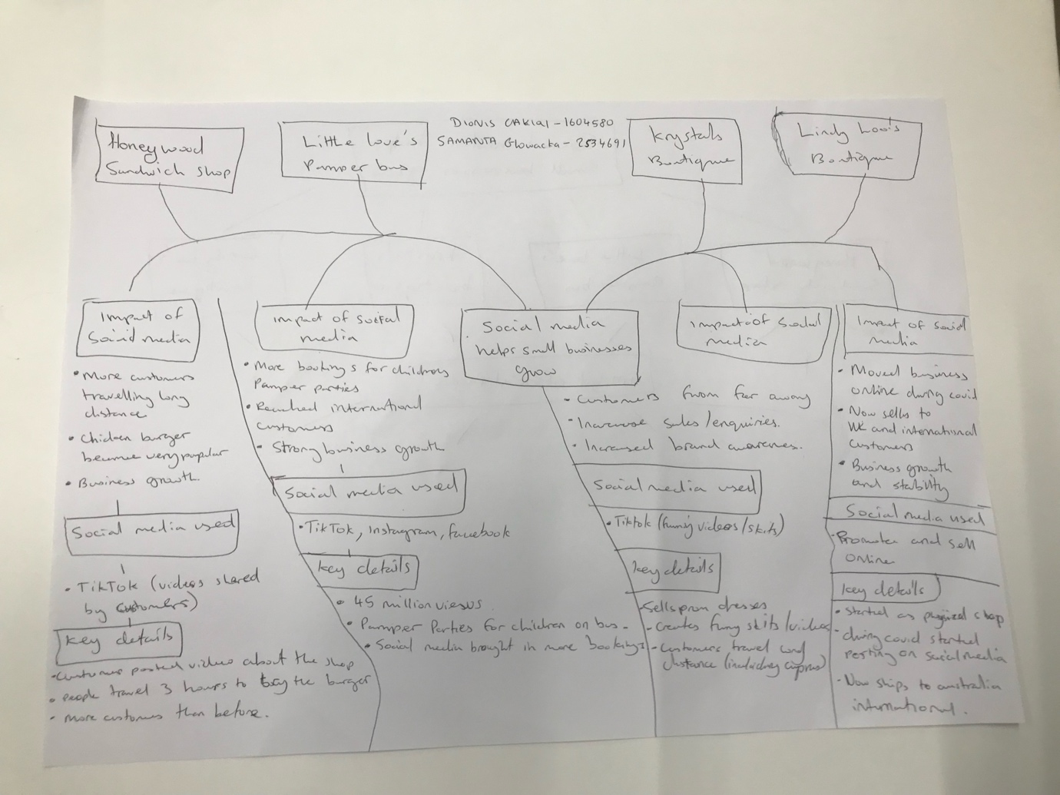
Academic Skills - Task 1 – Reading Task
a. What is the main idea of the text?
The main idea is that social media helps small businesses grow by attracting more customers and increasing sales. The article shows this through different businesses that became more popular after people shared videos about them online.
b. What are two key points?
One key point is that businesses can reach more customers when videos about them are shared on social media. For example, Little Love's Pamper Bus received millions of views online, which helped more people notice the business.
Another key point is that some customers travel long distances to visit businesses they have seen online. For example, customers travelled for hours to try food from Honywood Sandwich Shop after seeing it on social media.
c. What part of the text did you find most important? Why?
The most important part is the examples of different businesses because they show how social media can help businesses become more successful. Seeing how these businesses benefited from social media made the main idea easier to understand.
d. Was anything unclear or difficult to understand?
I was not sure why some businesses go viral so quickly on social media. I understand that videos can spread quickly, but it is still difficult to know why some businesses' posts become popular while others do not.
e. How did your group help you understand the text better?
My group helped me by discussing the article and helping me identify the main idea and key details. Listening to other people's ideas helped me understand that the article was not only about one shop, but about how social media can help different types of businesses grow.
Reflection
The hardest part was deciding which information was relevant in the articles for my mind map.

