University of Wales Trinity Saint David
Wales Institute of Science and Art


Engineering Performance and Emissions

Alternative fuels and combustion
ACHA 7002

Word count: 2067
Ewan Evans
2200899
Date submitted: 26/4/2026
Contents
1. Introduction 1
2. Model validation, refinement and limitations 2
3. Fuel comparison 4
4. Engine tuning 9
5. Conclusion 12
6. References 13
7. Appendix 14

Figure 1 - Pressure between the McLaren 570s and the Wave baseline model 3
Figure 2 - Temperature between the McLaren and the Wave baseline model 4
Figure 3 - NOx production against RPM for varying fuels in simulation 5
Figure 4 - analytical vs actual for equation (Eqn) and simulation model test (ANN) to calculate the NOx used (Meltem Goktas, et.al 2021) 6
Figure 5 - Varying fuels NOx prediction against actual NOx production (Meltem Goktas, et.al 2021) 6
Figure 6 – Power against RPM for varying fuels in the simulation 7
Figure 7 – Methanol mixture in relation to gasoline showing power output (Luke Oxenham, Yaodong Wang, 2021) 7
Figure 8 - Ethanol mixture in relation to gasoline showing power output (Luke Oxenham, Yaodong Wang, 2021) 7
Figure 9 - Influence of ethanol and gasoline in relation to power(Mortadha K.Mohammed, et.al 2021) 8
Figure 10 – Nox output for a change in burn duration and where the 50% burn point is at 18000 RPM 9
Figure 11 - Nox output for a change in SoC (Mohanad Aldhaidhawi Meuneer Naji, et.al, 2020) 10
Figure 12 - NOx production with change in combustion duration (Nguyen Xuan Khoa 2022) 10
Figure 13 - Max Power output for a change in burn duration and where the 50% burn point is at 18000 RPM 11
Figure 14 - Ignition timing influence on power (Mohanad Aldhaidhawi Meuneer Naji, et.al, 2020) 11
Figure 15 - Max temperature output for a change in burn duration and where the 50% burn point is at 18000 RPM 14
Figure 16 - Temperature production with change in combustion duration (Nguyen Xuan Khoa 2022) 14
Figure 17 - Max presssure output for a change in burn duration and where the 50% burn point is at 18000 RPM 15

Table 1- Accumulated chemical heat release flame front (J) against crank angle and RPM 2
Table 2 - RPM against Weibe function sections for gasoline fuel 2
Table 3 - Max temperature and NOx comparison between McLaren 570s and WAVE baseline 4
Table 4 - Fuels properties applicable in ICE system (Meltem Goktas, et.al, 2021) 5

Introduction
This report combines the use of both ANSYS Forte and Ricardo WAVE simulation to review the use of alternative fuels in Formula One internal combustion engines before the introduction of the energy recovery system (2010 season). Due to recent focus on the environmental impact of vehicles, specifically their fuel base and emissions, various motorsport disciplines as well as regular vehicles have shifted to more sustainable and environmentally friendly solutions. With this F1 have shifted to a more sustainable system. However, the question remains whether F1 could have continued with the original engines and the used an alternative fuel instead of the use of electric systems and the need for a change in engine. This leads to the investigation of alternative fuels for naturally aspirated V8 F1 engines for the 2035 season.
An accurate replication of the engine cycle needs to take place to replicate the engine/fuel specifications as accurately as possible. The engine used in the ANSYS Forte system is a Jaguar V8 as there is a preexisting model and with the pre electric car era being naturally aspirated V8. The combustion simulation engine characteristics that can be found using ANSYS Forte are then implemented into the Ricardo Wave. With this a comparison between the original fuel and the new version can be employed and a review of whether some alterations need to be made to improve performance. A fuel mixture is chosen and then adjusted using engine tuning to improve the NOx produced whilst keeping performance factors high.

Model validation, refinement and limitations
To gain confidence in the accuracy of the data the WAVE and ANSYS Forte combined model is compared to the pressure data from the McLaren 570S engine. This produced some differences to a naturally aspirated F1 engine however for the purposes of comparison they are not significant for this scenario.
However, before the data can be compared the compiling of the data needs to take place, which involves both ANSYS Forte and WAVE. Forte is used to retrieve the Wiebe implementation of the simulation due to the benefits of chemical reaction modelling. This is then brought into WAVE and implemented using the mass fraction burnt and the 50% burn point of the Wiebe function.

Table 1- Accumulated chemical heat release flame front (J) against crank angle and RPM
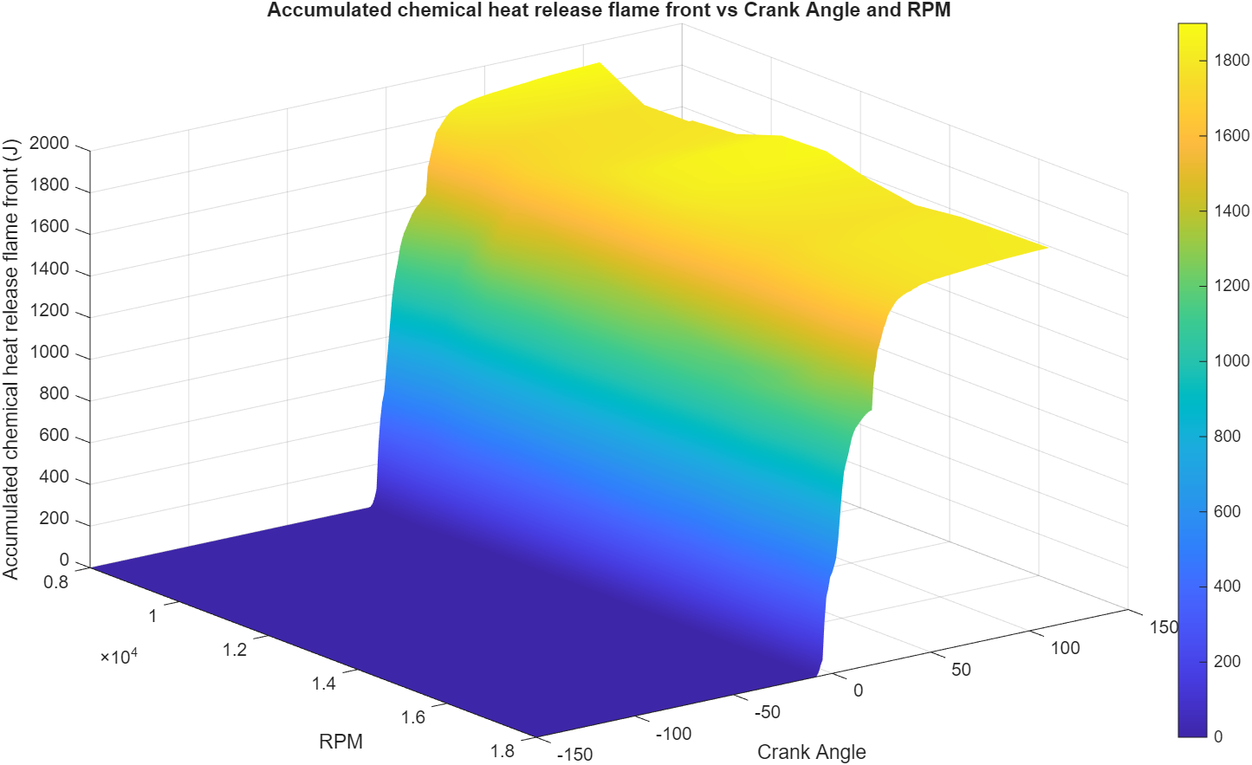

Table 2 - RPM against Weibe function sections for gasoline fuel
RPM | 8000 | 9000 | 10000 | 11000 | 12000 | 13000 | 14000 | 15000 | 16000 | 17000 | 18000
10% angle | -4.25 | -4.5 | -4.75 | -5 | -5 | -4.75 | -4.8 | -5 | -5.5 | -5.5 | -4.1
90% angle | 24.5 | 23 | 26 | 26.5 | 27 | 27 | 30 | 35 | 31 | 28.5 | 30.5
50% angle | 2.5 | 3 | 3.75 | 4.25 | 3.5 | 5 | 4.75 | 5.75 | 4.5 | 6.25 | 5.5
burn duration angle | 28.75 | 27.5 | 30.75 | 31.5 | 32 | 31.75 | 34.8 | 40 | 36.5 | 34 | 34.6

The data can then be analysed; however it needs to be stated that the Forte model is using an engine of similar characteristics (high performance Jaguar V8 engine) not the F1 engine. Some of these differences, such as bore, stroke and so on lead to slight deviances, however due to the implications of creating a model from scratch it is the most comparable out of the prebuilt models to a naturally aspirated V8 engine. However, cylinder characteristics were changed such as fuel injection and spark to give a more accurate representation of the data and then allowed for a comparison to real world pressure data.
This pressure data is in comparison to a McLaren 570s engine due to the most applicable engine data available in relation to the F1 engine. At first glance there seems to be some clear discrepancy between both sets of data. However, there are explanations behind these discrepancies. The McLaren data is turbocharged and is the predominant reason why the pressure is much higher. The initial pressure is not that different until the combustion process occurs within the McLaren data, then the turbo influence is clear [1] in figure 1. Furthermore, the delay in peak pressure crank angle of the McLaren data is once again due to the influence of the turbo delaying combustion timing. It could be suggested that the pressure in the cylinder of the WAVE data should be much higher, however due to this being the highest RPM the McLaren data can be compared too. The pressure of the F1 engine does exceed this and gets to 90 to 100 Bar.

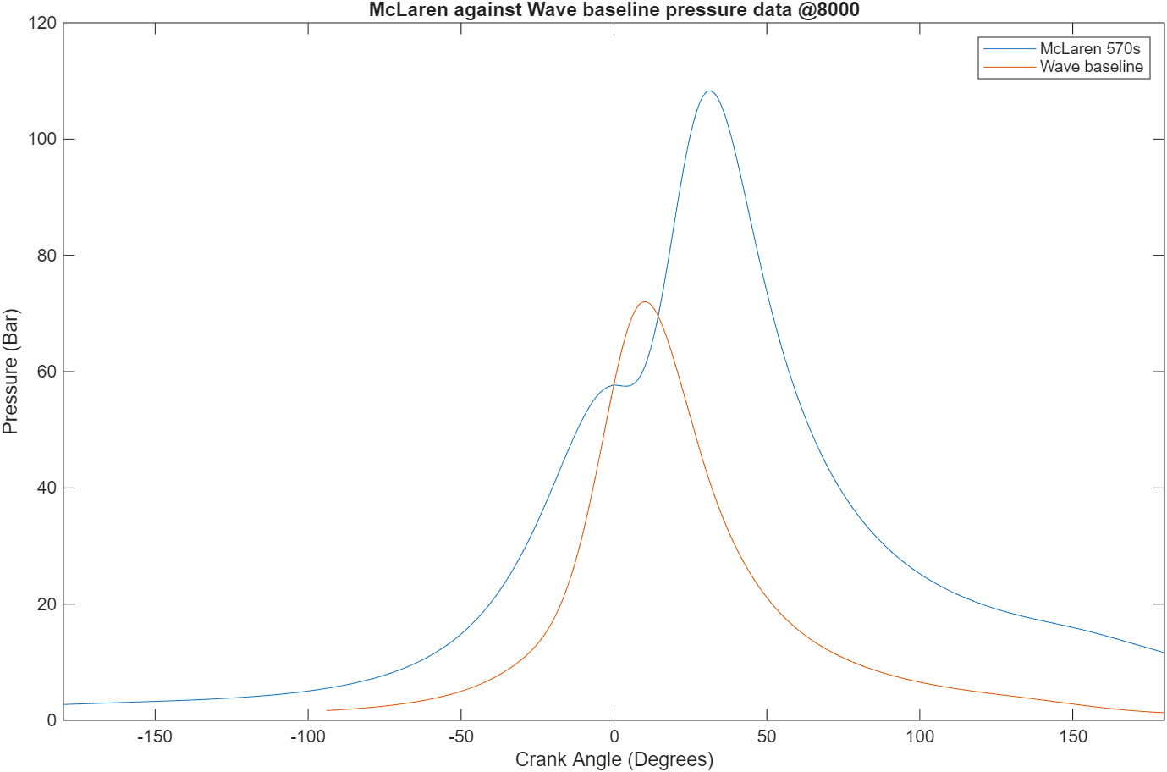
1

Figure 1 - Pressure between the McLaren 570s and the Wave baseline model

As shown in the data below the temperature and NOx production of the engines further proves the comparability between the two engines. The temperature data is offset by approximately 20 degrees however this is once again due to the influence of the turbo as mentioned previously. Therefore, with the understanding of these discrepancies, confidence can be given to the validation of the simulation.
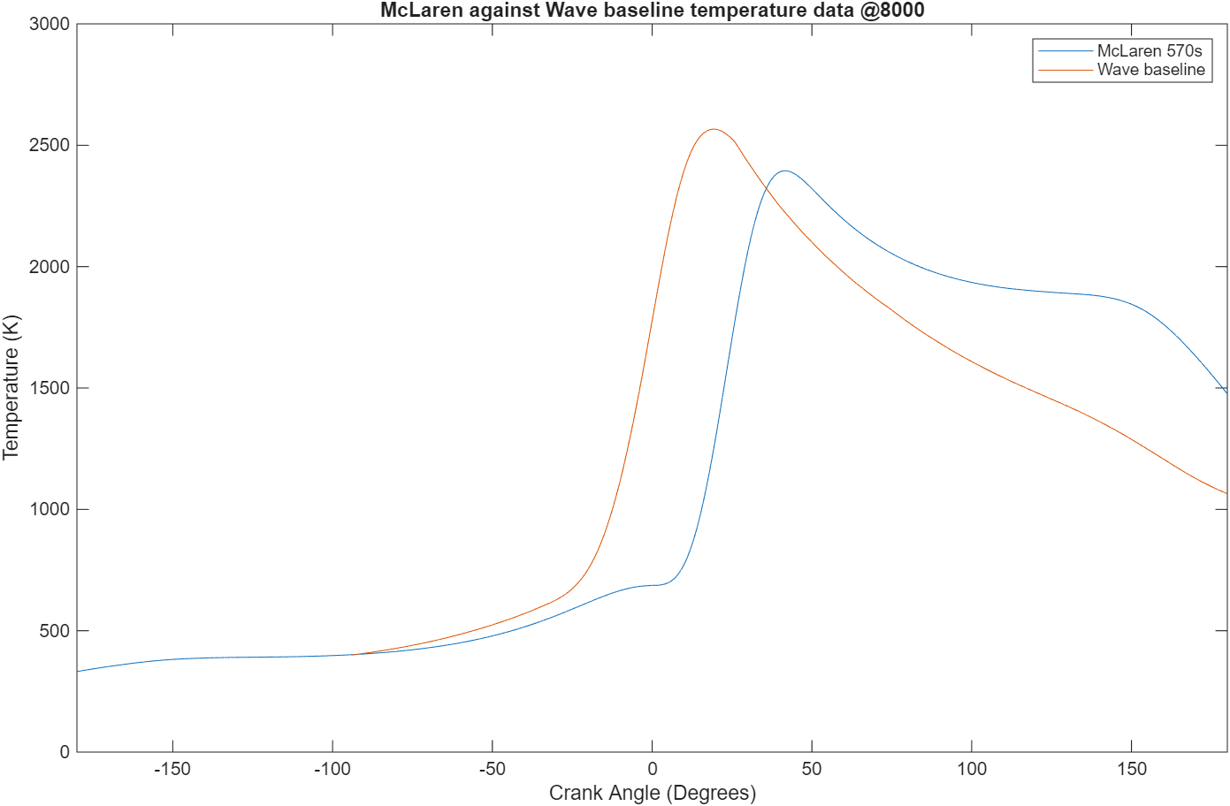
Figure 2 - Temperature between the McLaren and the Wave baseline model

Table 3 - Max temperature and NOx comparison between McLaren 570s and WAVE baseline
 | McLaren 570s | WAVE baseline
Max Temperature (K) | 2394 | 2565
NOx (PPM) | ~ 3000 | 3064

Fuel comparison
The implementation of varying types of fuel should be investigated to look at the emissions output and the performance that they have. A balance needs to be made between the power drop in relation to the improvement in emissions output. Due to the aim to keep the performance of the vehicle at high values to not remove from the motorsport aspect of the vehicle, the drop off in performance should be low (no less than 5%).
A selection of fuels were chosen from a technical paper on alternative alcohol fuels being used in SI engines (Meltem Gokta, et.al, 2021), these were then applied into the Forte model and moved into WAVE as carried out previously.

Table 4 - Fuels properties applicable in ICE system (Meltem Goktas, et.al, 2021)
Properties | Gasoline | Methanol | Ethanol
LHV | 44300 | 20100 | 26800
Latent heat of vaporisation | 349 | 1100 | 910
Research octane number | 90-100 | 108.7 | 109
Boiling point | 27-225 | 64.5 | 78.4
Stoichiometric A/F ratio | 14.6 | 6.46 | 8.97
Energy density (MJ/L) | 32-35 | 15.7 | 22

The fuels were first ran in Forte to retrieve the Wiebe section and then implemented into Wave. Details such as AFR (air-fuel ratio) values were also included to improve accuracy.
The NOx production is clearly larger with Gasoline and therefore would suggest a change to other fuels to reduce the overall NOx production in the system (Methane and Ethanol = 1-2% of Gasoline NOx). The lower Methanol and Ethanol NOx value comes from a lower heating value (LHV) and latent heat vaporisation; this is due to the methanol and ethanol requiring less energy to burn and therefore keeping the temperatures down, reducing the chemical reaction between the Nitrogen and Oxygen molecules (biologyinsights, 2025). This trend is consistent with alternative studies also suggesting LHV consistently drops NOx production (Kexin Liu, Victoria Sanderson, 2013).

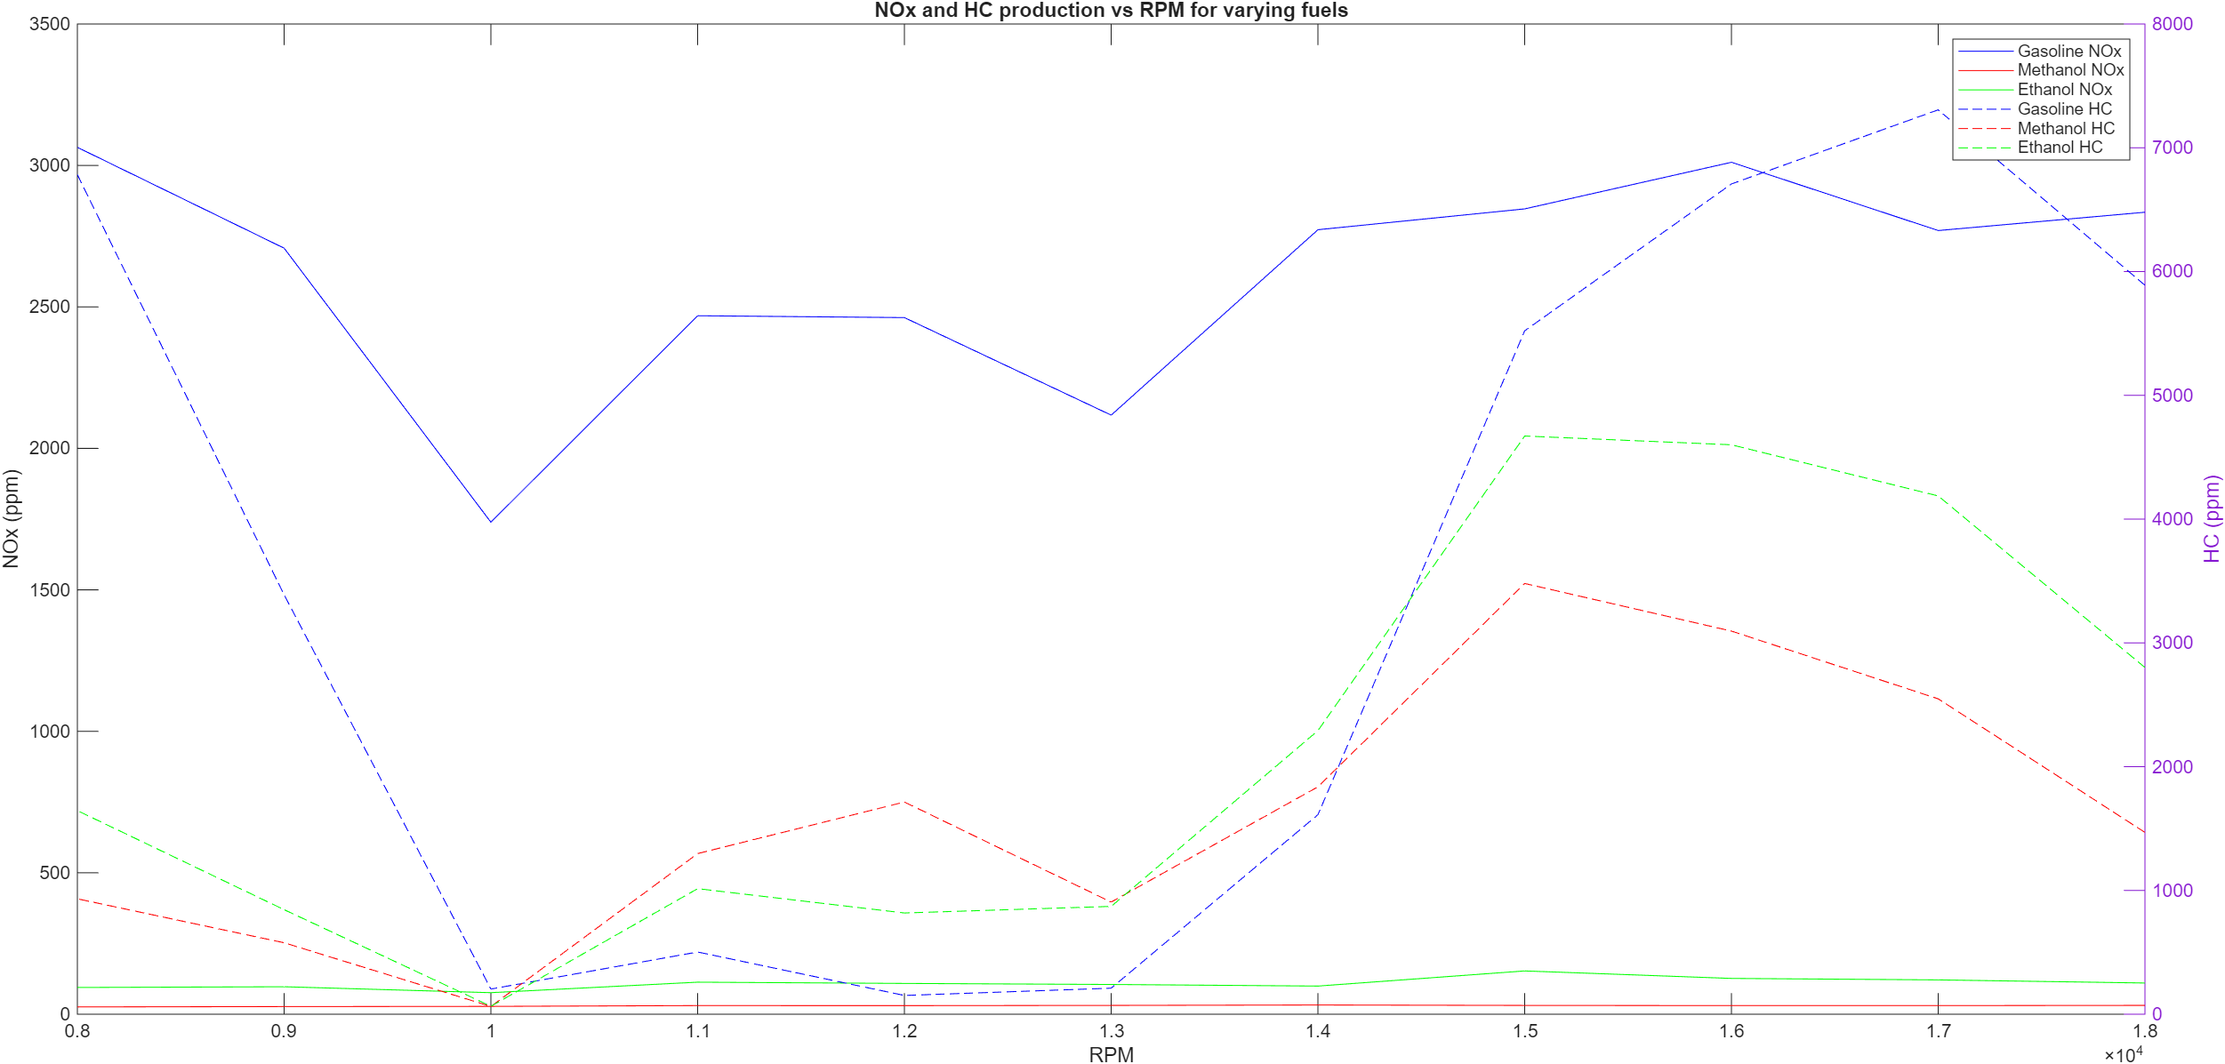
Figure 3 - NOx production against RPM for varying fuels in simulation

It needs to be stated that these are simulations and not real data, however when comparing this to various sources the accuracy deviates depending upon the fuel, as shown in the figures below. Therefore, the addition of real world emissions testing would be ideal to give further conclusiveness to the investigation.

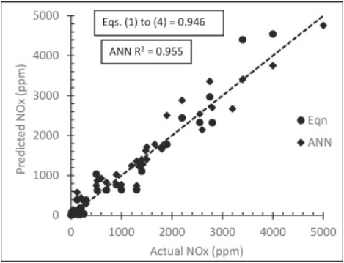
Figure 4 - analytical vs actual for equation (Eqn) and simulation model test (ANN) to calculate the NOx used (Meltem Goktas, et.al 2021)

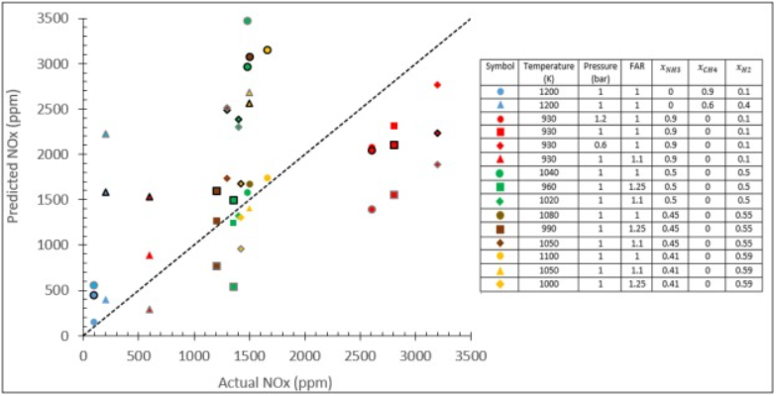
Figure 5 - Varying fuels NOx prediction against actual NOx production (Meltem Goktas, et.al 2021)

Gasoline produces much higher power outputs in comparison to Methanal and Ethanol as shown in figure 6. This aligns with an external study done on all three fuels and showed strong trends with the data gathered from the simulation as shown in figures 7 and 8 (Luke Oxenham, Yaodong Wang, 2021). This shows that even with good combustion, as shown through volumetric efficiency graph in appendix, the impact of the fuel having much lower energy density is clear to see through the drop off in power. One point that needs to be made is that when comparing the Ethanol fuel to an alternative paper, there is a contradiction to as stated previously (Mortadha K.Mohammed, et.al 2021), as shown in figure 9. However, due to the similarities in the data between the previous external study and the wave data gathered it would be concluded that the data that contradicts cannot be trusted in this situation.

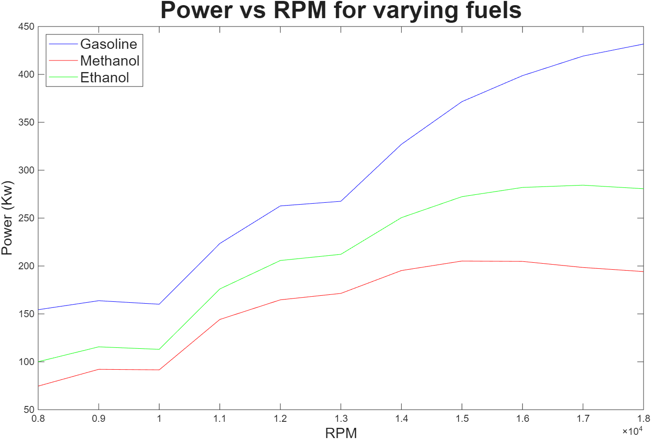
Figure 6 – Power against RPM for varying fuels in the simulation

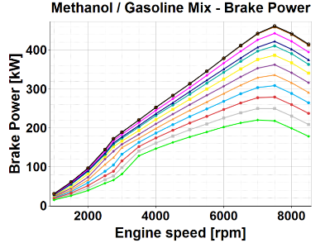  Figure 7 – Methanol mixture in relation to gasoline showing power output (Luke Oxenham, Yaodong Wang, 2021) | 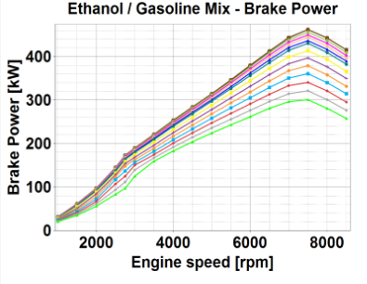  Figure 8 - Ethanol mixture in relation to gasoline showing power output (Luke Oxenham, Yaodong Wang, 2021)

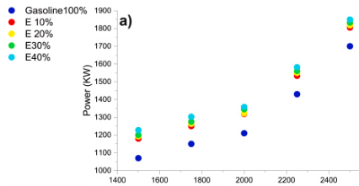
Figure 9 - Influence of ethanol and gasoline in relation to power(Mortadha K.Mohammed, et.al 2021)

Other factors need to be considered when considering Methanol and Ethanol, such as the implementation of these fuels into a real world scenario. One issue is the fact that Methanol is corrosive within the fuel system. This is not a significant implication in this scenario as the focus is for top end performance (Rockett brand racing fuel 2013). Furthermore, the fuel consumption of Methanol is around half of Gasoline, with this being implemented into the race application it would likely then require larger fuel storage systems, or alternatively refuelling during the race, which has its own implications (Rockett brand racing fuel 2013). With this being said Methanol does have some benefits, such as cleaner burn and a smaller cooling system is required.
Methanol has large implications of fuel consumption when in comparison to Gasoline, which Ethanol also experiences, however the drop off is not as extreme. It is due to the energy density of the fuels being lower than Gasoline, as shown in table 4. Furthermore, there is concern about increase in wear to the system, however due to the situation of this engine it is not an area of significant concern.
It would suggest that using ethanol and methanol is beneficial to performance in comparison to pure Gasoline and that the external simulation confirms this. Furthermore, it would be expected that use of a high Ethanol content would provide the benefits of power and NOx production in contrast to Gasoline. Therefore, a combination of 50% Ethanol, 5% Methane and 45% Isooctane is then chosen as the new fuel mixture to use going forwards.

Engine tuning
Ideally this would be tested, however due to licencing issues to make a new fuel in WAVE this could not be done and preset fuels had to be used in replace. The closest prebuilt fuel to E50I45M5 is the use of E85 as it has both the mixture of Ethanol and iso-octane at high content values. The focus is to maintain power output, whilst also reducing NOx in the system.

The NOx production is significantly influenced by the 50% burn point, whilst the burn duration does have an effect, however the impact is not as significant. The 50% burn point shows trends that are expected as when the burning is delayed at high RPMs it lowers temperatures and therefore as results produces less NOx (Carworship, 2024). Furthermore, the change in burn duration is not as significant of an impact, however values do change and with this a lower burn duration give an improvement to the NOx production. This contradicts external sources as seen in figure 11, where a longer burn duration improves NOx. However, the reasoning behind this is due to the limitations in the simulation as it is inputting a rate of fuel that is proportional to the burn duration, whilst the other study uses a continuous amount of fuel no matter the burn duration. The alternate study is more accurate as when burning the same amount of fuel over a smaller period of time the temperatures would increase as well (Nguyen Xuan Khoa 2022), as shown in appendix 16 and 17.

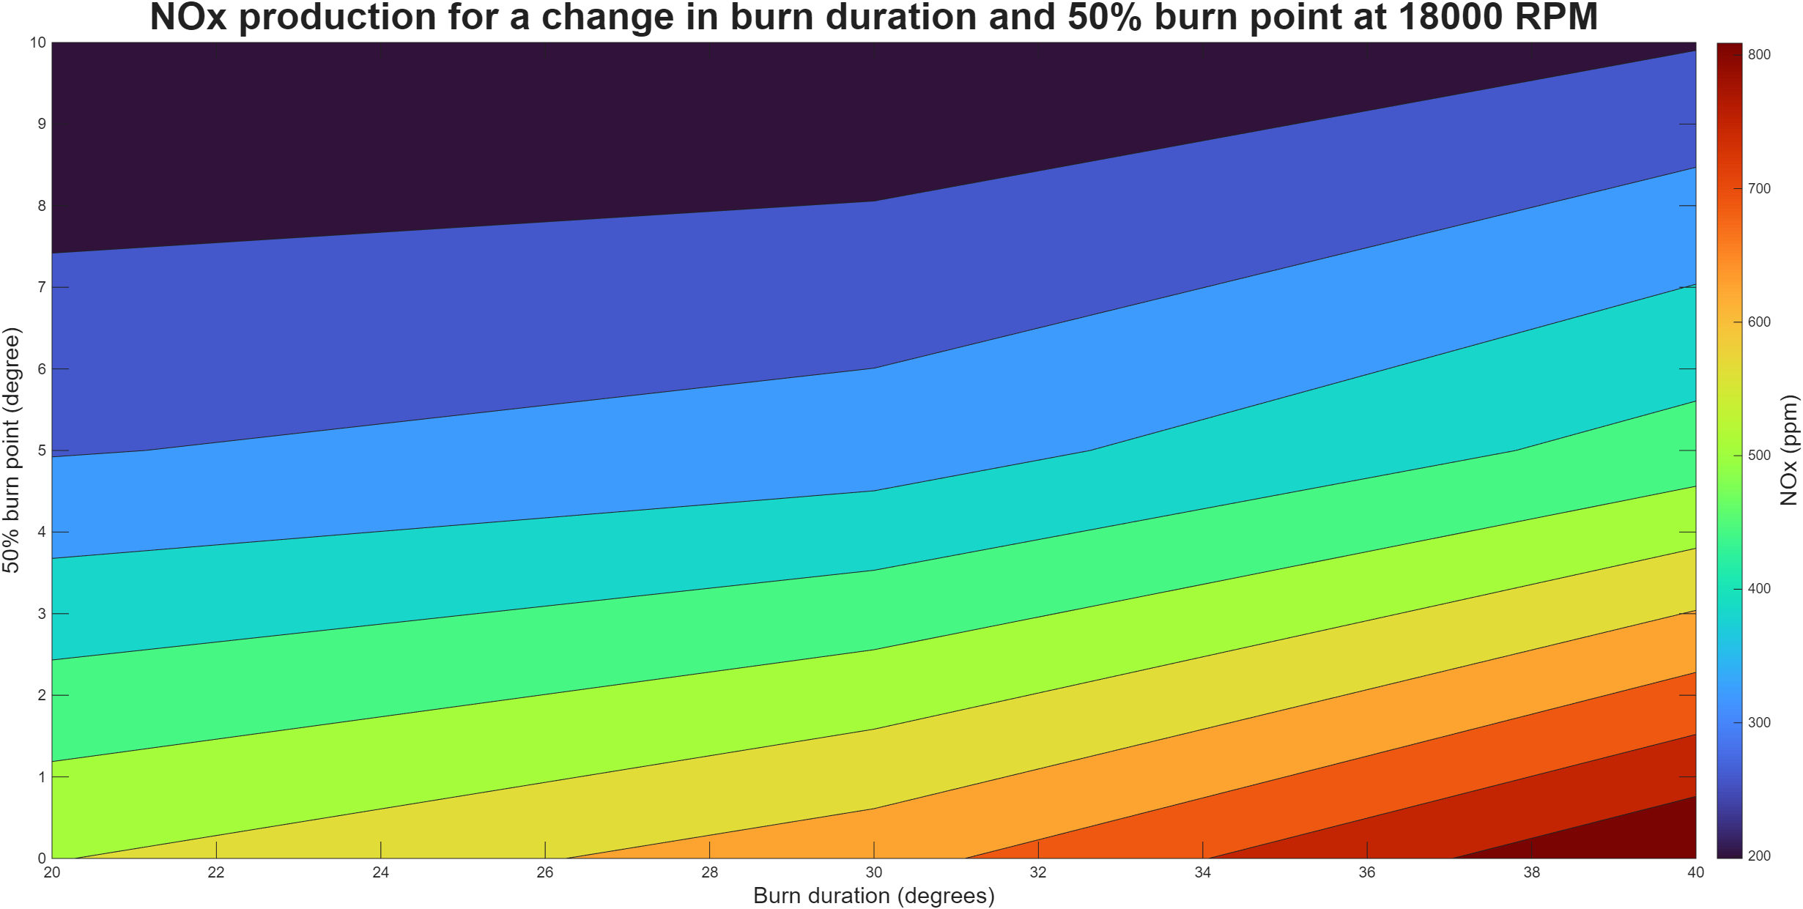
Figure 10 – Nox output for a change in burn duration and where the 50% burn point is at 18000 RPM
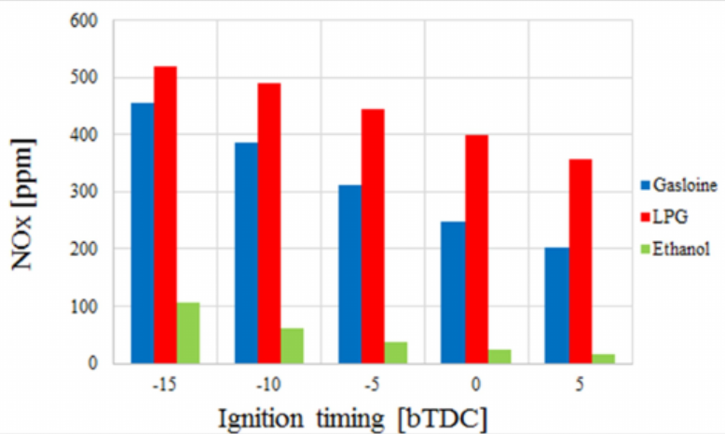
Figure 11 - Nox output for a change in SoC (Mohanad Aldhaidhawi Meuneer Naji, et.al, 2020)

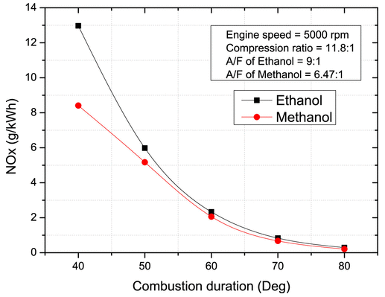
Figure 12 - NOx production with change in combustion duration (Nguyen Xuan Khoa 2022)

When comparing the power output of the data against external sources there is a clear discrepancy between the influence the 50% burn point has on the combustion of the engine. It could therefore be expected that the pressures follow a similar trend. However, this is not the case, with the pressures following trends that are as expected, due to the higher pressure occuring when fuel is closer towards TDC, as seen in appendix. Therefore, with the misalignment with external studies and the max pressure being away from TDC in the simulation, it would therefore suggest a simulation inaccuracy.
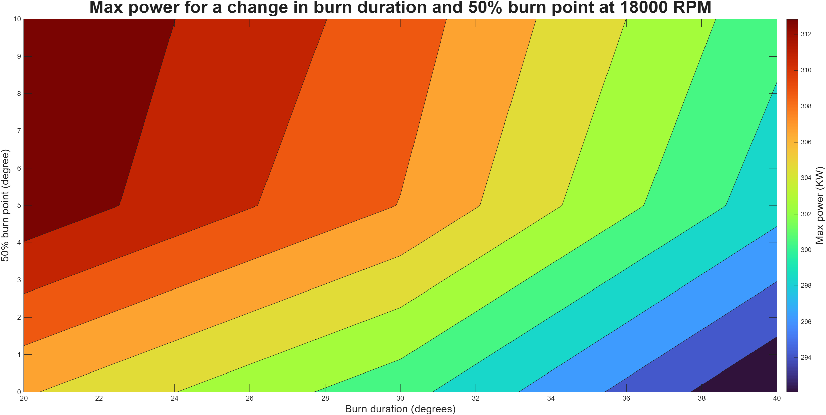
Figure 13 - Max Power output for a change in burn duration and where the 50% burn point is at 18000 RPM
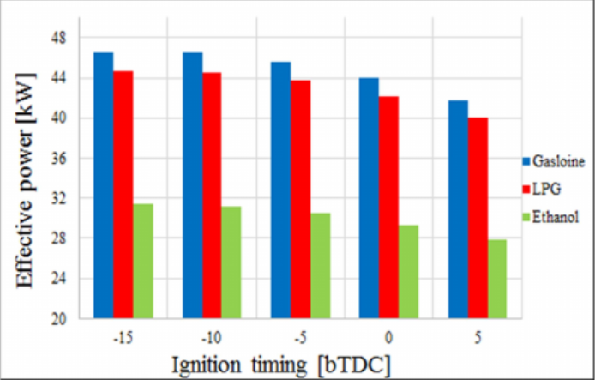
Figure 14 - Ignition timing influence on power (Mohanad Aldhaidhawi Meuneer Naji, et.al, 2020)

Conclusion
The investigation showed signs of correlation and similarities in certain aspects, with the general pressure trends when in comparison to the McLaren data, with several deviances being related to the impact of the turbo charger on the McLaren. It would be suggested that for a high performance engine the pressures are lower than expected, however can still give strong results, especially the difference in max temperature (171K) and NOx output (~64ppm).
The trends continued into the power output of alternative fuels. With this it aligned strongly with external data and contradicted others as well. However, due to the comparability between the wave simulation and external study (Luke Oxenham, Yaodong Wang, 2021), it allowed for strengthening the reliability in the wave model. NOx production showed strong correlation as well and that other simulations have discrepancies with NOx output, therefore suggesting that dynamometer testing could be done to improve this aspect. Furthermore, the addition of being able to implement the E50M45I5 fuel into WAVE would have also been beneficial to understand the performance factors of the desired fuel blend.
Tuning on E85 has some similarities with E50M45I5, however there will be some differences but due to the inability to create new blends this was the closest fuel with WAVE for the tuning purposes. SOC/ 50% burn point has significant impact on both the NOx and the power output and shows the importance of tuning this to control the NOx to power output ratio. In relation to the engine holding power that is not below a threshold around 5-10% is key to not remove performance and therefore controlling the NOx production with this is important. Ideally with the desired fuel the drop off in power between Gasoline and the blend would not be as extreme as simulated (~115 Kw, 37% drop in power for a ~88.5% saving in NOx).

References

BIOLOGYINSIGHTS, 2025. How Is NOx Produced From Natural and Anthropogenic Sources? . Date retrieved (25/4/2026)
CARWORSHIP, 2024. Ignition timing significantly impacts performance ignition systems by dictating when spark plugs ignite the air/fuel mixture within an engine’s cylinders. Date retrieved (26/4/2026)
ENGINEERFIX, 2025. Is Gas With Ethanol Bad for Your Engine? . Date retrieved (26/4/2026)
KEXIN LIU, V.S., 2013. The influence of changes in fuel calorific value to combustion performance for Siemens SGT-300 dry low emission combustion system. Date retrieved (25/4/2026)
LUKE OXENHAM, Y.W., 2021. A Study of the Impact of Methanol, Ethanol and the Miller Cycle on a Gasoline Engine. Date retrieved (26/4/2026)
MELTEM GOKTAS, MUSTAFA KEMAL BALKI, CENK SAYIN, MUSTAFA CANAKCI, 2021. An evaluation of the use of alcohol fuels in SI engines in terms of performance, emission and combustion characteristics: A review. Date retrieved (25/4/2026)
MOHANAD ALDHAIDHAWI, MEUNEER NAJI, ABDEL NASEER AHMEND, 2020. EFFECT OF IGNITION TIMINGS ON THE SI ENGINE PERFORMANCE AND EMISSIONS FUELED WITH GASOLINE, ETHANOL AND LPG. Date retrieved (26/4/2026)
MORTADHA K.MOHAMMED, HYDER H.BALLA, ZAID MAAN H. AL-DULAIMI, ZAID S.KAREEM, MUDHAFFAR S.AL-ZUHAIRY, 2021. Effect of ethanol-gasoline blends on SI engine performance and emissions. Date retrieved (26/4/2026)
NGUYEN XUAN KHOA, O.L., 2022. Influence of Combustion Duration on the Performance and Emission Characteristics of a Spark-Ignition Engine Fueled with Pure Methanol and Ethanol. Date retrieved (26/4/2026)
ROCKETT BRAND RACING FUEL, 2013. Advantages: Gasoline vs. Methanol. Date retrieved (26/4/2026)
SONG YANG, JINCHENG FENG, PING SUN, YU WANG, WEI DONG, XIUMIN YU, WEINA LI, 2023. Combustion and emissions characteristics of methanol/gasoline CISI engines under different injection modes. Date retrieved (25/4/2026)

Appendix

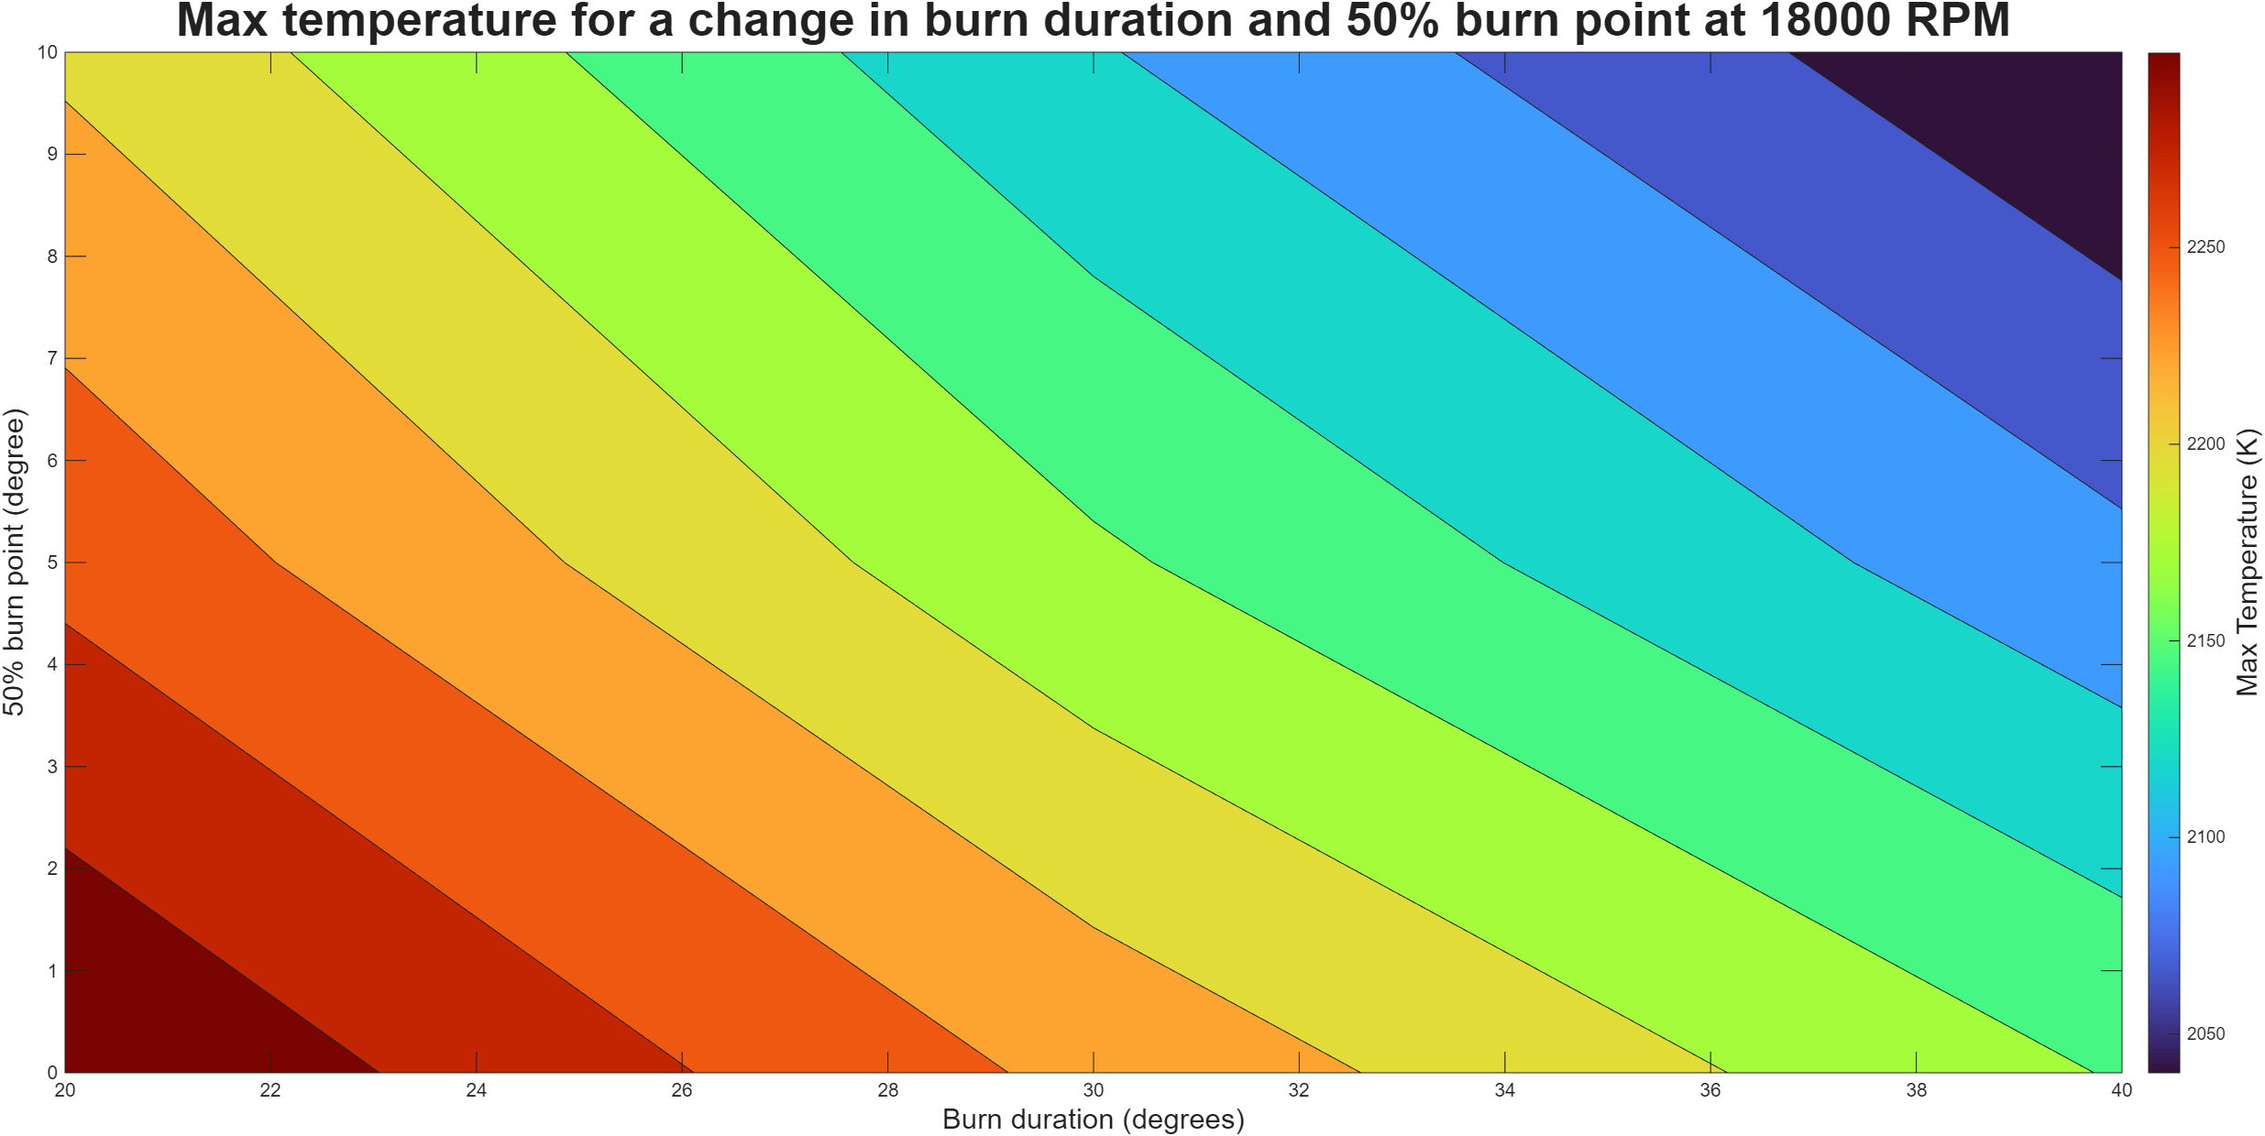
Figure 15 - Max temperature output for a change in burn duration and where the 50% burn point is at 18000 RPM

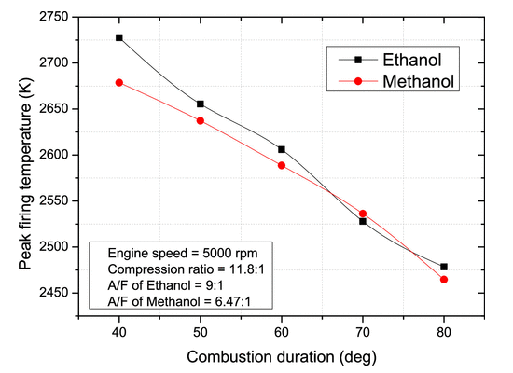
Figure 16 - Temperature production with change in combustion duration (Nguyen Xuan Khoa 2022)

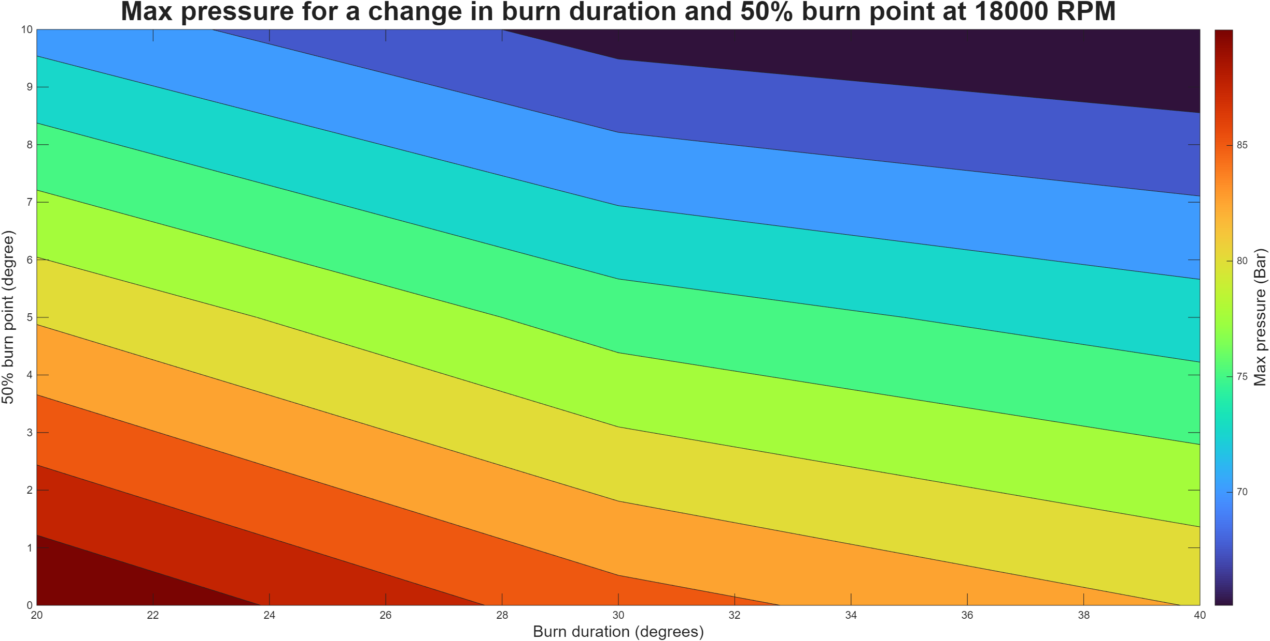
Figure 17 - Max pressure output for a change in burn duration and where the 50% burn point is at 18000 RPM

