Name:_________Joseph Protheroe__________________

Student Number: ______2532111_________________

WORKSHEET 3 – TESTING (Lap Times)

- Original code:
#Vairibles
Target_Lap = 0
Current_Lap = 0
Laps = []
Max_Laps = 5
flag = 0
Fastest_Lap = 0
Slowest_Lap = 0
Num_Laps_Better = 0
Last_Lap = 0
#Body
#Data entry
while flag == 0:
try:
Target_Lap = float(input("What is your target lap time?(in seconds): "))
except ValueError:
print("Please enter a valid lap time in seconds!")
else:
if Target_Lap <= 0:
print("Lap time cannot be less than or equal to 0!")
else:
flag = 1
flag = 0
for x in range(Max_Laps):
while flag == 0:
try:
print("What is the lap time for lap",x+1,"(in seconds):? ",end="")
Current_Lap = float(input())
except ValueError:
print("Please enter a valid lap time in seconds!")
else:
if Current_Lap <= 0:
print("Lap time cannot be less than or equal to 0!")
else:
flag = 1
flag = 0
Laps.append(Current_Lap)
#Data statistics
print("")
print("The Overall time for the",Max_Laps,"Laps was",sum(Laps),"Seconds.")
print("The average of the lap times was",sum(Laps)/Max_Laps,"Seconds.")
for x in range(Max_Laps):
if Laps[x] < Laps[Fastest_Lap]:
Fastest_Lap = x
print("The Fastest lap was lap",Fastest_Lap+1,"With a time of",Laps[Fastest_Lap],"Seconds.")
for x in range(Max_Laps):
if Laps[x] > Laps[Slowest_Lap]:
Slowest_Lap = x
print("The Slowest lap was lap",Slowest_Lap+1,"With a time of",Laps[Slowest_Lap],"Seconds.")
for x in Laps:
if x <= Target_Lap:
Num_Laps_Better += 1
print("There were",Num_Laps_Better,"laps better than or equal to the target time.")
print("")
for x in range(Max_Laps):
if x > 0:
if Laps[x] > Last_Lap:
print("Lap",x+1,"was Slower than Lap",x)
else:
print("Lap",x+1,"was Faster than Lap",x)
else:
print("First Lap, Nothing to compare to.")
Last_Lap = Laps[x]

- Code Testing
For each test below, run your code and show the results of the scenarios below. Present a screenshot of what happened when the programme ran. Did the programme behave correctly or did it do something unexpected, and if so, why?

- Test a lap time for your programme:
- 42 seconds
- 2 seconds
- -4 seconds
- 53444 seconds
- Test the target lap time – show that the values entered are reasonable

- Using the same five lap times as the sample output ie

Lap 1: 42.3
Lap 2: 42.1
Lap 3: 44
Lap 4: 44
Lap 5: 39.4

Examine each statistic (1-6) and comment on whether the correct answer(s) are displayed or not. (If any statistics were incomplete after Phase 1 (code completed in class) simply write “Unfinished”)

- Test two further sets of lap times of your own choice.

Template for tests:
Test:
a.1 lap time of 42 seconds (no instruction given as to target time so entered as 10 to allow the program to progress)
Screenshot(s) of output:
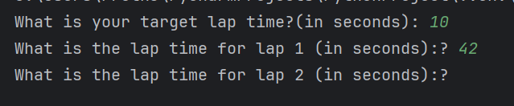
Result: Did the programme behave as expected i.e. syntactically and logically correct?
YES

The program continued as expected as a lap time of 42 is a valid lap time.

Test:
a.2 lap time of 2 seconds (no instruction given as to target time so entered as 10 to allow the program to progress)
Screenshot(s) of output:
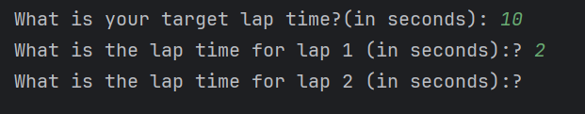
Result: Did the programme behave as expected i.e. syntactically and logically correct?
NO

A lap time of 2 seconds is unrealistic; the program should limit the entry of lap times to reasonable values potentially done as a range either side of the entered target lap time

Test:
a.3 lap time of -4 seconds (no instruction given as to target time so entered as 10 to allow the program to progress)
Screenshot(s) of output:
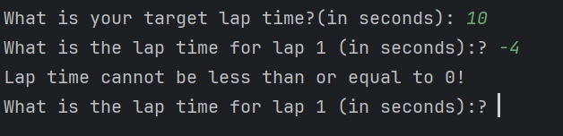
Result: Did the programme behave as expected ie syntactically and logically correct?
YES

A lap time of -4 seconds is impossible as it must be a positive number. The program correctly prompted the user to re-enter the data.

Test:
a.4 lap time of 53444 seconds (no instruction given as to target time so entered as 10 to allow the program to progress)

Screenshot(s) of output:
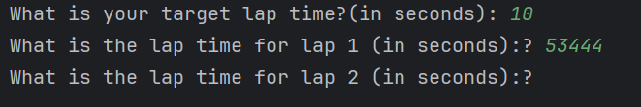
Result: Did the programme behave as expected i.e. syntactically and logically correct?
NO

A lap time of 53444 seconds is unrealistic, and the program should have prompted the user to re enter the data. Though a time of 53444 (890.7 mins) is possible even one of the longest circuits in the world the German Nordschleife Circuit which is 20.832 km (12.944 mi) can be completed by a go cart in around 15 mins.

Test:
a.5 Test Target lap functionality

Screenshot(s) of output:
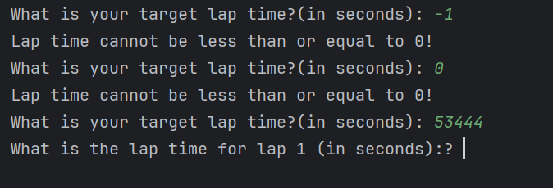
Result: Did the programme behave as expected ie syntactically and logically correct?
NO

The program was partially successful as it has a lower bound set (that being target time cannot be 0 or less) but it does not have a reasonable upper limit to the target lap time.

Test:
B (no target time specific so will enter 43)
Lap 1: 42.3
Lap 2: 42.1
Lap 3: 44
Lap 4: 44
Lap 5: 39.4

Screenshot(s) of output:
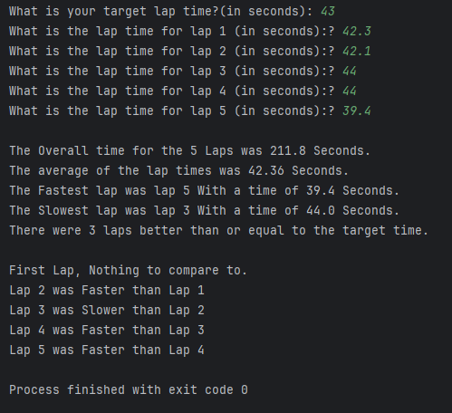
Result: Did the programme behave as expected i.e. syntactically and logically correct?
NO

Though most of the statistics are correct the part of the program that compares lap times against each other is flawed, as laps 3&4 were the same so the program should have identified that and correctly displayed “Lap 4 was the same as Lap 3”

Test:
C
Target Lap: 50
Lap 1: 53441
Lap 2: 51
Lap 3: 48
Lap 4: 55
Lap 5: 47

Screenshot(s) of output:
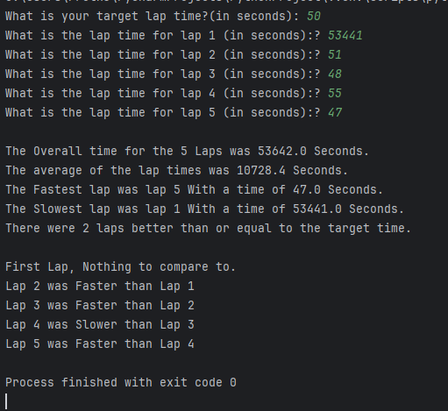
Result: Did the programme behave as expected ie syntactically and logically correct?
NO

The program should not have allowed the entry of the first lap time as it is unreasonable compared to the target lap time, it should have prompted the user to renter the data.

Test:
D
Target Lap: 50
Lap 1: 1
Lap 2: 51
Lap 3: 48
Lap 4: 55
Lap 5: 47

Screenshot(s) of output:
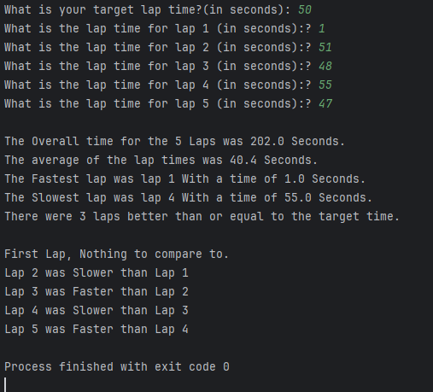
Result: Did the programme behave as expected ie syntactically and logically correct?
NO

The program should not have allowed the entry of the first lap time as it is unreasonable compared to the target lap time, it should have prompted the user to renter the data.

(Copy and paste box above for each of the rest of the tests)
- Consider the results of the above tests and revisit your original code in order to address any tests that failed and/or improve code efficiency.

(Note: you may not be able to solve all of the problems that were encountered, but solve as many as you can.)

Paste your full revised code here :

[Copy and paste your full revised code here – note, do not use a screenshot]
#DONE comparison of same laps
#DONE Upper bound on Target Lap
#DONE Upper and lower bound on lap entry based off target lap
#Vairibles
Target_Lap = 0
Lap_Upper_Bounds = 0.75
Lap_Lower_Bounds = 0.25
Current_Lap = 0
Laps = []
Max_Laps = 5
flag = 0
Fastest_Lap = 0
Slowest_Lap = 0
Num_Laps_Better = 0
Last_Lap = 0
#Body
#Data entry
while flag == 0:
try:
Target_Lap = float(input("What is your target lap time?(in seconds): "))
except ValueError:
print("Please enter a valid lap time in seconds!")
else:
if Target_Lap <= 0:
print("Lap time cannot be less than or equal to 0!")
elif Target_Lap >= 900: #900 seconds is 15 mins
print("Target lap time cannot be greater than 900sec (15mins)")
else:
flag = 1
flag = 0
for x in range(Max_Laps):
while flag == 0:
try:
print("What is the lap time for lap",x+1,"(in seconds):? ",end="")
Current_Lap = float(input())
except ValueError:
print("Please enter a valid lap time in seconds!")
else:
if Current_Lap <= 0:
print("Lap time cannot be less than or equal to 0!")
elif Current_Lap > Target_Lap * (1 + Lap_Upper_Bounds):
print("Lap time cannot be greater than ",int(100+(Lap_Upper_Bounds*100)),"% of target lap time")
elif Current_Lap < Target_Lap * Lap_Lower_Bounds:
print("Lap time cannot be less than ",int(Lap_Lower_Bounds*100),"% of target lap time")
else:
flag = 1
flag = 0
Laps.append(Current_Lap)
#Data statistics
print("")
print("The Overall time for the",Max_Laps,"Laps was",sum(Laps),"Seconds.")
print("The average of the lap times was",sum(Laps)/Max_Laps,"Seconds.")
for x in range(Max_Laps):
if Laps[x] < Laps[Fastest_Lap]:
Fastest_Lap = x
if Laps[x] > Laps[Slowest_Lap]:
Slowest_Lap = x
if Laps[x] <= Target_Lap:
Num_Laps_Better += 1
print("The Fastest lap was lap",Fastest_Lap+1,"With a time of",Laps[Fastest_Lap],"Seconds.")
print("The Slowest lap was lap",Slowest_Lap+1,"With a time of",Laps[Slowest_Lap],"Seconds.")
print("There were",Num_Laps_Better,"laps better than or equal to the target time.")
print("")
for x in range(Max_Laps):
if x > 0:
if Laps[x] == Last_Lap:
print("Lap", x + 1, "was Same than Lap", x)
elif Laps[x] > Last_Lap:
print("Lap",x+1,"was Slower than Lap",x)
else:
print("Lap",x+1,"was Faster than Lap",x)
else:
print("First Lap, Nothing to compare to.")
Last_Lap = Laps[x]

