Artificial Intelligence and Machine Learning Assignment – Search

by

Ben Kiddie

Student Number: 1800242

Submitted: DD / MM / YYYY

Abstract
For this assignment, the author has been given four tasks. The first was to conduct a depth first search of a text map finding objectives – this was implemented successfully, with an AI agent being able to traverse a text map and pick out coordinates for search goals.
Task two asks for a review of the Hill Climbing greedy local search algorithm. It was described in detail, with pseudocode provided to illustrate the process. Issues were highlighted, and potential improvements discussed. The algorithm was briefly evaluated against Enforced Hill Climbing, A-Star, and Local Search Space Learning Real-Time A* algorithms.
Task three and four ask for step by step illustrations of solving an 8-tiles problem with the tiles out of place heuristic and a second distance measure, respectively. Manhattan distance was selected as the second method. Task three also asks for a critical evaluation of the appropriateness of misplaced tile heuristic, for which its pros and cons were compared with Manhattan.

Table of Contents
1. Task 1 – Depth First Search 1
1.1. AI Agent Implementation 1
1.2. User Guide 5
1.3. Test Schedule 6
2. Task 2 - Hill Climbing Search 16
3. Task 3 - 8-Tiles Problem 20
4. Task 4 - Second Distance Measure 23
5. Bibliography 27

Table of Figures
Figure 1 File data handling struct, sFileData 2
Figure 2 File reading and data storage function, OpenFile 2
Figure 3 Node coordinate system, sPosition 3
Figure 4 Node stack manager and file data analyser, sDFSState 3
Figure 5 Agent step and main DFS loop manager, MapDepthFirstSearch function 4
Figure 6 Map modifier and stack manager, UpdateDFSState 5
Figure 7 Adjacent node position identifier, GetAdjacentNodePosition 6
Figure 8 Pseudocode sample of Hill Climbing search from “Local Search and Hill Climbing Overview” lecture notes [1] 15
Figure 9 Example of a local maxima versus global maxima issue [2, Fig. 4.1] 16

1. Task 1 – Depth First Search

1.1. AI Agent Implementation
The implementation of a Depth First Search using an AI agent was accomplished through a series of key steps. The first hurdle was having an area to traverse, which was accomplished through a file loading operation and struct which holds loaded data:
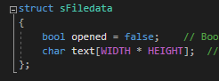
Figure 1 File data handling struct, sFileData
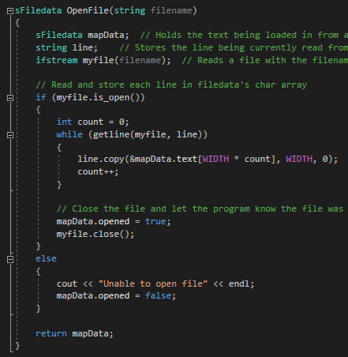
Figure 2 File reading and data storage function, OpenFile
Beginning with sFileData, this allows us to read lines of a text file into a char array of size defined by the user – which must remain consistent across all text files read. A successful file reading results in a bool being set to true, while unsuccessful readings set it to false.
Now that data is read in from an array, we have a traversal space. The next challenge is setting up a node system for which our agent and map conduct searching.
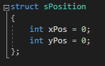
Figure 3 Node coordinate system, sPosition
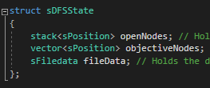
Figure 4 Node stack manager and file data analyser, sDFSState
A simple two-dimensional coordinate system is used to represent everything from nodes in our text map to the position of our agent, providing the foundation for traversal. The sDFSState struct manages several items, such as:
- A stack of open nodes, i.e. nodes the agent has identified and is going to visit.
- Objective nodes held in a vector – the goal of our depth first search.
- The data read in from our text map, so that we can evaluate our text map based on our open nodes and current agent state.
Now that the necessary resources are established for a DFS, we can begin by initialise our agent with a starting position – this will update throughout the search and is the only data our agent needs.
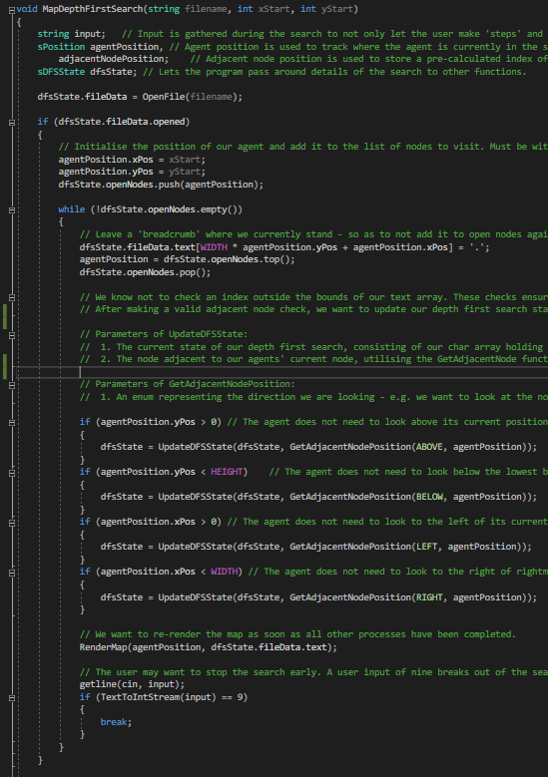
Figure 5 Agent step and main DFS loop manager, MapDepthFirstSearch function
The main loop of the DFS search encompasses a few key steps. Before the agent enters the loop, it is important to push in the initial node – i.e. our starting position, as an empty stack is our terminating condition for the search.
So, we push our initial position and enter the loop with the next subsequent move being to take the step onto the top (i.e. highest priority) node on our open nodes stack. The position of our agent is updated to this prioritised node, followed by dropping a “breadcrumb” at our feet – effectively preventing future checks from including visited nodes in our search following its removal from our list of open nodes.
Once our agent has completed the above procedures, it will begin looking at adjacent nodes in four directions – above, below, left, and right of the current agent position. Error checking for the agent to be within the bounds of the map ensure only valid positions are returned.
Inside our depth first searching loop, once we have checked if the agent is within a particular bound, we update the state of our search – this is done by calling an UpdateDFSState function, where we modify the current state of our search based on the adjacent nodes we are looking at.
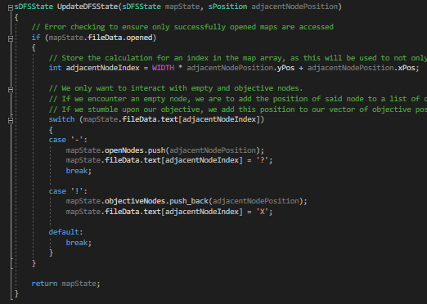
Figure 6 Map modifier and stack manager, UpdateDFSState
To provide UpdateDFSState with the information it needs, being able to identify nodes adjacent to our agent is imperative in constructing our stack and vector. As such, a function for identifying the index of nodes adjacent to our agent was designed.
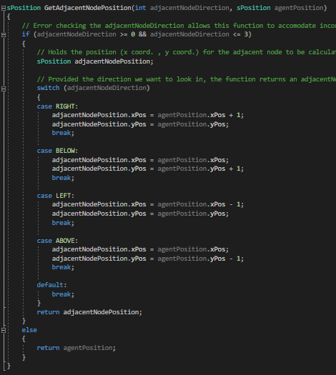
Figure 7 Adjacent node position identifier, GetAdjacentNodePosition

1.2. User Guide
The implementation begins with a menu in which one of three inputs determines the subsequent operation.
Entering “1” will load “Map1.txt”, whereas inputting “2” will load “Map2.txt”. A loaded map begins with rendering the initial state, and a step to the next state can be made by entering any key – with the exception of “9”, which stops the Depth First Search and returns current findings. The user is brought back to the menu if the search concludes.
Entering “9” at the menu will close the program.

1.3. Test Schedule
Testing is conducted using a table format, where each cell corresponds to various test elements, as seen below:
Test Case | Test Description | Prerequisites (e.g. user input)
Expected Result | Actual Result | Status (pass / fail)

Test Case 1 | A depth first search of “Map1.txt” can be initiated from the menu | The number key ‘1’ is entered
“Map1.txt” is opened upon the user entering ‘1’ | 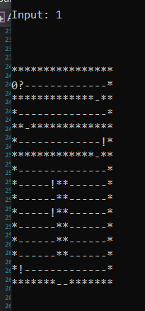 | PASS - The number key ‘1’ is entered, and the console window outputs the chars of “Map1.txt”

Test Case 2 | A depth first search of “Map2.txt” can be initiated from the menu | The number key ‘2’ is entered
“Map2.txt” is opened upon the user entering ‘2’ | 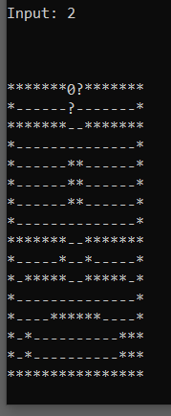 | PASS - The number key ‘2’ is entered, and the console window outputs the chars of “Map2.txt”

Test Case 3 | Non-existent files prevent the depth first search from going ahead. | Invalid filename passed into function MapDepthFirstSearch
If a non-existent file is accessed, the program will not conduct a DFS – with the reason being reported to the user. | 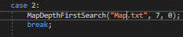  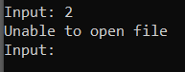 | PASS – The program prevents the user from conducting a DFS on non-existent files.

Test Case 4 | The program can close from the main menu | The number key ‘9’ is entered
The program is closed upon the user entering ‘9’ | 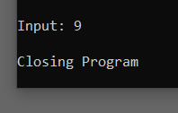 | PASS – The program successfully shuts down when the user enters ‘9’ at the main menu.

Test Case 5 | Invalid input will simply loop the menu back on itself. | An input other than ‘1’, ‘2’ or ‘9’ is entered.
The program loops back on the menu if invalid menu input. | 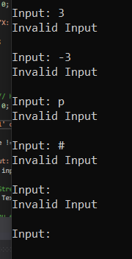 | PASS – The program accounts for input other than ‘1’, ‘2’ and ‘9’ at the main menu, looping back on itself.

Test Case 6 |  | Maps are rendered with each step taken by the user within the program | Keyboard input aside from ‘9’
A step taken will re-render the map being searched. |  | 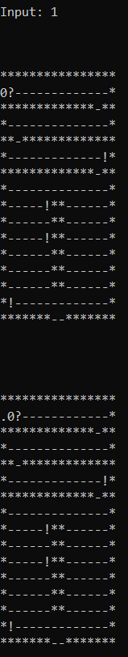 | PASS – The user can take steps during the search, where each will re-render the map.
Test Case 7 | Stepping can be halted |  |  | Number key ‘9’ entered
Entering the number ‘9’ will halt the search and return the user to the menu | 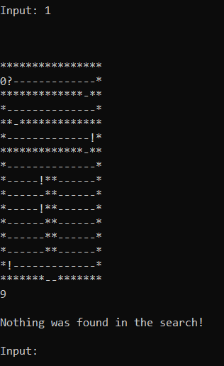 |  |  | PASS – Stepping can be cancelled with keyboard input of ‘9’, followed by the user being taken to the main menu.

Test Case 8 | The DFS will identify empty nodes to push onto the open node stack. | A step is taken with non- ‘9’ inputs.
Nodes adjacent to our agent identified as empty will be pushed onto a stack of open nodes to be visited later. | 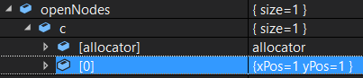  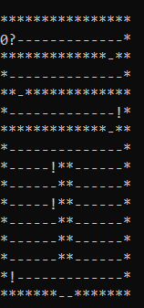  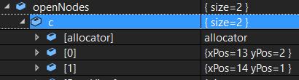  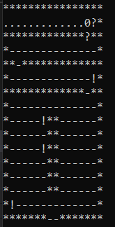 | PASS – Nodes adjacent to our agent are marked with a ‘?’ (i.e. to be visited) and pushed onto a stack of open nodes. Intersections cause the agent to push in nodes with order inverse to the direction priority, e.g. right is prioritised the most so we add it to the stack last.

Test Case 9 | Visited nodes are never revisited throughout the DFS. | Identified node has been stepped through
Nodes visited once are never visited again, i.e. pushed onto the open node stack more than once. | 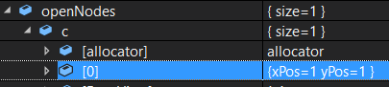  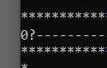  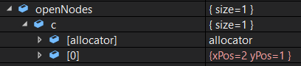  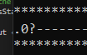  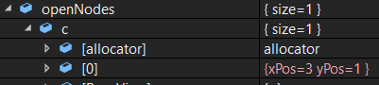  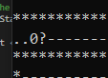 | PASS – Nodes that are once pushed in are not pushed back into open nodes stack as they are marked as visited, using the ‘.’ char. In the test case example, the position (1,1) was not added after being stepped through.

Test Case 10 | Our agent will update its position throughout the DFS. | Open nodes stack is populated with at least one node
Our agent will traverse the map by updating its X and Y coordinate to be equal to the top node on the open node stack. | 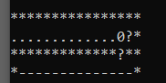  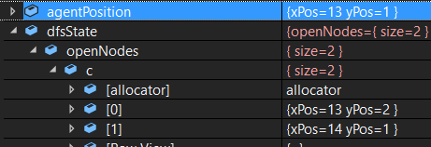  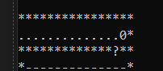  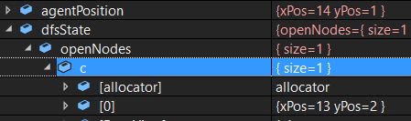 | PASS – As seen in the actual results, our agent will update its position to the node at the top of the stack.

Test Case 11 | The agent will report positions of the search objectives. | DFS search has concluded
Once a DFS search concludes, the positions of search objectives is displayed in the console window. | 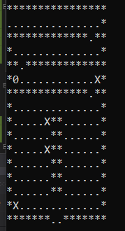  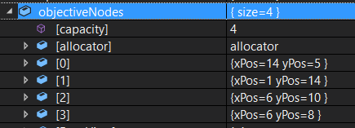  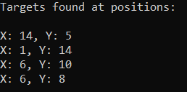 | PASS – Search objective X and Y coordinates are successfully displayed to the console window once a search concludes.

Test Case 12 | If no objectives are found, the agent will report this. | DFS search has concluded.
If a DFS search concludes and no objectives have been added to the objective node vector, the console window will report this. | 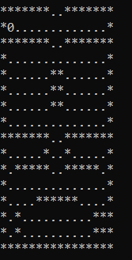    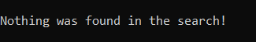 | PASS – If the objective node vector is empty, the program reports to the user that no objectives were found.

2. Task 2 - Hill Climbing Search
Hill Climbing is a method used to search through data nodes and to find an optimal path to take among the options available using local search methodology – i.e. it looks at nodes adjacent to the current one, and picks the next step based on which adjacent node provides a more optimal heuristic function h(). As such, it follows the below rule when determining the next step to take when seeking a local optima:
$$∆E ≤ 0$$
Where delta E represents our potential energy at our current position, seeking out better alternatives. Overall energy spent can be observed using the sum of increments taken. This allows us to evaluate the complexity of sorting our data set into a local optima. The below pseudocode describes a simple Hill Climbing search:
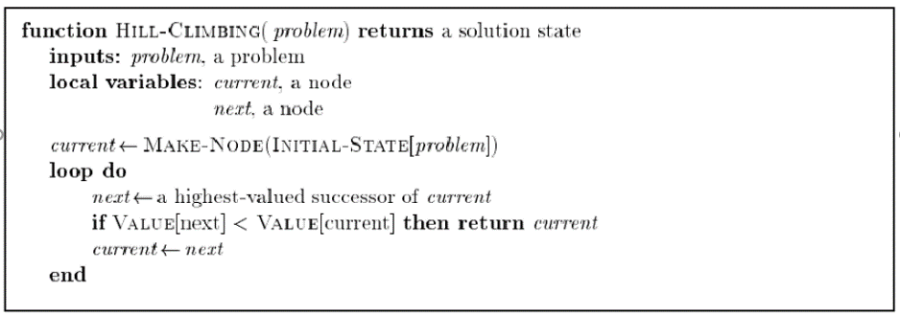
Figure 8 Pseudocode sample of Hill Climbing search from “Local Search and Hill Climbing Overview” lecture notes [1]
This search method is memory efficient, as it only stores the current state of h() and a potential new state. It is a greedy local search method, since it only seeks out local optima for a given problem – i.e. it purely seeks out to accomplish its objective without much worry for how well it is done, which can be considered a perk or drawback depending on the context [2, p. 122].
Some issues with Hill Climbing to consider:
- We may not achieve a global optima once our search concludes, e.g. we start our search in a position which leads to a less than ideal local optima (see Fig. 2).
- The total energy spent in searching for a local optima can vary wildly depending on the root node position.
- When our search finds itself in a position where any step we take is incrementally worse or is equal to our current state, h(). Additionally, we only ever keep track of our current state of h(), meaning we may inadvertently exit a local optima.
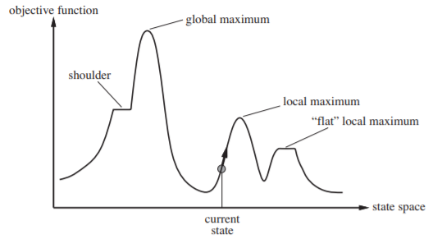
Figure 9 Example of a local maxima versus global maxima issue [2, Fig. 4.1]
The above figure describes various location states node sets may describe throughout. For example, a plateaux represents an area where only equivalent or worse steps exist, and local optima may describe a peak / trough, or a “flat” local optima – where the area surrounding our extrema is plateaued. Shoulders can be considered a plateaux in which some potential improvements to our state exist.
Considering potential optimisations to Hill Climbing based on the above problems, one optimisation is being able to track a best-ever state. We find ourselves in a local optima, so we keep track of this node and continue searching for a better state. If at some point we wish to revisit our last best state, we may do so – perhaps when we find ourselves surrounded by worse options, we can pull ourselves out of this situation by backtracking to the previous best state.
During the search for a stronger optima, we can find ourselves in a local extrema – i.e. we cannot escape taking a worse step if we continue. A possible solution to this is described by Wilt et al. [3, p. 3] - an “Enforced Hill-Climbing” method that allows our search to continue when all possible steps are worse states of h() by conducting a Breadth-First Search of nearby nodes until we find a node with a better state and move to it. Alternatively, Patrick suggests Random Restart Hill Climbing (RRHC) or Simulated Annealing as an option to escape local extrema [4, p. 177]. RRHC is conducted by randomly selecting new root nodes and traversing the best subsequent paths among them.
Simulated Annealing is another form of optimisation which allows the search to continue even when all possible options are worse steps to take, with the hope that future steps are beneficial enough to outweigh current decisions. This is described by the Carnegie Mellon University as like Hill Climbing, but instead of choosing the next best step, we take a random step with a probability that decreases with a worsening state (e.g. h() increases too much) [5].
To further understand the capabilities of Hill Climbing, some comparisons to other search methods will be analysed. Wilt et al. compare the Enforced Hill Climbing (EHC) search method with the Local Search Space Learning Real-Time A* (LSS-LRTA*) method by evaluating the performance of these measures in various situations [1, Table 2]. EHC falls short of LSS-LRTA* in some situations but is competent in others – most notably the pancake and vacuum problems. It can also be seen that the quality of EHC solutions are generally above average, while the failure rate is both acceptable in few cases, and too high in others. Versus LSS-LRTA*, when gives a higher look-ahead value as a parameter, the performance overall improves. This leads to greater performance than Hill Climbing in a few situations, although both search methods have strengths and weaknesses that make them competitive yet viable depending on the problem.
Alternatives to Hill Climbing - a greedy local search – are best first search algorithms (BFS), or informed searches. A* (A-Star) is one such method of BFS, where the algorithm evaluates the next node to move to based on the sum of cost to reach this node from the initial node and the cost to reach the goal from the next node [2, p. 93]. This methodology is all about ensuring we reach a global optima, versus taking the optimal path in front of us, meaning efficiency is not prioritised as much as Hill Climbing. Nodes are tracked using open and closed node lists, where the memory overhead is significantly greater than Hill Climbing. This does however prevent repeat steps from being made, effectively reducing cost to reach the goal. Furthermore, this algorithm never overestimates the cost to reach the goal from the start.

3. Task 3 - 8-Tiles Problem
The 8-Tiles problem describes a 3x3 set of nodes that need to be sorted so that they are in ascending order, going from left to right, top to bottom. The problem to solve in this assignment is seen below:
3 | 1 | 2
4 | 5 | 8
6 |  | 7

Using a heuristic function h() and the Hill Climbing method, we begin with identifying how many nodes are out of position, not counting the empty node. We can see above, in the starting state, that the nodes containing 3,4,5,8,7 are out of position, giving us our starting h value of 5.
3 | 1 | 2
4 | 5 | 8
6 |  | 7

Current: h() = 5
Next: h() = 6, 5, 4
We begin at the blank node, followed by an evaluation of nodes adjacent to the blank. 6 is in the correct position, thus increasing h() to 6. Moving 5 makes no difference to h(). 7 would decrease h() to 4, so we move 7 to produce the below:
3 | 1 | 2
4 | 5 | 8
6 | 7

Current: h() = 4
Next: h() = 5, 3
Swapping the positions of 7 and blank node gives us an increase to h() = 5, which is not ideal, so the alternative of moving 8 gives us h() = 3.

3 | 1 | 2
4 | 5
6 | 7 | 8
Current: h() = 3
Next: h() = 4, 2, 3
Evaluating 8 gives h() = 4, 5 gives h() = 2, while 2 is h() = 3.
3 | 1 | 2
4 |  | 5
6 | 7 | 8

Current: h() = 2
Next: h() = 3, 3, 1, 3
With four adjacent nodes, 7, 5 and 1 give h() = 3, leaving us with 4 to move, thus we have h() = 1.
3 | 1 | 2
 | 4 | 5
6 | 7 | 8

Current: h() = 1
Next: h() = 2, 2, 0
We can see that moving 4 and 6 give us h() = 2, while 3 gives h() = 0.
 | 1 | 2
3 | 4 | 5
6 | 7 | 8

Current: h() = 0
Next: -
Finally the tile problem is solved, and our heuristic function h() is at a local minima.
When considering the appropriateness of Hill Climbing algorithms in solving 8-Tile problems, there are cases in which using the tiles out of place distance measure will fail. The algorithm simply is not informed enough make the best overall move – which is the trade off for its cost efficiency. An alternate distance measure is Manhattan, which is slightly more costly in its summation of distanced of each node from their ideal but provides greater heuristic accuracy. This brings us closer to an optimal path, as generally Manhattan dominates tiles out of place measures – with an exception where h1 = h2.

4. Task 4 - Second Distance Measure
Alternative to the tiles out of place distance measure utilised in Task 3, is the Manhattan distance measure. This methodology identifies each node and the distances at which they lie away from their ideal position. All distances are summed together, where the result is known as the Manhattan distance [2, p. 103]. This allows us to evaluate the optimal choice to make when deciding how to perform Hill Climbing, as the smallest Manhattan distance is taken as the next heuristic state. The below once again shows our initial state (left), the goal state (right), with a Manhattan distance heuristic applied following these states:
 | 1 | 2
3 | 4 | 5
6 | 7 | 8
3 | 1 | 2
4 | 5 | 8
6 |  | 7

Nodes: 1 2 3 4 5 6 7 8
Displacement: 0 0 1 1 1 0 1 1
Initial state: h() = 1 + 0 + 0 + 1 + 1 + 1 + 0 + 1
h() = 5
The Hill Climbing method begins as normal – identify each potential step and determine the Manhattan distance for each of these steps. The below shows each potential next step’s state, along with their Manhattan distances:
3 | 1 | 2
4 | 5 | 8
 | 6 | 7
3 | 1 | 2
4 |  | 8
6 | 5 | 7
3 | 1 | 2
4 | 5 | 8
6 | 7

State 1 (left): h() = 0 + 0 + 1 + 1 + 1 + 1 + 1 + 1
h() = 6
State 2 (middle): h() = 0 + 0 + 1 + 1 + 2 + 0 + 1 + 1
h() = 6
State 3 (right): h() = 0 + 0 + 1 + 1 + 1 + 0 + 0 + 1
h() = 4
As seen in the above calculations, the third state is the next optimal step to take. The same calculations are then performed on new states that arise from selecting this path, as seen below:
3 | 1 | 2
4 | 5 | 8
6 |  | 7
3 | 1 | 2
4 | 5
6 | 7 | 8

State 1 (left): h() = 0 + 0 + 1 + 1 + 1 + 0 + 1 + 1
h() = 5
State 2 (right): h() = 0 + 0 + 1 + 1 + 1 + 0 + 0 + 0
h() = 3
We can see from the above calculations that state two offers a more optimal heuristic, while the first state calculated simply brings us back to our less optimal initial state. Taking state two as our solutions gives the following new states:

3 | 1
4 | 5 | 2
6 | 7 | 8
3 | 1 | 2
4 | 5 | 8
6 | 7
3 | 1 | 2
4 |  | 5
6 | 7 | 8

State 1 (left): h() = 0 + 1 + 1 + 1 + 1 + 0 + 0 + 0
h() = 4
State 2 (middle): h() = 0 + 0 + 1 + 1 + 1 + 0 + 0 + 1
h() = 4
State 3 (right): h() = 0 + 0 + 1 + 1 + 0 + 0 + 0 + 0
h() = 2
The next solution is state three, resulting in the subsequent states below:
3 |  | 2
4 | 1 | 5
6 | 7 | 8
3 | 1 | 2
4 | 5
6 | 7 | 8

3 | 1 | 2
4 | 7 | 5
6 |  | 8

3 | 1 | 2
 | 4 | 5
6 | 7 | 8

State 1 (top left): h() = 1 + 0 + 1 + 1 + 0 + 0 + 0 + 0
h() = 3

State 2 (top right): h() = 0 + 0 + 1 + 1 + 1 + 0 + 0 + 0
h() = 3
State 3 (bottom left): h() = 0 + 0 + 1 + 1 + 0 + 0 + 1 + 0
h() = 3
State 4 (bottom right): h() = 0 + 0 + 1 + 0 + 0 + 0 + 0 + 0
h() = 1
We can see from the above heuristic values that state four results in the most optimal output. The next step calculations are as follows:
 | 1 | 2
3 | 4 | 5
6 | 7 | 8
3 | 1 | 2
4 |  | 5
6 | 7 | 8
3 | 1 | 2
6 | 4 | 5
 | 7 | 8

State 1 (left): h() = 0 + 0 + 0 + 0 + 0 + 0 + 0 + 0
h() = 0
State 2 (middle): h() = 0 + 0 + 1 + 1 + 0 + 0 + 0 + 0
h() = 2
State 3 (right): h() = 0 + 0 + 1 + 0 + 0 + 1 + 0 + 0
h() = 2

State one is chosen as our final step, as the heuristic value has reached zero and no further steps can improve the current state.

5. Bibliography

[1] | G. Dickers, Local Search and Hill Climbing Overview, 2020.
[2] | S. J. Russel and P. Norvig, Artificial Intelligence: A Modern Approach (3rd Edition), New York City: Pearson Education Inc., 2010.
[3] | C. M. Wilt, J. T. Thayer and W. Ruml, “A comparison of greedy search algorithms,” in third annual symposium on combinatorial search, 2010.
[4] | K. Patrick, “Comparison of simulated annealing and hill climbing in the course timetabling problem,” African Journal of Mathematics and Computer Science Research, vol. 5, no. 11, pp. 176-178, 2012.
[5] | Carnegie Mellon University Computer Science Academy, “What is Simulated Annealing?,” Carnegie Mellon University Computer Science Academy, [Online]. Available: http://www.cs.cmu.edu/afs/cs.cmu.edu/project/learn-43/lib/photoz/.g/web/glossary/anneal.html. [Accessed 22 November 2020].

Appendix
  - Appendix 1 – Program Listing
// Set width and height to the dimensions of text files - must be consistent across all files to be read
#define WIDTH 16
#define HEIGHT 16

// Includes
#include <iostream>
#include <sstream>
#include <fstream>
#include <string>
#include <stack>
#include <vector>

// Enumerators

enum adjacentDirections { RIGHT = 0, BELOW = 1, LEFT = 2, ABOVE = 3 }; // Represents directions in which our agent looks when identifying adjacent nodes

// Structs

using namespace std;

struct sFiledata
{
bool opened = false; // Bool denoting the success or failure of a file opening procedure, were unsuccessful attempts result in an error message and termination of file reading
char text[WIDTH * HEIGHT]; // A text array which holds data read in from a text file. Dimensions must be specified beforehand, and all text files must follow this format, otherwise data may not be read in from a file.
};

// Simple 2d coordinate, represents the positions of nodes in a text file and is used in calculating an index within a 1d array using WIDTH * y + x
struct sPosition
{
int xPos = 0;
int yPos = 0;
};

struct sDFSState
{
stack<sPosition> openNodes; // Holds nodes to be visited within a text file, where nodes marked as empty in a text file are added to the stack
vector<sPosition> objectiveNodes; // Holds nodes containing the objective of a depth first search, outputs positions to the user at the end of a search
sFiledata fileData; // Holds the data needed in file searching, used in traversal and node identification
};
// Functions

int TextToIntStream(string input) // This function simply converts a string input to a number. Useful in taking user keyboard input and letting the program know when a terminating integer is entered.
{
int number;
stringstream stream;
stream.str(input);
stream >> number;
stream.clear();
return number;
}

sFiledata OpenFile(string filename)
{
sFiledata mapData; // Holds the text being loaded in from a file
string line; // Stores the line being currently read from the file
ifstream myfile(filename); // Reads a file with the filename parameter passed into OpenFile

// Read and store each line in filedata's char array
if (myfile.is_open())
{
int count = 0;
while (getline(myfile, line))
{
line.copy(&mapData.text[WIDTH * count], WIDTH, 0);
count++;
}

// Close the file and let the program know the file was successfully read by toggling bool opened
mapData.opened = true;
myfile.close();
}
else
{
cout << "Unable to open file" << endl;
mapData.opened = false;
}

return mapData;
}
void RenderMap(sPosition agentPosition, char* text)
{
// We re-render the entire text array, with the agent position being represented with its own unique character.
cout << endl << endl << endl;
for (int y = 0; y < HEIGHT; y++)
{
for (int x = 0; x < WIDTH; x++)
{
if (x == agentPosition.xPos && y == agentPosition.yPos)
{
cout << "0";
}
else
{
cout << text[WIDTH * y + x];
}
}
cout << endl;
}
}
sPosition GetAdjacentNodePosition(int adjacentNodeDirection, sPosition agentPosition)
{
// Error checking the adjacentNodeDirection allows this function to accomodate incorrect parameters. For example, we are given a direction not accounted for, so the function simply returns the agentPosition.
if (adjacentNodeDirection >= 0 && adjacentNodeDirection <= 3)
{
// Holds the position (x coord. , y coord.) for the adjacent node to be calculated
sPosition adjacentNodePosition;

// Provided the direction we want to look in, the function returns an adjacentNodePosition based on the agent position reflecting this parameter. RIGHT = increment agent x, LEFT = decrement agent x, ABOVE = decrement agent y, BELOW = increment agent y.
switch (adjacentNodeDirection)
{
case RIGHT:
adjacentNodePosition.xPos = agentPosition.xPos + 1;
adjacentNodePosition.yPos = agentPosition.yPos;
break;

case BELOW:
adjacentNodePosition.xPos = agentPosition.xPos;
adjacentNodePosition.yPos = agentPosition.yPos + 1;
break;

case LEFT:
adjacentNodePosition.xPos = agentPosition.xPos - 1;
adjacentNodePosition.yPos = agentPosition.yPos;
break;

case ABOVE:
adjacentNodePosition.xPos = agentPosition.xPos;
adjacentNodePosition.yPos = agentPosition.yPos - 1;
break;

default:
break;
}
return adjacentNodePosition;
}
else
{
return agentPosition;
}
}
sDFSState UpdateDFSState(sDFSState mapState, sPosition adjacentNodePosition)
{
// Error checking to ensure only successfully opened maps are accessed
if (mapState.fileData.opened)
{
// Store the calculation for an index in the map array, as this will be used to not only check the char at this position, but also overwrite it if need be.
int adjacentNodeIndex = WIDTH * adjacentNodePosition.yPos + adjacentNodePosition.xPos;

// We only want to interact with empty and objective nodes.
// If we encounter an empty node, we are to add the position of said node to a list of open nodes (i.e. to be visited), and as such we will leave a marker so that future checks do not add a replica of this node to the open list.
// If we stumble upon our objective, we add this position to our vector of objective positions. To ensure we do not add the same treasure again, we will mark it as identified.
switch (mapState.fileData.text[adjacentNodeIndex])
{
case '-':
mapState.openNodes.push(adjacentNodePosition);
mapState.fileData.text[adjacentNodeIndex] = '?';
break;

case '!':
mapState.objectiveNodes.push_back(adjacentNodePosition);
mapState.fileData.text[adjacentNodeIndex] = 'X';

default:
break;
}
}

return mapState;
}
void MapDepthFirstSearch(string filename, int xStart, int yStart)
{
string input; // Input is gathered during the search to not only let the user make 'steps' and view each state of the search, but also let the user conclude the search at any point by entering "9"
sPosition agentPosition, // Agent position is used to track where the agent is currently in the search - useful for identifying adjacent nodes, and must be initialised in or next to an empty node.
adjacentNodePosition; // Adjacent node position is used to store a pre-calculated index of a node next to our agent, and is used in modifying nodes based on our search state.
sDFSState dfsState; // Lets the program pass around details of the search to other functions.

dfsState.fileData = OpenFile(filename);

if (dfsState.fileData.opened)
{
// Initialise the position of our agent and add it to the list of nodes to visit. Must be within the bounds of our text file, i.e. 0 <= x <= WIDTH, 0 <= y <= HEIGHT
agentPosition.xPos = xStart;
agentPosition.yPos = yStart;
dfsState.openNodes.push(agentPosition);

while (!dfsState.openNodes.empty())
{
// Leave a 'breadcrumb' where we currently stand - so as to not add it to open nodes again. This is followed by stepping forwards to the next node within the stack, and a subsequent pop of the stack ensures we never revisit the previous node.
dfsState.fileData.text[WIDTH * agentPosition.yPos + agentPosition.xPos] = '.';
agentPosition = dfsState.openNodes.top();
dfsState.openNodes.pop();

// We know not to check an index outside the bounds of our text array. These checks ensure our agent only looks within the bounds of our map.
// After making a valid adjacent node check, we want to update our depth first search state with the UpdateDFSState function.

// Parameters of UpdateDFSState:
// 1. The current state of our depth first search, consisting of our char array holding the map, the stack of open nodes, and vector of objectives found. Only DFS states with a successfully opened map should be passed in.
// 2. The node adjacent to our agents' current node, utilising the GetAdjacentNode function. This allows us to update our list of nodes based on the identity of the adjacent node passed in.

// Parameters of GetAdjacentNodePosition:
// 1. An enum representing the direction we are looking - e.g. we want to look at the node currently above the agent, so we pass in ABOVE or '3'. Only directional enums should be passed in, or the numbers they correspond to, as anything outside this range will not be checked.

if (agentPosition.yPos > 0) // The agent does not need to look above its current position if at the top bound of the map
{
dfsState = UpdateDFSState(dfsState, GetAdjacentNodePosition(ABOVE, agentPosition));
}
if (agentPosition.yPos < HEIGHT) // The agent does not need to look below the lowest bound, i.e. beyond a user defined height
{
dfsState = UpdateDFSState(dfsState, GetAdjacentNodePosition(BELOW, agentPosition));
}
if (agentPosition.xPos > 0) // The agent does not need to look to the left of its current position if at the left bound of the map
{
dfsState = UpdateDFSState(dfsState, GetAdjacentNodePosition(LEFT, agentPosition));
}
if (agentPosition.xPos < WIDTH) // The agent does not need to look to the right of rightmost bound, i.e. beyond a user defined width
{
dfsState = UpdateDFSState(dfsState, GetAdjacentNodePosition(RIGHT, agentPosition));
}

// We want to re-render the map as soon as all other processes have been completed.
RenderMap(agentPosition, dfsState.fileData.text);

// The user may want to stop the search early. A user input of nine breaks out of the search loop and returns current findings.
getline(cin, input);
if (TextToIntStream(input) == 9)
{
break;
}
}

// In the event our search returns nothing, the user is informed of this. Otherwise we will want to report the coordinates of objectives added to the objectiveNodes vector.
if (dfsState.objectiveNodes.empty())
{
cout << endl << "Nothing was found in the search!" << endl << endl;
}
else
{
cout << endl << "Targets found at positions:" << endl << endl;
for (int i = 0; i < dfsState.objectiveNodes.size(); i++)
{
cout << "X: " << dfsState.objectiveNodes[i].xPos << ", Y: " << dfsState.objectiveNodes[i].yPos << endl;
}
cout << endl;
}
}
}
int main(void)
{
string input; // Holds user keyboard input from a getline function inside the menu loop
int menuChoice = 0; // User input is sent to a TextToIntStream function, returning an int held in this variable. If the user enters anything but a number, it is stored as zero.

cout << "Enter '1' or '2' at the main menu to conduct a depth first search of either 'Map1.txt' or 'Map2.txt' respectively." << endl << "Enter '9' to close the program when at the menu." << endl << "During a search, simpy press '9' to halt the search and report current findings, or press a different key to step towards the next state." << endl << endl;

while (menuChoice != 9)
{
cout << "Input: ";
getline(cin, input);

// TextToIntStream returns an int converted from a char passed in as a parameter, thus only number chars should be passed in for correct input.
menuChoice = TextToIntStream(input);

// Switch menu encompasses four integer inputs - 1,2,9. 1 and 2 open corresponding map files with MapDepthFirstSearch function. An input of 9 closes the program, while any other input causes the menu to do nothing and loop back on itself.
// Parameters of MapDepthFirstSearch:
// 1. The filename, e.g. Map1.txt. Amount of characters in file must equal WIDTH * HEIGHT.
// 2. AI Agent starting X coordinate. Must begin next to or on a char representing an empty space, i.e. '-'.
// 3. AI Agent starting Y coordinate. Also must begin next to or on a char representing an empty space.

switch(menuChoice)
{
case 1:
MapDepthFirstSearch("Map1.txt", 0, 1);
break;

case 2:
MapDepthFirstSearch("Map2.txt", 7, 0);
break;

case 9:
cout << endl << "Closing Program" << endl;
break;

default:
cout << "Invalid Input" << endl << endl;
break;
}
}

// End of program
cin.get();
return 0;
}

