Do levels of sensation seeking and tempo of music influence time perception?
(1642)

Abstract

When looking at the issue of time perception, there are questions on if levels of sensation seeking and tempo of music will have an effect. Research by Angrilli et at (2004) and Droit-Volet et al (2013) look at the effects of arousal on time perception which this study is based on. A group of 60 participants aged 18- 51 took part in a 2 x 3 multifactorial ANOVA, time perception task where they were asked to judge if a pink oval was on the screen for a short or long period whilst listening to different tempos of music. A sensation seeking questionnaire was additionally completed to assess levels and compare the levels of sensation seeking with the over or underestimation of time perception. Results showed that there was no effect on high levels of sensation seeking and fast tempo of music on time perception which contradicts previous research.

Introduction
The topic that will be discussed will concern the effect of sensation seeking and tempo of music on time perception. Sensation seeking can be defined as ‘a trait deﬁned by the seeking of varied, novel, complex, and intense sensations and experiences and the willingness to take physical, social, legal, and ﬁnancial risks for the sake of such experiences’ (Zuckerman, 1994, p.27). Many studies look at the relationship between these two aspects and from looking at different articles, it is clear to see that time perception can be affected by many factors.
A study by Angrilli et al (1997) looked at the influence of affective factors on time perception. Photographic slides were created for emotional valence and arousal were presented to separate groups of participants for 2, 4 and 6 seconds. Both groups were given different ways of recording the length of their responses, one with an analogue scale and the other using buttons. The results showed that neutral slides showed that time-estimation values were more underestimated than the mean of other emotional conditions, showing that high arousal level would have a higher effect on time perception, which relating to our research activity would suggest that high levels of sensation seeking will mean greater levels of time perception.
Additional support comes from Droit-Volet et al (2013) with research on the perception of the duration of emotional events which predicted that the viewing of emotional faces will produce an overestimation compared to neutral faces. The experiment aimed to assess an individual’s time perception by showing them a pink oval after they had seen a face and were asked to press the S key is it was appeared short (400ms) or L if it was longer (1600ms). The results showed that faces depicted as emotional had a higher overestimation in duration compared to the neutral faces. This research suggests that a stimulus seen as arousal can affect time perception.
This supported by Tipples, J. (2008) who looked to see if there was an increased overestimation of time when looking at facial expressions which include emotion to neutral faces. He found that there was an overestimation in time when looking at these facial expressions (angry, happy and fearless) compared to the neutral faces. He also found arousal had more of an effect rather than attention to the stimulus and this supports that arousal has a clear effect of overestimation on angry expressions.
Therefore, from the previous research recorded, if arousal can influence the estimation on time perception to allow individuals to overestimate, then sensation seeking may additionally have an effect. Meaning it can be hypothesised that a faster tempo of music and high levels of sensation seeking will lead to an overestimation in time perception.
Method
Participants
The participants which were used were recruited by means of opportunity sampling as those who were available at the time were used. There were 60 participants altogether (Male = 29, Female= 31) the ages ranged between 18 – 51 (M = 25.07, SD = 8.53). (Appendix A)
Design
The design used was a multifactorial between subject’s design, meaning the same group took part in both conditions. A 2 x 3 between subjects anova was used to find the significance of the results. When looking at the variables of the study there were two independent variables included. The first being the tempo of music which was listened to, given at three levels; fast tempo, slow tempo and no music. The second one being the level of sensation seeking which was categorised into high and low groups. The dependent variable was the time perception which was measured with 10 images of a pink oval.
Materials
The Arnett Inventory Sensation Seeking questionnaire (Arnett, J. 2004) was used to record the levels of sensation seeking (Appendix B). Levels were recorded on a four-point Likert scale which ranged from A – D with numbers ranging from 4 (A) – 1 (D) when scoring sensation seeking. There were 20 questions within the questionnaire which included questions such as “I can see how it must be exciting to be in a battle during a war.“ Within the set of questions, 6 of these needed to be reversed when scoring meaning A=1.
The questionnaire measured levels of sensation seeking using the mean score of fifty-three. Anything lower than the mean was considered low and fifty-four plus is considered high.
A programme called super lab was used to create this study which recorded time perception. There were two sections to the experiment which included a practice section where timings were 400 milliseconds (ms) and 1600 ms and then the actual experiment included 400, 800, 1000, 1200 and 1600ms. A pink oval image (Appendix C) was used and was shown for each of the seconds shown above. The oval was presented in the centre of the screen and was 12cm by 16cm. During the practice the oval was shown five times for each of the seconds included and the experimental phase, 10 ovals were shown for 1000ms and this measured if a person over or underestimated time and the other 10 were at random. Instructions were also included in the study which told the participant what to do at each stage. Additionally, a fixation cross was presented on the screen to separate the pink oval to the instructions.
The music which was included was fast tempo music at 71 beats per minute, slow tempo at 31 beats per minute and no music. Headphones were used to listen to the music.
Procedure
The first step carried out was gaining ethical approval from the school of psychology research committee. The participants were then recruited by means of opportunity sampling. They were given a consent form to sign and agree to the study (Appendix D) and a demographic information sheet (Appendix E). They were then instructed to complete a questionnaire regarding sensation seeking. Instructions were then given to the participants to put headphones on and follow further instructions which were displayed on screen. They were instructed to take part in a practice task whilst listening to the music which allowed them to understand what they would be taking part in. An x would appear on the screen followed by a pink oval. This image was shown 4 times each at lengths 400ms and 1600ms. They then would decide whether it was there for a long time or short by clicking the assigned buttons (A-Short, L- Long) whilst continually listening to the music, (if applicable). Additional instructions were then shown. The next step was the completion of the real task where the participant would have to do the same task at 400ms, 800ms 1000ms, 1200ms and 1600ms. At the end of the study a debrief form was given to the participant which allowed for further questions to be asked (Appendix F).
Results
A 2 x 3 multifactorial, between-subject ANOVA was conducted to measure the effects between sensation seeking levels (high and low), tempo of music (slow, fast and no music), in order to find differences in time perception. Reliability score 0.52 meaning not reliable. (Appendix G)
The descriptive were shown that time perception (M= 6.58 and SD= 2.62), Sensation seeking (M=53.43, SD= 6.30). (Appendix H)
The interaction effect between music group and sensation seeking and was shown to be non-significant; F (2, 54) = .23, P. 80. Additionally, the main effect of sensation seeking was also seen to be non-significant; F (1, 54) = .037. P= .851. The music group moreover showed non-significant main effects; F (2, 54) = .34, P=.72.
The main effect of study was found to be non-significant as significance = 0.508 which is greater than 0.05, thus indicating there was not an effect between the level of sensation seeking on time perception. This goes against our hypothesis so this must be rejected.
Discussion
When looking at the study carried out, it can be seen the original hypothesis must be rejected as there was no interaction effect between the level of sensation seeking and tempo of music on time perception. From looking at the results obtained there is no similarity from the previous research so there is a contradiction with the results. The articles by Angrilli et al (1997), Droid-Volet et at (2004) and Tipples, J (2008) all support that there would be an overestimation in duration of time on emotional faces when there were high levels of arousal which proceeded this hypothesis to believe that higher levels of sensation seeking would lead to overestimated time perception. Although the study by Droit-Volet et al (2004) was a similar study, the results produced within this study are different to previous research and the results cannot be supported.
One limitation of the study would be that there was a small sample of participants. This included sixty participants which included a higher number of students. To improve this, a larger sample could be used including more members of the general public to get a range of different results.
Moreover, the internal reliability of the questionnaire was weak. Supported by Haynes, C. A., 2000) where the scale showed low reliability and the subscales need more development through an empirical procedure, meaning a different scale could be used.
Furthermore, an improvement to this study could be to complete the study in a within-subjects design to see if a single participant shows different effects in the 3 different settings of music group. This may add support to show that different levels of sensation seeking, and tempo of music can affect time perception.
Regarding the research problem, additional studies need to be conducted to gain a better insight of the effects of levels of sensation seeking and tempo of music on time perception. Further steps to progress may include using different personality types such as impulsivity seen in a study by Berlin, H, A. (2004). Also, age could be taken into consideration to see if that impacts time perception.

Reference List
Angrilli, A., Cherubini, P., Pavese, A., & Manfredini, S. (1997). The influence of affective factors on time perception. Perception & psychophysics, 59(6), 972-982.
Arnett, J. (1994). Sensation seeking: A new conceptualization and a new scale. Personality and Individual Differences, 16(2), 289-296. doi: 10.1016/0191-8869(94)90165-1
Berlin, H. A., Rolls, E. T., & Kischka, U. (2004). Impulsivity, time perception, emotion and reinforcement sensitivity in patients with orbitofrontal cortex lesions. Brain, 127(5), 1108-1126.
Droit‐Volet, S., Brunot, S., & Niedenthal, P. (2004). BRIEF REPORT Perception of the duration of emotional events. Cognition and Emotion, 18(6), 849-858.
Haynes, C. A., Miles, J. N., & Clements, K. (2000). A confirmatory factor analysis of two models of sensation seeking. Personality and Individual Differences, 29(5), 823-839.
Tipples, J. (2008). Negative emotionality influences the effects of emotion on time perception. Emotion, 8(1), 127.
Zuckerman, M. (1994). Behavioural expressions and biosocial bases of sensation seeking. Cambridge university press.

Appendices
Appendix A

Descriptive Statistics
 | N | Minimum | Maximum | Mean | Std. Deviation
Age | 60 | 18.00 | 51.00 | 25.0667 | 8.53282
Valid N (listwise) | 60

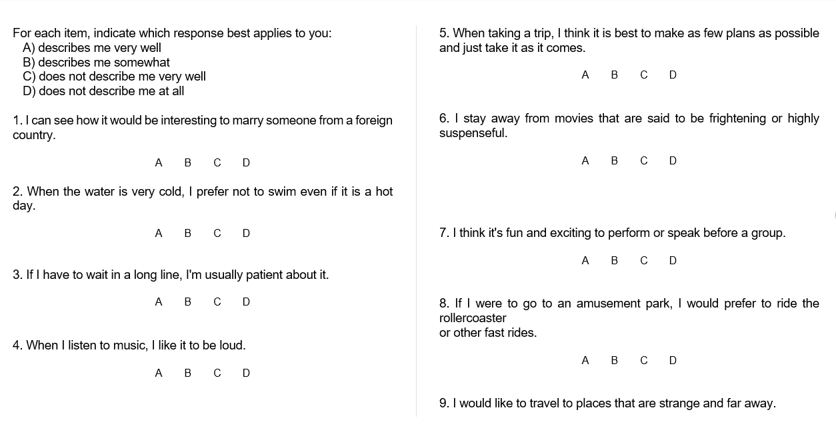
Appendix B

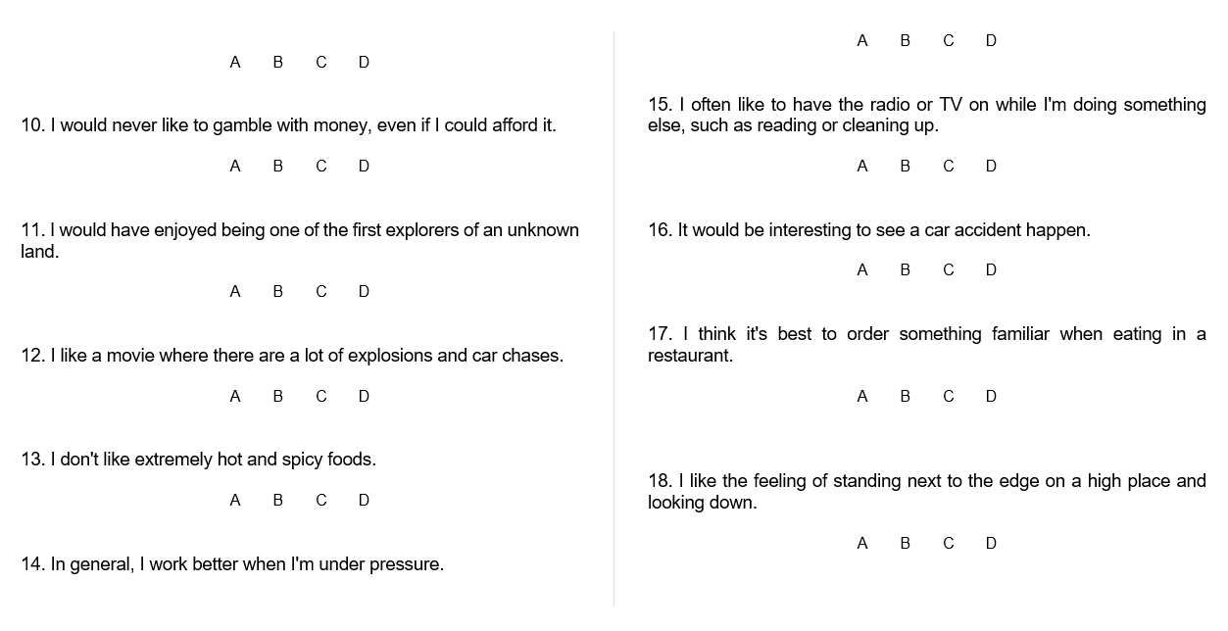
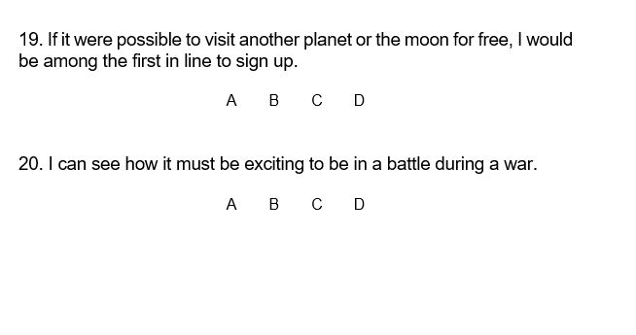
Appendix C

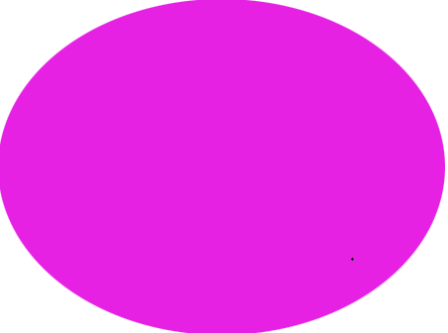

Appendix D

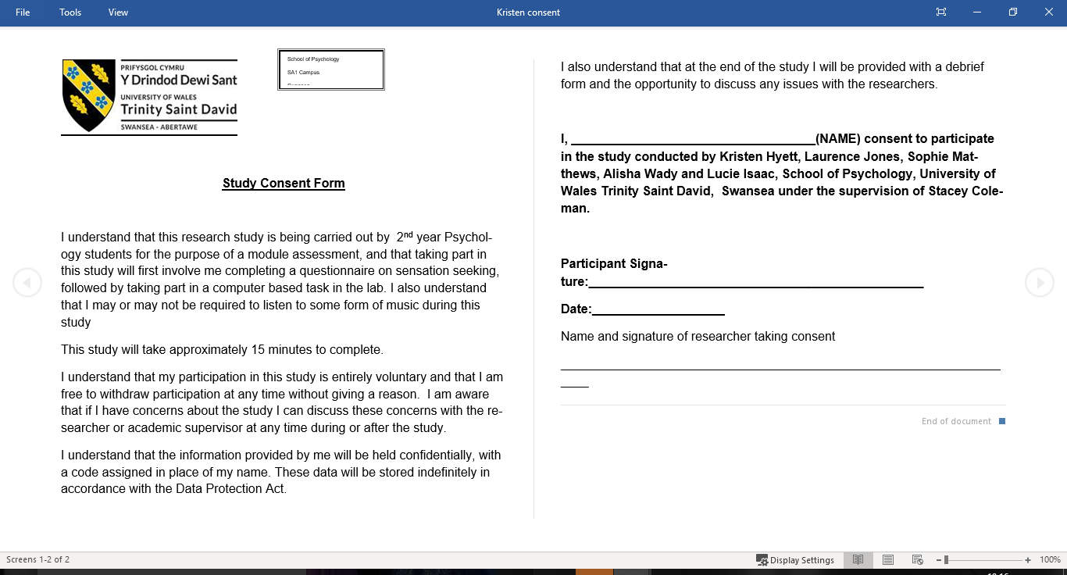

Appendix E
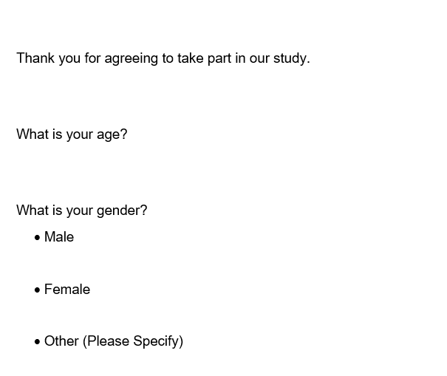

Appendix F
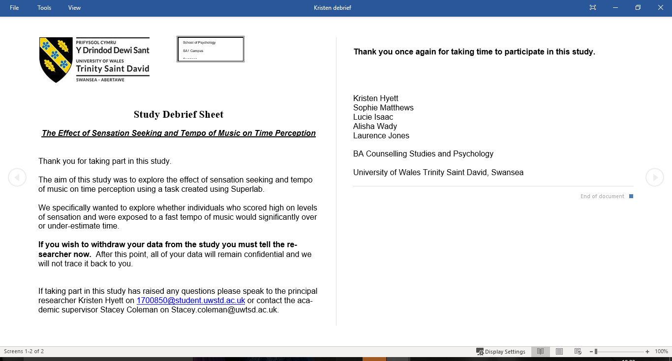

Appendix G

Appendix H


