Module Title: Food & Beverage Operations
Module Code: BMIH4002
Assignment Title: Crafting a Memorable Dining Experience Menu
Student name: Vasilica Crenganis
Student Id:2221600

Concept of the Restaurant
Adnir Restro is a new restaurant which is going to be established in the United Kingdom as well as introduced to the hotel chain of Hotel Trinity. With respect to that, this restaurant will be established in Liverpool, United Kingdom. Besides, the restaurant will involve fusion cuisine in their menu to happily serve the customers. Concerning that, the food will be prepared in the kitchen maintaining hygiene and delivered by the servers to the customers as well. The menu of Adnir Restro involves appetizers, main course, desserts, beverages and many more which will be prepared considering the choice of both vegetarian and non-vegetarian customers.

STP Analysis
Segmentation
Understanding the potential customers for the restaurant is essential for creating a strong customer base and placing the business in a higher position as well. In this context, Adnir Restro targets both national and international customers from various regions. With respect to that, being a multicuisine restaurant, all types of customers can visit the restaurant such as family, friends, couples and others. Besides, the restaurant mainly targets customers who have a stable income to afford its service. Apart from that, people between the ages of 18-45 and who love enjoying fusion food are the primary customers that are targeted by the restaurant (Dobroskok et al., 2022).
Targeting
The business of Adnir Restro mainly targets family members, friend groups or business persons with a good income. Apart from that, as the ambience of this restaurant is pleasant and attractive, it can attract high-class families and people between the age of 20-45. With respect to that, people who love spending special moments with good food can enjoy the service of this restaurant.
Positioning
The primary menu of Adnir Restro involves various types of appetizers and fusion cuisine that attract diverse customers who are passionate about exploring and enjoying new tastes. This will help the restaurant acquire a large number of customers and enhance the brand image in the market as well.

The rationale for the menu choice
Various aspects and factors have been considered for choosing the menu for Adnir Restro. Concerning that, the menu of the restaurant involves fusion cuisine that can be enjoyed by different types of customers. The food of Adnir Restro is prepared using both traditional and Western elements to target a diverse range of customers. There are various types of food based on the choice of different customers. Consequently, the chance of food declining can be reduced as customers can have both traditional and Western as per their choice, preferences and moods. The significant reason for choosing this menu is to retain customers with diverse food options and choices (Nisbets, 2023).
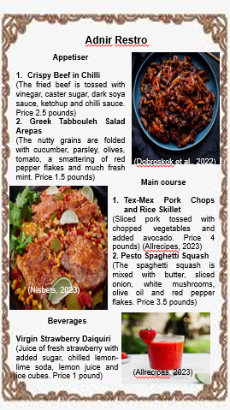

References
Allrecipes, (2023). Virgin Strawberry Daiquiri. [Online] Available at: https://www.allrecipes.com/recipe/107945/virgin-strawberry-daiquiri/[Accessed 11 10 2023].
Dobroskok, I., Penkovskyi, V. and Yatsenko, Y., (2022). Behavioral economics and consumer market segmentation as development factors of hotel-restaurant and tourist business enterprises. University Economic Bulletin, (53), pp.53-59.
Nisbets, (2023). WHAT IS FOOD FUSION?. [Online] Available at: https://www.nisbets.co.uk/what-is-food-fusion#:~:text=Food%20fusion%20allows%20experimentation%20and,of%20a%20completely%20different%20dish[Accessed 11 10 2023].

