DIGITAL SKILLS AND RESEARCH METHODS
Student Name: Stoyan Donchev
Student ID: 1920481

Executive summary
Implication of an advanced digital platform for delivering deep understanding options to the learner is considered as a Virtual learning environment (VLE). Moreover, engagement levels of learners are also increased through incorporation of friction in the study material which reduces their confusion in multiple conceptions. Various impacts are highlighted in this research through identification of various factors which indulges VLE in implementing over education systems.

Table of content
Chapter 1: Introduction 4
1.1 Introduction 4
1.2 Research background 4
1.3 Rationale of research 4
1.4 Research aim 4
1.5 Research objectives 4
1.6 Research questions 4
1.7 Research significance 4
1.8 Structure of dissertation 4
1.9 Summary 5
Chapter 2: Literature review 5
2.1 Introduction 5
2.2 Critical evaluation of different factor that influences VLE 5
2.3 Critical analysis of various impact of VLE 6
2.4 Critical evaluation of various challenges arose while execution of VLE 6
2.5 Critical analysis of various strategy that improves VLE 6
2.6 Conceptual framework 7
2.7 Gap in literature 8
2.8 Summary 8
Chapter 3: Methodology 8
3.1 Introduction 8
3.2 Research onion 8
3.3 Research Philosophy 8
3.4 Research Approach 9
3.5 Research Design 9
3.6 Sampling Technique and sample size 9
3.7 Data collection method 9
3.8 Data collection tools and techniques 10
3.9 Data analysis techniques 10
3.10 Ethical Consideration 10
3.11 Summary 10
Chapter 4: Findings and discussion 10
4.1 Primary quantitative analysis 10
4.2 Secondary qualitative analysis 14
4.2.1 VLE improves technical skills by offering accessible opportunity 15
4.2.2 Generation of eLearning Content improves application option of VLE 15
4.3 Data Analysis 15
Chapter 5: Recommendations and conclusion 15
5.1 Conclusion 15
5.2 Linking with objectives 15
5.2.1 Linking with first objective: 15
5.2.2 Linking with second objective: 15
5.2.3. Linking with third objective: 15
5.2.4. Linking with fourth objective: 15
5.3 Recommendations 15
5.3.1 Recommendation 1: Ongoing Feedback 15
5.3.2 Recommendation 2: Mixing of learning tools 16
5.4 Research limitation 16
5.5 Future scope 16
References 17

List of tables
Table 4.1.1: Gender 13
Table 4.1.2: Age 14
Table 4.1.3: Development of technical skills 15
Table 4.1.4: Limitation in presentation for traditional approaches 16
Table 4.1.5: Development of communication skill 17

Table of figures
Figure 1.1: Dissertation structure 8
Figure 2.1: Conceptual framework 11
Figure 3.1: Research Onion 11
Figure 3.2: Aspects of philosophy 12
Figure 4.1.1: Participant’s gender 14
Figure 4.1.2: Age of participants 15
Figure 4.1.3: Improvement of technical skill from VLE 16
Figure 4.1.4: Issues of traditional learning 17
Figure 4.1.5: Generation of Communication skill 18

Chapter 1: Introduction

1.1 Introduction
Virtual learning environment (VLE) has been considered as an innovative educational technology which is conducted by utilizing web-based platforms. This study focuses on various effects of VLE in the education system by alternation in learning experiences.

1.2 Research background
VLE involves delivering digital space to employees in terms of collecting advanced information from digital technologies. Engagement in e-Learning courses provides a wide scope in collection of recent information regarding changes in the market that they are supposed to make after updating their knowledge.

1.3 Rationale of research
Gaining information is one of the major areas that involves blending the learning environment (virtual-college.co.uk, 2020). Following context highlights that, time required for visiting physical education institutions is declared by inclusion of visual learning sessions that provide a wide scope for increasing their knowledge.

1.4 Research aim
Aim of this study is to determine the effect of VLE.

1.5 Research objectives
- To evaluates various driver of adoption of VLE
- To estimates different impact that is created over education system through VLE
- To identify various challenges appeared for implication of VLE
- To determine various strategy that influences of VLE

1.6 Research questions
- What are the various drivers that provoke VLE?
- What are the major impacts that are created by VLE on learning experiences?
- What are the factors creating barriers to implementation of VLE?
- How various strategies reduce issues of VLE activations?

1.7 Research significance
The main significance of this research is to analyse various impacts created by VLE on the education system through blending in digital and traditional learning approaches.

1.8 Structure of dissertation
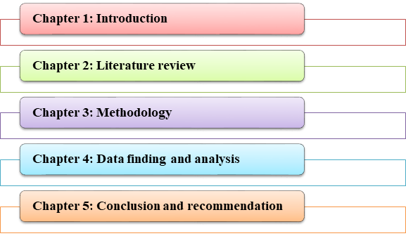

Figure 1.1: Dissertation structure
(Sources: Created by Author)

1.9 Summary
Graphical presentation of multiple conceptions is the main principle of this learning session. a deep understanding of the critical aspects of education is identified through various types of digital activities that are incorporated within the course.

Chapter 2: Literature review

2.1 Introduction
This chapter is focusing on different types of elements that act as a factor for making an implication of VLE according to the needs of students and staff. Additionally, challenges are also figured out from this study which can be solved through allocation of strategies.

2.2 Critical evaluation of different factor that influences VLE
Intellectual factor is a part that is involved in growth of mental consequences closely related with intelligence. On the other hand, identification of serious challenges is also identified through intellectual capability. Getting a low score in a subject does not identify the intellectual abilities of an individual. As opined by El-Omari (2016), Language learning is another major factor that creates impact over learning skills which offer positive as well as negative outcomes in communicating with others. Determination of vital parts for multiple concepts makes the development of critical thinking abilities that helps in development of cognitive functions. Narrowness of experimental background has been evaluated through identification of learning factors. Immediate collection of information through cross-checking of various parts provide support to make development of deficiencies.

2.3 Critical analysis of various impact of VLE
Engagement rate of students increases due to participation in a visual course that reduces their anxiety level. On the other hand, technical skills of an individual are also increased by equal accessibility that maintains interaction. Relationship developing skills are also analysed through maintaining a learning environment that boosts up technical skill. As per views of Baroni et al. (2019), participation rate increases that provides motivation to employees in an organisation. Implication of accurate information for conduction of tasks reduces cost. Delivering immediate feedback to students gets an exact idea regarding the weakness of facilities in making improvements.

2.4 Critical evaluation of various challenges arose while execution of VLE
Lack of capability to identify the non-verbal cues that get favoured through involvement in the physical education system. As discussed by Panconesi and Guida (2017), deduction of interest for involvement in universities read limitation in reflecting that knowledge for conduction of a task. Accessibility capacity reduced due to not handling digital technologies for transferring of knowledge from classroom that makes limitations in handling E-learning systems.

2.5 Critical analysis of various strategy that improves VLE
Generation of a learning environment by online teachers provide support to this education system in terms of developing an online supportive community for learners. Like other authors Duvall (2017), friction has been read by teenagers instead of reading books for gathering knowledge from it. Development of open forums increases communication skills that assist individuals in terms of generating innovative ideas.

2.6 Conceptual framework
Various challenges arose while execution of VLE
Different factor that influence VLE
Lack of capability to identify the non-verbal cues
Language learning factor
Intellectual factor
Technical skills improved
Engagement rate increases
Various impact of VLE
Development of open forums
Development of online supportive community
Various strategy that improves VLE
Accessibility capacity reduced
Digital Skills and Research Methods

Figure 2.1: Conceptual framework
(Sources: Created by Authors)

2.7 Gap in literature
This study highlighted different effects of VLE on individuals and various changes that appeared in literacy rate for this alternation in learning approaches. However, interrelationship between feedbacks with VLE for making improvements in the learning environment has been identified as a gap in this literature.

2.8 Summary
Learning factors are directly creating an impact over the cognitive function of an individual that becomes active through getting a visual representation of a concept. Delivery of this graphical presentation through blending of learning approaches is main concept of VLE.

Chapter 3: Methodology

3.1 Introduction
Collaboration of different methods for collection of information is main concept of this methodology chapter. Estimation of information by targeting the population, another aspect which influences researchers to collect information.

3.2 Research onion
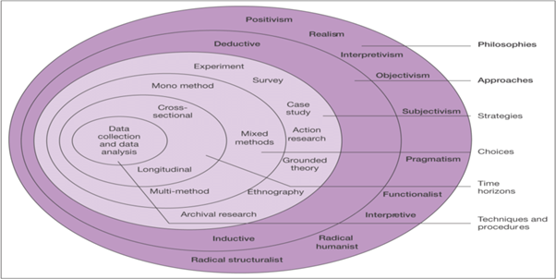

Figure 3.1: Research Onion
(Sources: Influenced by Saunders et al. 2015)

3.3 Research Philosophy
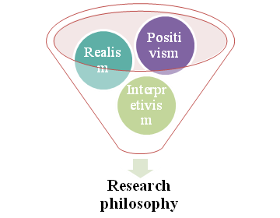

Figure 3.2: Aspects of philosophy
(Sources: Influenced by Saunders et al. 2015)
Collection of positive data which are rational and have been used for making strategies is the main concept of positivism philosophy which has been adopted by this researcher. Additionally, correlated information benefits of VLE have been targeted by the researcher.

3.4 Research Approach
Collaboration of existing information implication of scientific methods is a part of deductive approach. Collection of relevant factor information by researcher through adoption of these mentioned approach provide the wide scope identify various impact of this innovative learning session

3.5 Research Design
Descriptive design has been implemented by this researcher for estimation of various variables that are directly related to research questions. Additionally, generalizing information introduces challenges in terms of deduction of relevance.

3.6 Sampling Technique and sample size
Random sampling technique has been adopted by the researcher for conduction of survey. Moreover, 11 participants have been targeted for collection of primary information. Additionally, 4 journal articles are selection execution of secondary research.

3.7 Data collection method
This researcher focuses over both secondary and primary data collection methods for interpretation of information regarding this innovative learning method. Journal articles and books used by researchers for collecting secondary information that helps in conduction of qualitative research. Moreover, students are targeted for conduction of online surveys to help in maintaining the health crisis that appears for covid-19.

3.8 Data collection tools and techniques
Google Scholars at all the databases for collection of secondary information that highlights over existing information provided by authors. Moreover, close-ended questions had been used by researchers for collection of opinions from participants involved in online data collection sessions through a survey.

3.9 Data analysis techniques
Thematic data analysis techniques are used for generation of themes through aligning with research objectives. Furthermore, MS Excel has been used for collection and analysis of statistical information.

3.10 Ethical Consideration
Maintaining security to the information which is provided by participant’s increases interest to deliver their opinion regarding this unique blending learning system. However, allocation of legislations regarding maintaining privacy increases authentication of this study

3.11 Summary
This chapter focuses on data collection procedures by selecting accurate methods of true highlighting over situations.

Chapter 4: Findings and discussion

4.1 Primary quantitative analysis
4.1.1 Q1 What is your gender?
Components | Total no of respondent | No of participant | Percentage (%)
Male | 11 | 6 | 54.55%
Female | 11 | 5 | 45.45%
Others | 11 | 0 | 0%

Table 4.1.1: Gender
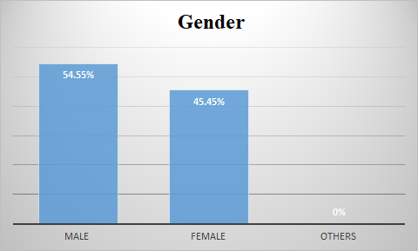

Figure 4.1.1: Participant’s gender
54% of male candidates are interested in submitting their opinion regarding VLE.
4.1.2 Q2 Which age group is yours?
Components | Total no of respondent | No of participant | Percentage (%)
18-25 | 11 | 3 | 27.27%
25-30 | 11 | 5 | 45.45%
30-35 | 11 | 3 | 27.27%

Table 4.1.2: Age
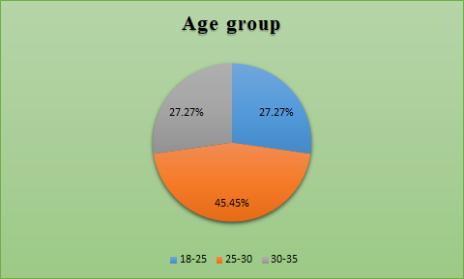

Figure 4.1.2: Age of participants
45% of participants are belonging from the age group of 25 to 30.
4.1.3 Q3 Do you agree that technical skills are improved through VLE?
Components | Total no of respondent | No of participant | Percentage (%)
Strongly agree | 11 | 7 | 63.63%
Agree | 11 | 2 | 18.19%
Neutral | 11 | 0 | 0%
Disagree | 11 | 1 | 9.09%
Strongly disagree | 11 | 1 | 9.09%

Table 4.1.3: Development of technical skills
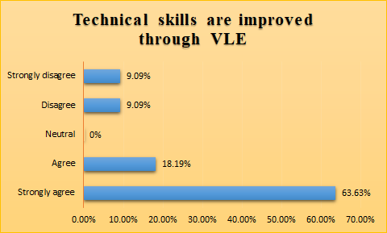

Figure 4.1.3: Improvement of technical skill from VLE
63% of participants support with idea of developing technical skills from VLE.
4.1.4 Q4 How do you agree that graphical presentation faces limitations in traditional learning approach?
Components | Total no of respondent | No of participant | Percentage (%)
Strongly agree | 11 | 4 | 36.36%
Agree | 11 | 3 | 27.27%
Neutral | 11 | 1 | 9.09%
Disagree | 11 | 1 | 9.09%
Strongly disagree | 11 | 2 | 18.19%

Table 4.1.4: Limitation in presentation for traditional approaches
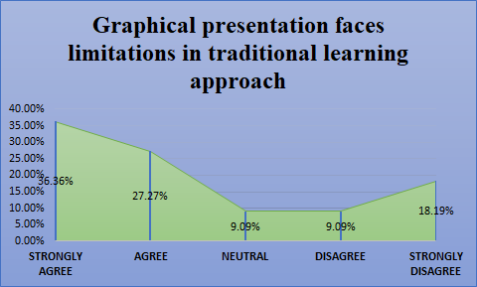

Figure 4.1.4: Issues of traditional learning
36% candidates support presentation reduces challenges of tradition learning approaches.
4.1.5 Q5 Do you agree that communication skill develops through generation online communities during VLE?
Components | Total no of respondent | No of participant | Percentage (%)
Strongly agree | 11 | 5 | 45.45%
Agree | 11 | 5 | 45.45%
Neutral | 11 | 0 | 0%
Disagree | 11 | 1 | 9.1%
Strongly disagree | 11 | 0 | 0%

Table 4.1.5: Development of communication skill
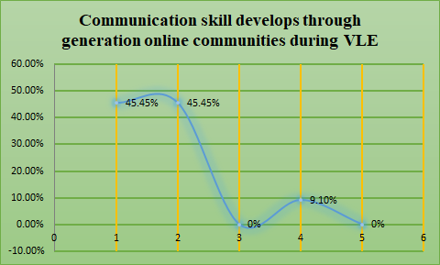

Figure 4.1.5: Generation of Communication skill
90% of participants support the development of communication skills from VLE.

4.2 Secondary qualitative analysis

4.2.1 VLE improves technical skills by offering accessible opportunity
Development of knowledge from virtual lessons by handling computers makes potential to access technology. As opined by Ifinedo et al. (2018), intrinsic motivation increases due to being capable of accessing technology that optimises usability factor of an individual. Collaboration of knowledge for generation of decision in a short time is one of the major parts of proper implication of Technical skills.

4.2.2 Generation of eLearning Content improves application option of VLE
Advancement in technology for balancing learning activity the establishment of a motivational learning environment for learners (Qian, 2018). Linking with content world generation of presentation provides the scope to develop creative skills within an individual.

4.3 Data Analysis
Based on the survey it has been identified that VLE is a learning session which generates motivation for making development of technical skills. Additionally, thematic analysis provides overview regarding improvement of learning procedure by aligning content with subject topic.

Chapter 5: Recommendations and conclusion

5.1 Conclusion
Digital resources are required for conduction of this education system. This study highlights that themes are generated according to research objectives. Engagement rates towards learning sessions are increased by adoption of VLE.

5.2 Linking with objectives

5.2.1 Linking with first objective:
This first objective gets linked with 2.2 of literature review (LR) and 4.1.2 of survey.

5.2.2 Linking with second objective:
2.3, and 4.1.3 get completely linked with survey and LR. However, 4.2.1 is also linked with the second objective.

5.2.3. Linking with third objective:
2.4, and 4.1.4 are fully connected with third objectives.

5.2.4. Linking with fourth objective:
2.5, 4.1.5, and 4.2.2 are conveying various strategies that get interlinked with forth objectives.

5.3 Recommendations

5.3.1 Recommendation 1: Ongoing Feedback
Estimation of weakness by delivering feedback immediately that helps in managing issues by an alternation of strategy. Motivation is also maintained through estimation of internal strength.

5.3.2 Recommendation 2: Mixing of learning tools
Engagement rates are increased from mixing of tools that extend working capability. Additionally, introduction of asynchronous activities makes a blend of classroom study with digital presentation that reduces debut in learning materials.

5.4 Research limitation
Time and cost are the two limitations which are faced by researchers for conducting this research. Adoption of online survey creates limitation in terms of exceeding budget due to managing health crisis that arose for pandemic situation.

5.5 Future scope
Maintaining relevance is another part which supports researchers to increase motivation for a future researcher.

References
virtual-college.co.uk (2020) Virtual learning environments 'benefit students and teachers'. Available at: https://www.virtual-college.co.uk/resources/2012/05/virtual-learning-environments-benefit-students-and-teachers [Accessed on: 18/11/2020]
El-Omari, A.H., (2016). Factors affecting students' achievement in English language learning. Journal of Educational and Social Research, 6(2), p.9.
Baroni, A., Dooly, M., García, P.G., Guth, S., Hauck, M., Helm, F., Lewis, T., Mueller-Hartmann, A., O’Dowd, R., Rienties, B. and Rogaten, J., (2019). Evaluating the impact of virtual exchange on initial teacher education: a European policy experiment. Research-publishing: London
Panconesi, G. and Guida, M. eds., (2017). Handbook of research on collaborative teaching practice in virtual learning environments. IGI Global:U.S.
Duvall, M.D., (2017). The impact of virtual literacy communities in an English language arts classroom: a case study using Goodreads. Drexel University: U.S.
Ifinedo, P., Pyke, J. and Anwar, A., (2018). Business undergraduates’ perceived use outcomes of Moodle in a blended learning environment: The roles of usability factors and external support. Telematics and Informatics, 35(1), pp.93-102.
Qian, Y. ed., (2018). Integrating Multi-User Virtual Environments in Modern Classrooms. IGI Global: U.S
Saunders, M.N., Lewis, P., Thornhill, A. and Bristow, A., (2015). Understanding research philosophy and approaches to theory development.



