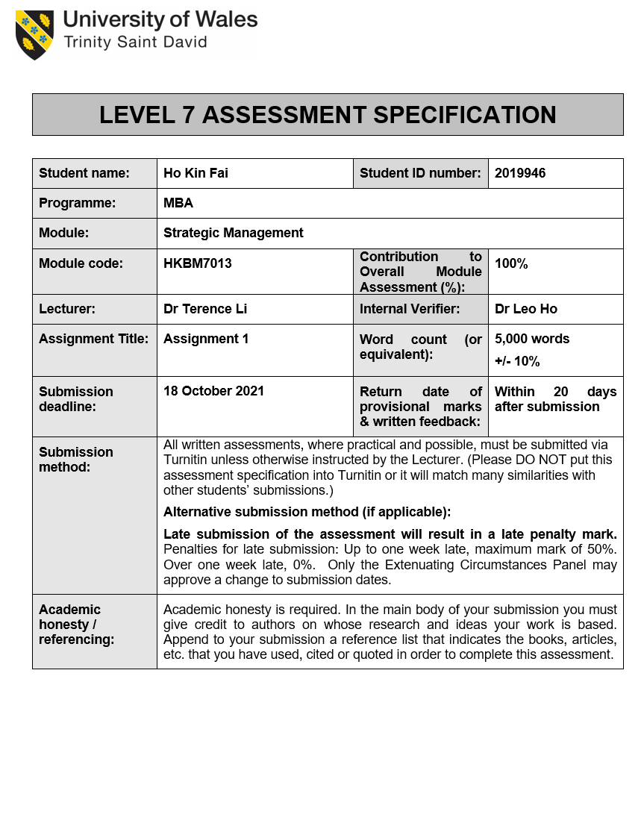

Table of content
Table of Contents
Table of content ii
List of Tables iv
List of Figures iv
1. Introduction 1
1.1 Company Background 1
1.2 Analyse Giordano Vision, Mission and Value 2
1.2.1 Vision 2
1.2.2 Mission 2
1.2.3 Corporate Values 3
1.2.3.1 quality – doing things right 3
1.2.3.2 Knowledge – updating expertise and sharing knowledge 3
1.2.3.3 Innovation – thinking out of the box 3
1.2.3.4 Service – exceeding customer's expectation 3
1.2.3.5 Simplicity – "Less is More." 3
1.3 Analysis of how VMV Affect the Strategic Direction 4
1.4 Study Contribution 5
2. Macro-Environmental Analysis 6
2.1 Macro-economic analysis by PEST 6
2.1.1 Economic 6
2.1.2 Social 7
2.1.3 Technology 8
2.1.4 Political 10
2.2 Concluded Summary 10
3. Value Chain Analysis 11
3.1 Primary Activities 11
3.1.1 Inbound logistics 11
3.1.2 Operation 12
3.1.3 Outbound Logistics 12
3.1.4 Sale and Marketing 13
3.1.5 Service 13
3.2 Support Activities 14
3.2.1 Technological development 14
3.2.2 Human Resource Management 14
3.2.3 Infrastructure 14
3.3 Concluded Summary 15
4. Evaluation of the current strategic planning based on Balanced Scorecard 15
4.1. Evaluation of the current business by Balanced Scorecard 15
4.2 Concluded Summary 18
5. Conclusion and Recommandation 19
5.1 Recommendation of Strategic Formulation 19
5.1.1 Maintain Differentiation Strategy 20
5.1.2 Look for New Segmentation 21
5.1.3 Improve Positioning Strategy 21
5.1.4 Promote Employee Branding 22
5.2 Implementation of Strategic Plan 23
5.2.1 Strategic Implementation Process 24
5.2.2 Strategic Implementation Timeline 25
5.3 Contingency Plan 26
Reference list 27

List of Tables
Table 1. Comparison of Giordano Sales between 2016-2020
Table 2. Giordano's major milestone 1983-2017
Table 3. Fashion Industry growth comparison in Hong Kong 2018 -2020
Table 4. Household Consumption Expenditure 2020 in Hong Kong
Table 5. Distribution channel in each country
Table 6. Financial Perspective
Table 7. Customer Perspective
Table 8. Internal Business Perspective
Table 9. Innovation and Learning Perspective
Table 10. Market positioning of Giordano and principal competitors
Table 11. Strategic Plan Gantt Chart
Table 12: Scenario template for Contingency Planning

List of Figures
Figure 1. Talent Distribution by the Reporting Markets
Figure 2. The Yarn Price trend between June 2020 and Jan 2021
Figure 3. Global Fashion Industry E-commerce
Figure 4. Revenue Forecasting on Apparel, Bags & Accessories and Footwear in Hong Kong
Figure 5. Preliminary Strategy Framework
Figure 6. Giordano Employee Age Distribution 2019
Figure 7. Strategic Planning Process

1. Introduction
Giordano International Limited is a Hong Kong fashion retail chain that sells men's, women's and children's apparel and accessories founded in 1981 (Giordano, 2021b). The company business model is operated by "retail and distribution" and "wholesales to overseas franchises partner". Giordano has successfully implemented a multi-market and multi-brand strategy, and operates approximately 2,100 stores in more than 30 countries and regions. Brands include "Giordano", "Giordano Lady", "Giordano Junior", "BSX" and "Beau Monde". To provide high-quality, value-for-money and easy-to-wear clothing and accessories through a network And promote the belief of "a world without strangers" as their philosophy.
The following session will briefly introduce Giordano by studying the company background on their mission and vision, looking around the industry running the similar model competitors to analyse the company's current strategic direction and how the company VMV affects their strategic planning in the future.

1.1 Company Background
According to the latest annual report sale data (Table 1), the pandemic affected sales from the beginning of 2020. Still, in the second half of the year, the Group's sales and gross profit margin improved, and the sales decline narrowed to -26.0% (first half of 2020: -44.4%) and gross profit. The interest rate is 56.4% (first half of 2020: 54.6%). For the year, the Group sales fell by 36% to HK$3.122 billion (2019: HK$4.852 billion), with a gross profit margin of 55.6% (2019: 58.7%) (Giordano, 2021).
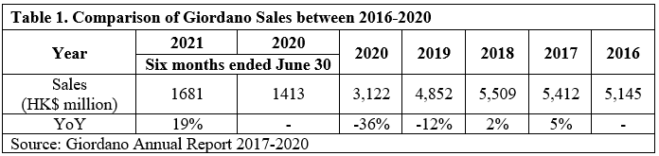
Beyond that, the Group has hired a different country workforce. The headcount reached 3,122 talents for the Reporting Markets as of December 31, 2020, with a 26.92% decrease from 2019 (Giordano, 2021). Figure 1 shows the employee has reduced seem likely they are cutting cost on human resource around the world. Giordano's business declined from 2016, and a fast drop in 2020 was affected by the pandemic.
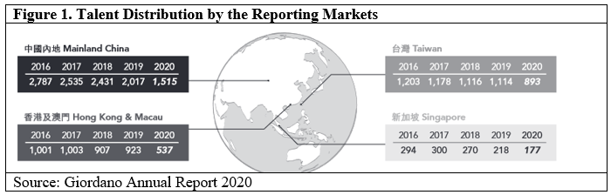
Giordano facing such a business environment, how the Group finds new directions from his vision, mission, and value and maintains the Group's competitive advantage in the post-pandemic era will be our discussion's goal.

1.2 Analyse Giordano Vision, Mission and Value
Giordano has a clear vision, mission and value, and a clear statement can bring confidence to consumers and investors and a clear understanding of the Group's operating philosophy, thereby gaining more recognition.

1.2.1 Vision
Giordano uses "To be the Best and the Biggest World Brand in Apparel Retailing" (Giordano, 2021 e) as the vision to telling the stakeholder that it wants to be the best and the most significant apparel retailing in the world—but judging from the "Best" and "Biggest" in the sentence. The definitions of the two are too broad, and it may not be clear what the best and biggest measure is? If the vision can stay more clearly on "Best" of the most excellent or desirable type or quality, and "Biggest" is associated with the market share or depend on the retail network can be more considerable.

1.2.2 Mission
Giordano Mission statement is To Make People "Feel Good" and "Look Great" (Giordano, 2021e). Since 1981, this straightforward mission statement has served Giordano well and guided the Group's development from a casual wear manufacturer to a leading international men's, women's and children's wear retailer. At the same time, "Feel Good" and "Look Great" in the sentence are subjective meanings to making different types of customers feel more flexible.
In addition, the customer experience can be in different regions. Giordano can provide everyone with relevant, indispensable and timeless fashion; and develop clothing for everyone, regardless of race, nationality or culture, which truly embodies us" "A world without strangers" brand value.

1.2.3 Corporate Values
Having clear company values can help you ensure that all employees are working towards the same goals. Research shows that company values play a crucial role in attracting talent: 46% of job seekers think company culture is important when choosing a company to apply to (Schur, 2020). And the company's core values can also support the company's vision and shape its culture.
Giordano uses the short-form word "QKISS" (Giordano, 2021e) to pronounce the corporate values and different characters to represent meaning.

1.2.3.1 quality – doing things right
Giordano reminds colleagues to do everything at any time and strive to do it right the first time. If you do the same thing repeatedly, it will waste time and cost.

1.2.3.2 Knowledge – updating expertise and sharing knowledge
"Knowledge is the source of life", GIORDANO encourages colleagues to continue to study and read to enhance knowledge and self-improvement.

1.2.3.3 Innovation – thinking out of the box
Giordano encourages colleagues to jump out of the habitual box, put forward different ideas and opinions, and try new methods.

1.2.3.4 Service – exceeding customer's expectation
Giordano provides products to fulfil customers' needs and encourages colleagues to start from the heart and deliver services that exceed customer expectations.

1.2.3.5 Simplicity – "Less is More."
In addition to product design, internal and external communication channels, even Giordano's organisational management structure also strives to be simple to avoid waste of resources.

1.3 Analysis of how VMV Affect the Strategic Direction
At the beginning of the establishment of Giordano, the Group adopted "a world without strangers" as its business philosophy. Their vision is to hope that the world is free of race, nationality and culture and that each other can live in a unified world. This vision will be implemented Applied to management and business operation level.
A core value is like a company' DNA (Corey, 2018). Having clear company values can help the company ensure that all employees are working towards the same goals. Maintain core values to support the company's vision and shape its operating culture. Every business decision of the Group should be consistent with these values.
Vision should have milestones, and those milestones can be based on a business or marketing Strategy. Table 2 lists Giordano's previous major milestones, indicating that Giordano has adopted different strategies to realise its value, such as daring to explore new overseas markets. Some regions will expand their business globally through franchising or joint ventures. Also, Giordano's multi-brand business model tries to make the product suitable for different customer segments and applied pricing strategies to make the price affordable.

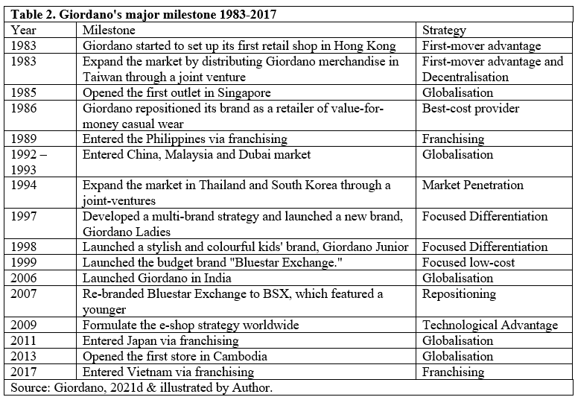
In addition, when the company begins to grow, the values written early may not be entirely relevant for the destination. However, as new opportunities and challenges emerge, companies need to update their values over time. Companies can help guide the process by regularly reviewing company values and getting feedback from existing employees (Darmanin, 2019).

1.4 Study Contribution
This research will analyse Giordano's entrepreneurial philosophy and use his vision, mission, and value to see how it affects the Group's past development and future strategic directions. The report will use news, academic articles, and annual reports to organise various data, and then uses PEST to analyse how Macro-environment affects Hong Kong's fashion business development. The Value Chain model will see how the Group caters to the VMV principle in various aspects and uses a Balanced Scorecard to evaluate whether the past strategy can reach. Finally, use academic articles to support some strategic management knowledge and advise Giordano on maintaining a competitive advantage and creating value in the post-epidemic era.

2. Macro-Environmental Analysis
This session uses the PEST model to analyse the impact of Hong Kong's Macro-environment factors on the development of the Group and the local fashion retail market and determine the opportunities and threats.

2.1 Macro-economic analysis by PEST
PEST analysis is a strategic framework used to assess a company's external environment by prioritising opportunities and threats into Economic, Social, technological and political factors. PEST analysis can be a practical framework used in corporate strategic planning, helping to determine the pros and cons of business strategies (Kenton, 2020).

2.1.1 Economic
For the Giordano Group and the entire fashion apparel industry, 2020 will be a challenging year. Table 3 shows the fashion industry in each category has a slight drop started from 2018. And 2020 has decade rapidly. Due to the COVID-19 outbreak at the beginning of the year. The total sales in 2020 plummeted by 35.7% to HK$3.122 billion, although the most significant impact was in the first half of the year.
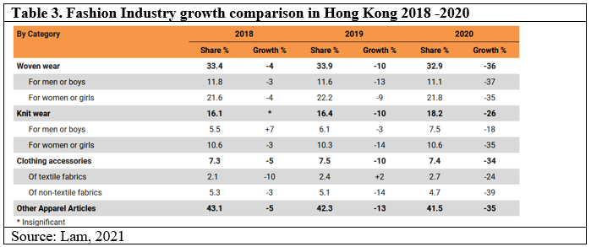
HKSAR C&SD 2021 has released provisional retail sales statistics in Hong Kong. Total sales value has increased 2.9 per cent (estimated at $27.2 billion) compared with the same month in 2020 among footwear, allied products, and clothing accessories +30.5% (C&SD, 2021).
Giordano as a manufacturing retailer has its factory to produce a variety of products. However, the sharp increase in raw material and yarn prices have brought significant challenges to the apparel and textile industries (Gunasekaran, 2021). Among the raw materials for clothing production, Figure 2 shows the cotton and yarn prices have not declined due to the decline in retail demand and production reduction by factories. On the contrary, it reduces shipments by the raw material suppliers affected by the pandemic. The impact of the operation of the raw material manufacturers is the cause of the price increase.
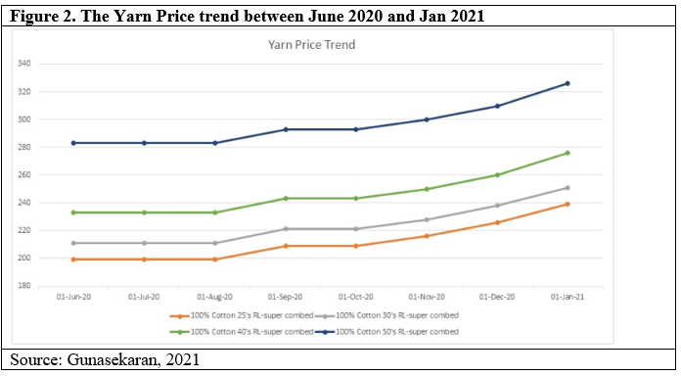

2.1.2 Social
Fashion retail is a competitive industry in Hong Kong, ranging from large and small fashion boutiques to fast-fashion chains. Hong Kong is a small place with many distribution channels for customers, and the population in the local market may not be enough to support the entire industry. However, consumer groups will be affected by population growth or decline. And Table 4 shows that one customer segment on household consumption expenditure on clothing and footwear is only 3% in 2020, which means the consumers during the pandemic are reducing their purchasing intention.

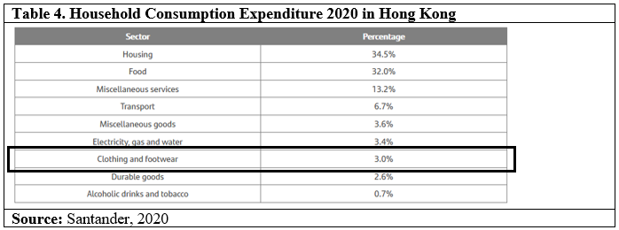
Due to millennials increasing disposable income, consumers are becoming savvier and expect higher quality and first-class customer service. The purchase is usually determined by the product's price, quality and technical specifications, and after-sales service. Consumers seek high-quality products and competitive prices. Given that Western trends greatly influence Hong Kong consumers, they prefer foreign products to domestic products.
In addition, the fast-fashion culture has changed the consumption pattern of the consumer group. Since new fashion styles are launched every week, consumers no longer need to wait for the season to buy the latest trendy clothing. Research indicates that 39% of Hong Kong people have discarded clothes that have only been worn once (YouGov, 2017).
Hong Kong has the most connected consumers in the world. Therefore, e-commerce has been growing exponentially and is expected to grow further in the next few years. As technology has changed the way products are sold and affected how products are researched, manufactured and marketed, Hong Kong consumers will have more diversified forms of shopping and choosing to buy.

2.1.3 Technology
Giordano online sales had soared to 10.5% from 5.5% of total sales last year. Although convenient online shopping has been recognised by consumers everywhere, their platforms may vary depending on the region and time. Each market must make a careful assessment to develop a multi-functional and sustainable online plan.
Except for Mainland China, the overall online sales scale is still small, but there are signs that overseas online sales are accelerating. Until December 2020, online sales have increased by 22.1% and accounted for 10.5% of total sales (2019: 5.5%). Online sales outside mainland China recorded an increase of 123.5% and accounted for 23.3% of online sales (2019: 12.7%). The Group's strategic focus is on substantive investments in third-party platforms that do not require capital (Annual Report,2020).
McKinsey data shows consumers and businesses have moved forward five years in adopting digital technologies. Globally, compared to 2020, the annual growth in 2021 is expected to exceed 20% (30% in Europe and the United States). Other positive trajectories will include the increasing influence of platform propositions as customers become more enthusiastic and updated on the market experience and brands and consumers' interest in local participation—reflecting the personal style that many people prioritise. (McKinsey & Company, 2020) and Figure 3 is a forecast for 2022 have 38% growth in the fashion industry will use E-commerce.
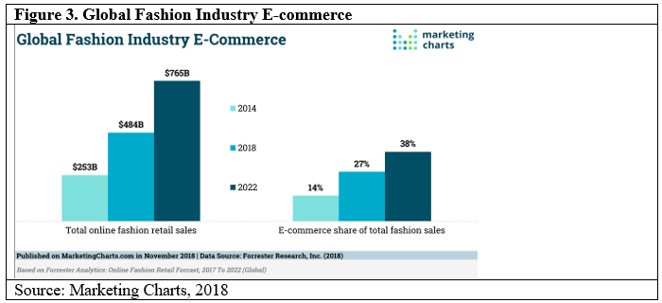
COVID 19 pandemic has accelerated the pace of digitisation. Digitisation helps international companies conduct online training, cross-departmental, cross-regional meetings, and close visual communication with suppliers and stores. Managers use digital tools to make faster and better decisions. This kind of action will be more common and will save the entire Group's expenses and time.

2.1.4 Political
The political in PEST will look at the government policy and action, including tax policy, labour law, Environmental policy and trade restrictions. Hong Kong has always been politically stable, except for the recent social unrest in 2019. In a level playing field, there are no restrictions on foreign equity holdings. Capital, talents, goods, and information all circulate freely.
Hong Kong is one of the most competitive economic systems in the world. The International Institute for Management Development (IMD) selected Hong Kong as the fifth most competitive among 63 economic systems in the 2020 World Competitiveness Yearbook, showing that Hong Kong is building. The open business environment is indispensable (InvestHK, 2021).
However, due to the global impact of the pandemic, the famous places of governments have formulated different types of prevention policies. Closing borders to reduce tourists' entry, shortening business hours, restricting social distance, etc., will affect business operations. The Group must pay attention to policy changes and make timely response strategies.

2.2 Concluded Summary
Summarised from the PEST, it seems that the economic factors have a profound impact. When the socio-economic environment is depressed, it will affect consumers' spending power and reduce their desire to consume. Consumer sentiment is also affected by social trends. For example, consumers' demand for clothing has decreased affected by the epidemic cause consumers not to go out and work at home. However, the Group has increased the opportunities for consumers to purchase online platforms during the outbreak to drive the online business. It also gave Giordano the idea of focusing on developing an online shopping platform in the future. The final political impact is not significant because Giordano knows how to choose some developed countries to enter the market, and the policies of these countries are relatively stable.
Although the global economies were affected by the pandemic in 2020. Nowadays, the pandemic has been under control by the emergence of vaccines. Some areas have begun to relax by social distancing measures in the second half of 2021 and coupled with the improvement in the labour force and unemployment rate, consumers are regaining their desire to buy (Stockdill, 2021). Revenue forecasts for clothing, bags, accessories, and footwear show an increase in year-on-year
(Figure 4).
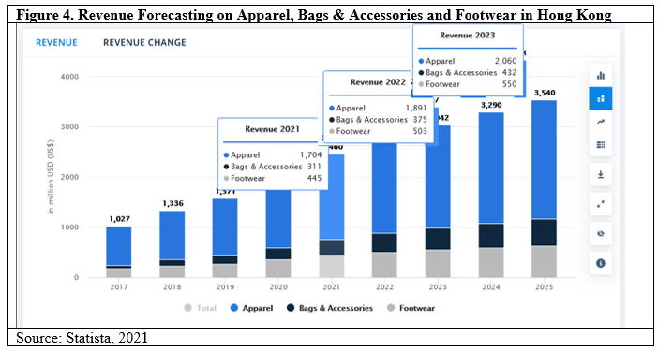

3. Value Chain Analysis
This chapter will be based on Proter Value Chain Model to demonstrate how the value chain can add value to each area. The value chain is a series of activities performed by a company to create products or services. The company that produces the product involves taking the product from concept to final sales and after-sales service and everything in between-such as purchasing raw materials, manufacturing, marketing, etc (Porter, 1985).

3.1 Primary Activities
The primary activities are activities directly involved in product creation or service execution, including:

3.1.1 Inbound logistics
Giordano has a total of 126 suppliers distributed all over the world. While suppliers in China account for 81.6% (Giordano, 2020), Giordano and suppliers adopt a B2B business model and directly purchase clothing and accessories with manufacturers. The Group's supply chain management maintains An ethical procurement concept.
Suppliers must reach core ethical procurement regulations with Giordano and comply with each of these regulations. For example, employees must meet the local legal minimum working age; local environmental protection laws and regulations must be maintained, and employees must be provided with a safe and healthy jobs environment and so on.

3.1.2 Operation
Giordano is committed to ensuring that its operations incorporate environmental protection concepts, from the procurement of raw materials, the supplier's production process to business operations. The Group makes every effort to reduce waste and emissions. For example, the production of raw materials and finished products will bring risks to the environment and reduce the packaging of raw materials by monitoring waste emissions. And use supply chain management to control the raw materials and finished products in the transportation process to minimise material loss or excessive and use inventory control to reduce the overstock by maintaining the inventory turnover days with 115 days (Giordano, 2021c).
The Group also uses a series of environmental protection laws and regulations to monitor and make good use of resources and reduce energy, water, paper, and raw materials to reduce carbon emissions and protect and conserve the environment.

3.1.3 Outbound Logistics
Giordano's business comprises six sub-segment markets: mainland China, Hong Kong and Macau, Taiwan, Singapore, Australia, and the Middle East. According to the perspectives of each brand, retail and distribution are further subdivided into Giordano & Giordano Junior, Giordano Ladies, Concepts One and BSX (Giordano, 2021b).
The Group is an international clothing retailer, Giordano's retail network. As of December 31, 2020, the Group had 2,185 stores, including the official online stores, and cooperated with third-party online stores in different regions for multi-channel sales. Table 5 show the distribution channel in each country and number of branch. However, due to the impact of the pandemic in 2020, the overall gross profit will decrease. The Group began to reduce the number of stores to save expenses and concentrate resources on developing the online store business. However, the global sales channels have cited the Group's Vision as the Biggest World Brand in Apparel Retailing.

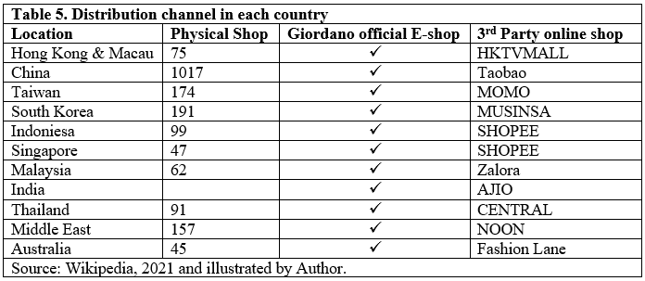

3.1.4 Sale and Marketing
Giordano offers high-quality, value-for-money and easy-to-wear apparel (Giordano, 2020) through physical and online stores, and the Group also uses social media for marketing. Giordano believes in celebrity endorsements and hired Jun Zhixian as the brand ambassador. The product will also crossover with well-known animated characters to launch clothes with characters printed on them.
To cater to various customer levels, Giordano has launched different new products. For example, during the pandemic, customers have increased their pursuit of work clothes that can be worn at home when working at home. After the pandemic, customers focused on health, and sportswear quickly emerged. Under this trend, sports and leisure apparel brands have expanded their product lines to cope with customer changes.

3.1.5 Service
Giordano means service, a principle proposed by Giordano earlier than 1989 (Chugani, 2016). Giordano's service philosophy has three principles: first, try on an unlimited number of times; second, don't ask any questions when customers exchange goods; third, always serve customers with a smile.
The Group has maintained these three philosophical principles to provide services so that Giordano has won different types of service awards (Giordano, 2021b) in various business areas and achieved one of the concept "S" services.

3.2 Support Activities
Secondary activities help primary activities become more efficient-effectively creating a competitive advantage-and are broken down into:

3.2.1 Technological development
Regardless of using technology to improve production technology and optimise operational processes, customers demand product quality and their online and offline purchase experience is closely related to technology. The Group will continue to introduce different technologies to optimise processes, upgrade technologies, and improve operations.
Innovative technology can improve Giordano's market competitiveness and maintain the "I" innovation in one of the Group's values. The establishment of an E-shop is also an advanced strategy to bring customers an online shopping experience.

3.2.2 Human Resource Management
Employees are an important asset of Giordano. The Group uses "A world without strangers" to hire local employees in areas where it does business, and the total number of employees has reached 3,122. Giordano has a series of employment policies and employee rules to ensure that employees can work in a fair and just environment to protect their rights and interests.
Giordano also encourages employees to learn, provides comprehensive training and development, and cooperates with the 3E (economic, efficiency, and effectiveness) policy to focus on talent cultivation and development so that they have an international perspective, insight into international practices and firm competitiveness. Giordano hopes that employees can keep the "K" knowledge in value.

3.2.3 Infrastructure
Giordano has always been committed to improving the level of corporate governance. The board of directors is responsible for formulating and reviewing the company's corporate governance and policies and practices in compliance with legal and regulatory requirements to protect the interests of all stakeholders.
The Group has a transparent infrastructure. The board of directors is fully responsible for assessing and determining the nature and extent of risks that the Group is willing to accept when reaching its strategic objectives. Especially the financial, operational and compliance monitoring and risk management functions, continuously monitoring its effectiveness to realise the "S" Simplicity in the value.

3.3 Concluded Summary
After analysing the value chain, the conclusion reached is that Giordano is constantly working hard to find suitable strategies and methods from various value chains to maintain a good relationship with all stakeholders. Giordano will also pay attention to the interests of suppliers and let They are treated equally. Although in 2020, Giordano is facing the impact of the epidemic, the Group still establishes positive thinking in Operation, Sale and Marketing, Service and Technological development. Hoping to bring employees and customers to see that Giordano is still confident in the clothing market after the epidemic, The Group will continue to maintain the company values, competitive advantage, and increase value.

4. Evaluation of the current strategic planning based on Balanced Scorecard
The balanced scorecard method was proposed by Robert S. Kaplan and David P. Norton in their article titled " The Balanced Scorecard—Measures That Drive Performance". The author believes that the organizational performance method is-"what you measure is what you get" (Kaplan and Norton, 1992).

4.1. Evaluation of the current business by Balanced Scorecard
The Balanced Scorecard of each company varies based on the nature, size of the firm and industry it operates in. According to Robert S. Kaplan and David P. Norton (1992), the advantage of using the balanced scorecard is that it can provide management level with a framework that they can use to develop an overall strategy, not just to optimise a part of the business. The balanced scorecard allows the management level to look at the company from four different perspectives.
- Financial Perspective (Table 6)
- Customer Perspective (Table 7)
- Internal Business Perspective (Table 8)
- Innovation and Learning Perspective (Table 9)
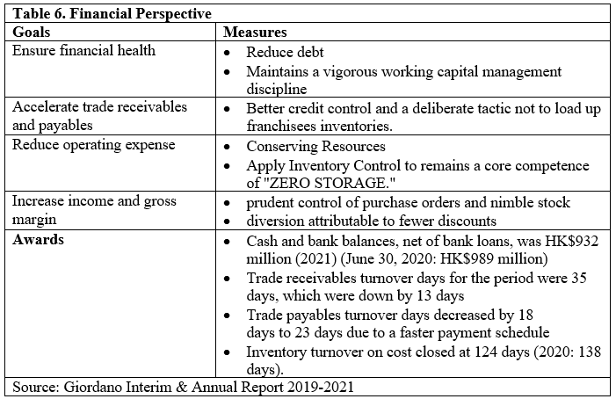
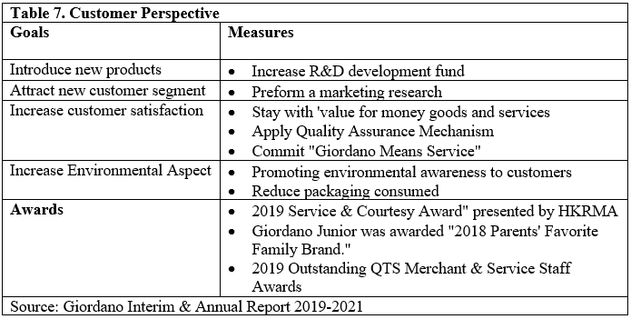

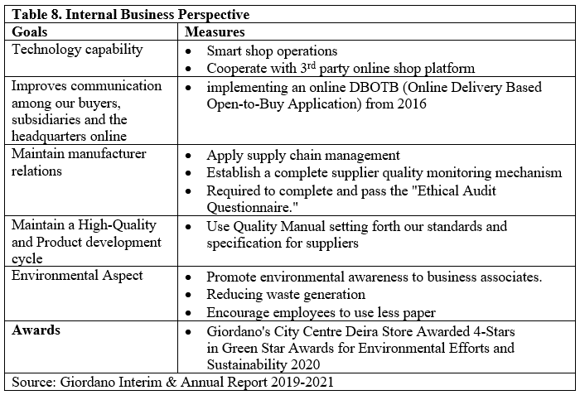
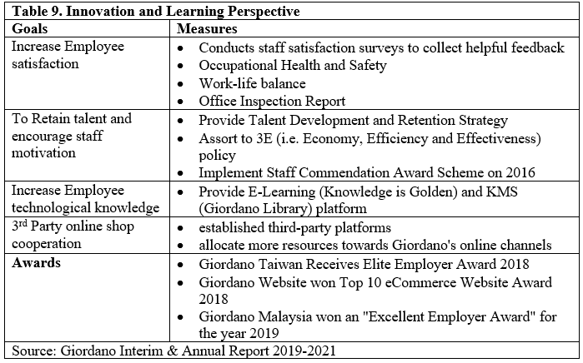

4.2 Concluded Summary
The balanced scorecard shows that Giordano has continuously invested resources and plans to achieve goals in any perspective. The awards won in different periods also prove that Giordano has given affirmation.
The Group will try its best to reduce debt and maintain substantial working capital to ensure financial health. And use credit control and prudent strategies to reduce inventory. The Group also reduced operating expenses by saving resources and finally allowed the Group to maintain Cash and bank balances, net of bank loans, was HK$932 million (2021).
On the customer side, the Group maintains the concept of Giordano Means Service, and continuously develops new products and increase environmental aspect to improve customer satisfaction. The Group has won multiple awards in service.
For Internal Business, implement online DBOTB (open purchase application based on online delivery) to improve online communication between buyers, subsidiaries, and headquarters to increase transparency. The application of supply chain management is to maintain the relationship between the producers. And Giordano also attaches great importance to environmental protection to reduce waste of resources.
In Innovation and Learning, the Group places great emphasis on innovation and the learning and development of its employees. Develop online stores and e-learning platforms, etc. The Group encourages employees to continue their education, provides subsidies, and strives to increase their satisfaction, making Giordano an excellent employer.

5. Conclusion and Recommandation
As a global company, Giordano has to take care of the consumer needs of more than 30 diversified worldwide markets. This challenge is not only Giordano facing. However, in recent years, most fashion apparel retailers have encountered this bottleneck. E-commerce has become a trend, and new ways of interaction between brands and consumers continue to emerge. The pressure on retailers is constantly escalating.
In addition, with changes in consumption patterns and increased functional demands on products, Giordano needs to maintain the brand's sustainability by developing more diversified products. It needs to interact more closely with social media to provide shoppers with exclusive content and a personalised experience.
The COIVD 19 pandemic in 2020 has led to a global economic recession, although Giordano's early regional diversification plan has helped the Group better resist regional economic decline than many competitors. In addition, Giordano successfully introduced the brand to more traditional emerging economies and developing countries. In existing markets, we will continue to adhere to core values ​​and maintain competitive advantages. The Group needs to continue to develop products following global standards and flexible strategies to meet local needs in emerging markets.
As the post-pandemic era approaches, the Group will need to seize opportunities actively and keenly select the winning market segments, market and channel combinations. Therefore, the task of decision-makers is to find a silver lining because they know that the era of change is inherently full of opportunities. Fashion companies that double their strategy align with significant trends and reflect the changing consumer landscape are likely to emerge from the crisis.

5.1 Recommendation of Strategic Formulation
The strategic formulation is when the internal and external environment is evaluated and integrated into the strategy and goals (Daft, 2006). And the strategic plan should establish short-term and long-term plans based on the organisation's weaknesses and strengths and the threats and opportunities in the business environment (Huiru, 2011).
According to a Researcher (AlDhaheri, Ameen and Isaac, 2020) has confirmed the effectiveness of strategy formulation and organisational performance and appropriate methods must be carefully selected to measure the correlation between the adoption of strategies and organisational performance. These studies show that strategy formulation will positively affect the performance of the organisation.
As a more mature brand, Giordano can consider the following four projections on Differentiation, Segmentation, Positioning and Branding to make strategies.
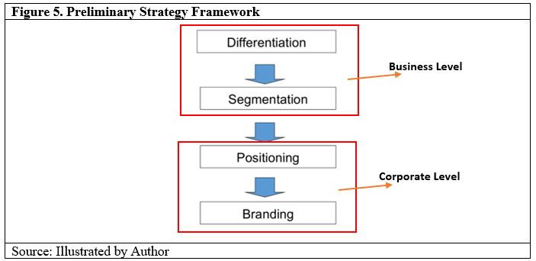

5.1.1 Maintain Differentiation Strategy
A significant objective of implementing a differentiation strategy is to increase competitive advantage. Giordano can grasp the concept of product differentiation. Since the early 1990s, it has emphasised Value-for-Money, High-volume and High-quality as product differentiation concepts. By enhancing product visual effects and expanding product lines, the Group also provides high-quality services as one of the differentiation characteristics (Ling, 2000). But it was facing the same type of competition in the market, such as Bossini and Baleno, plus fast-fashion H&M and Uniqlo. Product differentiation seems to be the only way out.
With the pandemic, customers have put forward requirements for the protection and function of clothes. For example, they want to have an antibacterial part in everyday clothes or bad weather, especially for vulnerable groups or children who need waterproof, quick-drying, etc. These demands will continue to rise and make it a profitable investment for retailers and brands (Amin, 2020).
"Functional fashion" is a term that combines fashion awareness, style and design with necessary protective functions and product life cycles. Among them, clothing and accessories are derived from the design process of user-specific requirements: functionality, abrasion resistance and desirability (Ross, 2017).
Of course, the biggest beneficiaries of product differentiation must be customers because as long as customers' needs can be met, they can be absorbed into a customer group. Then their market can be subdivided into another segmentation to develop business.

5.1.2 Look for New Segmentation
The purpose of market segmentation is to divide the target market into approachable customer groups. Market segmentation creates market subsets based on demographics, needs, priorities, shared interests, and other psychological or behavioural criteria used to understand the target audience better.
Giordano's initial products are aimed at a group of middle to high-income people. They are subdivided into Giordano ladies, Giordano Kids and the BSX brand for young people for each customer group. But in fact, competitors in the market are also implementing the same segmentation model, making Giordano difficult. In addition, the emergence of fast fashion has produced a post-purchase behaviour of fast-fashion consumers. As fast-fashion clothes continue to be updated, they have attracted a larger group of consumers to switch to popular and lower-priced fast-fashion (Joung, 2014).
How to attract customers back will be a big test for Giordano. The Group needs to find a way out in many market segments. As the pandemic temporarily affects the market environment, it is now conducting a comprehensive market survey to collect consumers, competitors, and product markets for future apparel needs. Understanding the profile of the target customer group and the acceptance of current or potential products will be a good way for the Group to confirm or reposition.

5.1.3 Improve Positioning Strategy
Giordano's current positioning strategy is high-quality products that are valued for money or inexpensive. According to research (Table 10), there are quite a few competitors in the market. Their positioning is the same as or similar to Giordano, which causes the Group to have no advantage in market share. The original reason is that customers can buy the same product at a comparable price or cheaper than other competitors.
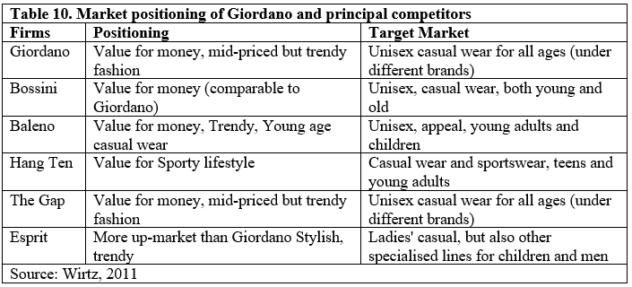
In the face of intense competition, the Group can position itself from two aspects. First, innovative positioning refers to producing products that are not yet available in the market and have specific characteristics. Fill the vacancies in the market in a position that is not occupied but has potential market demand. The second is repositioning. When the company finds that the positioning is inaccurate or in the current market position, but the market situation has changed, and the competitor's positioning is close to the company to invade part of the market share, repositioning should be considered.

5.1.4 Promote Employee Branding
The Group has a precise market positioning, product competitive advantages and established a consumer segment. To link up the products and services with consumer recognition requires long-term efforts to operate, so consolidating and establishing a company's identity and the image will be the following strategic arrangement. We believe that Giordano already has a certain degree of recognition and loyalty among the customer base in terms of branding. Still, as a sales industry, the employee brand is usually ignored. Employee branding refers to showing the company's image to customers and other stakeholders through employees. When the company has a good brand image, it must allow employees to show their positive image to customers. On the contrary, when employees are dissatisfied with the company, they will negatively affect customers (Mangold and Miles, 2007).
Giordano can enhance employees' sense of belonging and healthy and work-life balanced model from the human resources strategy and conduct regular employee satisfaction surveys to obtain valuable responses as a reference when formulating company policies. At the same time, talent development and retention strategy must also be maintained. Figure 6 shows that most of the Group's employees are 30-50 years old, and some of the Y-generation employees are newcomers in the workplace and lack work experience. Therefore, they are eager to acquire work-related knowledge and abilities. One of the ways to support their development needs is capacity development (Naim and Lenka, 2018).
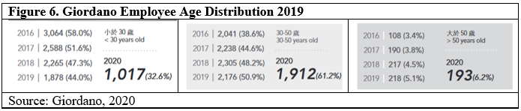
To provide comprehensive training and development for Y generation employees in sales and customer service and retain experienced and motivated employees to improve employee brand image and let employees recognise and abide by the Group's vision, mission, and value.

5.2 Implementation of Strategic Plan
Today's fashion industry is highly volatile and competitive. It is characterised by a "very short product life, fickle consumer preferences, numerous competitors, relatively easy entry and exit, and a myriad of manufacturing, marketing and retailing alternatives." (Saxena and Khandelwal, 2010). In a competitive environment, it is imperative to establish clear goals and develop appropriate strategies. This session has provided a Strategic Planning Process to monitor the whole strategic plan. And from the results obtained after the previous analysis, to suggest the future development direction of the Group.

5.2.1 Strategic Implementation Process
Planning a strategy can be inspired by vision, goals, tactics, tools. The milestone should be clear and proactive about what the companies will do and not be misleading or unreal. The design must have goals and plans to achieve the goals (Clark, 2020).
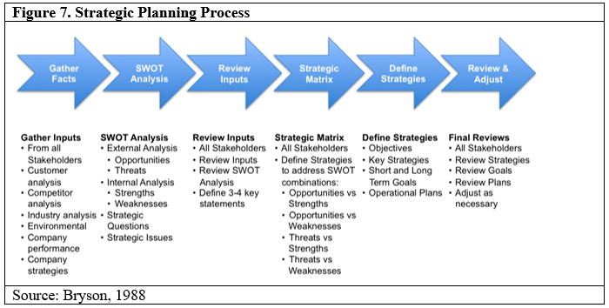
Figure 7 (Bryson, 1988) provided a clear pathway as a reference for Giordano when the company needs to develop a strategy, the management team can plan according to this process. The first step is to gather input by collecting data, including stakeholders satisfaction, analysing the business competition between competitors, and evaluating the company's performance and review current strategies, which is already obtained. The second step is using SWOT tools to analyse the external and internal factors to find out the opportunities, threats, strengths, and weaknesses. The third step is to review the input after collecting data and makes SWOT. The management team should be able to define some statements or new missions they want to achieve. After the third stage, a strategic matrix should be formulated and define the short and long term goals for design the strategic plan. And set up a timeline to review all plans are stick on the right track.

5.2.2 Strategic Implementation Timeline
The Strategic Plan will follow the Gantt Chart to allocate the working schedule and follow the date to meet the critical milestone.
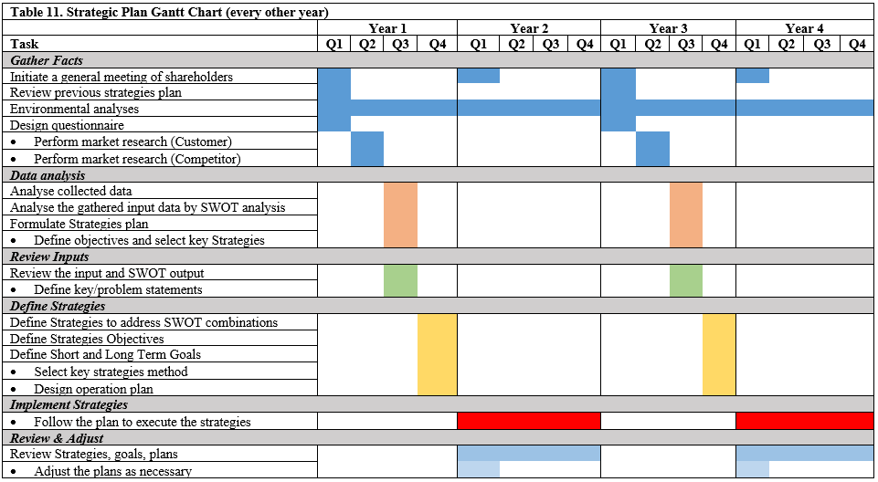According to research said strategic planning is essentially about planning for the medium and long-term future. The time frame of the strategic plan is usually 3-5 years (Martin, 2014). Strategic planning over a five-year time frame may be problematic because it is difficult to see the future so far. So suggest Giordano set a plan for four years and implement the program every other year.

5.3 Contingency Plan
When formulating the company's overall strategic plan, senior management can develop scenarios to simulate different situations to provide an SOP for the key responder for reference, like Table 12. For example, create a scenario for some known challenges that the company has faced before and point out which factors will trigger the scenario, how critical responders respond to these issues, and how long it takes to respond. Scenario examples can be when the business is in recession, and business is affected by changes in the company's financial or marketing channels, consumer demand for a specific product decreases, or how to respond when a competitor launches a new product, etc.
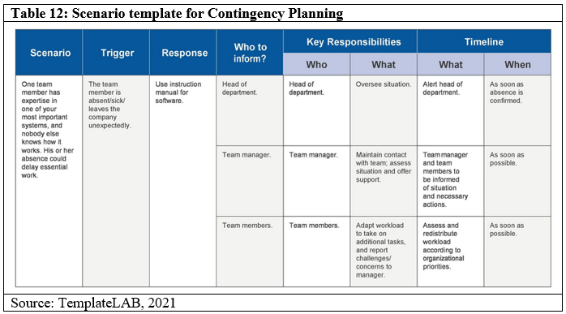
As Giordano's businesses worldwide are affected by the epidemic, there are still variables and unknown risks for future business development. Decision-makers can see which one of the current strategies is relatively stable and which one of the planned strategies is less affected by the macro environment. When the group has prepared a contingency plan, it can respond in time whenever changes occur.
Although the strategic emergency plan cannot predict future events and results, the strategic emergency plan provides a map for any possible future unknowns. The emergency plan involves the development of alternative methods to deal with unforeseen problems. The primary purpose of emergency planning is to provide a strategy to minimise the impact of unexpected situations.

Reference list
AlDhaheri, F., Ameen, A. and Isaac, O. (2020). The Influence of Strategy Formulation (Vision, Mission, and Goals) on the Learning and Growth. JOURNAL OF CRITICAL REVIEWS, 7(17). Aldhaheri, Fahed & Ameen, Ali & Isaac, Osama. (2020). The Influence of Strategy Formulation (Vision, Mission, and Goals) on the Learning and Growth. 2020. 10.31838/jcr.07.17.245.
Amin, T. (2020). A declaration of the era of "Functional Fashion." [online] Textile Today. Available at: https://www.textiletoday.com.bd/declaration-era-functional-fashion/ [Accessed September 17. 2021].
Belz, F.-M. and Peattie, K. (2009). Sustainability marketing : a global perspective. Chichester, West Sussex (Gb): J. Wiley, Dl, p.10.
Bryson, J.M. (1988). A Strategic Planning Process for Public and Non-profit Organisations. Long Range Planning, [online] 21(1), pp.73–81. Available at: https://citeseerx.ist.psu.edu/viewdoc/download?doi=10.1.1.458.5630&rep=rep1&type=pdf [Accessed September 9. 2021].
C&SD, HKSAR. (2021). Provisional statistics of retail sales for July 2021. [online] www.censtatd.gov.hk. Available at: https://www.censtatd.gov.hk/en/press_release_detail.html?id=4893 [Accessed September 6. 2021].
Chugani, I. (2016). Giordano means Service Campaign. [online] giordano-me.com. Available at: https://www.giordano-me.com/giordano-means-service-campaign/ [Accessed September 13. 2021].
Clark, D. (2020). The sequence of strategy - Strategic Thinking Video Tutorial. [online] LinkedIn. Available at: https://www.linkedin.com/learning/strategic-thinking/the-sequence-of-strategy-2 [Accessed September 2. 2021].
Corey, D. (2018). Council Post: Company Values And DNA: The Differences That Make Us Special. [online] Forbes. Available at: https://www.forbes.com/sites/forbeshumanresourcescouncil/2018/07/31/company-values-and-dna-the-differences-that-make-us-special/?sh=1401655c57e7 [Accessed September 8 2021].
Daft, R. (2006). Organisation Theory and Design. Cengage Learning..
Darmanin, D. (2019). How to Choose the Right Core Company Values? [online] Hotjar. Available at: https://www.hotjar.com/blog/company-values/#4-elements-of-effective-company-core-values [Accessed September 8 2021].
Giordano (2020). GIORDANO INTERNATIONAL LIMITED (Incorporated in Bermuda with limited liability) (Stock Code: 709) ANNOUNCEMENT OF UNAUDITED INTERIM RESULTS FOR THE SIX MONTHS ENDED JUNE 30, 2020. [online] GIORDANO INTERNATIONAL LIMITED. Available at: http://corp.giordano.com.hk/files/results_material/2020-08-11%2000.00.00.4099/Giordano%201H20%20Results%20Announcement%20(E).pdf [Accessed 19 Sep. 2021].
Giordano (2021a). Annual Report. [online] Giordano Hong Kong. Available at: http://corp.giordano.com.hk/files/financial_reports/2020-12-31%2000.00.00.7910/2021042000498_c.pdf [Accessed 31 Aug. 2021].
Giordano (2021b). Giordano Company Info. [online] Giordano Middle East. Available at: https://www.giordano-me.com/about-us/company-info/ [Accessed September 19. 2021].
Giordano (2021c). GIORDANO INTERNATIONAL LIMITED (Incorporated in Bermuda with limited liability) (Stock Code: 709) ANNOUNCEMENT OF RESULTS FOR THE YEAR ENDED DECEMBER 31, 2020 Overview. [online] GIORDANO INTERNATIONAL LIMITED. Available at: http://corp.giordano.com.hk/files/announcements/2021-03-11%2000.00.00.1605/ew0709.pdf [Accessed September 19. 2021].
Giordano (2021d). Giordano Milestones. [online] corp.giordano.com.hk. Available at: http://corp.giordano.com.hk/en/milestones.aspx [Accessed 13 Sep. 2021].
Giordano (2021e). Giordano Vision. [online] corp.giordano.com.hk. [online] http://corp.giordano.com.hk/en/vision.aspx [Accessed 13 Sep. 2021].

Gunasekaran, R. (2021). Raw material price increase – The latest storm to have hit the apparel industry. [online] Apparel Resources. Available at: https://apparelresources.com/business-news/manufacturing/raw-material-price-increase-latest-storm-hit-apparel-industry/ [Accessed September 11. 2021].
Gupta, S. (2020). Value Chain. [online] Medium. Available at: https://medium.com/dataseries/value-chain-7d02cbf22c4f [Accessed 29 Aug. 2021].
Huiru, D. (2011). THE IMPORTANCE OF STRATEGIC MANAGEMENT A case study of H & M. SAVONIA UNIVERSITY OF APPLIED SCIENCES UNIT.
InvestHK (2017). Open Business Environment. [online] InvestHK - Government Department of Foreign Direct Investment. Available at: https://www.investhk.gov.hk/en/why-hong-kong/open-business-environment.html [Accessed 31 Aug. 2021].
Joung, H.-M. (2014). Fast-fashion consumers' post-purchase behaviours. International Journal of Retail & Distribution Management, 42(8), pp.688–697.
Kaplan, R.S. and Norton, D.P. (1992). The Balanced Scorecard—Measures that Drive Performance. [online] Harvard Business Review. Available at: https://hbr.org/1992/01/the-balanced-scorecard-measures-that-drive-performance-2.
Kenton, W. (2020). PEST Analysis. [online] Investopedia. Available at: https://www.investopedia.com/terms/p/pest-analysis.asp [Accessed 31 Aug. 2021].
Lam, J. (2021). Clothing Industry in Hong Kong. [online] HKTDC Reseaech. Available at: https://research.hktdc.com/en/article/MzEzOTM4MzY2 [Accessed September 2. 2021].
Ling, P. (2000). Giordano: Marking a Value-for-money. High-volum, and High-quality Service Strategy Work. Asian Case Research Journal, [online] 4. Available at: https://www.ln.edu.hk/mkt/staff/l2peng/mkt355/Powerpoint_slides/giordano.pdf [Accessed September 17. 2021].
Mangold, W.G. and Miles, S.J. (2007). The employee brand: Is yours an all-star? Business Horizons, 50(5), pp.423–433.
Marketing Charts (2018). E-Commerce Grows in the Fashion Industry - Marketing Charts. [online] Marketing Charts. Available at: https://www.marketingcharts.com/industries/retail-and-e-commerce-106623 [Accessed September 17. 2021].
Martin, R.L. (2014). The Big Lie of Strategic Planning. [online] Harvard Business Review. Available at: https://hbr.org/2014/01/the-big-lie-of-strategic-planning.
McKinsey & Company (2020). The State of Fashion 2021: In search of promise in perilous times | McKinsey. [online] www.mckinsey.com. Available at: https://www.mckinsey.com/industries/retail/our-insights/state-of-fashion [Accessed 12 Sep. 2021].
Meffert, H., Rauch, C. and Lepp, H.L. (2010). Sustainable Branding — mehr als ein neues Schlagwort?! Marketing Review St. Gallen, 27(5), pp.28–35.
Naim, M.F. and Lenka, U. (2018). Development and retention of Generation Y employees: a conceptual framework. Employee Relations, 40(2).
Orendorff, A. (2021). The State of the Ecommerce Fashion Industry: Statistics, Trends & Strategy. [online] Enterprise Ecommerce Blog - Enterprise Business Marketing, News, Tips & More. Available at: https://www.shopify.com/enterprise/ecommerce-fashion-industry [Accessed September 1. 2021].
Ross, T.A. (2017). FuNCtioNal FashioN desigN: traNsFormiNg ProCesses to imProve outCome. Fashion - Scope: (Art & Design), 15, pp.8–12.
Santander (2020). Reaching the Hong Kong consumer - Santandertrade.com. [online] Santandertrade.com. Available at: https://santandertrade.com/en/portal/analyse-markets/hong-kong/reaching-the-consumers [Accessed 12 Sep. 2021].

Saxena, R. and Khandelwal, P.K. (2010). Is the magic of "feel good" and "look great" at Giordano still working? [online] ResearchGate. Available at: https://www.researchgate.net/publication/235304308_Is_the_magic_of_feel_good_and_look_great_at_Giordano_still_working [Accessed September 7. 2021].
Schur, K. (2020). 7 Reasons Why Office Culture is So Important. [online] Available at: https://www.applicantonesource.com/blog/office-culture [Accessed 21 Sep. 2021].
Stockdill, R. (2021). Hong Kong retail sales show steady growth ahead of voucher scheme. [online] Inside Retail. Available at: https://insideretail.asia/2021/08/31/hong-kong-retail-sales-show-steady-growth-ahead-of-voucher-scheme/?utm_source=irasia-newsbrief&utm_medium=email&utm_campaign=2021-09-01#daily [Accessed September 1. 2021].
TemplateLAB (2021). 40 Detailed Contingency Plan Examples (& Free Templates). Available at:
https://templatelab.com/contingency-plans/ [Accessed September 26. 2021].
Wikipedia (2021). Giordano International. [online] Wikipedia. Available at: https://en.wikipedia.org/wiki/Giordano_International [Accessed September 14. 2021].
Wirtz, J. (2011). Giordano: positioning for international expansion. Emerald Emerging Markets Case Studies, [online] (2045-0621). Available at: https://www.emerald.com/insight/content/doi/10.1108/20450621111110500/full/html#abstract.
YouGov Staff (2017). Fast fashion: 39% of Hong Kongers have thrown away clothing after wearing it just once. [online] YouGov: What the world thinks. Available at: https://hk.yougov.com/en-hk/news/2017/12/06/fast-fashion/ [Accessed September 17. 2021].

