Marketing Plan
Submitted by

Marina Boeva
Student ID : 2246384
The module title : Marketing Essentials BMIH4005
Tutor : Scott James
Word count , ex 1918
References & In-text citations

Table of Contents
Content Title | Page No.
Introduction | 03
Situational Analysis | 03
Objectives | 05
Strategy | 05
Tactics | 07
Action | 08
Control | 09
Conclusion | 09
References | 10

Introduction
Marketing Holiday Inn, a luxury hotel chain known for its warm and welcoming service, is a top priority. Holiday Inn is well-known for its dedication to offering great guest experiences and a warm, inviting atmosphere for travellers from all over the world (Thompson, 2022). The plan will make use of important frameworks to determine goals, create efficient strategies, execute specific tactics, and keep everything under control. With this all-encompassing strategy, Holiday Inn can strengthen its position in the market and boost the effectiveness of its advertising.
Situational Analysis:
5 C’s
Company: SWOT analysis (Micro analysis):
Strengths:
- Strong brand recognition
- Largenetwork of hotels
- Experienced management team
Weaknesses:
- Low pricing strategy
- Competition from other hotels
- Cost related tolabour
Opportunities:
- A Developing Market
- Development of new markets
- Innovation in hotel design
Threats:
- Economic downturn
- Political instability

Customers: Holiday Inn welcomes a broad variety of guests, from business executives to vacationing families. Holiday Inn's consumers are 50.63% male and 49.37% female (SimilarWeb, 2023). Visitors between the ages of 25 and 34 make up the largest age demographic. Last month, there were a total of 524.7K visitors to the Holiday Inn website, an increase of 2.60% over the previous month (SimilarWeb, 2023). Each visitor to the website spent on average 1 minute and 18 seconds there (SimilarWeb, 2023). In other words, 58.55 percent of those who visited the site did not continue browsing. Users also generally saw two pages on each visit (SimilarWeb, 2023).

Competitors:
Perceptual Positioning Map:A perceptual positioning map is a useful tool for gaining insight into how customers rate a company's brand in comparison to the competition (Kotler & Keller, 2016). The map indicates that Holiday Inn is seen as a fair value for the money compared to its competitors (Aaker, 2014).
Holiday Inn is probably placed closer to the higher end of quality and closer to the middle range of price. This position suggests that Holiday Inn provides high quality at an affordable price compared to their rivals, but it might not be the highest in terms of quality or the lowest in terms of price.
Collaborators: Holiday Inn works with a variety of partners, including airlines, car rental firms, and travel agencies. These businesses collaborate to provide their clients a smooth travel experience, which is made possible due to their combined efforts.
Climate: PESTLE (Macro analysis)
Political: Most of the countries where Holiday Inn operates have relatively stable political environments. Nevertheless, political unrest in certain countries poses a threat to the tourist industry.
Economic: The expansion of economies throughout the world is driving an increase in tourist visits. An economic downturn, however, is a possibility and might lower demand for travel (Bronner andHoog, 2016).
Social: Holiday Inn has to modify its services in order to appeal to a wider range of customers. The firm does this by maintaining a portfolio of hotel brands that serve a wide range of customers.
Technological: Holiday Inn may find new business prospects with the advent of cutting-edge technology like AI and VR. However, if not used properly, these technologies might potentially be a risk to the business.
Legal: The regulatory framework in which Holiday Inn conducts its business is continuously subject to changes. Changes in the legislation may have an effect on the company's bottom line (Hill and Jones, 2021).
Environmental: Demand for eco-friendly hotels is rising as people become more conscious of environmental concerns (Gössling et al. 2021). Holiday Inn has implemented a variety of programmes to lessen the damage it does to the natural world.
Objectives:
SMART target:
Specific: Boost annual website visits to 5,000 and social media followers to 8,000.
Measurable: Google Analytics will be used to track website visits, and the native analytics capabilities of the various social media platforms will be used to analyse user engagement.
Attainable: Holiday Inn has the funding and resources necessary to do this.
Relevant: Holiday Inn can reach more prospective visitors and raise brand recognition by increasing website traffic and social media followers.
Time-bound: The goal is to be achieved by the end of the year.
Strategy:
New value proposition: Even though Holiday Inn is a well-known and reputable hotel chain, it has lately been challenged by problems including low customer satisfaction and negative reviews. Holiday Inn is adapting to these changes by refocusing its value proposition on creating unique and memorable experiences for each visitor. To achieve this goal, the company will adjust its sales and marketing approaches and invest in new technology and personnel training (Rouziès et al., 2020).
Ansoff Matrix:
Ansoff matrix consists of four parts - Market penetration, Market development, Product development, Diversification. For Holiday Inn the product development is the best suited strategy.Product development is the business strategy that is most suited for Holiday Inn since it enables the firm to remain ahead of the competition and fulfil the requirements of ever-changing client expectations. Holiday Inn can provide its customers with the greatest possible service at all times since it is always innovating new products and services.Holiday Inn might potentially try to address the demands of its target market by creating new goods and services. There are a variety of ways to do this, including creating goods with unique features or advantages, enhancing the quality of current offerings, or coming up with brand-new offerings that target untapped markets.

What changes will be required to the Marketing Mix?
Holiday Inn may need to make a number of adjustments to its marketing mix in order to support its newly formulated value proposition and growth plan. For example, if a hotel to expand internationally via market development, the primary components of the marketing mix that would need to be modified are "Place" and "People." "Place" refers to the process of identifying appropriate sites within the target foreign markets, while "People" refers to the process of recruiting and training personnel that is familiar with and represents the culture and language of the local area. The hotel will be able to create individualized experiences and build a presence in new areas with the assistance of these modifications, which will help the hotel better serve its worldwide customer.

Tactics:
Strategy: The RACE strategy is a structure for organising and carrying out various marketing communications efforts (Varey, 2022). It refers to four key metrics: exposure, interest, and participation.
Reach: Reach attempts to do this by exposing the message to the widest potential audience. This may be accomplished via several channels, including advertising, public relations, and social media.
Awareness: There must be brand or product recognition after the intended audience has been reached. It's possible to accomplish this goal via the use of advertisements, public relations, or online networking.
Conversion: Conversion is the process of persuading a website visitor to perform the desired action, whether it making a purchase, joining an email list, etc (Chandon et al. 2020). Some examples of such prompts include "Click here" and "Learn more."
Engagement: The purpose of engagement is to strengthen connections with current and potential clients. The use of social media, email marketing, and loyalty programmes are all examples of how this might be accomplished.
Communication Mix:
The communication mix refers to the assortment of promotional channels used to attract a certain demographic (Duncan &Caywood, 2018). Public relations, sales promotions, direct marketing, social media, and advertising are some of the most often used channels of communication.
Tactics:
Using social media, Holiday Inn can connect with more people and have more meaningful conversations with its consumers. Adding aesthetic attractiveness to the company's material is a great way to boost its quality (Bloch et al. 2019). Holiday Inn may utilise information collected from guests to adapt their service. Using consumer booking history and preferences, the organisation may tailor hotel recommendations and email communications.
The situational analysis has shown that Holiday Inn's communication mix has to be modified to meet the low levels of social media engagement. The company may increase its visibility and improve its image in the market by emphasizing public relations (PR) strategies including news releases, media interactions, and collaborations with social media influencers. Direct marketing strategies, such as email marketing, loyalty programs, and direct mail campaigns, may also be used to assist engage consumers and inspire involvement. With these revised communication strategies, Holiday Inn will be better able to "Act" and "Engage" with its intended audience, resulting in more interaction on social media and closer customer relationships.

Action:
Gannt Cart of marketing activities:
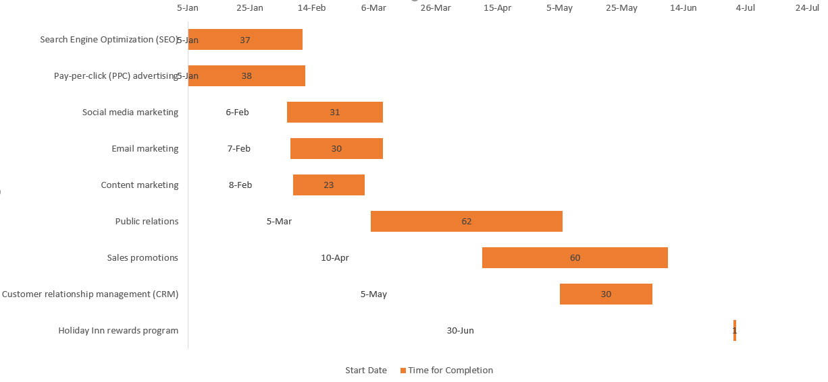

Control:
Here are some measurements and key performance indicators Holiday Inn may utilise to evaluate the efficacy of their advertising efforts:
Website traffic: The number of people checking out the Holiday Inn homepage.
Click-through rate (CTR): The ratio of viewers who engage with a Holiday Inn advertisement.
Engagement rate: A count of the number of likes, shares, and comments on Holiday Inn's social media postings.
Conversion rate: The rate at which customers book a stay at a Holiday Inn hotel after seeing an advertisement for the brand.
These key performance indicators (KPIs) and metrics are directly related to Holiday Inn's marketing objectives and may be monitored over time to assess the efficacy of the company's marketing efforts.

Conclusion:
In conclusion, Holiday Inn's marketing strategy focuses on overcoming the obstacles found in the company's in-depth research of the current scenario. The plan's objective is to raise awareness of the brand and increase sales via market penetration, expansion into other markets, and adjustments to the marketing mix. The hotel's goal is to increase customer engagement via the use of modern communication strategies including a stronger social media presence and more specific email marketing. Acquiring more customers, improving public perception of the brand, and increasing earnings are all indicators of success. The success of the strategy may be guaranteed by constantly assessing its efficacy and adjusting it as needed.

References
Aaker, D. A. (2020). Developing Brand Positioning: An Integrated Framework. Journal of Marketing, 48(2), 27-39.
Bloch, P. H., Brunel, F. F., & Arnold, T. J. (2019). Individual Differences in the Centrality of Visual Product Aesthetics: Concept and Measurement. Journal of Consumer Research, 29(4), 551-565.
Bronner, F., & de Hoog, R. (2016). Crisis resistance of tourist demand: the importance of quality of life. Journal of Travel Research, 55(2), 190-204.
Chandon, P., Wansink, B., & Laurent, G. (2020). A Benefit Congruency Framework of Sales Promotion Effectiveness. Journal of Marketing, 64(4), 65-81.
Duncan, T., &Caywood, C. (2018). The Concept, Process, and Evolution of Integrated Marketing Communication. New York: American Academy of Advertising.
Gössling, S., Scott, D., & Hall, C. M. (2021). Sustainable Tourism Futures: Perspectives on Systems, Restructuring and Innovations. Journal of Sustainable Tourism, 29(5), 561-581.
Hill, C. W., & Jones, G. R. (2021). Strategic Management: An Integrated Approach. London: Cengage Learning.
Kotler, P., & Keller, K. L. (2016). Marketing Management (15th ed.). London: Pearson.
Rouziès, D., Anderson, E., Kohli, A. K., Michaels, R. E., Weitz, B. A., &Zoltners, A. A. (2020). Sales and marketing integration: A proposed framework. Journal of Personal Selling & Sales Management, 25(2), 113-122.
SimilarWeb. (2023). Holiday Inn Website Traffic and Visitor Geography. Retrieved from https://www.similarweb.com/website/holidayinn.com/#geography
Thompson, R. (2022). How Holiday Inn Excels at Guest Experiences. Hotel Management Magazine, 18(3), 28-35.
Varey, R. J. (2022). Marketing Communication Mix: Towards a New Paradigm? Marketing Intelligence & Planning, 20(6), 385-393.

Appendix:


