White Glove
Home Services



Table of Contents
Table of Contents 2
Executive Summary 3
Business Overview 4
Markets and Competition 5
Target Markets 5
Competition 5
Sales and Marketing 9
Product Positioning 9
Marketing 9
Sales 9
Management 11
Key Personnel 11
Advisors and support services 11
Operations 12
Premises and Equipment 12
Employees 14
Suppliers 14
Financial Forecast 15
Sales 15
Cashflow 15
Profitability 15
Financing 16
References…………………………………………………………………………………………..17
Appendix 1: Business Insurance……………………………………………………………………20
Appendix 2: Vehicle Insurance……………………………………………………………………..21
Appendix 3: Basic Mortgage Calculator……………………………………………………………22
Appendix 4: Basic Steeple Analysis………………………………………………………………..23
Appendix 5: SWOT Analysis………………………………………………………………………25
Appendix 6: Sales Projections………………………………………………………………………26
Executive Summary

White Glove Home Services is a company focusing on end of tenancy cleaning. In the future it will also offer services such as emergency carpet cleaning, housekeeping services for second homes, and project management for building refurbishment works.

Our target markets will be large tenancy management organisations/property letting agents. And Private Second Homeowners looking for peace of mind that their property will be in a fit state for new tenants, or for tenants wanting to leave a property in a fit and proper state to get back deposits.

I will initially seek out the larger Property Letting Agents as they have the most potential for multiple property contracts. These will be done face to face so as to gain an understanding of what these companies require. I will then expand into a website and advertise through trade organisations if required.

Sales will be done initially face to face again. This is so as to understand what is required from each job and give a fair quote to the customer. Once the establishment of a working relationship has been made between myself and a letting agent, I will allow them to tell me what is required from each property.
Key Personnel will initially be me, as a sole trader. I have limited experiencing in the private sector, so will require the assistance of a bookkeeper, accountant, and a solicitor to help draw up contracts or to assist in making a template for them.
My financing plan is to remortgage my house to free up equity to give a large lump sum of cash as a reserve and to get the business off the ground. I have set out 3 scenarios titled Optimistic, Pessimistic, and most Likely in regard to sales and therefore cash flow. Optimistically I could have a net income of £49884.10 and pessimistically £3944.10. This is only taking into consideration End of Tenancy cleans and not the other services I may offer in the future. If sales edge towards pessimistic figures, I may expand the services early in order to boost revenue. If they head towards optimistic then I will consider taking on more staff to assist me.

Business Overview
White Glove Home Services is a one stop shop for services related to operating a second home. The idea for the business came from seeing colleagues in military housing having to pay for cleaning contracts which were carried out to a substandard quality leading subsequent tenants in Military Accommodation having allergic reactions or suffering from mould related health issues.

Initially as the business is setup the main target area is to focus on end of tenancy cleaning, and emergency carpet cleaning. This is where I feel the most income can be generated in order to broaden the companies scope of works.
Later on, a housekeeping service for owners of second homes will be provided. Focused on their needs this could be a complete clean after each guest or stay, a key keeping service in case guests lose their key, a property checking service for when the property is unoccupied, and the owner wants peace of mind in case of flood, fire, or general security.

Finally, after qualifications have been gotten in project management, I will offer a refurbishment service for these second homes. This may be a respectively small project such as an extension or a re-fit of a kitchen, or it may be a full refurbishment of a property in order to bring it into a decent specification on energy and style requirements for the 21st century.

Threats:

- No Property for the business: As the home I own is further North than my target area to operate the business I will have no address with which to operate from. To counter this, I will use a friends address for correspondence initially, I could also make use of their garage in which to keep stock of cleaning products.
- Vehicle Breakdown: Because the vehicle I use will be critical to operating the business any kind of breakdown will equate to no income being received. Because of this, I will want to operate a brand-new vehicle to have peace of mind of reliability. With a warranty also in place, any repairs will or should be free, minus consumables (brake pads, lights etc)
- Being undercut on price by larger companies: I may not be able to compete with larger companies on price and will have a minimum price in mind for each job. With that being said, they will have to raise their quality of service in order to compete with me.
- Illness to Myself: As with the vehicle this is a critical threat to the business as initially I will the sole worker. Eventually, if the business is capable of supporting an employee, then I will take one on board. If not, I will have to consider friends or family to support in case of a short illness. A medium-term illness will mean relying on the companies capital to get through, and a long-term illness may mean winding up.

Weaknesses:

- Limited Staff: Slightly different to the illness threat to myself previously identified, but being a sole trader means a maximum number of jobs or works I can take on. If bookings take off, then I will consider hiring an employee in order to assist.
- Large Distances between jobs: Travelling time between various jobs will mean less time carrying out work and so less time making money. The initial aim is to get a contract with a housing association in order to minimise travelling time and focus on a specific area. In the future, I will be able to manage jobs in order to come up with a logical solution to travelling.
- I am an unknown quantity in the market: I have little to no penetration into the market. In order to gain traction initially, I will use advertising to raise awareness, and keep prices low in order to build a client base.
- Lack of Capital: I will have to raise funds in order to keep the business from going into to much debt. I have a decent amount of equity in my home in Worcestershire, so my initial plan is to re-mortgage to free up cash. Once I’ve identified good suppliers of products I will use, I will apply for store credit if possible.
- Lack of Experience in the Private Sector: Most of my adult working life has been in the Public Sector and working for the MOD where all tax and book-keeping is done for us. I will have to employ an accountant and bookkeeper in order to ensure I am paying what I should for the services rendered. This is another cost, but one I feel is critical, as they will have the experience to tell me what I can claim back for tax purposes. With a better understanding and more experience in the 2nd or 3rd year, I may be able to go it alone to reduce this cost.

Markets and Competition
Target Markets:
Property Letting Agents:
These companies will be extremely useful in gathering large bases of homes/properties. They may operate by managing a large portfolio for a single customer, be it an organisation or individual and this may provide me with a solid base from which to work on.
Private Second Homeowners:
These people will probably be professionals and not have the time to invest in their 2nd homes and may need some assistance in getting it ready for future tenants or in-between holiday lets. My initial thoughts are London based people whose second homes are outside the commuting belt. They may visit during school holidays in order to escape the city but may let the property out in between to other people taking holidays. Again, the “golden customer” would be a private person who has a portfolio of properties in a small area. This would allow me a massive reduction in travel time between jobs. It would also give the properties owner peace of mind that all of their assets were properly being looked after.

Competition:
There is a plethora of end of tenancy companies available, and below is a selection of what I can find. The top competition would be the Penny Pot Cleaning Services, as they appear to have a similar business plan to what I am presenting, along with a similar amount of experience. Some of the language appears out of date though (Carillion Amey is now just Amey).
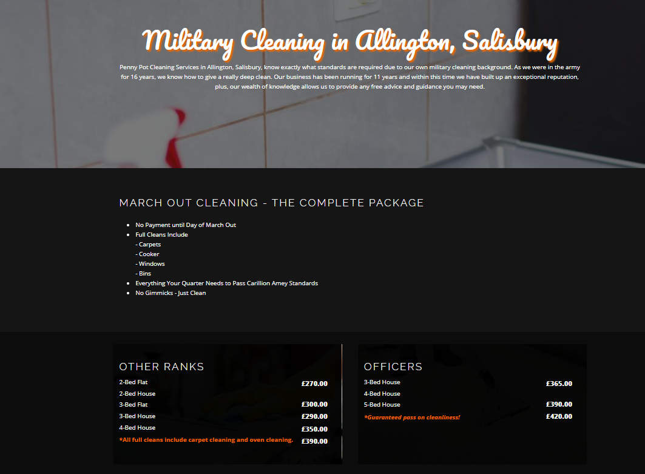
This company is my direct competition. To vary myself from them, I will not charge a different amount for officers. The houses are the same, it is just MOD policy to charge more from Officers and so a way to make a quick buck.

Andrea Cleaning Services:
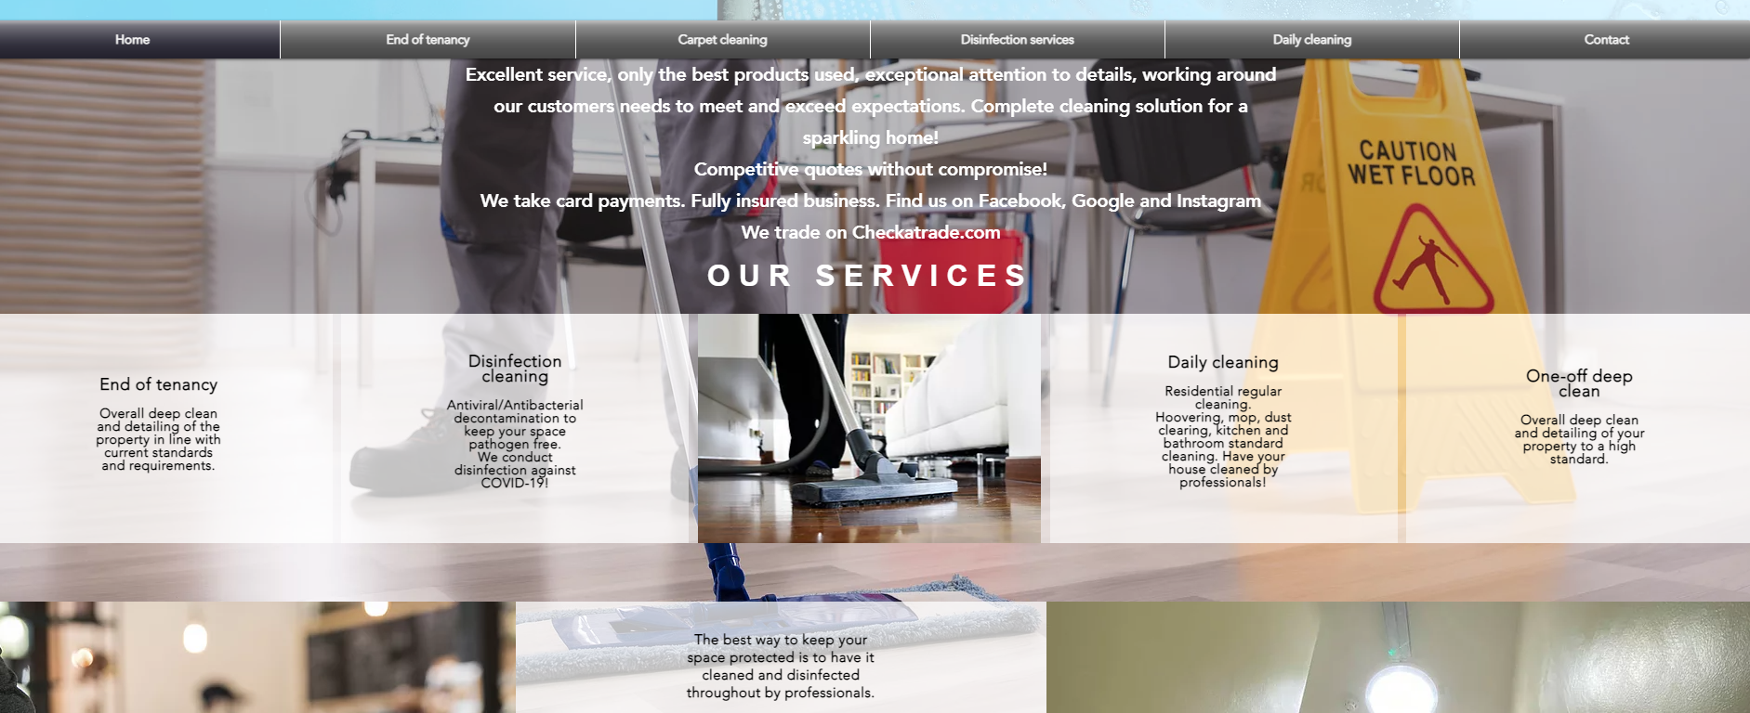
For me, not a very well-presented website. The prices look extremely competitive, but then carpet and oven cleaning are prices on top. My price structure would immediately undercut this, and I think my standards would be higher.
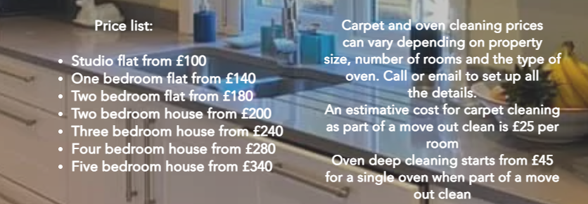

Total Clean Solutions: Website looks acceptable, although there is no prices on there, and there are no reviews in the section.

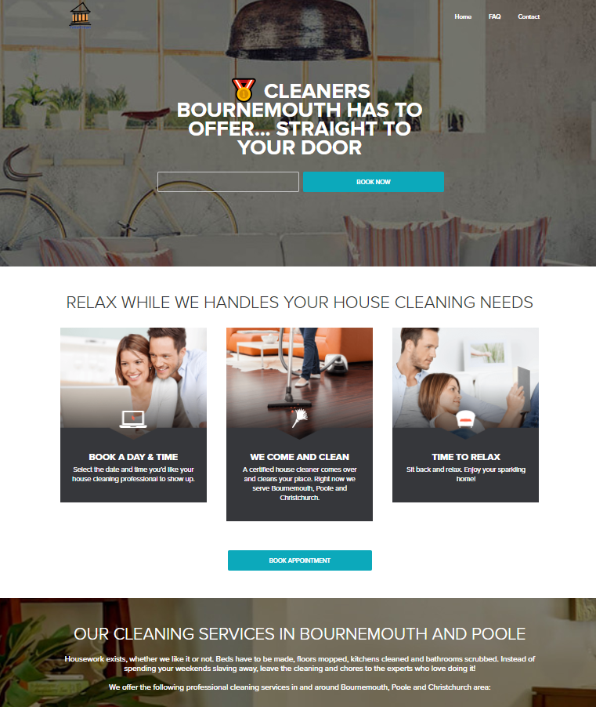
Sales and Marketing

Product Positioning

Checkatrade estimate that end of tenancy cleaning on average in the UK is between £250 for a 2-bed apartment, and £370 for a 4 or 5 bed house. I have estimated that the cost for products used during a clean is approximately £50 there is a large profit margin that I can scrape off in order to gain market penetration. As I would not want to reduce my prices to much but still be competitive, I think dropping my prices to £200 for a 2-bed apartment, and £310 for a 4/5-bedroom house would be acceptable.
For a customer with a large portfolio of properties, I’d consider reducing this price again in order whip up repeat custom, but I’d be cautious of devaluing the price to far in case they thought the product was inferior.
A common trend in the market is for guarantee’s or certificates to be given so that if a landlord is unhappy then the cleaner company would rectify anything they were dissatisfied with. I would also offer this.
I would offer the expected military standard when it comes to the cleaning. A high attention to detail is what I would like to be known for.

Marketing

My initial marketing strategy will be direct face to face meetings with my target audience where possible. If required I am open to creating a website, and through this advertising online via various trade sites (Checkatrade etc).
Marketing 5 P’s for the company

Product: End of tenancy cleaning, emergency carpet cleaning

Price: Market Penetration strategy, so below average price, rising through time once a foothold has been gained

Promotion: Free advertising with the van. I will offer discounts when I am recommended or with a good review.

Place: Predominantly Southwest England, focusing on Wiltshire to the Jurassic Coast

People: Initially I am the only employee. Smart turnout, freshly shaven. Customer facing with them at the centre of whatever is needed. Military experience has given taught me to enjoy cleaning to a very high standard.

Sales

To actively sell, I will have to attend each job to give a quote and understand the need of each customer. Longer term, if there is an organisation that runs multiple properties, they could give an estimate of works required for me, provided we can strike up a decent working relationship. I’d be disappointed to get to what I thought was a 2-bed house and find out it’s a 4 bedroom and has been not kept to a decent standard. I would like to use IT to help me draw up contracts and estimates either from the vehicle, or from the occupants property. This would be dependent on internet/mobile signal access.

Management

Key Personnel

I am the key personnel; I will operate initially as a one-man operation. Depending on how the business performs, I may take on an employee, or even make them a partner in order to share some of the liability. I would like them to be ex-forces as they have the same values and standards, and so hopefully the same work ethic as I do.

Advisors and support services

I have previously only worked in the public sector, so I feel I will need as much help as possible in the early years of operating the business before I fully understand the nuances of the private sector. To that end, I will have to employ:
Accountant & Bookkeeper in order to make sure that I am paying the correct amount of tax, so I’m not stung with a huge bill at the end of the tax year. I am aware there are apps that can assist with bookkeeping, but because of my inexperience, I would like to outsource this for the initial year so as to give me time to get a better understanding of how these processes work.
I would ideally see the accountant quarterly, or before expanding (assets or employees). This also includes at the start of the business, so before I purchase any stock or equipment, I would speak to the accountant to ensure I am paying the correct amount. “What is tax deductible”.
Because my initial aim is to go straight for large portfolio holders, I will need to have contracts drawn up. My best option for this is having a suitable solicitor who can help with the drawing up of contracts. Longer term, once I have experience again, I will feel more comfortable in drawing up my own contracts, but initially, I think it best to get help to ensure both parties are content with whatever work will be carried out.

Operations

Premises: Initially on setup the premises will be located from a friends house so that supplies can be delivered and stored there. Later on, if required, I will look at renting a lock up or self-storage area. This will need to be compliant with Health & Safety requirements because of the cleaning products that will be stored there. Storage cabinets for these chemicals will also require investment initially.
A rented storage container will provide an element of security for any equipment or supplies put in there, however it will need to have 24hour access in case I am required to attend an emergency appointment or have an early start in a distant location. An 80 square foot container located closest to where I am currently located will cost £90 per month.

Equipment: Initial outlay to purchase everything needed will be heavy. As identified in the threats section of the business overlay, my main concern will be breakdown of the company vehicle. This means that purchase of a brand-new vehicle to mitigate this risk is my biggest financial liability.

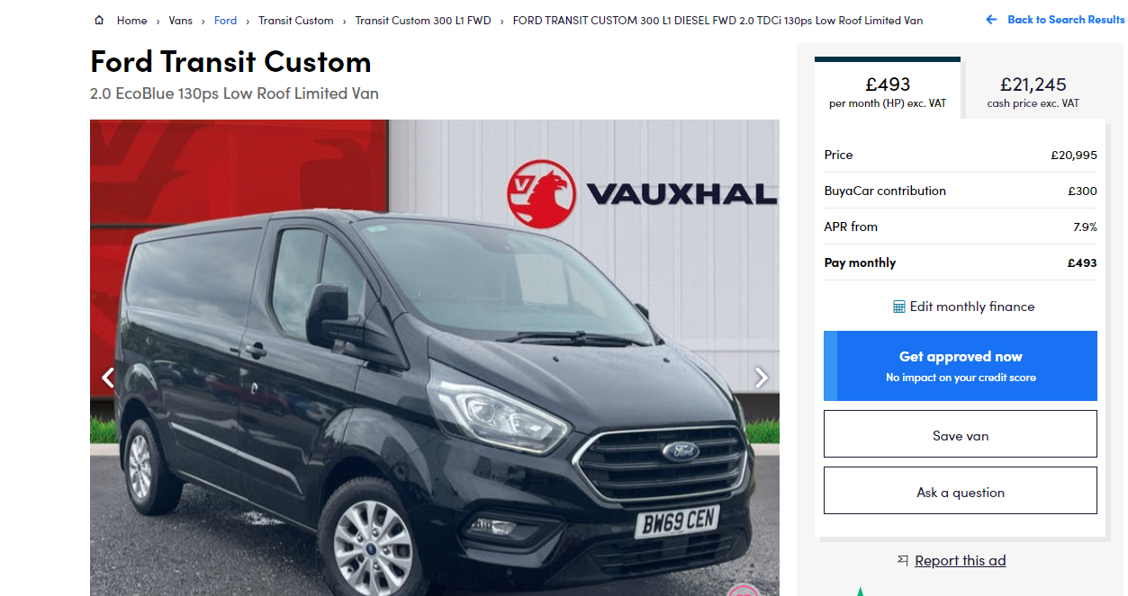

An example of the van I’d select. Well priced, low mileage, relatively new so still under warranty.
Vehicle Excise Duty (VED) for the vehicle would be the flat rate of £275 per year as per the Gov.uk website. As I would not be using it for personal mileage, I would not have to pay additional charges using a P11d Return.
Insurance for the year on this vehicle is £495.44
I will allow my Accountant to calculate what I need to pay for mileage but will keep up to date records of mileage. I will not be using the vehicle for personal journeys to keep the liability down as low as possible.
Monthly cost for the vehicle (Finance, Tax and Insurance) £557.19 This is not including fuel, which would be approximately £100 to fill, and would last 750 miles if I were to drive conservatively. I estimate £150 per month, but this could fluctuate.
Cleaning materials I estimate to cost £50 per property cleaned. This is made up of the costs of 2 X Oven pride packs, Cloths, Cleaning Fluids, Gloves, Masks, Overshoes, Scouring Pads and other things needed to deep clean a property.
Also required will be a Carpet Cleaning Steam kit. The initial outlay is over £2000, but this is what Id expect somebody to turn up with in order to deep clean my carpets and not a cheap Vax Carpet Cleaner. The Chemicals could also be hazardous, so I will purchase 2 COSHH Lockers. 1 for the van and 1 for the storage area be it the garage or the lockup. Another £504
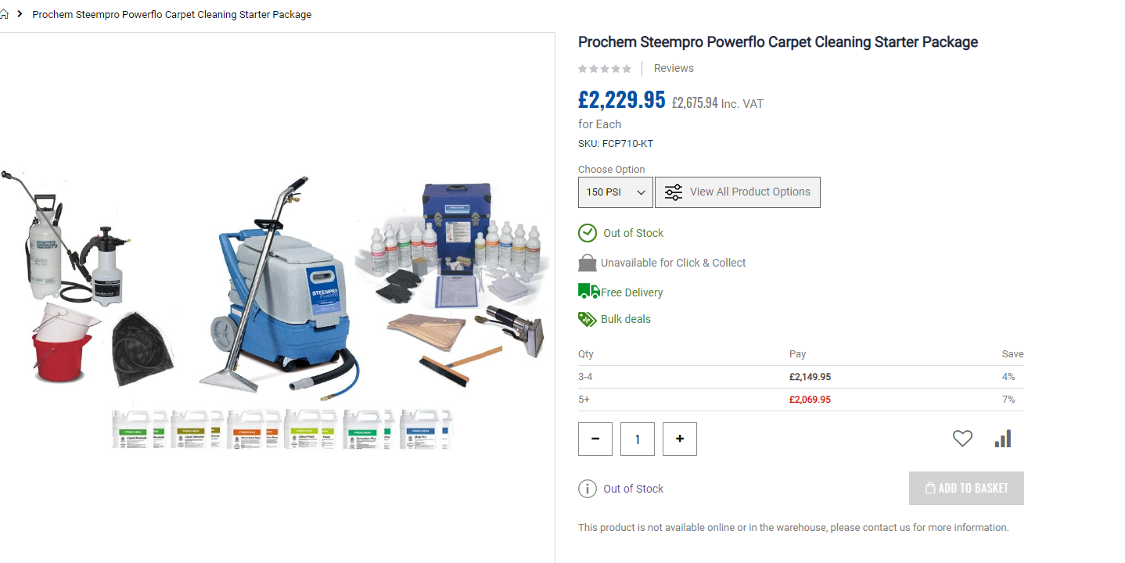

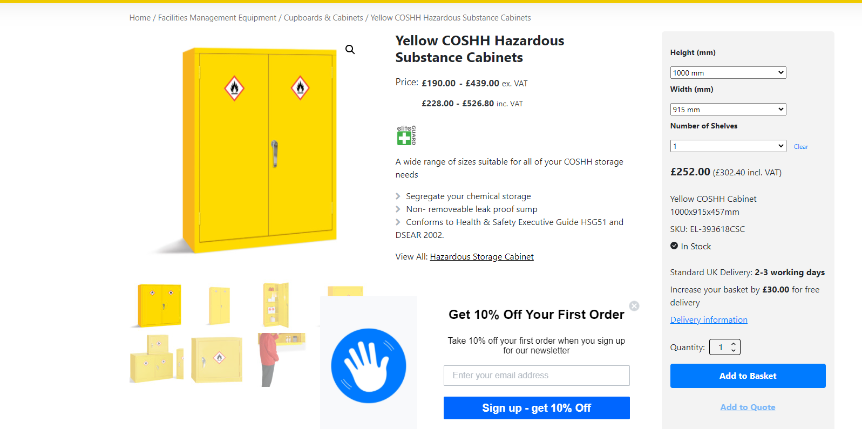

Employees:

Initially I will be a one-person operation, this keeps my risks low as it means I do not have to support another wage if times are lean. I am open to employing another person though, and if possible, I would like them to be ex forces as they should in theory understand the standards I would be striving to achieve. There would be minimal training required on specialist equipment, as the only piece I can think of is Steam Carpet Cleaner. Depending on the profitability of the company when taking on another person, I would look at doubling what I already have in place, like a second vehicle, another carpet cleaner allowing the potential employee to operate independently of me.
Being ex forces, they would already have had training with hazardous materials and how to store them and what to do in the event of a spill. Health and Safety should in theory be second nature to them in regard to the wearing of PPE, although this will be reinforced so as to avoid injury.

Suppliers: My initial supplier will be UK Cleaning Supplies. They offer delivery, which is also free on orders over £75, so I would probably buy in bulk as opposed to ordering bits and bobs to reduce delivery costs. The company offer business customers credit accounts,

Financial Forecast

This is the hardest part of the business plan as I am not already trading, and so my figures are based on assumptions and expectations. To keep the maths as simple as possible, I have chosen that each property worked on will be a 2-bed flat. Clearly if the opportunity to work on a bigger property arises then will mean more in the way of sales. The modelling does not consider seasonal changes, I could estimate that there may be a greater prevalence of house moves around school holidays especially around the summer as this is when people naturally take time off.

Tables for the 3 below Estimates are in the appendices.

Optimistic: I think I could get 2 houses deep cleaned per day, 5 hours per house with an hour of travelling in between. If I take the weekends off to recover that leaves me with about 20 working days a month. Meaning 40 jobs. Net Income £49844.10

Pessimistic: I have estimated that with disappointing sales, I could expect to deep clean a house once every 3 days, meaning a total of 10 properties cleaned. Net Income £3944.10
Most Likely: Realistically, I think 1 property a day, with a few days off per month is achievable. I have estimated this to be 25 properties per month. Net Income £26894.10

Cashflow: Because of the way I want to start the business, I will have a lot of cash ready and available initially to pay contractors. If sales take off and it slides towards the more Optimistic end of the scale, I will consider taking on another member of staff as I think that completing 40 properties per month is not achievable medium to long term. I think payment times will differ depending on which kind of customer I get. I large multi-property company/landlord I think I can afford to give time to pay provided I invoice correctly. If it was a private tenant and so a one-off customer, I would ask to be paid up front considering I will guarantee the clean is up to the landlords standard.
Profitability:
Even with a pessimistic estimate, I expect the company to be profitable, although this would also mean not drawing a wage. The second year would be free of start up costs, and I’d have a better understanding of how to bookkeep meaning less overheads. I’d also expect the 2nd year to have more sales.

Financing

Financing for the business is my hardest decision, and yet after understanding how comfortable I am exposing myself to risk I have decided that I would re-mortgage my house freeing up equity. I currently have approximately £150,000 in equity and would free up £50,000 of this to get the business off the ground. Start up costs would be my initial concern, and the biggest cost of that that I have identified is the purchase of a vehicle. If I were to buy it outright, it would immediately take half of my initial finance, so the best option I think is to have it on a lease. This would produce a monthly bill, but if the business has enough capital, then its minimal risk. I could then purchase all of the stock and equipment necessary to get the business off the ground outright.

Because the vehicle will be leased, or on finance, then the initial start up costs I estimate to be £3500. Broken down, this would be £2229.95 for the Carpet Cleaning equipment, £504 for the 2 COSHH cabinets, with the remaining budget purchasing stocks of cleaning fluids.
My monthly overheads would be in the region of £826. This includes the money for insurances, road tax, advertising, and storage container rent if required.

After start-up costs have been taken out of this initial lump sum injection, then that would leave me with £46500. This would mean that even if I did not bring a single penny of revenue in, I would still be able to pay the overheads for at least 2 years. I estimate my annual overheads initially to be nearly £10,000 per annum.
This realistically gives me a good amount of time to build a solid client base, and to understand what works, and what does not with the business model.

aa

References:
Company Logo:
Justice, A. (2013). Do You Have White Glove Status? | Social Media Sun. [online] Socialmediasun.com. Available at: http://socialmediasun.com/white-glove-accounts/ [Accessed 5 Jul. 2021].
Wiltshire Intelligence. (2021). Housing Wiltshire Intelligence. [online] Available at: https://www.wiltshireintelligence.org.uk/key-issues/housing/ [Accessed 9 Jul. 2021].
Infoentrepreneurs.org. (2021). Understand your competitors. [online] Available at: https://www.infoentrepreneurs.org/en/guides/understand-your-competitors/ [Accessed 20 Jun. 2021].
Checkatrade. (2021). End of Tenancy Cleaning Prices in 2021 | Checkatrade. [online] Available at: https://www.checkatrade.com/blog/cost-guides/end-of-tenancy-cleaning-prices/ [Accessed 13 Jul. 2021].
Corporate Finance Institute (2020). 5 P’s of Marketing. [online] Corporate Finance Institute. Available at: https://corporatefinanceinstitute.com/resources/knowledge/other/5-ps-marketing/ [Accessed 14 Jul. 2021].
Competition:
Pennypotcleaningservices.co.uk. (2021). Penny Pot Cleaning Services. [online] Available at: https://www.pennypotcleaningservices.co.uk/military-and-end-of-tenancy-cleans-salisbury [Accessed 10 Jul. 2021].
Andreea Cleaning Ser. (2015). End of tenancy | Andreea Cleaning Service | Salisbury. [online] Available at: https://www.andreeacleaningservice.co.uk/deep-clean [Accessed 10 Jul. 2021].
‌Totalclean-solutions.com. (2020). Cleaners Bournemouth | House Cleaning Bournemouth | TotalClean Solutions. [online] Available at: https://totalclean-solutions.com/ [Accessed 10 Jul. 2021].
‌

‌

‌

Equipment:
Vehicle:Government Digital Service (2011). Vehicle tax rates. [online] GOV.UK. Available at: https://www.gov.uk/vehicle-tax-rate-tables/other-vehicle-tax-rates [Accessed 10 Jul. 2021].
ISO Container: Portable Space. (2021). 10ft x 8ft Steel Storage Container for Hire. [online] Available at: https://www.portablespace.co.uk/product/10ft-x-8ft-steel-store [Accessed 20 Jun. 2021].
COSHH Lockers: Safe Industrial. (2020). Yellow COSHH Hazardous Substance Cabinets. [online] Available at: https://safeindustrial.co.uk/product/yellow-coshh-hazardous-substance-cabinets/ [Accessed 12 Jul. 2021].
‌
Finance:
MoneySavingExpert.com (2021). Mortgage Calculator UK: Repayment & interest only mortgages - MSE. [online] MoneySavingExpert.com. Available at: https://www.moneysavingexpert.com/mortgages/mortgage-rate-calculator/ [Accessed 13 Jul. 2021].

Business Insurance (Including Personal Cover)
Simplybusiness.co.uk. (2021). Your quotes - Business Insurance. [online] Available at: https://moneysupermarket.quote.simplybusiness.co.uk/q/business/new_business/quote_comparison/60e4435442ec3e0111c29b82 [Accessed 6 Jul. 2021].

Appendix 1:
Business Insurance
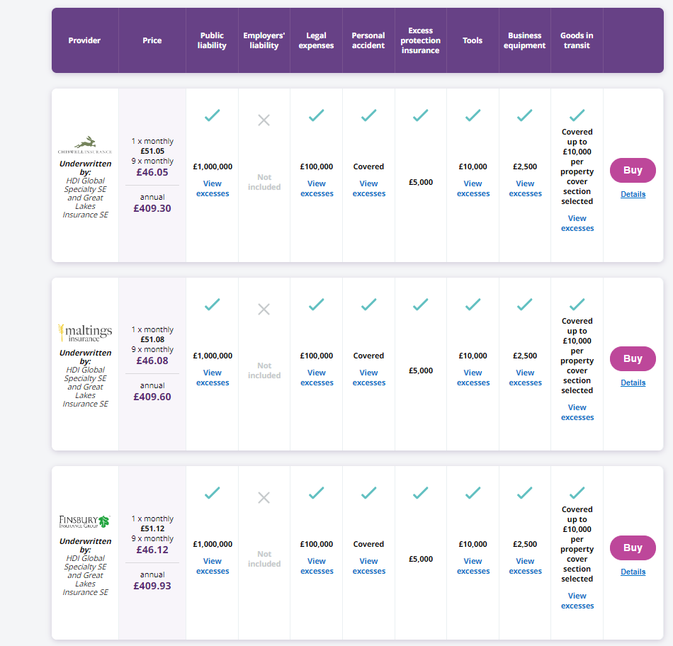

I would select the top quote of £409.30 as all the policies have the amount of cover. This quote is for having no employee liability.

Appendix 2: Vehicle Insurance
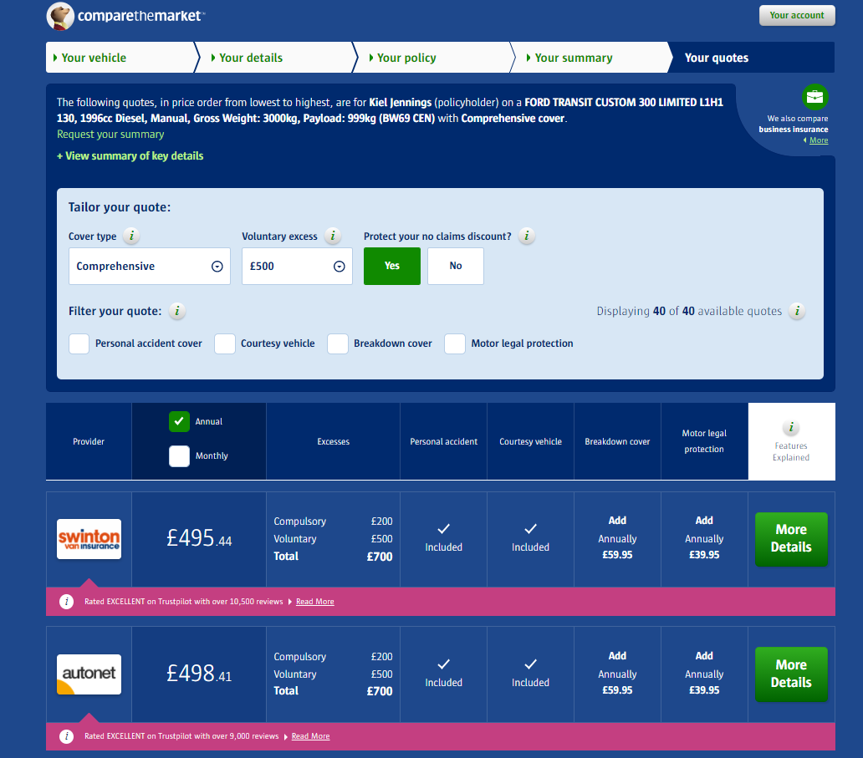
Cheapest results for Business Vehicle insurance, this was a quote from an online insurance supermarket, and aimed at the type of vehicle I want, along with my details. I would take the tope quote of £495.44. This is subject to change depending on the vehicle I would actually buy.

Appendix 3: Mortgage Calculator
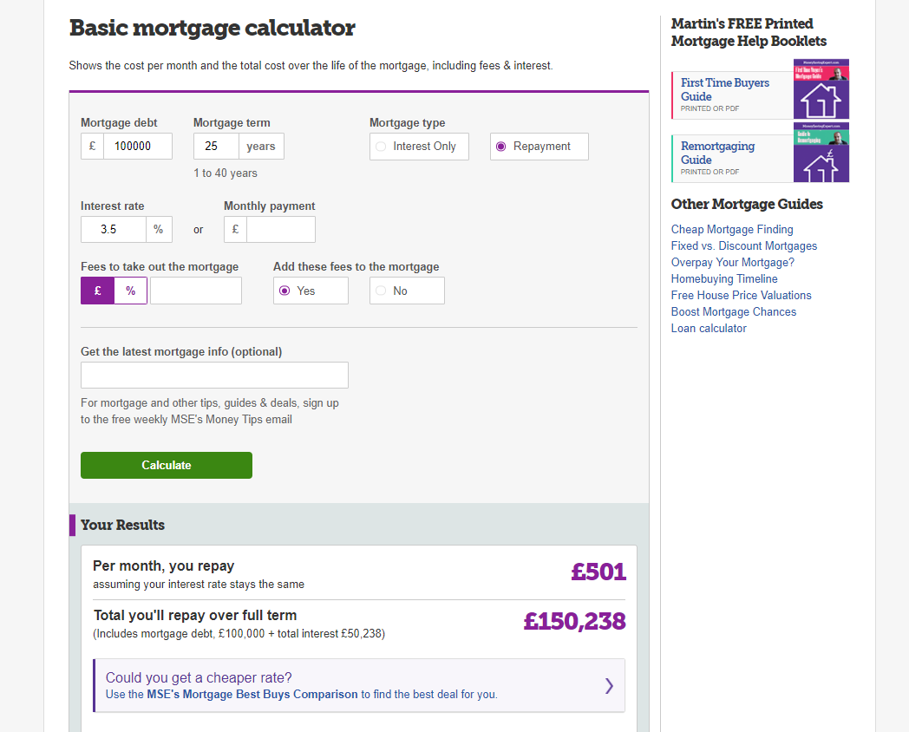

As my intention is to re-mortgage in order to free up cash and give me reserves, I though it prudent to show what Id expect to pay for the mortgage. I am 99% certain that I cannot claim a mortgage as a business expense. If I had to wind the company up for whatever reason, then a mortgage of £501 is perfectly acceptable to me and is a risk Id be comfortable taking as opposed to another funding solution.

Appendix 4: Basic Steeple Analysis:

Reliant Property Management will offer services to the owners of second homes in the Southwest of England. Initially as a one-man band operation it will provide re-assurance and services to 2nd homeowners when they cannot get to their properties. Initially, this will include checks on security, restocking supplies before the owners arrive, and basic maintenance tasks, but will expand in time to accommodate project management in renovation and expansion works to give peace of mind.
Social: The cultural make up of Great Britain means that there will be many different people who will have a 2nd home and understanding their needs and requirements should be a priority in order to provide the best service.

Technological: The use of all technology available is to be used. The company is to remain adaptive to new technologies and ideas. Social media remains one of the cheapest means of advertising and allows the business to specifically target the clients I want to attract. Communication tools such as Zoom, and Microsoft teams should also be used to communicate with clients and will save travelling time.

Economic: An economic downturn could disrupt the housing market meaning areas with high rates of 2nd home ownership may suddenly have lots of properties for sale. This would have a significant impact on the business. It may prove diligent to move into rental management also in order to diversify the business.

Environmental: Travelling from property to property will require a vehicle. This may mean emissions may rise and the company should consider using an EV if enough properties can be recruited in a small enough area.
One of the companies services will be to reduce electricity and gas emissions for homeowners by having these services properly maintained, this will also reduce the emissions that they will create in making unnecessary journeys.

Political: Media attention to 2nd home ownership has meant that tax breaks for 2nd homeowners have been reduced. Under a potential Labour government more taxes aimed at richer members of society may create a hostile environment for them.
Legal: To mitigate against financial and legal liabilities the company should take advice as to what kind of business model they want to operate under. My gut feeling is to be a limited company in order to protect my assets in case of major setbacks.

Ethical: In Cornwall local residents are finding it hard to find a property to live in because of the amount of 2nd homes being purchased for people from outside of the area. This is leading to homelessness and commuting larger distances to gain work which is also seasonal.

Appendix 5: SWOT Analysis

Strengths:  - Making use of technology to communicate to clients.  - 1-1 time with the client.  - Standards are high compared to a “it’ll do attitude”  - Quick decision making | Weaknesses:  - Limited Staff: 1 man operation initially  - Large distances in between jobs equals less time carrying out work.  - Unknown quantity in the market (little market penetration)  - Lack of Capital- Start up will come from re-mortgaging of house or loans.  - Lack of experience in the private sector i.e. book-keeping, paying taxes etc.
Opportunities:  - Customer Loyalty: Providing a good service may result in return custom.  - Word of mouth may create growth in clients.  - Using out of work ex-military personnel- they already hold the same values.  - Education development- Project management qualifications. | Threats:  - Worker shortage on the job market.  - No property for business (Vehicle Based).  - Vehicle Breakdown.  - Interest Rates increase equals higher outgoings.  - Possibly being undercut by larger companies who can take the financial hit.  - Illness to myself- Critical if work is missed and nobody available to cover planned work.

Appendix 6: Sales Predictions. Optimistic, Pessimistic, Most Likely
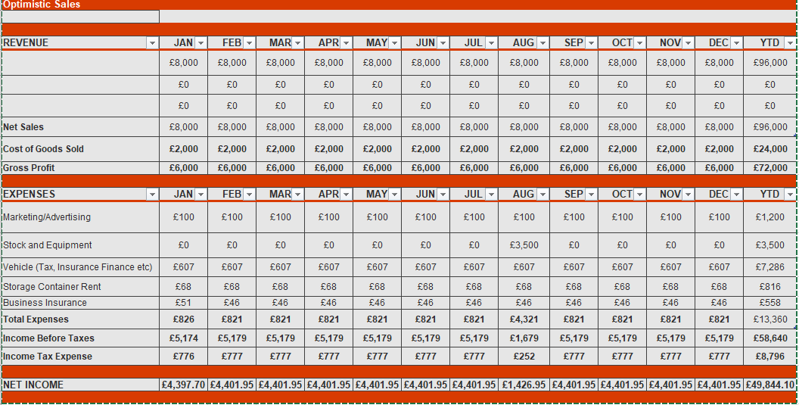
Optimistic Sales estimation:
40 houses cleaned, all 2 bed sized @ £200= £8000 in Net Sales, £2000 in products used (£50 per house) =£2000. This means Gross Profit of £6000 per month = £72000 per annum.
Minus all the overheads, and tax I have an optimistic figure of £49844.10 Net Income.

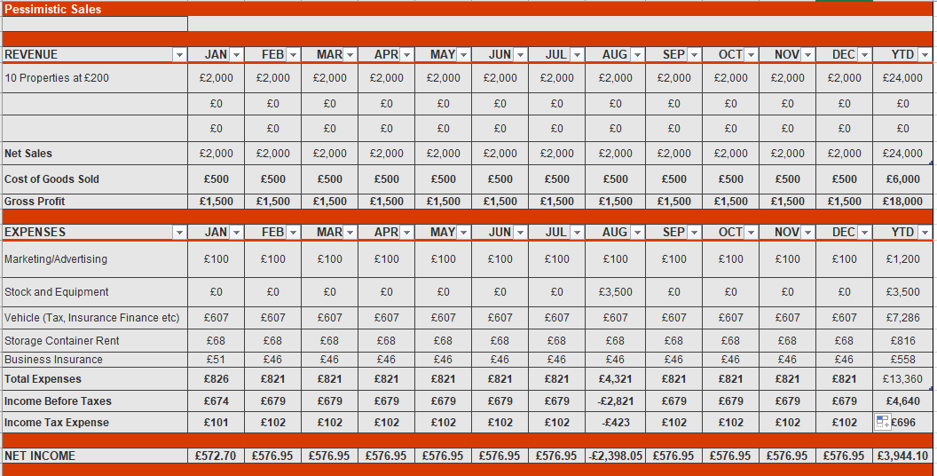
Pessimistic Sales
10 Houses cleaned (1 every 3 days) again all 2-bed sized @ £200= £2000 Net Sales. £500 in products used, Gross Profit of £1500 per month= £18000 per annum.
Gross Profit – Overheads = £3944.10

Most Likely Sales:
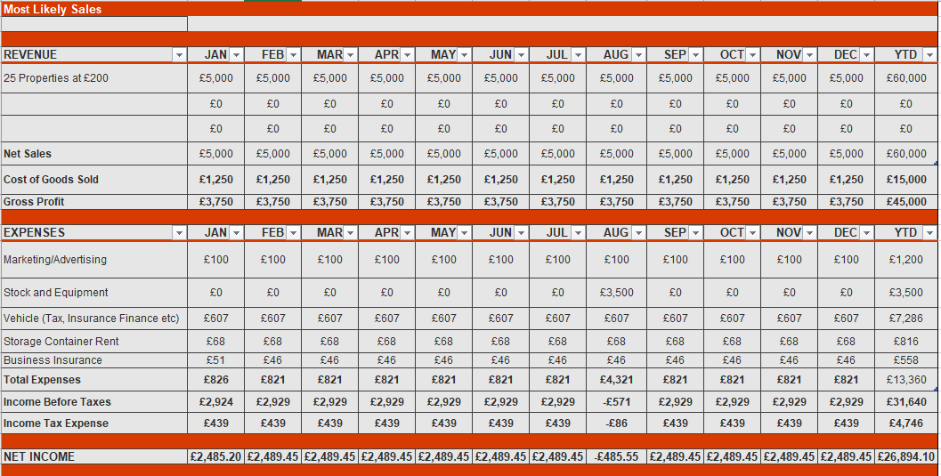
For Most likely sales, I have gone for 25 properties per month. Gross Profit of £3750 per month.
Minus overheads gives me a net income of £2485.20 per month. And so £26894.10 per annum.

