
Master of Business
Administration

Lidl Expansion Strategy Brazil Market
Student Name: Pragati vaghela Nileshbhai
Student ID: 2417656
Professor Name : Amare Desta
Course Name: Strategic Management
22 December 2025

Executive Summary
This report includes a strategic expansion plan of Lidl in Brazilian retail market and analyzes external as well as internal factors with a plan of a consistent market entry strategy. Lidl is a major global discount retailer and the part of the Schwarz Group that managed to operate more than 12,000 stores in 30 countries by following the model of cost-leadership and using its own-label business. Its efficiency based activities, centralized procurement and sound financial support give it the scope of easily expanding internationally.
The target market has been chosen as Brazil because of its massive population of over 200 million, very urbanised, and increasing retailing needs of an organised nature. A fragmented grocery industry and price sensitive customers give Lidl a chance of spreading its competitive footprints with its hard-discount model. Lidl is not present in South America; hence, Brazil is a new and strategically important market, which can be considered to investigate the possibilities of internationalisation into emerging markets.
PESTLE, Porters five forces, and VRIO frameworks were used to conduct an extensive strategic analysis. The macro-environmental analysis also indicated that political stability, complexities in regulations, and economic volatility were key issues. The industry analysis revealed that the competitive rivalry is high, threats posed by new entrants and suppliers are moderate, and buyers power are high. This was established through external analysis that Lidl has valuable, rare, and inimitable resources, including operational efficiency, supply chain capabilities, and expertise in own-label, which can be used to sustain its competitive advantage.
The suggested market entry concept is to develop wholly-owned subsidiaries of the major urban areas and implement the cost-leadership model created by Lidl with its own-label dominance. Supply chain risks, economic risks and regulatory risks are mitigated by means of localisation, a gradual investment, and active risk management. Ethical sourcing and environmental sustainability are other types of corporate social responsibility, which contribute to strategic legitimacy.
A Balanced Scorecard will be utilized to measure performance, through the combination of financial, customer, internal process, and learning and growth measures. With the help of this framework, Lidl can ensure the constant improvement and sustainable expansion into Brazil since it allows the company to track efficiency of its operations in the short run and the strategic success in the long one.

Table of Contents
1. Introduction 6
1.1 Background of the Study 6
1.2 Company Overview: Lidl 6
1.3 Purpose, Scope, and Structure of the Report 7
2. Selection of Organisation and Target Market 7
2.1 Rationale for Selecting Lidl 7
2.2 Rationale for Selecting Brazil as Target Market 8
2.3 Strategic Fit Between Lidl and the Brazilian Market 10
3. Strategic Environment Analysis 10
3.1 Macro-Environmental Analysis: PESTLE Framework 10
3.2 Industry Analysis: Porter’s Five Forces 14
3.3 Internal Analysis: VRIO Framework 17
3.4 Critical Evaluation of Strategic Tools Used 19
4. Strategy Development and Market Entry Proposal 20
4.1 Strategic Objectives for Lidl’s Expansion into Brazil 20
4.2 Market Entry Strategy 21
4.3 Risk Assessment and Mitigation Strategies 23
4.4 Corporate Social Responsibility and Sustainability Considerations 25
5. Performance Evaluation Framework 26
5.1 Selection of Performance Measurement Framework 26
5.2 Balanced Scorecard Dimensions and KPIs 27
5.3 Monitoring and Review Mechanisms 28
6. Conclusion and Recommendations 28
6.1 Summary of Key Findings 28
6.2 Strategic Recommendations 29
6.3 Final Reflection on Feasibility and Strategic Value 29
References 30

1. Introduction

1.1 Background of the Study
The report starts by acknowledging that global expansion is one of the fundamental strategic necessities of global organisations that aspire to growth and competitive edge in the long term. With the maturity of the domestic markets organisations are looking beyond the national borders to attract new consumers, increase economies of scale, a wider range of revenue streams and reduce market-specific risks. Emerging markets are particularly a promising market to many international retailers as a result of the growing consumer purchasing power, urbanisation and the ever growing need of organised retail format. The Latin American, Asian, and African economies have recorded continuous retail growth in the past few years, which offers the international firms room to bring in effective business models and differentiated products. An example of a company that has adopted this orientation, with numerous consequences, is Lidl, a group of German discount supermarkets, which has been keen on expanding its footprint globally and this has seen it gain a significant percentage of its current revenues, beyond its domestic base. Internationalisation has become a very important topic in strategic management today as the strategic change to emerging markets is not only a growth driver but also a hedge against competitive forces in developed markets which are now saturated (Porter, 2023).

1.2 Company Overview: Lidl
Lidl is a transnational chain of discount supermarkets and one of the most recognizable companies of the Schwarz Group, a multinational retailer group. Lidl was originally a small grocery wholesaler in Germany in 1930 that became a hard-discount retailer in the 1970s with its key features being efficiency, a low number of products and highly competitive pricing. Currently, Lidl has over 12,000 stores in over 30 countries, annual revenues of over €130 billion, and approximately 376,000 employees located all over the world, the main business model is to preserve low operation costs, source products of high quality in its own brands, and provide the customer with value-based prices. This model has enabled Lidl to compete with the old school of supermarkets and emerge as a pioneer in the discount grocery industry in Europe as well as in the United States which is beginning to pick up. Lidl has the advantage of shared resources, integrated supply chains, and coordinated strategic planning as part of the Schwarz Group, which makes it scale up and adapt quickly in a variety of international markets (Mádr and Náplava, n.d.).

1.3 Purpose, Scope, and Structure of the Report
The main objective of the report is to estimate the strategic feasibility of Lidl entry into the Brazilian retail market, suggesting a systematic expansion plan, which presupposes the thorough outside and inside analysis. The research areas of study are the macro-environmental review, competitiveness of the industry, internal ability review, and strategy development appropriate to Brazil economic and retail environment. The secondary research in this report is based on reliable industry data and academic frameworks and also company details (De Sousa and Castañeda-Ayarza, 2022).

2. Selection of Organisation and Target Market

2.1 Rationale for Selecting Lidl
Lidl is chosen to be the subject of the present study because its cost-leadership and own-label business model is strong and has been proven to be scalable. Lidl, being a hard-discount retailer, concentrates on operational effectiveness, restricted product collections and high percentage of own-brand merchandise, which normally comprises more than 80 percent of the total merchandise. This strategy enables Lidl to have strict cost management, negotiate good rates with its suppliers and provide relatively low prices without compromising on quality levels. The models are highly efficient especially in price sensitive markets and have helped Lidl to succeed in competing effectively with the old fashioned supermarkets as well as rival discount chains in Europe (Kreutzer, 2023).
Moreover, Lidl has shown a great experience in international expansion, which supports its appropriateness to this strategic analysis. Lidl has aggressively grown since the 1990s not only outside of Germany to Western and Eastern Europe, but more recently to the United States. Its arrival in the US market in 2017 exemplifies how Lidl can shift its store operations, supply chain, and products to new and highly competitive settings. Although early performance problems have been mentioned, Lidl has been adjusting its US approach, which demonstrates organisational learning and long-term devotion to international expansion as opposed to short-term retreat.
Lastly, Lidl has strategic preparedness in the case of new markets as it has a centralised decision-making structure, well-funded by the Schwarz Group, and has expertise in working in various jurisdiction and economic settings. The cost efficiency, discipline in its supply chain, and sourcing of its own labels gives the company flexibility in the market, which is marked by the income inequality and inflationary pressures (MAZIDI, 2025).

2.2 Rationale for Selecting Brazil as Target Market
Brazil is chosen as the target market because of its economical size, population importance, and changing retail environment that all offer long-term development prospects in the long run. Brazil is the biggest economy in South America and it boasts a population of more than 200 million individuals and a large urban middle and lower-income consumer base. Even though Brazil is regularly affected by economic swings, it is still a major consumption-based economy, and food and grocery retail is one of the most robust segments even in the periods of decline. This scale gives international retailers the possibility of realizing volume based efficiencies, which is very crucial in discount based companies like Lidl (Portugal et al., 2021).
The sector in Brazil of retail has also been a beneficiary of the continual urbanisation and growth of the organised retail formats. Metropolitan cities including, but not limited to, São Paulo, Rio de Janeiro, and Belo Horizonte have experienced a high demand of modern supermarkets that are convenient, of competitive prices and have regular supply of products. Albeit, there are already large international and local retailers in Brazil, such as Carrefour and GPA, the market is fragmented, and there is a significant difference in the quality of services and prices across the regions. This internationalisation opens up possibilities of effective entrants who can standardise operations and provide stable value propositions.
Another reason is the sensitivity of consumers on price, which had been aggravated by the inflationary pressures and income inequality. Discount retail formats are often appealing to the Brazilian consumers, who often focus on the value of money when buying basic products. The Lidl focus on low end-label products and the efficient operation of stores does well to fit the such consumer behaviour, providing a viable substitute to the standard supermarkets which tend to have a greater cost base (Jaravel, 2021).
More importantly, Lidl is not yet operating in South America, which means that Brazil is a true new-market expansion and not a continuation of the already existing operations. This lack enhances the strategic topicality of the analysis, because it will be possible to evaluate the possibility of entry, risks, and competitive position in the entirety. Brazil is thus a high potential/highly challenging environment to subject to the rigorous strategic management evaluation (Omowole et al., 2024).
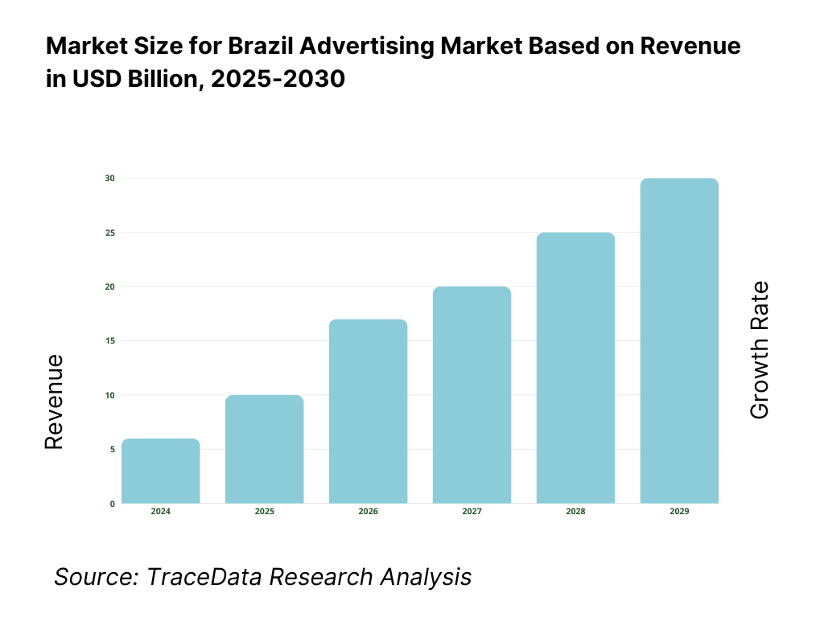
Figure 1: Brazil as Target Market

2.3 Strategic Fit Between Lidl and the Brazilian Market
The cost-leader approach, focus on its own-label, and the efficiency of Lidl is very similar to the high number of consumers who value prices in Brazil and the fragmentation of the retail industry. This strategic fit implies that the business model developed by Lidl can be successfully modified to suit the Brazilian market and retain a competitive edge (Moura, 2023).

3. Strategic Environment Analysis

3.1 Macro-Environmental Analysis: PESTLE Framework
Political Factors
Brazil is a federal democratic republic with a fairly sound political system, which however can be unstable with policy continuity depending after electoral periods. The past governments have focused on economic recovery, social programmes and investments in infrastructure, which facilitates indirectly the domestic consumption and retail activity. The opening attitude to foreign direct investment (FDI) is also a general trend in Brazil whereby 100% foreign ownership in retail business is permissible, an aspect that reduces barriers to structural barriers to foreign entrants like those of Lidl. Nevertheless, the level of bureaucratic complexity, federal and state tax fragmentation, and regulatory compliance expenses are also significant issues. The trade policy is moderately protectionist especially in farming and production and this can have an impact on the import sourcing strategy. In the case of Lidl, the political situation implies that entering the market is institutionally plausible, but it would take a robust policy and regulatory manoeuvring skills, and local supply chain building to overcome the policy and administrative risks (Schlegel, 2022).
Economic Factors
Brazil is the biggest economy in the South American region with GDP of more than USD 2 trillion which makes it a good destination of large scale retailers. In the recent past, economic growth has been lopsided due to the volatility of the inflation rate, interest rate, and the state of the global economy. The pressures of inflationary forces have occasionally led to the decrease in purchasing power by the household causing a rise in demand of affordable grocery products. Alternating prices of the Brazilian real cause cost uncertainty to retailers that rely on imports, which further supports the relevance of the local sourcing strategies. The income distribution in Brazil is still very unequal, and the big part of consumers form the lower and middle-income groups. This property of the structure allows maintaining the demand in the discount retail formats principle, which attaches importance to value-based prices (Carvalho and Nechio, 2023).
Social Factors
The Brazilian population is above 200 million people, with the majority of the demographic profile being urban since more than 85 percent of Brazil citizens live in cities. Value-based consumers in urban areas are showing a growing preference towards organised forms of retailing groceries, particularly because they appreciate convenience, reliable stocks and offer competitive prices. Price-sensitivity of Brazilian consumers, especially on buying staple food products, is usually high, especially because of the wide income disparities and exposure to inflation. The rise in acceptance of the own-label has been increasing and particularly in the necessity items where the consumers focus on the lower cost rather than on the brand image. Purchase behaviour is also determined by cultural inclination towards fresh products and local food which would necessitate adjustment in assortments by the retailer. Such social attributes are closely in line with the value-driven model of Lidl but signify that the localisation of the product selection and marketing processes is required to appeal to the expectations of Brazilian consumers (Boing, Boing and Subramanian, 2021).
Technological Factors
The retail sector in Brazil has undergone a trend of increased use of digital technologies, especially the ones related to inventory management, logistics coordination and electronic payment systems. The high adoption of digital payment devices, such as debit cards and instant payment systems, such as Pix, has enhanced efficiency in transactions and minimized the cash dependence. The penetration of e-commerce grocery is still low as compared to the developed markets but has increased compared to the time before the COVID-19 pandemic, and retailers have been encouraged to combine online and offline platforms. The system of logistics in Brazil is developing, but it is unevenly distributed throughout the country, where congestion and transportation expenses are a problem. The sophisticated supply chain systems, centralised procurement, and data-based inventory control may be seen as competitive advantage of Lidl, which, however, has to be adjusted to the infrastructural limitations of Brazil and the diversity of its regions (Reardon et al., 2021).
Legal Factors
The legal environment in Brazil is defined as having an extensive labour regulation such as minimum wage laws, employee benefits, and good laws that protect workers. Although such regulations improve the social protection, it also adds to the expenses of employing workers and makes labour less flexible to the retailers. The competition law has been proactively implemented to keep off the market dominance and anti-competitive behaviour by ensuring adherence to pricing and supplier contracting. Retailers are also required to comply with consumer protection laws that are related to the transparency of prices, labeling of the products and the return policy. In the case of Lidl, the legal environment of Brazil requires serious human resource planning and compliance mechanisms but does not pose any entry barriers. The Lidl has transferable legal and compliance capacity owing to its experience in working in highly regulated markets within Europe.
Environmental Factors
The importance of environmental sustainability has been raised on the Brazilian regulatory and social agenda especially in waste management, packaging, and food sourcing. The pressure on retailers increases to limit plastic consumption, handle food waste in a responsible manner, and show environmental responsibility. Megasupermarket chains are meant to assist in recycling and sustainable sourcing. These expectations are met by Lidl current sustainability undertakings in Europe such as packaging minimization and energy efficient stores designs (Vadakkepatt et al., 2021).
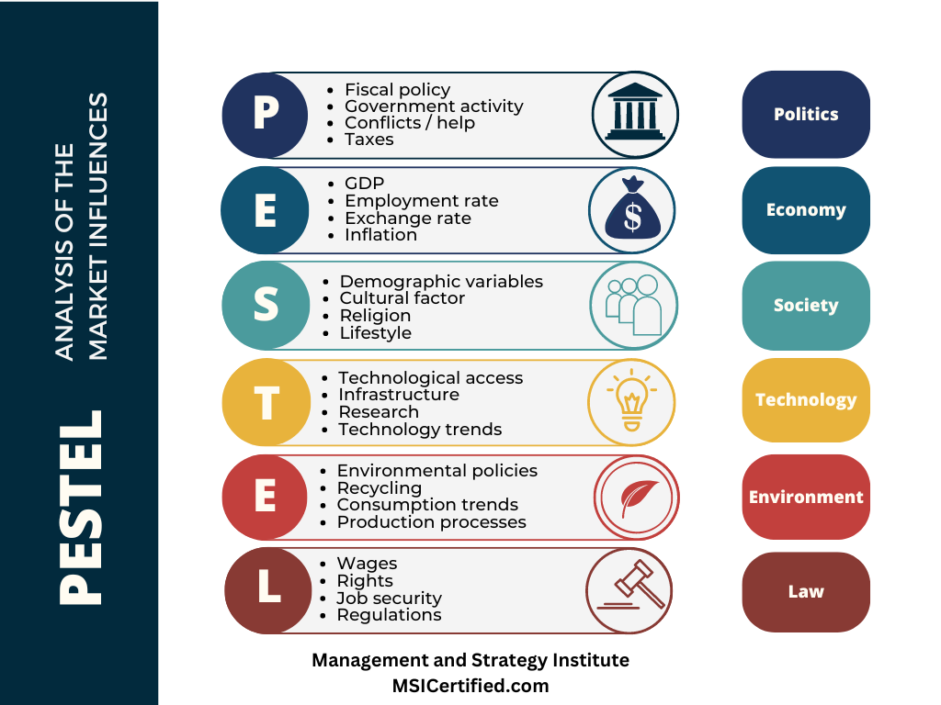
Figure 2: PESTLE Framework

3.2 Industry Analysis: Porter’s Five Forces
Competitive Rivalry
The level of competition in the Brazilian grocery retail market is intense due to the existence of large foreign and local players including Carrefour, GPA and local supermarket chains. The competition with regard to pricing is fierce especially in the category of staple foods since the retailers are in the hunt of cost-sensitive consumers. There is a lack of differentiation and a great number of companies that have the same product mix and store strategies. The customers are normally attracted and maintained through promotional prices and loyalty programmes. Irrespective of this competition, there is a high level of operational efficiency, as among rivals, which opens the opportunities to highly efficient entrants. The limited assortment and emphasis on its own-label model of Lidl has the potential to allow the company to compete on price as well as still having margin discipline, should it attain sufficient scale and supply chain efficiencies (Martin, Paulo and Katiúscia Moreno Galhera, 2021).
Threat of New Entrants
Entrant threats are moderate because of capital requirements, economies of scale and logistical complexity. To build a national grocery chain in Brazil, it is costly in terms of distribution centres, relationships with suppliers, and real estate. Entry costs are also exaggerated by regulatory compliance and tax complexity. The industry is not however unappealing and there are no laws that prohibit foreign entries. The monetary power and success of large rollouts in Lidl diminishes all these obstacles yet to become large-scale in the short-term would be necessary to counterbalance startup expenses.
Bargaining Power of Suppliers
Power of suppliers of the Brazilian grocery industry is moderate. Big box stores are able to bargain because of bulk buys whereas poor agricultural farmers lack bargaining power. There is however, the risk of the supplier power because of relying on branded multinational suppliers in some areas. The use of private-label strategy, which Lidl has adopted, means that the company is not dependent on branded suppliers thus allowing the firm to have more control over prices and margins. Building relationships with domestic suppliers would also reduce supplier power and foster ease of cost and localisation (Steenkamp, 2023).
Bargaining Power of Buyers
The power of buyers is high because consumers have low switching costs and different retail alternatives. Frequent promotions and price transparency motivate consumers to have a shopping experience with a number of retailers. The dynamic exerts pressure on the prices and standards of service continuously. The value the proposition of Lidl tackles the buyer power directly by providing low prices without needing any promotional efforts, which may help the company build better customer loyalty with the price-sensitive groups.
Threat of Substitutes
The competitors or substitutes provide traditional local markets, independent grocery stores, and wholesale clubs. These options are of interest to customers who want fresh products or those who want to shop in large quantities at low prices. Nonetheless, there is a tendency that substitutes are not as convenient, standardised, and price committed as modern supermarkets. The small store formats and edited assortments available at Lidl have the potential to appeal to customers that currently use fragmented options (Novikova, 2021).
Overall Industry Attractiveness
Competition is intense, as well as the buyer power; however, the grocery industry in Brazil is still quite appealing with the available market size, stability in the demand, and the potential of entrants with efficiency benefits. The model puts Lidl in a competitive position in case scale and localisation are realised.
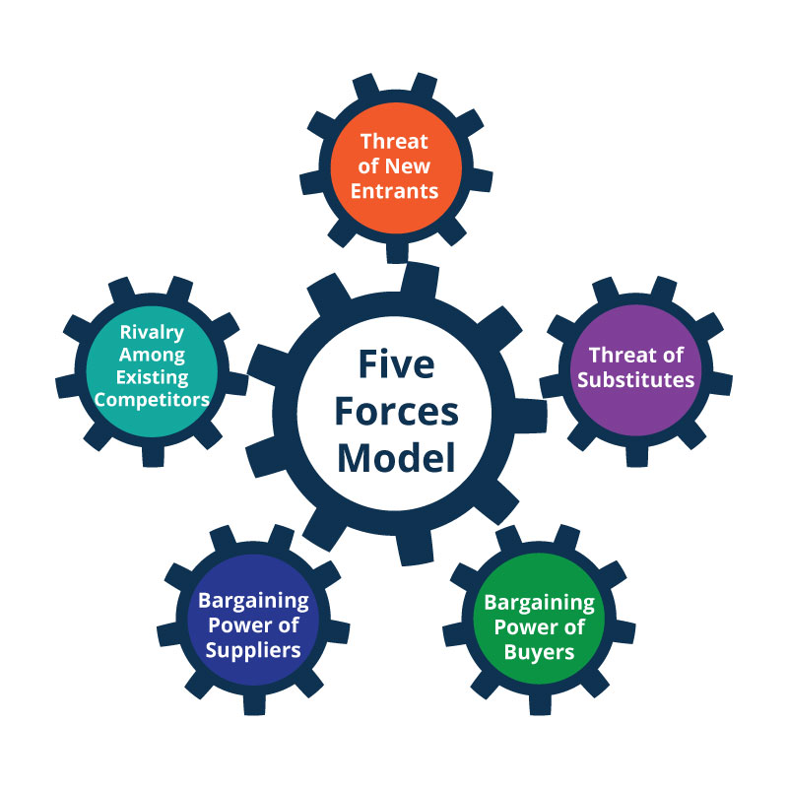
Figure 3: Porter’s Five Forces

3.3 Internal Analysis: VRIO Framework
Valuable Resources and Capabilities
The resources that Lidl has include very effective supply chain, centralised procurement systems and the product portfolio that is dominated by the own labels. These strengths make it possible to lead in costs and have similar prices in the market. The store design standardisation of Lidl and the lean staffing model also increase efficiency in the operations. The Schwarz Group offers financial support to facilitate large-scale growth and investment in infrastructures to help with long-term strategic plans, which are financed by the financial support of the Schwarz Group (Lundberg, 2023).
Rarity and Inimitability
Cost leadership is not a new concept, but scale, purchase efficiency, and expertise in own-label make Lidl rather hard to imitate in the short term. The rivals can copy the following points of the model, but it takes a lot of time and financial resources to recreate the combinations of integrated systems, relationships with suppliers, and organisational routine as Lidl. This generates a level of long term competitive advantage especially in those markets where the discount formats are not well developed.
Organisational Support
The centralised decision-making structure and the culture of performance of Lidl contributes to efficient allocation of its resources. The use of standardised procedures and great managerial control help to provide uniformity within markets but allows minimum adaptation to local markets. These organisational attributes favour global scalability.
Summary of Competitive Advantage
The resources of Lidl can be combined to offer a short-term yet defendable competitive advantage, depending on the successful localisation and achievement of scale in Brazil.
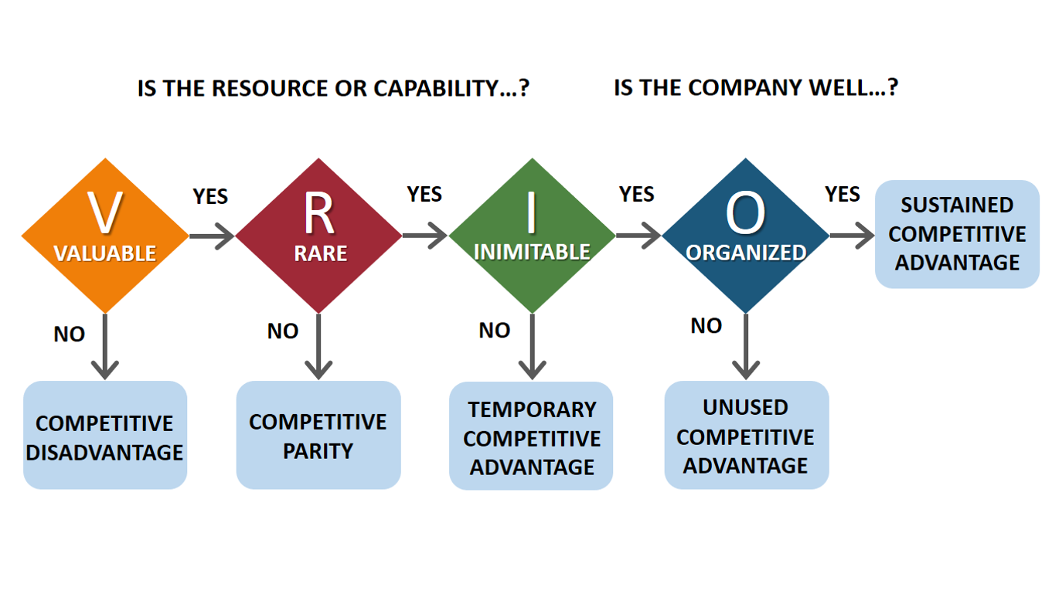
Figure 4: VRIO Framework

3.4 Critical Evaluation of Strategic Tools Used
All of the mentioned frameworks (PESTLE, Five Forces framework, VRIO) are structured strategies to examine the external and internal strategic environment of Lidl. PESTLE provides a general idea of macro-level factors especially in emerging markets where political, economic and legal conditions play a significant part in the business environment. Porters Five Forces allows the systematic evaluation of industry competitiveness and potential profit, with structural forces, including rivalry and buyer power, identified. VRIO is a supplement to these tools because it concentrates on internal capabilities of Lidl and its possible competitive advantage sources (Zhu et al., 2021).
Nevertheless, both structures are constrained. PESTLE has a tendency to simplify the complex interaction between the environmental elements whereas Five Forces presumes relatively stable industry boundaries and may not adequately account for the dynamic retail innovation or informal market competition. VRIO pays attention to the firm level of resources but does not take into consideration the external shocks and institutional limitations prevalent in the emerging economies. The combination of these frameworks will relieve the shortcomings of individuals by balancing macro and industry, as well as, firm levels. This three-faceted strategy reinforces strategic thinking and justification as well as makes discerning decisions about the proposal of Lidl to enter Brazil (Asamoah, 2021).
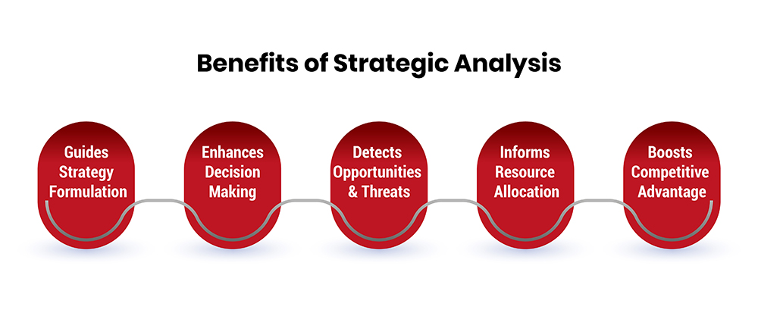
Figure 5: Strategic Tools Used

4. Strategy Development and Market Entry Proposal

4.1 Strategic Objectives for Lidl’s Expansion into Brazil
The penetration, cost leadership, and brand establishment should be the strategic goals in the expansion of Lidl into Brazil. The ultimate goal is to get a fast penetration in the major metro areas like in Sao Paulo and Rio de Janeiro where the population density and the purchasing power can provide high store throughput. Initially, entering with a regional, as opposed to national coverage would enable Lidl to scale quickly without having to deal with a complex operation (Cesar, 2024).
The second goal is to repeat the proven cost-leadership concept used by Lidl, aiming at using the dominance of own labeling, lean store functioning, and centralised procurement. In Brazil, the price-sensitive grocery industry, consumers are also highly price conscious and therefore it is crucial to maintain low operating costs. The history of providing low prices in Europe and the United States by Lidl proves that it can maintain margins despite the high competition.
Last but not least, Lidl should seek to create a clear brand image of a value retailer that is dependable, sells quality products at fair prices. Lidl is a brand that is known worldwide, but it does not have a consumer awareness in Brazil. Pricing transparency, store standardisation and consistency coupled with trust building would ensure customer loyalty in the long term. These goals combined give a consistent strategic framework that is in tandem with the global expansion goals of Lidl and the Brazilian market environment (Ahmed, 2021).

4.2 Market Entry Strategy
Entry Mode Selection
Lidl has to make a strategic decision of entering Brazil by investing in a fully-owned subsidiary or a joint venture with a Brazilian company. The joint venture would help mitigate the initial investment risk and the local market familiarity especially when going through Brazil regulatory environment and complex tax system. Local associates can also provide existing supplier systems and real estate entry, faster market penetration (Morschett et al., 2025).
Lidl however has a history of pattern of expansion that is highly biased towards wholly-owned subsidiaries as seen in its European and US operations. Full ownership of the business allows Lidl to have a tight grip on pricing, store design, buying and branding standards, which are very important in sustaining the cost-leadership paradigm. The joint ventures can water down operation control and cause a lack of strategic alignment especially in situations where the operating partners focus on short-term profitability more than long-term efficiency.
Since Lidl has a significant financial base and experience in venturing into foreign markets, the entry mode of choice will be the wholly-owned subsidiary. This strategy, although capital-intensive, enables Lidl to employ its standardised operating systems and not compromise but change over time to suit the local conditions. The partial investment by regional rollouts will help in reducing the risk, and strategic control will be maintained, so complete ownership is the most suitable in the case of Brazil (Gomes da Silva et al., 2025).
Market Positioning Strategy
The international positioning of Lidl in Brazil must focus on price leadership with dominance over the private-label. Brazilian shoppers are also highly sensitive to prices of grocery goods, especially when they relate to quality essential products and this presents good environment to hard-discount format. The limited assortment strategy at Lidl makes the company less complex and less expensive in terms of inventory, which allows it to provide low prices without the need to resort to frequent promotions.
Lidl Brazil would be dominated by a range of products under its own label, which would make it easier to control the margins and decrease its reliance on branded products. Lidl has been able to position its own brands as viable alternatives to domestic brands in the European markets, which are usually well rated in terms of quality. The same strategy in Brazil where products with local origins would be used would help in not only being affordable, but also acceptable by the consumers. This may help distinguish Lidl among the conventional supermarkets with wider assortments and a higher cost of operation (Gielens et al., 2021).
Generic Strategy Application
The strategy of expansion of Lidl can be described by the Cost Leadership Strategy developed by Porter. The company aims at achieving the lowest cost producer in Brazilian grocery industry through standardisation of its operations, overhead reduction and maximisation of the economies of scale. This plan will help Lidl compete well in the markets where competition on price is low and the consumer loyalty is based on the value and not the brand prestige. Cost leadership as well offers stability even in times of recession that are typical of emerging markets like Brazil.
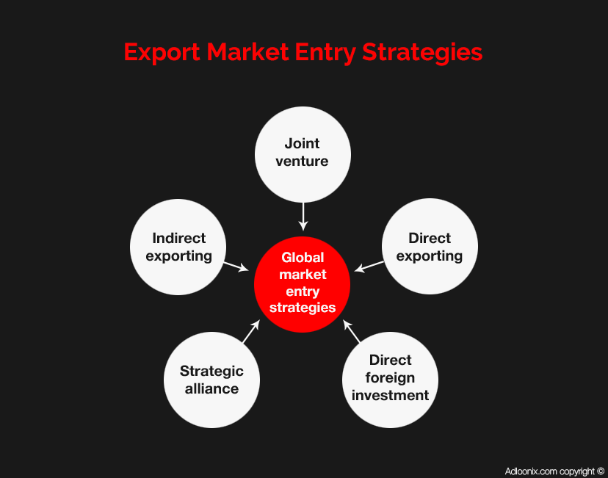
Figure 6: Market Entry Strategy

4.3 Risk Assessment and Mitigation Strategies
Operational and Supply Chain Risks
The geographical location and infrastructure disparities of Brazil pose great operational and supply chain risks. Inventory flows could be affected and become expensive due to delays in transportation, logistics congestion, and inequity in the quality of the suppliers in the regions. The dependence on imported products can put Lidl at risk of being affected by the delays of the customs and introduction of the tariffs. Moreover, the operation of stores in different regions could put pressure on standardised managing.
In order to deal with them, Lidl must focus more on local sourcing, build regional distribution centres and roll out progressively to perfect logistics capacity before expanding. Digitising the supply chain and monitoring supplier performance would also contribute to the reliability of operations (Ferreira, Biazzin and Hong, 2024).
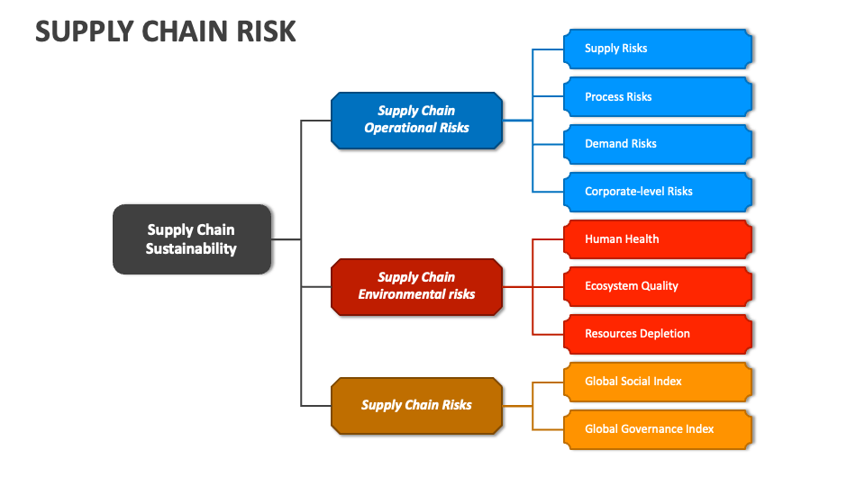
Figure 6: Supply Chain Risks
Economic and Currency Risks
The Brazilian economy is under the volatility of inflation and the exchange rate, which may influence the cost of inputs as well as the purchasing power of consumers. Depreciation of currency can lead to higher costs of imports and inflation can squeeze household budgets. The low-cost model offered by Lidl offers partial defense, yet there has to be proactive price and sourcing measures.
Regulatory and Political Risks
The tax regime and regulatory procedures in Brazil are complicated, which makes doing business there more expensive and unpredictable. Profitability may also be influenced by the alteration of labour laws or trade policies. This is best achieved by tapping local legal knowledge and keeping the operation planning flexible so that the risks can be easily avoided.
Mitigation Measures
The mitigation of risks should aim at localisation, gradual investment, knowledge in regulations, and flexibility of supply chain. All these are to minimize exposure strategic control is maintained.
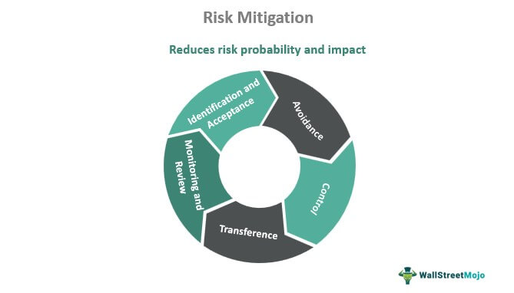
Figure 7: Risk mitigation

4.4 Corporate Social Responsibility and Sustainability Considerations
Sustainability and corporate social responsibility (CSR) are becoming central to Brazil retail sector due to the pressure of regulations and customer mind. Lidl has to employ an entry strategy that incorporates ethical sourcing, environmental responsibility, and positive social impact to be able to achieve long term legitimacy (Niel Rooi, Botha and Van, 2023).
Ethical sourcing is of great concern especially in Brazil where agricultural supply chains may comprise environmental and labour hazards. Lidl can implement the codes of conduct of its suppliers, which are already employed in Europe, in order to make sure compliance with the labour regulations and responsible agriculture. Cooperation with local manufacturers, who are certified, would also lessen the impact on the environment and help in the economic growth in the country.
Environmental responsibility must emphasize on minimization of waste, minimization of energy consumption and sustainable packaging. Lidl has in the past invested in energy efficient store designs and also minimized the use of plastic packaging in all its operations in Europe. The practices would be applicable to Brazil as growing regulatory pressure on retailers to minimize waste and emissions. It would be necessary to work with the local waste management systems in order to implement them well.
Lastly, Lidl would have a positive impact by creating employment, developing skills, and providing affordable food to the Brazilian communities. Lidl can improve on its social licence to operate by providing stable employment and training opportunities. Integrating the CSR in the expansion plan is the right measure to reduce the reputational risk but also enhancing brand confidence and future competitive advantage in Brazil market (Velga Vevere et al., 2025).

5. Performance Evaluation Framework

5.1 Selection of Performance Measurement Framework
Balanced Scorecard (BSC) is chosen as the most suitable performance measurement model to be applied to the expansion of Lidl to Brazil. The BSC is a combination of financial and non-financial indicators as opposed to financial metrics, and therefore it gives a holistic picture of strategic performance. It is especially true in the case of international expansion where success in the early stages might be based on customer acceptance, operational effectiveness and organisational learning and not necessarily short-term profitability (Luiz et al., 2025).
Cost-leadership approach developed by Lidl presupposes that the operational measures and financial performance should be tracked closely. Balanced Scorecard gives the management the ability to monitor the realization of low-cost goals without being able to affect the quality of services and the ability of the employees. Also, the framework facilitates strategic alignment among various functions whereby operational decisions strengthen long-term goals. This holistic solution can improve managerial control and strategic coherence in such a complex and unfamiliar market as Brazil (Lius, 2024).

5.2 Balanced Scorecard Dimensions and KPIs
Financial Perspective
The indicators that should be regarded as key financial KPIs are revenue growth, operating margin, and cost-to-sales ratios. Growth in revenue by region would be an indication of success in penetrating the market whereas operating margin would be used to show cost-leadership success. It is also imperative that the capital expenditure efficiency is high due to the intensity of the investment in store rollouts. These measures insure financial discipline and help in supporting expansion objectives (Chmutova I et al., 2024).
Customer Perspective
Price perception, customer satisfaction and repeat purchase behaviour should be measured using customer-oriented KPIs. The surveys on price competitiveness and basket size would provide the answer to the question on whether the value proposition provided by Lidl appeals to Brazilian customers. Retention and increase in footfall rates of customers would also be indicators of the brand acceptance and development of loyalty in new markets.
Internal Business Process Perspective
The KPI should monitor internal inventory turnover, reliability of the supply chain, and efficiency of the stores. The rapid inventory turnover means that the assortment is managed, whereas the reliable delivery means the quality of logistics. Store labour productivity helps in controlling costs and maintaining consistency of services (Kalf et al., 2023).
Learning and Growth Perspective
KPIs in the field of learning and growth must involve the number of hours spent on the training of employees, retention of employees, and localisation of the management. Talents in local management increase operational resiliency and cultural fit. The indicators are in favour of long term organisational capability building.

5.3 Monitoring and Review Mechanisms
The review of performance must be done on a quarterly basis using scorecards and management dashboards, and also periodically reviewing the strategy. The continuous improvement mechanisms allow Lidl to change the pricing, sourcing, and operation based on the market feedback so that the organization can be strategic in its expansion (Porter, 2023).
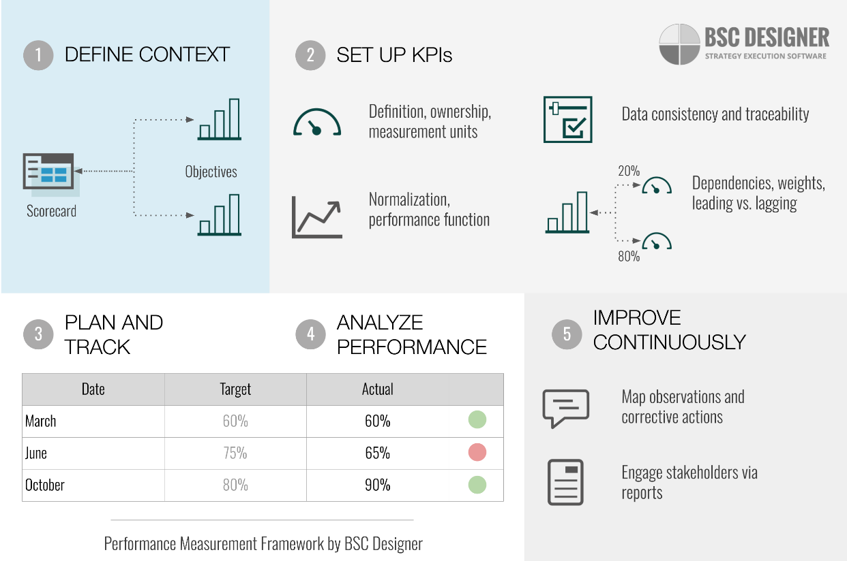
Figure 8: Balanced Scorecard Dimensions and KPIs

6. Conclusion and Recommendations

6.1 Summary of Key Findings
As shown in this report, Brazil is a strategically appealing, but a difficult market where Lidl can expand its international business. The macro-environmental analysis showed favourable demographical and demand environment, economic and regulatory complexities. The industry analysis showed that the competition was very high however there were potential entrants that could be efficiency based. Internal analysis has verified that Lidl has powerful capabilities that can be transferred and help in cost leadership (Vansvik and Friskytt, 2024).

6.2 Strategic Recommendations
It is suggested that Lidl should approach Brazil with a wholly-owned subsidiary with the main initial target in major urban areas. The focus is to be on the development of own-label, local sourcing, and incremental investment. Effective compliance systems and sustainability programs must be incorporated at the beginning to facilitate the legitimacy and success in the long run.

6.3 Final Reflection on Feasibility and Strategic Value
On the whole, the expansion of Lidl in Brazil is both strategic and in accordance with the global growth strategy. A disciplined execution, localisation and long term commitment on cost leadership will be required to succeed in a complex emerging market environment (Jerab and Mabrouk, 2023).

References
Ahmed, M. (2021). An analysis of the Impact of Brand Image on Consumer Purchase Behavior : The case of Lidl, Sweden. [online] www.diva-portal.org. Available at: https://www.diva-portal.org/smash/record.jsf?pid=diva2:1582255.
Asamoah, D. (2021). Perceived causes of low academic performance of Senior high school students in core mathematics in the Kumasi metropolis. Ucc.edu.gh. [online] doi:https://doi.org/23105496.
Boing, A.F., Boing, A.C. and Subramanian, S.V. (2021). Inequalities in the access to healthy urban structure and housing: an analysis of the Brazilian census data. Cadernos de Saúde Pública, 37(6). doi:https://doi.org/10.1590/0102-311x00233119.
Carvalho, C. and Nechio, F. (2023). Challenges to Disinflation: The Brazilian Experience. Brookings Papers on Economic Activity, [online] 2023(1), pp.217–242. Available at: https://muse.jhu.edu/pub/1/article/919915/summary.
Cesar (2024). Perceptions of international expansion of Brazilian brands among the Brazilian community in Ireland: targeting a potential market. Ncirl.ie. [online] doi:https://norma.ncirl.ie/8392/1/bernardcesardasilva.PDF.
Chmutova I, Guo X, Zhang Q, Mazhuta V and Nimets A (2024). Formulating Key Performance Indicators For An Integrated Enterprise Management System Using A Sustainable Development Balanced Scorecard. Hneu.edu.ua. [online] doi:http://repository.hneu.edu.ua/handle/123456789/34787.
De Sousa, G.C. and Castañeda-Ayarza, J.A. (2022). PESTEL Analysis and the macro-environmental Factors That Influence the Development of the Electric and Hybrid Vehicles Industry in Brazil. Case Studies on Transport Policy, [online] 10(1), pp.686–699. doi:https://doi.org/10.1016/j.cstp.2022.01.030.
Ferreira, F.C.M., Biazzin, C. and Hong, P.C. (2024). Transition Paths of Brazil from an Agricultural Economy to a Regional Powerhouse: A Global Supply Chain Perspective. Sustainability, [online] 16(7), p.2872. doi:https://doi.org/10.3390/su16072872.
Gielens, K., Ma, Y., Namin, A., Sethuraman, R., Smith, R.J., Bachtel, R.C. and Jervis, S. (2021). The Future of Private Labels: Towards a Smart Private Label Strategy. Journal of Retailing, 97(1), pp.99–115. doi:https://doi.org/10.1016/j.jretai.2020.10.007.
Gomes da Silva, M.A., Ribeiro Alves Cunha, L., Dourado, F. and Leiras, A. (2025). From setback to breakthroughs: The shift in financial investment balance perspectives for disaster risk and management in Brazil. International Journal of Disaster Risk Reduction, 119, p.105283. doi:https://doi.org/10.1016/j.ijdrr.2025.105283.
Jaravel, X. (2021). Inflation Inequality: Measurement, Causes, and Policy Implications. Annual Review of Economics, [online] 13(1), pp.599–629. doi:https://doi.org/10.1146/annurev-economics-091520-082042.
Jerab, D. and Mabrouk, T. (2023). Achieving competitive advantage through cost leadership strategy: Strategies for sustainable success. [online] Social Science Research Network. doi:https://doi.org/10.2139/ssrn.4574945.
Kalf, H.A.I., Ibrid, A.A., Furaijl, H.B., Salma, A., Hasan, A.A., Shatawi, H.H., Qusai, N., Retha, R.A. and Hasan, A.A. (2023). Identifying Key Performance Indicators (KPIs) and Measurement Frameworks to Assess and Improve the Performance of Construction Supply Chains. INTERNATIONAL JOURNAL OF CONSTRUCTION SUPPLY CHAIN MANAGEMENT, [online] 13(1), pp.260–275. Available at: https://ijcscm.com/menu-script/index.php/ijcscm/article/view/214.
Kreutzer, R.T. (2023). Marketing Strategy. Practice-Oriented Marketing, pp.187–242. doi:https://doi.org/10.1007/978-3-658-39717-3_4.
Lius, I.-M. (2024). Strategic Applications of Cost Accounting in Global Business Operations. [online] Available at: https://www.utupub.fi/bitstream/handle/10024/179218/Thesis_Ida_Lius.pdf?sequence=1.
Luiz, M., Castro, L., Raimundo, Marinho, M., Silva and Lobato, S. (2025). BALANCED SCORECARD IN ENVIRONMENTAL SCIENCES: A TOOL FOR SUSTAINABLE MANAGEMENT. Aracê., [online] 7(5), pp.25876–25900. doi:https://doi.org/10.56238/arev7n5-280.
Lundberg, E. (2023). Private label effect on small producer business development. [online] stud.epsilon.slu.se. Available at: https://stud.epsilon.slu.se/18945/.
Mádr, M. and Náplava, R. (n.d.). Retail Sale in Non-Specialised Stores in the Czech Republic. [online] Available at: http://ftp.mendelu.cz/RePEc/men/wpaper/93_2024.pdf.
Martin, S.B., Paulo, J. and Katiúscia Moreno Galhera (2021). Expansion, Conflictual Cooperation, and Rising Legal Scrutiny: 2003–2014. Springer eBooks, pp.81–149. doi:https://doi.org/10.1007/978-3-030-74672-8_4.
MAZIDI, S. (2025). The Digital Shift: An Overview of the Retail and Delivery Sectors Post-Covid-19. Unipd.it. [online] doi:https://hdl.handle.net/20.500.12608/89519.
Morschett, D., Schramm-Klein, H., Joachim Zentes and Bader, B. (2025). Wholly-Owned Subsidiaries. pp.447–466. doi:https://doi.org/10.1007/978-3-031-86213-7_18.
Moura, S. (2023). The impact of storytelling marketing in brand identity : a case study on LIDL Portugal. [online] Repositorio.ucp.pt. Available at: https://repositorio.ucp.pt/entities/publication/11bd9677-806b-4207-a060-588eb27fdefe.
Niel Rooi, Botha, D. and Van (2023). Corporate social responsibility applications in the retail sector: Lessons from the international experience. Journal of Contemporary Management , 20(1), pp.499–535. doi:https://doi.org/10.35683/jcman1023.206.
Novikova, K. (2021). Unique Assortment as a Key Factor of Local Food Retail’s Competitiveness Increase. Lecture notes in networks and systems, pp.1086–1103. doi:https://doi.org/10.1007/978-3-030-89477-1_97.
Omowole, B.M., Olufemi-Phillips, A.Q., Ofodile, O.C., Eyo-Udo, N.L. and Ewim, S.E. (2024). Big data for SMEs: A review of utilization strategies for market analysis and customer insight. International Journal of Scholarly Research in Multidisciplinary Studies, 5(2), pp.001-018. doi:https://doi.org/10.56781/ijsrms.2024.5.2.0044.
Pathirana, G. (2024). Beyond Metrics: Crafting a Dynamic Performance Evaluation System. Advances in logistics, operations, and management science book series, pp.145–172. doi:https://doi.org/10.4018/979-8-3693-4387-6.ch006.
Porter, M.E. (2023). Changing Patterns of International Competition. International Strategic Management, pp.61–86. doi:https://doi.org/10.4324/9781315058993-8.
Portugal, P.H.F., Moreira, J.F., Póvoas, M. dos S., Silva, C.A.F. da and Guedes, A.L.A. (2021). The Favela as a Place for the Development of Smart Cities in Brazil: Local Needs and New Business Strategies. Smart Cities, 4(4), pp.1259–1275. doi:https://doi.org/10.3390/smartcities4040067.
Reardon, T., Heiman, A., Lu, L., Nuthalapati, C.S.R., Vos, R. and Zilberman, D. (2021). ‘Pivoting’ by food industry firms to cope with COVID‐19 in developing regions: E‐commerce and ‘copivoting’ delivery intermediaries. Agricultural Economics, 52(3), pp.459–475. doi:https://doi.org/10.1111/agec.12631.
Schlegel, R. (2022). Dynamic de/centralization in Brazil, 1889–2020: The prevalence of punctuated centralization. Regional & Federal Studies, pp.1–33. doi:https://doi.org/10.1080/13597566.2022.2125507.
Steenkamp, J.-B.E.M. (2023). What is holding private label back in the United States and in emerging markets? Journal of Retailing, [online] 100(1). doi:https://doi.org/10.1016/j.jretai.2023.11.002.
Vadakkepatt, G.G., Winterich, K.P., Mittal, V., Zinn, W., Beitelspacher, L., Aloysius, J., Ginger, J. and Reilman, J. (2021). Sustainable Retailing. Journal of Retailing, [online] 97(1), pp.62–80. doi:https://doi.org/10.1016/j.jretai.2020.10.008.
Vansvik, S. and Friskytt, I. (2024). How to succeed with a large retail expansion into an emerging market. ‘How can multinational retail companies concur the challenges presented by a Brazilian venture and what strategies lead to long-term success?’ gupea.ub.gu.se.
Velga Vevere, Shina, I., Gamage, M., Iveta Linina and Zvirgzdina, R. (2025). INTEGRATING DIGITAL TECHNOLOGIES TO ENHANCE CSR STRATEGIES FOR RETAIL COMPANIES IN LATVIA. Environment Technology Resources Proceedings of the International Scientific and Practical Conference, [online] 2, pp.367–374. doi:https://doi.org/10.17770/etr2025vol2.8579.
Zhu, N.J., Ferlie, E.B., Castro-Sánchez, E., Birgand, G., Holmes, A.H., Atun, R.A., Kieltyka, H. and Ahmad, R. (2021). Macro level factors influencing strategic responses to emergent pandemics: A scoping review. Journal of Global Health, 11. doi:https://doi.org/10.7189/jogh.11.05012.

