A Strategic Situational Analysis of Deliveroo (UK) Using Porter’s Five Forces  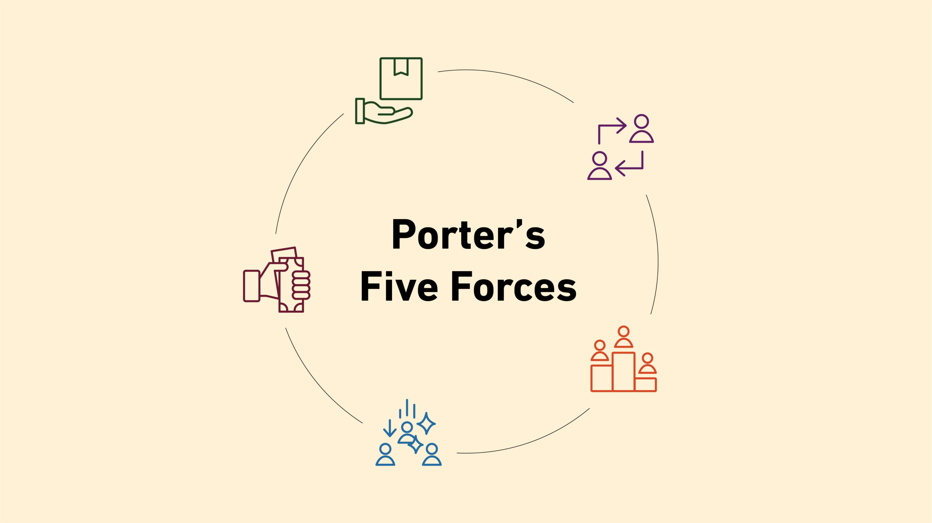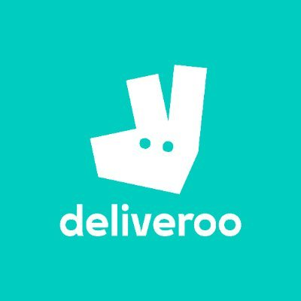 | Individual Report  Module code - LCBB5015_BIRM  Module Name - Principles of Marketing  Lecturer’s Name - Ivan Rodriguez Hernandez  Student Name - Ovidiu Florin Socel  Student Number - 2310644  Submission deadline - 22nd of Feb 2026

Contents
1. Introduction. 2
2. Situational Analysis: Porter’s Five Forces. 2
2.1 Competitive Rivalry (Very High). 2
2.2 Threat of New Entrants (Moderate). 3
2.3 Bargaining Power of Suppliers (Increasing). 3
2.4 Bargaining Power of Buyers (High). 3
2.5 Threat of Substitutes (Moderate). 4
3. Critical Evaluation and Strategic Implications. 4
4. Conclusion. 4
Summary of Key Findings. 4
Strategic Recommendations. 4
Importance of Situational Analysis. 5
References. 5

A Strategic Situational Analysis of Deliveroo (UK) Using Porter’s Five Forces.

1. Introduction.
Deliveroo is a digital food delivery platform headquartered in the UK that operates in the online food services industry.
Set up in 2013, the company is a multi-sided platform joining consumers, restaurants and delivery riders via a technology-enabled logistics network. As mentioned by Pang et al. (2022), Deliveroo operates in the accessibility sector of the UK market, offering delivery in a rapid way and availability to high-quality restaurant partners, notably in urban areas.
The main purpose of the report is to carry out a rigorous situational analysis of Deliveroo, with a main focus on the competition environment. So that external forces evident in the industry can be identified, analysed and evaluated for their influence on strategy and organisational performance. The Porter’s Five Forces analysis model provides a systematic way in which to think about industry structure and can lead to choosing a strategy that is more likely to produce a sustainable competitive advantage in a particular industry. (Porter, 2008) The paper analyses and critically assesses the model, as well as its implications and limitations in relation to digital platform markets.

2. Situational Analysis: Porter’s Five Forces.

2.1 Competitive Rivalry (Very High).
The intense nature of competitive rivalry in the UK online food delivery market is exceptionally intense. Due to the nature of the core business similarities, such as Uber Eats, Just Eat, and Deliveroo, they do not have much room for differentiation. In a market where services are increasingly homogeneous, competition based on price is becoming more widespread. This is manifested in frequent discounting and promotional subsidies, as well as free delivery (Teece et al., 1997).
According to Rodriguez and Piccoli (2020), there is evidence that suggests profit margins have been structurally compressed by such rivalry. By premium branding and offering fast delivery, the food delivery company Deliveroo has tried to differentiate itself from its competitors. However, both of these strategies increase operational costs and are easy to copy for competitors. Therefore, competition is the biggest limitation on Deliveroo's long-term profitability.

2.2 Threat of New Entrants (Moderate).
It is moderately difficult to enter the industry rather than low. Although technological entry barriers lost meaning in the aftermath of improved access to digital infrastructures, Deliveroo benefits from economies of scale, brand value and a dense logistics network that altogether raise entry barriers (Friederici et al., 2022). Nevertheless, Porter (2008) warns that, in platform markets, scale advantages are not persistent since venture-backed entrants can rapidly subsidise growth. Regulatory compliance and high customer acquisition costs may deter small entrants; however, the appetite of the well-capitalised challengers limits Deliveroo’s structural protection.

2.3 Bargaining Power of Suppliers (Increasing).
The restaurant partners and delivery riders of Deliveroo are gaining importance as suppliers. According to Barnett (2022), restaurants’ extensive multi-homing gives them moderate bargaining power, enabling them to negotiate commission fees more effectively or switch from platforms. Deliveroo cannot take as much value from its restaurant base.
Increased legal and regulatory scrutiny concerning employment classification has strengthened the bargaining power of riders, more importantly. As the regulations become more stringent, platforms in the gig-economy will face tougher labour costs and less flexibility (Lord et al., 2023). Deliveroo has a structural vulnerability to this trend, which undermines its reliance on labour flexibility as a competitive advantage.

2.4 Bargaining Power of Buyers (High).
The UK online food delivery market provides purchasers with that much power. Switching costs for consumers are close to zero, and consumers can compare prices, delivery times and restaurant availability easily. Greater transparency makes customers sensitive to price and thus less loyal (Pang et al., 2022).
Deliveroo has started offering subscription-based models like Deliveroo Plus to lessen buyer power. However, competitor schemes dilute the effectiveness of the strategy. According to Li et al. (2018), the high buyer power forces the firms to compete on short-term incentives and not long-term value creation, causing margin pressure.

2.5 Threat of Substitutes (Moderate).
The threat posed by substitutes is average and is increasingly contextual. During economic uncertainty, when discretionary spending falls, options like home cooking, click and collect services, and direct restaurant delivery become more appealing (Furlan, 2021).
Nonetheless, Deliveroo is differentiated from most substitutes by its proposition of convenience and quickness. Growth in demand is restrained by substitution and not direct displacement of the platform.

3. Critical Evaluation and Strategic Implications.
According to Porter’s Five Forces, and with regard to specific evidence from the industry, Deliveroo is part of a structurally unattractive industry that has very strong rivalry and buyer power. As Porter (2008) points out, these conditions greatly limit the chances of earning sustained above-average returns except through defensibly differentiated firms.
According to Teece et al. (1997), to succeed in such an environment, internal capacity must be in line with external constraints. In the case of Deliveroo, continued market expansion is not enough. Rather, operational efficiency, selective market presence and value-enhancing partnerships must gain strategic attention. While this analysis highlights the relevance of the Porter model, it also indicates deficiencies in its application and merits criticism. For instance, the model overlooks the importance of network and data effects in business markets (Competition and Markets Authority, 2020). In other words, we do need a complementary framework analysis to do a more complete strategy analysis.

4. Conclusion.

Summary of Key Findings.
To conclude, the situational analysis reveals that the UK industry in which Deliveroo is operating is quite competitive and characterised by intense rivalry, high bargaining power of buyers, increasing bargaining power of suppliers, moderate barriers to entry and a high threat of substitution. These forces, taken together, continually squeeze profitability and limit strategic flexibility.

Strategic Recommendations.
From our analysis, the recommendations that are being made are:
Focused Differentiation: Welcoming only premium and independent restaurants to keep price-based competition to a minimum.
Cost and Efficiency Leadership: Smart investments in logistics optimisation and data analytics can offset rising costs of labour and regulations.
Regulatory Strategy: Constantly modifying labour practices in response to regulations to eliminate long-term risks, both legal and reputational.

Importance of Situational Analysis.
Strategic planning and its importance to situation analysis are the subject matter of this report. Deliveroo can develop more robust and better-informed strategies in a more dynamic market by systematically assessing the forces in the industry while recognising their limitations.

References.
Barnett, J.M. (2022). ‘Illusions of dominance? Revisiting market power in platform ecosystems’, Antitrust Law Journal, 86(2), pp. 459–502. Available at: https://www.americanbar.org/content/dam/aba/publications/antitrust/journal/86/issue-1/illusions-of-dominance.pdf (Accessed: 18 February 2026).
Competition and Markets Authority (2020). Online platforms and digital advertising: Market study final report. London: Competition and Markets Authority. Available at: https://assets.publishing.service.gov.uk/media/5efc57ed3a6f4023d242ed56/Final_report_1_July_2020_.pdf (Accessed: 18 February 2026).
Friederici, N., Reischauer, G. & Lehdonvirta, V. (2022). The business of European platforms: How digital intermediaries in e-commerce, food delivery, health and care, and social networking manage value and compete. Berlin: Alexander von Humboldt Institute for Internet and Society (HIIG) & Oxford Internet Institute. Available at: https://www.hiig.de/wp-content/uploads/2022/11/Spark-Paper-II_The-Business-of-European-Platforms.pdf (Accessed: 18 February 2026).
Furlan, A. (2020). Food delivery: an analysis of existing and future business models based on digital platforms. Master's Degree Programme in Management, University of Ca' Foscari, Venice. Available at: https://unitesi.unive.it/bitstream/20.500.14247/11177/1/861943-1255479.pdf (Accessed: 18 February 2026).
Li, X., Kauffman, R.J. and Chiang, R.H.L. (2018) ‘Buyer Power and Competitive Pressure in Digital Platforms’, Sustainability, 10(12), p.4527. Available at: https://www.mdpi.com/2071-1050/10/12/4527 (Accessed: 18 February 2026).
Lord, C., Bates, O., Friday, A. & McLeod, F. (2023). ‘The sustainability of the gig-economy food delivery system (Deliveroo, UberEATS and Just-Eat): Histories and futures of rebound, lock-in and path dependency’, International Journal of Sustainable Transportation, 17(5), pp. 490–502. Available at: https://doi.org/10.1080/15568318.2022.2066583 (Accessed: 18 February 2026).
Pang, X., Shang, Y. & Song, J. (2022). ‘An analysis of Deliveroo’s operation strategy and food takeaway industry’, in Proceedings of the 2022 7th International Conference on Financial Innovation and Economic Development (ICFIED 2022), Atlantis Press, pp. 142–155. Available at: https://doi.org/10.2991/aebmr.k.220307.023 (Accessed: 18 February 2026).
Porter, M.E. (2008). ‘The five competitive forces that shape strategy’, Harvard Business Review, 86(1), pp. 78–93. Available at: https://hbr.org/2008/01/the-five-competitive-forces-that-shape-strategy (Accessed: 18 February 2026).
Rodriguez, J. & Piccoli, G. (2020). ‘Competing within aggregators: Competitive moves in the Deliveroo online delivery platform’, BLED eConference 2020 Proceedings, pp. 345–360. Available at: https://aisel.aisnet.org/bled2020/20/ (Accessed: 18 February 2026)
Teece, D.J., Pisano, G. and Shuen, A. (1997) ‘Dynamic capabilities and strategic management’, Strategic Management Journal, 18(7), pp. 509–533. Available at:
https://www.researchgate.net/publication/227356181_Dynamic_Capabilities_and_Strategic_Management (Accessed: 18 February 2026).

