Rosy Emanuel
Wolverhampton WV2
07402 482031
rosyemanuel@live.co.uk

Personal Profile
An enthusiastic, confident and hardworking individual with a passion for delivering excellent customer service. Experience in food services, customer service, management and production. Having a willingness to handle various responsibilities, follow instructions and work under supervision. Now looking for a new challenging position with a reputable and exciting employer who offers competitive rates of pay as well as excellent career progression and development opportunities. Available to start work immediately.

Key Skills
- Excellent customer service skills
- High attention to detail
- The ability to work well with others
- Sensitivity and understanding
- Active listening skills
- Organised and efficient
- Good verbal communication skills
- the ability to accept criticism and work well under pressure
- Full, clean driving license – car owner
- Problem solver

Work History

September 2023 to July 2025: Restaurant Manager, Uncle Samuel Takeaway, Wednesbury
Duties and responsibilities:
- Customer service
- Ordering
- Food preparation
- Managing staff rotas
- Staff recruitment and training
- Maintaining health and safety and food safety regulations
- Banking duties

September 2022 to December 2022: Food Delivery Manager / Courier, Evri
Duties and responsibilities included:
- Coordinating delivery schedules and managing courier team
- Ensuring timely and accurate food deliveries
- Customer service
- Ensuring food safety standards and hygiene regulations are maintained

March 2021 to December 2021: Food Delivery Driver, Uber
Duties and responsibilities included:
- Ensuring timely and accurate food deliveries
- Customer service
- Ensuring food safety standards and hygiene regulations are maintained
- Handled app-based order management and payment systems

April 2016 to February 2021: Sandwich Artist, Subway, Welcome Break, M25 Services
Duties and responsibilities included:
- Food preparation / customer service
- Food production
- Provided excellent customer service
- Supervised junior staff
- Quality checks
- Stock control

Education / Training
Educated to high school in Pakistan

Hobbies and Interests
- Watching dramas
- Walking with the family
- Reading
- Music
- Cooking

References
Available on request

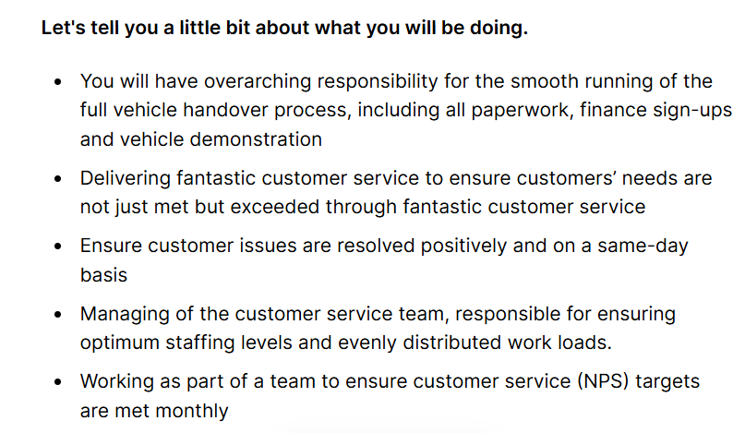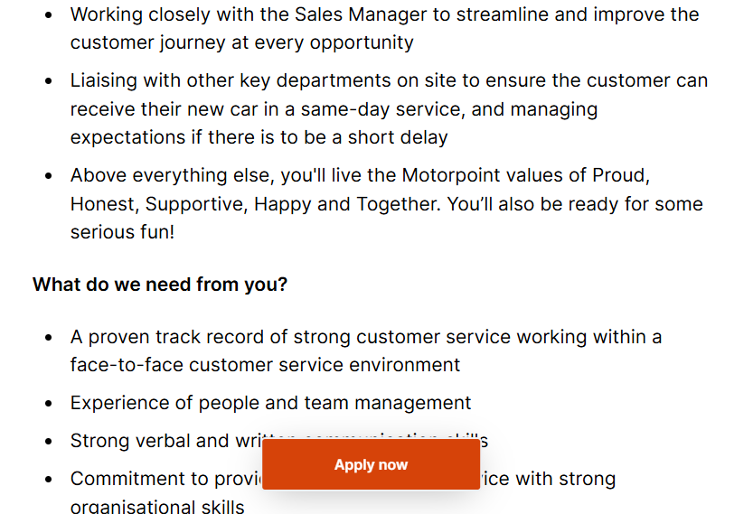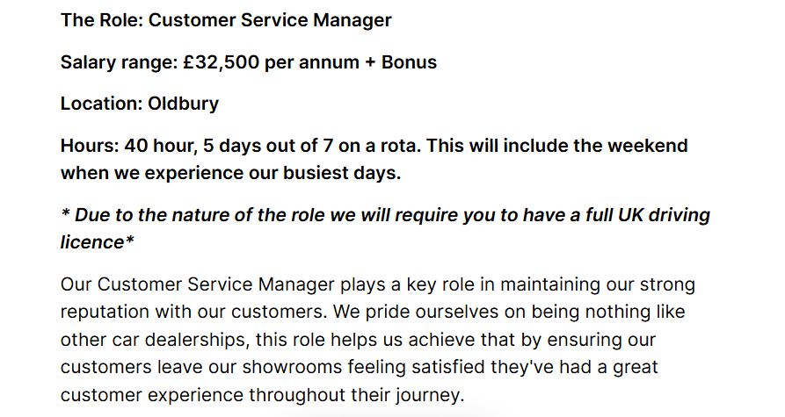
Rosy Emanuel
rosyemanuel@live.co.uk l 07402482031 l Wolverhampton
4th June 2026
Re: Customer Service Manager

I would like to apply the Customer Service Manager nature of the full UK driving licence. Good company of Motorpoint Oldbury, advertised on Indeed website.
As required, I am enclosing my CV.
I am in the final 2 months of completing my level 4 in certificate of business Skill for the Workplace in Birmingham UWTSD. I have experience of customer service; it will pride honour to work with your and gain experience. I have developed my analytical skills and ability to manage, range of business intelligence sources
- Sandwich Artist; moving from managing the store of Subway supervisor on M25 work with busiest place of my life where to deal with 100 of customers in the day.
- Audit; target to pass the audit been made 5 in row with 5-star rating.

I have also:
- Worked in and led at restaurant Food preparation. Meet the target of sale every week.
- Restaurant customers dealing and communication.
- Solved problems as team leader. Staff cover and dealing with customers complaints
- Worked flexibly, early and late shifts and covering for absences, sometimes at the short notice.
- Managed my time when combining study with work and children.

I have improved my language skills and mix with people from different background. Especially old and young.
I look forward to hearing from you.
Yours sincerely
(Rosy)
Rosy Emanuel

