
LEVEL 7 ASSESSMENT SPECIFICATION
Student name: | Akbar Hossain | Student number: | 2519734
Programme: | Master of Business Administration
Module: | International Business Concepts
Module code: | LCMB7034
Lecturer: | Gladius kulothungan | Internal Verifier: | Vasilios Tavlaridis  Hoang Nguyen
Assignment Title: | Report | Word count (or  equivalent): | 5000

Title:
“Strategic Internationalization Analysis: Organizational Alignment, Macro-Environmental Assessment, and Foreign Market Entry Strategy for Apple Inc. in Pakistan”

Table of Contents
Introduction 3
Section 1: 4
1. Organizational Classification and Global Strategy 4
1.1 Strategic Categorization (Bartlett & Ghoshal) 4
1.2 Global Configuration and Competitive Advantage 5
2 Macro-Environmental Appraisal and Market Attractiveness 6
2.1 Host Country Analysis: PESTLE framework 6
2.2 Market Entry: Dunning’s Eclectic (OLI) Paradigm 11
3. Entry Mode Strategy and Strategic Synthesis 13
3.1 Historical Entry Modes 13
3.2 Strategic Fit for Pakistan 13
3.3 Conclusion and Recommendations 14
Section 2: Reflective Account Analysis 17
Application of Gibbs’ Reflective Cycle 17
References 21

Introduction
Apple Inc. is one of the largest technology companies in the world, whose consumer electronics are extremely standardized and high quality. Although Apple is found all over the world, there is currently no official Apple operational presence in Pakistan (no Apple stores, manufacturing plants); instead, Apple has third-party national distributors (authorized in Pakistan) like Mercantile, and indirect retail deals. Discuss Apple's international strategy and then use the framework of Bartlett and Ghoshal 1989 to classify it and analyse Apple's current geographic footprint, then discuss how Apple's operations around the world support its competitive advantage. then do a focused PESTEL (Political, Economic, Legal, Cultural) analysis of Pakistan's external market environment as relevant to high-end consumer electronics. Apply a Dunning's eclectic (OLI) paradigm to synthesize these insights and determine the critical ownership, location and internalisation factors that will determine Apple's market entry viability. Finally, recall the history of how Apple has entered the market and examine the suitability of these with the Pakistani context and come up with a strategic recommendation. Section 2 is a reflective approach to the analytical, methodological and data-synthesis processes which have occurred during the development of this report and follows the Gibbs' Reflective Cycle (1988).

Section 1:

1. Organizational Classification and Global Strategy

1.1 Strategic Categorization (Bartlett & Ghoshal)
Apple exhibits a highly integrated global strategy. The company's product development and design take place in its California headquarters, and its supply and distribution system reach across the world to offer a uniform product (Ahmed et al., 2023). Apple's international strategy extends beyond merely marketing items in several nations; it aims to cultivate a cohesive experience that surpasses geographical boundaries. Bartlett and Ghoshal define a global strategy as “taking the world as a whole largely as a single undifferentiated market and exploiting the economies that come with a standardised product design, global-scale manufacturing and a strategy formulated and controlled by the headquarters” (Praveen Parboteeah and Cullen, 2017). Apple's model is very close: The flagship devices such as the iPhone, iPad, MacBook are virtually identical in countries, just with some local changes (e.g., languages or mobile-band compatibility). The marketing, branding and ecosystem (App Store, iCloud, etc.) of Apple are very concentrated. An example of this is every iPhone box that was designed by Apple in California, but assembled in China, highlighting Apple's one centralized place of product design and a network of manufacturing overseas (Sekar, 2024).
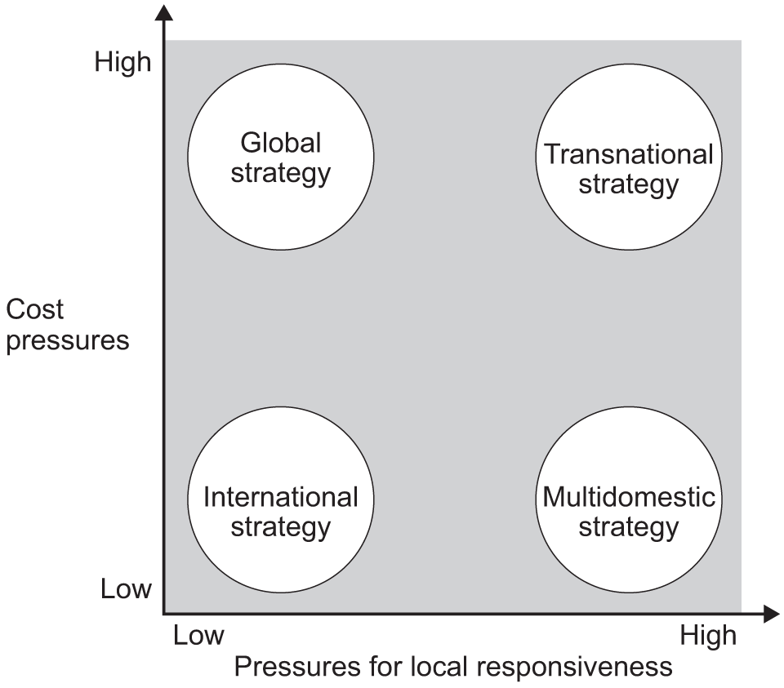
Figure 1: Bartlett & Ghoshal Framework (1989) (Neves and Kogut, 2023)
Apple isn't entirely oblivious to local variations either. It designs its marketing campaigns, some of its services and its language support to national markets according to those markets (Sherif, 2024). This implies a certain transnational approach (high global integration at the same time with selective local responsiveness). The global emphasis, however, of Apple's approach is more broadly seen in its research and development, design specifications, key components and brand image, which are managed centrally, resulting in economies of scale. As Bartlett and Ghoshal put it, Apple is essentially following a global or transnational approach, which emphasizes efficiency and standardization globally with some local adaptations. It's created Apple robust cost and quality benefits, and a formidable global brand (Asseraf and Gnizy, 2026).

1.2 Global Configuration and Competitive Advantage
Apple’s geographic footprint reflects its global strategy. The company has a wide distribution network and regional subsidiaries in almost all major developed and emerging markets. Apple's supply chain includes more than 60 countries, with parts and workforce from all over the world to manufacture products (Bank, 2026). It uses components from all over the world and finishes them in major production centres such as China and increasingly India. For example, Apple recently made a $1.5 billion investment in India to manufacture iPhones, as part of its strategy to move at least a portion of production overseas (Asseraf and Gnizy, 2026). These manufacturing international agreements enable Apple to outsource work to the lowest bidder and scale up quickly and improve the cost competitiveness.
Apple's stores are sparse but more conspicuous in affluent areas on the revenue side. In mid-2026, Apple had 537 company-owned Apple Stores in 27 countries, highlighting its worldwide retail footprint (Babu and Aithal, 2023). About half of these (269 stores) are in the United States, followed by China (50 stores), the UK (39 stores), Canada (28 stores) and other mature markets. This small number of premium retail stores, as opposed to mass-market chains, suggests Apple's interest in affluent urban markets with a strong desire for high-end devices (Bapuji et al., 2023). Beyond its Apple stores, the company's authorized distributor and reseller network expand its global reach. For instance, there are markets in which Apple does not have any stores; its official channels fill the need.
This operating structure is a key enabler of Apple's competitive edge and value creation. The location of design and R&D in California guarantees consistency in innovation across markets and a wide supplier base lowers costs and risk. It has a global brand and integrated ecosystem, which generates network effects (like cross selling of services) and thus strengthens customer loyalty globally (Berndt, Fantapié Altobelli and Sander, 2023). At the same time, local managers use their own brand power in each country's culture (regional marketing) to gain market share. Overall, Apple's configuration is the standardisation of products and branding along with the broad global channels that leads to high efficiency and high margins.

2 Macro-Environmental Appraisal and Market Attractiveness
Evaluating a direct market entry into Pakistan requires a detailed examination of the external macro-environment using the PESTLE framework (Political, Economic, Legal, Socio-Cultural, Technological, Environmental), synthesized through Dunning’s Eclectic (OLI) Paradigm.

2.1 Host Country Analysis: PESTLE framework
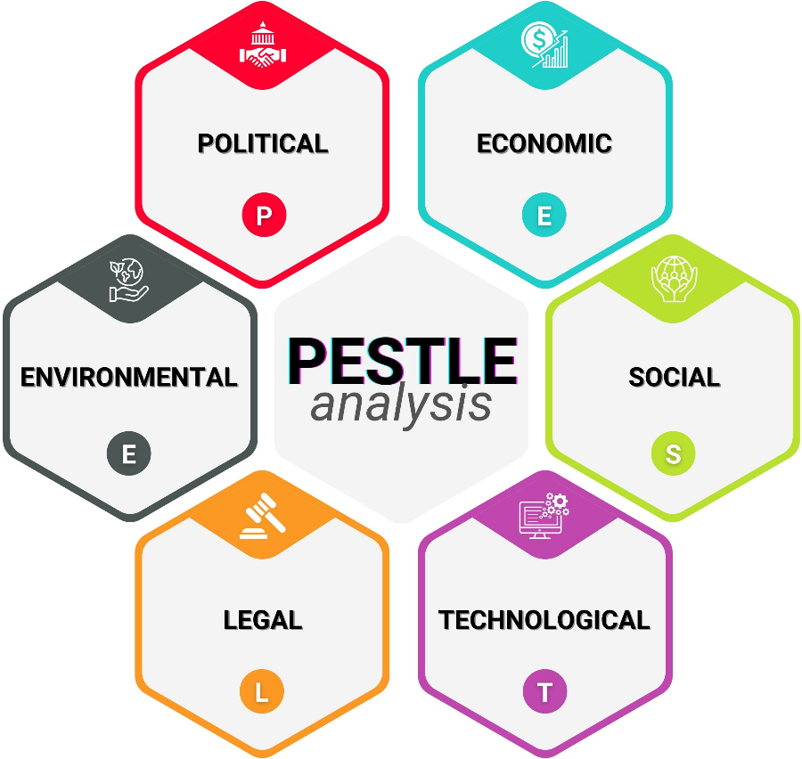
Figure 2: PESTLE Analysis (Iqbal, 2025)

Political Environment
The political climate in Pakistan is dynamic in respect of foreign direct investment (FDI). There have been political coalition changes and regional geopolitical realignments, but programmatic continuity in terms of the objectives of expanding and industrializing digital economy has existed across successive national governments (Asmussen et al., 2023).
One of the key political issues in Apple's sector is the national Mobile Device Manufacturing Policy (MDMP) managed by the Ministry of Industries and Production and Pakistan Telecommunication Authority (PTA). The MDMP offers international original equipment manufacturers (OEMs) tax exemptions, duty breaks for knock-down kit imports and regulatory clearance for setting up assembly lines here (Contractor et al., 2026). More than 30 foreign and joint-venture assembly plants have been set up under this policy, such as Samsung, Xiaomi, Vivo, and Transsion.
At the same time, Pakistan is expanding the economy's logistics and telecoms infrastructure through its economic collaboration with China under the China-Pakistan Economic Corridor (CPEC) along important trade routes (Fuchs, 2022). Apple is based in the USA, but its main manufacturing bases are in China, India and Vietnam. Efficient operation of the supply chain can only be assured with stable trade policies between Pakistan and these regional manufacturing hubs (Jamal, 2025).
But political factors may also arise because of the federal government's need to secure fiscal revenue targets in the context of international financial stabilization programmes by imposing import tariffs and taxes on luxury electronics (Yu. Baykov and Ershov, 2023). Fully assembled consumer electronic products, as a consequence, are subject to higher regulatory requirements, thus providing a policy incentive for foreign technology manufacturers to switch from product imports to local manufacture.
Economic Environment
Pakistan is a developing mixed economy ranked 40th by the nominal Gross Domestic Product (GDP) ($452.1 billion) and 20th by Purchasing Power Parity (PPP) ($2.17 trillion) in the world (Statista, 2024). The country has a population of ~257.4 million, providing strong population scale (IMF, 2026).

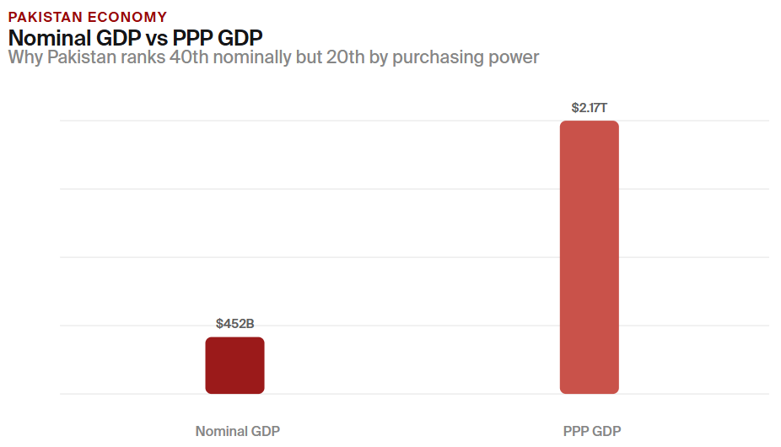
Figure 3: Pakistan's GDP at Purchasing Power Parity (IMF, 2026)
A detailed macroeconomic analysis highlights a stabilizing domestic economy. Headline Consumer Price Index (CPI) inflation came back to the near 3% mark between 3.0% and 3.5% after a spike in inflation during the past several months of 2023 (29.2%) (Jamal, 2025). The disinflation enabled State Bank of Pakistan (SBP) to take the policy rate cut by 1,100 basis points to 11.0% (Khitab, Zia and Tabassam, 2025). Lower rates help consumers' credit conditions, helping commercial banks and consumer fintech sites provide structured instalment plans for high-dollar items.
Further, worker remittances at $38.3 billion per annum were also larger than total goods export revenue ($40.79 billion) and were a significant contributor to the overall purchasing power of households (Kona, 2025). Remittance inflows go straight into private consumption and thus into premium mobile devices purchases; even though the nominal per capita GDP levels are low ($1,901) (World Bank, 2023). The structural economic problems are, however, still present:
The risk of currency needs to be continually assessed. The Pakistan Rupee (PKR) depreciated for multi-years period against the US Dollar, which led to the hike in the landed cost of finished goods imports. Apple's pricing of its devices worldwide in USD leads to fluctuations in retail prices in local currencies which affects the stability of demand at mass scale (Lin, Xiaoyu and Jianqiang, 2023).
Market access is also mediated by income inequality. The access to flagship products like the iPhone 17 Pro Max (which costs up to PKR 619,999) is still limited to high income group as the national poverty rate is 44.7% (Malik, 2024). Rather, the top 10% of urban households is a consumer mass of more than 25 million with purchasing power more akin to that of the upper middle-class consumers in well-developed EMRs (Shen, Giroud and Han, 2025).
Legal and Regulatory Environment
A multi-agency approach to regulation and oversight over mobile technology imports and telecoms in Pakistan is set by the Pakistan Telecommunication Authority (PTA) and the Federal Board of Revenue (FBR).
The main instrument of regulation is the PTA's Device Identification Registration and Blocking System (DIRBS). DIRBS calls for all mobile devices accessing a domestic cellular network to be checked and registered in the national database using their 15-digit International Mobile Equipment Identity (IMEI) number (Pereira et al., 2022). Unregistered devices are disconnected after 60 days when they are used in domestic cellular networks.
Technical verification is done by PTA and import duties are calculated and collected by FBR in accordance with published Customs Valuation Rulings (CVRs), for example, Valuation Ruling 1999/2025 and updated Valuation Ruling 2035/2026 (Oldroyd and Morris, 2023). The duties on imported luxury smartphones are Customs Duty (CD), Regulatory Duty (RD), Sales Tax (18% ad valorem), Advance Withholding Tax (WHT), and a fixed duty known as Mobile Levy (or the duty 15% of the import value) (Sheth, Uslay and Sisodia, 2020).
Table 1: Source: (Burhan Shah, 2025; Elena Rodriguez, 2026)
iPhone Model Variant | Assessed C&F Base (USD) | FBR Duty (CNIC Local Reg - PKR) | FBR Duty (Passport Reg - PKR) | Indicative Retail Price (PTA Approved - PKR)
iPhone 13 (128GB Used/Refurb) | ~$350 – $450 | ~PKR 45,000 – 63,139 | ~PKR 35,000 – 53,732 | ~PKR 179,999
iPhone 16 Standard (128GB) | ~$799 | PKR 144,723 | PKR 120,066 | ~PKR 385,000
iPhone 16 Pro Max (256GB) | ~$1,199 | PKR 183,005 | PKR 154,868 | ~PKR 495,000
iPhone 17 Standard | ~$899 | PKR 155,000 | PKR 129,000 | ~PKR 440,000
iPhone 17 Pro Max (512GB) | ~$1,399 | PKR 214,000 | PKR 183,000 | ~PKR 619,999

This tax regime creates substantial retail cost increases of finished goods from outside the EU. For instance, a typical iPhone 17, which costs PKR 899 (~PKR 250,000 pre-tax), will involve more than PKR 155,000 in combined taxes after it is registered on the CNIC, bringing the total consumer expenditure to more than PKR 400,000 (Elena Rodriguez, 2026).
In addition, FBRs have two types of registration: CNIC and Passport. Also, FBRs have two kinds of registration, i.e., CNIC and Passport registration with different duty rates for domestic commercial import and international travellers respectively. This price difference has created a black market for unregistered devices that do not carry a PTA logo and illegal IMEI cloning. According to Burhan Shah (2025) about 38% of the non-PTA iPhones listed online were having mismatching IMEIs and tampered firmware. The localized contract assembly would help Apple avoid these finished-goods import tariffs, keep prices down and cut down on the grey market incentives.
Socio-Cultural Environment
Pakistan has a strong inclination towards mobile technology adoption as per socio-cultural trends:
Demographically, more than 60% of total population of Pakistan (257.4 million) is below 30 years of age (Statista, 2024). It's definitely a young audience that is highly engaged with digital, actively uses social media, and has a keen interest in world-class consumer tech brands.
Demand also grows as a result of the growing digital economy. 81% of the adult population are covered by mobile broadband, Youth unemployment (12.6%) is one of the contributing factors that have made Pakistan develop a huge global IT freelancing sector, which contributes more than $2.6 billion in annual service exports (Taqi, 2026; Sekar, 2024). The estimated local economic value generated via digital platforms and AI tools is estimated to be PKR 3.9 trillion (IMF, 2026). This expanding, digital workforce demands the right kind of hardware, which opens up a new customer base for Apple's professional suite of products (MacBook Pro, iPad Pro, iPhone Pro series).
Furthermore, the iPhone enjoys a strong brand image in the major cities such as Islamabad, Lahore and Karachi. The brand equity gives Apple pricing power and helps them keep their average per-capita income in line with lower average income per nation, while keeping the price premiums (Zeng, 2021).

2.2 Market Entry: Dunning’s Eclectic (OLI) Paradigm
To determine whether Apple Inc. should transition from indirect exporting via Mercantile to direct foreign direct investment (FDI) in Pakistan, its strategic assets can be evaluated using John Dunning’s Eclectic (OLI) Paradigm.
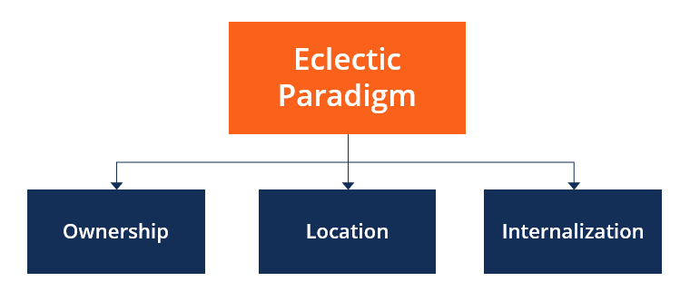
Figure 4: The OLI Framework (The Eclectic Paradigm) (CFI, 2022)
Ownership advantages (O): Apple's big assets are its brand, its own technology (hardware designs, iOS ecosystem, patents), and its capital resources (Asseraf and Gnizy, 2026). The O-advantages allow Apple to provide value that is different from its local rivals the premium brand and integrated ecosystem (Dunning, 2001). But it is a problem for Apple, whose products are quite expensive in a low-income market. Factors to consider when buying Apple into a company: Apple's know-how, patent strength, economies of scale (worldwide production reduces per-unit expense) (Ahmed et al., 2023). The Apple brand could attract a premium among the wealthy consumers in the Pakistani market. On the other hand, low IP protection can be defeated by counterfeiting or unauthorized grey imports.
Location advantages (L): A large population (240 + million) with a growing urban middle class in Pakistan, Long-term potential for tech consumption, the youthful demographic (median age ~20.6) (Bank, 2026). Pakistan also has more affordable labour than Western economies, and Apple's products are not labour-intensive in Pakistan, as they are imported. Parts may be sourced due to the proximity to China and China-Pakistan economic ties. But the location challenges are also poor consumer purchasing power, political instability, infrastructure gaps (such as inconsistent electricity, logistics etc.) (Bapuji et al., 2023). In response to problems with location, Apple has diversified its production, such as moving some manufacturing to India (Babu and Aithal, 2023). It may be tempting for Apple to produce in Pakistan if the country will offer assembly incentives to lower the tariffs. Currently, there are no such facilities in Pakistan. Overall, the location mix is mixed: a large market size and growth outlook (L advantage) but challenging operating environment (L disadvantage).
Internalization advantages (I): There are good reasons why Apple will continue to keep its technology and brand under wraps. By in-house, Apple can protect its IP and ensure a high level of customer experience by establishing its own subsidiary or wholly owned store (Berndt, Fantapié Altobelli and Sander, 2023). The risk of brand dilution or IP leaks would be present with licensing and/or franchising. So, Apple generally wants its own software and retail operations around the world, but outsourcing manufacturing to overseas partners such as Foxconn. If the country has a hostile legal environment, Apple will have to consider the costs of internalisation. Apple, in Pakistan's case, has not been internalized through a 100% presence, but through authorised distributors (Burhan Shah, 2025). This indicates that Apple is wary of investing in a challenging market. Internalization considerations, therefore, pull in two directions control would likely favour a direct subsidiary, but risky locale would likely favour non-equity modes at first.
The synthesis of key OLI Factors
Apple’s strong ownership (brand and technology) is an asset that can create value in Pakistan, but only if adequate local controls exist. While the size, youth, and diaspora inflows make for a location advantage, it has significant macro and regulatory disadvantages (Asmussen et al., 2023). Its internalization preference suggests that it would typically be investing at a high level (such as building stores and offices) if it felt the market justified it, but the risks might dictate that it should enter the market in a more conservative manner.
To sum up, Apple's OLI analysis indicates that they have a lot of ownership advantages to capitalize on, and location advantages, but lots of risks to overcome. The balance of factors suggests that Apple will have to be highly involved (to ensure the protection of their brand) and that they will be waiting for better market conditions before investing heavily. At first less committed entry modes (e.g., authorized distribution or a joint venture) may be more suitable, and internalization can be planned at the long term if political-economic conditions are becoming more stable (Contractor et al., 2026).

3. Entry Mode Strategy and Strategic Synthesis

3.1 Historical Entry Modes
Apple has used wholly owned subsidiaries and direct investment in foreign countries in the past to expand overseas. In fact, Apple's approach in most markets is to open its own stores (usually 100% owned) and office, as they want to have full control over sales, service and brand image (Elena Rodriguez, 2026). This is clearly visible in countries such as China, Europe and the Middle East, where Apple Inc. or its affiliated stores are present and control the distribution of Apple products. In most instances there isn't have any franchising, instead Apple allows particular retailers or carriers to sell its products with strict agreements (Fuchs, 2022). Many countries have only one local distributor signed up with Apple to import Apple's products, and they have strict licensing conditions. Still another is contract manufacturing (Foxconn and Pegatron are manufacturing for Apple, but not entering the market). The trend for Apple is direct investment in retail and corporate activities, alongside exclusive distribution deals (Yu. Baykov and Ershov, 2023).

3.2 Strategic Fit for Pakistan
The lessons of the past are applied to Pakistan and the applicability of a similar entry mode is discussed. If Apple came to Pakistan through a wholly owned subsidiary (e.g., company owned stores) it will have maximum control over the brand and service. This is consistent with Apple's high-end branding. The initial attractiveness of heavy investment, however, is reduced by the high political and economic risk. The business environment in Pakistan is highly volatile with substantial risk of losses of capital or forced concessions due to local political navigation required for a greenfield subsidiary (e.g., approvals from the government) (Iqbal, 2025). The burden of all regulatory hurdles would be shouldered by Apple. In addition, sometimes the local legislation restricts foreign retail investment (involving a local partner and/or special permit), which could cause bureaucratic delays on a WOS route.
Considering these risks, Apple has opted for a less risky approach of authorized distributor/retailer model in Pakistan. For example, in the late month of December 2025, Apple's authorized partner (GNext/Airlink) announced the first official Apple branded retail outlet in Lahore Pakistan (Praveen Parboteeah and Cullen, 2017). This store is an Apple authorised local store that carries genuine Apple products and warranties but is not owned by Apple Inc. This is a concept of basically licensing and authorized retail, which diminishes Apple's risk. Apple has the ability to gain market share and reach customers via trusted local partners without bearing the full burden and risk of their own subsidiary (Jamal, 2025). The downside is less control: Customer experience and pricing go partly to the partner, and Apple can't reap all the profits. But it is in keeping with the practical fact that Pakistan is an emerging, not so sure, market.
Alternative modes: A joint venture with a local company would have also been an option, but Apple's record in major markets shows they have shown little interest in equity-sharing retail outlets (Khitab, Zia and Tabassam, 2025). However, any partial equity stake (e.g., a minority stake in a distributor) may help align. Wholly exporting to Pakistan without local presence is another option Apple already uses to some extent via grey and authorized channels (Malik, 2024). Lastly, Apple may choose to assemble or contract manufacture locally to lower the tariff rate and to demonstrate its commitment (Kona, 2025). However, the establishment of an assembly plant (with partners) would require a big scale and government subsidies, which are not prevalent in Pakistan.

3.3 Conclusion and Recommendations
Recommendations
Based on the above analysis, it is recommended to have a staggered entry. It's a good idea to stick with the existing authorized-distributor model at first. The advantage of this low-risk approach is that it lets Apple see how the market reacts and slowly gains the trust of the brand, which is why GNext was hired and will open a store in Lahore (Taqi, 2026). This also avoids up-front big investments and regulatory hassles. After-sales support and official channels should be continued to be invested by Apple (e.g., extend the network of Apple authorized outlets beyond Lahore) (Neves and Kogut, 2023). Meanwhile, Apple needs to push for more favourable environment for business (e.g., cut import duties, enforce IP rights on products) in the regulatory arena.
If market demand and economic reforms come to fruition (such as the economy being stabilized, middle class expanding, laws strengthening protections), then Apple may consider further investment (Shen, Giroud and Han, 2025). For instance, setting up a 100% outlet in Karachi or in Islamabad when profits are guaranteed, or even setting up local assembly line to cut costs when profits are assured (Sekar, 2024). These should be carefully staged and dependent on sales target or regulatory developments.
The most sensible plan for Apple in Pakistan is to take a gradual and phased approach: with distribution in the form of licensed operators and to gradually increase the level of control, once the ownership benefits are clearly greater than the Pakistan risks are (Sherif, 2024). This will help Apple maintain its control and profit while at the same time dealing with Pakistan's political, economic, and legal issues.
Conclusion
In this report, it has been shown that Apple's strategy is mainly global and transnational: with central design, standardized products and limited adaptation, the brand is controlled. The setup is a key element of Apple's competitive edge, as it benefits from economies of scale, supply chain efficiency, and high brand loyalty, backed by a network of company-owned stores and authorised distribution partners around the world.
Pakistan has a market with significant long-term possibilities, bolstered by a youthful population, increasing digitalisation and the emerging urban affluent class. But macroeconomic instabilities, currency devaluation, high import taxes, income disparity and changing regulations under PTA and FBR limit this potential. According to Dunning's OLI approach, Apple has significant ownership advantages in terms of brand and technology, but the location advantage is mitigated by significant operational risk and at this juncture, a cautious and low commitment mode of entry prevails. Apple's current authorised-distribution model, as seen with GNext/Airlink, is thus the most viable option for current market conditions. This way, Apple can establish brand presence and gain market insights without significant financial and regulatory risks. As the economy and regulatory framework of Pakistan continues to mature, Apple should gradually take more control, starting with partial ownership of retailers and ultimately complete ownership and/or assembly. In the end, an incremental internationalisation approach is the most effective way of balancing Apple's brand protection requirements with the uncertainties of the Pakistani market.

Section 2: Reflective Account Analysis

Application of Gibbs’ Reflective Cycle
This section presents a critical reflection on the research, data synthesis, and strategy formulation processes conducted for Section 1, structured using Gibbs’ Reflective Cycle (1988). My approach began with a clear understanding of the assignment brief: to analyse Apple’s international strategy, evaluate Pakistan’s macro-environment, apply the OLI framework, and recommend an appropriate market entry mode.
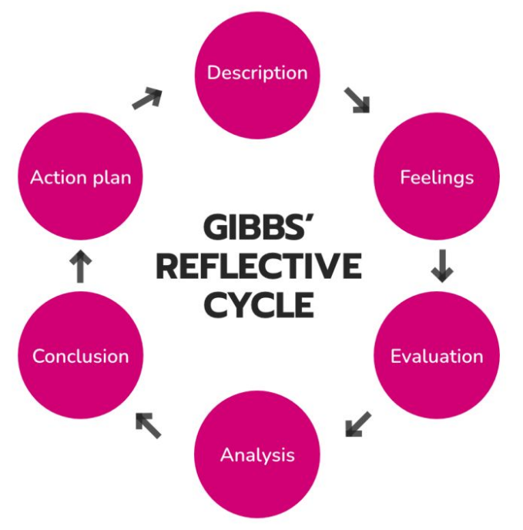
Figure 5: Gibbs' Reflective Cycle (McLeod, 2025)
The description stage identified the core requirements of the assessment and these were mapped to the structure of the report. I studied Apple's overall strategy, overseas presence, Pakistan market and the importance of foreign entry modes. The planning stage was crucial as it provided a logical order to the report and ensured that all sections connected to the strategic question (Sheth, Uslay and Sisodia, 2020). It also highlighted the need for the report not to just inform, but also evaluate, and to compare concepts, interpret evidence, and to make recommendations.
I was overwhelmed at the scope of the assignment during the feelings stage. The topic must involve knowledge of international business theory, country analysis, and strategic decision making, and must be related to the real market. As I started to get to know the frameworks, however, I felt more confident as the theories gave me something to organize information around. The biggest problem we faced was learning how to blend the theory from the academy with the company and market data while maintaining a logical flow throughout the report.
Research and analysis process
At the evaluation stage I had time to think about ways of collecting and analysing information. I started by reviewing lecture notes, readings from the module and case examples to refresh myself on the concepts of global strategy typology by Bartlett and Ghoshal, PESTEL analysis and the eclectic paradigm by Dunning (Oldroyd and Morris, 2023). These materials enabled me to understand the theories more practically instead of just memorized as separate models. The lectures were particularly helpful in emphasizing how multinational companies adjust their operations in different markets whilst maintaining their core benefits. That's really the key to my discussion about Apple, because consistency and responsiveness are both important parts of their strategy with Apple globally.
Having revised the theoretical aspect, I went to the targeted research to collect supporting data regarding the operations of Apple and the Pakistani context. For this, I researched the retail, manufacturing, distribution, and market strategies of Apple as well as the political, economic, legal, and socio-cultural environment of Pakistan. One of the important things emphasized was to use recent and current sources, not just older academic sources, as the assignment called for knowledge of the market that is current. There's some data about Apple's presence in Pakistan and market conditions that was inconsistent and limited, so I had to compare them carefully. This in turn required careful consideration of the source, particularly when making decisions about what claims were sufficiently substantiated to include in the report.
The one part of the process of research that proved to be extremely beneficial was bringing together theory and evidence. In the case of Bartlett and Ghoshal, this classification, Global, integrated, selectively adapted, could only be confirmed by reference to evidence of standardised products, centralised design and global brand consistency (McLeod, 2025).
Challenges and response

The analysis stage was the second one, where raw information was transformed to a structured argument. The biggest hurdle was categorizing Apple's business. On the other hand, its centralised architecture and closed environment are well suited to a global approach (Malik, 2024). Its local distributors and selective adaptation, however, imply transnational aspects. I settled for recognising the complexity, and not imposing a simplistic label on it. It added value to the report as it revealed critical thinking and no overstatement.
One of the other challenges was the assessment of Pakistan as a market without stereotyping or negative assumptions. Although the country poses obvious challenges such as currency volatility, import duties, and regulatory complexity, it has tremendous growth potential due to its youth population, digital adoption, and urban premium segment (Kona, 2025). I learned that strategic analysis has to take into account opportunity as well as constraint. This balanced approach was supported by course discussions, where market attractiveness and market entry feasibility were not equated. That's a distinction that influenced my thinking about a “slow and steady” approach to investing, not a “big bang” one.
Time management was also a challenge. Since the report must be divided into linked sections, I needed to limit the time I could spend on either one model or one source. To overcome this, I drafted the basic framework first, added evidence and then tightened up the argument later. This iterative approach helped to enhance the coherence, as each section was updated based on the preceding ones.
Learning and improvement
I identified some significant learning outcomes in the conclusion of Gibbs cycle. First, I got a better grasp of how international business structures can be applied in combination and not in isolation. Bartlett and Ghoshal were able to account for Apple's global orientation, while OLI explained the external environment and the connection between firm-specific assets and decisions to enter the market. Second, I developed the skills to assess sources and consider evidence selectively. Third, I found that describing a company is not enough for reflective/analytical writing; rather, it is necessary to explain why these are strategic decisions in a given market.

I was challenged by content of the course throughout the assignment. The lectures and reading gave a good conceptual understanding, and the case studies demonstrated how MNC's adjust their strategy in various institutional environments. These resources helped to translate theory into practice, especially as they applied to Apple's entry escalations in Pakistan. Overall, it helped build my confidence in analysing strategic international business and helped develop my skills to synthesise theory with practice. It also helped me to understand that sound recommendations should be realistic, and should be based on a balance of risk and opportunity and a context-specific interpretation.

References
Ahmed, S., Yongyuan, C., Bashir, M.T., Jamee, B., Atta, S.H., Shah, S.H.H., Kalsoom, H. and Younas, M.W. (2023). Marketing strategy of OPPO mobile phone in Pakistan. European Journal of Theoretical and Applied Sciences, [online] 1(6), pp.134–143. doi:10.59324/ejtas.2023.1(6).13.
Asseraf, Y. and Gnizy, I. (2026). Agile Mindset in International Business: The Case of Organizational Culture and Behavioral Performance. Review of International Business and Strategy, pp.1–24. doi:10.1108/ribs-04-2025-0064.
Babu B., M. and Aithal, P.S. (2023). The scope of sustainability in an orientation-based approach to penetration of foreign markets. [online] Social Science Research Network. Rochester, NY. doi:10.2139/ssrn.4575581.
Bank, A.D. (2026). Economic Forecasts: Asian Development Outlook April 2026. [online] Asian Development Bank. Available at: https://www.adb.org/outlook/editions/april-2026.
Bapuji, H., Chrispal, S., Vissa, B. and Ertug, G. (2023). Local, yet global: Implications of Caste for MNEs and International Business. Journal of International Business Policy. doi:10.1057/s42214-022-00146-9.
Berndt, R., Fantapié Altobelli, C. and Sander, M. (2023). International Market Entry Strategies. International Marketing Management, pp.165–200. doi:10.1007/978-3-662-66800-9_7.
Burhan Shah (2025). iPhone PTA tax in Pakistan – 2026. [online] PakTaxCalculator. Available at: https://paktaxcalculator.pk/iphone-pta-tax-in-pakistan/
CFI (2022). Eclectic Paradigm. [online] Corporate Finance Institute. Available at: https://corporatefinanceinstitute.com/resources/management/eclectic-paradigm/
Christian Geisler Asmussen, Fosfuri, A., Marcus Møller Larsen and Santangelo, G. D (2023). Corporate Social Responsibility in the Global Value Chain: A Bargaining Perspective. Journal of International Business Studies, 54(7). doi:10.1057/s41267-023-00635-w.
Contractor, F.J., Cantwell, J., Gereffi, G. and Sauvant, K.P. (2026). The shift to a more turbulent IB environment, and how MNEs respond to this shift. International Business Review, 35(2), p.102538. doi: 10.1016/j.ibusrev.2025.102538.
Dunning, J.H. (2001). The Eclectic (OLI) Paradigm of International Production: Past, Present and Future. International Journal of the Economics of Business, [online] 8(2), pp.173–190. doi: https://doi.org/10.1080/13571510110051441.
Elena Rodriguez (2026). What Is the Real iPhone Price in Pakistan? PTA vs Non-PTA Explained. [online] Alibaba.com. Available at: https://electronics.alibaba.com/question/iphone-pakistan-price-guide-pta
F. Yu. Baykov and Ershov, V.S. (2023). International Trade digital transformation impact on the global digital platforms expansion. doi:10.1109/emctech58502.2023.10296940.
Fuchs, M. (2022). Market Entry Modes. International Management, [online] pp.179–230. Available at: https://link.springer.com/chapter/10.1007/978-3-662-65870-3_5
IMF (2026). https://www.imf.org/external/datamapper/profile/PAK. [online] www.imf.org. Available at: https://www.imf.org/external/datamapper/profile/PAK
Iqbal, A. (2025). PESTLE Analysis: The CEO’s Guide to Future-Proofing a Business. [online] Medium. Techno-Preneurship. Available at: https://medium.com/techno-preneurship/pestle-analysis-the-ceos-guide-to-future-proofing-a-business-877e6c4e20ea
Jamal, Z. (2025). Pta tax on iPhone 17 series in Pakistan – A complete buyer’s guide (2025). [online] Modern Electronics. Available at: https://modernelectronics.pk/blogs/news/pta-tax-on-iphone-17-series-in-pakistan
K. Praveen Parboteeah and Cullen, J.B. (2017). International Business. Taylor & Francis.
Khitab, M., Zia, M.H. and Tabassam, A. (2025). A critical analysis of the strategic implications of globalization on business performance: Evaluating opportunities, challenges, and adaptive strategies. Social Science Review Archives, [online] 3(1), pp.1995–2008. doi:10.70670/sra. v3i1.510.
Kona, V.G. (2025). Impact of Exchange Rate Fluctuations on International Business. Ncirl.ie. [online] doi: https://norma.ncirl.ie/9046/1/venugopalkona.pdf.
Lin, Q., Xiaoyu, L. and Jianqiang, Z. (2023). The Apple company’s foreign expansion and market entry strategy. International Journal on Recent Trends in Business and Tourism (IJRTBT), 7(3), pp.47–60. doi:10.31674/ijrtbt. 2021.v07i03.004.
Malik, S. (2024). Cross-cultural marketing and international business expansion. International Journal of Multidisciplinary Research, [online] 2(03), pp.137–152. Available at: https://www.theijmr.com/index.php/ijmr/article/view/35
McLeod, S. (2025). Gibbs Reflective Cycle. [online] Simply Psychology. Available at: https://www.simplypsychology.org/gibbs-reflective-cycle.html
Neves, L. and Kogut, C.S. (2023). Diversity and Inclusion Programs in Multinationals: Opportunity for Reverse Knowledge Transfer. Rae-revista De Administracao De Empresas, 63(5). doi:10.1590/s0034-759020230503.
Oldroyd, J. and Morris, S. (2023). International Business. John Wiley & Sons.
Pereira, C.S., Durão, N., Moreira, F. and Veloso, B. (2022). The Importance of Digital Transformation in International Business. Sustainability, [online] 14(2), p.834. doi: https://doi.org/10.3390/su14020834.
Sekar, N. (2024). Apple’s Globalization Strategy. Why 70% of Consumers Worldwide Trust the Brand? [online] Medium. Management Matters. Available at: https://medium.com/management-matters/apples-globalization-strategy-8ca9783bb6d3
Shen, Y., Giroud, A. and Han, X. (2025). Navigating turbulent waters: A literature review of socio-political risks and multinational enterprises’ nonmarket strategies. International Business Review, [online] 34(6), p.102498. doi: 10.1016/j.ibusrev.2025.102498.
Sherif, A. (2024). Apple sales revenue by country 2019 | Statista. [online] Statista. www.statista.com. Available at: https://www.statista.com/statistics/382175/quarterly-revenue-of-apple-by-geograhical-region/.

Sheth, J., Uslay, C. and Sisodia, R. (2020). Global Expansion Strategies for Multinationals from Emerging Markets. The Global Rule of Three, [online] pp.195–226. doi:10.1007/978-3-030-57473-4_7.
Statista (2024). Global Revenue of Apple from 2004 to 2024. [online] Statista. www.statista.com. Available at: https://www.statista.com/statistics/265125/total-net-sales-of-apple-since-2004/
Taqi, S.A. (2026). Pakistan Economic Indicators 2000-2025. [online] kaggledatasets. Available at: https://www.kaggle.com/datasets/alitaqishah/pakistan-economic-indicators-2000-2025
World Bank (2023). Pakistan | Data. [online] Worldbank.org. Available at: https://data.worldbank.org/country/pakistan
Zeng, L. (2021). An analysis of Apple’s internationalization strategy. International Journal of Frontiers in Sociology, [online] 3(17). Available at: https://francis-press.com/index.php/papers/5092

