


`

Module Name: Digital Skills for Personal and Professional Growth
Module Code: BMSW4008
Assignment Name:
Task 1: Questionnaire analysis and the design of the website and marketing materials.
Task 2: The importance of Excel in the digital era.
Student Name: Devi Raju
Student Number: 2435195
Lecturer: Dr. Gareth Hughes
Deadline: 16.03.26

AI Acknowledgement:

I confirm that I have not presented any AI generated materials as my own work.
I confirm that I have copies of my drafts, notes, and other resources I used, which I may be asked to prove in evidence.

Task 1: Questionnaire analysis, the design of the website and marketing materials.

Contents
1. Introduction 4
1.1 Report Remit 5
2. Data Analysis and Key findings: 5
2.1 Findings 5
2.2 Frequency of Visiting Indian Restaurants 5
2.21 Significance for the Business Idea 6
2.22 Impact on Marketing and Websites 6
2.3 Reasons for Visiting Indian Restaurants: 6
2.31 Significance for the Business Idea 7
2.32 Impact on Website and Marketing 7
2.4 Factors Influencing Restaurant Choice 8
2.42 Impact on Marketing and Websites 9
2.5 Food Preferences and Spice Levels 9
2.51 Significance for the Business Idea 10
2.52 Impact on Website and Marketing 10
3. Customer Segmentation 10
4. Search Engine Optimisation (SEO) 11
5. Conclusion 11

List of Figures:
Figure.1 Frequency of visiting Indian restaurants
Figure. 2 Reason for visiting Indian restaurants
Figure. 3 Factors influencing restaurant choice
Figure. 4 Recommendation of Indian restaurants

Appendices:
Appendix 1 Nalas Kitchen Webpage 1 (Using Canva)
Appendix 2 Nalas Kitchen Webpage 2 (Using Canva)
Appendix 3 Nalas Kitchen Website with visible web address (www.nalaskitchen.co.uk) (Using Canva)
Appendix 4 Visiting card (Using Canva)
Appendix 5 Flyer (Using Canva)
Appendix 6 Nalas Kitchen – Loyalty card (using Canva)
Appendix 7 Location map (Using google map)

Questionnaire analysis and the design of the website and marketing materials.

1. Introduction
A questionnaire was carried out to understand people’s choice, opinions about visiting Indian restaurants. The survey has been conducted by using Microsoft google forms, collected responses from participates with different background like students, working professionals and business owners. The aim of the survey was to identify the customer food preferences, their choice of visiting the restaurant and the main factors that influence people, when choose an Indian restaurant.

1.1 Report Remit
The results from the questionnaire survey help support the development of the business’ idea and help make decisions for designing the website and marketing materials. These findings also help identify the target audience and support the Search engine optimisation (SEO) strategy for the website.

2. Data Analysis and Key findings:

2.1 Findings
This report focuses on four main questions from the survey.,
- Frequency of visiting Indian restaurants – Most respondents visit monthly, while some visit yearly and a few never visit.
- Reasons for visiting - People mainly visit for casual dining, family outings, celebrations, and takeaway.
- Factors that influence their choice of restaurant - Tasty food is the main factor, followed by location, ambience, and service.
- Food and spice preferences - Most prefer non-vegetarian dishes, especially chicken, or lamb with spice levels ranging from mild to very spicy.

2.2 Frequency of Visiting Indian Restaurants
The questions asked participants is how often do you visit Indian restaurants? The results show that most respondents visit Indian restaurants monthly, while some visit once a year. A small number of participants said that they never visit Indian restaurants.
This survey suggests that Indian restaurants are often considered as an occasional dining option rather than a regular weekly choice. Restaurant visit frequency can vary based on customer preferences and dining behaviour (Nderitu and Mutinda, 2024).

Fig.1 Frequency of visiting Indian restaurant.

2.21 Significance for the Business Idea
For the business idea, these findings show that the restaurant should focus on creating a special and enjoyable dining experience so customers can recommend the restaurant to others.
The restaurant could implement the following to increase customer acceptance,
- Discounts for students – Lower prices offered to attract students.
- Loyalty schemes – Rewards for customers who visit regularly.

2.22 Impact on Marketing and Websites
Special offers and promotions should be displayed on the website, such as social media posts, or flyer with special offers to increase customer support. Customers often search online for restaurant information before deciding where to dine (Lo, Tavitiyaman and Tsang, 2024).

2.3 Reasons for Visiting Indian Restaurants:
The most common answers for these questions, included casual dining, family outings, celebrations, and takeaway or delivery. According to Chua et al. (2020), customer restaurant choice is influenced by different dining occasions and restaurant types
Casual dining and family outings were the most popular reasons. This shows that people often visit Indian restaurants as a social experience where they can spend time with friends or family

Fig. 2 Reason for visiting Indian restaurant

2.31 Significance for the Business Idea
This result suggests that the restaurant should provide a comfortable and welcoming atmosphere - suitable for groups and families. The restaurant environment should make customers feel relaxed and enjoy their time.
For example, the restaurant could include the following:
- Space for group dining – Allows families and friends to dine together.
- Friendly and helpful staff - Improve customer service and overall satisfaction.
These features can improve the overall customer experience.

2.32 Impact on Website and Marketing
The website should show images of the restaurant interior and dining atmosphere. This helps potential customers imagine the experience before they visit.
Marketing materials should highlight the restaurant as a wonderful place for gatherings, celebrations, and family meals.

2.4 Factors Influencing Restaurant Choice
People are more likely to visit a restaurant when its atmosphere, menu, and services meet their dining needs and motivations (Balaji and Ponnam, n.d).
The main elements discussed were,
- Tasty food – Good flavour and good-quality food attract customers.
- Facilities and location – Easy access and good facilities improve convenience to customers. Customer behaviour and preferences can be used to recommend suitable restaurant locations and dining options (Taneja et al., 2016).
- Ambience – A pleasant atmosphere attracts more customers.
- Friendly assistance – Friendly and helpful staff improve overall satisfaction.
Customers often evaluate restaurants based on factors such as food quality, service, and overall atmosphere (Pezenka and Weismayer, 2020).

Figure 3 Factors influencing restaurant choice
The most crucial element among these is delicious food. This means that customers mostly choose restaurants based on the quality and flavour of the food.
2.41 Significance for the Business Idea
The restaurant must focus on serving high-quality, authentic, and tasty dishes. If customers enjoy the food. A strong restaurant concept and proper management are important for delivering a successful dining experience (Walker, 2021).
Many respondents also say they would recommend Indian restaurants to friends and family, showing the importance of word-of-mouth marketing.
Figure 4
Recommendation of Indian restaurant

2.42 Impact on Marketing and Websites
The website should display high quality images of popular dishes and provide clear descriptions of the menu.
Marketing materials should focus strongly on food presentation; social media posts and advertisements should highlight popular dishes such as chicken curry, butter chicken, and chicken biryani, which were mentioned in the survey responses.

2.5 Food Preferences and Spice Levels
Most respondents said they prefer non-vegetarian foods, especially chicken dishes. Some of them also prefer vegetarian meals, also some prefer mild or medium spice levels, while others prefer very spicy food. Consumers often select menu items depending on their taste preferences and dietary choices (Peters and Remaud, 2020).

Fig.5 Food Preferences and spice levels

2.51 Significance for the Business Idea
Customers should be able to choose dishes that suit their taste. Offering adjustable spice levels can help satisfy different customers.
The menu should include:
- Popular chicken dishes – Offers popular chicken dishes like butter chicken, chicken tikka that many customers enjoy.
- Vegetarian options – Provides lots of vegetarian and vegan options.
- Different spice levels – Allows customers to choose mild, medium or spicy food.
This variety can help attract a wider range of customers.

2.52 Impact on Website and Marketing
The online menu should clearly show the spice level of each dish, such as mild, medium, or spicy. This helps customers choose meals that match their preferences.

3. Customer Segmentation
The questionnaire results help identify the main target customers for the business.
The first group are students who made up the largest respondents. They usually look for affordable meals – offering students discounts and group discounts.
Secondly, working professionals – this group may prefer convenient options such as take away and delivery – online ordering and quick delivery services.
Then, families and social groups who visit restaurants for celebrations and gatherings – comfortable seating, friendly service and pleasant atmosphere.

4. Search Engine Optimisation (SEO)
SEO is important to help the restaurants website appear in online search. Based on the questionnaire results, the website should focus on keywords such as,
- Indian restaurant near me – Help customer to find nearby Indian restaurant.
- Best Indian food – Attracts people searching high quality Indian cuisine.
- Chicken curry restaurant – Target customers looking for Indian curries.
- Indian takeaway and delivery – Reach customer looking for take away & dine in options.
The business should create and optimise its Google Business profile, include the restaurant’s location on the website, and encourage customers to leave reviews. Customer reviews on online platforms help evaluate dining experiences and restaurant performance (Mathayomchan and Taecharungroj, 2020).

5. Conclusion
The questionnaire provided useful information into customer behaviour and preferences when visiting Indian restaurants. The results show that people usually visit Indian restaurants for casual dining, family gatherings and celebrations. The most important factor influencing their choice of restaurant is tasty food.
The results also helped guide decisions for the website design and marketing materials, including the use of attractive food images, promotional offers, and easy online ordering options. Finally, a strong SEO strategy focusing on local searches and relevant keywords will help increase the restaurant’s online visibility and attract more customers.
6. Appendices:
Appendix 1: Nalas Kitchen Web page 1 (Using Canva)
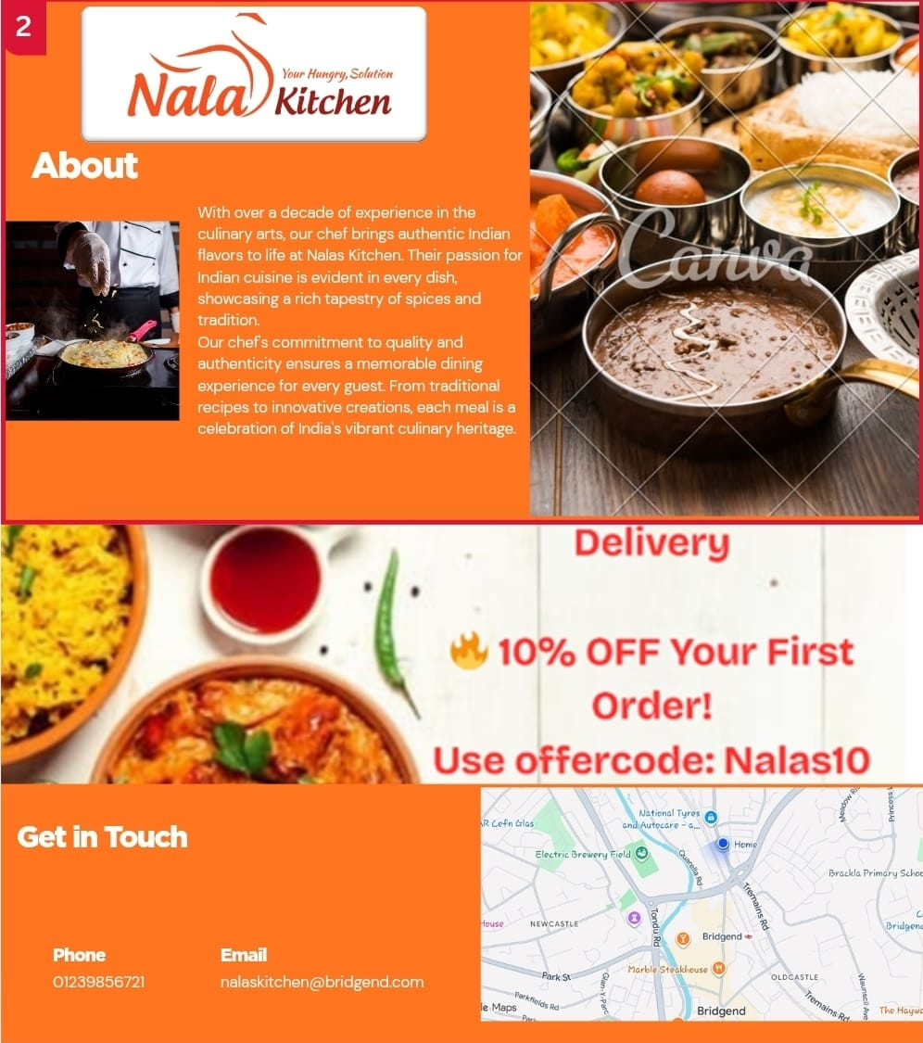

Appendix 2: Nalas Kitchen Web page 2 (Using Canva)
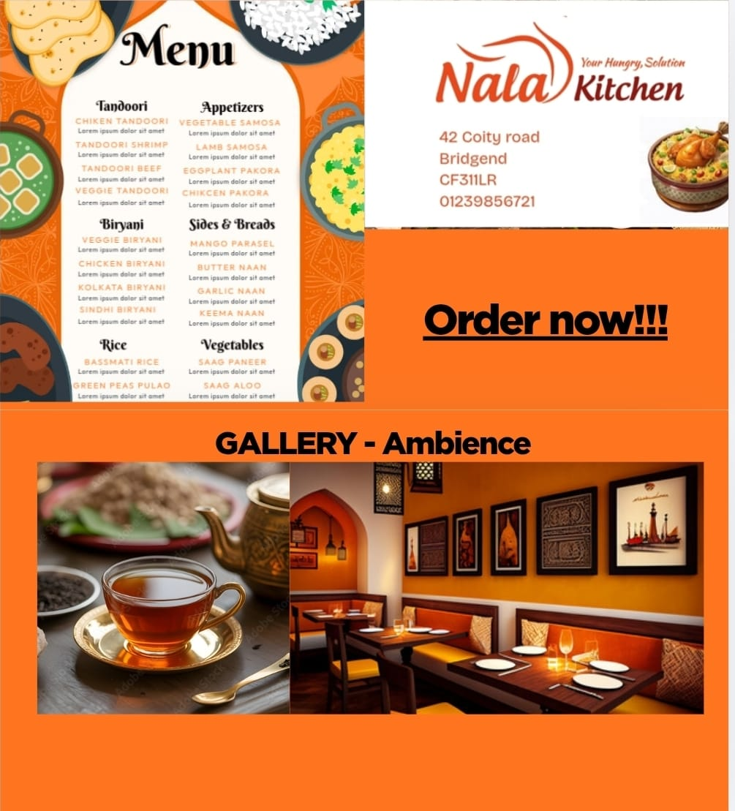

Appendix 3: Nalas Kitchen Website with visible web address (www.nalaskitchen.co.uk)
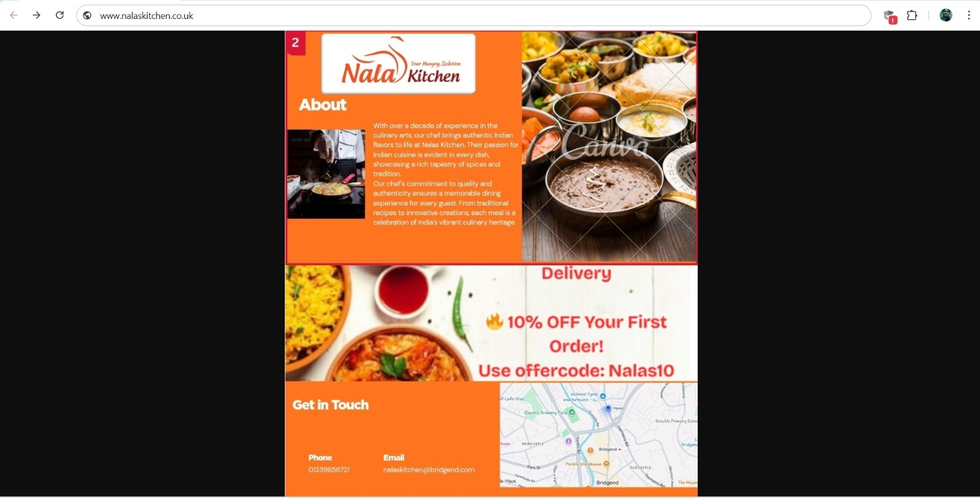


Appendix 4: Visiting card (Using Canva)

Appendix 5: Flyer (Using Canva)
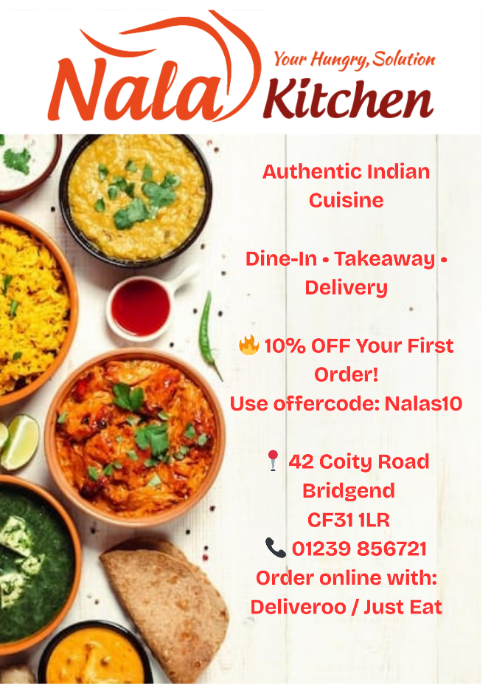
Appendix 6 Nalas Kitchen – Loyalty card (using Canva)


Appendix 7: Location
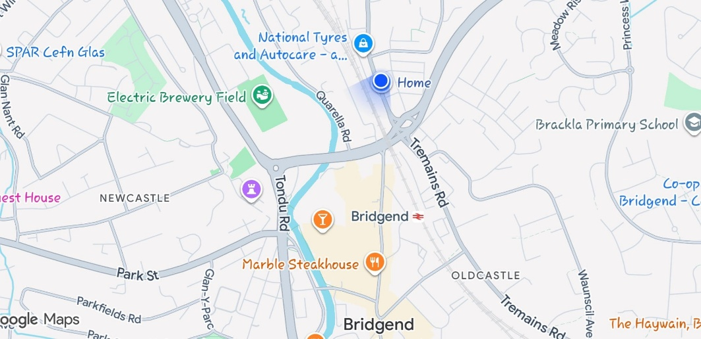

References:

1. Al-Haraizah, A., Abdelfattah, F.A., Rehman, S.U., Ismaeel, B., Mufleh, M. and Omeish, F.Y., 2025. The impact of search engine optimization and website engagement towards customer buying behaviour. Global Knowledge, Memory and Communication.
Available at: https://www.emerald.com/gkmc/article-pdf/doi/10.1108/GKMC-06-2024-0347/9797888/gkmc-06-2024-0347.pdf
2. BALAJI, M. S. and Ponnam, A. (no date) “Matching visitation-motives and restaurant attributes in casual dining restaurants.”
Available at https://doi.org/10.1016/J.IJHM.2013.10.004
3. Biswas, A. and Verma, R.K., 2023. Augmenting service quality dimensions: mediation of image in the Indian restaurant industry. Journal of Foodservice Business Research, 26(3), pp.496-527.
Available at: https://www.tandfonline.com/doi/pdf/10.1080/15378020.2022.2027198?casa_token=s7ELThc1nrkAAAAA:MyOCYYy7L-x8350ndqaGSn8n3HE02auP1iBskuM4btfEvW8PEgYCGYVzOb1fqExnIxYe-Avv028t
4. Chua, B.L., Karim, S., Lee, S. and Han, H., 2020. Customer restaurant choice: An empirical analysis of restaurant types and eating-out occasions. International Journal of Environmental Research and Public Health, 17(17), p.6276.
Available at; Customer Restaurant Choice: An Empirical Analysis of Restaurant Types and Eating-Out Occasions - PMC
5. D’Souza, E., 2025. Perceived service quality, price fairness, and their effect on customer satisfaction and loyalty in the Indian restaurant sector. Journal of Hotel Management and Tourism, 3(1), pp.1-29.
Available at: https://www.researchgate.net/profile/Edgar-Dsouza/publication/392518843_Perceived_Service_Quality_Price_Fairness_and_Their_Effect_on_Customer_Satisfaction_and_Loyalty_in_the_Indian_Restaurant_Sector/links/6846b33ec33afe388acafe6d/Perceived-Service-Quality-Price-Fairness-and-Their-Effect-on-Customer-Satisfaction-and-Loyalty-in-the-Indian-Restaurant-Sector.pdf
6. Lo, S.K.J., Tavitiyaman, P. and Tsang, W.S.L., 2024. Impact of customers' needs on online information search of upscale restaurant attributes and customer satisfaction. British Food Journal, 126(3), pp.941-964.
Available at: https://www.emerald.com/bfj/article-abstract/126/3/941/1213792/Impact-of-customers-needs-on-online-information?redirectedFrom=PDF
7. Mathayomchan, B. and Taecharungroj, V., 2020. “How was your meal?” Examining customer experience using Google maps reviews. International Journal of Hospitality Management, 90, p.102641.
Available at: https://scholar.google.co.uk/scholar?output=instlink&q=info:F-8oXxdJnCQJ:scholar.google.com/&hl=en&as_sdt=0,5&as_ylo=2020&as_yhi=2025&scillfp=5514668685117588237&oi=lle
8. Nderitu, L. and Mutinda, R., 2024. Hygiene and sanitation practices on customer satisfaction in ethnical restaurants found in Nairobi County. International Journal of Advanced Research, September.
Available at: Hygiene And Sanitation Practices On Customer Satisfaction In Ethnical Restaurants Found In Nairobi County
9. Peters, K. and Remaud, P.H., 2020. Factors influencing consumer menu-item selection in a restaurant context. Food Quality and Preference, 82, p.103887.
Available at: https://www.sciencedirect.com/science/article/am/pii/S0950329319303726
10. Pezenka, I. and Weismayer, C., 2020. Which factors influence locals’ and visitors’ overall restaurant evaluations? International Journal of Contemporary Hospitality Management, 32(9), pp.2793-2812.
Available at: https://www.emerald.com/ijchm/article-pdf/32/9/2793/822662/ijchm-09-2019-0796.pdf
11. Taneja, A., Gupta, P., Garg, A., Bansal, A., Grewal, K.P. and Arora, A., 2016, December. Social graph-based location recommendation using users' behaviour: By locating the best route and dining in best restaurant. In 2016 Fourth International Conference on Parallel, Distributed and Grid Computing (PDGC) (pp. 488-494). IEEE.
Available at: https://ieeexplore.ieee.org/iel7/7907562/7913107/07913244.pdf?casa_token=leIKZk4OYJ4AAAAA:58Y_ZspYPEzbN5wMDcbPcEj-E_kthgWG6JSpzQpfwLCvYjC4ptvdfrLoTqCdGaYue1BKb33s8fRl
12. Walker, J.R., 2021. The restaurant: from concept to operation. John Wiley & Sons.
Available at:
https://books.google.co.uk/books?id=_1GEAAAQBAJ&lpg=PR7&ots=s98DqPkatu&dq=Significance%20for%20the%20Business%20Idea%20%20indian%20restaurants&lr&pg=PR7#v=onepage&q=Significance%20for%20the%20Business%20Idea%20-%20indian%20restaurants&f=false

Task 2
The Important of Excel in the Digital era and its Application in Business:

My business Nalas kitchen 12month Finance plan and its profit and loss with bar chart.

Nalas Kitchen Finance plan -Devi Raju 2435195.xlsx

In today’s digital era, Businesses are relying on data, organisation and accurate financial management. In a world where technology is evolving rapidly, some tools have managed to stand the test of time. One such tool is Microsoft Excel, one of the oldest spreadsheets that continues to be an essential part of businesses, research and data management. According to Kumar (2023) investigates the significance of Microsoft Excel’s data analysis and statistical tools in supporting research activities.
Excel remains highly relevant because of its simplicity, flexibility and practical usefulness. According to Mustafy and Rahman (2024) examine how Excel can be effectively utilized for performing statistical calculations and data analysis. It is not only a tool for calculations but also a powerful system for managing information and analysing performance.
Excel plays an important role in business organise and interpret data. In any business, there are large amounts of information are generated daily, including sales records, operational costs, customer data, and financial transactions. Excel provides a clear and organized way to store, categorise and analyse data. Al Maruf et al. (2022) explain how SQL and Excel play a key role in supporting data-based business decisions, especially for aspiring analysts. Spread sheet format allows users to arrange information logically, making it easier to understand financial and operational activities. Winston (2021) explains how to use Microsoft Excel for analysing data and creating business models, focusing on Office 2021 and Microsoft 365.
One of the main reasons Excel is very important in the digital era is its accessibility. Unlike many specialised tools, Excel is easy to learn and use. Even individual can use without advanced technical knowledge, anyone can perform essential tasks such as calculations, reporting, budgeting, all other financial transactions and making chart. According to Park, Hong, and Kondrat (2022), Excel serves as an effective learning tool that positively influences students’ attitudes toward statistics. Excels are very useful for students, small business owners and entrepreneurs.it gives practical solution for managing business information without requiring expensive or other complex systems.
From a business perspective, Excel is very important in financial management. Every business, either its small or big business, they must keep track of its income and expenses. They must maintain the budgeting and organisational structure. Excels provides an efficient way to maintain those records. By entering daily sales figures and operational cost into spreadsheets, business can easily monitor their financial position. This helps prevent errors and supports better financial control. According to Bluttman (2021), Excel is widely used in both every day and professional contexts. It supports various personal tasks such as budgeting and organisation, while in the workplace it serves as an essential tool for data analysis, reporting, and information management due to its efficiency and flexibility.
In my own Indian restaurant business, Excel is an extremely useful for managing my business income and expenses. It allows me to record all sources of all incomes like, dine in sales, take away sales, delivery catering and events sales, or other earnings in a structured manner. At the same time, I can list all expenses, including rent, salaries, utilities, marketing expenses, raw materials and miscellaneous expenses. Having all this information clearly organised makes it much easier to see where money is coming from and where it is being spent. Also, I can easily maintain my monthly income and expenses to calculate my yearly profit and loss statement. Rachmanto and Utami (2024) discuss how small businesses can improve the efficiency and accuracy of their financial reporting by effectively utilising Microsoft Excel. Their work highlights Excel as a practical tool for enhancing reporting processes and supporting better financial management. This is very essential for maintaining financial discipline and avoiding unnecessary expenditure. More importantly it allows me to analyse financial flow over different periods of time, such as monthly or early comparisons
I have used bar chart to compare income and expenses, in my business this helps me evaluate performance more effectively, visual presentation of data supports clearer understanding and better planning my business. Remenyi, Onofrei, and English (2022) demonstrate Excel’s statistical functions and methods through practical examples, presenting the results using visualisations such as bar charts, line charts, and scatter plots.
In conclusion, Excel remains an essential tool in the digital era. Its plays an important role in organising data, managing finances, support decision making. In my own business, Excel is particularly important for maintaining income and expenses, preparing profit and loss statements, analysing my 12th month (yearly) cashflow of my financial statements and planning for the future. Excel continues to provide businesses with a simple, yet powerful way to manage information and achieve financial goal and control.

References:
1. Al Maruf, A., Paul, R., Imam, M.H. and Babar, Z., 2022. A Systematic Review of The Role Of SQL And Excel In Data-Driven Business Decision-Making For Aspiring Analysts. American Journal of Scholarly Research and Innovation, 1(01), pp.249-269.
Available at: https://researchinnovationjournal.com/index.php/AJSRI/article/download/46/35
2. Bluttman, K., 2021. Excel formulas & functions for dummies. John Wiley & Sons.
Available at: https://books.google.co.uk/books?hl=en&lr=&id=dFNPEAAAQBAJ&oi=fnd&pg=PA3&dq=Excel+profit+and+loss+analysis&ots=hDeBOSC_VW&sig=Io6JTtnMmY2qcwWiA5iWmkEjLFA&redir_esc=y#v=onepage&q&f=false
3. Kumar, M.D., 2023. A study on importance of microsoft excel data analysis statistical tools in research works. Journal of Management & Educational Research Innovation, 1(3), pp.25-33.
Available at: https://www.jomeri.org/index.php/jomeri/article/download/12/14
4. Lindquist, J.M. and Sulewski, C.A., 2024. Microsoft Excel. Handbook Of Military And Defense Operations Research, 21.
Available at: https://books.google.co.uk/books?hl=en&lr=&id=2U0REQAAQBAJ&oi=fnd&pg=PA21&dq=excel+and+its+importance+in+digital+era&ots=BkPM49cmbw&sig=7dEo0GWzCDcJJU_ww7xs3-KdtP8&redir_esc=y#v=onepage&q&f=false
5. Mount, G., 2024. Modern Data Analytics in Excel. " O'Reilly Media, Inc.".
Available at:
https://books.google.co.uk/books?hl=en&lr=&id=zecEEQAAQBAJ&oi=fnd&pg=PP1&dq=excel+and+its+importance+in+digital+era&ots=k23PZPAO83&sig=x04y18RxefXiLP6G_HVpgNi0t7Y&redir_esc=y#v=onepage&q=excel%20and%20its%20importance%20in%20digital%20era&f=false
6. Mustafy, T. and Rahman, M.T.U., 2024. Excel. In Statistics and Data Analysis for Engineers and Scientists (pp. 81-134). Singapore: Springer Nature Singapore.
Available at: https://link.springer.com/chapter/10.1007/978-981-99-4661-7_3
7. Park, T., Hong, M. and Kondrat, D., 2022. Undergraduate students’ attitudes toward statistics: How Excel makes a student’s life easier. Journal of Evidence-Based Social Work, 19(3), pp.263-271.
Available at: https://www.tandfonline.com/doi/pdf/10.1080/26408066.2022.2025968?casa_token=jmCLinbu1EAAAAA:aJ4CqXWlM0ODs_VKutWJukEqH86DHRQFNXAjv3kHSzYdJXZvSjBPOw2-Ja8IdNVctkzmos9HlDPY
8. Rachmanto, A. and Utami, E.R., 2024, June. Optimizing Financial Reporting in Small Businesses: Leveraging Microsoft Excel for Efficiency and Accuracy. In Proceeding of International Conference on Business, Economics, Social Sciences, and Humanities (Vol. 7, pp. 284-294).
Available at: https://proceedings.unikom.ac.id/index.php/icobest/article/download/538/524
9. Remenyi, D., Onofrei, G. and English, J., 2022. An introduction to statistics using Microsoft Excel. Uj Press.
Available at: https://books.google.co.uk/books?hl=en&lr=&id=ePWBEAAAQBAJ&oi=fnd&pg=PR1&dq=excel+bar+charts&ots=Rgz__duShI&sig=rZd3GK6csTQPADyqIw6tj8e0t6g&redir_esc=y#v=onepage&q=excel%20bar%20charts&f=false
10. Winston, W., 2021. Microsoft Excel data analysis and business modeling (Office 2021 and Microsoft 365). Microsoft Press.
Available at: https://books.google.co.uk/books?hl=en&lr=&id=dtfPEAAAQBAJ&oi=fnd&pg=PP17&dq=excel+and+its+uses+for+business&ots=q-jBYABaDN&sig=WrodbwSyTov89CcI0ACyjspcgH8&redir_esc=y#v=onepage&q&f=false

Task 3
Short Advertisement video of Nalas Kitchen
Advertisement of Nalas kitchen Devi Raju 2435195.mp4
(Created by using Canva)

