

Student name: Haroon Ahmed
Student ID number: 2437163
Programme: Master of Business Administration
Module: Marketing Management
Module code: LCMB7024
Lecturer: Laila Maazouz Dian Mayasari
Assignment Title: Assessment component 1: Marketing Environment Analysis
Word count: 2745
Submission deadline: 27th March 2026

Table of Contents
1. INTRODUCTION 3
2. INDUSTRY & COMPANY OVERVIEW 4
2.1 Electric Vehicle (EV) Industry Overview 4
2.2 Tesla (Pioneer Organisation) 5
2.3 BYD (Follower Organisation) 6
3. TASK 1: MACRO ENVIRONMENT ANALYSIS 6
3.1 PESTLE Introduction 6
3.2 Technological Factor 6
3.3 Political / Legal Factor 8
3.4 Comparative Insight 9
4. TASK 2: STRATEGIC RESPONSES (Part 1) 9
4.1 Strategy Introduction 9
4.2 ANSOFF MATRIX 10
4.4 STRATEGIC EVALUATION 12
5. CRITICAL DISCUSSION 12
6. CONCLUSION 13
7. REFERENCES 13

1. INTRODUCTION
The analysis of the marketing environment is an important pillar to strategic decisions that organisations can employ to determine the external opportunities and threats that influence the competitive positioning and long-term performance. Instead of being a purely descriptive tool, it offers a frameworked prism that firms view the complex and dynamic external forces of technological disruption, regulatory change, and shifting consumer expectations through (Kotler et al., 2020). The industry of electric vehicles (EVs) across the world offers a rather specific scenario to focus on these dynamics as it is marked by an extremely high pace of technological advancement, heavy regulation, and increasing pressure of society to sustainability. The policies of decarbonisation, developed by governments, and the development of the battery technology and the shift of consumers towards green mobility increased the market growth and competition (IEA, 2023).
These macro-environmental forces, however, do not have homogenous impacts on firms, but rather generate differentiation opportunities and constraints based on the organisational capabilities and strategic orientation. Such imbalance is witnessed in the difference in positions of Tesla and BYD in the EV market (Arowolo et al., 2024). Tesla being an innovative organisation has developed a high differentiation advantage due to constant innovations, brand equity and technology leadership. On the contrary, BYD, being a follower, has implemented a more cost-efficient strategy, scale, and the ability to use favourable domestic policy settings to experience rapid market growth (Lazonick and Li, 2022). Strategic positioning defines outcomes and macro forces do not have an equal impact on firms.
In this respect, this report seeks to critically examine how the macro-environmental factors of choice influence Tesla and BYD and assess their strategic reactions relying on the proven models, such as PESTLE analysis, the generic strategies developed by Porter, and the Ansoff matrix. The report will be laid out in such a way that it initially evaluates the impacts of the environment and then evaluates the way each of the firms is adjusting itself strategically in order to maintain competitive advantage (Han et al., 2023).

2. INDUSTRY & COMPANY OVERVIEW

2.1 Electric Vehicle (EV) Industry Overview
The electric vehicle (EV) market has been growing faster over the last ten years due to the structural change towards decarbonisation, the growing price of fossil fuels, and the pressure of rising regulatory requirements to minimise emissions in the global market. The sale of EVs in the world market has been growing rapidly; it is indicative of the demand that is promoted by the policies and the rise in the dismissal of sustainable mobility solutions by consumers. But this expansion is not directly another result of environmental consciousness at all; it is rooted in geopolitical moves, technological development, and national industrial policies (Campbell et al., 2021).
More importantly, the EV market is marked by a high level of competitive rivalry and fast-paced technological development, especially in battery efficiency, a charging system, and autonomous systems. This makes the environment a dynamic one where companies have to be innovative always and are under pressure to control costs and supply chain limitations (Lau et al., 2022). More so, sustainability demand is no longer a differentiating factor which is now a baseline expectation thus escalating competition because companies are moving towards the same environmental value propositions. Consequently, competitive advantage is being conditioned more and more by the efficiency with which organisations combine innovation, scale, and strategic responsiveness and no longer just by being involved in the green transition (Ogrean & Herciu, 2022).
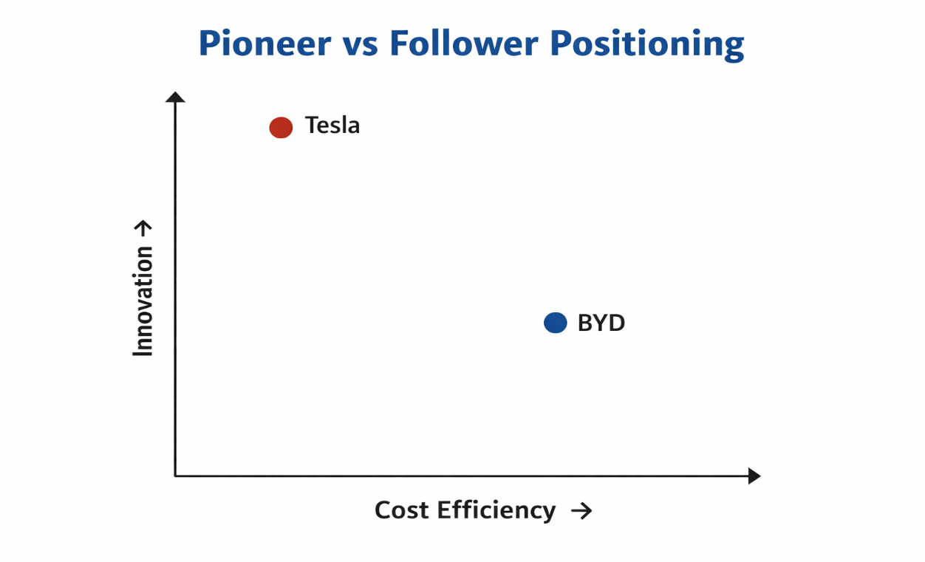
FIGURE 1: Pioneer vs Follower Positioning
TABLE 1: EV Industry Overview
Factor | Insight
Growth | Rapid global expansion driven by policy and innovation
Drivers | Climate regulations, fuel price volatility, sustainability demand
Competition | Intensifying rivalry with technological convergence

2.2 Tesla (Pioneer Organisation)
Tesla is a market leader and an industry first-mover, having built first-mover advantages over many years of investment in innovation, especially in battery technology, software integration, and autonomous driving systems. Its differentiation emphasis has helped the company to develop strong brand equity in terms of technological difference and high quality (Mangram, 2012). Nevertheless, the same positioning puts Tesla at greater risk of operations such as cost pressures and growing competition as other competitors copy central technologies. More importantly, Tesla has the strength not just in its innovation but commercialisation and scaling technological breakthroughs before major companies (Suzuki et al., 2024).

2.3 BYD (Follower Organisation)
BYD is a very efficient follower strategy, utilising cost effectiveness, vertical integration and good governmental support in order to gain market share within a short period of time. In contrast to Tesla, BYD is interested in the low prices and the mass-market coverage, which is backed by the fact that the company has a bear on both battery production and supply chains (Liu and Meng, 2017). This enables the company to enjoy the economies of scale and be elastic to local and foreign demand. Most importantly, the case of BYD demonstrates that the competitive edge of the EV industry can be innovation-based, but it may also be created due to the systematic alignment with policy frameworks and operational cost-effectiveness (Jetin, 2023).

3. TASK 1: MACRO ENVIRONMENT ANALYSIS

3.1 PESTLE Introduction
PESTLE analysis offers a systematic way of analysing the macro environmental forces which influence the industry dynamics and organisational strategy. It allows the companies to strategically evaluate the impact of external variables on opportunities and limitations in a particular market through political, economic, social, technological, legal, and environmental means (Johnson et al., 2020). Nevertheless, though PESTLE provides analytical vividness, its usefulness is not in categorisation but the effectiveness with which organisations perceive and react to such forces. Macro-environmental factors do not act independently in industries that are highly dynamic, like electric vehicles (EVs), in that they create unequal competitive advantages, thus benefitting companies with unique strategic capabilities (Kumar et al., 2025).

3.2 Technological Factor
The most drastic element of change in the EV industry is technological progress, which essentially determines the innovation of the products, cost bases, and positioning. On the most basic level, EV technology covers battery efficiency, energy density, charging infrastructure and, to an increasing degree, software integration and autonomous driving systems. These are technological dimensions that not only define the performance of the vehicles but also affect how consumers take up the vehicles as well as their ability to survive in the long-run in the market (Kley et al., 2011).
Innovation at a fast rate has been experienced to increase competition at the industry level, with companies competing to come up with more efficient batteries and scalable production processes. Advancement in technology has also increased barriers to entry by new entrants and on the existing firms to engage in continuous research and development (R&D). This is a paradox in whichalongside being a source of competitive advantage, innovation is the driver of convergence in the industry (Dong, 2025). Tesla is a vivid example of a technology-oriented policy which uses significant investments in R&D to remain one of the leaders in innovations. Its vertically-integrated ecosystem with proprietary battery technology, software functions and over-the-air updates allow the product to improve continuously and support brand differentiation. More importantly, Tesla has an upper hand not just in the features of its products but also in its capacity to commercialise innovation on a large scale, which becomes a way of bringing technological leadership to a competitive advantage over time (Vynakov et al., 2016).
However, BYD is more flexible in its technology, concentrating on cost-effective innovation and mass production. Although its R&D potential is on the rise, the existing competitive advantage of BYD is its vertical integration especially in battery production that the company can use to lower its costs and improve control over the supply chain (Zapata et al., 2024). Instead of pioneering technological advances, BYD leverages on the available innovations to realise the effect of fast penetration in the market especially in the price-sensitive markets.
TABLE 2: Technological Impact Comparison
Aspect | Tesla | BYD
Innovation | High – industry leader in EV tech | Moderate – adaptive innovation
R&D | Strong investment and capability | Growing but cost-focused
Strategy | Differentiation through innovation | Cost adaptation and scalability

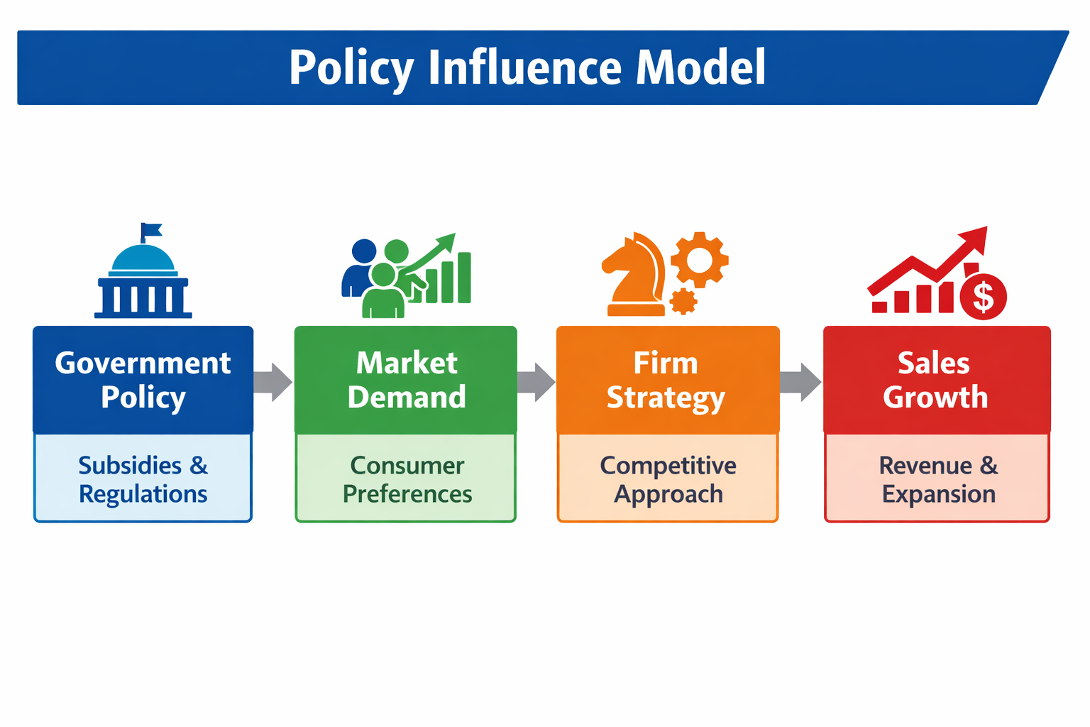
FIGURE 2: Policy Influence Model

3.3 Political / Legal Factor
Legal and political influences are considered determinant in the formation of the EV industry, as the government intervention directly influences the demand in the market, the incentives to produce, and to be positioned in the competition. Subsidies, tax incentives, emissions regulations, and trade restrictions are some of the policies that have increased the use of EVs in the world, turning the niche market into a strategic industry priority (Mazzucato, 2018). Regulatory frameworks within the industry level provide opportunities and constraints. Consumer demand is boosted with subsidies and incentives whereas strict emissions standards force manufacturers to switch to internal combustion engines. Nevertheless, such policies tend to be disproportionately located in the regions, which causes a major difference in the competitive advantage. The trade laws such as tariffs and localisation policies complicate the access to the global market and strategic development (Shalu & Pandey, 2025).
Tesla is in a complicated global regulatory environment, enjoying the initial advantages of government incentives in countries like the United States, but at the same time, worries about the fact that the regulatory pressure is growing stronger because subsidies are eliminated and competition is also growing stronger. The global expansion business model presents it to different legal risks, where it has to constantly adapt to local compliance standards. More importantly, the fact that Tesla has become less dependent on the direct assistance of the government in recent years indicates its shift towards the market-driven competitive approach (Huang and Xiang, 2024).
On the other hand, BYD has substantially enjoyed a long-term and high level of government support in China, such as subsidies, favourable industrial policies, and infrastructure development. This has been facilitated by policy congruence that has helped BYD to grow production at a high rate and become a cost leader (Midler and Alochet, 2023). Moreover, the industrial policy of China on the development of EV has placed a protective environment that favours local companies. Nevertheless, the dependence of BYD on the benefits associated with policy can become a risk in the case when the conditions of the international regulations change or the international barriers to trade are elevated (Ruiz, 2024).
TABLE 3: Political Impact Comparison
Factor | Tesla | BYD
Government Support | Limited and declining | Strong and sustained
Regulation | High global compliance pressure | Domestic policy advantage
Market Access | Global but complex | Policy-driven expansion

3.4 Comparative Insight
The discussion indicates that forces in the macro-environment create disproportionate outcomes in the competitive environment of the EV industry. The strength of Tesla lies more on being technologically advanced, and capable of product differentiation, which is innovation-driven. By contrast, BYD has a competitive edge that is a policy-based one, backed by the positive intervention of the government and cost-efficient activities (Otero-Iglesias et al., 2025). Such a dissimilarity demonstrates that successfulness in the same macro-environment is not contingent on the external conditions as much as it is about the effectiveness with which the firms match the strategic strengths with the external conditions. As a result, the environment does not provide competitive advantage on its own, but rather it is a combination of environmental forces and organisational strategy (Tolossa et al., 2025).

4. TASK 2: STRATEGIC RESPONSES (Part 1)

4.1 Strategy Introduction
The core issue is that the strategic reactions of the companies in the EV industry are predetermined by the way they perceive the macro-environmental forces, namely the technological disruption and regulatory pressure that were revealed in Task 1. Instead of being reactive, the organisations are proactive in the alignment of their competitive strategies to capitalise on chances and counteract the limitations created by these outside circumstances. This emphasises the fact that strategy is not neutral but it is of necessity dependent on the environment (Porter, 1985). In this respect, Tesla and BYD can be described as rather opposite, but equally objective as strategic approaches due to their resource advantages, market positions, and reactions to the technological and political processes (Pan, 2022).

4.2 ANSOFF MATRIX
Ansoff Matrix offers a strategy tool of analysing the ways in which companies seek to grow by expanding their products and markets. Nevertheless, in evolving sectors like electric cars, it is not only relevant in categorisation but also in the way companies are able to balance the risks, innovation and scalability (Ansoff, 1957). The two companies Tesla and BYD show opposing growth patterns that show their difference in strategic priorities and reaction to the macro-environmental pressures.
The Tesla strategy of growth is strongly product-oriented, which is a result of the constant innovation of battery technology, software integration and autopilot. This will be in line with its differentiation strategy where new product features will support its premium positioning and technological leadership (Temouri et al., 2025). Moreover, Tesla is undertaking market development by expanding internationally to venture into new geographic markets to expand the brand. Nonetheless, it has a comparatively low market penetration emphasis meaning that it has a strategic emphasis on high-value customers and not on dominance in the mass-market. More importantly, the innovational nature of growth at Tesla puts the company at a considerable risk since the large expenditure on research and development, coupled with the risk of technology, will not necessarily be able to deliver direct commercial gains (Wattana et al., 2024).
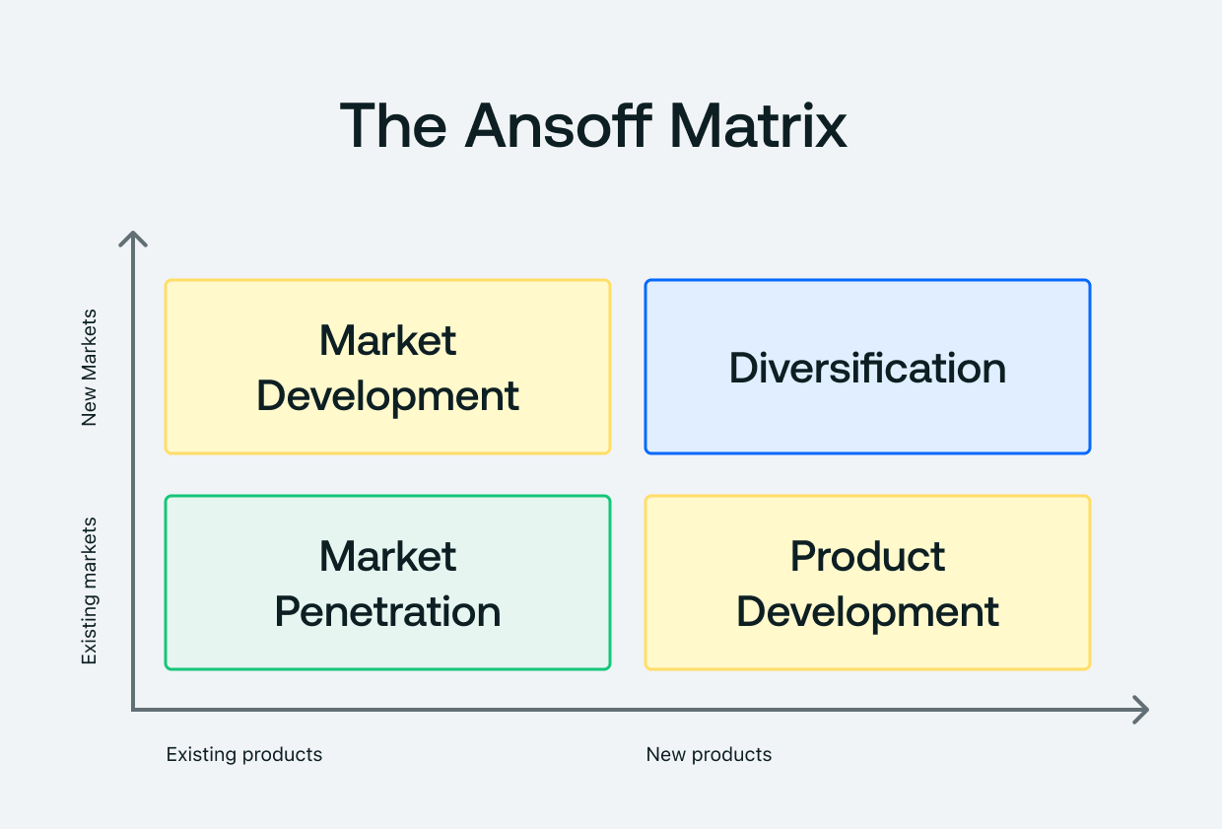
FIGURE 3: Ansoff Matrix
By contrast, BYD has a more balanced and risk-averse implementation of the Ansoff Matrix in that it focuses on market penetration and diversification. Its pricing capability to provide cheap EVs enables it to experience a fast rate of market share, especially in the new economic growth and the economically sensitive markets (Patil et al., 2024). Additionally, the fact that BYD extends its operation to battery manufacturing, electric buses, and energy solutions is an indication of the strategy to eliminate reliance on a particular market, as well as to utilise its primary competency. Its product development activities are relatively moderate; although they are cost-efficient and scalable, they are strategically oriented towards these aspects and not technological leadership (Lin, 2025).
TABLE 4: Ansoff Matrix Application
Strategy | Tesla | BYD
Market Penetration | Moderate – premium segment focus | Strong – mass market capture
Market Development | Global expansion | Expanding internationally
Product Development | High – innovation-driven | Moderate – cost-focused
Diversification | Limited | Strong – batteries, energy, transport

4.4 STRATEGIC EVALUATION
Competitive strategy of Tesla and BYD is a point of strategic opposition that brings out two different competitive approaches to success. The innovation-based strategic orientation of Tesla allows the firm to lead the technology and have effective brand differentiation but risks the business highly as it invests heavily in research and development and does not understand the market (Kouam, 2024). Conversely, BYD has an approach based on scalability, which exploits the concept of cost-efficiency, vertical integration, and policy congruence to attain rapid market growth at relatively less risk. More importantly, it implies that innovation might help to generate long-term competitive advantage but scalability and operational efficiency might provide a more immediate and sustainable growth in highly competitive and price-sensitive markets (Cooke, 2020).

5. CRITICAL DISCUSSION
Although some frameworks like PESTLE and Ansoff Matrix are useful tools of analysis, their limitations should be taken seriously. PESTLE analysis, in particular, provides a classic depiction of the external environment, not reflecting a dynamic representation of the changes in the rapidly technologically developed industry (Zou et al., 2025). Such fixed analysis can simplify reality in the continuously unpredictable innovation cycles of the EV industry. In the case of Tesla, the company uses differentiation and includes some features of vertical integration whereas BYD relates cost leadership and technological adaptation. This strategic boundary ambiguity questions the relevance of the Porters model in the modern market (Kim and Mauborgne, 2015). Although the Ansoff Matrix is very helpful in classifying the growth strategies, it lacks in explaining variability of risks and external uncertainties. It presupposes a certain degree of predictability which is not usually true of volatile sectors like EVs, when geopolitical tensions, supply chain interruptions and regulatory shifts can lead to a substantial change in strategic performance (Lang et al., 2021).
TABLE 5: Model Limitations
Model | Limitation
PESTLE | Static and oversimplified
Ansoff | Ignores uncertainty and risk dynamics

6. CONCLUSION
This report has analysed critically competitive dynamics in the EV industry in terms of how macro-environmental forces influence the industry, on the basis of Tesla as a leader and BYD as a follower. Task 1 analysis has shown that the technological and political forces provide an unequal competition environment, as Tesla has advantages in the innovation creation, whereas BYD has advantages in providing a solid policy support and cost-effectiveness. The implications of these findings include the fact that macro-environmental forces do not work in a homogenous way but rather interact with firm-specific capabilities to affect competitive positioning. Expanding on this, Task 2 determined strategic responses of both companies Ansoff Matrix. The differentiation and product development used by Tesla to create products characterises an innovation-based growth model, and the cost leadership and market penetration strategy applied by BYD reflects a scalability-based strategy. This comparison has shown that the two strategies are viable in their context but have varying mitigation of risk and sustainability.

7. REFERENCES
Ansoff, H.I. (1957) ‘Strategies for diversification’, Harvard Business Review, 35(5), pp. 113–124.
Arowolo, W., Diallo, M. and Pérez, Y. (2024) Electric mobility investments: Insights from power-transport coupling from developing countries. Available at: https://doi.org/10.2139/ssrn.4910542
Campbell, L., Häfner, M., Lu, X., Noussan, M., Raimondi, P. and Zhu, E. (2021) Securing decarbonized road transport: A comparison of how EV deployment has become a critical dimension of battery security strategies for China, the EU, and the US. SSRN Electronic Journal. Available at: https://doi.org/10.2139/ssrn.4017429
Cooke, P. (2020) ‘Gigafactory logistics in space and time: Tesla’s fourth gigafactory and its rivals’, Sustainability, 12(5), 2044. Available at: https://doi.org/10.3390/su12052044
Dong, Y. (2025) ‘Environmental perception and willingness to pay for electric vehicles: An analysis using the lens model’, SAGE Open, 15(2). Available at: https://doi.org/10.1177/21582440251335517
Han, X., Liu, W. and Jiang, T. (2023) ‘Practising future-making: Anticipation and translocal politics of Tesla's Gigafactory in Shanghai as assemblage’, Transactions of the Institute of British Geographers, 49(2). Available at: https://doi.org/10.1111/tran.12645
Harryson, S. and Lorange, P. (2024) ‘Vertical integration versus open innovation? From winner takes it all to winners make it all’, California Management Review, 67(1), pp. 138–163. Available at: https://doi.org/10.1177/00081256241279334
Hill, C.W.L. (1988) ‘Differentiation versus low cost or differentiation and low cost: A contingency framework’, Academy of Management Review, 13(3), pp. 401–412.
Huang, Q. and Xiang, C. (2024) ‘Interdependence and coordination challenges: EV charging infrastructure and carbon emissions in the Yangtze River Delta’, Environment and Planning B: Urban Analytics and City Science, 52(4), pp. 931–948. Available at: https://doi.org/10.1177/23998083241277865
IEA (2023) Global EV Outlook 2023. Available at: https://www.iea.org
Jetin, B. (2023) ‘Electric batteries and critical materials dependency: A geopolitical analysis of the USA and the European Union’, International Journal of Automotive Technology and Management, 23(4), pp. 383–407. Available at: https://doi.org/10.1504/ijatm.2023.136568
Johnson, G., Scholes, K. and Whittington, R. (2020) Exploring Corporate Strategy. 12th edn. Harlow: Pearson.
Kim, W.C. and Mauborgne, R. (2015) Blue Ocean Strategy. Boston: Harvard Business Review Press.
Kley, F., Lerch, C. and Dallinger, D. (2011) ‘New business models for electric cars—A holistic approach’, Energy Policy, 39(6), pp. 3392–3403.
Kotler, P., Keller, K.L., Brady, M., Goodman, M. and Hansen, T. (2020) Marketing Management. 4th European edn. Harlow: Pearson.
Kouam, A. (2024) Blocking or embracing the competition: Discussing the trade war on the electric vehicle industry from a global perspective. Available at: https://doi.org/10.21203/rs.3.rs-5508657/v1
Kumar, P., Raju, G., Bajaj, M., Alluraiah, N., Gopi, P., Pulumithi, S. and Зайцев, Є. (2025) ‘Integrated thermal and battery management for electric vehicles: Experimental validation and simulation-based optimization of lithium-ion batteries’, Energy Exploration & Exploitation, 43(5), pp. 2100–2158. Available at: https://doi.org/10.1177/01445987251337094
Lang, J., Reber, B. and Aldori, H. (2021) ‘How Tesla created advantages in the EV automotive paradigm through an integrated business model of value capture and value creation’, Business and Management Studies: An International Journal, 9(1), pp. 385–404. Available at: https://doi.org/10.15295/bmij.v9i1.1790
Lau, Y., Wu, Y. and Yan, M. (2022) ‘Electric vehicle charging infrastructures in the Greater Bay Area of China: Progress, challenges and efforts’, Frontiers in Future Transportation, 3. Available at: https://doi.org/10.3389/ffutr.2022.893583
Lazonick, W. and Li, Y. (2022) China’s development path: Government, business and globalization in an innovating economy. Available at: https://doi.org/10.36687/inetwp190
Lin, O. (2025) ‘Decarbonizing ASEAN’s transport sector: A critical review of electric vehicle and biofuel policy pathways’, Wiley Interdisciplinary Reviews: Energy and Environment, 14(4). Available at: https://doi.org/10.1002/wene.70017
Liu, Z. and Meng, X. (2017) ‘The development and strategic transformation of BYD’, Journal of Chinese Economic and Business Studies, 15(4), pp. 347–364.
Mangram, M. (2012) ‘The globalization of Tesla Motors: a strategic marketing plan analysis’, Journal of Strategic Marketing, 20(4), pp. 289–312.
Mazzucato, M. (2018) The Entrepreneurial State: Debunking Public vs. Private Sector Myths. London: Penguin.
Midler, C. and Alochet, M. (2023) ‘When regulations shape the future of an industry: The case of the high-voltage battery’, International Journal of Automotive Technology and Management, 23(4), pp. 343–382. Available at: https://doi.org/10.1504/ijatm.2023.136572
Ogrean, C. and Herciu, M. (2022) ‘Sustainability performance and reporting – A strategic issue for electric car automakers’, Studies in Business and Economics, 17(3), pp. 288–305. Available at: https://doi.org/10.2478/sbe-2022-0061
Otero‐Iglesias, M., Steinberg, F. and González-Agote, A. (2025) China’s dual circulation strategy and its impact on European industry: The case of the electric vehicle. Available at: https://doi.org/10.21203/rs.3.rs-6973843/v1
Pan, H. (2022) Will Chinese new energy vehicle manufacturers survive without government subsidies? Available at: https://doi.org/10.2991/aebmr.k.220307.342
Patil, G., Pode, G., Diouf, B. and Pode, R. (2024) Sustainable decarbonization of road transport: Policies, current status, and challenges of electric vehicles. Available at: https://doi.org/10.20944/preprints202408.1098.v1
Ruiz, P. (2024) ‘New energy vehicles and the political geoecology of China’s ecological civilisation’, Environment and Planning C: Politics and Space, 42(8), pp. 1317–1331. Available at: https://doi.org/10.1177/23996544241231683
Shalu, S. and Pandey, A. (2025) ‘A study on the factors influencing the adoption intentions of electric vehicles’, NMIMS Management Review. Available at: https://doi.org/10.1177/09711023251375288
Suzuki, K., Arnold, J., Château, J., Sripumphet, S., Poolee, W., Pereira, Á. and Hemmerlé, Y. (2024) A growth-friendly and inclusive green transition strategy for Thailand. Available at: https://doi.org/10.1787/35b34175-en
Temouri, Y., Luong, H., Pereira, V. and Rammal, H. (2025) ‘Regional environmental protection investments, cluster ecosystems, and firm innovation: Evidence from Germany’, Business Strategy and the Environment, 34(5), pp. 5760–5780. Available at: https://doi.org/10.1002/bse.4270
Tolossa, A., Singh, M. and Gautam, R. (2025) ‘Bridging competitive advantage and sustainable development: The moderating role of value creation for stakeholders in Ethiopian SMEs’, Business Strategy & Development, 8(1). Available at: https://doi.org/10.1002/bsd2.70066
Vynakov, O., Savina, N. and Rymar, S. (2016) ‘Tesla Motors: Innovation and development of electric vehicles’, Procedia Engineering, 134, pp. 377–383.
Wang, J., Zhou, J., Si, F. and Wang, Y. (2025) ‘Optimal supply chain decision with pre- and aftersales services and capital constraints’, Economics and Politics, 37(2), pp. 826–837. Available at: https://doi.org/10.1111/ecpo.12344
Wattana, B., Wattana, S., Sa-ngiamvibool, W., Thanarak, P. and Luo, J. (2024) ‘Electric vehicles penetration in Thailand: Rationale, challenges and strategies’, Journal of Infrastructure Policy and Development, 8(8), 6829. Available at: https://doi.org/10.24294/jipd.v8i8.6829
Wells, P. and Nieuwenhuis, P. (2022) ‘Transition failure: understanding continuity in the automotive industry’, Technological Forecasting and Social Change, 175.
Zapata, S., Gomez, D., Aristizábal, A., Castañeda, M. and Romero-Gelves, J. (2024) ‘Assessing the diffusion of photovoltaic technology and electric vehicles using system dynamics modeling’, Energy Exploration & Exploitation, 42(6), pp. 2351–2369. Available at: https://doi.org/10.1177/01445987241277917
Zou, Y., Nengmin, W., Dong, R. and He, Z. (2025) ‘Shareable or exclusive: The decision regarding green technological innovation’, Journal of Industrial and Management Optimization, 21(1), pp. 42–78. Available at: https://doi.org/10.3934/jimo.2024075

