Managing Enterprise in the 21st Century

Part 2 – Business Plan

Students: Vladimir Todorov (2015304), Simona Krasteva (2020614), Corina Popescu (2026257).
Module: Managing enterprise in the 21st century.
Module code: BMSW4006_BIRM
Lecturer: Nauman Ali

Executive summary:
Products are marketed to teenagers and young adults in their twenties. The firm will be established in London, England. It has set several objectives to boost sales and get a more significant part of the market. It's also expected that the market will continue to grow in the next several years. In addition, the market is incredibly crowded and competitive. Competitors are well-known in the marketplace. On the other hand, the company will be able to provide a wide variety of products at a lower price, which will give it an advantage. Given the current state of the industry and the strength of the firm, the demand for Romanian cakes and pastries is expected to rise shortly. Finally, the economic analysis shows that the company will be profitable in the long term.
Table of Contents
Executive summary: 2
1. Business Overview 3
2. Product and Services 4
3. Market audit 5
3.1 Competitors 6
3.2 SWOT Analysis 6
3.3 PESTLE Analysis 7
4. Target Market 9
5. Marketing Plan 10
6. Management Team 11
7. Financial Plan: 11
7.1 Cashflow Forecast 12
7.2 Profit & Loss 12
Conclusion 13
Reference 15

Business Overview
Without question, the bakeries industry is thriving more than it ever has previously in our day and age. Every corner in a metropolis has at least one patisserie or cafe, and that isn't saying much. Balkan Cakes and bakes is a bakery business that aims to satisfy the need for bakery products around the locality (Abdullah Saif, 2015). It is situated at 35 Jesmond Rd, in Kilndown City, London. Traditional Balkan baking techniques create their bakery delicacies, lovingly crafted by hand. Great coffee is like a well-timed gift. They are planning to focus on their product development activities, and regularly they are trying to provide their customer with a better experience. As a young company, we all shared the goal of opening a bakery. Our inventiveness and desire to work in the baking sector were the driving forces behind our decision to create a bakery. One of our parents ran a bakery in the past, but it had to close for various reasons. The team members have always had a sweet craving. After that, the individual desired to create his own bread business to resurrect their parents' beloved goal. Additionally, we've looked into the state's interest in bakery items and have predicted that it would be substantial. As a result, starting this firm will be feasible and exciting.

Product and Services
Theme cake: Our shop will include shark-themed cakes, doll-themed cakes, edible engraved cakes, and more.
Bread and buns: Customers will choose from various bread and buns to attract this consumer.
Rolls: So, we will have a variety of cinnamon rolls, custard rolls, and chicken rolls on hand to satisfy the needs of our small clientele.
Biscuits: A variety of sugar-free, fruit and nut-filled biscuits and cookie varieties will be provided to the consumer.
Pound cakes: There are pound cakes, fruit pound cakes, and cupcakes to choose from.
Cheesecakes: The popularity of cheesecakes is rising. We'll do all we can to accommodate requests for cheesecake and fresh berries gel toppings.
Our menu will include cakes, pies, tiny pizzas, mini buns, and more.

Market audit
As previously indicated, the company's offerings are primarily aimed at young people and middle-aged professionals. London and the surrounding areas will be served with Romanian pastries and baked goods (Ciftci & Darrough, 2015). The site's customers can afford to purchase such products since they are well-to-do. If businesses are wondering how much money the bread industry in the United Kingdom is worth 3.9 billion dollars, they are not alone. Organizations must first do a market study of Balkan's cake and bakery market to satisfy local demand and open a viable storefront for Romanian cakes and baked goods.

Competitors
If people are looking for a bespoke or gluten-free cake, plenty of other bakeries in the area can meet their needs. They have a few hard-to-get consumers and visitors. Balkan cakes and bakes goods have a distinct flavor that sets them apart from the rest of the world's offerings. People who are on a strict diet, have adolescents with obesity or diabetes, or are vegan are among those who have specific dietary requirements that need to be met by the bakery (Cohen, 2016). These two bakeries don't have much room for personalization. Nordic Bakery and Jacob the Angel are Balkan Cakes & Bakes' main competitors in the market. This type of meal is popular among professionals in their twenties and thirties. Whenever there is a get-together, this cuisine is frequently served.

SWOT Analysis
Croissants, pies, crackers, and cupcakes are famous among other flour-based baked foods (Saker et al., 2014). They can't help but salivate just thinking about baked goodies. There are still several establishments outside of the bakery business that sell bakery goods. Some bakeries also sell and produce confectionery products. Using a SWOT analysis is the best way to discover your company's strengths, vulnerabilities, threats, and ambitions, as well as those of your competition (Garipova, 2019). What the Balkan cakes and bakes lack and where they need to improve.

Balkan Cakes & Bakes
Strengths  A wide variety of goods and services  Quality of product and pricing must be in balance.  Distinctive selling point | Opportunities  A more significant number of people may be taken advantage of
Weaknesses  Recently introduced to the market  There is virtually little consumer awareness of the brand in the marketplace. | Threats  Unrelenting Rivalry  Customer retention is low.

PESTLE Analysis
When it comes to industry changes over time, PESTEL research focuses on external variables.
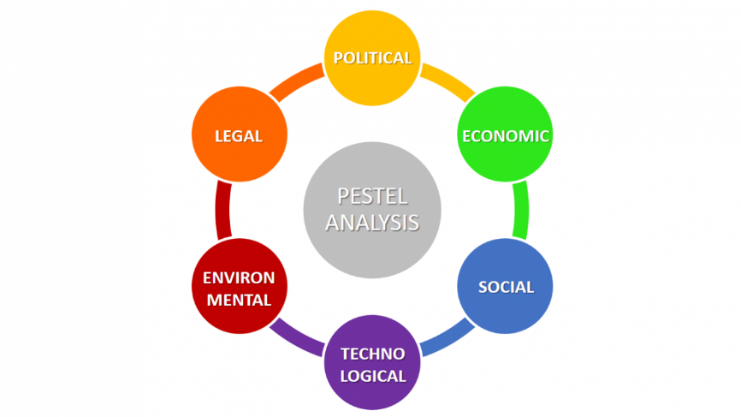
Figure: PESTEL Analysis
Source: (Lewis, 2016)
Political: An advantage of the UK coalition government's decision to implement a low-carbon economy is that it recognizes the importance of production. In a move to save the economy, the political climate favors industrial businesses such as food-producing firms like Balkan Cakes & Bakes.
Economical: The UK prioritizes the insurance, commercial, and banking sectors since they generate a sizable portion of the country's gross domestic product (Longenecker, 2015). There has been a steady drop in the Balkan Cake & Bake Company due to the global economic slump, and the administration has just recently begun attempting to restore financial stability.
Social: A growing number of consumers are paying attention to things like nutritional value and health benefits, so the firm makes sure that its goods satisfy those standards (Mohapatra & Das, 2021). As a result, the firm has added juices and chicken items to its menu to meet the needs of its clients.
Technological: Fortunately, technical advancements in global transportation infrastructure have allowed the Balkan Cakes & Bakes to expand their reach and offer their products internationally.
Environmental: When it comes to fulfilling their responsibilities, Balkan Cakes & Bakes acts ethically and responsibly. According to UK legislation on producing products, this is accomplished through financial regulation and standards. Thus, the organization assures that it minimizes its environmental impact and reduces manufacturing waste by using renewable resources.
Legal: The Code of Practice set by the Food Retailing Commission has had a significant impact on Balkan Cakes & Bakes, as have other government laws. Because of this code, the system was reworked entirely, which affected the final product.

4. Target Market
Because pastry shops in Balkan specialize in Balkan cakes and bakes, this product will appeal to a wide range of consumers. Desserts are enjoyed by people all around the world to celebrate special events and brighten their days. Our primary audience will be people of all backgrounds, including toddlers, adults, and the elderly. We'll do our best to make the prices reasonable enough that everyone can afford to purchase them. In addition, the store will be close by so they can easily access it. The shop's target market is densely populated, and baked goods are highly demanded. Although there are other bakeries in the area, Balkan Bakes & Cakes plans to stand apart from the crowd. There will also be a sitting area in the bakery where customers can relax while waiting for their desserts to be ready. We may assume that the business will be frequented by tourists and visitors because there are a few hotels nearby. In addition, the area is quite festive, and they frequently require cakes.

5. Marketing Plan
To spread the word about the shop's original Balkan delicacies, the firm must use some of the most popular advertising methods. Bakeries in Balkan use three key ways to contact their target clients better. Below, you'll find a list of them.
Website: A well-designed web page will be the company's primary method to reach its customers (West, 2017). As a result, individuals will easily purchase their favorite bakery items from the internet. Online and in-store sales will play a significant role in the company's product sales. One of the most acceptable methods to advertise your brand is to take advantage of the growing demand for online shopping.
PR: The role of public relations (PR) in the commercial world has grown significantly. Businesses use this method to give promotional gifts to Instagram influencers and personalities so they may use them to spread the word about their brand. This makes it easier to convert the fans of such celebrities into paying clients. To gain a foothold in the market quickly, the bakery might deliver some treats to the influencer.
Marketing activities such as current customer interactions and marketing will help the firm build a favorable brand image and consumer loyalty (Resources & Tips, 2022). Brand image will undoubtedly be improved since customers will be educated about the company's beneficial attributes. As a result, consumer perceptions of and commitment to the brand improve.

6. Management Team
The management team consists of six people, including the CEO. The first member is in charge of marketing. Simultaneously, the second person in the group manages the financial department. The third management team member is in the number of human resources. The fourth and fifth management team members are in customer service and administration. A start-up's success depends on leadership (Purba et al., 2018). The ruling council will run everything. Our executive team knows how to meet the demands of local clients by anticipating their needs. Our firm will have four layers of management, all controlled by the CEO. Working in many firms has given me a broad understanding of team and staff management. My other employee will handle the investigation, planning, administration, and IT. Our CFO will join the team.
The financial manager is generally in charge of all financial records and filing. In short, he will manage all finances. Assemble a team to do market research. He just concluded an internship at a well-known food company. The research and planning supervisor will keep an eye on market changes (Park, 2018). Our customers' needs and expectations will be met. He'll make plans and tell me about them. Another group member will assist consumers. He will be in place to make sure every customer is handled well and returns to buy products from us. The customer service manager should ensure excellent customer service.
On the other hand, he'll want to keep clients, which is Finalist: IT manager. He'll keep us running by monitoring and maintaining computer networks. He will handle our IT needs and provide recommendations. The present economic situation and the impact of new technologies make IT professions vital.

7. Financial Plan:

7.1 Cashflow Forecast
Twelve months cash flow statement

7.2 Profit & Loss

Conclusion
Young professionals and entrepreneurs in their late thirties are the target demographic for Balkan cakes and bakes. It will be an S company based in London, United Kingdom, having its headquarters there. There will also be a wide range of things to choose from at a single location. In addition, despite the industry's competitive nature, there are several opportunities. The business's promotional efforts will assist in the accomplishment of the objectives. In addition, a plan has been put in place to make sure that everything goes as planned. It seeks to employ technology to assure long-term prosperity. Giving back is also part of their mission.

Reference
Abdullah Saif, N., 2015. How does Marketing Strategy Influence Firm Performance? Implementation of Marketing Strategy for Firm Success. International Journal Of Innovation And Economic Development, 1(3), pp.7-15.
Ciftci, M. and Darrough, M., 2015. What Explains the Valuation Difference between Intangible-intensive Profit and Loss Firms?. Journal of Business Finance & Accounting, 42(1-2), pp.138-166.
Cohen, W., 2016. The marketing plan. Hoboken, NJ: Wiley.
Garipova, A., 2019. STRATEGIES FOR APPLYING SWOT-ANALYSIS INTODAY'S BUSINESS ENVIRONMENT. National Association of Scientists, 2(50), pp.56-58.
Lewis, J., 2016. Board approves revised strategic plan activities; reviews financial, Committee reports; creates communication plan. AORN Journal, 61(6), pp.932-933.
Longenecker, J., 2015. Small business management. Mason, OH: Thomson/South-Western.
Mohapatra, S. and Das, A., 2021. Paris Bakery: Implementing Omnichannel Strategy in the Consumer Value Chain. FIIB Business Review, p.231971452110207.
Nindiani, A., Hamsal, M. and Purba, H., 2018. Product and Service Quality Analysis: An Empirical Study of Customer Satisfaction in a Bakery. Binus Business Review, 9(2), pp.95-103.
Park, W., 2018. Bakery business. Boston: Little, Brown and Co.
Reed, G., Story, V. and Saker, J., 2014. Business‐to‐business marketing. Marketing Intelligence & Planning, 22(5), pp.501-510.
Resources, F. and Tips, S., 2022. How to Start a Bakery (with Business Plan). [online] WebstaurantStore. Available at: <https://www.webstaurantstore.com/article/12/start-a-bakery-with-three-planning-essentials.html> [Accessed 22 February 2022].
West, A., 2017. A business plans. London: Pitman.

