Bethany Curtis
P Number: 1700923
Programme of Study: Graphic Design
Module: M5X01599
Word Count: 2165
Tutor: Louise Burston

What does it mean to commemorate? How do memorials create personal meaning in a public place?

To commemorate is to show respect for someone or something, it is an act of remembrance. This is usually done in the form of a memorial. There are many different forms of memorial, which help serve as a form of memory for something (an event) or for a person. Popular forms of memorials range from the traditional gravestone or memorial plaque, to art objects such as sculptures and statues.
Non-official responses to death, are a rising occurrence in contemporary society. The response to events such as the Manchester Arena bombing 22th May 2017, and the Grenfell Tower fire 14th June 2017, are clear examples of this. Thousands in the communities of Manchester and London joined forces to remember those who tragically lost their lives. Another example of this was the aftermath of the death of Princess Diana in 1997. But the question is, why has this become the case? Doss explains that “these practices of public mourning suggest that traditional forms of mourning do not meet the needs of today’s publics.” (Doss, 2008:15) Participation in religious ceremonies may not be meeting the needs of the communities any longer, so they turn to this form of mourning instead. It is clear that non-official responses are a strong representation of changed cultural and social practices regarding public mourning. According to Doss “Modern Western assumptions that grief is a private, internal emotion and mourning is an external, social behaviour are increasingly challenged today.” (Doss, 2010: 80) The widespread presence of particular non-official responses to catastrophe’s and the death of those in the public eye suggests this. The aim of this essay is to argue whether non-official responses to death create a more powerful and personal meaning for individuals in a public place.
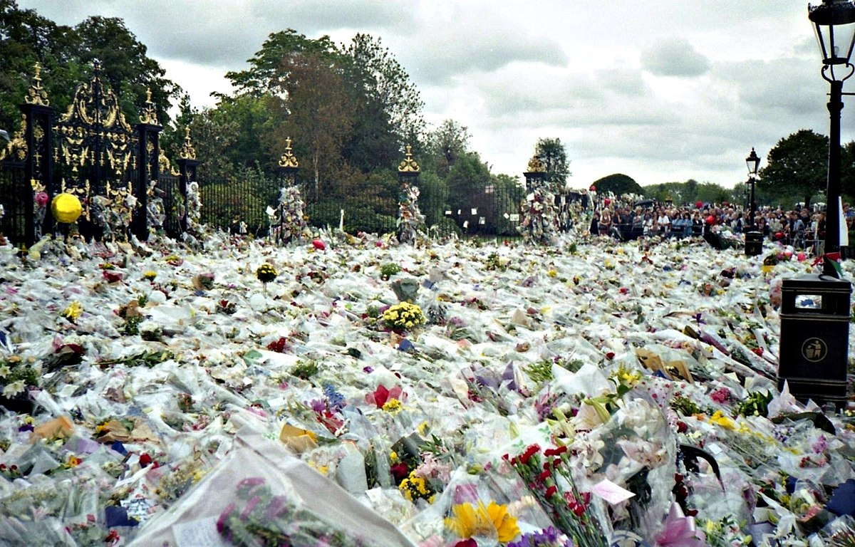Figure 1: Flowers placed outside Kensington Palace, 1997

In 1997 after the sudden death of Diana, Princess of Wales: “the national grid recorded a power surge as millions switched on their tv’s and kettles as the news of her death spread.” (Parfitt, 2017) Tens of thousands of bouquets of flowers were placed and stretched more than 9 meters from the gates of Kensington Palace. The scenes of public mourning were extraordinary. “Crowds began to assemble in public demonstrations of mourning outside royal palaces and in common spaces. The media, struggling to produce coherent accounts of these deaths and of the growing scale of response to them, focused on and thereby created mourning Diana as both public spectacle and spectacular media event.’ (Steinberg and Kear, 1999:2) The public wanted to pay their respects and show their admiration for Diana, ‘the people’s princess’. This large scale non-official response to the death of Diana made the public feel they had participated in remembering Diana, as many could not attend and take part in the official service of memorial. Maclean (2017) suggests “Non-official responses to tragedy fill a need not always met by formal memorial services. Often such services don’t offer the opportunity for the general public to actively participate in, and it is through actions, such as placing flowers that the grief stricken feel they have made more than a token effort.” (Maclean, 2017) The public’s grief was so intense there was even a dramatic increase in calls to suicide hotlines. It was really a reaction of public mourning that had never been seen for anyone or anything before. “Simon Critchley has argued that the death of Diana, Princess of Wales was ‘possibly the biggest single event in world history” (Steinberg and Kear,1999:2) However, it could be considered that it is in fact the media who are the instigators that create this phenomenon in regard to death of someone in the public eye and once broadcasting stops, it all dies down. The Princess had an ambivalent relationship with the press, often complaining about the media’s intrusion and there was even a period of time where the media were blamed for Diana’s death. “Communities of mourning have a period of intensity and then they dissipate. Once the cameras turn off and the headlines change, the deep grieving beings for those whose connection was close and heartfelt.” (Gibson, 2007:1) The tributes of these non-official responses to death being laid in public for a long period of time may start to affect people nearby physiologically. “It can be highly distressing for people to be confronted with communal grief and distress of others for extended periods of time.” (Whitton, 2018) This could have a negative effect of an individual’s grieving process. Like when the suicide hotlines had an increase in phone calls.

On the 14th of June 2017, Britain woke to hear the news of a fire in the Grenfell Tower high rise apartment block, situated in the Royal borough of Kensington and Chelsea. It is known as one of the worst modern disasters. Macleod (2018) explains the fire was “widely acknowledged to be the worst experienced during UK peacetime since the nineteenth century. It is confirmed to have resulted in 72 casualties and 70 physically injured. It has also left a community physically and emotionally scarred.” (Macleod, 2018) The tower was built in the 1970’s but had recently been renovated. A public inquiry is still underway, but it is thought that the buildings cladding was a main cause of the spread of the fire. There was an immediate response from residents to the scene of the fire, to try to help survivors. The community became united, with a remarkable effort to help those affected. “People in the immediate area and from across London rallied to assist victims of the fire, in a response that saw people of all ages, races and social classes come together.” (Moffat, 2017) The aftermath of the disaster saw hundreds of volunteers collect food and clothes to distribute to those who were now homeless. Residents were desperately seeking news about missing family members and friends, whilst the firemen continued to battle the blaze. The aftermath was a very intense and emotional time for not only individuals, but for the community as a whole. Tributes of remembrance began around the community, flowers were laid, missing posters were hung, and candles were lit. “It was pandemonium around the front of the rest centre. The world’s media is there, people are crying, shouting, they are exhausted and anxious.” (Smith, 2017)
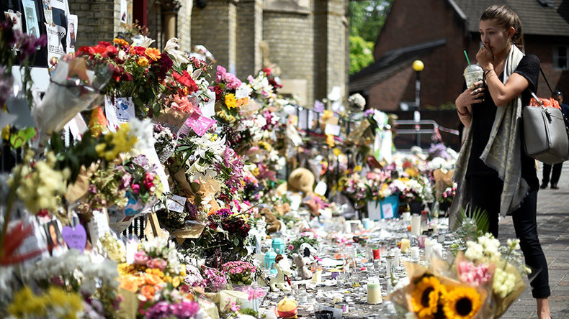
Figure 2: Grenfell Tower fire memorials, 2017
There was seen to be a lack of procedure put in place during the aftermath of the fire. The community were seething over what many saw as a betrayal by the authorities. “There appeared to be a lack of overall leadership. Standard response procedures should have been implemented, but we couldn’t see any sign of that.” (Taylor, 2018) With emotions running high for the community, with loss of homes and deaths of loved ones, their non-official response to the tragedy - such as protesting about the authorities, could have played a negative part in their mourning process. What should have been felt as grief, was turned to rage among the grieving and the community solidarity: “evidenced by some messages on the tribute wall that was erected next to Latymer Christian Centre … Go to hell all those responsible… Justice for Grenfell. Jail those responsible.” (Ross, 2017) The media’s involvement in the aftermath of the fire left the community feeling betrayed by their appearance, and they were angry that the media weren’t interested in the resident’s fears before the disaster happened. “You should have come here before,” he shouted, unfurling a sign that read “This is not a photo opportunity.” (Ross, 2017) Therefore, poor handling of the responses of remembrance from the community, such as the flowers laid and the tributes that had been written by residents in anger could have caused more upset for them and created a larger feeling of negativity towards the authorities. “Disrespectful handling of memorial items can be distressing for people impacted by the events of those who have participated in the memorial.” (Whitton, 2018) As another form of remembrance, silent walks take place on the 14th of every month to pay respects for those who lost their lives. These are held by Justice4Grenfell, a community led organisation. Their focus is: “Obtaining justice for the bereaved families, survivors, evacuated residents and the wider local community, partnering with 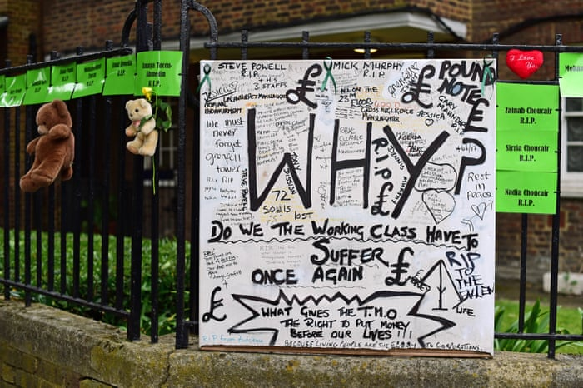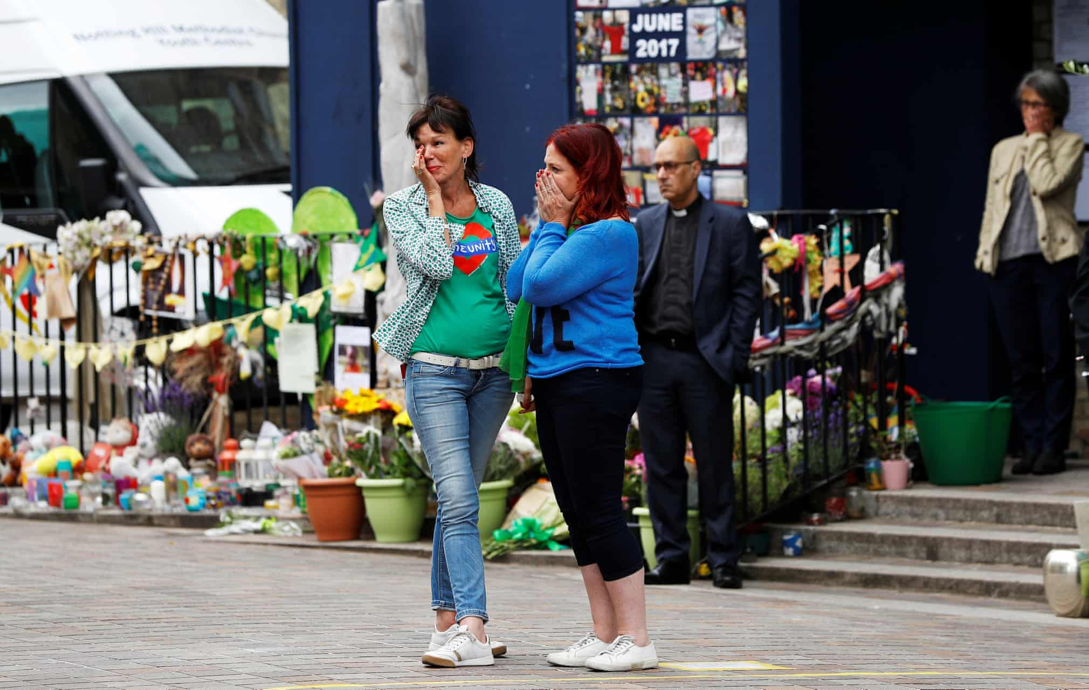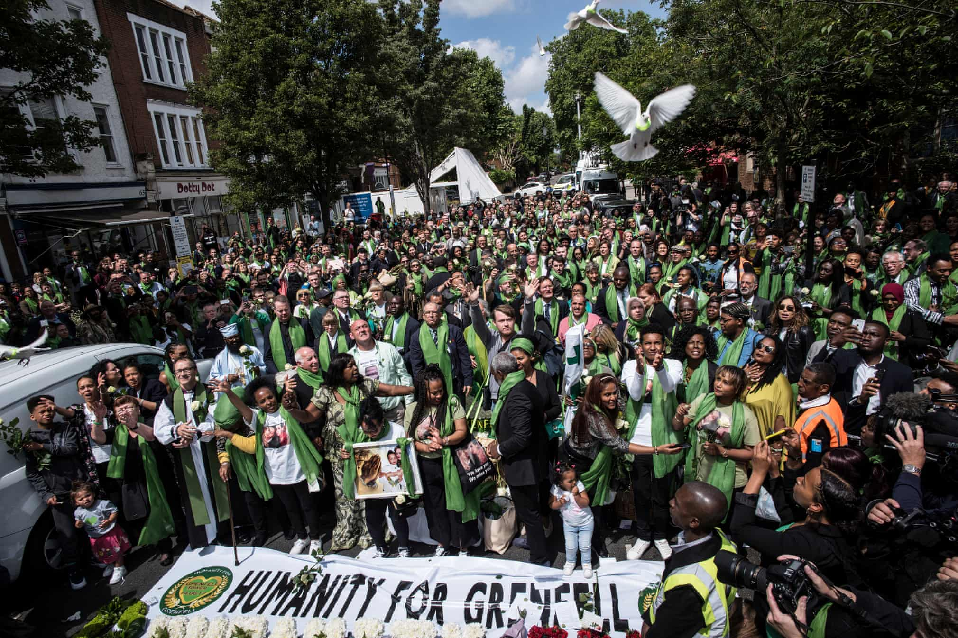representative organisations.” (Justice4Grenfell, 2017)
Figure 3: Grenfell Tower 1 Year Anniversary silent walk, 2018
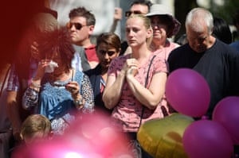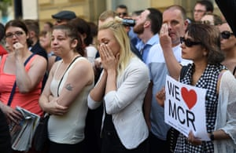On May 22nd, 2017, a night that was meant for joy and song at an Ariana Grande concert in Manchester Arena, ended up in disaster. An Islamic terrorist named Salman Ramadan Abedi, detonated a homemade bomb in the foyer of the arena, just moments before the concert was due to end, whilst the encore was being sung. The concert of a singer that is mostly popular with children and teenagers, had been the target of an act of terrorism for months prior to the event. 22 people were killed, 10 of them under the age of just years. A further 116 people required hospital treatment for physical injuries. It was: “The most deadly attack in Britain in a decade.” (Dodd, 2017) On reflection of the event a year later, new details were released claiming a higher number of those affected. “it is believed that more than 800 people suffered physical or psychological injuries.” (Quaile, 2018) Many people suffered from psychological effects after being involved in the tragedy.
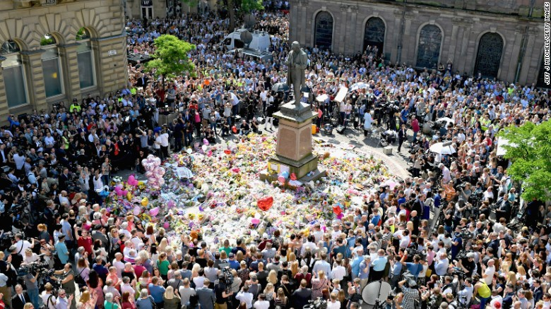
Figure 4: Manchester Arena bombing minute silence memorial, 2017

Soon after the event happened flowers, balloons and other items were left in the city’s St Ann’s Square, where a public shrine was created for individuals and the community, to come together in mourning to remember those who tragically lost their lives. “Manchester came together in a moving demonstration of solidarity.” (Anderson Q.C., 2017) On the 25th, just a few days after the terrorist attack, thousands gathered in St Ann’s square to observe a minute silence for the victims. This non-official response provided a space for individuals to express their grief in the community. They did not have to suffer in silence this way. “Participation in collective memorialising provides people affected by crisis with a safe space to express their grief, shock, sadness and can be an important first step in the grieving process. (Rosenblatt, 1997)” (Whitton, 2018) The non-official response acted as a form of community resilience: “Communities within Manchester were united as the council and people who involved themselves in the art culture in Manchester embraced the symbol of the bee.” (Hurdsfield, 2018)
The worker bee is an emblem for Manchester, it symbolises the hard-working past of the city. As another form of remembrance, people got tattoos of the bee after the attack to honour the victims of the bombing.

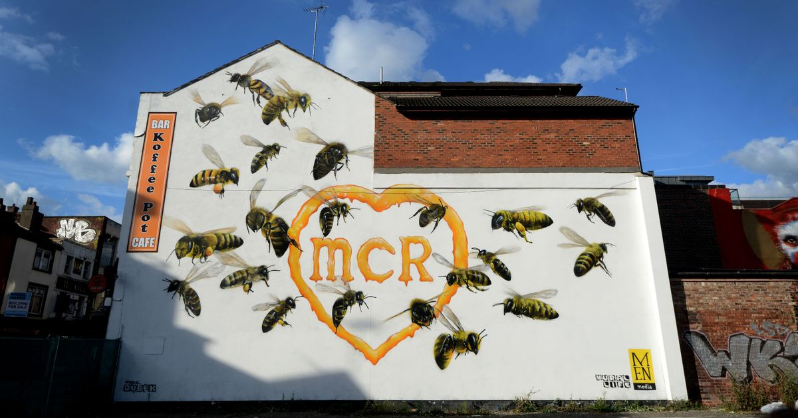
Figure 5: The Koffee Pot bee memorial, Manchester, 2017
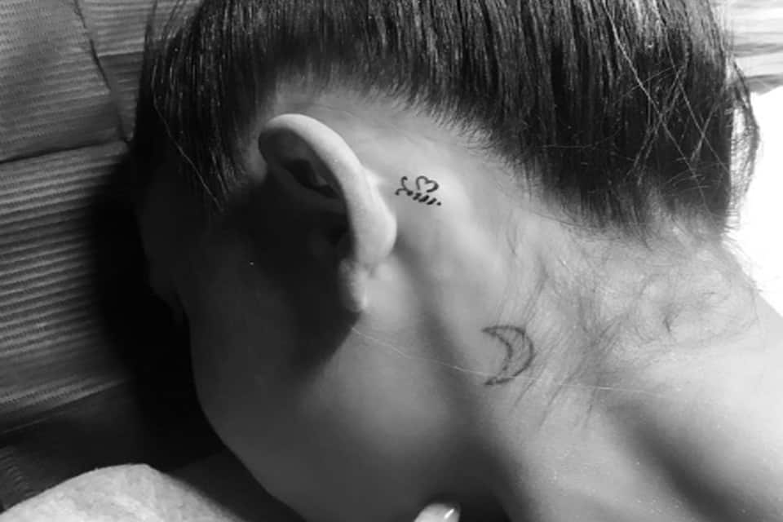
Figure 6: Ariana Grande shows her Manchester Bee tattoo, 2018

It is thought that non-official responses to death could be considered a nuisance for authorities. “In many cases they are considered to be a problem that needs to be managed rather than a roll for supporting recovery of the community affected.” (Whitton, 2018) This was not the case in Manchester. Plans were drawn up to make the memorials that were temporarily laid more permanent for the victims and those that were affected. Manchester City Council discussed this idea with the families of those killed. “The sea of flowers will be pressed and preserved. Petals will be used in memorial books to be presented to the families of those who died in the atrocity. Pot plants left in the square will be replanted across the city and wilted bouquets will be used for compost – to help new life flourish.” (Bardsley and Abbit, 2017)

To conclude, this essay has addressed points as to whether non-official responses to death create a more powerful and personal meaning for individuals in a public place. When the public laid flowers after the death of Diana in 1997, it was comforting for them to do as a form of remembrance, as they were not able to attend private memorial services. However, the media broadcasting put light onto the death, but once they stopped the mourning dissipated and the grief began for those with a close connection. In 2017 after the Grenfell fire tower, the community was brought together in solidarity to support each other in a time of disaster. Shrines were created, and messages were written. But grief was turned to anger by the media and authorities, and this could have affected an individual’s grieving process. In Manchester after the terrorist attack in 2017, creating a public shrine in St Ann’s Square and holding a minute’s silence, enabled individuals a safe space to express their grief in the community. They stood together in solidarity and this was effective in enabling a community resilience, by embracing the symbol of the Manchester Bee.
It is clear that non-official responses are a strong representation of changed cultural and social practices regarding public mourning. The advancement in technology has encouraged cultural and social practices to change. “Communication technologies – telephone, text mobile messaging, email, internet, television, and radio- have also created new ways in which the dead are memorialised through communication technologies.” (Gibson, 2007) People take to Facebook to write messages of remembrance. This wouldn’t have been the case a few decades ago, because social media did not exist then, but now it has become the norm.

Bibliography

Doss, Erika. (2008) The Emotional Life of Contemporary Public Memorials. Amsterdam University Press, Amsterdam.

Doss, Erika. (2010) Memorial Mania: Public Feeling in America. University of Chicago Press, London.

Parfitt, Tom. (2017) Tears, tirades and tensions: How Princess Diana’s death sent world into meltdown. Available: https://www.express.co.uk/news/royal/847426/Princess-Diana-death-car-crash-Paris-died-20-years Last accessed 2nd December 2018.

Maclean, Hilda. (2017). Public mourning: a brief history. Available: https://moodle.uwtsd.ac.uk/pluginfile.php/119434/mod_resource/content/1/Reading%20on%20public%20mourning.pdf. Last accessed 18 November 2018

Kear, Adrian. Steinberg, Deborah (1999) Mourning Diana: Nation, Culture and the Performance of Grief. London, Routledge.

Gibson, Margaret. (2007). Some Thoughts on Celebrity Deaths: Steve Irwin and the Issue of Public Mourning. Mortality. 12 (1)

Macleod, Gordan. (2018) The Grenfell Tower Atrocity. City: Analysis of urban trends, culture, theory, policy, action. 22 (4)

Moffat, Polly. (2017) The Grenfell Tower fire: a devastated community demands answers. Journal of Health Visiting. 5 (10)

Smith, Sam. (2017). Community come together after Grenfell Tower tragedy. Available: http://blogs.redcross.org.uk/appeals/2017/06/community-comes-together-grenfell-tower-tragedy/. Last accessed 22nd November 2018.

Taylor, Diane (2018). Grenfell emergency chiefs speak out about 'chaotic' response. Available: https://www.theguardian.com/uk-news/2018/jun/14/grenfell-emergency-chiefs-speak-out-about-chaotic-response. Last accessed 22nd November 2018.

Ross, Alice (2017) ‘Jail those responsible’: how Grenfell tower residents’ grief turned to rage. Available: https://www.theguardian.com/uk-news/2017/jun/16/shock-grief-and-anger-grenfell-tower-residents-left-in-the-dark. Last accessed 2nd December 2018.

Whitton, Shona. (2018). Post disaster temporary memorialising: psychosocial considerations for disaster managers. Australian Journal of Emergency Management. 2

Justice4Grenfell. (2017). Welcome to Justice4Grenfell. Available: https://justice4grenfell.org. Last accessed 4th December 2018.

Dodd, Vikram. (2017). At least 22 killed, 59 injured in suicide attack at Manchester Arena. Available: https://www.theguardian.com/uk-news/2017/may/22/manchester-arena-police-explosion-ariana-grande-concert-england. Last accessed 23rd November 2018.

Quaile, A. (2018). Manchester stands united after terrorist attack. Journal of Paramedic Practice. 10 (7)

Anderson Q.C, David. (2017). Attacks in London and Manchester. Available: https://assets.publishing.service.gov.uk/government/uploads/system/uploads/attachment_data/file/664682/Attacks_in_London_and_Manchester_Open_Report.pdf. Last accessed 23rd November 2018.

Hurdsfield, Georgina. (2018) Community Resilience and Visual Art: Responses to the Manchester Arena attack (Unpublished)

Bardsley, Andrew. Abbit, Beth. (2017). Lasting tribute planned after floral display laid for victims of Manchester terror attack cleared overnight. Available: https://www.mirror.co.uk/news/uk-news/amazing-lasting-tribute-planned-flowers-10591532. Last accessed 23rd November 2018.

Gibson, Margaret. (2007). Death and Mourning in Technologically Mediated Culture. Health Sociology Review. 16 (5), 415-424

