

RESEARCH PROPOSAL

AI-Powered Chatbots in Customer Support using Transformer Models & Sentiment Analysis

NAME- ATHISH THOMAS PAUL
STUDENT NO- 2406092
LECTURER- Dr. SEENA JOSEPH

TABLE OF CONTENT

1. INTRODUCTION 3
1.1 Context and Background 3
1.2 Research Problem 3
1.3 Research Aim and Objectives 4
1.4 Significance of the Research 4
2. Literature Review 4
2.1 Introduction to the Literature Review 5
2.2 Evolution of Transformer Models 5
2.3 Sentiment Analysis Techniques 5
2.4 Theoretical and Technical Frameworks 6
2.5 Relation to the Current Study 7
2.6 Literature Summary 7
3.Research Design and Methodology 8
3.1 Research Design 8
3.2 Research Methods and Materials 8
4. Expected Outcome 10
4.1 Anticipated Results 10
4.2 Implications 10
4.3 Limitations 11
4.4 Contribution to Research and Practice 11
5. Timeline 11
6. References 12

1. INTRODUCTION

1.1 Context and Background
In recent years, the integration of artificial intelligence (AI) into customer service platforms has gained significant traction. Businesses across industries from retail and finance to healthcare and education are increasingly leveraging AI-powered chatbots to streamline communication, resolve customer queries, and provide 24/7 support. Chatbots offer several advantages over human agents, including faster response times, cost efficiency, and scalability. However, traditional chatbot systems primarily rely on rule-based architectures or basic natural language processing (NLP) techniques, limiting their capacity to understand complex language or nuanced emotional context. These limitations have posed challenges in providing truly engaging and empathetic customer service [1], [2].
Artificial intelligence, particularly in the domain of natural language understanding, has evolved rapidly with the emergence of deep learning and Transformer-based models. Among these, the Bidirectional Encoder Representations from Transformers (BERT) model, introduced by Devlin et al. in 2019, has revolutionized how machines process and interpret human language [7]. BERT’s architecture allows for context-aware language representation, enabling more accurate and meaningful interactions. This capability presents a unique opportunity for enhancing the emotional intelligence of chatbot systems [6], [7].
Despite these advancements, most customer service chatbots still lack the ability to recognize and respond appropriately to the emotional tone of a user’s message. Emotional disconnects between customers and chatbot agents can result in frustration, miscommunication, and even the loss of customer trust. This gap has prompted growing interest in integrating sentiment analysis into conversational AI [8], [9]. Sentiment-aware chatbots can adjust their responses based not only on the content of the message but also on the emotional cues expressed within it.
Companies like Amazon, H&M, and KLM Airlines have begun exploring the use of more intelligent chatbots capable of understanding customer mood and adapting tone accordingly [3]. Yet, academic literature reveals a significant gap in simplified, reproducible, and lightweight chatbot frameworks that embed sentiment-awareness without requiring extensive computational resources [13], [14]. Many studies rely on complex, resource-intensive models or narrowly defined datasets, making it difficult to replicate or scale such systems in constrained research environments.

1.2 Research Problem
The central research problem addressed in this study is the limited emotional responsiveness of current AI-powered chatbots used in customer service contexts. While these systems may provide accurate information or perform task automation efficiently, they often lack the emotional intelligence required for empathetic communication [2], [5]. Traditional models do not consider user sentiment as a critical factor in response generation, leading to generic, tone-deaf interactions that diminish user satisfaction and brand perception.
Furthermore, most commercial implementations are proprietary, and few academic projects offer open, accessible frameworks for building and evaluating sentiment-aware bots. There is a clear need for lightweight, efficient, and transparent approaches that combine proven NLP methods (such as BERT) with sentiment classification capabilities to enable emotionally intelligent chatbot interactions [9].

1.3 Research Aim and Objectives
Aim:
The aim of this research is to design and evaluate a sentiment-aware chatbot through the fine-tuning of Transformer-based models for enhanced customer support services.
Objectives:

- Conduct a targeted literature review to explore existing sentiment analysis techniques and Transformer model applications in chatbot development.

- Develop a basic sentiment-aware chatbot prototype using a pre-trained Transformer model (e.g., BERT).

- Evaluate the chatbot's sentiment detection and user interaction effectiveness through defined metrics such as accuracy and F1-score.

1.4 Significance of the Research
Importance of the Research:
Addressing the research problem will have both academic and practical significance. It will contribute to the academic body of knowledge by providing empirical evidence on the advantages of integrating emotional intelligence into AI-based customer service systems. Furthermore, it has societal implications, offering pathways to more humane and satisfactory AI-driven customer experiences [7], [9], [2], [4].
Potential Applications:
The practical applications of this research are vast. Sentiment-aware chatbots could be deployed in sectors such as banking, healthcare, e-commerce, and telecommunications, where customer interaction quality is paramount [13]. Beyond textual chat, future extensions could include voice-enabled, multilingual sentiment-aware agents, thereby broadening the accessibility and impact of empathetic AI technologies.

2. Literature Review

2.1 Introduction to the Literature Review
This literature review aims to explore and critically examine existing research related to sentiment analysis, Transformer-based NLP models, and their integration into chatbot systems. As AI-driven chatbots gain prominence across industries, researchers have increasingly focused on improving their linguistic and contextual understanding capabilities. However, achieving empathy and emotional responsiveness in automated conversations remains an underexplored domain. This review synthesizes prior work in four key thematic areas: evolution of Transformer models, sentiment analysis techniques, integration of sentiment analysis in chatbots, and known limitations and challenges.

2.2 Evolution of Transformer Models
The development of Transformer-based models has significantly advanced the field of NLP. Vaswani et al. [6] introduced the Transformer architecture, which replaced the recurrent structures of earlier models with self-attention mechanisms. This innovation facilitated parallel processing and improved performance in language modelling tasks. BERT (Bidirectional Encoder Representations from Transformers), introduced by Devlin et al. [7], further enhanced the Transformer framework by enabling bidirectional contextual understanding. Unlike unidirectional models, BERT captures both left and right context, making it highly effective for tasks such as question answering, sentence classification, and named entity recognition.
BERT’s effectiveness inspired several variants such as RoBERTa [12], which optimized pre-training procedures, and DistilBERT [9], which reduced computational demands while maintaining performance. These models provide a robust foundation for downstream tasks, including sentiment classification. Recent studies have highlighted the scalability and versatility of these models in various languages and domains, suggesting their suitability for real-time applications like chatbots.

2.3 Sentiment Analysis Techniques
Sentiment analysis, also referred to as opinion mining, involves the computational identification and categorization of opinions expressed in text. Early approaches were rule-based or employed basic machine learning algorithms like Naive Bayes, Support Vector Machines, or Decision Trees [11]. These models often relied on handcrafted features and sentiment lexicons, which limited their adaptability and contextual understanding.
With the advent of deep learning, more sophisticated architectures such as Convolutional Neural Networks (CNNs) and Recurrent Neural Networks (RNNs), including Long Short-Term Memory (LSTM) networks, were applied to sentiment analysis tasks. These models improved accuracy but struggled with long-range dependencies and contextual nuances. Transformer-based models addressed these issues effectively, enabling more accurate classification by embedding contextual word meanings.
Zhang et al. [9] and Young et al. [8] documented the success of BERT in sentiment classification tasks across multiple datasets. The IMDB and Amazon reviews datasets have frequently served as benchmarks, and BERT consistently outperforms traditional approaches. Moreover, fine-tuning BERT on domain-specific datasets has shown that even smaller versions like DistilBERT achieve competitive performance, making them suitable for constrained environments such as academic prototypes.

- Integration of Sentiment Analysis into Chatbots
The application of sentiment analysis in chatbot systems is a growing research area. Studies such as Chhibber et al. [2] and Tang [3] have proposed models that integrate sentiment classifiers into conversational agents to dynamically adjust their tone and content based on detected user emotions. These models typically enhance user satisfaction, reduce churn, and create a more human-like interaction experience.
However, implementation remains challenging. Many proposed systems are either too computationally intensive or trained on narrowly focused datasets. Commercial systems like Amazon Lex or Google Dialogflow offer sentiment tracking, but these are often black-box solutions with limited customization. In contrast, research into open-source, sentiment-aware chatbot frameworks remains sparse.
Recent projects that embed pre-trained BERT models within chatbot interfaces demonstrate promising results. For instance, the work of Adelakun and Baale [15] showed how fine-tuned BERT models on financial datasets can achieve over 95% accuracy in sentiment classification. Such findings validate the feasibility of using BERT in production-like scenarios and lay the groundwork for lightweight academic prototypes.
- Challenges and Limitations in Sentiment-Aware Chatbots
Despite the progress, several challenges persist. First, sentiment analysis often struggles with sarcasm, idiomatic expressions, and cultural context. Models like BERT perform well with binary sentiment classification but may misclassify ambiguous or mixed-emotion statements [13]. Second, many research implementations require high-performance computing infrastructure, making them inaccessible to smaller institutions or student projects.
Third, datasets used for fine-tuning are not always domain-specific or emotionally rich. Generic datasets like IMDB may not fully capture the emotional tone present in customer support dialogues. Lastly, ethical considerations surrounding user privacy, dataset bias, and model interpretability continue to be areas of concern [14].

2.4 Theoretical and Technical Frameworks
The theoretical backbone of this research is the Transformer model and its application through BERT and DistilBERT. These models have proven highly adaptable for text classification tasks, including sentiment analysis. Technically, the research adopts the transfer learning paradigm, whereby a pre-trained language model is fine-tuned on a task-specific dataset. This approach allows for the rapid development of functional models with relatively limited data and computational resources.
In this study, HuggingFace Transformers library and associated tools such as Scikit-learn and TensorFlow will be used to implement and evaluate the sentiment classifier. Model outputs will be integrated with a Python-based chatbot interface, allowing for the live demonstration of emotionally aware conversational AI.

Conceptual Architecture Of Rule-based and AI-based chatbots
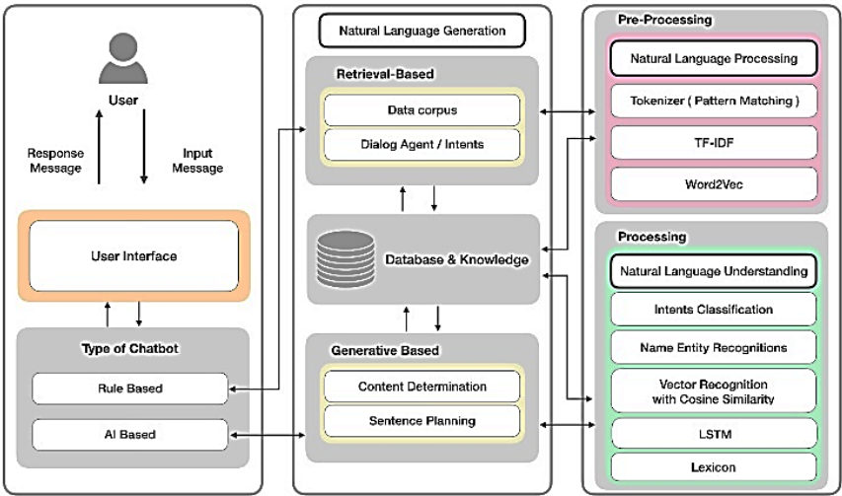
Figure: 1. Chatbot System [16].

2.5 Relation to the Current Study
This research aims to fill a gap in the literature by presenting a lightweight, accessible, and reproducible prototype of a sentiment-aware chatbot built using BERT. Unlike previous works that require extensive infrastructure or proprietary tools, this study prioritizes transparency, simplicity, and academic replicability. It contributes both a methodological template and empirical evaluation, thus supporting future studies in this domain.

2.6 Literature Summary
The literature reviewed provides a robust foundation for understanding the evolution of Transformer-based NLP models and their application in sentiment analysis and chatbot systems. The efficacy of BERT and its variants in capturing contextual nuances is well-documented; however, many studies still fall short in addressing the practical constraints of implementing such models in real-time chatbot environments. A significant portion of the existing research either leverages proprietary systems or assumes high computational availability, which limits scalability and reproducibility especially in academic or resource constrained settings.
Moreover, while studies have demonstrated improved sentiment classification performance using deep learning, few critically evaluate how this translates into meaningful user interaction in conversational AI systems. There remains a gap in aligning sentiment detection with actual user experience metrics such as empathy, satisfaction, or conversational flow.
This research proposal addresses those gaps by advocating for a lightweight, open-source, and replicable framework that operationalizes sentiment-aware conversation within the practical limits of academic research. In doing so, it seeks to bridge theoretical advancement with real-world utility an area still underrepresented in the current body of literature.

3.Research Design and Methodology

3.1 Research Design
This research project adopts an applied research framework that incorporates elements of both design science and empirical evaluation.
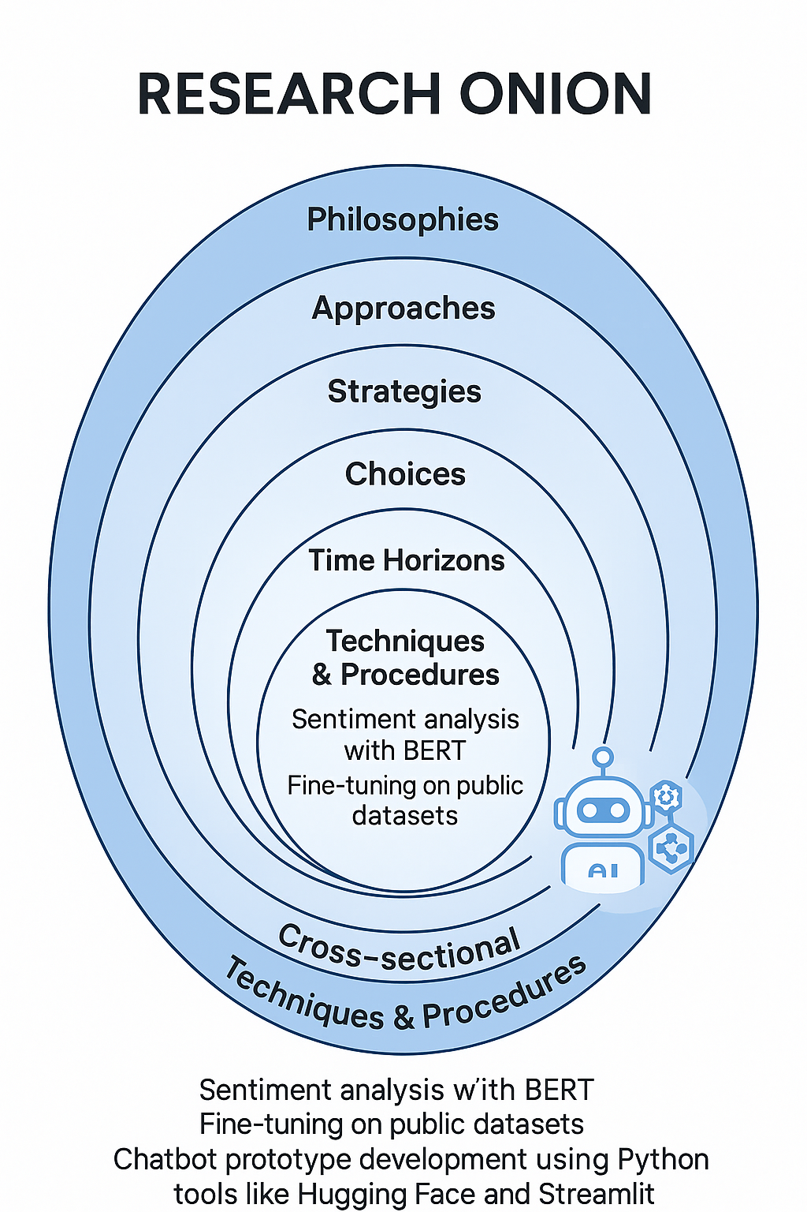
Figure: 2. Research Onion
The primary goal is to design, develop, and evaluate a sentiment-aware chatbot prototype tailored for customer service interactions. Applied research is ideal for this project, as it bridges academic theory and real-world application [4]. By utilizing design science, this study emphasizes the creation of a functional technological artifact the chatbot and by embedding empirical evaluation, it ensures that the system's performance is rigorously measured through established scientific methods [5].
Design science research provides a systematic approach for designing and refining IT artifacts to solve identified problems. In this context, the chatbot serves as a solution to the lack of emotional intelligence in current AI-driven customer support systems. Meanwhile, empirical testing allows the research to demonstrate that the chatbot is not only functional but also meets performance benchmarks in sentiment recognition and response appropriateness [13], [14].
This dual-layered approach design and empirical analysis supports both the theoretical advancement in AI research and practical implementation insights. The research is grounded in real-world relevance and scientific rigor, aligning with the principles of postgraduate academic standards.

3.2 Research Methods and Materials
Methods
Research Methodology: A quantitative research approach is utilized in this study, focusing on evaluating model performance using classification metrics. Quantitatively, the chatbot’s sentiment classification performance will be measured using statistical metrics such as accuracy, precision, recall, and F1-score [10].
Research Strategy: The research follows an experimental case study methodology. A simplified chatbot prototype will be developed using a pre-trained BERT (or its lightweight variant, DistilBERT) model. The aim is to minimize training complexity while ensuring effective sentiment detection. The system will be tested on sentiment-rich textual data and evaluated for accuracy and conversational quality [15].
System Architecture: The system will consist of three main components:
- A sentiment analysis module using a BERT-based model.
- A user-facing chatbot interface built using a simple UI framework such as Streamlit.
- A back-end integration mechanism that connects the model’s predictions with dynamic chatbot responses.
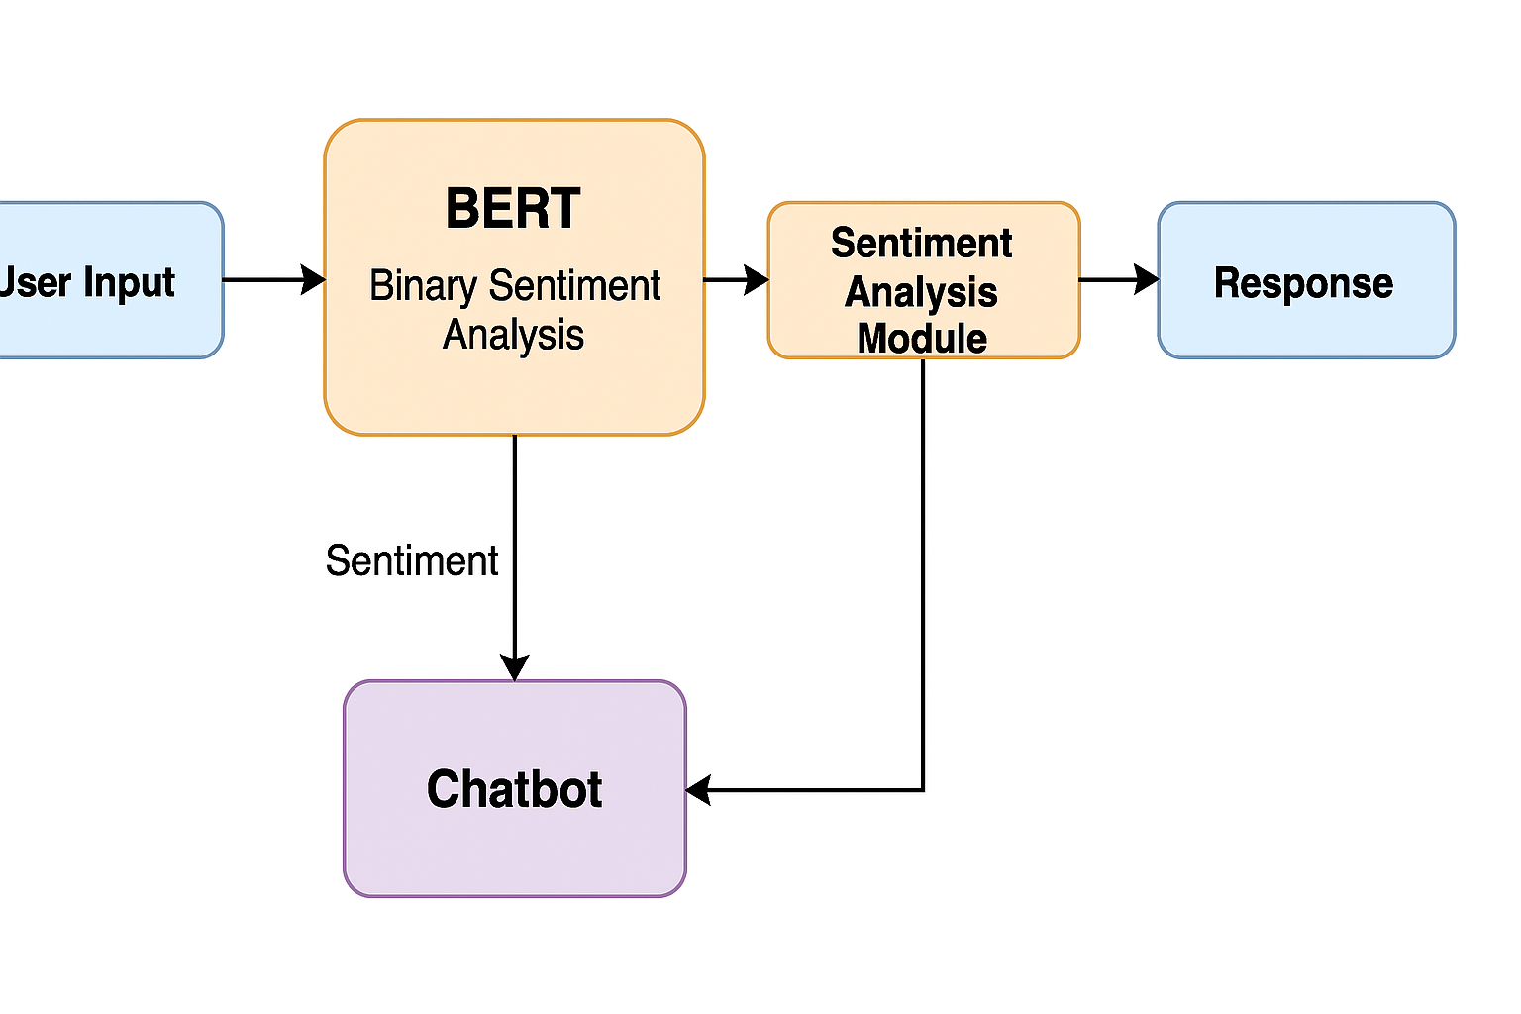
Figure: 3. System architecture of the BERT-based sentiment-aware chatbot
The user interface will simulate a customer support conversation, while the back end will classify the user's emotional tone and generate suitable replies. By combining pre-trained models and open-source tools, the project maintains feasibility within a limited development timeframe [7].
Data Analysis and Evaluation: Quantitative evaluation will rely on labelled test datasets to compute classification metrics. These metrics accuracy, precision, recall, and F1-score are standard in sentiment analysis.
Materials
Data Sources: The project will use publicly available datasets that are commonly used in sentiment analysis research:
- The IMDB Movie Reviews Dataset, consisting around 50,000 movie reviews labelled as positive or negative.
- The Amazon Fine Food Reviews Dataset or Kaggle Customer Support on Twitter dataset for multi-domain and customer-service-specific language [15].
Software and Libraries:
- Python (primary programming language)
- HuggingFace Transformers (for loading BERT or DistilBERT)
- TensorFlow or PyTorch (for model fine-tuning)
- Scikit-learn (for evaluation metrics)
- NLTK/TextBlob (for auxiliary sentiment analysis or preprocessing)
- Streamlit or Flask (for building the chatbot interface)
These tools are free, open-source, and widely used in the NLP research community.
Development Environment: Google Colab will be used as the primary development environment, offering access to free GPUs for model fine-tuning and testing. Colab’s flexibility allows for reproducible code, easy sharing, and efficient resource management [7]. For local development, a standard CPU laptop with at least 8GB RAM and Python 3.10+ installed is sufficient.
Hardware Requirements:
- Google Colab (for GPU-backed model fine-tuning)
- Local machine (for prototype testing and front-end development)
Ethical Considerations: The datasets used in this project are publicly available and anonymized, minimizing any risk of privacy violations. No personal, sensitive, or confidential user data will be collected or processed. The chatbot will not be deployed in a real production setting, so all interaction testing will be simulated using dummy or publicly sourced texts [14].
Furthermore, the project will comply with the university's ethical guidelines for research.
Conclusion: The proposed methodology balances rigor and feasibility. By using pre-trained models and open datasets, the project avoids time- and resource-intensive challenges associated with full-model training. At the same time, it ensures academic value by contributing to research on integrating sentiment analysis in chatbot systems using Transformer-based approaches. This methodology provides a practical roadmap for delivering a meaningful prototype within the project's 3-month timeframe.

4. Expected Outcome

4.1 Anticipated Results
The primary expected outcome of this research is the successful development of a sentiment-aware chatbot that utilizes a fine-tuned BERT-based model for classifying user input in real-time conversations. The prototype will be able to identify basic emotional tones positive, negative, or neutral from customer messages and generate corresponding responses with an appropriate tone. The chatbot is expected to perform better than traditional rule-based systems in terms of relevance, tone sensitivity, and user satisfaction.
Quantitatively, it is anticipated that the model will achieve a high level of classification accuracy likely exceeding 85% on benchmark datasets such as IMDB or Amazon product reviews. While performance may vary depending on the training corpus and model size (BERT vs. DistilBERT), the overall goal is to demonstrate that even simplified Transformer models can deliver competent sentiment detection capabilities.
In the context of a simulated customer support environment, the chatbot should be able to adapt its response strategy based on the sentiment expressed. For instance, when encountering a message flagged as negative, the bot could offer apologies or escalate the query, whereas positive messages would be met with confirmations or acknowledgements. This adaptive behaviour is expected to create a more personalized and human-like user experience.

4.2 Implications
From a technical standpoint, this research will demonstrate that emotional intelligence in chatbots is achievable even with constrained resources. Unlike large-scale commercial systems, this study uses publicly available datasets, open-source libraries, and cloud-based tools such as Google Colab to build a functional prototype. This validates the feasibility of incorporating sophisticated NLP models into academic and small-business environments.
From a user experience perspective, sentiment-aware bots may foster more emotionally resonant conversations. This could increase user engagement, trust, and satisfaction, which are crucial metrics for any customer-facing technology. As organizations increasingly rely on AI to interact with their customers, the need for emotionally intelligent systems will continue to grow.
Moreover, this research could serve as a foundation for future enhancements such as multi-emotion detection (e.g., anger, sadness, joy), multilingual capabilities, and integration with voice-based AI assistants. While these features fall outside the current project's scope, the system architecture will be designed in a modular way to support future expansion.

4.3 Limitations
Despite the anticipated benefits, certain limitations are acknowledged. First, the chatbot will be trained and evaluated in a controlled environment using synthetic or pre-existing datasets. Real-world customer dialogues often contain noisy, ambiguous, or sarcastic language, which may reduce classification accuracy. Addressing such linguistic complexity would require larger datasets and more sophisticated models beyond the project's timeframe.
Second, while BERT-based models are more efficient than earlier deep learning approaches, they still demand considerable computational power for fine-tuning. The use of DistilBERT may help mitigate this issue, but trade-offs in accuracy must be considered.
Third, the current system will be designed for binary or ternary sentiment classification. It will not detect nuanced emotional states such as confusion, surprise, or sarcasm. Addressing these limitations would require more diverse labelled datasets and more granular classification frameworks.

4.4 Contribution to Research and Practice
This research contributes to academic literature by offering a replicable methodology for embedding sentiment awareness into chatbots using Transformer based models. It demonstrates the viability of adapting state of the art NLP tools for emotionally aware communication without requiring excessive infrastructure.
In practice, the outcomes can inform developers, educators, and organizations looking to deploy similar systems. The project showcases how open source tools can be leveraged to produce intelligent conversational agents that are not only functionally sound but also emotionally responsive.
By the conclusion of this research, a fully documented, modular chatbot prototype will be delivered along with detailed performance metrics and recommendations for improvement serving as a template for future explorations into empathetic conversational AI.

5. Timeline
The Gantt chart below depicts the project's primary steps, beginning with the literature review and research presentation and progressing through model creation, assessment, and final report submission. Key milestones are connected with realistic dates to ensure that the study is delivered in an organized and timely manner.
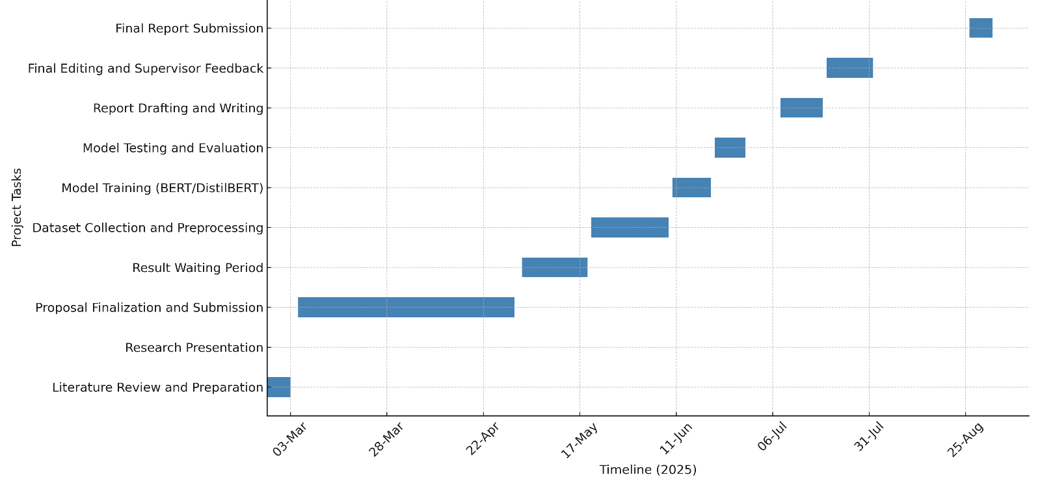
Gantt Chart of AI-Powered Chatbots in Customer Support using Transformer Models & Sentiment Analysis

6. References
[1] U. Singh and Paridhi, "Comparing Transformer Architectures for Sentiment Analysis: A Study of BERT, GPT, and T5," International Journal of Innovative Research in Technology (IJIRT), vol. 11, no. 3, pp. 394–399, Aug. 2024.
[2] M. Chhibber, R. Mittal, and A. Singh, "AI-powered Chatbot for Improved Customer Feedback Management using NLP," in Proc. 14th Int. Conf. on Computing Communication and Networking Technologies (ICCCNT), Delhi, India, Jul. 2023.
[3] J. Tang, "Leveraging Transformer Neural Networks for Enhanced Sentiment Analysis on Online Platform Comments," in Proc. 4th Int. Conf. on Machine Learning and Computer Application (ICMLCA), Hangzhou, China, Oct. 2023, pp. 256–260.
[4] A. K. Durairaj and A. Chinnalagu, "Transformer-based Contextual Model for Sentiment Analysis of Customer Reviews: A Fine-tuned BERT," Int. J. of Advanced Computer Science and Applications (IJACSA), vol. 12, no. 11, pp. 474–480, 2021.
[5] K. Pipalia, R. Bhadja, and M. Shukla, "Comparative Analysis of Different Transformer Based Architectures Used in Sentiment Analysis," in Proc. 9th Int. Conf. on System Modeling & Advancement in Research Trends (SMART), Moradabad, India, Dec. 2020.
[6] A. Vaswani et al., "Attention Is All You Need," in Advances in Neural Information Processing Systems, vol. 30, NeurIPS, 2017.
[7] J. Devlin, M.-W. Chang, K. Lee, and K. Toutanova, "BERT: Pre-training of Deep Bidirectional Transformers for Language Understanding," in Proc. Conf. of the North American Chapter of the Association for Computational Linguistics (NAACL), 2019.
[8] T. Young, D. Hazarika, S. Poria, and E. Cambria, "Recent Trends in Deep Learning Based Natural Language Processing," IEEE Computational Intelligence Magazine, vol. 13, no. 3, pp. 55–75, Aug. 2018.
[9] L. Zhang, S. Wang, and B. Liu, "Deep Learning for Sentiment Analysis: A Survey," IEEE Transactions on Affective Computing, vol. 5, no. 3, pp. 1–15, 2018.
[10] B. Pang and L. Lee, "Opinion Mining and Sentiment Analysis," Foundations and Trends in Information Retrieval, vol. 2, no. 1–2, pp. 1–135, 2008.
[11] Y. Liu et al., "RoBERTa: A Robustly Optimized BERT Pretraining Approach," arXiv preprint arXiv:1907.11692, 2019.
[12] E. Cambria, D. Das, S. Bandyopadhyay, and A. Feraco, "Affective Computing and Sentiment Analysis," in A Practical Guide to Sentiment Analysis, Springer, 2017, pp. 1–10.
[13] T. Mikolov, K. Chen, G. Corrado, and J. Dean, "Efficient Estimation of Word Representations in Vector Space," arXiv preprint arXiv:1301.3781, 2013.
[14] N. Khurana and V. Prabhu, "Ethical Considerations in Sentiment-Aware Chatbots: Fairness, Bias, and Transparency," AI & Society, vol. 37, no. 4, pp. 1–14, 2022.
[15] N. O. Adelakun and A. A. Baale, "Sentiment Analysis of Financial News Using the BERT Model," Journal of Engineering and Technology for Industrial Applications (JETIA), vol. 10, no. 48, pp. 21–27, 2024.
[16] W. Maroengsit, K. Phonyiam, S. Pongnumkul, P. Chaovalit, T. Piyakulpinyo, and T. Theeramunkong,
"A Survey on Evaluation Methods for Chatbots," in Proc. 2019 ACM International Conference on Human-Computer Interaction, Mar. 2019, pp. 1–10.

