Managing Projects in the Organisation

Task: 2
Evaluation of Project Management Plan

Name: Bikash Roy
Module Code: BMSW5104_LON
Term & Group: T-2 G-1
Teacher’s Name: Dr Rexon Nting

River Side Cool Cold Storage

Contents
1.Introduction: 2
2. Main Body: 2
2,1. Stakeholder: 2
2,2. Structure of the Project: 3
2,3. Process of the Project: 5
3. Operating Procedure: 5
3,1. Sample Control: 5
3,2. Risk Evaluation: 6
4. Risk Management: 6
5. Cost and Resources: 7
6. Conclusion: 7
7. References: 7
Appendix: 8
Task-1 Slide Presentation 8

1.Introduction: As Bangladesh is my back home and a growing developing country. At this moment they are politically and economically a stable country. Considering climate change and global environmental situation, they are in advantageous position. I have chosen Bangladesh as a place to invest and my next project destination. To propose a project plan, first we need a clear concept about project idea, its necessity, out come and social-economical value.
A project is a special undertaking having a start and an end, conducted by people to achieve predetermined goals under constraints of money, time and quality. (PMI, 2004)
A project is a group of people and other resources that brought together to achieve a specific goal, typically with a definite budget and a fixed period. Projects are typically related to new products, first-time executions of existing procedures, or modifications to established procedures. (Pinto, 2010)
Recently Bangladesh had an emerging development on industrial production and earn of revenue. However, it is an agroeconomic based country. All over the year they have verity of fruits and vegetable to product, unfortunately not enough secure storage system. June 2022, they opened a wide opportunity for the farmer, when south and north part of Bangladesh is connected by a 6.5km long bridge. If they get sufficient cool cold storage to conservation, it will encourage them to cultivate and benefited, help country to receive revenue. In that concept we want to build a multi factor cool cold storage on the north part of the bridge, conserve their product and ready for sale all over the world.
2. Main Body: It is not possible to build, maintenance and continue to provide services. So, my plan is to asking participation of local people those who have any other activities around these area, prominent businessperson to invest for these projects.
2,1. Stakeholder: Anyone with a stake in a project’s success is a stakeholder. Identification of each individual stakeholder using three simple questions.
- Who gains from the project first?
- How is the project funded?
- Who will the project affect?
Need to put attention on the project deliverable and the audience it will serve. The deliverable might be anything from a new software programme or marketing campaign to an entirely new internal procedure. Choose the people or organisations on whom you will rely on to complete the project. Members of the project team, the project sponsor, and outside subject-matter experts may included in this. The project deliverable may influence parties that are not necessarily in its best interests, for as when the IT department updates software for customers. These people and organisations must be regarded as stakeholders since the deliverable will have an impact on their job. (Fundamentals of Project Management, J. Heagney 2016)
In my proposed project as I mentioned previously, stakeholders should be well-wisher those who want to support and be a part of this project, local people and mostly those who related the cultivate/production of fruits and vegetables, prominent businessman those who wanted to join with these projects and invest, person those who involved with transport and delivery, authority of city corporation and the government for citizen’s and benefit of revenue. We know that it is not easy to work with various kinds of people. The project manager must focus on and implement a flexible method for stakeholder communication because most people speak in their comfort zones.

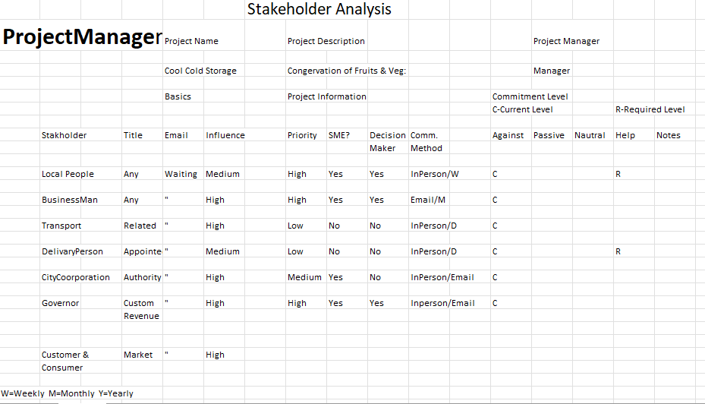
https://www.projectmanager.com/templates/stakeholder-analysis-template
2,2. Structure of the Project: The infrastructure and agricultural sectors of Bangladesh have suffered significant damage from natural disasters on a regular basis over the past years, despite the country’s robust economic growth and steady decline in poverty. This has had a negative impact on the poor and vulnerable access to and availability of food. More than 80% of Bangladesh’s population is considered to be poor, therefore climate shocks and strains have a particularly detrimental impact on their wellbeing as well as the security of their food supply and means of subsistence. A total of 36 million MT of rice and about 2.6 million MT of wheat are produced annually in Bangladesh. Additionally, during times of crisis, more food grains may be imported to handle urgent needs. Proper food storage capacity is necessary for securely storing food grains. The government is aiming to increase the necessary food storage capacity. Government warehouses and silos currently have a total storage capacity of about of about 2.1 million MT, by 2030, this capacity will have expanded to 2.7 million MT, and by 2035 it will have reached about 3 million MT. Additionally some private warehouses offer storage on a leasing basis.
Bangladesh is primarily an agricultural nation, and the agricultural industry provides roughly 17% of the GDP and employs more than 45% of the labour force (BBS, 2015). Fruit and vegetable production grew to 12,983 tonnes and 4,677 tonnes, respectively, from 10.923 tonnes and 4,525 tonnes in 2010, respectively, according to the Bangladesh Bureau of statistics.
As previously the carrying cost and time was not suitable for the farmers, moreover there was not enough storage facilities, people were dishearten with their benefits. Recently the government of Bangladesh built a 6.8km long bridge, which connected the northern and southern part of Bangladesh. It’s a great opportunity for the farmer to get their expected value of their product if they got support with good storage system it will encourage them to multiple their activities. Not only farmers also those who related with their activities will benefited. Since ¾ years world facing a global digester with COVID-19. Every country forced to break up with their production, export, import, and government loss earning of revenue. Now as its slowing down and some restrictions that stopped people to move normally. It is the perfect time to stay connected with them and open a wide opportunity for all.
Bangladesh is a tropical nation in the worldwide climatic zones, with average daytime temperatures ranging from 23 to 34 degrees Celsius. Seasonal fruits and vegetables must be stored in refrigerated warehouses, known as “cold storage.” Most fruits and vegetables are stores at varying temperatures between 30 and 50 degrees Celsius for off-season sale at a premium price in significant urban marketplaces like Dhaka and Chittagong. Many perishable products such as tomato, carrot, green chilli, beans, cauliflower & mango may be sold off-season at profits ranging, 100-500 per cent). However, Bangladesh suffers from a severe scarcity of compact cold storage units, which leads to the loss and damage of 25-45% of its perishable produce.
According to statistical portal’s 2016 data, Asia produces the freshest produce (251.57 million tonnes), with China alone producing 169.23, India producing 33.22, Africa producing 19.72, Europe producing 10.62 and America producing 7.62 million tonnes. According to the Food and Agriculture Organization (FAO, 2017), 30-40% of all vegetables and fruits are lost globally due to perishability, lack of suitable post-harvest storage, processing facilities and transportation infrastructure.
Unfortunately, the lack of adequate post-harvest cold storage facilities causes the farmers to lose and destroy a lot of perishable goods, and they also become targets of exploitation by local wholesalers and intermediaries at both the producer and consumer ends. According to a 2017 feasibility study by PKSF( Palli Karma Sahayak Foundation), there is hardly any initiative for small-scale cold storage, despite the growing demand for cold storage among farmers, fisheries and rural small businesses for the short-term preservation of perishable agricultural products near wholesale rural markets. Due to grid power supply issues, processing and transportation obstacles and financial institution restrictions, banks and financial institutions are reluctant to lend money to small business electricity costs and un. According to conventional business culture, “Cold Storage” refers to a sizable facility (2,000-5,000 tonnes of potato storage only) that requires a significant financial commitment, expensive electricity costs, and unpredictable financial results due to frequent load shedding and unreliable power supply. The main issue that owners of cold storage facilities deal with is the erratic supply of grid electricity. Cold storage owners spend a lot of money on risky and unreliable standby generators as a temporary fix. Banks and other lenders so discourage small farmers from making cold storage investments until pilot programmes show profitability.
The owners, operators and clients suffer significant monetary loss when power outages increase in frequency during the summer when cold storages must run under pick-load conditions. Other firms, employees and the overall economy are also impacted by this. The primary producers and retailers in Bangladesh alone experience losses and damages of up to 60% of the seasonal fruits, vegetables, fish, milk, and meat products, totalling $360 thousands. According to FAO the approximate global loss and damage is $1 trillion, while the estimated value of a 1% loss is $45 million (World Bank, 2017). Both current and prospective owners of cold storage facilities are actively looking for “small solar cold storage” as the greatest alternative sources of dependable, sustainable, cost-effective, and environmentally friendly sources of power to minimise loss and maximise revenues. Direct current (DC)from the Sun during the day and battery backup during the night are two naturally occurring sources of solar power that were given to us by our creator. The use of solar-powered small cold storage by farmers in Bangladesh’s on-grid and off-grid regions is a fascinating example of inventive technology. With the help of proper funding. The Government of Bangladesh promotes the use of small cold storage with solar and other alternative power sources through SREDA to convert loss and damage into profit (Power Division). With the government’s agreement, PKSF has provided funding for two pilot plants (6-8 tonnes capacity) that will be erected to ensure the growth of businesses among farmers and intermediaries who supply healthy food. Pilot solar small cold storages successful operation will inspire hundreds of additional investors to make the necessary investment.
2,3. Process of the Project: It is better to make a frame design how we can proceed for the project. We can prepare a Quad chart.
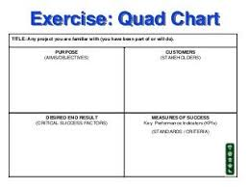
National and International Market
Success comes when all bodies will get expected outcome
Farmers, Investors and Gov will be benefited
Serve for the community
A quad chart is a type of technical documentation that uses prose, illustrations, and/or photographs to briefly illustrate an invention or other discovery. Because they are separated into four quadrants and laid out from a landscape perspective, these papers are known as quad chart. They are often only one page long, and their concision speeds up decision-making. Although they are shorter, quad charts frequently serve the same purpose as white papers and the two documents are frequently requested together.
This marketing one-page enables to highlight the strongest aspects of the project,
Purpose: What the organisation can offer.
Capabilities: What product and service can perform and why it is superior to alternatives.
Customers: List of any existing users of products and partners.
Success/Connection: Business strategy and contact information.
3. Operating Procedure: The purpose is to outline how to operate research-grad cold storage facilities to ensure the secure and effective storage of samples. The need for cold storage in research is ever-increasing, especially in the life sciences and the medical fields. Materials necessary for clinical trials, drug testing and other investigations are kept in storage with the expectation of their protection. One ultra-low temperature (ULT) freezer can easily house goods worth more than £10.000. Most research-intensive institutions will have hundreds of these freezers, but few of these institutions will impose a management policy to guarantee samples are stored in a uniform manner. This strives to guarantee that all samples will have sufficient and effective storage facilities.
3,1. Sample Control: To facilitate analysis, samples should be kept in a rack system or as organised as feasible. Emergency removal in the case of defrosting. Every sample should include a label that indicates the anticipated storage time(freeze resistant labels, freezer suitable storage containers).All samples must be labelled so that anybody may determine the sample’s owner(s), affiliated laboratory, contents, date of storage, expiration date, or when it should be discarded, as well as amount(if necessary) in the event of defrosting or an emergency removal.
3,2. Risk Evaluation: At a bare minimum every freezer in a central shop will have a secondary temperature probe that displays temperatures outside. Central temperature monitoring is required. The need for alarms in any freezer operating at -40c or lower should be evaluated. An explanation must be logged and recorded if an alert system is rejected. Alarms should be centrally monitored with established call-out procedures in the event of an emergency. Once every day, the temperatures of every freezer in the central stores are recorded and monitored. Ny questions regarding the running temperatures of the freezer should be addressed to a specific member of the laboratory or facilities staff who has access to the temperatures that have been recorded. Avoid opening the freezer door unless it is absolutely required in an emergency.
A current list of the owners of the freezer’s contents as well as the appliance number(barcode), alarm/external temperature monitor, any special instructions for handling the contents in the absence of the owners and contact of emergency should all be readily visible on each freezer. The SOP has been revised to include a process map for freezer failure, which should be used whenever applicable(unless an alternative is used). Not only are single freezer situations covered by emergency protocols but also emergencies on a building, campus or institution. Although this is entirely up to the owner’s description. It is recommended that all cold storage units in research spaces have secondary temperature monitoring or alarms. Response hierarchy, data centralization and after-hours answers should all be considered.
4. Risk Management: Before risks can be managed, they must be properly stated. Needs to be take care of the major hazards first. Incorporate risk management actions into the overall project plan or action item list. A project shouldn’t be evaluated merely on the quantity or type of risks discovered, based on your goals, a risky project can be the greatest option.

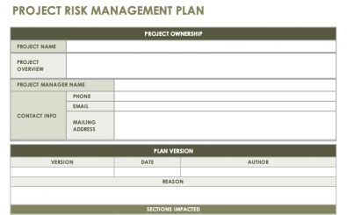
Serve for the community and do business
Modern and Digital 1st of Sept. 2022 Bikash Roy
Gants Hill, Ilford, Essex UK.
Trin@org.com
078888885555
Bikash Roy
Build a Cold storage in the bank of the river for easy communication system
River Side Cool Cold Storage
5. Cost and Resources: It’s broken up into few groups, processing areas, machinery rooms, storage areas, parking lots are few of the distributions. A cold storage facility’s basic layout, as well as its design and machinery should all be carefully examined. The room’s measurements may be 13 feet by 19 feet by 10 feet. If the outside temperature is 38 degrees centigrade, the needed temperature will be +6+ -1. According to the demand, the capacity will be 2.6 MT for preserving fruits and vegetables. 300 kg of incoming goods will be loaded per day, and 60mm PUF will be used as insulation. The refrigerator should have a 30000Btu/hr capacity and the humidity storage area should be between 80 and 90 percent.
The investment cost for cold storage in Bangladesh includes a variety of other costs £110.000. The price of the machinery might range from £1500 to £2500. The remaining expenses will total about £1000. The installation cost plus overall taxes bring the amount £15000. The cost of setting up a cold storage facility in Bangladesh is quite costly but it is worthwhile and essential for the development of the country.
6. Conclusion: Even though there will be to face lots of unexpectable obstacles to proceed with proper plan. However, considering necessity and its outcome, as I expected there will be join lots of investor and together we will build a future plan.

7. References:
- Fundamentals of Project Management, (J. Heagney 2016)
- Making things happen mastering project management. ( Berkun and Scott, 2008)
- Project management. (Maylor and Harvey, 2010)
- Cold storage Management Standard Operation Procedure. (Kings College London, May 2015)
- Journal daily sun. (5th Sept 2022)

Appendix:

Task-1 Slide Presentation




