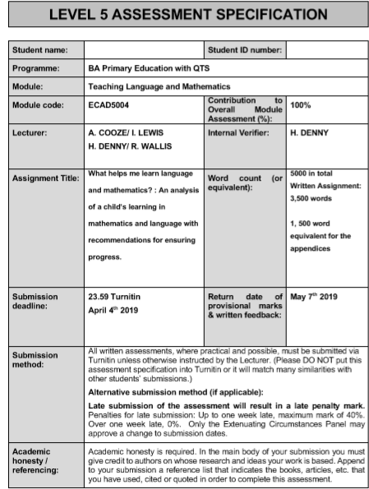
1701466

Student Number: 1701466
ECAD5004: Language and Mathematics
Module Lead: Helen Denny
Programme of Study: BAEd Primary Education with QTS

What helps me learn language and mathematics? : An analysis of a child’s learning in mathematics and language with recommendations for ensuring progress.

The purpose of this assignment is to identify ways that a child learns and how practitioners can support them most appropriately to ensure academic and personal progression in language and mathematics. The assignment will discuss a variety of approaches to teaching and learning methods of language and mathematics and some of the opportunities and challenges that both the practitioner and the learners can be faced with in reflection of these methods. Using observational notes, an interview with the learner and samples of work, I will be identifying the way or ways that a child within the Key Stage 2 (KS2) class develops skills most appropriately from the National Curriculum and relevant Frameworks. All data collection will follow GDPR guidelines (Information Commissioner’s Office, 2018), supported by a consent form (see appendix 1) completed on behalf of the school confirming consent to carry out research, and a verbal agreement with the pupil discussed, as identified in appendix 2. For this assignment the practitioner employed the ‘Mosaic Approach’ which encourages learners to share their perspectives of their education through interviews, observations, maps or drawings and samples of work (Clark and Moss, 2011) (Joseph Rowntree Foundation, 2001). The ASK Model has been used to analyse data gathered and to ensure that all aspects of learning have been considered, including the attitude to learning (A), the wider skills required to complete an activity (S) and the knowledge that is highlighted as a result of the activity (K).
For this assignment, the pupil discussed is an 8-year-old girl, hereafter ‘Child A,’ in Year 3 who works at a typically average level within this class. The school that Child A attends is a two-form-entry school that welcomes learners from diverse backgrounds and various personal and academic needs. Child A’s class is, on average, working towards national expectations of achievement and understanding. The class supports children who are learning English as an additional language (EAL), children who are on the Autistic Spectrum and children with various other needs and diagnoses. Child A has no known additional learning needs (ALN). Child A typically works within the middle ability group however works at a slightly higher level in Mathematics than language. Typically, learners within this classroom work with peers of the same or similar level regardless of the topic or activity at hand: it is rare that learners work with peers of a different level of understanding.
Vygotsky’s theory of social development suggests that social interaction impacts and precedes cognitive development (David, 2014) therefore affecting the learning process. Unlike Piaget who emphasises the importance of learning individually (Brown, 2007), Vygotsky argued that “social interaction was foundational in cognitive development” (Brown, 2007, p.14), therefore indicating that learners require social interaction in order to develop their understanding of a concept. Meanwhile, the AAIA (2019) argue that effective Assessment for Learning (AFL) techniques are fundamental to the development of independent learners within the classroom. This is supported even further by the Education Endowment Foundation (2018) who argue that AFL strategies that encourage metacognition combined with activities that are of an appropriate level of challenge can lead to greater understanding of concepts, control over their learning and increased progress over a shorter period (Education Endowment Foundation, 2018). The Education Endowment Foundation (2018) are not isolated in their views that each learner must undertake activities of suitable challenge: Vygotsky’s “Zone of Proximal Development” theory suggests that each individual learner has an ideal level of challenge, where the learner can access the work but still requires them to engage and extend their understanding in order to complete the work (David, 2014). Vygotsky’s theory was utilised in the classroom by the practitioner when teaching: the learners were often encouraged to ‘think-pair-share’ their ideas with one another, a process which also encourages the employment of the ‘more knowledgeable other,’ (MKO) which further supports the social development theory (David, 2014). Through observation (see appendix 3) it was acknowledged that Child A made some academic progress when using this AFL strategy, including developing the ability to share her own ideas about concepts and listen to others, supporting requirements from the Literacy and Numeracy Framework (LNF)(Learning Wales, 2014) and the skills framework (DCELLS, 2008). Arguably due to regular use of the strategy, discussing challenges with peers has become a natural response to difficulty for Child A, but it is also worth noting that these AFL strategies should be altered to suit the individual rather than being implemented as a blanket approach to establishing understanding (CCEA, 2018). When observing Child A, it was noticed that she naturally turns to the MKO for support when uncertain, demonstrating that she has some awareness of how to ensure that her understanding of a concept increases (see appendix 4).
In this section of the assignment I will explore the approaches to teaching and learning and whether Child A’s knowledge and understanding of the topic or concept developed as a result of these approaches. Over the duration of the PTE the approach to teaching and learning was largely cross-curricular, with the focus lying primarily upon the overarching theme of Gods and Gladiators. This theme allowed learners to explore language and mathematics in various areas of learning and experiences (AOLE). As a result of this cross-curricular approach to teaching and learning, much of Child A’s work is not clearly defined into a language or mathematics activity, but instead falls into topic work, allowing for simultaneous development of skills branching from the language and mathematics frameworks and curriculums and from the skills framework itself.
During observation of the whole class, it was noted that the learners often used resources to support their understanding within Mathematics activities which were suggested by the teacher. However, Child A indicated during the interview (see appendix 2) that she often uses resources to support herself in language and mathematics that require minimal teacher-input or guidance, including her spelling book and a 100 square for instance. These open-access resources allow the learners to retain some control over how they could support their own understanding of concepts, however it was noted that some learners did not have the level of independence to access these resources without some guidance. It was noted that at times Child A required some direction, particularly with Mathematics, on the resources that she could use to support herself, however she has, generally, developed the independence to do so with minimal guidance. Fox and Surtees (2010, p.20) argue that whilst practitioners should advocate the “effective use of resources and group interaction” we should also respect each learner’s mode of learning, therefore if a learner feels uncomfortable approaching a task in a particular way, they should be supported using the method or they should be provided with an alternative approach to learning. The following language, mathematics and cross-curricular activities all aim to support Child A through her preferred learning approach, however throughout all activities opportunities to explore and use alternative learning approaches were presented to Child A in order to ensure holistic development.
Within language lessons, the learners were working towards producing a newspaper report about the Roman invasion, supporting the theme of Gods and Gladiators. Initially Child A showed limited awareness of the topic, however demonstrated interest through questioning and quickly retained information (see appendix 5). In order to develop understanding of how to write a newspaper report, the learners were initially invited to share their prior knowledge of the features of a newspaper. This activity encouraged all learners to collaborate their ideas and provide reasoning behind their ideas of the content of a newspaper. Child A responded well to this activity: observation of this activity confirmed that she is a social learner, developing her skills most appropriately when provided with opportunities for discussion and contribution to the lesson (see appendix 5) (Jarmy, 2013). Jarmy (2013) argues that interactive learning that involves discussion between learners fosters a learning environment that encourages learners to provide reasoning behind opinions and discuss alternative perspectives. As this was the introduction to the topic, Child A was aware that she was exploring her prior knowledge at this point, therefore she would have varying levels of understanding of different aspects of the topic that she could use to support herself and her peers in future activities. Child A was able to successfully relate and express her prior knowledge and experience of what a newspaper report is with a degree of succinctness, as a result developing her speaking and listening skills in line with the national curriculum (DCELLS, 2016) (see appendix 5). In contrast, in another lesson Child A was asked to write down everything she already knew and what she would like to learn about habitats independently, with limited discussion with peers. As identified by the sample of work (see appendix 6), Child A was less engaged during this writing activity, arguably due to the requirement that she drew upon her own prior knowledge before partaking in a class discussion on the topic.
One activity that Child A and her peers were most engaged in was an exploration activity of habitats outside the classroom. Child A was partnered with a learner of a different ability and they were encouraged to discuss and explore potential habitats in the school environment, developing their communication and debate skills, with guidance from the practitioner. It is my belief that Child A was more engaged with this activity due to the active engagement approach to learning: the learners were able to explore the habitats first hand which supported their understanding more effectively than viewing pictures in the classroom. This is supported by Unicef (2002) who argue that children learn most effectively when they have access to actively explore their environment, however it is worth considering the Centre for Educational Neuroscience’s (CEN) view that individuals could have different learning styles (CEN, date unknown) which therefore would suggest that activities and learning opportunities should be tailored to the individual.
As identified by Unicef (1999) one approach to teaching and learning is to encourage partner and group work as a method to encourage development of effective communication and learning to work collaboratively to achieve a goal. When undertaking the exploration of habitats outside, at times Child A worked effectively with her partner, but occasionally struggled to listen to her partner. Child A demonstrated an enthusiastic attitude towards the activity and was able to use key vocabulary and develop her oracy skills in line with the learning objectives. Despite this, it is evident from the sample of work (see appendix 7) that Child A was so immersed in the learning experience that she didn’t record all the data required. Irrespective of the reduced amount of written work, Child A responded well to the activity and developed her oracy and listening skills whilst working with her partner. In hindsight, it is possible that Child A struggled to recall all the expectations therefore focussed upon those that she could recall.
In a mathematics activity, Child A worked with seven peers to problem-solve and answer a series of questions intended to develop understanding of telling the time. Not only did this activity allow Child A to develop her mathematical skills in terms of telling the time, she also developed and appropriately used mathematical language and developed wider skills from the skills framework (DCELLS, 2008). Immediately, it is evident that this activity supported Child A in many aspects of her academic and personal development. Child A’s attitude to the learning experience was maintained throughout which was reflected in her attention to her work. On occasion, Child A does not complete the expected amount of work during any given session, however this active engagement appears to have motivated Child A as all four activities were completed within the timeframe. Furthermore, during the plenary reflection, Child A demonstrated some retention of understanding of how to tell the time, highlighting that this active involvement and group collaboration supported her in the learning process.
In mathematics, Child A demonstrated greater interest when using various resources than when provided with worksheets, possibly due to the hands-on nature. One concept that Child A focussed upon was telling the time. The first of three lessons encouraged the learners to explore telling the time through a resource carousel. Child A demonstrated a resilient approach to this lesson suggesting a positive approach to learning regardless of her ability. This carousel of activities provided Child A with the opportunity to develop her communication, listening, problem-solving and teamwork skills, whilst simultaneously allowing development of mathematics and language skills in line with the National Curriculum. This series of short activities encouraged Child A to access her prior knowledge, namely the awareness of the order and placement of the numbers around the clock face and how times are represented using a clock face, and apply it to different problems. Child A demonstrated sound ability to interact appropriately with her peers throughout this series of tasks, supporting her peers in group work through consistent active engagement with the set tasks (see appendix 8).
During the interview, Child A identified some specific resources that she believes support her in the learning of mathematics, however struggled to name specific resources that support her in the development of her language skills. Contrary to what is portrayed in the interview (see appendix 2), observations highlighted that Child A regularly used various resources to support herself in the learning of language. These resources included whiteboards, dictionaries and fact and fiction books. It is arguably due to the cross-curricular potential of these resources that Child A did not associate these resources with learning language. Crucially, these resources allowed Child A to not only develop subject-related skills but also develop wider general skills, such as listening to others and recording what they say. During one language lesson Child A independently suggested the use of a whiteboard to support her learning with a partner (see appendix 9). In line with the views of Fox and Surtees (2010), Child A was encouraged to approach the learning experience in the way that she felt most appropriate, which potentially resulted in greater participation and engagement from Child A.
Child A’s attitude to learning varies dependent upon the activity and the approach to learning, as with most learners. During observation, Child A was provided with a worksheet about temperature upon which she was required to show what different temperatures would look like on a thermometer. Child A wasn’t engaged in this activity: she was often talking to peers about unrelated topics and required multiple reminders to complete her work. This approach to teaching and learning, using a worksheet instead of active involvement, didn’t suit this activity nor Child A. However, undertaking this activity did allow Child A to develop skills including listening to others and “responding to information in different forms” (DCELLS, 2008, p.19b). Child A had limited prior knowledge of temperature and had no understanding of what a thermometer was nor how to use one correctly.
Within the following section of the assignment various suggestions will be made to ensure that Child A continues to develop her skills appropriately in language and mathematics alongside cross-curricular skills such as thinking and communication. It is worth noting that many of the following suggestions could be applied to various subjects, topics or concepts.
Primarily, the data gathered strongly indicates that Child A works most effectively when she can receive support from the MKO. In reflection of this, where possible Child A should continue to be encouraged to utilise her communication skills to support others and herself when experiencing academic difficulty, however does also need to develop her independence so that she can support herself when encountering difficulties. One recommendation to support the development of independence on an individual and a class basis is to introduce a visual guide that the learners can refer to when encountering challenges. This guide could provide cross-curricular or subject-specific information, including suggestions of resources to use and books to consult for guidance. Furthermore, amongst other learners, Child A could be provided with the activity or lesson expectations in a written, accessible format that can be referred to throughout the lesson. This will allow Child A to ensure that she is remaining on-task and can remain more independent than previously. This approach to teaching and learning should support Child A is all aspects of her learning, including both mathematics and language.
Child A needs to develop her understanding of how to tell the time. Whilst she demonstrated accurate understanding of how to tell the time using o’clock and half-past intervals, Child A’s understanding and awareness of how to tell the time in quarter-hour and five-minute intervals requires attention. In order to ensure Child A’s understanding of the concept is maintained and improved upon, one recommendation is to establish some daily routines focussing upon areas of mathematics, including telling the time, that Child A and other learners struggle with. These routines could include the practitioner sharing video clips with the learners, encouraging short collaborative activities and some problem-solving opportunities, all of which would expose Child A and other learners to more challenging concepts including telling the time. Crucially, however, Child A should have access to various resources, including clocks, stopwatches and watches, allowing Child A to have a concrete visual of time itself.
Child A also needs to establish a more concrete understanding of temperature. In order to ensure that Child A’s understanding of this concept is built upon, I would recommend using a more visual and concrete approach to teaching temperature. Ideally, the practitioner should model using a thermometer before inviting Child A to work with her peers to complete a series of tasks requiring the learners to problem-solve and work as a team.
As identified by the Education Endowment Foundation (2018), practitioners cannot expect learners to make the transition from working with peers to working independently without guidance. They suggest that support should be “gradually withdrawn” (Education Endowment Foundation, 2018). This indicates that in order to maintain or improve the standard of work not only produced by Child A but with all learners, the practitioner will need to establish a variety of supporting materials to encourage a gradual release of responsibility. According to Fisher and Frey (2013), the gradual release of responsibility instructional framework encourages the transition from adult-led instruction to child-led exploration of activities or topics. It should be this approach that the practitioner should endeavour to implement in order to support Child A most appropriately in her academic progress towards independence as a learner, who can collaborate, communicate, problem solve and more, within language, maths and all other areas of learning and experience.
Furthermore, in order to ensure Child A and all other learners progress appropriately in their knowledge and understanding of mathematics and language, AFL techniques should be employed in order to establish the most appropriate way to allow learning to progress (Kyriacou, 2009) (Best and Thomas, 2007).
In conclusion, to ensure that Child A makes academic progress in language and mathematics, her individual learning preferences need to be accounted for and appropriate resources should be provided and accessible. In my personal opinion, the pivotal alteration that a practitioner should make to ensure academic development is to establish a positive classroom ethos that encourages exploration of challenges and peer support.

Reference List
AAIA (2019) “Assessment for Learning,” Association for Achievement and Improvement through Assessment. [blog] (Date unknown) Available at: https://www.aaia.org.uk/blog/category/afl/ (Accessed: 02/04/2019)
Best, B. and Thomas, W. (2007) Everything you need to know about teaching but are too busy to ask. London: Continuum.
Brown, H.D. (2007) Principles of Language Learning and Teaching. 5th edn. New York: Pearson Education.
CEN (date unknown) Children have different learning styles. Available at: http://www.educationalneuroscience.org.uk/resources/neuromyth-or-neurofact/children-have-different-learning-styles/ (Accessed: 01/04/2019)
Clark, A. and Moss, P. (2011) Listening to Young Children: The Mosaic Approach. 2nd edn. London: NCB.
CCEA (2018) What is Formative Assessment? Available at: http://ccea.org.uk/curriculum/assess_progress/types_assessment/formative (Accessed: 30/03/2019)
David, L. (2014) "Social Development Theory (Vygotsky)," Learning Theories [blog] (July 23 2014) Available at: https://www.learning-theories.com/vygotskys-social-learning-theory.html (Accessed: 30/03/19)
DCELLS (2008) Skills framework for 3 to 19-year-olds in Wales. Available at: https://learning.gov.wales/docs/learningwales/publications/140626-skills-framework-for-3-19-year-olds-en.pdf (Accessed: 02/04/2019)
DCELLS (2016) Programme of Study for English: Key Stages 2-4. Cardiff: Welsh Government.
Education Endowment Foundation (2018) Metacognition and Self-regulated learning. Available at: https://educationendowmentfoundation.org.uk/tools/guidance-reports/metacognition-and-self-regulated-learning (Accessed: 02/04/2019)
Fisher, D. and Frey, N. (2013) Better Learning Through Structured Teaching: A Framework for the Gradual Release of Responsibility. 2nd edn. Virginia: ASCD.
Foreman, M. and Gamble, N. (2002) ‘Getting it write! Supporting and responding to children’s writing,’ in Moyles, J. and Robinson, G. (ed.) Beginning Teaching: Beginning Learning in Primary Education. Buckingham: Open University Press.
Fox, S. and Surtees, L. (2010) Mathematics Across the Curriculum: Problem-Solving, Reasoning and Numeracy in Primary Schools. London: Continuum.
Information Commissioner’s Office (2018) Guide to the General Data Protection Regulation. Available at: https://assets.publishing.service.gov.uk/government/uploads/system/uploads/attachment_data/file/711097/guide-to-the-general-data-protection-regulation-gdpr-1-0.pdf (Accessed: 02/04/2019)
Jarmy, C. (2013) ‘Classroom practice- speak easy: learning through discussion,’ Times Education Supplement. [blog] 20th September. Available at: https://www.tes.com/news/classroom-practice-speak-easy-learning-through-discussion (Accessed: 02/04/2019)
Joseph Rowntree Foundation (2001) Listening to Young Children: The Mosaic Approach. Available at: https://www.jrf.org.uk/report/listening-young-children-mosaic-approach
Kyriacou, C. (2009) Effective Teaching in Schools: Theory and Practice. Cheltenham: Nelson Thornes.
Learning Wales (2014) National Literacy and Numeracy Framework. Available at: https://learning.gov.wales/resources/browse-all/nlnf/?lang=en (Accessed: 02/04/2019)
UNICEF (2002) Children learn best from experience. Available at: https://www.unicef.org/teachers/learner/exp.htm (Accessed:01/04/2019)
UNICEF (1999) Teaching styles for active learning. Available at: https://www.unicef.org/teachers/teacher/styles.htm (Accessed: 01/04/2019)

Appendices

Appendix 1
This shows the consent form completed and signed on behalf of the school, providing consent to collect and analyse data focussing upon one learner. All names, including the name of the school, and signatures have been removed to ensure anonymity of this assignment.
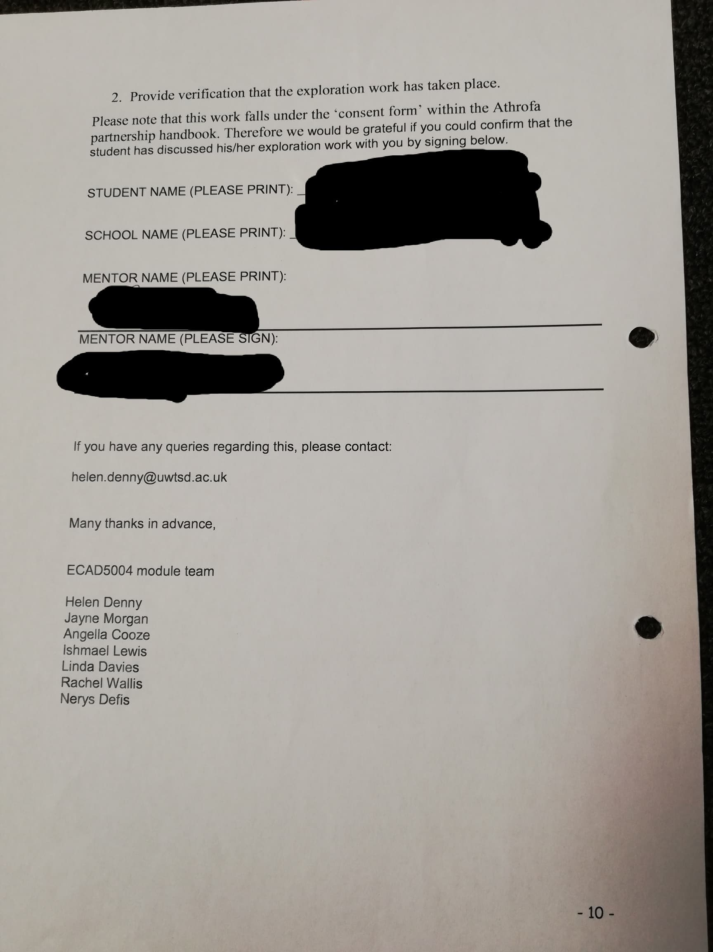
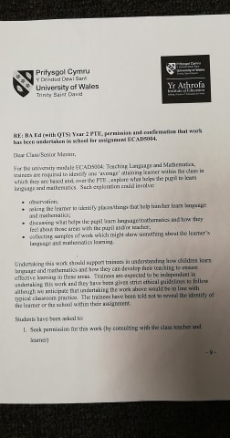
Appendix 2
Interview with Child A
Before this interview started, to ensure that ethical guidelines were met, the learner was made completely aware that she could withdraw from the interview or being observed at any time. Child A said she was happy to assist the me with my University work. Child A was encouraged to be honest throughout and was also told that if she wasn’t sure of a question or didn’t want to answer a question then she should say. Child A was also told that there are no right or wrong answers. Where possible, I wrote down exactly what child A said, however at times this wasn’t possible, so key words and phrases were noted instead. This interview is a combination of both.

T= Trainee
CA= Child A

T: What helps you to learn Language?
CA: The teachers… computers…my mum.
T: Do any things help you to learn Language?
CA: Computers. My spelling book. We do KWL grids too.
T: Okay. Where do you learn language?
CA: In the classroom. (Child thinks) In my house. Outside of school. And on my language table.
T: What happens if you get stuck?
CA: I try my best. I’ll ask a friend…no, 4 friends. And then we go to the teacher. That’s what miss says.
T: What does your teacher say if you’re stuck?
CA: She says try your best, use your spelling book. And ask a friend.
T: What happens if you get a question wrong?
CA: I just say okay, I got that wrong. If I do that again I’ll try again. The teacher sometimes puts a dot.
T: What’s your favourite thing to do in Language lessons?
CA: I like to write stories.
T: Is there anything else you would like to tell me about your language lessons?
CA: (Thinks) No.
T: Okay, we are going to talk about Maths now, is that okay?
CA: Yes. I like Maths.
T: Okay. So, where do you learn maths?
CA: In my classroom, on my maths table. And at my house with my mum. She’s a teacher too.
T: That’s helpful! When do you learn maths?
CA: We have Thinking Thursday. And Monday, Tuesday… (lists all days except Sunday)
T: Can you tell me what helps you learn maths?
CA: Hmm… Numicon, 100 square, my times tables. That’s all I can think of.
T: Is there anything else you would like to tell me about your Maths lessons?
CA: They’re fun. Fun. Sometimes hard though…
T: Is there anything else you would like to tell me?
CA: No, I don’t think so.

Appendix 3
Observational note
Language: Child A used think-pair-share well. I noticed that she took time to think carefully about prior-knowledge/understanding before sharing her thoughts with a partner. Child A was then able to explain her own and her partner’s thoughts during the class sharing. Child A was happy to contribute to the class discussion. Able to recall key facts and use prior knowledge to inform learning. Needed guidance initially however became more independent.

Appendix 4
Observational note
Maths: Learners were encouraged to use a mirror to support their understanding. Some guesses were made. Child A decided to work with a partner, unprompted, for this activity to support herself. Child A was heard working with her partner to answer the questions.

Appendix 5
Observational note
Language: Introduction to newspapers. Initially unable to suggest any features of a newspaper, until other learners suggested some. Child A then suggested some features of a newspaper and carefully listened to peers and using think-pair-share to extend understanding. By the end of the lesson Child A was able to draw upon the knowledge she had gained to explain what a newspaper report is and suggest some features.

Appendix 6
Sample of work
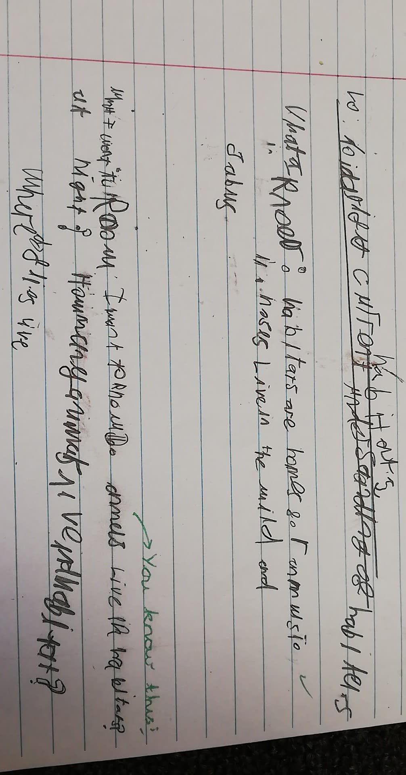

Appendix 7
Sample of work
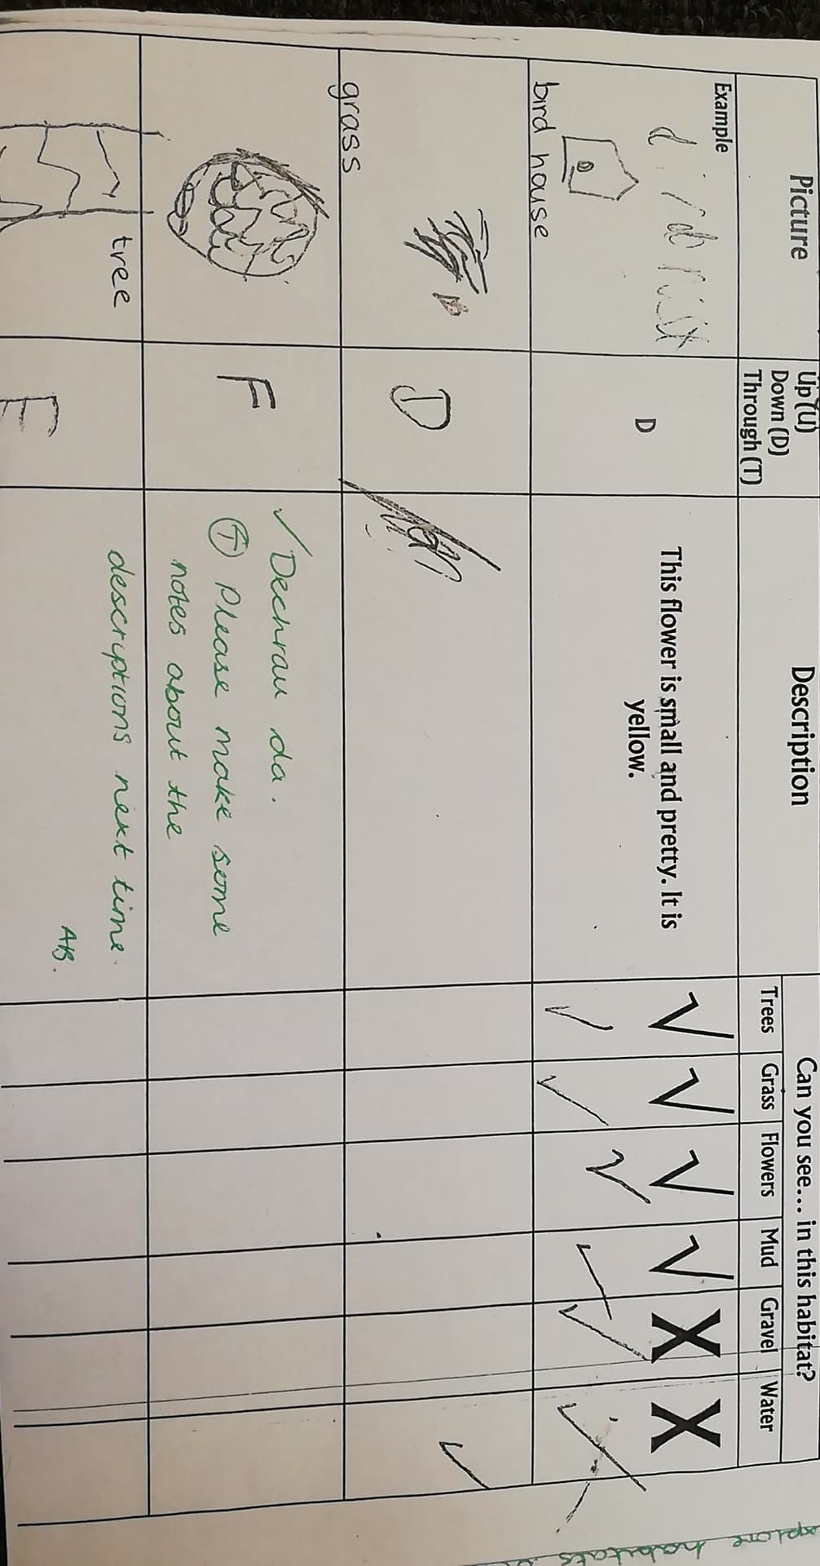

Appendix 8
Observational note
Maths: Child A interacted with peers throughout. She took part in all the activities in the time carousel. With support from peers, Child A was able to sequence cards showing various times (of 15-minute intervals) accurately. Child A also accurately placed the numbers on the clock-face and was able to draw the hands to represent various times. Child A can independently recognise half-past and o’clock times. She can also, at times, recognise some quarter-to/past times. Child A does tend to get confused when it is quarter to/past nine or three due to difficulty differentiating between the clock hands.

Appendix 9
Observational note
Language: Child A followed the instructions well and worked effectively with her partner. Some periods of distraction in the session- alternative plenary/aim? Children to share their answers/explain reasoning? Child A asked to use a whiteboard to record ideas- this was effective for Child A and partner- this method of note-taking requires limited presentational skills and also encouraged communication between the two learners.

