Clydach Community Council

Table of contents

Reflective Commentary
References
Portfolio Evidence I
Information about Clydach Community Council
The History
The role of a councillor
The work that councillors do
Evidence 2
Reflective logs
Evidence 3
Code of Members' Conduct
Evidence 4
Certificates of training
Evidence 5
Attendance Form Placement/Work Experience
Evidence 6
Invite to interview and offer to become a councillors emails

References

Reflective Commentary

During this reflective commentary, I will use Gibbs' Reflective Cycle (1988) to reflect upon the time I spend volunteering with Clydach Community Council. I will also explore how this role has allowed me to demonstrate and improve my core counselling skills set out in the works of Rogers (1959) Midwinter &Dickson (2015).
I volunteered to become a community councillor as I believe it is important to help others and try to enhance your local community. At the time I did not truly understand what being a councillor involved, I had read through the information on their webpage, “Being a Councillor with Clydach Community Council” (Council, 2022) which whilst being insightful and setting out what is expected of a councillor it does not truly prepare you for the role, I have gained a fuller insight of the role by the experiences as a councillor, Kolb's (1984) Experiential Learning Theory suggests we learn by experience.
I have faced numerous challenges since I have become a councillor, one being the lack of organisation, other than the Council meetings, times, and dates to complete a task can change last minute, which is frustrating, as I have scheduled the task in for that time, meaning that I must rearrange several other commitments.
I also find the lack of respect shown to each other by some counsellors extremely challenging. They brush it off saying that to be a councillor you need to be thick-skinned; this goes against my personal beliefs and that of Carl Rogers (1959). Teaching, actively listening to another person shows that you respect them (Midwinter & Dickson 2015) you might not always agree with their point of view, however, you should always be respectful. I understand that this is not a therapeutic setting, however, I believe that it has demonstrated to me the importance of the core counselling skills, as without them, people do not feel respected and might become defensive resulting in the breakdown of the relationship and even a hostile environment. In the short time I have been there three councillors have resigned sighting bullying as the main or a contributing factor.
During the Summer fate I felt out of my depth at times as I did not know what was expected of me. I completed various tasks such as ensuring that people knew what events were there, then I went to help my daughter man the large bouncy castle obstacle course, the ride was overcrowded with individuals ranging in age from around a year old accompanied by an adult to sixteen-year-olds, this created an unsafe environment. I located and informed the owner of the ride of my concerns, she basically just came and shouted at the older children and said only 8 were allowed. However, the ride was free, and there was no fencing around it and no age limit which caused challenges. The teenagers who ran away when they were shouted at returned and said they had done nothing wrong, I had to use my communication and listening skills to ensure that everyone was safe. I demonstrated to everyone there that I was listening to them and that I was treating them fairly, everyone had just the same right to use the ride. The older children felt discriminated against when the ride owner shouted at them, I explained to them that while they were not doing anything wrong and I understood why they felt angry for being shouted at, that parents were worried about their small children’s safety, as they could accidentally hurt them. By treating everyone with positive regards (Rogers 1959), I reached a comprise, the older children could complete the course and be boisterous, but then wait for the younger ones to have a turn, on the whole, this worked out well and the older children even helped us.

The role of the counsellor is to support an individual through their journey as they resolve their own challenges, (Myers, 2001) as a councillor people expect you to resolve the issues for them, this is not always possible, however, even if you are unable to fully resolve their concerns you should always remain empathic and be congruent.
One example of this, is when my friend’s mother phoned me in the evening, at first, I thought that she was ringing to inform me that my friend was ill, however, she was annoyed as her husband’s birthday cards had not arrived, I used a range of counselling micro-skills during the conversation, firstly I made sure that my voice remained calm and steady and I asked minimum questions to establish what the problem was, once I discovered the issues was a lack of road signs, I continued to actively listen to her, by using a range of skills including minimal encouragers and paraphrasing, her voice lowed when I said “I hear your frustration at the situation” and “yes I can see how that would upset you” as stated in McLeod, & McLeod, (2011). I explained that the community council were unable to install or repair road signs, however, I would find out who the best person to contact would be and inform them how frustrating it was when even a new postman (postal operative) could not work out where they lived and agreed that yes it must be a worry if her husband became ill and an ambulance could not find them, we chatted a little more about both their health and how unwell they had been recently. My friend later apologized for not warning me that her mother was going to ring me, as she believed that her mother had become more cantankerous in recent years, and she wanted to make sure I was okay. I am glad that she had not informed me beforehand as I might have tried to rehearse what I was going to say, therefore, I would not have been actively listening to what she was saying and released that she was worried that an ambulance would not be able to locate them. I felt both relieved and proud when my friend informed me the next day that her mother felt understood. I believe had I not employed the skills I had learned, the conversation could have been completely different.
Though this is not a traditional counselling setting I have gained many useful skills, being part of a team yet being able to use my own initiative, many of the counselling skills are useful for any situation. I have learned that I should be more assertive in the future.

References
Gibbs, G. (1988). Learning by Doing: A Guide to a Teaching and Learning Methods. Further Educational Unit.
Midwinter, R., & Dickson, J. (2015). Embedding counselling and communication skills : A relational skills model. New York: Routledge, p.29 doi:10.4324/9781315730493
McLeod, J., & McLeod, J. (2011). Counselling Skills: A Practical Guide For Counsellors And Helping Professionals: A practical guide for counsellors and helping professionals. McGraw-Hill Education (UK).
Myers, J. (2001). Basic counseling skills. In D. C. LockeJ. E. Myers, & E. L. Herr The handbook of counseling (pp. 237-256). SAGE Publications, Inc., https://www-doi-org.ezproxy.uwtsd.ac.uk/10.4135/9781452229218.n15

Nemec, P. B., Spagnolo, A. C., & Soydan, A. S. (2017). Can you hear me now? teaching listening skills. Psychiatric Rehabilitation Journal; Psychiatr Rehabil J, 40(4), 415-417. doi:10.1037/prj0000287

Rogers, C. R. (1959). A theory of therapy, personality, and interpersonal relationships: As developed in the client-centered framework (Vol. 3, pp. 184-256). New York: McGraw-Hill.

Evidence 1
Clydach Community Council was established under the Local Government Act 1972 which replaced the previous system of parish councils. Community Councils are the nearest level of democracy to the people serving the smallest area and being responsible for local matters.
Clydach is served by sixteen councillors who each represent individual wards within Clydach, they are often approached by the people of Clydach seeking advice, for example, if someone wishes to start a charitable project, councillors can signpost them to the right people.
Councillors hold public office and must adhere to a Code of Conduct, which they must agree to and sign before they can take office.
The council is funded by "precept" a sum of money that is collected annually with the council tax.
The Community Council is the voice of the residents and has powers to represent its constituents on planning, and to do anything that they consider would promote or improve the economic, social, or environmental well-being of the area making Clydach a better place to live, grow, work, and learn thus improving the quality of life for the people of Clydach.
The Council helps to make Clydach an attractive and safe place to live and work, by maintaining flower beds, hanging flags and decorating and hanging Christmas trees, installing Defibrillators, speed prevention strategies, working in partnership with My Green Valley a community organization that concentrates on reducing litter and maintaining green spaces within the Swansea Valley, plus a whole host of other things.
Clydach Community Council manages two community halls which can be hired out for parties, dance classes, and by a variety of other groups, use of the hall is free to all non-profit community groups such as the Brownies and Rainbows. The council also maintains a play area and several plots of land throughout Clydach.

Every year, the council hosts numerous events, such as Summer Festival, Fireworks Display, and Christmas Parades, any profit from these events, is put back into the community by means of the community fund grant, local non-profit organizations can apply for a grant of up to £300.

Community councillors can propose their own projects to improve the local community, I have been in discussions with our chair about two projects that I believe would benefit my local community (Council, 2022)

Firstly, a homework club which would provide children with an environment for them to study, as not every child’s home is suitable for them to study, they might not have the equipment needed, a quiet area or someone there that they can ask for assistance and give them support and encouragement. The Homework club would provide laptops, free access to online resources, printing, photocopying, and hopefully, some free stacks.
Secondly, I believe that the people of Clydach would benefit from a clothes library, this would enable people to borrow clothes for special occasions, like proms, weddings, and job interviews, many people will buy clothes for special occasions and never wear them again, whereas some people cannot afford to buy an outfit for a special occasion and therefore, may feel excluded, the clothes library will not only help people on low incomes but will also reduce the number of clothes that end up in landfills.

Evidence 2

Student Name: | Mary Cherrington
Name of Host Employer: | Clydach community council

Record of project work carried out (add more entries as needed)
Date: | 6th August 2021
Tasks completed: | Party on the green (summer fate) set up 2 hours
Reflection: | This was a good way to meet my fellow councillors and to gain an insight into the dynamics of the group.

Date: | 7th August 2021
Tasks completed: | Party on the green (summer fate). 5 hours
Reflection: | I felt out of my depth at times as I did not really know what I should be doing, I completed various tasks such as ensuring that people knew what events were taking place and generally talking to people, I also went to help my daughter man the large bouncy castle obstacle course.  I found this event changeling, when I went to assist my daughter, I noticed that there were far too many individuals on the bouncy castle, my daughter had not been told there was a limit. I went and found the owner who was supervising another ride, she then relayed the maximum number allowed at one time. However, as the ride was free and had no fencing around it, this was problematic, additionally, there was not an age limit, therefore, there were young toddlers some with their parents right up to older teenagers. I had to use my communication and listening skills to ensure that everyone was safe. I demonstrated to the parents, children, and the teenagers that I was listening to them and that I was treating them fairly, everyone had just the same right to use the ride, the teenagers and older children felt discriminated against when the ride owner shouted at them, parents were worried about their children’s safety. By treating everyone with positive regards (Rogers 1959), I reached a comprise, the older children and teens could complete the course and be boisterous, but then wait for the younger ones to have a turn, I informed the parents that their little ones could go on at any time, however, if they waited for two minutes the younger ones could go on together.

Date: | 8th August 2021
Tasks completed: | Party on the green (summer fate). Pack away and clean up 2 hours
Reflection: | I had to use my skills times to negotiate with others as most people had different views on how complete each task, which was very time-consuming.

Date: | 10th August 2021
Tasks completed: | General community Council meeting. All councillors and planning  2 hours
Reflection: | I was unsure what to expect, I mainly just observed, as I did not feel confident to really contribute

Date: | 9th, 12th, 17th and 26th August 2021
Tasks completed: | Training hosted by one voice Wales 6 hours
Reflection: | I did not know that the community council had so many responsibilities, I felt overwhelmed by this level of responsibility, the different training helped me gain confidence.

Date: | 31st August 2021
Tasks completed: | Halls and events, community Council meeting 1.5 hours
Reflection: | I felt more comfortable contributing in this meeting and expressed my concern over the summer fate, this must be done carefully as I had noticed that some of the councillors seem to take any form of constructive criticism as a personal attack, however, I did not want to be put in that situation again.

Date: | 6th September 2021
Tasks completed: | Takedown the hanging baskets 2.5 hours
Reflection: | Working as part of a team to benefit my local community gave me a sense of purpose

Date: | 14th September 2021
Tasks completed: | General community Council meeting. All councillors 1.5 hours
Reflection: | I started to feel more confident to share my opinion and to disagree with others if needed.
Date: | 28th September 2021
Tasks completed: | Halls and events, community Council meeting 1.5 hours
Reflection: | Planning the different events were both enjoyable and gave me the opportunity to share my views on the upcoming events, trying to give my views and negotiate a different way of doing things can cause issues, therefore, I needed to be very respectful
Date: | 26th October 2021
Tasks completed: | Halls and events, community Council meeting 1.5 hours
Reflection: | Planning the fireworks display, I found this meeting frustrating, my daughter is afraid of fireworks, they trigger painful memories for her, I realised that when it comes to my children, I can become very protective, I had to remind myself that not everyone understands how people can be affected by something that other people enjoy, I was being judgemental. I made sure that I explained that I would help beforehand or the next day, however, I would not be there during the fireworks display, I did not need them to fully understand why I could not help out, I only needed them to know that I could not help out, they had no need to understand my reason

Date: | 1st November 2021
Tasks completed: | Cleaning planters and Judging window display 3 hours
Reflection:

Date: | 9th November 2021
Tasks completed: | General community Council meeting. All councillors 1.5 hours
Reflection:

Date: | 28 – 1 December November 2021
Tasks completed: | Putting lights on trees and installing trees on buildings 5 hours
Reflection: | I was working with various people, there are too many people with differing opinions which can make any task problematic, I tried

Date: | 30th November 2021
Tasks completed: | Halls and events, community Council meeting 1.5 hours
Reflection:

Date: | 4th December 2021
Tasks completed: | Christmas parade 4 hours
Reflection:

Date: | December 14th 2021
Tasks completed: | General community Council meeting. All councillors 1.5 hours
Reflection:

Evidence 3

CLYDACH COMMUNITY COUNCIL

Code of Members' Conduct
- This Code of Conduct is adopted pursuant to the Council's duty to promote and maintain high standards of conduct by Councillors and co-opted members (1) of the council.
- This code applies to you as a member or co-opted member of this Council when you act in that role and it is your responsibility to comply with the provisions of this code.
SELFLESSNESS
- You must serve only the public interest and must never improperly confer an advantage or disadvantage on any person including yourself.
OBJECTIVITY
- In carrying out public business you must make decisions on merit, including when making appointments, awarding contracts, or recommending individuals for rewards or benefits.
ACCOUNT ABILITY
- You are accountable for your decisions and actions to the public and must submit yourself to whatever scrutiny is appropriate to your office.
OPENNESS
- You must be as open as possible about your actions and those of your Council and must be prepared to give reasons for those actions.
HONESTY AND INTEGRITY
- You must not place yourself in situations where your honesty and integrity may be questioned, must not behave improperly and must on all occasions avoid the appearance of such behaviour.
LEADERSHIP
- You must promote and support high standards of conduct when serving in your public post, in particular as characterized by the above requirements, by leadership and example in a way that secures or preserves public confidence.
(1) A "co-opted member" for the purposes of this code is, as defined in the Localism Act 2011 Section 27 (4)" a person who is not a member of the council but who
- is a member of any committee or sub-committee of the council; or
- is a member of, and represents the council on, any joint committee or joint sub-committee of the council; and who is entitled to vote on any question that falls to be decided at any meeting of that committee or sub-committee".

GENERAL OBLIGATIONS
- You must ensure that you are aware of and comply with all legal obligations that apply to you as a
member or co-opted member of the Council and act within the law.
10. You must treat others with respect
11. You must not bully (2) any person.
- You must not do anything that compromises or is likely to compromise the impartiality of those who
work for, or on behalf of the Council.
- You must not disclose information given to you in confidence by anyone, or information acquired by you
of which you are aware, or ought reasonably to be aware, is of a confidential nature except where:
(i) you have the consent of a person authorized to give it;
(ii) you are required by law to do so;
(iii) the disclosure is made to a third party for the purpose of obtaining professional legal advice
provided that the third party agrees not to disclose the information to any other person; or
(iv) the disclosure is:
- reasonable and in the public interest;
- made in good faith and in compliance with the reasonable requirements of the Council
and in accordance with current legislation.
- You must not improperly use knowledge gained solely as a result of your role as a member for your own
personal advantage.
- When making decisions on behalf of or as part of the Council you must have regard to any professional
advice provided to you by the Council's officers.
16. When using or authorising the use by others of the resources of the Council:
(i) you must act in accordance with the Council's reasonable requirements;
(ii) you must make sure that you do not use resources improperly for political purposes and do
not use them at all for party political purposes.
REGISTERING AND DECLARING INTERESTS

- You must within 28 days of taking office as a member or co-opted member, notify the EHDC's
Monitoring Officer of any disclosable pecuniary interest as defined by regulations made by the Secretary
of State, where the pecuniary interest is yours, your spouse's or civil partner's, or is the pecuniary interest of someone with whom you are living with as a husband or wife, or as if you were civil partners.
- You must disclose the interest at any meeting of the Council at which you are present, where you have a disclosable interest in any matter being considered and where the matter is not a 'sensitive matter'.
- Following any disclosure of an interest not on the Council's register or the subj ect of pending notification, you must notify the Monitoring Officer of the interest within 28 days beginning with the date of disclosure.
- Unless dispensation has been granted, you may not participate in any discussion of, or vote on, or
discharge any function related to any matter in which you have a pecuniary interest as defined by
regulations made by the Secretary of State. You must withdraw from the room or chamber when the meeting discusses and votes on the matter.
- An ‘Interest’ may not always be a direct interest a councilor has with another person, body, organization or process that may benefit himself or herself. An Interest may be any action that may be perceived as being an interest by an member of the public. Councillors should give thought as to what may be perceived as being an interest by any constituent.

Evidence 4
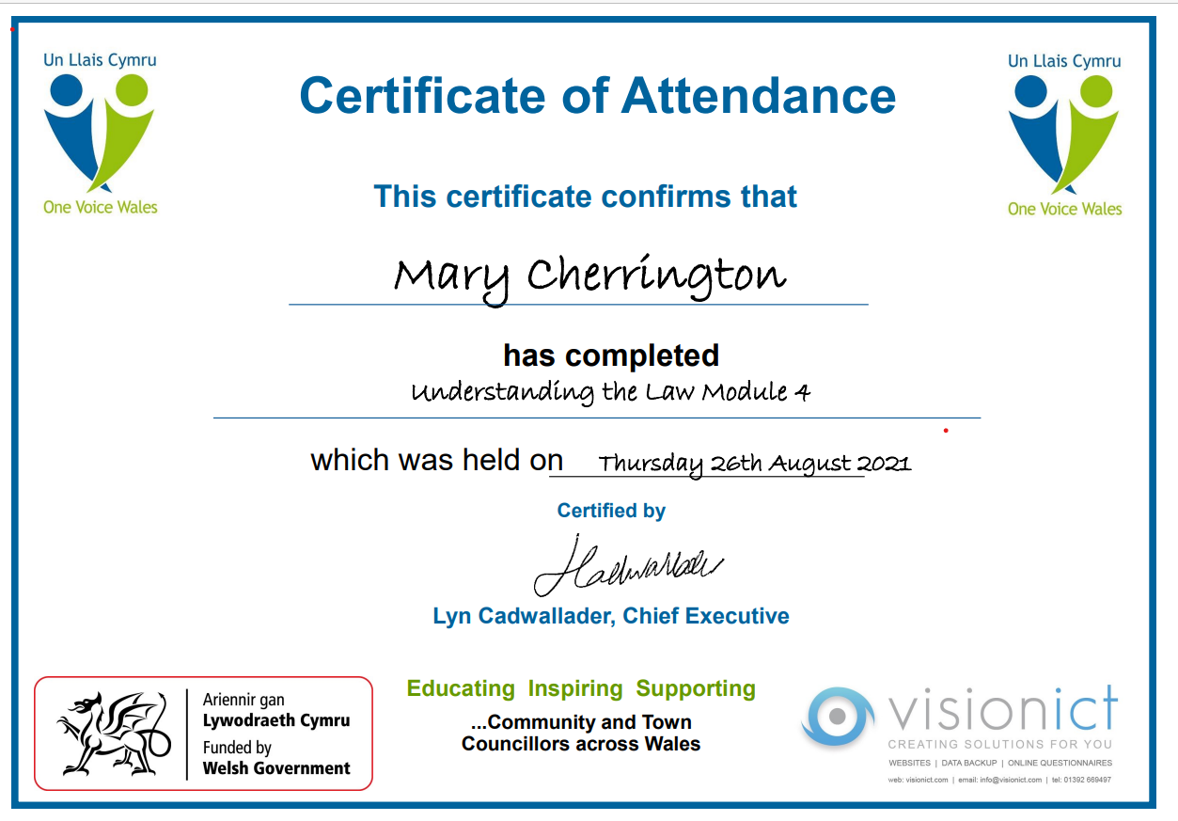
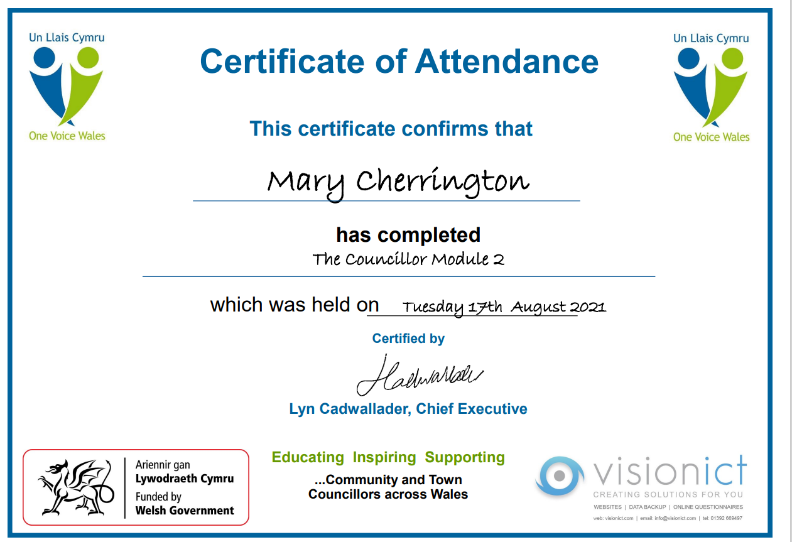
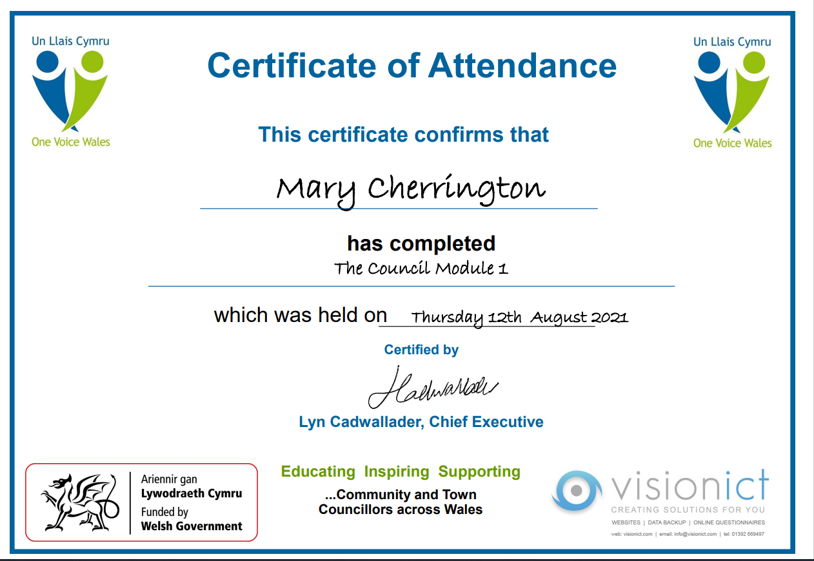
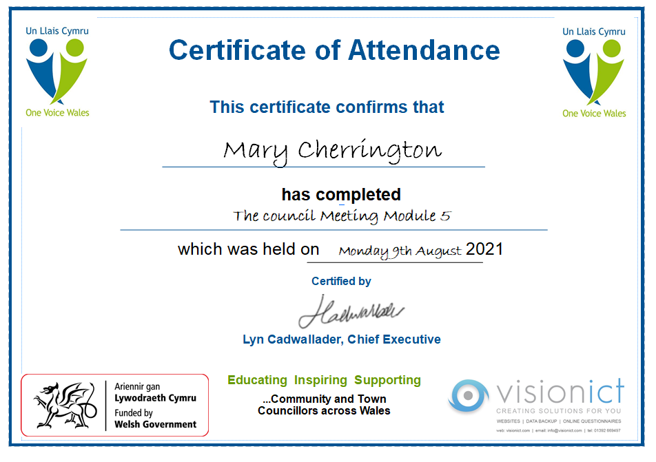

Evidence 5

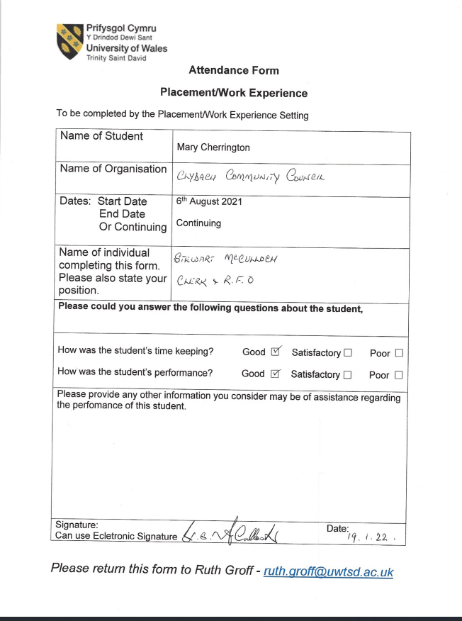

Evidence 6
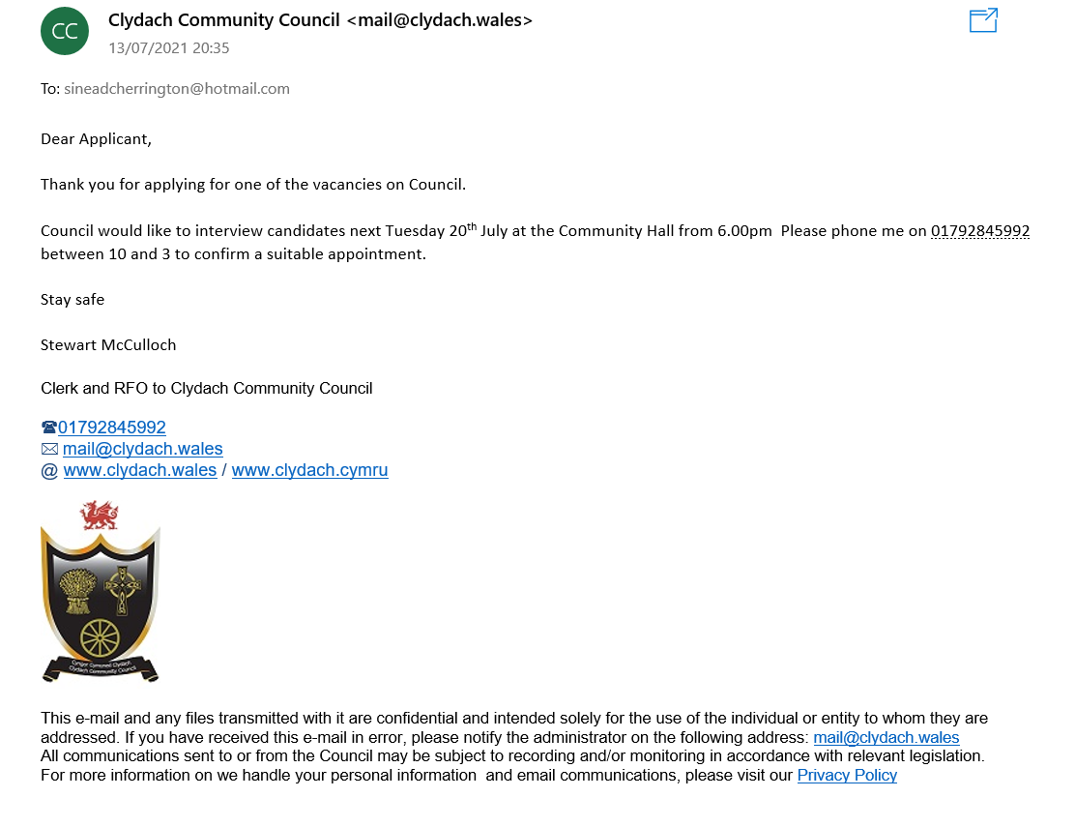

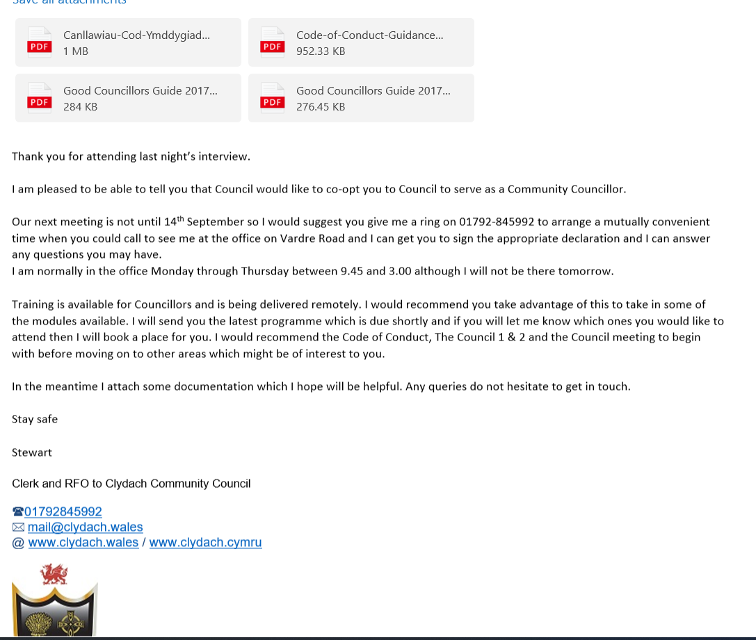

Reference
Council, C. (2022). Clydach Community Council. Retrieved 2 January 2022, from https://clydach.wales/council-vacancies

Appendix.

Name of Student: | Mary Cherrington
Proposed Placement Setting and Address: | Within the community of Clydach.  Clydach Community Council  Clydach Community Hall, Vardre Rd, Clydach, Swansea, SA6 5LP
Proposed Dates of Placement: | August 2021 on going
Name of Contact for Venue:  Please also state their position: | Mr. Stewart McCulloch  (Clerk & Responsible Financial Officer)
Email Address: | * mail@clydach.wales
Telephone Number for Contact at Placement: | 01792 845992
Is a DBS required for you to attend this placement? | X No  If Yes, have you applied for this?  - Yes applied on _________________  - No
Explain how your role in this organisation/on this placement meets the criteria for the assessment for the module | This role enables me to help people in a number of ways, the community council provides funding for supports various local projects. Community councilers can be the first port of call for local residents if they have concerns about safty issues, schools and a whole host of other things, therefore, you must be able to listen to their concerns reminding non judgemental and empathic. The community council is there to represent the community.



Being a Councillor with Clydach Community Council

What is a Community Council?
Community and town councils are an elected tier of local government. The other tier in Wales consists of Unitary Authorities and in the case of Clydach, this is the City and County of Swansea (Swansea Council). Unitary Authorities have a legal duty to deliver services such as education, town and country planning, environmental health and social services. Community and town councils have the legal power to take action, but they have fewer duties and freedom to choose what action to take. They can play a vital part in representing the interests of their communities and influencing other decision makers. Furthermore they can take action to improve the quality of life for local people and their local environment and, in some cases, they can deliver services to meet local needs.
Each council is made up of elected members, or in some cases co-opted members. A typical community council represents around 1,500 people but the largest population served by a town council is Barry with over 50,000. Clydach Community Council currently represents around 7,500 people. The diversity of community and town councils is a strength. Each can provide a unique response to the needs of their community with a sensitivity that is more difficult for county and county borough councils to achieve. In Wales there are approximately 8,000 community and town councillors who represent the interests of the communities they serve as a whole. They are recognised as having a role in providing the voice of the citizen in the development and delivery of public services in Wales.
In Wales they are known as community councils or town councils - in England they are called parish or town councils. In both England and Wales they are elected units of local government whose activities are controlled by Acts of UK Parliament or legislation introduced by the National Assembly for Wales.

What do these councils do?
Community and town councils are the part of local government closest to the people. They serve the smallest area and are responsible for the most local of matters. Very importantly, these councils can "precept" - raising a sum collected with the council tax each year to improve facilities and services for local people.
Community and town councils have a number of basic responsibilities in our communities, making them better place to live, grow, work and learn. Essentially these powers fall within three main categories: representing the whole electorate within the community; delivering services to meet local needs; and striving to improve quality of life in the community.
Community or town councils have a range of individual powers include the provision and maintenance of community transport schemes, traffic calming measures, local youth projects, tourism activities, leisure facilities, car parks, village greens, public conveniences, litter bins, street lighting, street cleaning, burial grounds, allotments, bus shelters, commons, opens spaces, footpaths, bridleways, and crime reduction measures. The Welsh Government encourages community and town councils to deliver more services and play a greater part in their communities.
The Local Government (Wales) Measure 2011 introduced the new power of ‘well being’ reflecting the Welsh government's initiative to revitalise local democracy enabling the sector to do more to improve the local social, economic and environmental situation of an area.
Additionally, the Local Government (Wales) Measure 2011 introduced new legislation allowing the appointment of up to two individuals to act at any one time as community youth representatives. Several community and town council have established youth councils and youth representatives in their areas.
Councillors are elected to represent an individual geographical unit on the council, known as a ward or – mainly in smaller communities – the entire community or town council area. They are generally elected by the public every five years.
Where a vacancy arises within the a community or town council during this term, a notice is advertised locally. If no more than one person declares an interest in the vacancy, council would be instructed to Co-opt a member.

A councillor has a duty to act properly and a responsibility, in particular, to:
- attend community or town council meetings when summoned to do so; the notice to attend a council meeting is, in law, a summons, because you have a duty to attend;
- prepare for meetings by studying the agenda and making sure you are properly informed about issues to be discussed, taking advice where appropriate;
- take part in meetings and form objective judgements based on what is best for the community - and then to abide by majority decisions;
- ensure, with other councillors, that the council is properly managed;
- act on behalf of the whole electorate equally, and not just those who supported your election campaign;
- similarly take an interest in all issues equally and not just those local issues for which you campaigned;
- listen, and then represent the views of the community when discussing council business and working with outside bodies;
- maintain proper standards of behaviour as an elected representative of the people.

Responsibility Summary
1. Decision making - Through meetings and attending committees with other elected members, councillors decide which activities to support, where money should be spent, what services should be delivered and what policies should be implemented. In undertaking their role they are bound to observe the provisions of the Councillor’s Code of Conduct.
2. Monitoring - Councillors make sure that their decisions lead to efficient and effective services by keeping an eye on how well things are working.
3. Getting involved locally - As local representatives, councillors have responsibilities towards their constituents and local organisations. These responsibilities and duties often depend on what the councillor wants to achieve and how much time is available, and may include:
- Going to meetings of local organisations such as tenants' associations.
- Going to meetings of bodies affecting the wider community.
- Taking up issues on behalf of members of the public.
- Running a surgery for residents to raise issues.
- Meeting with individual residents in their own homes.

Rules and regulations for councillors
All councillors are expected to uphold the highest standards of behaviour. The public needs to feel confident that you are living up to the high standards that they have a right to expect from you.
Councillors are bound by a statutory Code of Conduct which outlines what is expected of them in terms of behaviour and conduct; this code applies to councillors whenever they are acting or appear to be acting as a councillor – in short pretty much all of the time. According to the Code, councillors need to act very clearly in the ways outlined below:

- Act only in the public interest - not in favour of yourself or anyone else
- Be honest and declare any interests you have
- Act with integrity - not be influenced by any people or organisations for their benefit
- Act within the law
- Use the council’s resources lawfully and prudently
- Always take decisions on merit, using all the information and evidence available
- Always show respect to other people no matter who they are and what they believe
- Be as open as possible about your actions and the actions of the council
- Be prepared to be open to the scrutiny of the public for what you do
- Lead others by example and be a positive role model for the council to the public and officers
Breaches of the Code can be referred to the Public Services Ombudsman for Wales and sanctions can include formal apologies, training or even suspension or disqualification from office. Councillors are expected to formally agree to the Code when signing their acceptance of office following election. (Source: Code of Conduct, NAfW, 2001)

Are You Eligible To Be A Councillor?
Yes - most people are. However there are a few rules.
You have to be:
- a British subject, or a citizen of the Commonwealth or the European Union; and
- on the “relevant date” (i.e. the day on which you are nominated or if there is a poll the day of the election) 18 years of age or over;
And additionally:
- on the “relevant day” a local government elector for the council area for which you want to stand; or
- have during the whole of the 12 months preceding that day occupied as owner or tenant any land or other premises in the council area; or
- have during that same period had your principal or only place of work in the council area; or
- during that 12 month period resided in the council area (or within three miles of it)

You cannot stand for election if you:
- are subject of a bankruptcy restriction order or interim order.
- have, within five years before the day of the election, been convicted in the United Kingdom of any offence and have had a sentence of imprisonment (whether suspended or not) for a period of over three months without the option of a fine.
- you work for the council you want to become a councillor for (but you can work for other local authorities, including the principal authorities that represent the same area).

Political Affiliation
You are welcome to be, or to become a member of any recognised political party. Likewise, you may be an independent councillor and not affiliated to any party. As a Community Councillor, your political affiliation will be made public.

Specific Duties of Clydach Community Council
- Attend at least 1 Full council meeting within every 4 month period. Failure to do this will disqualify councillors from office.
- Attend separate council committee meetings as required, dependent upon your membership of committees.
- Attend training sessions as required by the council’s standing orders, unless superseded by any national requirements.
- Support with the council’s public events. This work may include marshalling, erecting marquees, litter picking, liaising with pitch holders.
- Supporting with community activities which may include placing flags throughout the village each year, weeding planters, litter picking areas, helping with local groups etc.
- Ensure that items listed as action for you from meetings are completed within the required timeframes.
- Take part in surgeries arranged by the council.
This list is non-exhaustive and the role may contain other responsibilities to be carried out in the spirit of the post of councillor.
If you are interested in becoming a councillor, it would be advisable for you to sit as a member of the public in any of the council’s public meetings which are held on the second Tuesday of each month (excluding August).

