
Skills for the Workplace
Module Assignment Submission
Student Name: | Nadia Leigh Phillips
Student Number: | 1405457
Module No: | BMSK4003
Module Title: | Digital Skills and Research Methods

Statement of Confirmation of Authenticity
By the act of making this submission, the student declares that this is the work of the student named above. The work has not, in whole or in part, been knowingly presented elsewhere for assessment, or where assessment has been built on a previous assessment, this has been identified. Where materials have been used from other sources it has been properly acknowledged. If this statement is untrue, the student acknowledges that an assessment offence has been committed.
Attention is drawn to the plagiarism and unfair practice policies of both the University and of ILM.
Permission for ILM to use this script
ILM uses learners’ submissions – on an anonymous basis – for assessment standardisation. By submitting, both the centre and the learner agree that ILM may use this script on condition that identifying information is removed. However, if you are unwilling to allow ILM use this script, please refuse by ticking the box: □

Table of Contents
What has been the impact of 21st Century Technologies on the modern workplace? 3
Part 1 3
An Overview of the 21st Century Workplace 3
An in-depth look at technologies used in own workplace 3
Part 2 4
An exploration of the use of social media in the workplace generally 4
An in-depth look at the use of social media in own workplace 4
The use of social media to enhance networking and career prospects 4
LinkedIn Profile 4
Conclusion 5
References 6
Appendix 1 7
Appendix 2 8

What has been the impact of 21st Century Technologies on the modern workplace?

Part 1

An Overview of the 21st Century Workplace

The workplace over the last 21st century has evolved and developed really quite quickly, now co-operations absolutely rely on the advances of technology. It’s hard to imagine the office without there being computers, printers, WIFI routers, telephones and iPads. Businesses are now dependent on WIFI more than ever before, from receiving emails, payments in and out of accounts, social media and in-house activity. Since the cloud has been available this has also been at the gain of organisations, “cloud computing is the concept of procuring computing power from another company as one does with a utility, such as electricity, cable TV or cell phone service” (Shor, 2011, p.3). Basically storing information/data without a hard drive, by using the cloud this gives a sense of security, also access to have different software’s that allow engaging to team members or access to data. As a whole, technology has been at the convenience of the employer, employee and consumer.
The employer can benefit in many different areas as communication in and outside of the company is cost effective and faster via emailing, one of the most popular forms of communication. The employer is also at an advantage by using a variety of resources such as up to data software, internet or computer tools, even having technology courses available, employees are now capable to do their own marketing, data analysis, accounting, making the office more efficient than ever before. Social media has impacted the large businesses but also micro businesses have the opportunity to compete with bigger companies, social media for companies is defining the objective of business and then engaging with customers (Evans, 2010). Regarding online, on the Gov.uk website advises to remain competitive, then these are the four main objectives maintain a web presence, sell online, use the cloud and digitise back-office functions such as payroll. The only negative is that it does take a lot of upkeep online to remain relevant which could possibly make or break a sales deal or in worst case scenario, potentially affect the whole company.
Firstly the employees has benefited from the advances of technology from the recruitment process, being able to immediately search for job vacancies, then research the needs and wants that the vacancies desire, applying immediately and able to set up a standard CV and send to multiple vacancies. Once in the job, there are technology competencies courses. Also the software in the work place that is unique to job description making duties easier and more applicable, a simple example of this is on Microsoft word it has an icon that edits incorrect words typed. Overall for employees technology has increased the knowledge, access and speed for job duties giving companies opportunities to grow and strive.
The consumer has adapted a little slower to the increase of technology, for many reasons but mainly because there was no real need, then costs of sustaining WIFI, PC, IPad or mobile phones and lack of interest/knowledge when PC’s became available to the general public. Overtime the average house hold having WIFI increased drastically in recent years (as seen in Appendix 1). It has become apparent that having technology the general public has become dependent on the ‘Cloud’ for phone back up, internet for social media, finding out anything and everything, but most importantly for businesses to buy things. Marketing has evolved greatly, the deals and offers are all done by analysing what has had the most views/interest online, what has the best reviews, recent searches, recent purchases and so on. First points that consumers would do before an expensive purchase is, check emails for any personal offers from the company, then go into internet search and compare prices and then check reviews. This aspect has made the market easier and harder for sales for co-operations, easier because they know the competition that is out there but if the price is a lot higher the consumer will know, the buying process is a lot more honest in that sense.
Technology has impacted everyday life, from the household and workplace. There is no doubt that the increase of technology has made life easier, however, the problem for the workplace is if the WIFI was to disconnect randomly then it would mean staff would be hanging around until fixed. The other negative factor is employer, employee or consumers data online is not always safe. The chart below displays the type of risk there is with each form of technology (Spiceworks, 2018). Especially in larger organisations, hackers tend to take customers data for example use the email address of the customers for bank details and so on, or can upset systems to slow businesses down, steal future information and many other factors.
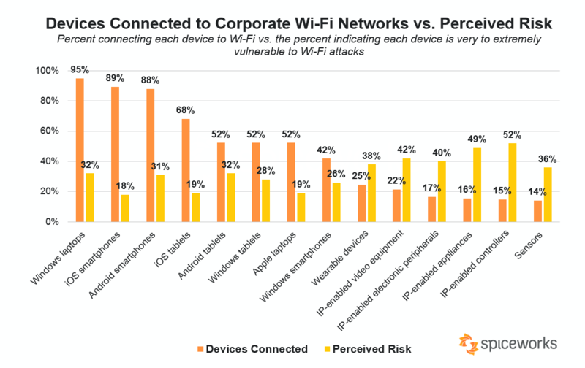

An in-depth look at technologies used in own workplace

A closer look into my own workplace which is a used car sales company that specialises in mechanical and body work repairs for private work and in particular insurance companies, there are over twenty computers in the garage. The main software used is ‘CDK Global’ this is a very common installation for distributors to book vehicles in and out - for all types of work, payments for parts, invoicing and more. The work that I complete I can then decide what information can be seen with colleagues and also with outside companies. Using CDK allows there to be ‘cloud hosting’ which means within the monthly subscription they will then secure the cloud storage from any unwanted hackers or misuse of information.
At the garage there is a multi-phone call service, which helps direct incoming calls. This service will ask for the customers vehicle registration and then find the registration on the computer system to find the department that is either already in or going to.
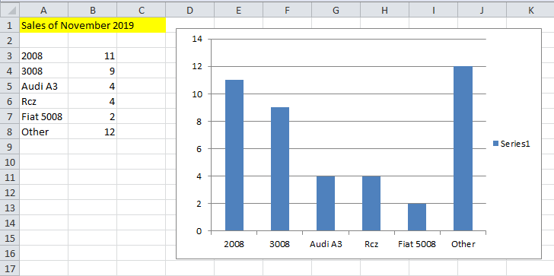
As seen below, the employees are always using IT skills, whether it’s for customer notices, staff updates, but most importantly for their data analyses. In order to recognise the market changes for targets and sales, Microsoft Office is the most efficient and used on the daily basis.

These charts are sent to the accounts department to analyse targets or changes from the previous months, if over time a certain car or department are not as profitable then the aims are changed. This chart may look simple to the eye, but over months or years it is important to have a clear chart that symbolises the change of sales in the cars for targets. This is just an example of a chart from the month November, using the results then the accountant and sales manager decided to buy an extra ten of 2008 cars, five of 3008 cars and then a mixture of cars for the forecourt. That is a simple example of how Microsoft affects the direction in which the garage goes. Overall technology in the last 21st century has become essential to analyse how the business is running and to remain relevant.

Part 2

An exploration of the use of social media in the workplace generally

Social media has advantages and disadvantages for the workplace. The positive points, especially for micro business, social media can allow your brand to grow by being independent; the creator is the person that can post their own ideas being original.
Once there is an online following, sharing information and updates, sales or offers are also important on social media to attract attention. The big businesses/franchises are not affected as much online, as they can afford the adverts on the social media sites.
Facebook is the leading social media; businesses are dependent on having Facebook, very rare that a business will not have a page. Facebook uploads any desired information, pictures or videos. Facebook is used efficiently can be the most interactive, easy to analyse what the following like or dislike, the target area, easiest to add friends to create a big following. There are many ways of engaging, with deals or offers and even free competitions for friends of the business page, this has become very popular.
Twitter, seems to be very popular for bigger companies, twitter has a limited character use; this normally means it’s more frequent with shorter announcements. Google and twitter have a good relationship, tweeting frequently and about topics for which you want to rank to contribute to your overall online footprint (Monaghan, 2015). Marketing expert Mark Schaefer said in his recent book ‘Known’ that if you had to choose one distribution channel for your content, he recommends Twitter (Schaefer, 2017). Twitter is influenced by the leaders of the world, politicians, the leaders of the celebrities and also the leaders of the businesses.
Then Instagram is a visual form of marketing, easier to target the audience, by posting pictures and seeing what the followers respond to most. There is also the power of hash tags, people can advertise a page or product they like by simply hash tagging the company, the business then benefits from people clicking on the page and creating interest. Small businesses on Instagram usually try to find a celebrity to wear or hash tag a business, as Instagram is influencing where and what people look at.
In reflection all three Social Medias are extremely beneficial for information, announcements, engaging, influencing, these are all the factors that marketers need, if social media is used effectively and often the chances are the businesses can be sustainable and even successful.

An in-depth look at the use of social media in own workplace

In the ‘Phillips of Llanelli’ a car garage, the data analysis has recognised that social media has a big impact on the sales but not on the service or body shop department. The garage is adequate at updating the Facebook account by pictures of cars for sales, however, when researching the social media I found the Facebook account was private. Does that have a positive or negative impact, obviously private for some security reasons, but if the Facebook page is only for business purposes does that matter? If the consumer is looking for a particular car and it the search engine brings up ‘Phillips Of Llanelli’ but cannot access the page, the question as a consumer would you wait for the friend request to be accepted or keep searching on other sites. In future I would advise that the Facebook pages becomes open to the public and more relevant, mentioning prices for certain mechanical work, the regular services or winter services, MOT’s, even stating how qualified the mechanical staff is. The Facebook page could announce that there are now MOT video links, as there was a high request in people wanting evidence if their car failed an MOT. The garage also supplies free lifts home or car pickups/drop offs for customers within ten mile radius, to save the inconvenience of finding lifts. The garage is family run and has so much potential, if these positive factors where displayed on Facebook to the public audience it would be very appealing to loyal and new customers. In my opinion the Facebook page is not reaching its maximum capability, with a few simple changes there could be a rise in the sales for all the departments not just the car sales section.
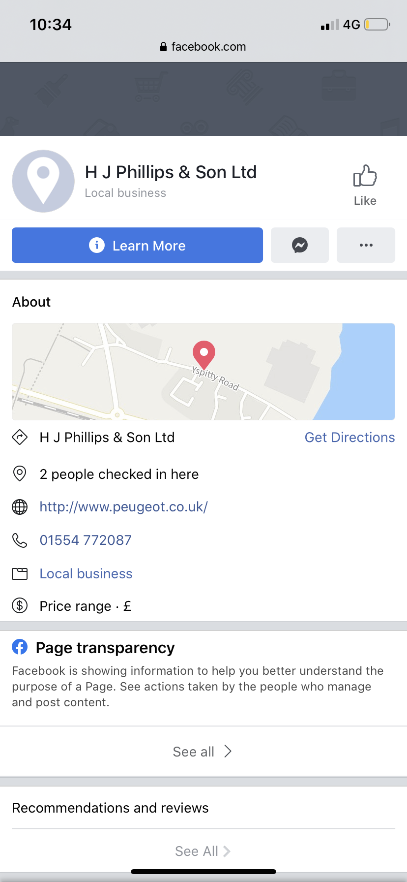

The twitter page did not hold a lot of information, no real engagement or updates of any value, with only 100 followers. I would say this form of social media does not have any influence on sales or interest for the garage. This means the lack of posts there is no search engine optimize, in fact it was quite hard to find on the internet. To improve the twitter account, announcements could be made weekly as a start, for example opening times changes, offers or price list for service or body shop department, pictures of new cars. Twitter does not have to be over kill a simple few announcements, to remind people that the business is still running and modern.

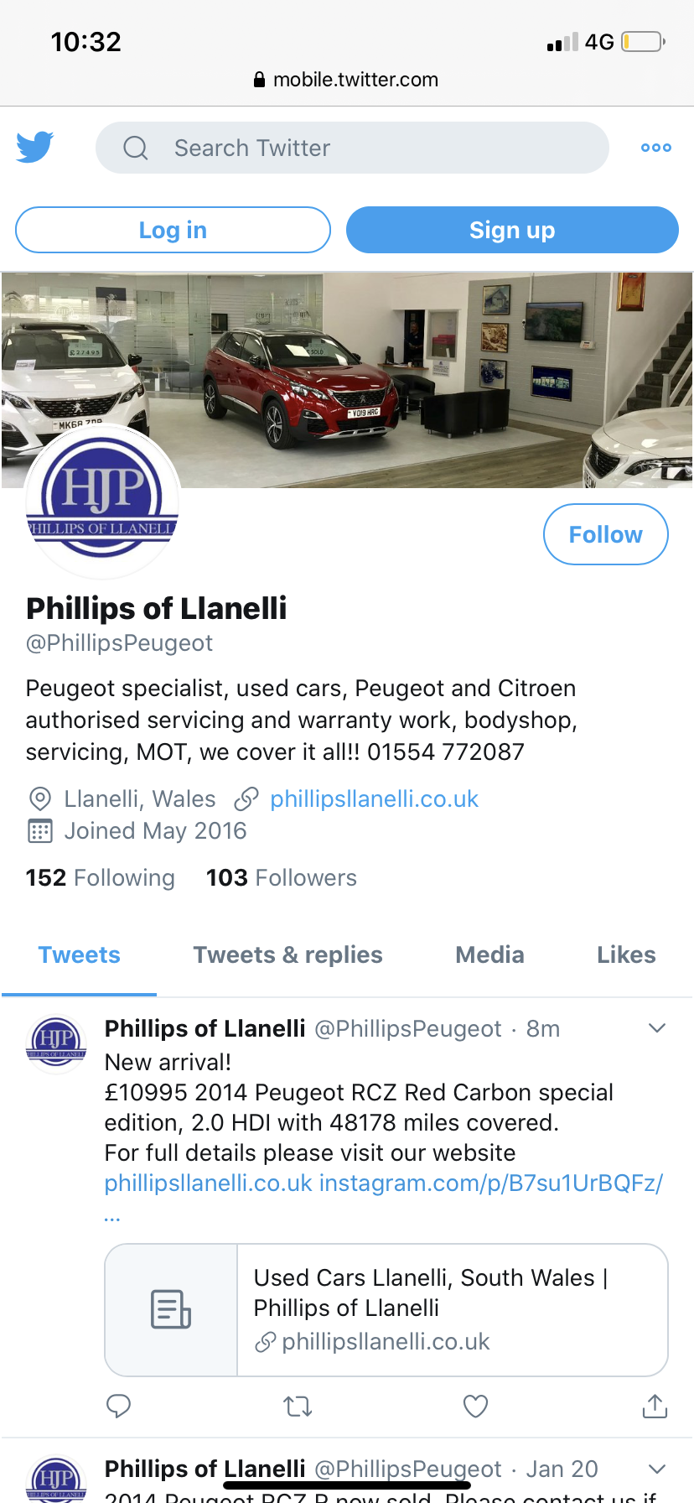

Then the Instagram page, there have only been regular posts since November 2019 until current, the correlation between Instagram and sales, have increased even though over the last five December has been the worst month for sales. People are responding to the car pictures that they like and the sales team have bought more of the popular cars, which have been selling quicker. Overall Instagram so far is proving to be successful. It is important to keep posting new cars, as the younger generation are familiar with Instagram and if they are looking for their first car or not sure where to go for their first MOT then if the Instagram is appealing this could create the younger customers instead of relying on the loyal customers solely.



In reflection of my work place, the Facebook page is not being used sufficiently, with the page being private and lack of information, this is not attractive for consumers. There is no reason for people to return to the page as there is no competition to other car garages. Twitter there is not a great deal of engagement and not many announcements, meaning there is no connection made with the followers. Then Instagram there has been an increase in posts in recent months and has already 100 followers whereas the twitter page has been running for over eight years and yet has 103 followers. People are responding more to the Instagram because there is interaction and recent updates. In the questionnaire I produced in (Appendix 2 and 3) for ten staff members at the garage, all ten of said that twitter is the least preferred Instagram is effective for sales department.
I would advise there to be a specific team member to take control of the social media, and post on all three Social Medias pictures of the cars, information of any changes in the garage and to respond to any comments or questions. I would recommend is, due to no evidence that social media has impacted or increased the service or body shop department, in matter a fact there has been no mention of service or body shop deals, information, prices on any of the pages. This would be beneficial for attracting new customers.

The use of social media to enhance networking and career prospects

Social media in this modern day, everything that is displayed to the public needs to be controlled and constructed; a part of employers screening candidates, for job interviews are to search their social media. Employers look for university information, former employment, likes, interests, and Facebook groups that may the person may follow. All of these aspects show the whole person.
On social media there are a few ways that can make the profile look professional, by talking about interest similar to the career, adding groups that are similar to the career for example, if pursuing a job vacancy at a vets then it would be good to follow ‘RSPCA’ or animal lover groups. Then if/when the employer goes to research the candidate this would reinforce the love for helping animals. Also pictures can be a positive or negative impression, people always look through photos as they can tell a thousand stories of the person. Family photos should be limited, friend photos should be activity based and civilised or photos of interests. Unnecessary photos of alcohol, nights out or things like smoking.
It is interesting because social media does not display how a person speaks, if they are an introvert or extravert, the manner of a person, online if clever enough the profile can tick all the boxes of an interviewee before even attending the interview. Being on social media and applying for a job, researching their companies posts can really give an idea of what the company wants out of the staff, online audience and customers.
Although for personal reasons it is important to remain private, the information should be given or displayed should be broad. The employer or anybody else should not know the school your children are in or why you and your partner have argued over. Firstly for security reason and secondly want to leave a good impression that the private part of life is to remain private. There are data protection acts now that can protect data going so far but ultimately if it the information is not online in the first place nobody can steal it.

LinkedIn Profile

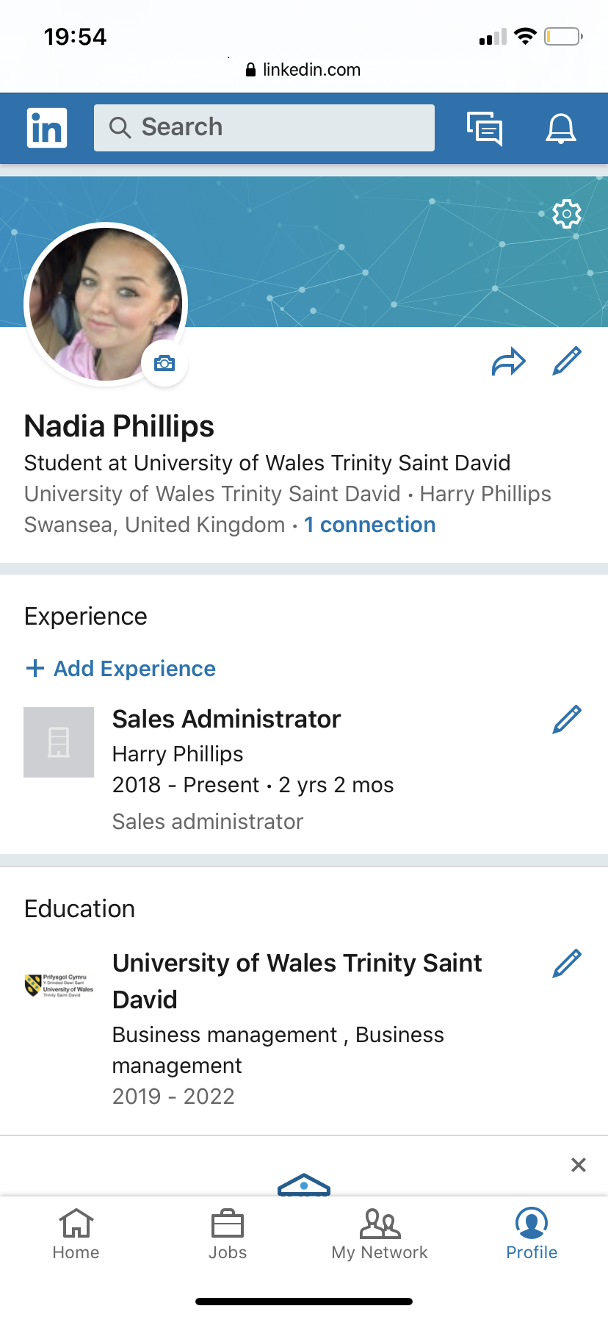

I joined the ‘LinkedIn’, LinkedIn was quite hard at first but gradually as you see the home screen posts the opportunities are clear. LinkedIn is based on professions and professionals connecting and discussing matters. LinkedIn has an extensive job list and a high rate of job opportunities through the site. LinkedIn is recommended by successful business people for example Richard Branson, this is encouraging that such high business people are fond of it and influences other people. This demonstrates that by engaging with other people of the same mind set can produce business like opportunities.

However, it was difficult as on a personal level as I am not an over sharer, I don’t really like the idea of displaying where I work or what education I have, for myself I found it hard to find what I needed from it, as I have a job that I am extremely happy with and I am not looking to become friends with people because of their job. For myself I think it would be essential, if in fact, I was preparing to leave my current job or could be useful for advice or opinions of like-minded people. On the whole I am not yet convinced that it would enhance my career as an introvert even though I am aware that it has helped thousands of people start a new job and purely because I am happy where I am working.

Conclusion

From conducting this essay, the main consensus is that over this 21st century technology has evolved and developed drastically, to the extent that society cannot get a job without being present and professional online. In fact not only can the public find a job without being technically able to a degree, but the workplace is also dependent on being run by many forms of technology. Technology has become one of the most popular ways to communicate with family and friends over the world via social media. Social media is not only a place to communicate casually but a place that employers can screen test, comparing profiles of candidates; social media has also enabled micro business to become an economic success, all down to having an audience that likes the product. Technology being this amazing bombshell to the 21st century it is essential to run private life and work life but that comes with risks that they do not blend together, which leads to the huge and current topic – privacy. It is key to be clever and careful when it comes to sharing information online. For example to write the job title is different to writing the address of where the business is. Privacy concerns are on the rise, up until now it has been popular to overshare, as technology has adapted so has society. The other concern is, there is a duty that employers have regarding social media misconduct of discrimination, for example Alistair Stewart an ITV presenter commented racially on twitter recently, as he works for ITV they decided that he did not represent the company in a well manner and publicly fired him. Even though this is a well-known situation, this does happen in smaller businesses as well, any form of online discrimination can affect the professional career, whether it’s a private profile or not.

Lastly, businesses need to remain relevant or good at marketing their social media to the target audience, for the business to have a chance at being successful. This also can determine a person finding a job, there are many tips, advice and even course to showcase online the type of well-rounded person the candidates are. Technology and social media is still evolving and benefiting society, the workplace has never been so efficient (Schaefer, 2017).

References

Evans, D. (2010) Social Media Marketing: The Next Generation of Business Engagements. Wiley
Fahmy, Miral (2009). Facebook, YouTube at work make better employees, Reuters, Yahoo Tech Available at: http://tech.yahoo.com/news/nm/20090402/wr_nm /us_work_internet _tech_life, (Accessed 19 January 2020)
Monoghan , M. (2015). SMART BIRD SOCIAL: Available at: https://smartbirdsocial.net/benefits-twitter-small-business/ (Accessed on 27 January 2020)
Schaefer, M, W. (2017). KNOWN. Schaefer Marketing Solutions. US publishers
Shor, R.M. (2011) INFOLINE Cloud Computing for Learning and Performances professionals. ASTD Press

Spiceworks (2018). Data snapshot: Wi-Fi security in the workplace and beyond Available at: https://community.spiceworks.com/networking/articles/2941-data-snapshot-wi-fi-security-in-the-workplace-and-beyond (Accessed 23 January 2020)

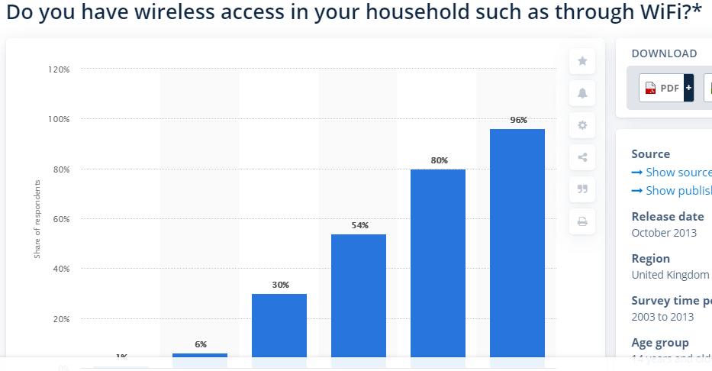

Appendix 1

Appendix 2

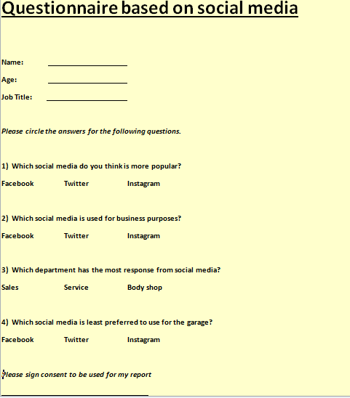

Appendix 3



