Module Name: Financial Management for the Hotel Industry
Module Code: BMIH5007
Assignment Title: Report Case Study-The City Hotel
Student Name: Klaudia Modrzejewska
Student ID: 2243846
Word count: 2040

AI guidance acknowledgement
I confirm that I have not presented any AI generated text as my own work. I confirm I have copies of my drafts, notes, and other resources I used before, and after the use of AI tools which I may be asked to provide in evidence.

Executive Summary
The entire study described the key financial details of the City Hotel that operating its business in the hotel industry. However, in the recent financial period the firm is struggling to generate profit and revitalise its financial health. The core reason behind its financial decline is identified that the firm has poor supply chain management system which increased total overhead costs and declined its profit margin. On the other hand, high inflation rate of 7.3% is a major external factor that has negatively affected operational costs, consumer spending’s and labour costs. At the same time, global recessions highly decreased RevPAR of the hotel which also affect total cash inflow of the business. Concerning all of these, the study recommended that the organisation need to invest on staff training and development system and emerging technologies, raising funds with relevant funding source and conduct an effective market research. Consequently, the firm will be able to revitalise its financial health and enhance its financial strength to meet its future needs with long-term stability.

Table of Contents
Introduction 3
Evaluating the trends and patterns in the hotel's financial performance over the past three years 4
Income Statement 4
Balance Sheet 4
Identifying the key reasons behind the decline in profitability 7
Developing a comprehensive turnaround strategy 8
Conclusion 10
Reference List 11

Introduction
The entire study aims to analyse the key details of the financial performance of The City Hotel, a hotel that offers restaurant, event and bar facilities in the urban landscape. Financial performance analysis is crucial to understanding organisational financial stability by identifying its liquidity and solvency position, profitability and financial efficiency to meet obligations (Drury, 2021). In the current context, by considering data from its financial statements, the core reasons behind decline in profitability of the City Hotel will be recognised. Based on that effective and relevant recommendations will be made to revitalise its future financial health and strength financial capability to meet future needs.

Evaluating the trends and patterns in the hotel's financial performance over the past three years

Income Statement
An income statement is a crucial financial document that plays a vital role in analysing organisational financial performance. Financial analysts can understand the revenue, total expenses and profitability of a firm by using the important data of an income statement (Seal, 2019). In the current context, considering information on the income statement, the financial health of the City Hotel will be known over three consecutive financial years. Based on that, effective decisions will be made for better financial performance in the future.
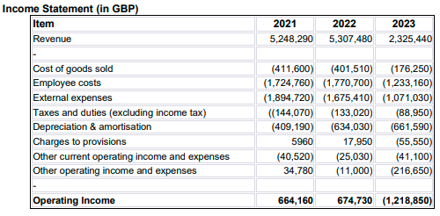
Figure 1: Income Statement
(Source: Self-developed)
The above figure represents the financial information of the City Hotel for three financial years. As per the above figure, it is recognised that the business generated revenue of £5,248,290, £5,307,480 and £2,325,440 in 2021, 2022 and 2023 respectively. The financial outcome depicts that the firm maintained a decline in its financial performance in generating revenue over recent periods. On the other hand, the firm increased its operational expenses from £11,000 in 2022 to £216,650 in 2023 which affected its net earnings at the end of the period. After all of these, it is found that the firm generated an operating income of £66,160 and £674,730 in 2021 and 2022 respectively. However, due to high operational spending, the firm faced a huge financial loss of -£1,218,850 in 2023 which depicts a huge decline in its profitability.
Apart from this, an income statement has a few limitations as it does not reflect organisational efficiency in its assets management system as well as maintaining its solvency position. Financial analysts also face issues in recognising organisational liquidity position over the financial period by only considering the values of an income statement (Walker, 2021). Hence, they need to prepare a balance sheet with its key components to address the concerns of financial analysis and make more informed and relevant decisions for future financial developments.

Balance Sheet
A balance sheet is also considered a statement of financial position as it helps to understand organisational financial position over a financial period. In this case, investors or financial analysts can identify how efficiently the firm manages its assets to meet long-term and immediate financial obligations (Atrill and McLaney, 2021). Based on that they can identify organisational liquidity and solvency position and make effective decisions for future investments or developments. In the current context, a balance sheet has been presented for The City Hotel for three years to understand its recent financial position including its efficiency in managing organisational assets.
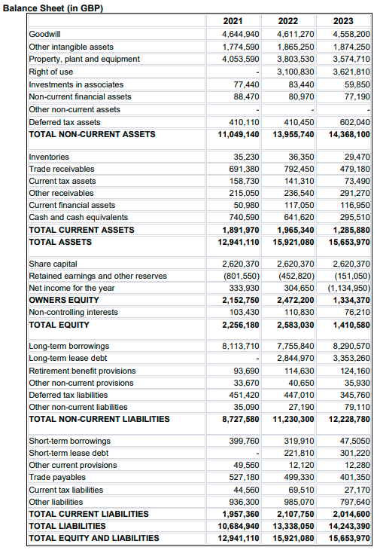
Figure 2: Balance Sheet
(Source: Self-developed)
As per the above figure, the hotel organisation decreased its total current assets in the recent financial period as it reflects total current assets at £1,891,970 in 2021 and £1,285,880 in 2023. In this case, it is recognised that the firm was very much concerned about using its assets to meet its financial obligations over the period. Considering that the liquidity ratio of the restaurant is determined as below;
Current ratio = “Current assets / Current liabilities”
“For 2021, £12,941,110 / £1,957,360 = 6.61”
“For 2022, £15,921,080 / £2,107,750 = 7.55”
“For 2023, £15,653,970 / £2,014,600 = 7.77’
The above determination depicts that it maintained a better liquidity position in the consecutive financial period as it increased current ratio from 6.61 to 7.77 in the year 2023. In this case, it has been also recognised that the firm focused on decreasing its current liabilities over the year as it resulted in a positive financial outcome. On the other hand, considering its debt and equity amount the solvency position is evaluated as below;
Debt/Equity Ratio = “Total Debt / Total Equity”
“For 2021, £8,113,710 / £2,256,180 = 3.6”
“For 2022, (£7,755,840 + £2,844,970) / £2,583,030 = 4.1”
“For 2023, (£8,290,570 + £3,353,260) / £1,410,580 = 8.3”
The financial data reflects that the firm declined its solvency position in recent years as it increased its debt-to-equity ratio from 3.6 to 8.3 in 2023. The outcome also represents a poor credit score for the business which may raise the threat of bankruptcy and sustainability in the competitive hospitality industry. Hence, the firm needs to focus on improving its financial condition and enhancing financial efficiency to recover its losses and maintain long-term financial stability.

Identifying the key reasons behind the decline in profitability
As per the entire financial performance analysis by using financial statements it is recognised that the hotel organisation highly declined its profitability and solvency position in the recent financial period. The core reason behind its declined profitability is the firm highly increased its total spending’s on operational activities. As per the internal business management practice, it is found that the firm has an inadequate supply chain which increased its total operating cost. Inefficient use of company assets or resources may increase production costs and lead to a low-profit margin at the end of the period (Nukala and Prasada Rao, 2021). In the current context, the poor supply chain management plan of City Hotel often constrains managing investment costs as well as decreased financial capability to meet market needs. On the other hand, focusing on external factors it is found that due to global economic downturns and the global pandemic situation of COVID-19 decreased consumer spending, reduced market demand and increased travel restrictions. A high inflation rate of 7.3% in 2023 also negatively affect labour costs of the hotel organisations in the UK marketplace (Statista, 2024). At this point, it also increased the total operating costs of the hotel organisations including the City Hotel to attract the attention of potential customers and retain their existing customers. Ultimately, it faced complexities in increasing total revenue, raising its total spending as compared to operating income and facing high financial losses over the period 2023.
Apart from this, the organisation also has poor efficiency in using digital technologies and online marketing processes. Digital transformation is one of the biggest contemporary challenges in the current era that supports organisations to expand their business and reach a wide range of customers easily (Schneider and Kokshagina, 2021). Lack of financial ability also constrains the firm from investing in its digitalisation system and expanding its market reach. As per the financial outcomes of the solvency ratio, it was found that the firm declined its solvency position over the financial period of 2023. The global recession is another real-world event that affected the international hospitality industry negatively as it highly decreased total business spending. The real-world event affected quarterly GDP growth in the UK as a quantitative dataset depicts that national GDP of the UK was -0.3% in the third quarter of 2023 (Bbc, 2024). The economic downturn due to the global recession also decreased RevPAR by 14% and ADR or Average Daily rate had dropped by 12.6% over the financial period 2023. The global hotel industry faced major challenges in raising their financial capital by applying a debt financing system as it reduced the total spending of consumers as well as decreased business investments by the investors. Hence, the City Hotel highly emphasised considering the debt financing system as compared to equity financing to raise its financial capital. Consequently, it increased its potential risks of facing high financial loss which distracted a large number of investors in the external marketplace.

Developing a comprehensive turnaround strategy
Investment in digital technologies: The City Hotel has a poor workforce to improve its digitalisation system and maintain sustainability in the contemporary business development era. Digital transformation is one of the strategic solutions in the current situation and most importantly after the pandemic era. Investment in digital technologies helps a firm to build digital resilience by getting support for the next business cycle, and streaming business process (Mourtzis and Panopoulos, 2022). In the current context, the hotel organisation focuses on increasing investment in emerging technologies; it also will be able to reach a wide range of customers through its online marketing system. At this point, the firm also will get severe opportunities to save its total marketing and operational costs and increase its profit margin over period efficiency. Eventually, the firm will increase its conversion rate, streamline business processes and improve its service quality at a low cost.
Conducting market research: Poor market reach and intensive market competition have made it challenging for the City Hotel to maintain its sustainability in the competitive marketplace. In this concern, it can be recommended that the firm need to conduct effective market research to understand the changing consumer behaviour and perspectives over periods. Effective market research helps a firm understand its competitors and customers alongside support to make informed decisions to drive organisational growth and sustainability (Gupta et al., 2021). By conducting effective market research alongside competitor analysis, the City Hotel will be able to enhance its market reach, understand the challenging consumer preferences in the contemporary situation and make informed decisions for service productions. Eventually, the firm will be able to enhance its competitiveness and maintain its sustainability in the highly competitive marketplace in the long run.
Raising funds with relevant funding sources: The fundraising process is an effective and most important concern of a business organisation that supports a firm in enhancing its financial capability. The application of appropriate funding sources helps a business get strong financial support and enhance financial strength to meet future business requirements (Palepu et al., 2020). In the current context, it can be recommended that the firm apply the crowdfunding system as a significant funding source. Crowdfunding is a popular method for organisations to raise their capital and get financial support to implement projects successfully. In this case, investors invest money altruistically or get financial rewards such as equity in the firm that raised the money. At the same time, the funding sources also have low financial risks consequently the City Hotel will be able to improve its fundraising system and enhance its financial capability to meet future financial requirements. Eventually, it will support the firm to improve its solvency position and increase its credit score over a period.
Investment in staff training and development: Considering the internal business management practice it is also recognised that the firm has a poor workforce to adopt contemporary changes. Concerning that it can be recommended that the firm needs to be focused on increasing its investment in the training and development process for its staff. An effective staff training and development process in a hotel organisation helps to increase the knowledge and adaptability of staff to changes and supports the firm in implementing contemporary changes successfully (Luo et al., 2022). Once the City Hotel focuses on increasing its investment in staff training and development process it will even enhance its competencies in using digital technologies and adaptability to changes. Consequently, the firm will be able to develop an effective workforce and enhance operational efficiency to meet organisational strategic goals in the future.

Conclusion
The entire study concluded that the City Hotel is struggling to improve its financial performance in the last financial period. The financial performance analysis depicted that the firm faced a huge amount of financial loss in 2023 and delayed its solvency position; however, it maintained a positive liquidity position. Poor supply chain, global pandemic situation, economic downturns, global recessions and more are internal and external factors that increase its operations spending and decline its profitability. Concerning all of these, it has been recommended that the organisation need to invest in digital technologies and staff training and development processes, raise funds through crowdfunding, and conduct effective market research in the future. Consequently, the firm will be able to revitalise its financial health and enhance workforce efficiency to meet all strategic goals successfully.

Reference List
Atrill P, McLaney E., 2021. Management Accounting for Decision Makers, FT Prentice Hall.
Bbc, 2024, ‘Effects of global recession in the UK’ [Online] Available at: <bbc.com https://www.bbc.com/news/business-52986863> [Accessed on: 8th November, 2024].
Drury C., 2021. (11th Ed) Management and Cost Accounting, London, Prentice Hall.
Gupta, S., Justy, T., Kamboj, S., Kumar, A. and Kristoffersen, E., 2021. Big data and firm marketing performance: Findings from knowledge-based view. Technological Forecasting and Social Change, 171, p.120986.
Luo, C.Y., Tsai, C.H.K., Su, C.H.J., Kim, H.J., Gao, J.L. and Chen, M.H., 2022. How does hotel employees’ psychological capital promote adaptive performance? The role of change readiness. Journal of Hospitality and Tourism Management, 51, pp.491-501.
Mourtzis, D. and Panopoulos, N., 2022. Digital transformation process towards resilient production systems and networks. In Supply Network Dynamics and Control (pp. 11-42). Cham: Springer International Publishing.
Nukala, V.B. and Prasada Rao, S.S., 2021. Role of debt-to-equity ratio in project investment valuation, assessing risk and return in capital markets. Future Business Journal, 7(1), p.13.
Palepu, K.G., Healy, P.M., Wright, S., Bradbury, M. and Coulton, J., 2020. Business analysis and valuation: Using financial statements. Cengage AU.
Schneider, S. and Kokshagina, O., 2021. Digital transformation: What we have learned (thus far) and what is next. Creativity and innovation management, 30(2), pp.384-411.
Seal W., 2019. (6th Ed) Management Accounting, London, McGraw Hill.
Statista, 2024, ‘Inflation rate of the UK’ [Online] Available at: <https://www.statista.com/statistics/270384/inflation-rate-in-the-united-kingdom/> [Accessed on: 8th November, 2024].
Walker J., 2021. Introduction to Hospitality, Harlow, Pearson.

