DS 1 – Majid Ali Final

Screenshot/Photo 1
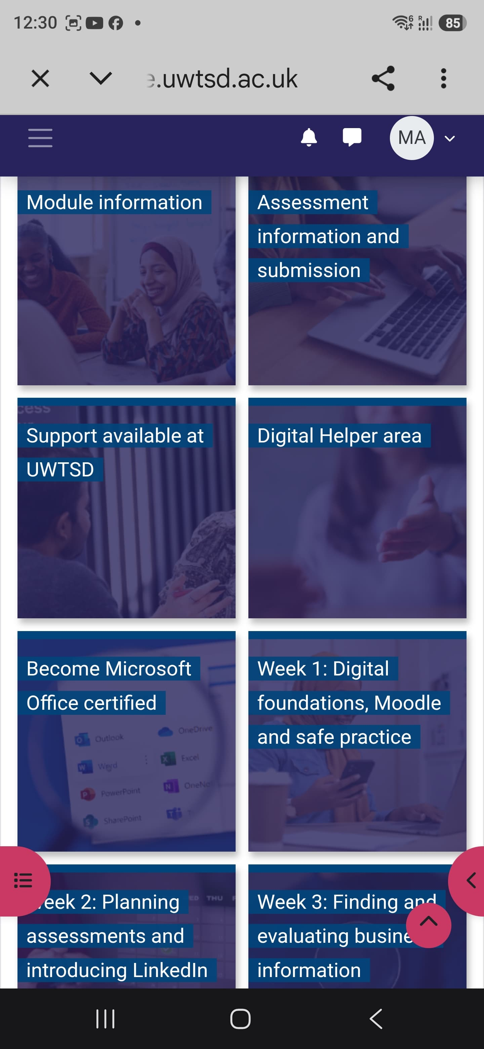
This is the screenshot of Moodle, where I find coursework templates and deadline dates.

Screenshot/Photo 2
[Insert Photo/Screenshot below]

This is a screenshot of Facebook, where I buy and sell items.

Screenshot/Photo 3
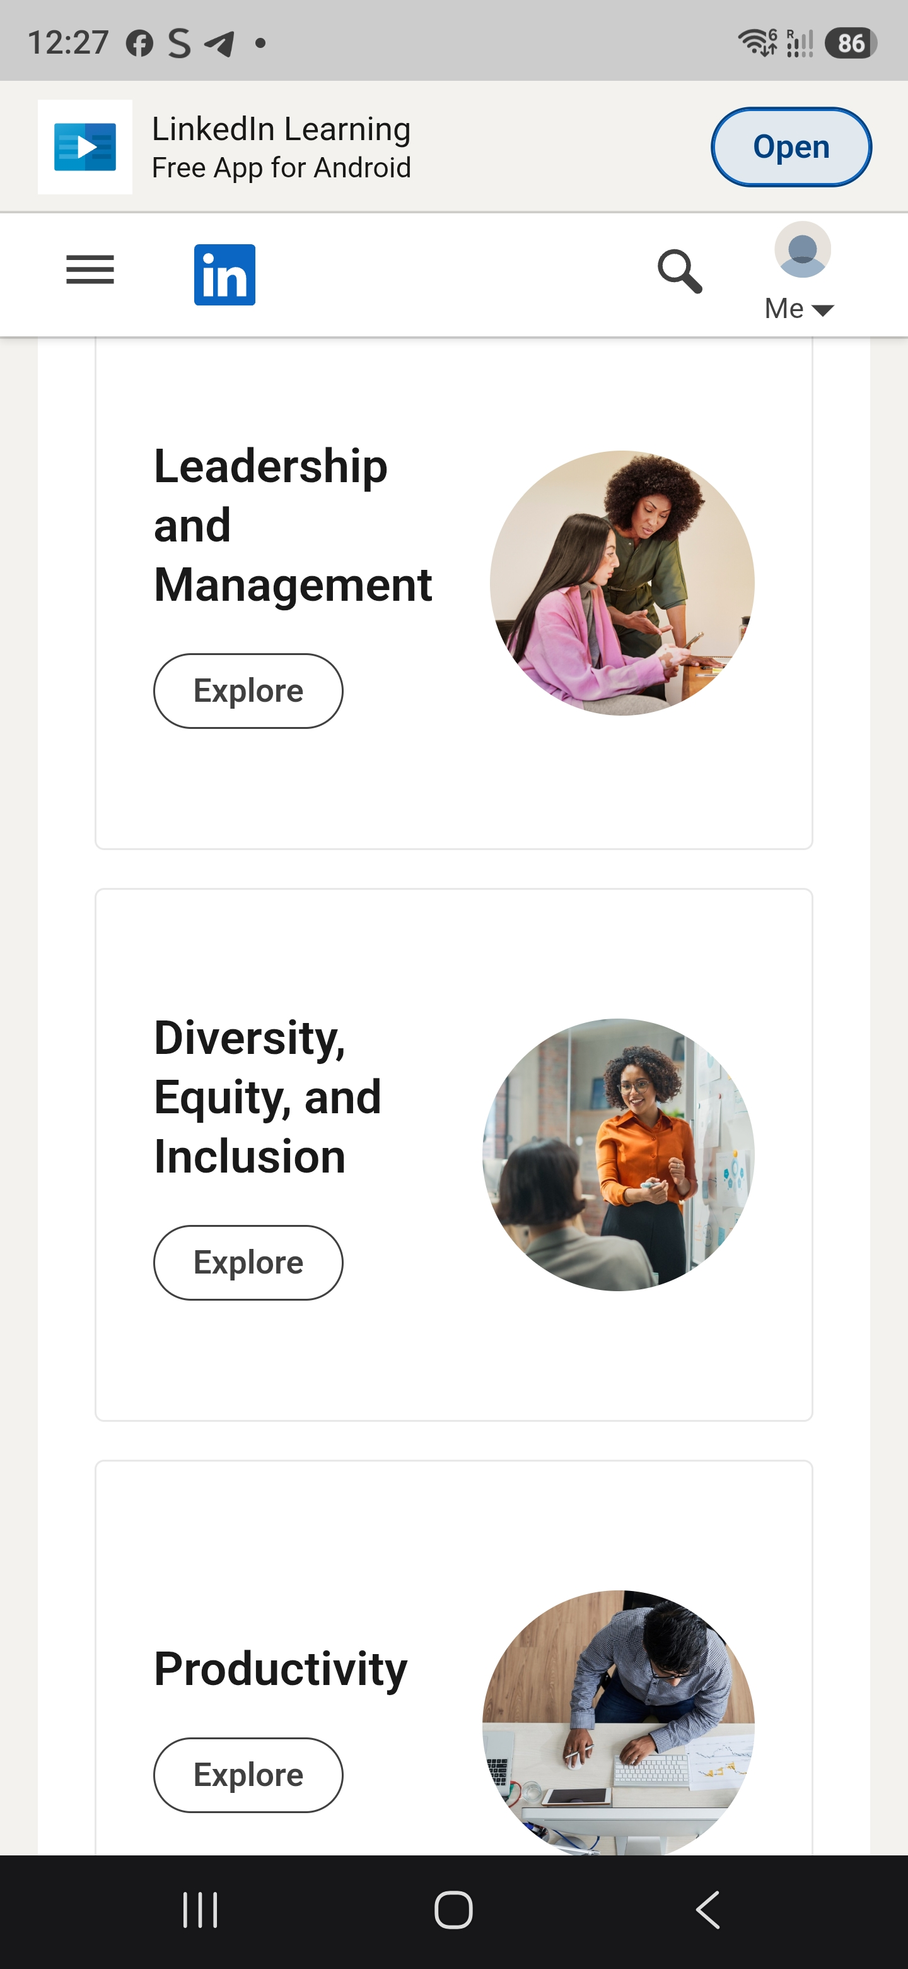
This is a screenshot of LinkedIn Learning. This is where I get learning materials from.

Screenshot/Photo 4
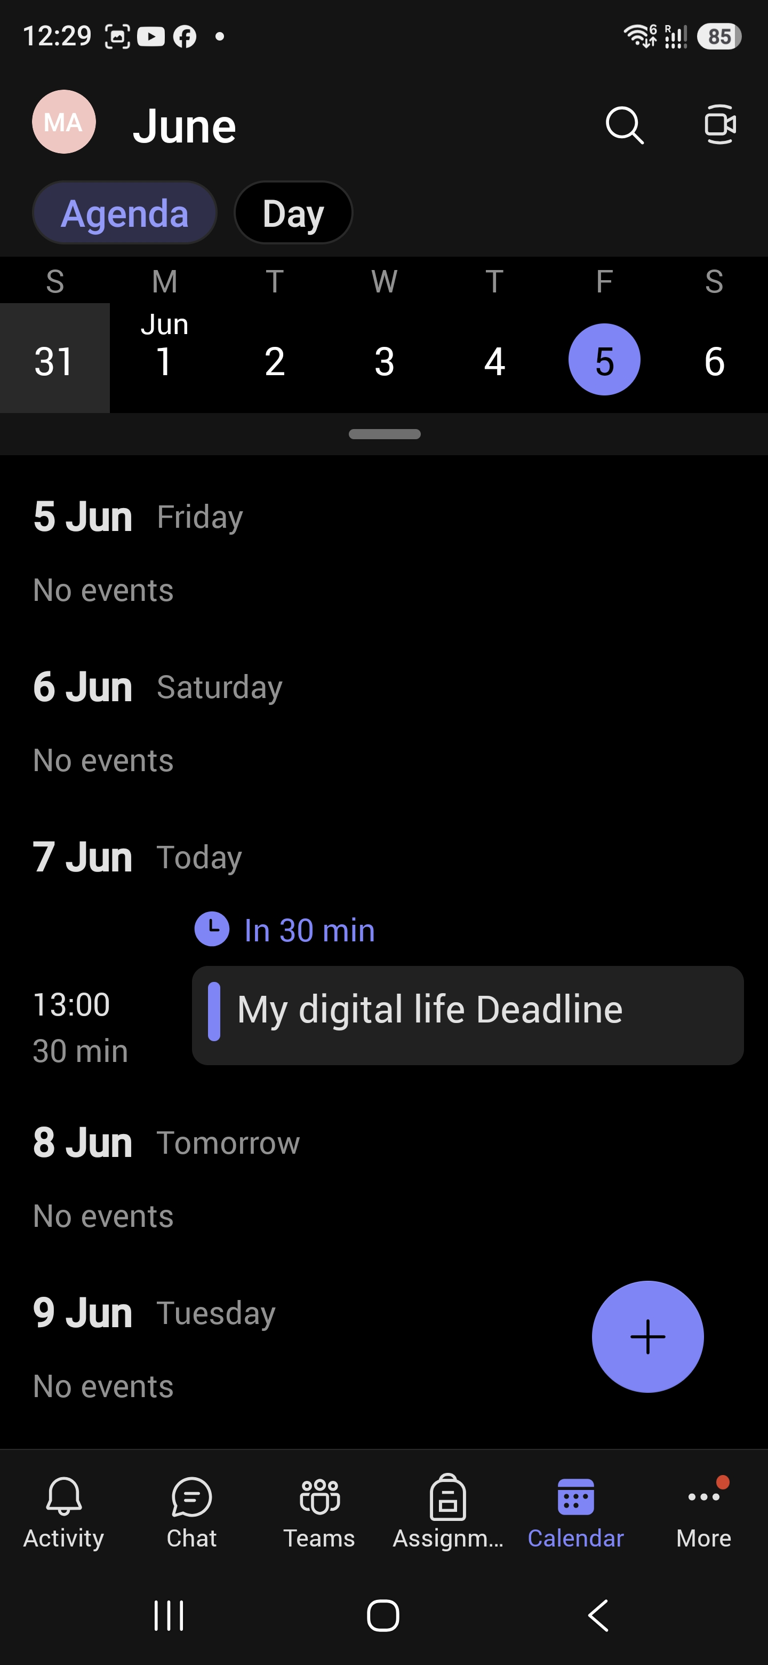
This is a screenshot of Microsoft Teams, which I use to contact colleagues and staff members whilst also using the calendar for organisation.

Screenshot/Photo 5
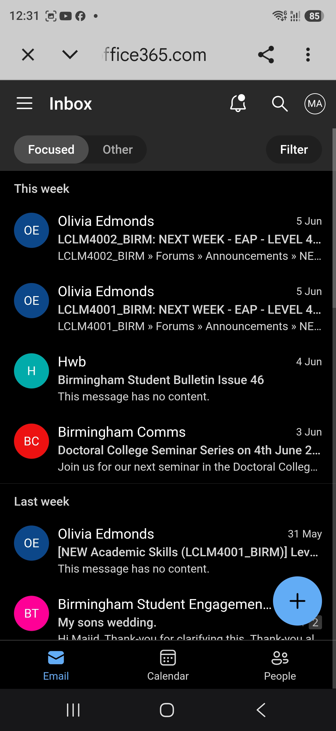
This is a screenshot of Outlook, where I send and receive emails, photos and attachments.

Screenshot/Photo 6
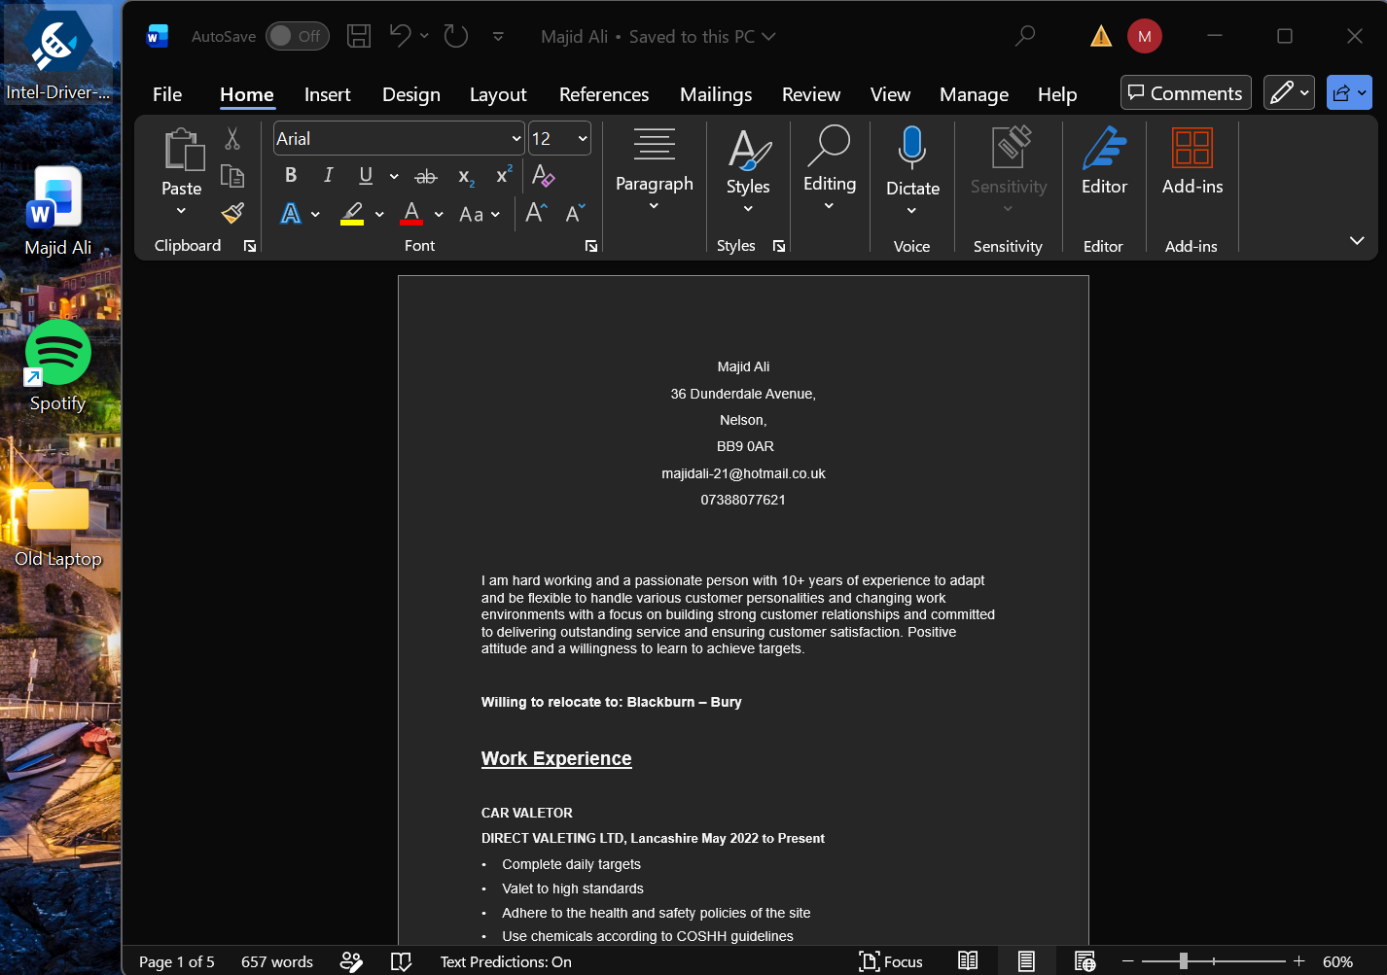
This is a screenshot of Word, where I create and edit documents, tables and charts.

My Short Reflection
I use digital tools to communicate, research, learn and make my working life easier and more efficient. Outlook, LinkedIn and Moodle are some of the apps I use. I use Outlook app to read, send and sort important emails. I find the Outlook app easy to navigate and use. The Moodle app I use for checking upcoming events for the week, I’m new to this app and I am still learning to navigate this app. I the used LinkedIn app for the first time on this course, where I now realise how important this app is in the business world. It will help with my career development, where using LinkedIn Learning, I will be able to improve my knowledge on certain skills. It shows vacancies and what employers are looking for.
I hope this module will help me feel more confident and more efficient. I can achieve this by using these apps on a regular basis. Digital skills are important to me as they can improve my potential and hence achieve better job prospects. Nearly all companies use digital tools in one way or another.

Submission Checklist
Before you submit, please check:
​​​ ☒ I added 4–6 screenshots
☒ I wrote short sentences for each screenshot
☒ I wrote my short reflection
☒ My work is my own
☒ My file opens correctly
​​☒ My file opens correctly

