

Evaluating the Efficacy of SIEM Systems in Detecting and Mitigating Cyber Attacks

by
Cameron Brown

Supervisor: Odayne Haughton

Project submitted as part of the requirements for the award of
BSc (Hons) Computing (Computer Networks and Cybersecurity)

April 2024

Declaration Form and Form of Consent

Declaration
I, Cameron Brown, declare that I am the sole author of this Project; that all references cited have been consulted; that I have conducted all work of which this is a record, and that the finished work lies within the prescribed word limits.
This work has not previously been accepted as part of any other degree submission.

Date: 12/04/24

Form of Consent
I, Cameron Brown, hereby consent that my Project, submitted in candidature for the B.Sc. (Hons) Computing (Computer Networks and Cybersecurity) degree, if successful, may be made available for inter-library loan or photocopying (subject to the law of copyright), and that the title and abstract may be made available to outside organisations.

Date: 12/04/24

Abstract
This project aims to evaluate the efficacy of Security Incident and Event Management (SIEM) tools. The tool of focus for this report is on Splunk and how well it can assist in detecting and mitigating cyber threats. The objectives include testing Splunk against various malware to assess its capability in being able to detect cyber threats, and evaluating the Add-ons that exist within Splunk to create tailored configurations for potential specific needs of organisations.

The methods used include setting up Splunk in a virtual machine, and then deploying malware on the system and using Splunk to examine events created by ingested logs to assess Splunk’s performance. Various malware will be tested, and an assessment of whether Splunk was able to help with detecting these attacks will be done by looking through logs that get ingested into Splunk.

Key findings of the experiment show that Splunk is a very complex tool, and the Add-ons are equally as complex. Trying to set up different configurations is a difficult task that requires great knowledge of the SIEM tool. Despite this, Splunk was able to assist in detecting each of the tested malware every time across 5 tests each. Following this, recommendations were given for configurations that an organisation may consider if it fits their needs.

In conclusion, this report showcases the efficacy of Splunk in enhancing security by how well the tool can assist with detecting and mitigating cyber threats, with the potential for ever increasing capabilities within the tool, due to the extensive number of Add-ons, which continues to grow. This project can be expanded upon in numerous ways, such as including the increase of the variety of attacks performed and increasing the variety of SIEM tools that were tested on.

Contents Page
Declaration Form and Form of Consent 2
Declaration 2
Form of Consent 2
Abstract 3
Contents Page 4
Chapter 1 - Introduction 4
Chapter 2 - Review of Literature 5
Chapter 3 - Development Methodology 8
Methodology 8
Ethical Issues 10
Risks & Limitations 10
Chapter 4 - Design & Implementation 11
Design 11
Implementation 13
Chapter 5 – Evaluation 29
Chapter 6 - Conclusion & Recommendations 30
Conclusion 30
Recommendations 31
Chapter 8 – Reflection 33
References 34

Chapter 1 - Introduction
As the world becomes more and more dependent on technology to store and send information, the need to protect this information grows exponentially. Criminals are rapidly evolving their cyber-attacks to combat against the equally rapidly improving security infrastructures. One type of tool was developed to assist in protecting networks and data, these tools are called Security Information and Event Management (SIEM). SIEM tools have emerged and have become a vital part of an organisation's security infrastructure.
The purpose of this report is to investigate SIEM tools and how well they perform their role in protecting the security infrastructure of an organisation. Various resting and analysis will be done to provide findings that will help organisations to enhance their security and make informed choices regarding the use and configuration of SIEM tools. SIEM tools ingest data from various systems, devices and servers in a network which allows for the detection and prevention of cyber threats [1].
This report aims to evaluate the efficacy of Splunk, which is one the more popular SIEM tools of choice for an organisation and evaluate its effectiveness in detecting and mitigating possible and ongoing cyber threats. This evaluation will be done in numerous ways, such as assessing Splunk’s capability to ingest data from systems, exploring different configurations and combinations of add-ons and assessing their impact and testing malware on Splunk to get a hands-on example of how well Splunk does its job in the face of an ongoing attack. After these objectives have been met, recommendations on different Splunk configurations to enhance its effectiveness to meet certain needs will be given.
In the upcoming chapters, a discussion on existing literature relevant to the topic will be given, a look into the development methodology applied to the experiment is talked about, the overall design and implementation that allows the project to function discussed in detail, the evaluation of the results of the experimenting is elaborated on, the conclusion and recommendations about the efficacy of Splunk and what configurations work the best for their jobs is given, and finally, an overall reflection of the entire project will be discussed near the end.

Chapter 2 - Review of Literature
This literature review will be done by looking at research that consists of the use of SIEM tools. This will help to further my understanding of how researchers examine SIEM tools in a scholarly and comprehensive manner across various scenarios. Looking into the research surrounding the tools will help towards building up and supporting my study alongside further increasing my knowledge on the topic to assist in creating an accurate and consistent experiment.

One piece of literature on the use of SIEM tools belongs to Gustavo Gonzalez-Granadillo, Susana Gonzalez-Zarzosa and Rodrigo Diaz. This literature goes into depth about the different SIEM tools and discusses their benefits and limitations against helping to prevent attacks [2]. G. Gonzalez-Granadillo, et al. discusses how an institution like Gartner, analyses SIEM tools by positioning them into 4 categories, which are market leaders, challengers, niche players and visionaries [2]. The literature includes a table containing 41 SIEM tools from 2010 to 2020 and assigns them 1 of the 4 categories proposed by Gartner [2]. This table lists only 7 tools in the leader category, these are RSA/EMC, IBM, LogRhythm, Splunk, Rapid7, Exabeam and Securonix [2]. This literature, while providing plenty of information on SIEM tools and their general ratings throughout the years, seems to miss out on a major SIEM provider that was, and still is, used consistently in an enterprise setting. This SIEM tool is Microsoft’s very own Sentinel. Sentinel released in 2019, and while the table provided by G. Gonzalez-Granadillo, et al. doesn’t provide values for 2019 because “no report was delivered in 2019”, the table does include 2020, in which Sentinel would have been active and used in enterprise settings [2] [3]. This questions the reliability of the table due to not including a major leader in SIEM tools, especially due to how cloud focused Sentinel is. The literature goes on to discuss the limitations of SIEM tools, one limitation that stood out to me was the section titled “Incomplete Data” [2]. This section mentions how none of the SIEM tools “have all the data needed to process and detect all security incidents” and claims that this is due to it not being cost effective to process all the data [2]. This is quite an interesting statement because how can SIEM tools end up being functional and be reliable if it doesn't get all the data that’s needed to detect all security incidents? I hope to analyse this claim further within my experimentation to see if the claim still holds up or not 4 years after the literature's publication. G. Gonzalez-Granadillo, et al. then proceeds to discuss the use of SIEM tools within critical infrastructures such as energy distribution, water supplies, transportation, healthcare, and financial services and comes to the general conclusion that since everything is becoming more digitalised, these services are becoming victims of cyber-attacks and that security administrators have used SIEM tools to effectively detect and prevent threats [2].

In conclusion, the result of this literature portrays that G. Gonzalez-Granadillo, et al. have displayed that the use of SIEM tools have drastically helped the security of critical infrastructure and discussed what tools were current leaders while also acknowledging their limitations that should be improved to better secure these critical infrastructures even more in the future [2].

Another piece of literature worth noting is titled “Risk Assessment Driven Use of Advanced SIEM Technology for Cyber Protection of Critical e-Health Processes”, written by L. Coppolino, et al. [4]. This report goes into detail regarding the use of SIEM tools in protecting smart hospitals against cyber-attacks and discusses an interesting argument where risk assessment technologies can't keep up with emerging threats, which makes critical infrastructures, such as smart hospitals, very vulnerable during these times and forces them to rely purely on their employees [4]. This pushes the suggestion that because of this vulnerability, these infrastructures are even more vulnerable to social engineering attacks [4]. L. Coppolino, et al. then proposes a risk assessment approach for smart hospitals which allows them to analyse vulnerabilities within their medical facilities, both at the IT level and the human level [4]. They achieved this approach by measuring 3 aspects, the first being how much the smart hospital was exposed to cyber threats, the second being the privacy risk involved with personal data within the smart hospital and how effective the training and awareness programs are overtime within the facilities [4]. This information is useful as it helps put into perspective how much these critical infrastructures are paying attention and focusing on protecting their confidential data.

This literature also discusses how L. Coppolino, et al. had designed a custom SIEM tool to fit the exact needs of the smart hospital in which they specifically mentioned a cloud solution, this, in theory, should drastically increase the security compared to using one that isn’t configured to their needs [4]. Following up the risk assessment evaluations and the SIEM tool customisation, L. Coppolino, et al. had experimented on the tools by simulating two attacks on the system [4]. The results of these two attacks seemingly demonstrated that the customised SIEM tool was able to detect the attacks in an acceptable time that meets the requirements that a critical infrastructure would have [4]. While my experiment won’t be tested within a critical infrastructures environment, I hope to find out how well these SIEM tools do assist in detecting cyber threats and to see if the results are comparable.

The results of this literature experiment showcase that the risk assessment evaluation proved to be successful in evaluating the security of the infrastructure, which is then used to design a SIEM tool that dramatically increases the security of the smart hospital by being tailored to their needs [4]. An important result worth noting is that the experiment mentions that it “enables the Chief Security Officer (CSO) of the hospital to identify the most critical business process”, this helps the smart hospital to prioritise some sections more than others where the data is of a higher value and has the most impact on a patient's health [4]. This literature helps to understand how even vital infrastructures, such as hospitals, are still not completely secure despite having incredibly confidential and valuable data, and systems in which a cyber-attack could potentially take down and out of service, putting people's lives at risk.

B. D. Bryant and H. Saiedian created an interesting piece of literature about the application of the kill-chain model to SIEM tools [5]. B. D Bryant and H. Saiedian states that the application of the kill-chain model to SIEM tools were “easily adaptable” and “results in improved alerts” which ended up outperforming false positive and false negative sensor rates [5]. The experiment of this literature included the comparison of the quality and quantity of the alarms generated by both a default configuration SIEM tool and a custom SIEM configuration within a virtual network [5]. While my experiment uses Splunk, B. D. Bryant and H. Saiedian opted to use LogRhythm due to the author's prior experience with the tool [5]. Nonetheless, being able to compare the results of both experiments would be interesting into how well both tools work.

The testing of this literature consisted of 26 tests on both SIEM configurations, and the results of this testing showed that in the custom SIEM configuration, 25 out of the 26 tests were detected, while only 7 out of the 26 tests were detected on the default SIEM configuration [5]. This experiment stands out amongst the others due to it not being a pure SIEM solution. B. D Bryant and H. Saiedian had opted to increase the tools used in their security system to further increase the effectiveness of the SIEM tool, these tools comprise of many different tools from Microsoft, Linux based systems, and some software from McAfee [5]. This showcases how you can further the use of SIEM tools beyond the tool itself. Implementing more tools to work in tandem with the existing SIEM tool puts into perspective how the configuration can be much more than someone may originally thought. Furthermore, the involvement of the kill-chain model has reportedly assisted the analyst and engineers in increasing the communication of the SIEMs new alarm performance, demonstrating the usefulness of integrating the kill-chain model into the use of SIEM tools [5].

While the other pieces of literature did not mention any testing of a default configuration SIEM tool, the results of the custom SIEM configurations seem to match across all the literature. My experiment also aims to test SIEM configurations, in which these pieces of literature will assist in having existing work to compare to once the experiment is done.

A third piece of literature worth looking at belongs to B. Al-Duwairi, et al. which is titled “SIEM-based detection and mitigation of IoT-botnet DDoS attacks” [6]. This literature delves into the discussion of using SIEM tools to detect and mitigate DDoS attacks caused by Botnets from IoT devices [6]. B. Al-Duwairi, et al. provides a real-world example with the “DDoS attack against Dyn DNS service” as an example as to why these security systems should be improved [6]. The authors propose a system that uses Splunk to monitor specific packet types to implement a system that detects the IoT botnets [6]. B. Al-Duwairi, et al. describes that the system automatically configures the firewall to add new rules which ends up blocking the traffic from the attacker [6]. The literature mentions that while Splunk does come with predefined source types, it doesn’t recognise the IoT traffic which gets captured [6]. The authors solved this issue by defining their own source type, but it was surprising to see that Splunk didn’t natively support it [6].

The conclusion of the report by B. Al-Duwairi, et al. shows that the SIEM system put in place, does effectively detect, and block the DDoS traffic from IoT devices, showcasing how capable SIEM tools are at protecting against attacks [6].

Each of these literatures generally had the same conclusion, which is that SIEM tools drastically help to enhance security, and that configuring it for specific needs increases its efficiency even more. These reports were tested in different fields, two in critical infrastructures, one in including a kill-chain model in the implementation of SIEM tools and one in mitigating IoT-botnet DDoS attacks. This shows how useful SIEM tools are due to all the different systems that benefit from the use of SIEM tools. It’s valuable to be able to look at various uses of these SIEM tools as it puts into perspective the wide range of uses and applications that they can be implemented in.

Chapter 3 - Development Methodology

Methodology
This project uses an experimental based research methodology to test Splunk as a SIEM tool in how well it does its job in detecting and mitigating cyber threats. The experimental methodology was chosen because it allows for the collection of evidence through rigorous testing which will be done in a simulated environment.
When looking at the research onion and its 6 layers, each layer had a section that applied to the research of the project [7]. The first layer is philosophy. The philosophy of the project would be pragmatism, this is because pragmatism is quite open ended in what the result could be. This works well for the project due to how the result differs due to the vast variety of configurations that SIEM tools can have [8].
The second layer is approach. Out of all the possible selections for the project, the one that fits it the best would be deductive. Deductive is used because of all the testing and experimenting that will be done to collect results regarding the efficacy of SIEM tools [8].
The third layer is strategy. The strategy chosen for the project is experimentation. Experimentation is chosen due to the nature of the project being based around changing the configuration of the tools to see the results of how well Splunk can do its job when given different configurations, alongside how well Splunk assists in detecting cyber threats, in which it should be quite successful with existing researching backing it up [9].
The fourth layer is methodology choices. The methodology that best fits the project would be quantitative, this is because the project will collect information on the performance of Splunk, the number of security events and effectiveness of the logs given.
The fifth layer is time horizons. A longitudinal time horizon was chosen due the nature of testing Splunk over time. Testing with various configurations is needed to evaluate how well the tool does its job in different environments.
The sixth and final layer is data collection and analysis. The data collected will be the configurations of the tools alongside the captured security logs and the simulated attacks that will be conducted within a simulated environment within a virtual machine. The data analysis will be done via collecting all the data and interpreting the data in a way that makes sense of what has been collected and then formatted in a presentable way.
The hypothesis of the project is that Splunk will provide high efficiency and effectiveness in detecting and mitigating cyber threats within an organisation when configured accordingly and paired with relevant Add-ons within the tool.
The hardware being used on the host machine is a Windows 11 machine with a CPU with 8 cores (16 logical cores), 32GB of RAM and a GPU with 8GB of VRAM.
The software being used is Oracle VM VirtualBox in which a virtual machine using Windows 11 is used to conduct the entire project. The virtual machine has been allocated 6 logical processors and 8GB of RAM and 128MB of VRAM from the host machine to increase the performance of the virtual machine [10]. The virtual machine itself is running Splunk Enterprise.
The inputs into the project are downloading and setting up Splunk on the virtual machine and simulating cyber-attacks against the system. This was done via malware samples that will be used to experiment with Splunk when configured in various ways.
The project will be conducted with validity in mind by configuring Splunk with easily accessible Add-ons within the tool and using known malware from existing malware repositories. This is done to ensure that the results can be replicated by those who wish to do so.
The reliability of the project will be ensured with plentiful testing of various configurations and the replication of testing to guarantee that the results are consistent throughout the experimentation.
The project aims to mirror a real-world situation as closely as possible, and in doing so, the findings should be closer to the results found within real environments facing similar threats. Efforts to generalise the project will be done by documenting the setups and configurations done to Splunk to allow replication. The generalisation will vary though due to the different configurations being tested for different potential needs of an organisation.
The project will be conducted by setting up a simulated environment within a virtual machine and testing known malware samples against the system with Splunk running and configured to analyse the results given by Splunk which includes evaluating the performance and security events provided by the tool. The virtual machine is used to separate the environment from the host machine to ensure that it is protected against malware usage [11].

Ethical Issues
Due to the nature of the experiment requiring the usage of malware, the network that is being used during the experiment could be exposed and affect other users [12]. To avoid the risk of infecting other devices on the network, the network on the VM is immediately disconnected to sever any connection to the host machine and the network it is connected to. This will allow the experiment to be conducted while not affecting those who are also sharing the network.

Risks & Limitations
With a similar point to the “Ethical Issues” section, malware can be extremely dangerous to experiment with. One such risk would be executing the malware on a VM with the network still attached or without adequate security configurations taking place on the VM itself. An example of this would be installing “guest additions” on the VirtualBox software. This is because “guest additions” allows for closer access to the host machine to gain quality of life features on the virtual machine, such as being able to increase the resolution of the virtual machine which is normally locked to a particularly small setting [13]. Another risk would be not turning off the network while any malware is running on the system, this is because some malware can spread through the network and infect other devices [12]. This risk will be combated by making sure the network is disconnected completely on the virtual machine before executing the malware. Furthermore, a snapshot of the virtual machine will be taken right before any malware will be downloaded, which allows the virtual machine to be reverted completely back to a malware free state before the network is re-enabled.
The experiment does have some limitations worth noting. One is the realism of the simulated environment. While care has been taken to simulate a real-world environment, it would be incredibly difficult to simulate what an enterprise environment would be and would consist of many machines being connected and sending logs to be ingested at the same time [14]. Another limitation is the potential subpar configuration of Splunk, there is potential for the configuration to not be up to standards, and while this shouldn’t affect the results negatively very much, it may limit how successful the experiment may be. A third limitation would be the lack of variety of SIEM tools being used. While Splunk by itself is a very widely used and trusted tool at an enterprise level, it doesn’t speak for the efficacy of other SIEM tools. This will be worked around by going into great depth on Splunk and numerous configurations possible within it.

Chapter 4 - Design & Implementation

Design
The design of the project was the configuration of Splunk, a SIEM tool. There were many SIEM tools to choose from, Splunk, Microsoft Sentinel, ELK Stack, Graylog, LogRhythm and much more. The tool that was chosen for the project was Splunk, this is because when compared to the alternatives, Splunk fit the part for ease of use, swift setup, high quality user interface, configuration needs and scalability [15]. Other tools also have some of these and more. ELK Stack for example is known to be highly scalable with great configuration, has great customisation variety and is also open source [16]. This puts it at a cost advantage over Splunk, but ELK Stack is more complicated to set up and isn't quite as user friendly as Splunk [17]. Splunk offers a ton of add-ons to incorporate into the configuration which speeds up the setup dramatically, while also adding extra support for other systems.
Splunk also has plentiful learning resources and even industry recognised certifications to help show off your knowledge, the only other SIEM tool that has them at this quality would be Microsoft Sentinel [18] [19]. Sentinel wasn’t chosen for this project due to being a very expensive option and only being usable with cloud-based systems, which an organisation may not be using [20]. With all the positives and negatives of each tool compared to one another, the result was that Splunk would be the better tool to use in this experiment.
For Splunk to do its job, it needs to be configured accordingly. This experiment uses various Add-ons that are easily accessible and findable within Splunk itself to help configure the tool in a more precise and efficient way. These add-ons will be talked about in depth in the “Implementation section.”
A virtual machine would be used as a simulated environment to perform testing on, the software options for these were VirtualBox and VMware. Ultimately, the decision ended up being in VirtualBox’s favour. VirtualBox is open source which makes it a lot more accessible to people, and because of this, VirtualBox has extensive documentation from not only from officials but also from consumers [21]. This makes any sort of troubleshooting and optimisation a lot easier. VMware is also considered to have better performance compared to VirtualBox, but the experimentation of the project wasn’t designed for demanding usage.
One thing to consider is that VirtualBox doesn’t have integrations with cloud services, while VMware does include integrations with cloud services with some of VMware's different versions [21]. Regarding the experiment, the inclusion of cloud services does not matter but it may be worth considering if testing on the cloud was an idea for a future experiment.
VirtualBox needs an ISO file of an operating system to create a virtual machine. The choice for the operating system was Windows 11, in which the ISO file was gathered from Microsoft themselves. This is because Windows is the leading operating system for general business use and while Linux distributions are used widely in an enterprise environment, most logs pulled into SIEM tools are likely to be from Windows systems [22].
One vital part of the experiment would be the attack simulation. This will be done by collecting malware from a known repository called “The-MALWARE-Repo” which is managed by the user “Da2dalus” on GitHub. This repository was chosen due to having plenty of known malware which has been categorised by their type within the repository itself. This makes choosing specific types of malware, such as trojans and spyware a lot easier. The malware being tested is a spyware called “AgentTesla” and 3 trojans, called “Alerta”, “Whiter.A” and “NoStart”. These were chosen at random so that a malware that was known by me, isn’t chosen which would make the testing unreliable as the effects of the malware would be already known and easily detectable.
All these parts of the design will be kept consistent throughout testing, except for the configuration. To test the efficacy of Splunk, testing against different configurations is a must. Every other aspect will be kept the same and used in the same manner throughout the experiment to ensure that the testing is valid and replicable.
The first part of the project is setting up the virtual machine with VirtualBox, this was a simple process and default settings were used in all fields except for resource allocation for RAM and CPU core counts. Once the virtual machine was set up, the next thing to do was to install Splunk enterprise on the VM. To do this, the “Splunk Universal Forwarder” needed to be installed onto the system.
There were some issues with installing the Splunk Universal Forwarder, and it was faster to revert to a VM snapshot taken just before setting it up, than it was to get rid of and reinstall the forwarder. Numerous reversions back to the snapshot was needed to get the forwarder set up correctly. The purpose of the Splunk Universal Forwarder is to collect system data and forward it into Splunk for the logs of the system to be usable within Splunk.
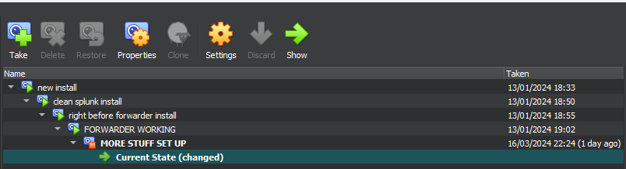
Figure 1, illustrating numerous virtual machine snapshots.
When setting up the data to be ingested, there are a lot to choose from. The scope of this project only warranted the use of System, Security and Application logs, so only those were chosen. The rest of the logs have their uses, but in context of the experiment, only the 3 previously mentioned were needed.
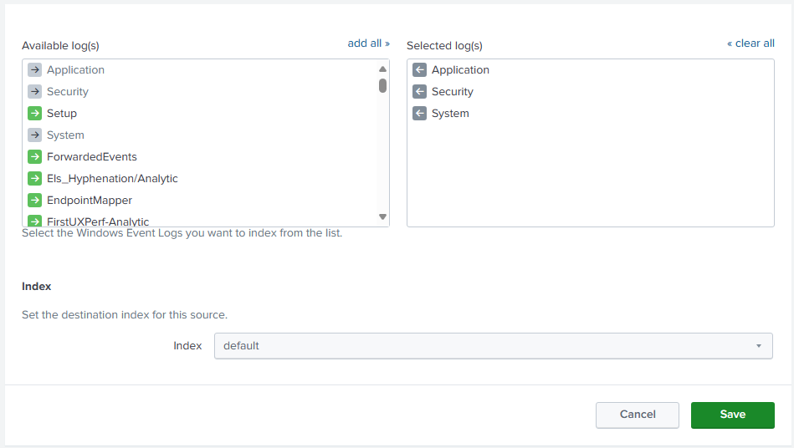
Figure 2, illustrating the setup of logs being ingested into Splunk.
Windows Defender logs were also included by creating a subscription inside of the Event Viewer for the Windows Defender logs, that were to be included in the forwarder that’s sending data into Splunk.
When installing Add-ons to configure and test, it turned out that my knowledge of the tool simply wasn’t enough to properly configure them. This had put a big hole in the experiment that now needed to be filled. Originally the testing against a relatively unconfigured Splunk was to be quite low, and more of the focus being on a Splunk configured with Add-ons. This changed and as a result, testing was increased on the relatively unconfigured Splunk to see how useful Splunk was before tailoring its configuration to an organisation's needs. Not everyone will be competent in configuring a SIEM tool incredibly well right at the start, and having a working baseline SIEM tool is likely to still be better than having no SIEM tool at all. The following experimentation will put this idea into play and see how truthful it is.

Implementation
Now that Splunk was up and running, it was time to start evaluating the tool. This will be done by looking into how log searching in Splunk feels with the default configuration, a look into how to set up alerts, a testing of malware on the default configuration, a brief analysis of some potentially useful add-ons and then finally, extensive testing of Splunk to see how well it can do its job.
With the way Splunk was set up from the Forwarder, there were thousands of logs. In which most of them weren’t relatively useful for the experiment, such as the “Available Memory” and “CPU Load” logs. These logs are useful for resource monitoring and ensuring that there isn’t some potential threat that’s using up a lot of system resources for malicious means. This isn’t useful as the experiment aims to analyse the logs that are directly caused by the malware, and use those as a means to detect it.
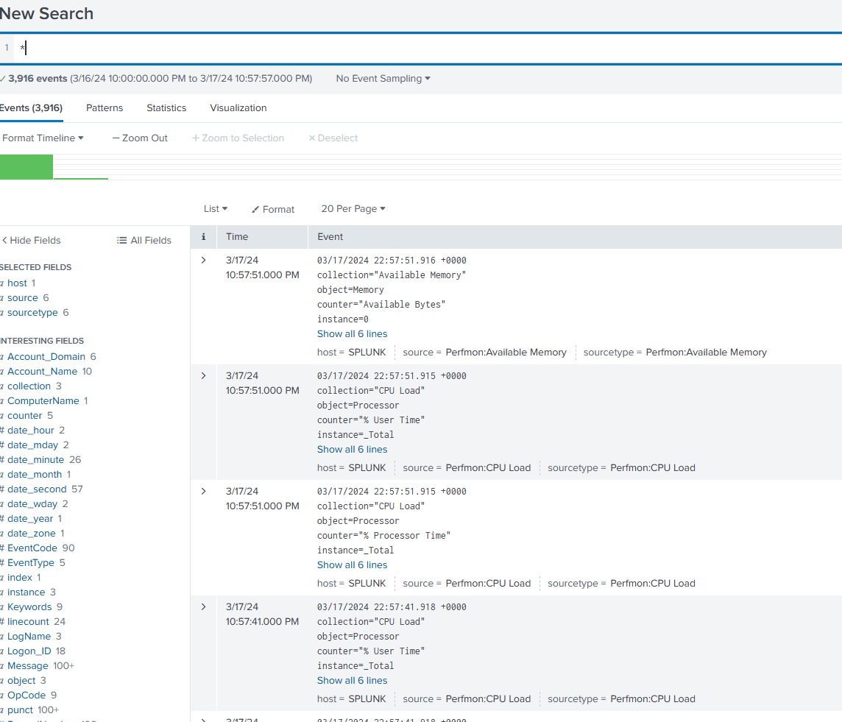
Figure 3, illustrating numerous logs being ingested into Splunk.

Splunk allows you to filter the search results very easily. This is done by adding various syntax to the search by clicking on any point in a log and adding/excluding it from the search results. This drastically helps in refining the logs displayed to only give those that are wanted and is especially useful if you are ingesting thousands of logs. With enough knowledge, Splunk allows you to create complex searches using its syntaxes.
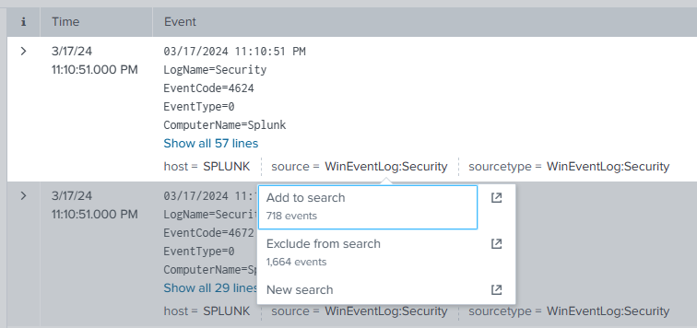
Figure 4, illustrating the capability of Splunk’s search feature.
The search function has near limitless capabilities for narrowing down logs. It can specify certain hosts, certain IPs, Event codes, source types and much more. A basic example would be specifying the source as a Windows security event log with an error code of 4648. This shows logs where login attempts had failed. While login attempt failures will be expected in a large network, if they consistently originate from a certain host a lot more frequently than others, then it could indicate a potential attack that should be investigated further.
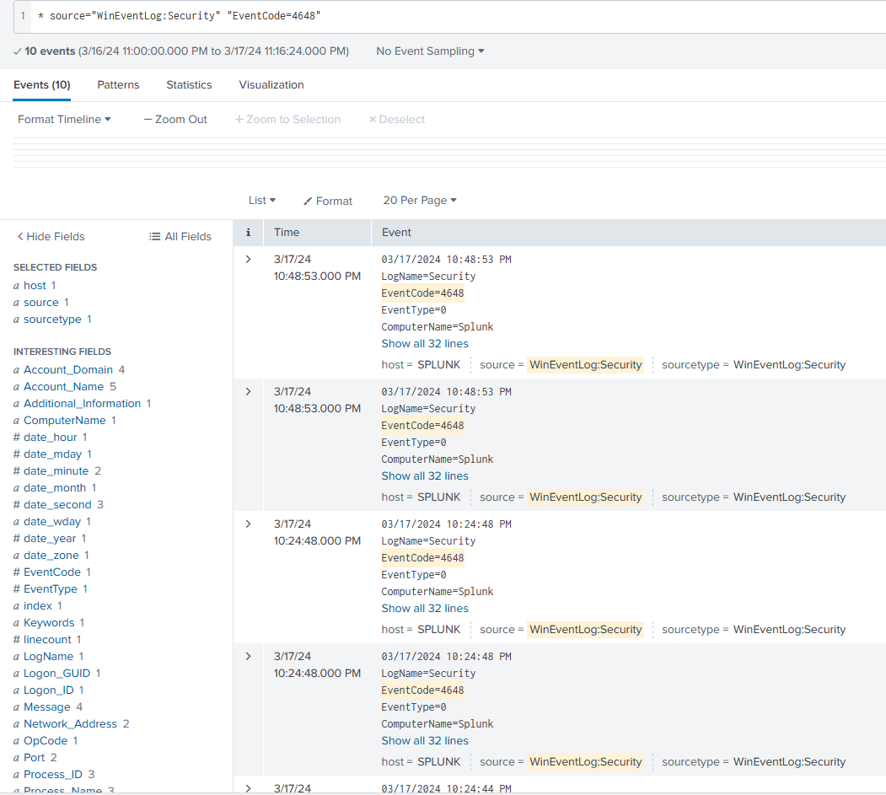
Figure 5, illustrating the usefulness in filtering the search feature to get specific log types.
Splunk allows you to save these searches as alerts. These alerts will notify you based on the configuration. In the previous example, 10 failed logins may be too little to warrant an alert. The number of logs needed to trigger the alert can be changed under “Trigger Conditions” where it is set as 0 in the default setting. The alert can be configured to search continuously in real-time or on a schedule which allows flexibility for what an organisation may want.
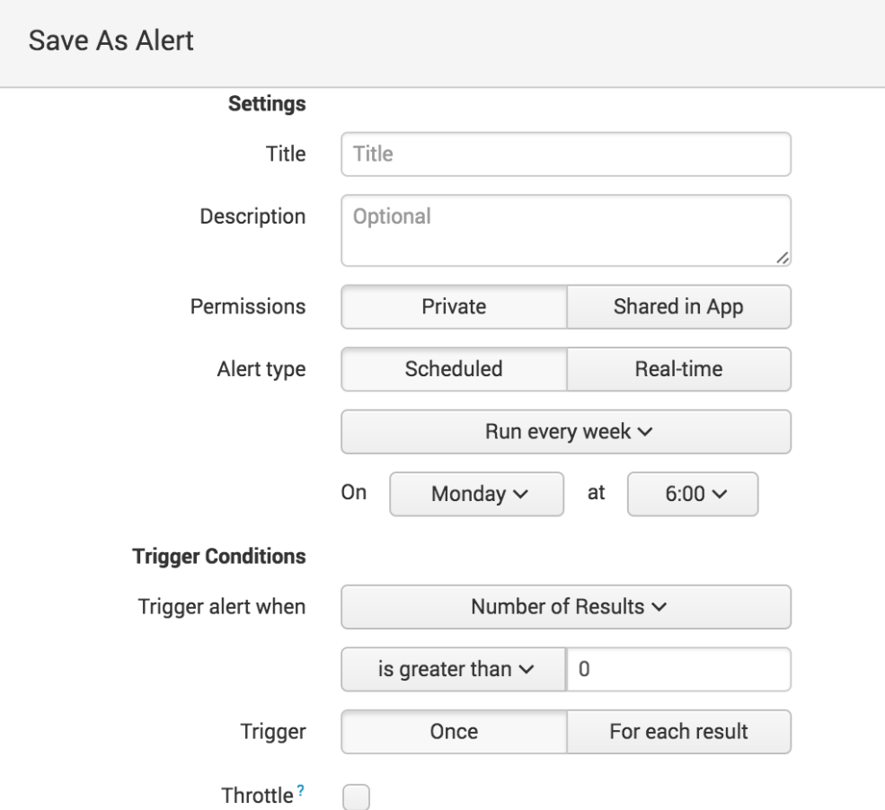
Figure 6, illustrating the configuration of alerts within Splunk.
The depth of the searches and the convenience of the alerts ends up making threat hunting quite a bit easier than expected. This is because by using alerts, potential threats can be instantly found and investigated without the need for an administrator to sift through potentially thousands of logs to find a trace of a potential attack.
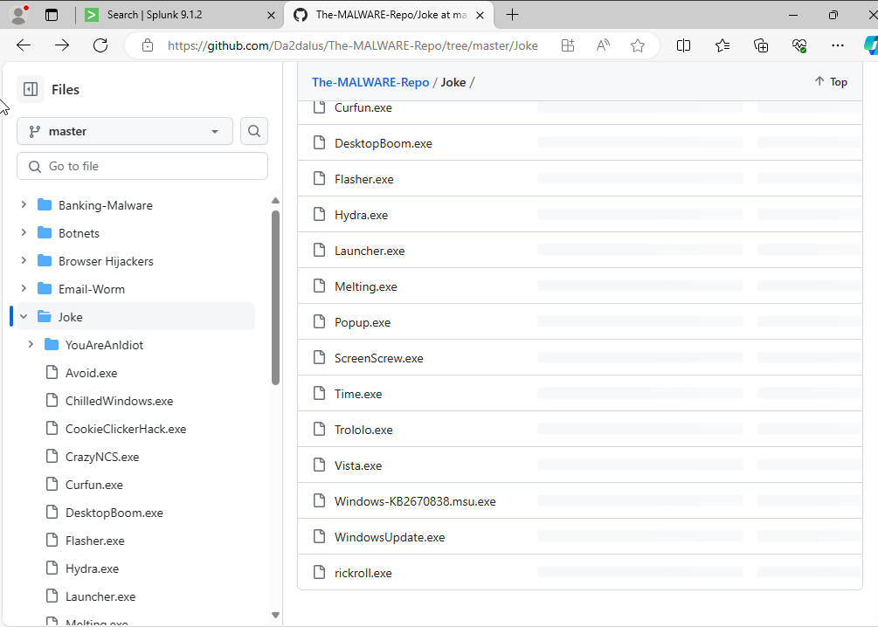
Figure 7, illustrating the malware repository being used for testing.
Next up was to test malware on an unconfigured Splunk by using a known malware repository on GitHub. Each malware is to be tested 5 times to make sure that the logs consistently show up and aren't a byproduct of something else entirely. To ensure that the host machine that was running the virtual machine was safe, a “joke” malware called “Trololo.” was first run to make sure that the host was not vulnerable. This ended up going well and the host machine was perfectly fine, but it had locked up the VM so reverting back to a snapshot of the VM taken before malware execution was done due to being faster than trying to undo the malware.
When the malware was downloaded, an event occurs when network activity is detected, and it informs the administrator which host the event stems from, and the value of bytes downloaded. This would be useful as an alert if some host downloads mass amounts of information, which an administrator may want to investigate.
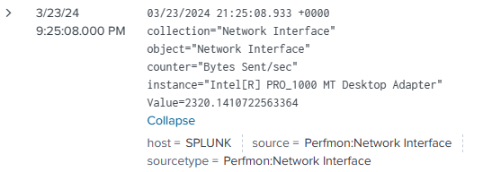
Figure 8, illustrating a log that displays network activity when malware was downloaded.
Another thing that happened when downloading malware samples was that Windows Defender first blocks every single one of them. When it does this, it creates an event within Splunk that mentions that the status for Windows Defender was updated. This is incredibly useful as it informs the administrators of attempted malware installation and which device it originated from to help investigations.
After running a Spyware called “AgentTesla” from “https://github.com/Da2dalus/The-MALWARE-Repo”, new events appeared in Splunk. This event informs the user that the access history in a registry hive, in this case it would be “settings.dat”, has been cleared and 2 registry keys were updated alongside 1 page being modified. Considering we know in advance that this has happened following the execution of Spyware, it is safe to assume that the malware had accessed the registry editor and changed 2 keys to capture user data and then had tried to clear its trace by clearing the access history. If an organisation doesn’t have one in place already, it would be incredibly easy to turn the search that found the specific event into an alert. This would alert the administrator as soon as the event is created, or a certain number of events are created where the access history is being cleared and having keys updated. This log showed up on all 5 of the testing.
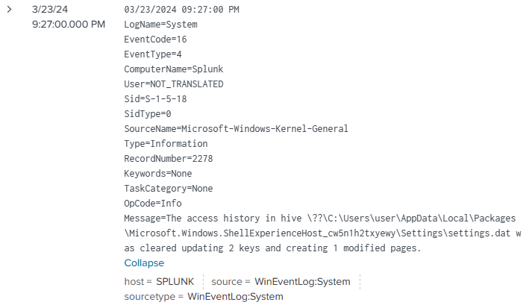
Figure 9, illustrating a log created when executing the “AgentTesla” malware.
The next malware to be tested was a Trojan by the name of “Alerta”, this malware didn't work. It seems that some file was missing for it to execute properly, Splunk created an event that included the failed trojan execution. This is useful to see if users are executing suspicious or broken software. Both can easily be security risks, which would warrant further investigation. Even after redownloading, this trojan never seemed to function.
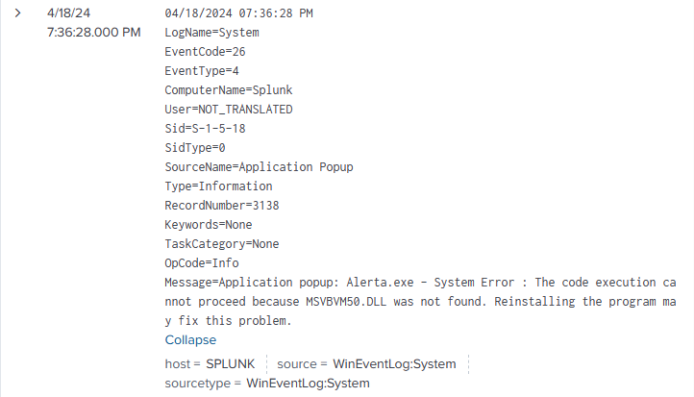
Figure 10, illustrating a log created when the “Alerta” malware failed to execute.
“Whiter.A” was another trojan that was tested against Splunk. This trojan destroyed the system by making core components unusable, such as file explorer. This could cause catastrophic damage if the system held data that wasn’t backed up anywhere else. The trojan also read stored credentials in the credential manager, meaning any credentials present on the machine before everything was destroyed, is now in the hands of the attacker. This renders other systems as a possible victim due to credentials typically being able to work on other machines in a company's network. This trojan seems to disguise itself as a Windows Audit, this is done to try and trick an admin into thinking that it’s simply just an audit being done rather than the credentials being read by an attacker. This log appeared on each of the 5 tests for this trojan.
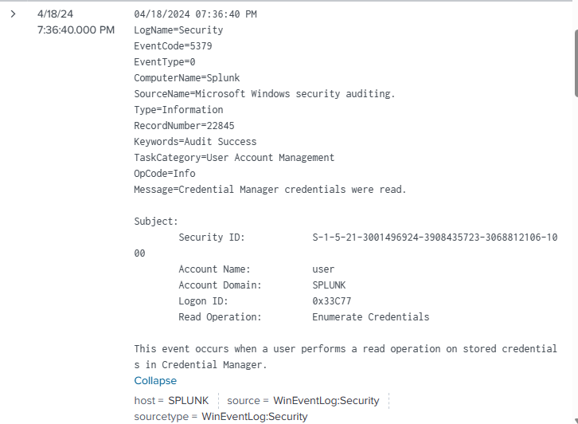
Figure 11, illustrating a log created when the “Whiter.A” malware was executed.
The next malware to be tested was the “NoStart” trojan. This trojan makes a query to find the existence of a blank password for an account, it does this 8 times. This is done to try and see if a system is using insecure passwords to easily gain access to a user with high privileges. Much like the previous malware tested, this trojan also seems to disguise itself as an official audit to avoid suspicion. Splunk displayed the log in each of the 5 tests of the trojan.
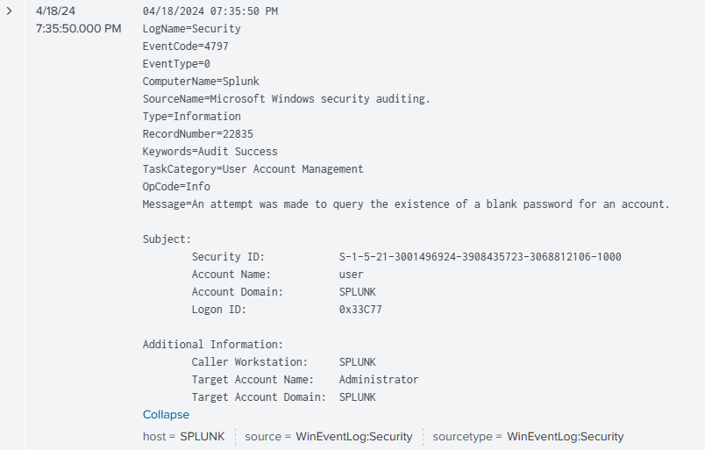
Figure 12, illustrating a log created when executing the “NoStart” malware.
As “Alerta” did not work, it was not included in the results. It is still worth noting that Splunk had detected the failed execution, but that was an unexpected outcome that wouldn’t determine if the tool had detected the malware or not.
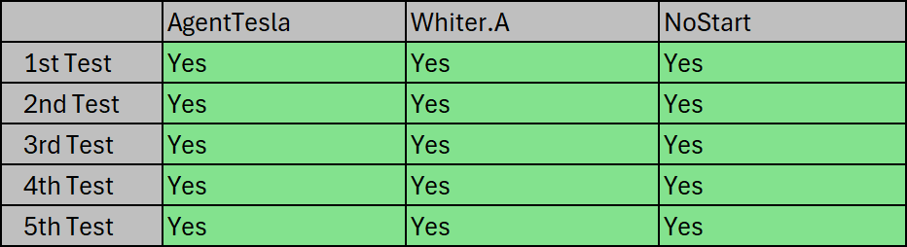
Figure 13, illustrating the results of each malware being tested 5 times.
The results show that each of the malware that was able to be executed, was discovered via the logs that were ingested into a barebones configured Splunk on each of the 5 tests. Due to the nature of Splunk working via ingesting system logs, it was expected that Splunk would detect them all. This is because malware must affect/change the system in some way to perform its attacks, these will generate logs which get ingested into Splunk to be displayed. The “Alerta” trojan failing to execute was not expected, this is because the malware repository is quite well known and could result in the malware repository potentially not being as reliable as was initially thought. This gave the experiment 1 less malware to work with which could also make the experiment less reliable due to having less to work with.
These results lined up with what was displayed in the literature reviews. The first and second literature reviews showed that SIEM tools were useful in protecting critical infrastructures, while the other two literature reviews showcase how well SIEM tools work when implementing kill-chain models into SIEM tools and how well the tools work in protecting against IoT botnets, respectively [1] [3] [4] [5]. The results that I had obtained in the experiment support the results from the literature review due to the malware being detected easily.
The next part of the experiment is to look at Splunk and its Add-ons. Splunk has a section dedicated to Apps/Add-ons that can be installed onto the service. These Add-ons can increase the efficiency of the tool by adding features that allow for extra support and configuration of certain services. An example of this would be “Splunk Add-on for Microsoft Cloud Services”, this add-on allows Splunk Enterprise to support the ingestion of data from cloud services even though Splunk doesn’t natively wouldn’t support it.
Another example of an add-on for Splunk is “Splunk Add-on for Microsoft Windows”, which is made to include predefined inputs for data from a system running Windows. This speeds up setting up a system to collect info and allows a smaller infrastructure without extensive knowledge on the tools to still create secure systems with valuable data being inputted. There are similar Add-ons to this for other systems such as AWS, Linux, Cisco ASA, etc.
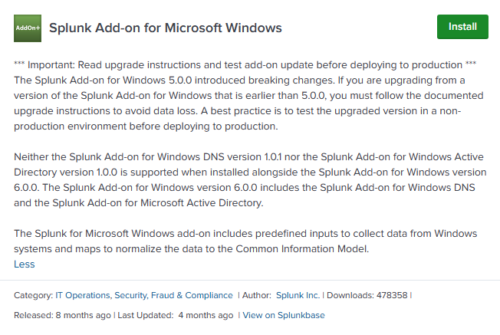
Figure 14, illustrating an Add-on for Splunk.

Another Add-on worth mentioning is the “Splunk Dashboard Examples” Add-on. This Add-on provides examples to teach the user the basics of creating useful dashboards to simplify data visualisation, in a hands-on way. This Add-on, like the previous one, helps the user in being able to create an efficient environment within the SIEM tool.

Figure 15, illustrating an Add-on for Splunk.
There also exists an Add-on called “Splunk Security Essentials”. This Add-on provides the user with out-of-the-box systems and presets that allows the tool to be set up in an acceptable way very quickly. Add-ons such as the ones mentioned can drastically speed up the configuration of the tool, especially for an administrator who may not be extremely proficient with using the tool just yet.
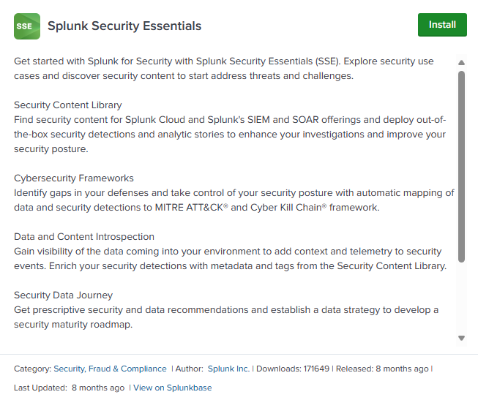
Figure 16, illustrating an Add-on for Splunk.
While there are more basic Add-ons, there’s also no shortage of more advanced Add-ons such as “Splunk Machine Learning Toolkit” and “Python for Scientific Computing”. These Add-ons, respectively, are useful for predictive analysis when given prior information and anomaly detection and for allowing the use of python into Splunk to assist with important tasks such as data analysis.
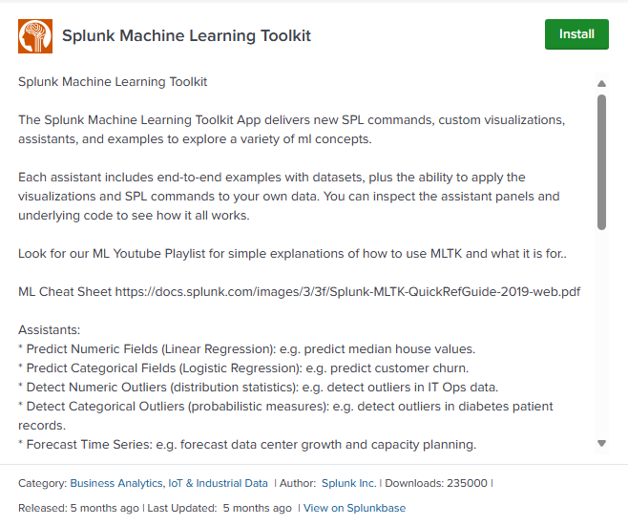
Figure 17, illustrating an Add-on for Splunk.
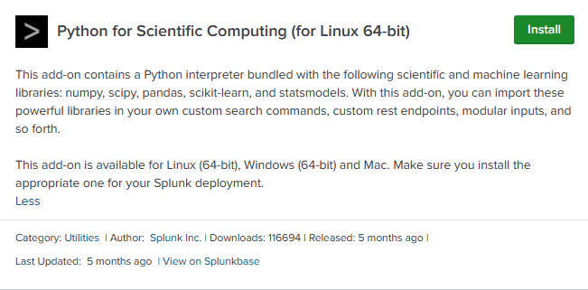
Figure 18, illustrating an Add-on for Splunk.
The overview of Splunk’s Add-ons gives the impression that the Add-ons are incredibly useful and results in the tool being unexpectedly customisable. Splunk’s Add-ons consist of a variety of simple and complex features that allow for unique and powerful configurations of Splunk using most systems that you can think of. Splunk has 2221 Add-ons as of the writing of this document, which provides near limitless configuration potential of combinations of both complex and simple Add-ons which makes every Splunk configuration unique and tailored specifically for an organisation's needs. This amount of configuration was not expected, this is due to the sheer number of Add-ons available being unfathomable and providing support to any system that the user could possibly use.
When looking at Add-ons, it brings into perspective how the authors of the respective literature reviews were able to configure their SIEM tools so uniquely and tailored specifically to their needs for their research. This is because with the quadruple digit number of Add-ons, Splunk can become an incredibly adaptive tool which can support an incredible number of systems and funnels the logs all into one place for ease of access.

Chapter 5 – Evaluation
When looking at the results from the experiment, we can see that Splunk is a very capable tool in enhancing an infrastructure's security. While the full scope of the experiment wasn’t achieved, the findings were still valuable. Each of the malware tested were able to be detected via event logs that were ingested into Splunk. Furthermore, configuring Add-ons in Splunk was quite difficult, since they required knowledge that neither I, nor potentially an administrator would currently have. The general conclusion from the data gathered showcases that even a baseline SIEM configuration is still proficient in helping to protect networks. The results also show that the Add-ons are quite complex and could use some streamlining of some features to make them more understandable.
When comparing my results to the literature reviews, the results obtained from the experiment do support the results obtained in the literature reviews. This is because each of the literature's experiments ended up with the SIEM tool being useful in enhancing the security of infrastructures, in which the result of my project had also helped enhance the security of the simulated infrastructure [1] [3] [4] [5].
The aims and objectives of the experiment were partially met. Splunk was able to be tested with various malware, but configuring Splunk with Add-ons wasn’t possible with my current knowledge of the tool. Due to this, research into the Add-ons and potential configurations theorised by the knowledge gained from the research, will be given in the conclusion section underneath.
The results were generally what was expected. The SIEM tool was able to detect the attacks by creating events using logs that were ingested into Splunk, this ends up with Splunk detecting all the malware over 5 tests each. Not being able to properly configure Add-ons did reduce the scope of the project and prevented me from completely evaluating the tool in full.
If I were to repeat this experiment, the main thing I would do differently would be to gain more knowledge of the tools, test more SIEM tools and increase the variety of simulated attacks. I had vastly underestimated how complex SIEM tools are, and as a result, I was unable to meet the full aims and objectives that I had set for the project. Increasing my knowledge of the tools more than I did, would drastically help with increasing the scope of the project. Splunk has competition with the existence of Microsoft Sentinel, ELK stack, LogRhythm and more [23]. This provides a lot more variety of tools for organisations to research into and to then pick one that best fits their needs. Being able to compare these tools would allow for a more detailed grasp on SIEM tools entirely rather than only one. Another change I would make would be to learn more about how to properly perform penetration testing. This would enable the testing to evolve from only some malware testing, into more focused and targeted attacks that an organisation may face.

Chapter 6 - Conclusion & Recommendations

Conclusion
In conclusion, the initial setup of Splunk was quite technical but easily done, getting logs ingested and displayed into Splunk was also quite simple. Splunk has many useful features such as alerts and Add-ons, which provide vast customisation. These, when all working together, ends up with a tool that provides incredible security, which is supported by the literature reviews where each one had demonstrated that SIEM tools drastically help towards strengthening an infrastructure.

All things considered, SIEM tools are very complex tools. While the amount of depth is immense, the amount of knowledge needed to take full advantage of these tools is equally immense. Splunk’s Add-ons, while being incredibly vast, are complex to configure well. This resulted in me struggling to test different Add-ons due to not being able to properly configure them.

To further expand on the experiment, testing various SIEM tools and increasing the variety of attacks simulated would be highly valuable. This is because the number of attacks I had tested on a baseline Splunk configuration does not show the full extent of the tool. Increasing the variety of attack methods, plus repeating the testing on numerous other SIEM tools will give a greater insight on how well these tools work in general, rather than just how well a singular one does. My experiment created holes in which these additions would perfectly fill to completely evaluate SIEM tools in their entirety and with increased depth.

Recommendations
Due to the number of Add-ons available, Splunk can be configured to a wide variety of needs. For example, Splunk Enterprise doesn’t natively support Amazon Web Services (AWS), but if the Splunk Add-on for Amazon Web Services is installed onto Splunk Enterprise, then it becomes possible to ingest data from AWS services into your Splunk Enterprise environment.
If a pure cloud environment is being used, then Splunk Cloud Platform would likely be better. This is due to reasons such as having default support with Cloud services such as AWS and Microsoft Azure. The setup for Cloud Platform is also simpler and faster compared to using Splunk Enterprise with the AWS Add-on. An upside to using Enterprise with the AWS Add-on is that it supports cloud ingesting while ingesting non-cloud systems data as well, while Splunk Cloud Platform can only support a cloud infrastructure. While this section mentions AWS specifically, other cloud services have their own Add-ons within Splunk Enterprise such as Microsoft Azure.
In summary, an organisation should use Splunk Cloud Platform for a pure cloud environment or use Splunk Enterprise with the relevant cloud Add-ons for the cloud services used if the organisation uses a mix of cloud and non-cloud solutions.
For security monitoring and threat detection in an organisation, an administrator may opt to use the Splunk Security Essentials, Palo Alto Networks and Cisco Security Suite Add-ons. This recommendation comes with the assumption that the company is using Palo Alto Networks and using Cisco devices. This assumption is made since Palo Alto Networks and Cisco devices are widely recognised and adopted into company’s infrastructures.
Splunk Security Essentials, as explained prior, gives an out-of-the-box solution for companies to get their security improved rapidly. This is done by the Add-on providing curated security features such as detection searches and compliance reports. The Add-on also provides guidance and teaching if certain elements are confusing.
Palo Alto Networks allows for Splunk to ingest data generated by Palo Alto Networks’ products. The Add-on provides pre-made dashboards to help visualise and display information from Palo Alto Networks all in the Splunk environment.
Cisco Security Suite is very similar to the Palo Alto Add-on where it allows Splunk to ingest data from Cisco devices and provides pre-made dashboards to help visualise and display information from Cisco devices. For security monitoring and threat detection, these Add-ons will be enough to keep a company safe and secure.
These Add-ons combined allow for an organisation to ingest logs from all their services into Splunk. This provides convenient ease of access while also providing a great learning tool that is implemented into Splunk Security Essentials.
If a company wants additional configuration for vulnerability scanners, then the Add-ons Nessus Security Scans Dashboards App and Tenable Add-On For Splunk. These Add-ons allow Splunk to get data from Tenable security scans and provide dashboards within Splunk for easier visualisation of the results. The pre-made dashboards provide valuable information such as Vulnerabilities by Environment, Vulnerabilities by Category, Top 25 Widespread Vulnerabilities, Vulnerabilities by Severity, etc. These dashboards allow for data to be shown in a clean and understandable way automatically which saves a lot of time of someone manually creating them themselves. The option to export the dashboards into a PDF also exists, where the contents of the dashboards are put into an easy presentable format.
This allows an organisation to streamline the use of their vulnerability scanners with the use of Splunk. This Add-on allows the vulnerability scan results to be shown and presented in a neat and easy to understand format by default with its pre-made dashboards. Not only does this save time for whoever may oversee the sorting of the results, but it also allows for a quicker recognition of the vulnerabilities.
Service monitoring and management is another section that an administrator may prioritise configuring Splunk for. The Add-ons they can use for this would be, Splunk Add-on for Microsoft Windows, Splunk Add-on for Amazon Web Services (AWS), Splunk Add-on for Unix and Linux, Splunk Supporting Add-on for Active Directory, Splunk Add-on for Google Cloud Platform and Splunk Add-on for Microsoft Cloud Services. All these Add-ons provide additional support within Splunk for each of their respective services, which includes predefined inputs to collect data from these systems. These Add-ons allow for swift setup and configuration for mostly all of what an administrator may want to ingest from them.
These Add-ons don’t need to all be installed unless an organisation uses every single one of them. Instead, an organisation should look to see what services and providers they use and install the ones that are relevant to what's being used. These Add-ons allow for each of these services to get ingested into Splunk quite easily, saving time for the administrator/engineer who may have had to do it all from scratch otherwise. This saves a lot of time and allows for that time to be better spent improving other areas.
In conclusion, Add-ons within Splunk are incredibly vast and useful. They provide incredible customisation and can personalise a Splunk configuration to the exact needs of an organisation. Companies should evaluate what Add-ons would be useful to them to improve the efficiency of Splunk and to save time from configuring everything from scratch and without Add-ons.

Chapter 8 – Reflection
This project has taught me a lot, both about the topic and about myself as a person. The topic involved the use of complex tools, of which I had no prior experience with. Due to this, I had struggled with the project and had to put in a lot more time and effort than what I had originally expected. This led me to believe that I not only underestimated the project, but I had also overestimated myself. I had believed that the project would be relatively easy since there was a lot of documentation on Splunk. Despite all the documentation, I had still struggled massively and had to spend a lot more time than expected towards researching the tool, and I still fell short.

If I were to do this project again, I would use what I’ve learned from this experience and allocate more time towards researching every little aspect of the project in a lot more depth. Despite all this, I had learned a great deal from struggling as much as I did. I had gotten better at looking over documentation in an effective manner, I had gotten a lot better with the use of SIEM tools and ultimately learned to not overestimate myself while underestimating the work required of me. These issues mixed unsurprisingly resulted in a struggle.

I had gotten better knowledge of malware and its effects, and how to spot its usage. Cyber threats aren’t always malware though, which created a slight hole in my project since it didn’t cover if the tools were just as capable of detecting the more focused attacks, which the literature reviews did cover. I’d improve on this by performing penetration testing on the system, instead of just running some malware as this wouldn’t completely simulate what a real scenario may entail.

While the setbacks may have caused some panic, I was ultimately able to keep it under control and make sure I was able to do what was possible of me given the circumstances. This resulted in the scope of the project being reduced, but my main priority was being able to complete what I could. If my time management was better, I potentially could have fixed the issues I was having which could have resulted in a more coherent and detailed experiment, but sadly that wasn’t the case.

I had gone from having little knowledge and no experience with SIEM tools, to now having a decent amount of knowledge and some experience with the tools. This isn’t the most impressive, but I’d consider it a good foundation to build off of for future employment, due to how popular the use of SIEM tools is in organisations.

The project was a very intimidating and stressful experience, but it was valuable. I had slacked on it due to the intimidation of how large of an undertaking it was, but I eventually learned to push through the intimidation and work on it despite how stressful it was. This is a very useful skill to learn since work environments likely have their fair share of stressful situations, in which slacking off would lead to worse consequences. The project had plenty of ups and downs, but overall, it was a valuable experience that has only improved my knowledge and skills.

References
[1] S. S. Sekharan and K. Kandasamy, "Profiling SIEM tools and correlation engines for security analytics," 2017 International Conference on Wireless Communications, Signal Processing and Networking (WiSPNET), Chennai, India, 2017, pp. 717-721, doi: 10.1109/WiSPNET.2017.8299855.
[2] G. González-Granadillo, S. González-Zarzosa, R. Diaz. “Security Information and Event Management (SIEM): Analysis, Trends, and Usage in Critical Infrastructures”. 2021. https://doi.org/10.3390/s21144759
[3] S. Dispensa. “Azure Sentinel general availability: A modern SIEM reimagined in the cloud”. 2019. https://azure.microsoft.com/en-us/blog/azure-sentinel-general-availability-a-modern-siem-reimagined-in-the-cloud/
[4] L. Coppolino, L. Sgaglione, S. D'Antonio, M. Magliulo, L. Romano, R. Pacelli. “Risk Assessment Driven Use of Advanced SIEM Technology for Cyber Protection of Critical e-Health Processes.” 2021. https://link.springer.com/article/10.1007/s42979-021-00858-4
[5] B. D. Bryant, H. Saiedian. “A novel kill-chain framework for remote security log analysis with SIEM software”. 2017. doi: 10.1016/j.cose.2017.03.003
[6] B. Al-Duwairi, W. Al-Kahla, M. A. AlRefai, Y. Abdelqader, A. Rawash, R. Fahmawi. “SIEM-based detection and mitigation of IoT-botnet DDoS attacks”. 2019. doi: 10.11591/IJECE.V10I2.PP2182-2191
[7] R. Alturki. “Research Onion for Smart IoT-Enabled Mobile Applications” 2021. doi: 10.1155/2021/4270998
[8] V. Kaushik, C. A. Walsh. “Pragmatism as a Research Paradigm and Its Implications for Social Work Research”. Social Sciences. 2019. https://doi.org/10.3390/socsci8090255
[9] M. Selvaganesh, P. Naveen Karthi, V. A. Nitish Kumar and S. R. Prashanna Moorthy, "Efficient Brute-force handling methodology using Indexed-Cluster Architecture of Splunk," 2022 International Conference on Electronics and Renewable Systems (ICEARS), Tuticorin, India, 2022, pp. 697-701, doi: 10.1109/ICEARS53579.2022.9752323.
[10] F. Ramezani and M. Naderpour, "A fuzzy virtual machine workload prediction method for cloud environments," 2017 IEEE International Conference on Fuzzy Systems (FUZZ-IEEE), Naples, Italy, 2017, pp. 1-6, doi: 10.1109/FUZZ-IEEE.2017.8015450.
[11] T. Y. Win, H. Tianfield and Q. Mair, "Big Data Based Security Analytics for Protecting Virtualized Infrastructures in Cloud Computing," in IEEE Transactions on Big Data, vol. 4, no. 1, pp. 11-25, 1 March 2018, doi: 10.1109/TBDATA.2017.2715335.
[12] J. M. Kizza. “Guide to Computer Network Security”. 2024. https://link.springer.com/book/10.1007/978-3-031-47549-8
[13] VirtualBox. “Chapter 4. Guest Additions”. https://www.virtualbox.org/manual/ch04.html
[14] D. Harris, J. Bird, P. Smart, M. Wilson and S. Vine. “A Framework for the Testing and Validation of Simulated Environments in Experimentation and Training”. Front Psychol. 2020 doi: 10.3389/fpsyg.2020.00605.
[15] H. Aitiddir and N. Kerzazi, "Cloud Infrastructure Monitoring Using Splunk: Expectations and Challenges," 2023 14th International Conference on Intelligent Systems: Theories and Applications (SITA), Casablanca, Morocco, 2023, pp. 1-8, doi: 10.1109/SITA60746.2023.10373692.
[16] M. D. Poat, J. Lauret and D. Fedele. “Flexible visualization of a 3rd party Intrusion Prevention (Security) tool: A use case with the ELK stack” 2023. https://iopscience.iop.org/article/10.1088/1742-6596/2438/1/012040
[17] V. Sharma. “Getting Started with Logstash. In: Beginning Elastic Stack”. 2016. https://doi.org/10.1007/978-1-4842-1694-1_1
[18] Splunk. “Splunk Certifications”. https://www.splunk.com/en_us/training/certification.html
[19] Microsoft. “Configure SIEM security operations using Microsoft Sentinel”. https://learn.microsoft.com/en-us/credentials/applied-skills/configure-siem-security-operations-using-microsoft-sentinel/
[20] R. Kaneko, T. Saito. “Detection of Cookie Bomb Attacks in Cloud Computing Environment Monitored by SIEM”. 2023. https://www.jait.us/show-227-1308-1.html
[21] D. T. Vojnak, B. S. Ðorđević, V. V. Timčenko and S. M. Štrbac, "Performance Comparison of the type-2 hypervisor VirtualBox and VMWare Workstation," 2019 27th Telecommunications Forum (TELFOR), Belgrade, Serbia, 2019, pp. 1-4, doi: 10.1109/TELFOR48224.2019.8971213.
[22] N. Economides, E. Katsamakas. “Linux vs. Windows: A Comparison of Innovation Incentives and a Case Study”. 2005. http://dx.doi.org/10.2139/ssrn.2323440
[23] U. Ünal, C. N. Kahya, Y. Kurtlutepe and H. Dağ, "Investigation of Cyber Situation Awareness via SIEM tools: a constructive review," 2021 6th International Conference on Computer Science and Engineering (UBMK), Ankara, Turkey, 2021, pp. 676-681, doi: 10.1109/UBMK52708.2021.9558964.

