Student Name: | Kristina Koleva
Student ID: | 1812788
Module Name: | Digital Skills and Research Method
Module ID: | BMSK4001
Lecturer: | Balan Kandasamy

Table of Contents
Introduction 3
Evaluating the effectiveness of the use of modern technology: 4
Web Conferencing: 4
Benefits: 4
Disadvantages of Web Conferencing: 5
Skype 5
GoToMeeting 5
Recommendation: 6
Self-Checkout 6
Benefits: 6
Disadvantages: 6
Social media as a tool 8
Evidence of own professional online presence 10
Referencing 12

Introduction
The digital skills play an important role in education, work and active participation in social life. They are one of the main skills for 21st century and involve ability to use information technology and Internet effective at the workplace. (Martin John P, 2018).
Digital technology has related to almost every sector of the modern life-travel, work, shopping, communication, entertainment, etc. Electronic devices and machines are tightly connected with digital technology.
Digital skills can help grow the business if employees use them productive. They save us time and money. It is not necessary to look in piles of paper to find the information you need. You can store it online and use it whenever and wherever you want. You are saving space and energy. Photos, video, contacts, etc. can be stored online, in mobile phones. (Barker, S., 2018)
One of the main aims of this report is to show the benefits of using Digital technology in the workplace (Health and social care).

Evaluating the effectiveness of the use of modern technology:

Web Conferencing:
Meetings, conferencing, presentations and trainings can be provided in a real time with people in different parts of the world with web conferencing help. (3CX, n.d.)

Benefits:

Files sharing:
This is ability to share and present all your desktop and application in real time and be sure all participants in the meeting know what you are talking about. During web conferencing everyone can manipulate with all sharing files. (Webconferencing.org, 2010)

Save time:
People all over the world can join in this meeting. In the same time you can talk with many people and they can find all the information in real time. No more coordinating. You are not wasted of your time for traveling. Meantime through the platform clients can give you instructions for their product and you are not wasting time with researching. (Webconferencing.org, 2010)

Training:
Advantages of web conferencing is ability to do employee’s training. People in different locations are in training process in same time. (Webconferencing.org, 2010) If someone of the medical staff needs to know about new drugs or new treatment’s method, they better use web conferencing.
There are many learning opportunities. World population have access to all sources in internet. Virtual lessons and courses are easier way to qualify yourself without waste of time and money. It makes disable people’s life easier and it gives them same opportunities as the other part of the population. (Goodman, 2019)

Improve relations:
Modern technologies can improve customer relationships with video conversations. It makes communication with friends and family the easiest way. (Goodman, 2019) Web conferencing gives customer service opportunities to support client’s computers in distance and solve the problems in short period. (Webconferencing.org, 2010)
Meetings in Health and social care are important part because medical staff often have difficult situations with the patients. They need of advice or they can give some. Web conferencing software will save not only travel amount but also it helps with getting quick and adequate decision for a treatment. (Jack, 2012)

No more geographical limitation:
It does not matter where is your location, you can manage and coordinate your businesses in all over the world. (Webconferencing.org, 2010) Universal working is a natural working process now. Many people choose to work from home. Thanks to digital technology many jobs can be done and share with other people in the company from different places of the world, it is not necessary to be in the same building. (Goodman, 2019)

Translation:
The option in United National meetings to use translation devices lets language barrier to be removed. People of different nationalities can involve in the meetings. (Janice, 2017)

Disadvantages of Web Conferencing:
Hacking is the most common problem now. And the most secure product cannot stop hackers from tapping data which is causing sometimes major company’s damages. Some businesses are using their own servers as a tool to protect their meetings and information. But that costs them money.
Sharing data can brings serious company’s problems if this information reaches mass audience. And sometimes people involve in this business conferencing willingly or unintentionally share confidential data. (Janice, 2017)

Skype and GoToMeeting are two of the web conferencing softwares. In the tables bellow I am going to show their advantages and disadvantages.

Skype
Pros | Cons
Unlimited meetings | Free for up to 3 people
Secure (personalized link invitation) | Not working good with unstable connection
Sharing screen and files | No emergency services
Using with different devices (PC/MAC, iPad, iPnone, Android) | No language translator
Draft, draw and edit together | Base sound quality
Writing messages and sharing ideas during the meeting | Background noises
Using interactive tools (PowerPoint)
Easy interface
Using USB speakerphone, camera, etc.

GoToMeeting
Pros | Cons
Unlimited meetings | Cost money
Secure (you can lock your meeting) | It needs good connection
Keyboard and mouse sharing | Does not work well with Open Office
Screen sharing | Less welcoming interface
Draft, draw and edit together | Does not work with Android and Windows mobile
Writing messages and sharing ideas during the meeting
26 participants involved in one meeting
Record and sharing locally or saving in the cloud and listening as much as you can

Recommendation:
Since Microsoft bought Skype it became number one web conferencing. I recommend using it specially for business because it has more accessible interface, cost less money, for broadcast or webinar it lets 5000 attendees more than GoToMeeting.

Self-Checkout

Self-checkout machines allow customers to scan, packet and make a payment without any cashier help. Mixture of web devices and internet is commonly used now to provide speed and quality in client sector. They can be qualified into two groups: used remotely (online banking, online shopping, wide range telephone) and used on the spot (automatic teller machines, gas pump stations terminals, booking flights, hotel’s room reservation, self-checkout in supermarkets, paying utility bills, etc.). (Fernandes, T; Pedroso, R, 2017)

Benefits:

Speed and quality
The most essential benefit is the speed that clients can checkout and make payment for all that they buy and it is not need to wait in a long queue. This can help in a Big Sales when stores are full of costumers and the staff is not that enough to serve all of them. That can be save time and make clients happy of this fast shopping and reduce the staff’s stress.

Occupies a small area
It is not that important for the big supermarkets but for the small shops this can be big advantage. Most of traditional checkout areas with casher take up to more space than the self-checkout machine.

Reduce staff
There is time of the year when costumers are shopping less than the rest of the time. And employees do not have enough work to do. One casher can monitor several self-checkout machines in the same time and it will save money for salary. (Pratt, M. 2013)

Disadvantages:

Clients weaknesses
Some people can manage with that new technology easy. But for the others that is a big problem and they cannot feel confident. Sometimes products need of age evidence or bar codes cannot be scanned. It is not enough video and audio navigation for some people.

Misappropriation
Even the good security system that most of the companies have there are still ways to scam it. The client can scan cheap product instead of expensive one, or even he can miss to do it. Costumer service is not able to observe every single transaction and even when they found a misappropriation the robin can says he didn’t know or he can get as an excuse that the machine does not work properly.

Need of personal contact
Although good results from using the self-checkout some client still looking for physical contact. They prefer a quick chat with the casher while they finish their shopping. These are usually the oldest generation. They can not change their worldview that easily. (Pratt, M. 2013)
Self-checkout interface can be useful in Healthcare sector either. New patients can use it to register themselves and it will allow the staff to handle with some other things- “accounts at high risk of going uncollected, claims denials, or upfront collections”. On the other side this self-service takes a risk of duplicating a patient in the system. (Self-service Options Coming to Patient Access, 2018)

Social media as a tool
Developed brand allow to social media’s users to see it and use your services. Online platform is a way to advertise, refer or shape your experience. Google store information about their user’s habits and sell it to companies and that allow them to make better marketing strategy. Looking for admiration and uniqueness more and more people are using sites like Facebook, Instagram, Twitter, etc. Social media let us to find potential partners, clients in sites such as Linkedin and Facebook. (Gonzalez,2018)
All Facebook users become sick and It is increasingly common for them to share, as they are giving us examples of their own fight against disease, asking for advice their friends or other people in the social media. Facebook can allow healthcare specialists to give everyone information and instructions in any time about medications for widespread diseases, essential wellness programs, etc. Social media can control everything- by the way and time that they can give feedback to the way they handle death.
One of the examples that Facebook helps everyone is opening an organ donor register in May 2013. Thousands of people from 22 countries made organ donor registration in first 24 hours. (Daniela Hernandez,2013) That shows us how powerful the Facebook social media can be and how it becomes better promoter than TV and newspapers.
In Facebook platform many care homes can show themselves. With that site social companies can find what their customers need. They like their ideas, they are disagreed with their thoughts, sometimes they are angry. They also can give them feedback. One klick is more than enough more people to see their ideas.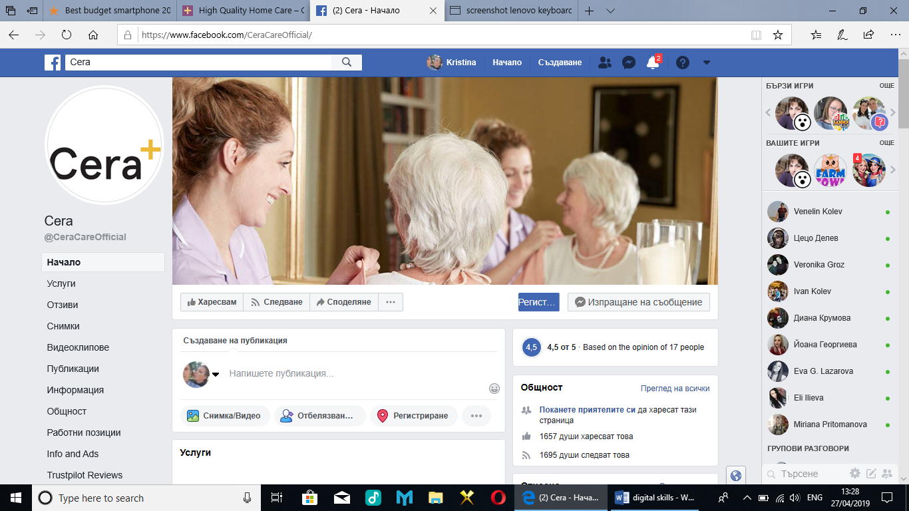
This is the Facebook page of one of the care homes in London. It shows us that is very popular home care because the followers are 1695 people. Feedback rate is good either. The customers, their families and even new coming staff can find information of a different nature- what is the working process, how important for them is the good relationships between clients and carers, what covers the personal assistance, etc. This home organizes social events for the people who lives there and carers and it makes their life pleasant and even fun. I think everyone who is looking for care home need of place like this. All care staff support costumers needs. Customers and their members can be involved in getting decisions for creating a workshop for Christmas or other big holiday, charity events for poor people or getting high technology equipment. This Facebook page can appeal companies for donations. In the other side the big and famous companies themselves contribute for effective advertising either. The more people see it, the more people will know and will look for this care service.

Evidence of own professional online presence

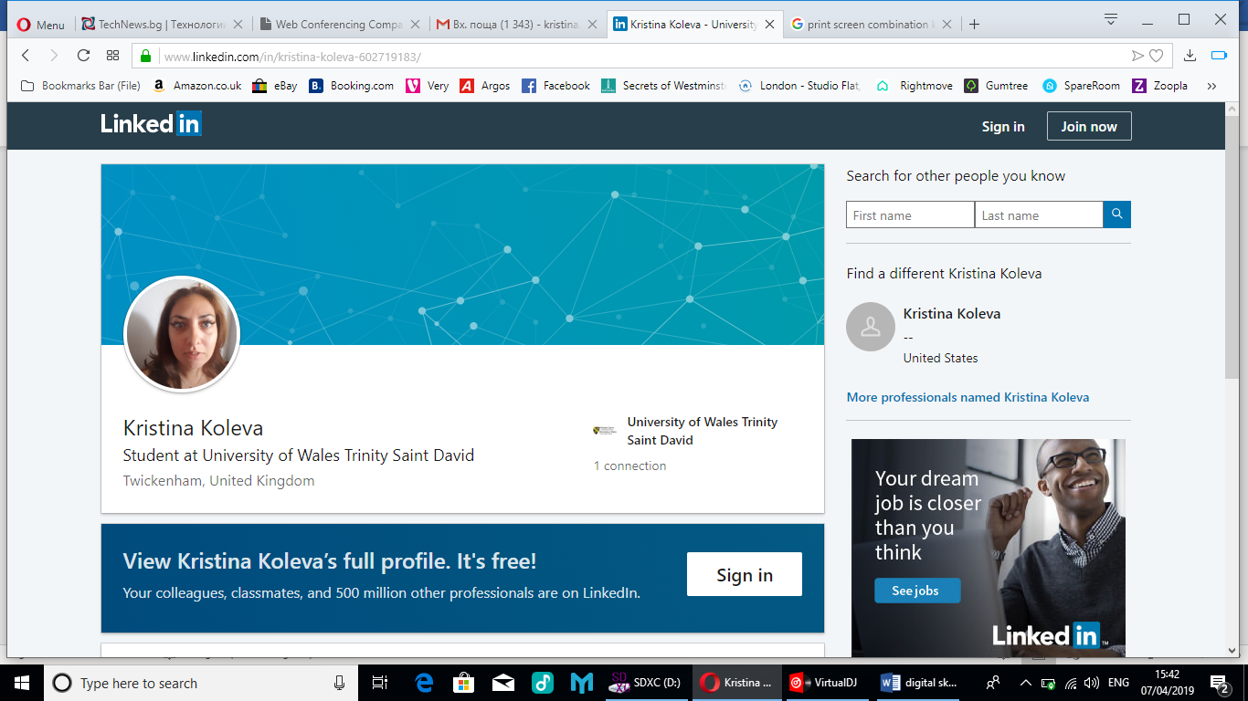
https://www.linkedin.com/in/kristina-koleva-602719183/

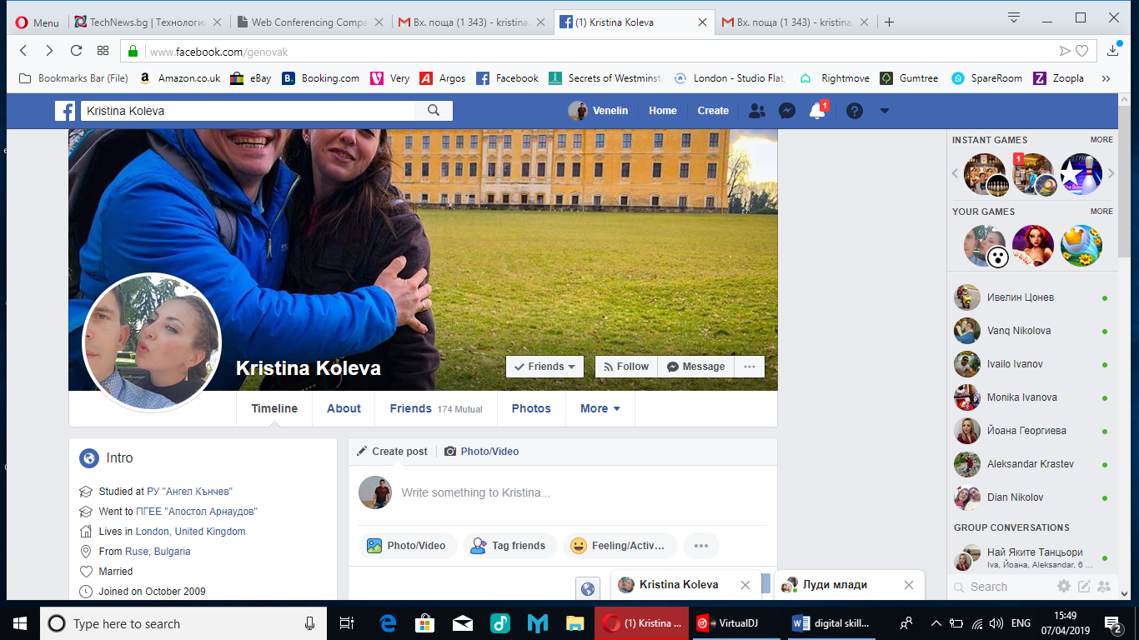
https://www.facebook.com/genovak?fref=pb&hc_location=friends_tab

https://twitter.com/KristinaKolev10
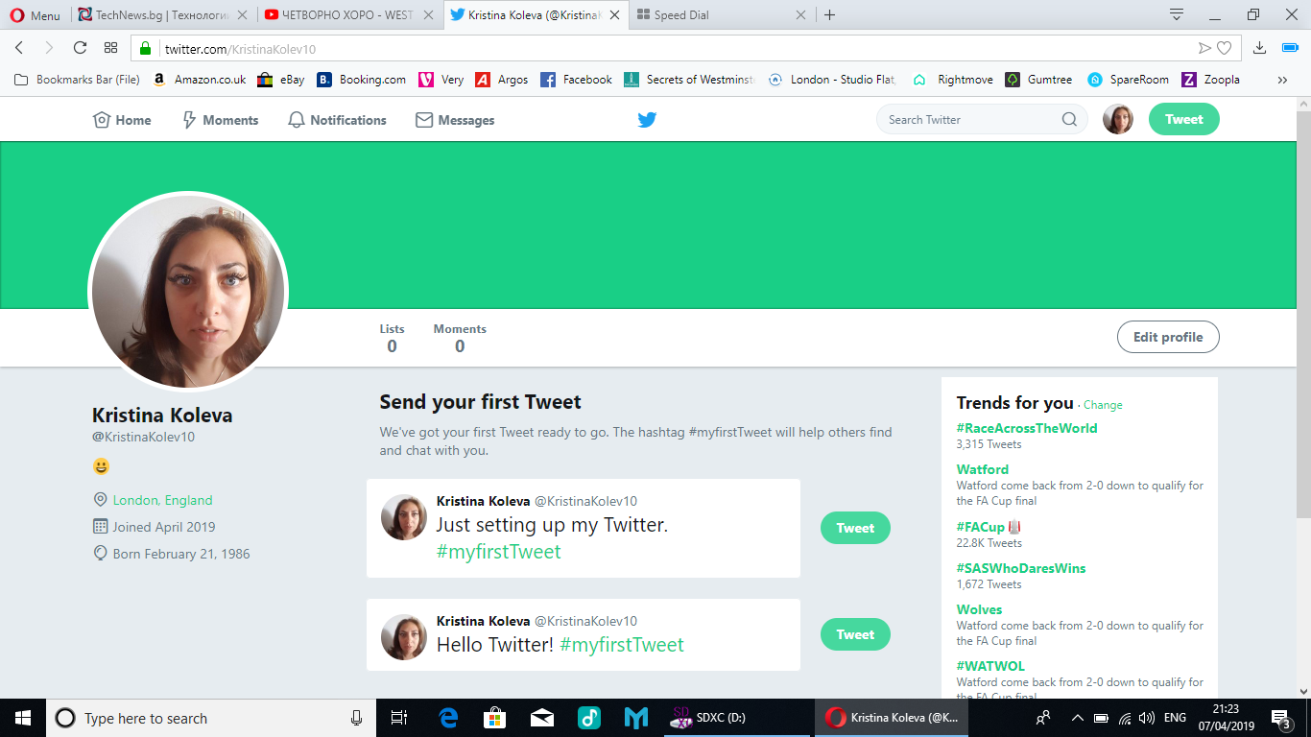

Referencing
Barker, S. (2018). The Importance of Digital Skills in the Workplace - Seetec. [online] Seetec.co.uk. Available at: https://www.seetec.co.uk/insights/the-importance-of-digital-skills-in-the-workplace [Accessed 29 Apr. 2019].
Gotomeeting.com. (n.d.). Easy Online Meetings With HD Video Conferencing | GoToMeeting. [online] Available at: https://www.gotomeeting.com/en-gb/lp/easy-online-meetings?c_name=Google_EMEA&c_date=Evergreen_Google&c_mark=EMEA_GB&c_prod=GTM&c_cell=Branded&c_kwd=gotomeeting-Exact&c_cmp=sf-701000000005nkQ&nst=0&ds_rl=1254899&ds_rl=1260006&gclid=Cj0KCQjwnpXmBRDUARIsAEo71tRlZ2BS7tRkFEzK1f1U79Ej_3MTcC6TExMOHLkocuzKHhjS6nSRUlAaAtCVEALw_wcB&gclsrc=aw.ds [Accessed 28 Apr. 2019]
Fernandes, T. and Pedroso, R. (2016). The effect of self-checkout quality on customer satisfaction and repatronage in a retail context. Service Business, 11(1), pp.69-92.
GONZALEZ, AGUSTIN L,O.D., F.A.A.O., 2018. Serve your patients, grow your practice with social media. Primary Care Optometry News, 23(8), pp. 11.
Goodman, P. (2019). 16 Advantages of Digital Technology. [online] TurboFuture. Available at: https://turbofuture.com/computers/Advantages-of-Digital-Technology [Accessed 4 Mar. 2019].
Hernandez, D., Thompson, N., Tiku, N., Simonite, T., Barber, G., Baker-Whitcomb, A. and Finley, K. (2013). How Facebook Is Transforming Science and Public Health. [online] WIRED. Available at: https://www.google.com/amp/s/www.wired.com/2013/02/how-facebook-is-changing-science-and-health-care/amp [Accessed 28 Apr. 2019].
Jack, E. (2012). The Benefits of Web Conferencing for the Healthcare Industry. [online] Info.infiniteconferencing.com. Available at: http://info.infiniteconferencing.com/bid/78385/The-Benefits-of-Web-Conferencing-for-the-Healthcare-Industry?fbclid=IwAR225NuD_3OOc6uYQ7KqgPbb-JPPjp2FagORgXAPBeWmQBcA46VNIhSFFsk [Accessed 28 Apr. 2019].
Janice (2017). The Pros and Cons of Web Conferencing | ezTalks. [online] Eztalks.com. Available at: https://www.eztalks.com/video-conference/pros-and-cons-of-web-conferencing.html [Accessed 128 Apr. 2019].
MARTIN, J.P., 2018. Skills for the 21st Century: Findings and Policy Lessons from the OECD Survey of Adult Skills. St. Louis: Federal Reserve Bank of St Louis
Self-service Options Coming to Patient Access? 2018.Hospital Access Management,37(7)
Skype.com. (2010). Skype for business - with security and control of Microsoft. [online] Available at: https://www.skype.com/en/business/ [Accessed 29 Apr. 2019]
Webconferencing.org. (2010). Web Conferencing Comparison » 5 Advantages of Web Conferencing. [online] Available at: http://webconferencing.org/5-benefits-of-web-conferencing/ [Accessed 28 Apr. 2019].
3CX. (n.d.). What is Web Conferencing. [online] Available at: https://www.3cx.com/global/gr/voip-sip-webrtc/web-conferencing/. [Accessed 29 Apr. 2019]

