Alexander Lemos (1917608)

Certificate in Higher Education

PRS
Problem Solving and Decision Making
(BMSW4004_LON)

Report on Problem Solving and Decision Making

Term 3 Group 2

Mr. Yahesh Kumar

April 2021

Table of Contents Page
- Introduction…………………………. 3
- Complex Problems………………… 3
- Swot Analysis………………………. 4
- PESTLE Analysis…………………... 5 & 6
- Fishbone Diagram………………….. 6 & 7
- Conclusion…………………………… 9
- References…………………………... 10-12

- Introduction

Booker Retail services is a food service and cash and carry company that serves over 400k clients (Wikipedia, 2021) in the UK and has over 20 000 products to choose from (Booker, 2021). Booker has over 120 years of experience in the food and beverage business and has several logistic warehouses in different parts of the UK. Booker was acquired by Tesco in 2017 for 3.7 billion pounds (Economicsonline,n.d). Booker was founded in 1835 and currently hires over 500 employees nationwide.

- Complex Problems
Booker like any other big company has issues and complex problems. The company is getting some dissatisfaction comments from some of its best clients because of poor stacking, missing items, and late arrivals.
Poor stacking- Items are either crushed or broken due to poor food handling. Some food pickers are piling heavy items such as butter on top of bread or milk when it should be the other way around to avoid these mishaps. These items are returned to our warehouse, causing losses and time and logistic problems, these items have to be resent to the client, and sometimes, all food has to be thrown into the bin.
Missing Items- This is also a major problem Booker is having with its clients. Many of our small Tesco’s are complaining they are not getting all the items they ordered. The company is looking deeply into it since it has a negative balance to Booker’s reputation. The company is finding out if our supplier is not sending the correct amount of items or pickers are putting these missing items in other Tesco’s food cages. The company is doing a comprehensive investigation to finish this issue, there are no definite answers nor solutions at this moment.
Late arrivals- As we all know the saying, ‘time is money, and it also applies to bookers. Food has to arrive at a certain time of the day, otherwise, it cannot be sold or it has to be thrown away. This is another issue Booker has to find a quick solution as soon as possible. Upper and middle management are right now struggling to sort these problems out. If they do not find swift and radical solutions immediately, there will be consequences and perhaps the closure of the warehouse located at Hemel Hempstead.
These are the solutions that will be put into place to sort these problems out:
• SWOT analysis
• PESTLE analysis and
• Fishbone diagram

- SWOT Analysis
The Swot analysis is a great tool to understand an organization as it helps to make decisions for all sorts of situations in a business (Morrison, 2016).
The SWOT analysis was created by Albert Humphrey in the 1960’s and early 1970’s. This analysis is divided in two segments:
- Internal- Strengths and Weaknesses these are related within the business.
- External- Opportunities and Threats these are related to factors that are outside the business (Business & IP centre, n.d).
With the SWOT analysis I will dive deep into the reason why of the poor stacking at our warehouse in Hemel Hempstead facilities.
Strengths Weaknesses
- Experience in Food and Beverage Untrained Workers
- Several warehouses in the UK No Weekends Off
- Good Pay Not Enough Workers
- Discounts at Tesco Stores No Chance to Escalate
- Training Available Waste of Food/Losses

Opportunities Threats
- Increase Number of Stores to Deliver Competition
- Customer Loyalty Cancellation of Contracts
- Excel to be ahead of the Competition Covid-19
- Consolidate the brand Name Brexit

Source: https://rapidbi.com/swotanalysis/
The SWOT analysis chart shows that poor stacking might be related to untrained staff, even though the training is available is either done late or not given at all. This issue needs immediate action. Also, the chart shows that there are not enough workers to perform good stacking, making employees rush leading to mistakes and underperformance.
- PESTLE Analysis
A PESTLE or PESTEL analysis is a tool to monitor macro-environmental factors that have a deep impact on a business. This tool is very useful when starting a new business or starting to expand foreign markets. It is often used with a SWOT analysis as well as Porter’s five forces to have a clear understanding of internal and external factor affecting a business (Business-to-you, 2016).
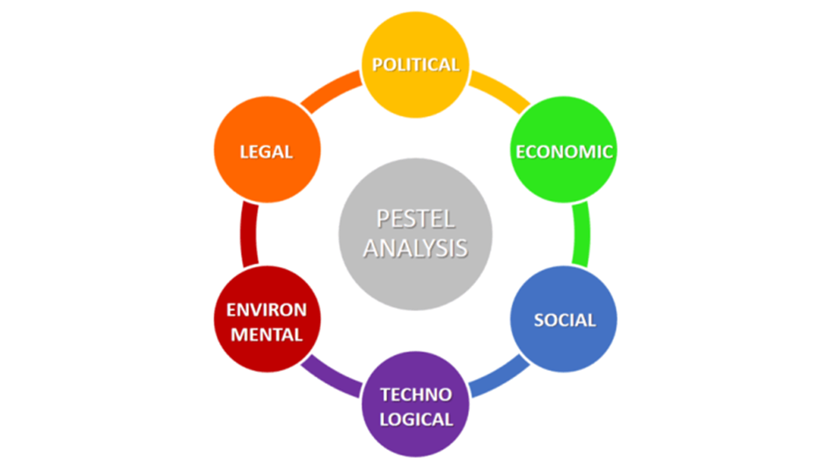
Image source: https://www.business-to-you.com/scanning-the-environment-pestel-analysis
This tool is very useful to analyse and monitor the macro-environmental factors that affect businesses.
The concept of PESTLE was first used by Francis Aguilar in 1967 (Lucidity, n.d).
With the PESTLE analysis, I will try to find out the problems that are causing complaints from stores about missing items or items not being delivered.
The acronym PESTLE stands for:
- P- Political- The UK has withdrawn from Europe’s single market.
- E- Economic- Economic growth has been negative -7.3% in the first quarter of 2021 and the unemployment rate is 5% (Trading Economics, 2021).
- S- Social- Population growth- The current population of U.K. in 2021 is 68,207,116, a 0.47% increase from 2020 (Macrotrends, 2021).
- T- Technological- Online shopping has grown exponentially during The COVID-19 pandemic. Although online shopping has increased the consumer spending has fallen (UNCTAD, 2020).
- L- Legal- Employment laws are enforced at my workplace, as well as, the discrimination and safety laws.
- E- Environmental- Recycling- Our Company encourages all clients to return plastic and cardboard to be baled at our warehouse.
The PESTLE analysis clearly shows the reason why clients are missing items in their shopping orders. The political and trading status of the UK towards the EU has changed because of Brexit. Food items are now more expensive to buy or they have to overcome more custom checks, making these items arrive late or being rejected by our supplier. Another reason might be the decreasing buying power of our clients, therefore changing the buying habits of many of our clients.

- Fishbone Diagram
The fishbone diagram or Ishikawa diagram or cause and effect diagram, this helpful too was designed by Kauru Ishikawa in the 1960s. This diagram helps to find out what is causing a problem and how to solve it (Mindtools, n.d).
This diagram consists of 3 categories:
- 6 M’s- Methods, Machines, Materials, Manpower, Measurement, and Management.
- 4 P’s- Place, Procedure, People, and Policies.
- 4 S’s= Surroundings, Suppliers, Systems, and Skills.
Once the company or business knows the problem they have to ask themselves- “Why is this happening?” When the company looks deep into the answers and sees that one item appears in more than one category it becomes one the “most likely cause”. After the problem has been spotted, the team trying to solve the issue should achieve unanimity on listing these problems in the right order of priority with the first item being “The most probable cause (Knowledgehills, n,d).
Missing Items
Measurement
Method
People
Receiving Untrained

Training Picking
Missing
Items
Bonus Demotivated Tired
Loading

Food Cold Broken Machine
Loud
Cages Lonely Glitches
Poor Maintenance
Materials
Environment
Machine

Image Source: https://asq.org/quality-resources/fishbone

The problem of missing items might be due to:
The lack of training- This is one of the major reasons why items are missing, new employees put items in any cage.
Broken machines (scanners) - Sometimes employees have to pick items manually, meaning without a scanner which induces human error.
Lack of bonuses- Employees feel unappreciated because they do not get any type of bonuses no matter how good they are doing their job.

Evaluating Solutions using PMI Techniques
PMI is a technique developed by Edward de Bono to find the following criteria:
- P- Positive points- list all positive points.
- M- Minus points- list all negative points.
- I- Interesting points- list all interesting points (JD, n.d).
Looking back at the 3 major problems in my workplace:
- Poor stacking
- Missing Items
- Late arrivals
I have come to the conclusion that poor training is the major factor affecting our company at this moment. Although lack of employees is also a problem our company should try first training employees and see in time if more people are needed. Results should be tracked on a weekly basis to either stick to just training or employing more people, depending on the outcome our company should act accordingly.
Training new and old employees
Plus Points | Minus Points | Interesting Points
Feeling Integrated | Pick-rate falls | Find employees weak/strong points
Less mistakes | Time consuming | Train employees in other areas
Less complaints | Loading might be delayed | Could save the company money
Less losses in the company | People not being trained are asked to pick more | Boost performance
Source: https://linapmichart.weebly.com/about-pmi-chart.html
The training of new employees should be tracked on a weekly basis using a Gantt chart. A Gantt chart is basically a project management tool that displays activities, tasks, and events in a period of time. Each activity is represented by a bar showing the start of a task and the end of it, as well as, the activity that was performed during that time. These are the benefits of using a Gantt chart:
- What activity is being performed
- Start and finish of the task
- How long this activity is supposed to last
- When activities overlap and by how much
- Start and end of the entire project
The benefits of using this tool are endless and can be changed when the activity is finished (Gantt.com, n.d).
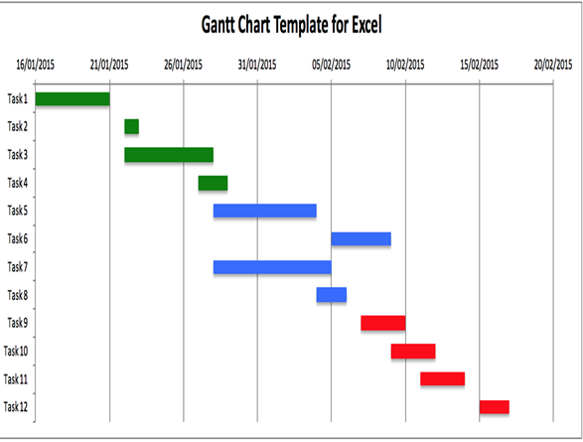
Source: Moodle week 8.3/ Implementation Plan (PRS)

Communication to Stakeholders
The stakeholders are the people that have an interest in the company that can be affected directly or indirectly depending on the company’s decisions. There are two types of stakeholders:
Primary stakeholders- Investors, employees, customers, suppliers, etc. These are considered primary stakeholders because they have a direct link to the company.
Secondary stakeholders- communities, local government, trade associations, work unions, etc. Secondary stakeholders do not have a direct link to the company but their decisions can affect the company, for example, recycling and pollution laws may affect the company directly (Fernando, 2021).
Our company should hold a meeting with all the employees, and management (primary stakeholders) to communicate the situation of the company. Also, tell everyone about the next steps the company is going to take. This is very important to let everyone know that without teamwork nothing can be accomplished. We all should make an effort to make the company profitable, otherwise, we are heading for closure if things do not take a dramatic turn for the best.
Recommendations
Create a two-way communication channel between employees and management to settle any misunderstandings or bad feelings about these changes. Management should monitor and review all procedures to find out exactly what the problem is. Like I said before, using the Gantt chart is a great way to monitor all employees, as well as, the performance of the company. Management should make adjustments to achieve the goal and inform all employees of any advances or drawbacks during the implementation of these new procedures.
- Conclusion
All companies have problems and are the duty of management, as well as, employees to overcome these problems. There is a myriad of problem-solving tools that have to be used in case a problem surges in the workplace. I have identified three major problems at my workplace. I have used three different ways of solving these problems to the best of my abilities. Although there are many more tools to accomplish this problem-solving task, I used the ones that I think are the best ones for this situation. To conclude, management and employees should be in a permanent two-communication system to tackle any problems or issues that may arise in any company. Once this is achieved, most problems can be solved.

- References

Booker (2021). Guide to the Booker Website.
Available at: https://www.booker.co.uk/content/pages/service/website-guide
(Accessed: March 15 20221).

Business & IP Centre, (n.d). Bright Ideas Inspiring People. - What is SWOT Analysis?
Available at: https://www.bl.uk/business-and-ip-centre/articles/what-is-swot-analysis#
(Accessed: March 30 2021).

Business-to-you, (2016). Scanning the Environment: PESTEL Analysis.
Available at: https://www.business-to-you.com/scanning-the-environment-pestel-analysis/
(Accessed: March 30 2021).

Economics online, (n.d). Tesco Buys Booker.
Available at: https://www.economicsonline.co.uk/Business_economics/Tesco_buys_Booker.html
(Accessed: March 15 2021).

Fernando, J., (2021). Stakeholder.
Available at: https://bit.ly/2Pedega
(Accessed: March 23 2021).

Gantt.com, (n.d). What is a Gantt Chart?
Available at: https://www.gantt.com/
(Accessed: March 23 2021).

JD, (n.d). How to Use the PMI Technique to Think Better.
Available at: https://sourcesofinsight.com/avoid-the-intelligence-trap/
(Accessed: March 22 2021).

Knowledgehills, (n.d). Fishbone Diagram – Fishbone Analysis- What is a Fishbone Diagram and Fishbone Analysis?
Available at: https://cutt.ly/qx5JKa3
(Accessed: March 20 2021).

Lucidity, (n.d). Introduction to PESTLE Analysis.
Available at: https://getlucidity.com/strategy-resources/introduction-to-pestle-analysis/
(Accessed: March 30 2021).

Macrotrends, (2021). U.K. Population Growth Rate 1950-2021.
Available at: https: https://bit.ly/32z725D
(Accessed: March 20 2021).

Mindtools, (n.d). Cause and Effect Analysis
Identifying the Likely Causes of Problems
Available at: https://cutt.ly/9x5RFcX
(Accessed: March 20 2021).

Morrison, M., (2016). SWOT Analysis (TOWS matrix) Made Simple.
Available at: https://rapidbi.com/swotanalysis/
(Accessed: March 20 2021).

Trading Economics (2021). United Kingdom GDP Annual Growth Rate.
Available at: https://tradingeconomics.com/united-kingdom/gdp-growth-annual
(Accessed: March 20 2021).

UNCTAD, (2020). COVID-19 Has Changed Online Shopping Forever, Survey Shows.
Available at: https://unctad.org/news/covid-19-has-changed-online-shopping-forever-survey-shows
(Accessed: March 20 2021).

Wikipedia (2021). Booker Group.
Available at: https://en.wikipedia.org/wiki/Booker_Group
(Accessed: March 15 2021).

