Problem Solving and Innovation
Table of Content
Student Name : Noemi Bagi
Student ID :2330383
Introduction 3
Introduction to SWOT analysis. 4
A summary of Starbucks 7
History of Starbucks 7
Current condition of Starbucks 8
Complete a SWOT analysis of Starbucks in the UK. 9
Recommendations 12
Conclusion 13
Reference list 14

Introduction
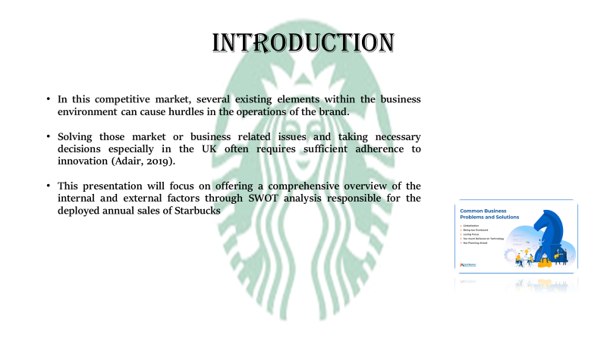
- In this competitive market, several existing elements within the business environment can cause hurdles in the operations of the brand.
- Solving those market or business related issues and taking necessary decisions especially in the UK often requires sufficient adherence to innovation (Adair, 2019).
- This presentation will focus on offering a comprehensive overview of the internal and external factors through SWOT analysis responsible for the deployed annual sales of Starbucks.
Along with those problem solving abilities are also needed. In the opinion of Proctor (2019), problem solving and decision making skills are collaborative factors that enable any manager or concerned business authorities to solve any business related issues while forming and implementing any business related ideas. Likewise, while observing the current sales depilation in Starbucks brand a comprehensive and detailed SWOT analysis can be a better solution to identify the issue.

Introduction to SWOT analysis.
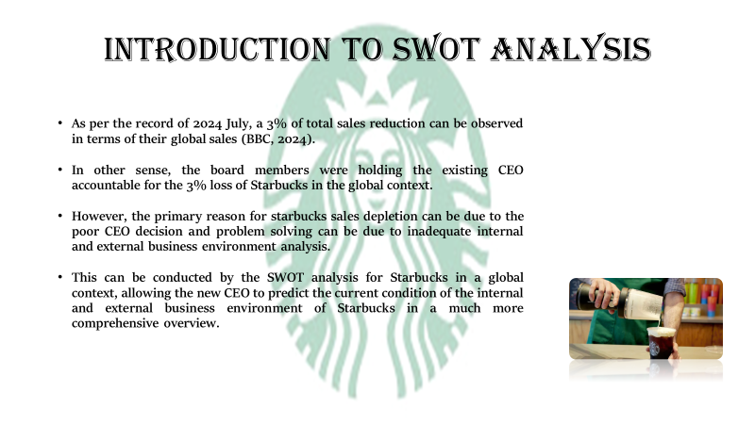
- As per the record of 2024 July, a 3% of total sales reduction can be observed in terms of their global sales (BBC, 2024).
- In other sense, the board members were holding the existing CEO accountable for the 3% loss of Starbucks in the global context.
- However, the primary reason for starbucks sales depletion can be due to the poor CEO decision and problem solving can be due to inadequate internal and external business environment analysis.
- This can be conducted by the SWOT analysis for Starbucks in a global context, allowing the new CEO to predict the current condition of the internal and external business environment of Starbucks in a much more comprehensive overview.
While observing the current intense competition across the food and beverage markets across the international market, it can be fair to claim that even for a renowned brand such as Starbucks, it can be challenging to sustain. As per the report of BBC in the year 2024, the Starbucks brand which is renowned and recognised across the globe to serve a luxurious and diverse coffee and beverage products has been currently facing certain loss in annual sales. Along with this, to tackle these sales depletion issues the board members of Starbucks have also aimed to replace the existing CEO with a new CEO (Brian Niccol) to retrieve from these losses in August 2024.
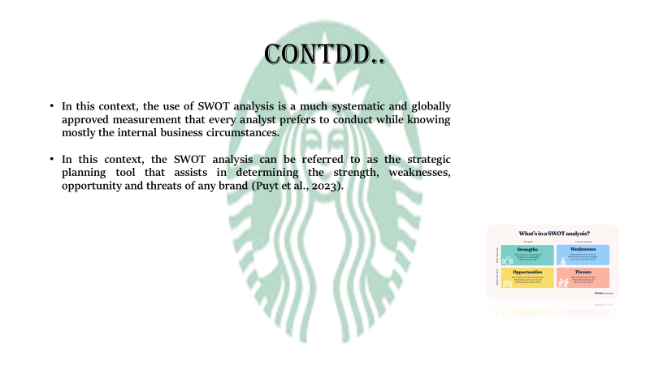
- In this context, the use of SWOT analysis is a much systematic and globally approved measurement that every analyst prefers to conduct while knowing mostly the internal business circumstances.
- In this context, the SWOT analysis can be referred to as the strategic planning tool that assists in determining the strength, weaknesses, opportunity and threats of any brand (Puyt et al., 2023).
However, as the globally recognised cafe Starbucks is facing 3% sales depletion, it is important to also adhere to the internal business environment using the SWOT to determine the exact areas to develop. In simple terms, the SWOT analysis is conducted by the Entrepreneurs and the business entities to identify their personal business traits and areas of issues to be adhered while operating in a competitive internal business. Likewise, using the SWOT analysis, the Starbucks not only can be aware of their current strengths but can also get acquainted with their consecutive weaknesses to develop.
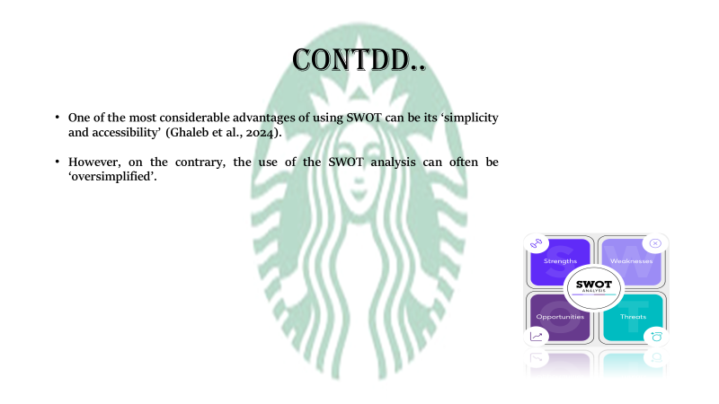
- One of the most considerable advantages of using SWOT can be its ‘simplicity and accessibility’ (Ghaleb et al., 2024).
- However, on the contrary, the use of the SWOT analysis can often be ‘oversimplified’.
The application of SWOT analysis often has various advantages and disadvantages. The application of SWOT is relatively much easier to implement and understand, allowing diversified knowledge and identification of the areas of issue causing 3% sales depletion in Starbucks. The use of the SWOT analysis due to its oversimplification may not capture adequate complex situations into account and may leave the new CEO unaware of the complex internal conductions.

A summary of Starbucks

History of Starbucks
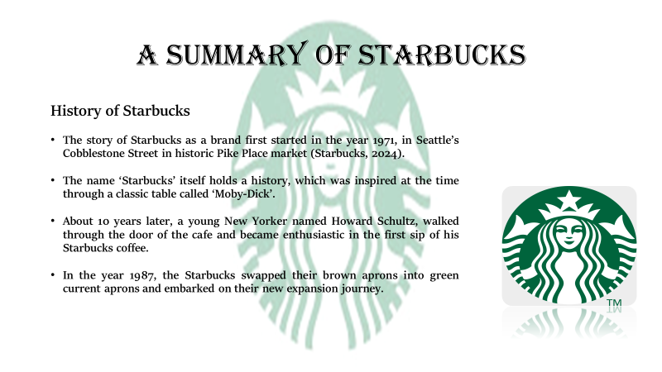
- The story of Starbucks as a brand first started in the year 1971, in Seattle’s Cobblestone Street in historic Pike Place market (Starbucks, 2024).
- The name ‘Starbucks’ itself holds a history, which was inspired at the time through a classic table called ‘Moby-Dick’.
- About 10 years later, a young New Yorker named Howard Schultz, walked through the door of the cafe and became enthusiastic in the first sip of his Starbucks coffee.
- In the year 1987, the Starbucks swapped their brown aprons into green current aprons and embarked on their new expansion journey.
This was the location that initiated and observed the first store of Starbucks coffee. The unique flavour and the first cafe store to offer the fresh-roasted coffee beans, tea and spices from around the globe. This beautiful essence of freshly roasted coffee beans and high and raw coffee products often makes this small outlet boost their local sales. The story is about an early coffee trader that inspired the owner of the small outlet and named it as Starbucks.
Later, Howard Schultz joined the company in the year 1982, and thus the starting of the development of Starbucks as a brand. Furthermore, in a trip to Milan, Spain in the year 1983, Howard Schultz was inspired by the cafe idea and came back to Seattle and strives to impose those artistic preferences in the formation of Starbucks. The brand after the year 1987, started expanding their global market journey, expanding initially into Chicago and Vancouver, Canada and then on to California, Washington, D.C. and New York. Aling with this, in 1996, Starbucks crossed the Pacific to open their first store in Japan followed by Europe in 1998 and China in 1999. The mission for this Starbucks remained the same uptill now. That is “With every cup, with every conversation, with every community - we nurture the limitless possibilities of human connection” (Starbucks, 2024).

Current condition of Starbucks
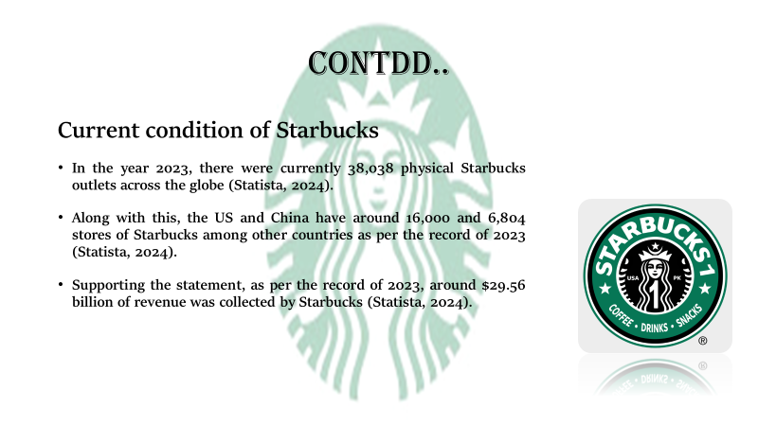
- In the year 2023, there were currently 38,038 physical Starbucks outlets across the globe (Statista, 2024).
- Along with this, the US and China have around 16,000 and 6,804 stores of starbucks among other countries as per the record of 2023 (Statista, 2024).
- Supporting the statement, as per the record of 2023, around $29.56 billion of revenue was collected by Starbucks (Statista, 2024).
In the current condition, with the starting of their international market expansion often encourages the authorities to keep on expanding and serving and revolutionising the tastes of premium coffee across the globe. Additional to this, it can also be considered that the Starbucks brand is most acknowledged due to their premiums and high quality coffee products and various beverage options, that certainly has created a market value leading to much higher annual revenue incomes. However, there is a rise in issues of current sales depilation of 3% globally, which often needs adequate decisions and problem solving attributes of the concerned CEO and higher authorities of Starbucks (BBC, 2024).

Complete a SWOT analysis of Starbucks in the UK.
Strengths
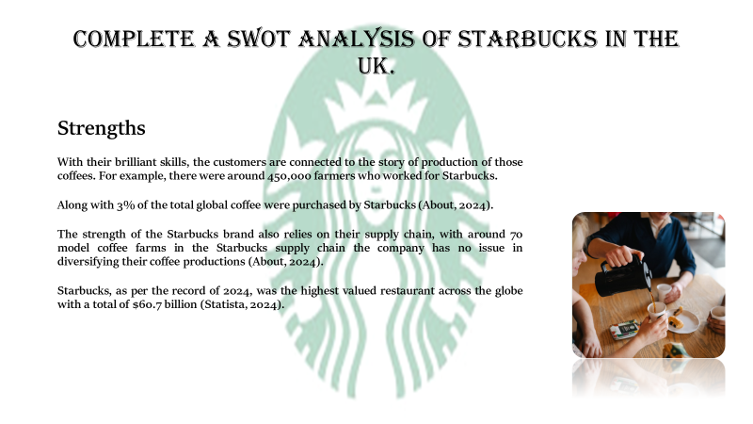
- With their brilliant skills, the customers are connected to the story of production of those coffees. For example, there were around 450,000 farmers who worked for starbucks.
- Along with 3% of the total global coffee were purchased by Starbucks (About, 2024).
- The strength of the Starbucks brand also relies on their supply chain, with around 70 model coffee farms in the Starbucks supply chain the company has no issue in diversifying their coffee productions (About, 2024).
- Starbucks, as per the record of 2024, was the highest valued restaurant across the globe with a total of $60.7 billion (Statista, 2024).
Weaknesses
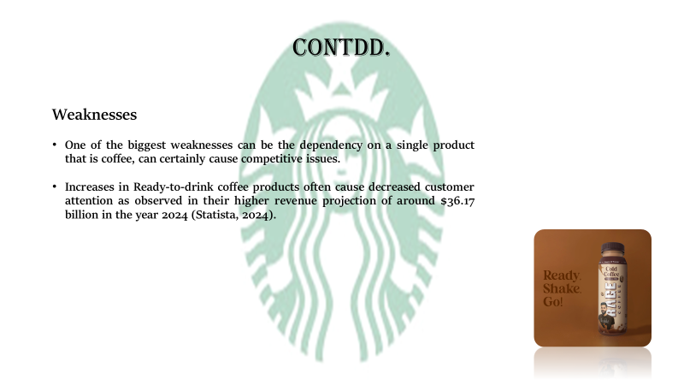
- One of the biggest weaknesses can be the dependency on a single product that is coffee, can certainly cause competitive issues.
- Increases in Ready-to-drink coffee products often cause decreased customer attention as observed in their higher revenue projection of around $36.17 billion in the year 2024 (Statista, 2024).
Opportunities
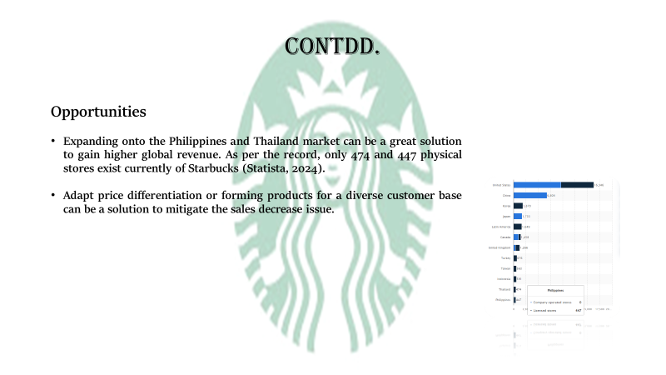
- Expanding onto the Philippines and Thailand market can be a great solution to gain higher global revenue. As per the record, only 474 and 447 physical stores exist currently of Starbucks (Statusta, 2024).
- Adapt price differentiation or forming products for a diverse customer base can be a solution to mitigate the sales decrease issue.
Threats
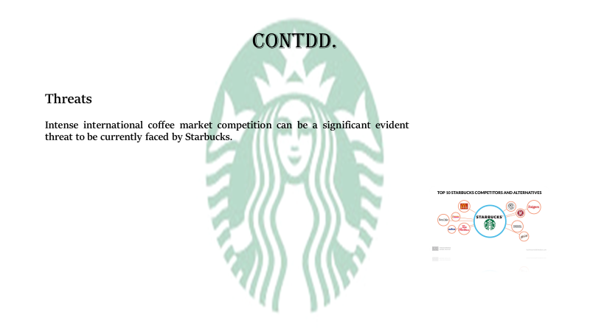
- Intense international market competition can be a significant evident threat to be currently faced by Starbucks.

Recommendations
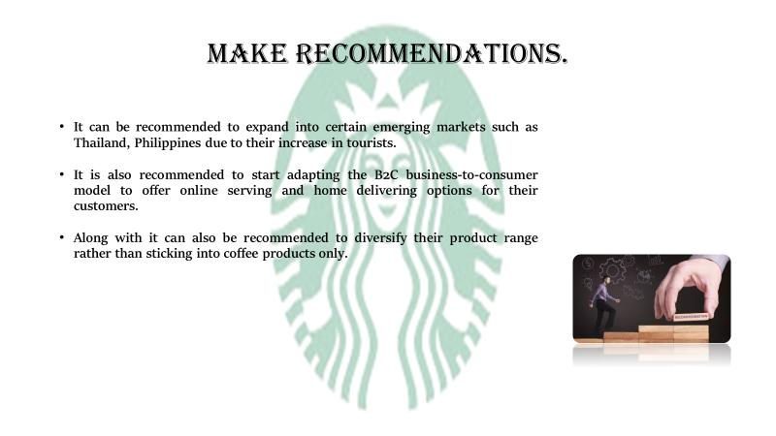
- It can be recommended to expand into certain emerging markets such as Thailand, Philippines due to their increase in tourists.
- It is also recommended to start adapting the B2C business-to-consumer model to offer online serving and home delivering options for their customers.
- Along with it can also be recommended to diversify their product range rather than sticking into coffee products only.

Conclusion
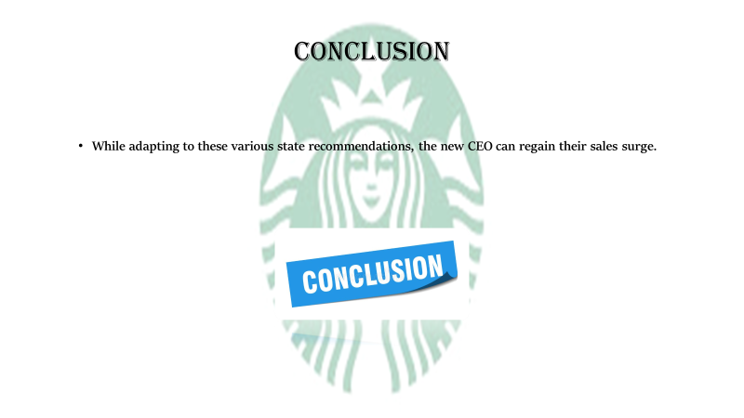
- While adapting to these various state recommendations, the new CEO can regain their sales surge.
Along with this, it can allow the concerned authorities of the Starbucks to not only develop their marketing but also diversify their production line up. Mitigating those issues and solving those market issues is something challenging even for any established business like Starbucks.

Reference list
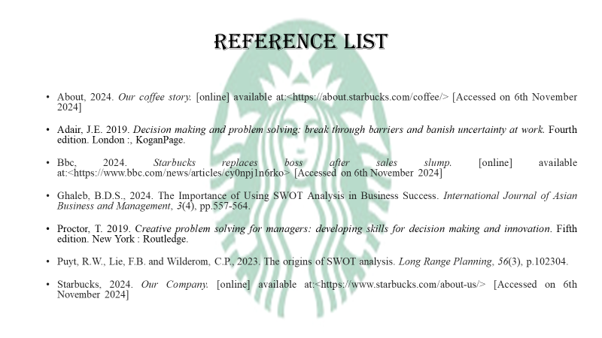
About, 2024. Our coffee story. [online] available at:<https://about.starbucks.com/coffee/> [Accessed on 6th November 2024]
Adair, J.E. 2019. Decision making and problem solving: break through barriers and banish uncertainty at work. Fourth edition. London :, KoganPage.
Bbc, 2024. Starbucks replaces boss after sales slump. [online] available at:<https://www.bbc.com/news/articles/cy0npj1n6rko> [Accessed on 6th November 2024]
Ghaleb, B.D.S., 2024. The Importance of Using SWOT Analysis in Business Success. International Journal of Asian Business and Management, 3(4), pp.557-564.
Proctor, T. 2019. Creative problem solving for managers: developing skills for decision making and innovation. Fifth edition. New York : Routledge.
Puyt, R.W., Lie, F.B. and Wilderom, C.P., 2023. The origins of SWOT analysis. Long Range Planning, 56(3), p.102304.
Starbucks, 2024. Our Company. [online] available at:<https://www.starbucks.com/about-us/> [Accessed on 6th November 2024]
Statista, 2024. Global revenue of Starbucks 2003-2023. [online] available at:<https://www.statista.com/statistics/266466/net-revenue-of-the-starbucks-corporation-worldwide/> [Accessed on 6th November 2024]
Statista, 2024. Most valuable restaurant brands worldwide 2024. [online] available at:<https://www.statista.com/statistics/407892/brand-value-of-the-leading-global-fast-food-brands/> [Accessed on 6th November 2024]
Statista, 2024. Ready-to-Drink (RTD) Coffee - Worldwide. [online] available at:<https://www.statista.com/outlook/cmo/non-alcoholic-drinks/ready-to-drink-rtd-coffee-tea/ready-to-drink-rtd-coffee/worldwide> [Accessed on 6th November 2024]
Statista, 2024. Selected countries with the largest number of Starbucks stores worldwide as of October 2023. [online] available at:<https://www.statista.com/statistics/306915/countries-with-the-largest-number-of-starbucks-stores-worldwide/> [Accessed on 6th November 2024]
Statista, 2024. Total Starbucks locations globally 2003-2023. [online] available at:<https://www.statista.com/statistics/266465/number-of-starbucks-stores-worldwide/#:~:text=There%20were%2038%2C038%20Starbucks%20stores,over%20the%20past%20twenty%20years.> [Accessed on 6th November 2024]

