✈️ Travel the World While Boosting Your Career – with Funding Available! 🌍

Ever dreamed of taking your studies global? 🌎 With UWTSD International Opportunities, you can gain international experience next summer — and with funding support available for travel and living costs, it’s more affordable than ever!
Check out the exciting opportunities for Summer 2026 👇

🍁 Camp Kodiak, Canada
A unique summer camp for children & teens with & without learning differences (LD, ADHD, ASD Level 1).
📅 19 June – 17 August 2026
💰 Paid placement (meals & accommodation included)
🔗 Applications open 10 October 2025
👉 Apply to Camp Kodiak
💬 “Best summer ever—I grew in confidence and made lifelong friends while supporting amazing young people.” – Former UWTSD Student

🌆 Absolute Internship
Launch your career with international internships in industries from Fashion 👗 to Engineering ⚙️, Marketing 📈 to Law ⚖️.
✨ NEW for 2026 – 2 Week Programmes
📍 Seoul (K-POP & Fashion) | Barcelona (Business & Innovation)
📅 27 June – 11 July 2026
💰 £2,219 (accommodation, programme, visits included – flights & meals extra)
🌍 1–3 Month Internships
📍 Global cities like London, Tokyo, Paris, Singapore & New York
💰 £3,500–£6,000 (includes accommodation, placement, cultural activities & career workshops)
👉 Explore Absolute Internship
💬 “My internship abroad gave me global insight and professional confidence—life-changing!”

🌺 Think Pacific Expeditions & Internships
Make an impact while exploring the South Pacific & Asia!
🌴 1-Month Expeditions
📍 Fiji (£2,145) | Bali (£1,895) | Thailand (£1,895)
🌱 Youth empowerment, education, sustainability, sports, mental health & more
⏳ NEW 14-Day Projects
📍 Bali & Thailand (£1,200 all-inclusive)
Fiji Projects (1-month Expedition: £2,145)
• Youth Empowerment Projects (covering public health, mental health, sports development, environment, and enterprise)
• Global Team Internships
• Community Build Project
• Sports Development Projects
• Mental Health Projects
Bali Projects (1-month: £1,895)
• Global Team Internship
• Education Project
• Mental Health Project
Thailand Projects (1-month: £1,895)
👉 Join Think Pacific
💬 “Think Pacific gave me the chance to contribute to real community projects and grow my career skills.”

📚 Copenhagen Business School (CBS)
Study at one of Europe’s leading business schools while living in Copenhagen!
📚 3-week or 6-week courses (7.5 ECTS each)
📅 June – July 2026
🌍 Gain credit + cultural experiences in Denmark
👉 Discover CBS Summer University

✅ Ready to Go Global?
Don’t miss your chance to travel, grow, and gain experience this summer — with financial support available through UWTSD!
👉 Contact the International Opportunities Team today for advice on funding and applications.
✉️ goglobal@uwtsd.ac.uk
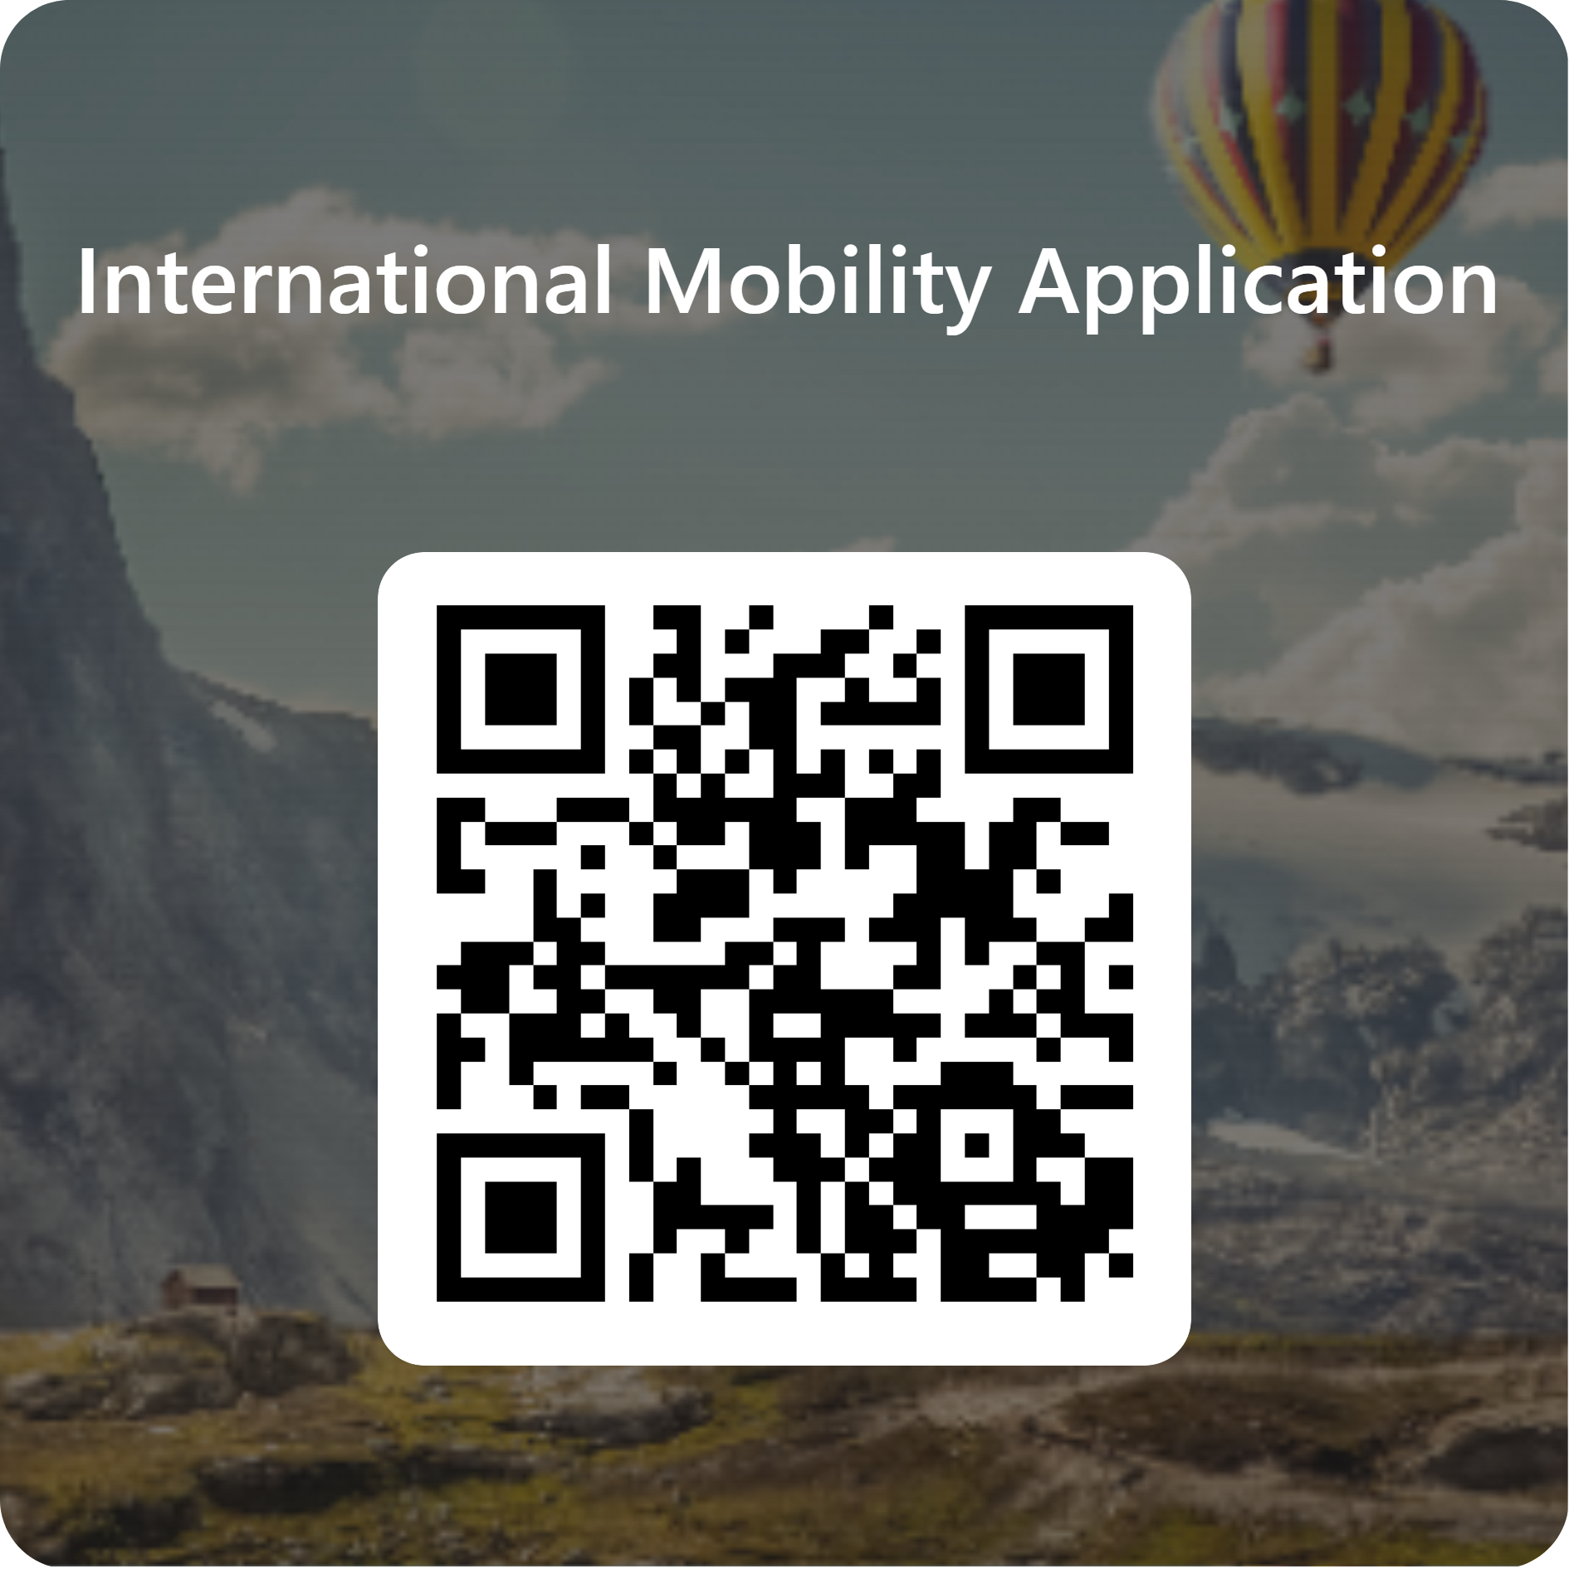

✈️ Teithio’r Byd wrth Hybu’ch Gyrfa – gyda Chyllid ar Gael! 🌍
Wedi breuddwydio erioed am fynd â’ch astudiaethau’n fyd-eang? 🌎 Gyda Chyfleoedd Rhyngwladol UWTSD, gallwch ennill profiad rhyngwladol yr haf nesaf — ac, gyda chefnogaeth ariannol ar gael ar gyfer costau teithio a byw, mae’n fwy fforddiadwy nag erioed!
Edrychwch ar y cyfleoedd cyffrous ar gyfer Haf 2026 👇

🍁 Camp Kodiak, Canada
Gwersyll haf unigryw i blant a phobl ifanc gyda neu heb wahaniaethau dysgu (LD, ADHD, ASD Lefel 1).
📅 19 Mehefin – 17 Awst 2026
💰 Lleoliad taledig (prydau bwyd a llety wedi’u cynnwys)
🔗 Ceisiadau’n agor 10 Hydref 2025
👉 Gwnewch gais i Camp Kodiak
💬 “Haf gorau erioed—tyfais mewn hyder a wnes i ffrindiau oes wrth gefnogi pobl ifanc anhygoel.” – Cyn-fyfyriwr UWTSD

🌆 Absolute Internship
Cychwynwch eich gyrfa gyda interniaethau rhyngwladol mewn diwydiannau o Ffasiwn 👗 i Beirianneg ⚙️, Marchnata 📈 i Gyfraith ⚖️.
✨ NEWYDD ar gyfer 2026 – Rhaglenni 2 Wythnos
📍 Seoul (K-POP & Ffasiwn) | Barcelona (Busnes ac Arloesedd)
📅 27 Mehefin – 11 Gorffennaf 2026
💰 £2,219 (llety, rhaglen, ymweliadau wedi’u cynnwys – hediadau a phrydau bwyd yn ychwanegol)
🌍 Interniaethau 1–3 Mis
📍 Dinasoedd byd-eang fel Llundain, Tokyo, Paris, Singapore a Efrog Newydd
💰 £3,500–£6,000 (yn cynnwys llety, lleoliad, gweithgareddau diwylliannol a gweithdai gyrfa)
👉 Archwiliwch Absolute Internship
💬 “Rhoddodd fy interniaeth dramor weledigaeth fyd-eang a hyder proffesiynol i mi—newid bywyd!”

🌺 Think Pacific – Anturiaethau ac Interniaethau
Gwnewch effaith wrth archwilio’r De Môr Tawel ac Asia!
🌴 Anturiaethau 1 Mis
📍 Fiji (£2,145) | Bali (£1,895) | Gwlad Thai (£1,895)
🌱 Grymuso pobl ifanc, addysg, cynaliadwyedd, chwaraeon, iechyd meddwl a mwy
⏳ NEWYDD – Prosiectau 14 Diwrnod
📍 Bali a Gwlad Thai (£1,200 popeth wedi’i gynnwys)
Prosiectau Fiji (Anturiaeth 1 mis: £2,145)
• Prosiectau Grymuso Ieuenctid (yn cwmpasu iechyd cyhoeddus, iechyd meddwl, datblygiad chwaraeon, yr amgylchedd a mentergarwch)
• Interniaethau Tîm Byd-eang
• Prosiect Adeiladu Cymunedol
• Prosiectau Datblygu Chwaraeon
• Prosiectau Iechyd Meddwl
Prosiectau Bali (1 mis: £1,895)
• Interniaeth Tîm Byd-eang
• Prosiect Addysg
• Prosiect Iechyd Meddwl
Prosiectau Gwlad Thai (1 mis: £1,895)
👉 Ymunwch â Think Pacific
💬 “Rhoddodd Think Pacific y cyfle i mi gyfrannu at brosiectau cymunedol go iawn a datblygu sgiliau gyrfa.”

📚 Ysgol Fusnes Copenhagen (CBS)
Astudiaethwch mewn un o ysgolion busnes blaenllaw Ewrop wrth fyw yng Nghopenhagen!
📚 Cyrsiau 3 wythnos neu 6 wythnos (7.5 ECTS yr un)
📅 Mehefin – Gorffennaf 2026
🌍 Ennill credyd + profiadau diwylliannol yn Nenmarc
👉 Darganfyddwch Brifysgol Haf CBS

✅ Yn Barod i Fynd yn Fyd-eang?
Peidiwch â cholli’ch cyfle i deithio, tyfu, ac ennill profiad yr haf hwn — gyda chefnogaeth ariannol ar gael drwy UWTSD!
👉 Cysylltwch â’r Tîm Cyfleoedd Rhyngwladol heddiw am gyngor ar gyllid a cheisiadau.
✉️ goglobal@uwtsd.ac.uk

