

The dark web: discovering criminal actions and difficulties faced by the Police.

Name: Patryk Juraszek
Student number: 2236191
Degree: Professional Policing
Word Count: 7358

Declaration
This work has not previously been accepted in substance for any degree and is not being concurrently submitted in candidature for any degree.
Signed: Patryk Juraszek
Date: 06/10/2025

STATEMENT 1
This dissertation is being submitted in partial fulfilment of the requirements for the degree of BA.
Signed: Patryk Juraszek
Date: 06/10/2025

STATEMENT 2
This dissertation is the result of my own independent work/investigation, except where otherwise stated.
Other sources are acknowledged by footnotes giving explicit references. A bibliography is appended.
Signed: Patryk Juraszek
Date: 06/10/2025

STATEMENT 3
I hereby give consent for my dissertation, if accepted, to be available for photocopying and for interlibrary loan, and for the title and summary to be made available to outside organisations.
Signed: Patryk Juraszek
Date: 06/10/2025

STATEMENT 4
I hereby give consent for my dissertation, if accepted, to be available on the university’s IT system to those who have consent to use the system.
Signed: Patryk Juraszek
Date: 06/10/2025

Abstract
This dissertation aims to provide research into dark web and the internet. This research was conducted due to growing issues where the internet is being used to commit crime especially as the internet is hugely accessible to most people around the world.
The research within this dissertation aims to understand the views of Police officers who may be or have dealt with crime committed via the internet as well as members of the public who may have been a victim of crime committed online. The research also aims to understand greater safety issues and what risk it poses to people, with limited knowledge about dark web, why people access it and how the dark web is commonly used.
This dissertation has set out objectives which are:
To analyse how cybercrime affects Policing.
To compare the perception of what impact cybercrime has on Police officers.
To examine how cybercrime affects the public.
To develop guidance to address the cybercrime.

Table of Contents
1.Chapter One – Introduction………………………………………………………………………………………………6
1.1 Research…………………………………………………………………………………………………………………………7
1.2 Ethical Issues…………………………………………………………………………………………………………………..7
2.Chapter Two: Literature Review……………………………………………………………………………………..…7
2.1 Introduction……………………………………………………………………………………………………………………7
2.1.1 Layers of the internet…………………………………………………………………………………………………..8
2.2 – The dark web……………………………………………………………………………………………………………….8
2.2.1 – Issues for investigating officers…………………………………………………………………………………9
2.2.2 – The functions of the dark web…………………………………………………………………………………..9
2.2.3 – The dark web, children and young people………………………………………………………………10
2.2.4 – The dark web growth………………………………………………………………………………………………10
2.2.5 – Dark web, Law enforcement success………………………………………………………………………11
2.3 – The onion router………………………………………………………………………………………………………..11
2.4 – Artificial Intelligence…………………………………………………………………………………………………..11
2.4.1 – Law enforcement advantage using artificial intelligence…………………………………………12
2.5 – Conclusion………………………………………………………………………………………………………………….12
3.Chapter Three: Research Methods…………………………………………………………………………………..13
3.1 Introduction………………………………………………………………………………………………………………….13
3.1.1 – Research Questions…………………………………………………………………………………………………13
3.2 – Mythology………………………………………………………………………………………………………………….13
3.2.1 – Expectations……………………………………………………………………………………………………………13
3.2.1 – Preparation for recommendations………………………………………………………………………….14
3.3 – Data Collection…………………………………………………………………………………………………………..14
4.Chapter Four – Data Analysis…………………………………………………………………………………………..15
4.1 – Introduction……………………………………………………………………………………………………………….15
4.2 – What is data analysis………………………………………………………………………………………………….15
4.3 – Participants………………………………………………………………………………………………………………..15
4.4 Questionnaire Findings…………………………………………………………………………………………………16
4.4.1 - Level of familiarity with the dark web………………………………………………………………………16
4.4.2 – Accessing the Dark Web………………………………………………………………………………………….16
4.4.3 - Most significant challenge for law enforcement agencies in policing the dark web and responders’ opinion……………………………………………………………………………………………………………17
4.4.4 – Dark web and risk to National security……………………………………………………………………18
4.4.5 – Reporting suspicious dark web activity to Law enforcement…………………………………..18
4.4.6 – Types of crime most prevalent on Dark Web…………………………………………………………..18
4.4.7 – Resources of Law enforcement to police the Dark Web………………………………………….19
4.4.8 – Responders thought on the most effective way to combat dark web crimes…………..19
5.Chapter Five – Conclusion……………………………………………………………………………………………….20
5.1 Introduction………………………………………………………………………………………………………………….20
5.2 – Objective 1, To analyse how cybercrime affects Policing……………………………………………20
5.3 – Objective 2, To compare the perception of what impact cybercrime has on Police officers……………………………………………………………………………………………………………………………….21
5.4 - To examine how cybercrime affects the public…………………………………………………………..21
5.5 - To develop guidance to address the cybercrime…………………………………………………………21
5.6 – Conclusion………………………………………………………………………………………………………………….22
5.7 – Recommendations……………………………………………………………………………………………………..23
6 – Bibliography………………………………………………………………………………………………………………….24
7 – Appendix………………………………………………………………………………………………………………………27

- Chapter One – Introduction
The web or surface web as it is commonly known, is easily accessed by any person with internet access, is used on a daily basis and is where common websites can be found. However, there is also a deep web which sits underneath the surface web and contains content and websites which require logins. This includes sites such as online banking, social media and subscription services such as Netflix or Spotify. The dark web then sits below the deep web, which contains sites which are well hidden and can only be accessed by a specially designed browser software, which is capable of making its users anonymous to other people as well as the police. Using the dark web software isn’t illegal itself as it has legitimated and approved uses. Due to the software capability of making the users anonymous, it makes it difficult to identify if a crime is being committed and by who. (College of Policing, 2024).
A lot of the dark web users conceal their identities by using nicknames from social media websites; however some users take more steps to conceal their identity by using more advanced software, which grants them with more protection of finding out who they are. The most favoured software used to conceal identities is The Onion Router known as ‘TOR’. It is roughly calculated that around 2.5 million people use the software worldwide. A lot of the TOR users, use it to go online anonymously to use the service web. TOR can be used for many different things such as bypassing the internet censorship or for file sharing. TOR also allows its users to post anonymously through “TOR Hidden Services” also known as ‘THS’. THS is commonly used by criminals as it allows them to sell drugs, weapons and even child pornography on websites which look and are laid out in a format much like eBay. (UK Parliament 2015).
To identify a suspect online, it is necessary to trace and obtain their internet protocol address also known as IP address. However, this may not be possible if the suspect had accessed the dark web using the TOR website software. In the past the dark web was illustrated as out of reach for Police and other law enforcement agencies as the criminals were protected by a cover of technology which provided them with anonymity, but this is no longer the case. The Police all over the world and in the UK have come up with a range of processes to identify the criminals to arrest and convict drug dealers, weapon buyers, terrorists, child pornographers and other criminals. Some of the processes and techniques used by the Police are not known to the public, however one that the Police is known to use is Open-Source intelligence in all cyber investigations. Open-Source intelligence also known as OSINT is data that is collected legally from public sources. The information gathering is not required in covert or secret effort to get it and is gathered in a legal manner which also meets the copyright requirements. The Police are hunting and following the OSINT sources with small fragments of information which fit together like pieces of a puzzle. Once all or partial pieces of information are put together, they are analysed and with the information gathered may help in uncovering the true identities of the criminals. The pieces of information are usually left on open sources due to errors of the criminals. (The Journal of Criminal Law, 2020).

1.1 Research
The research study will use articles from websites found online such as government articles and journals to obtain as much information possible. The best way to research the internet is the internet itself. Due to rising criminality committed online, most sources and research is published online. However, the research in this study will also include primary research, which will be obtained by asking the police officers and members of the public questions relating to the dark web and criminality committed online. This will be obtained through questionnaire format. The research will aim to provide the questions to around 50 – 100 participants. By carrying out research via a questionnaire it will reveal how the topic is seen from different perspectives and check the knowledge of the participants. The questionnaire will be carried out anonymously which will promote honest answers. However, one issue with this is due to the questionnaire being anonymous and shared online, any persons will have access to it, which may not show true data of the understanding of the dark web compared to those who answered honestly. Another issue could be people who received the link to the questionnaire not answering the questions due to lack of time or other personal reasons.
1.2 Ethical Issues
There are ethical issues identified within this study. There may be questionnaire participants who have no knowledge about the dark web at all and may feel embarrassed to answer the questions honestly, therefore it will be ensured the participants are fully aware that the questionnaire is fully anonymous and not at any point during the questionnaire their details will be asked from them. This also means that the participants are protected, and no danger is posed to them. Due to questionnaire being available to anyone online, some of the participants views on the dark web may be found controversial to others. To minimise risk of bias, the research will be carried out by researching and evaluating the academic and non-academic sources on the topic of the dark web to see perspectives from all and that the research remains impartial at all times.

- Chapter Two: Literature Review
2.1 Introduction
The Internet made a massive difference around the world and to people by giving more possibilities and abilities. The Internet made it easier to access information and provided an easier way of communication between people. Since the start of 2025 it is estimated that 5.56 billion people globally are connected to the internet, which is around 67.9% of the world's population (DataReportal, 2025).
The Internet continually shapes and develops the world in ways we never thought possible. It made it easier to carry out research, learn, communicate, make purchases and keep on top with the latest news storeys from around the world. The Internet is monitored and protected from undertaking activities which could be harmful to its users. IP addresses make it easier to identify criminal activities happening on the internet. The Internet Service providers and the network admins can check and monitor the traffic online and secure it if needsed, but this is not always the case, and the protection is not always guaranteed and is only made certain for a small part of the internet which is accessible to the public (Saleh. H, 2023).
2.1.1 Layers of the internet
There are three layers to the internet, and they are frequently referred to as Surface Web, Deep Web and Dark Web. Surface Web is accessible and available to the general public. The users can access Surface Web on day-to-day basis by using standard website browsers such as Mozilla Firefox, Microsoft’s Internet Explorer and Google Chrome. The Deep Web on the other hand is the part of the internet that is not listed and cannot be search or accessed by the standard internet browsers. To access the Deep Web the users must log in or have access to a specific Uniform Resource Locator (URL) or IP address to access a specific website. Some pages that are available to the general public are part of Deep Web, but they do not use domains such as .com, .gov or .UK, so they are not easily found by the internet browsers commonly used. A lot of Deep Web websites contain data that work as a back up to the services general public use every day. Those services could be social media or banking websites. And lastly there is Dark Web, which is harder to access, and it is a small fragment of the Deep Web (CIS, 2025).
2.2 – The dark web
The Dark Web is an internet network of websites which are encrypted with hidden websites, chatrooms and marketplaces which can only be accessed using unique software. The most common software to access the hidden websites is TOR. The dark web is dangerous and became a breeding ground for criminals who are trolls, child pornographers, drug dealers, hackers, political extremists, computer scientists, Bitcoin programmers, self-harmers and vigilantes, which lacks accountability. The Police and other law enforcement agencies globally are facing extreme challenges when it comes to investigating the dark web. The Dark Web forums and marketplaces repeatedly disappear or change making it harder to gather information and evidence. (Bartlet, 2015).
Being anonymous on the dark web and advanced encryption attributes make it very difficult for Police and other law enforcement agencies to uncover and point out criminal responsible for criminal activities online (Christin, 2013). The use of cryptocurrency namely Bitcoin makes it a lot more difficult and complex for the investigators who investigate criminal activity. Machine learning and deep learning techniques are used in financial areas to aid trading such as mobile banking, payments and making credit decisions. These techniques play an important part in tackling financial crime, cyberattacks and fraud. The online financial crime is becoming more common and is increasing. The criminals are using a mixture of hacking and social engineering methods which are capable of working around financial and corporate security. (Le-Khac et al. 2022).

2.2.1 – Issues for investigating officers
The bigger issue lays with the investigating officers not understanding the dark web and how it works. Due to this, the criminals use it to their advantage. Criminal investigators frequently overlook the remnant of data left behind by the criminals. The data may include cryptocurrency wallets, encryption keys, or dark web addresses which can be followed back to the source. However, the encryptions and the anonymity that shields the criminals from the investigators make it so much harder to piece the data together to identify and to prove who is behind a crime. (Goodison, S. et al. 2019). Further issues appear when criminal activity takes place where numerous countries and involved making it tough for Police and other agencies to organise and correlate their resources to gather information and evidence across borders. (Europol, 2024).
Resource limitations such as funding and shortage of staffing is an enormous setback for the Police and other law enforcement agencies as it curbs their facility to gather information and commit officers to investigate the Dark Web. (FBI, 2024). The Dark Web is also very complicated and consists of an evolving environment where new technologies and websites are being created persistently (Dupont et al. 2024). Due to the Dark Web’s complexity, the immense volume of criminal activities on the dark web can make it challenging and difficult for Police and other law enforcement agencies to highlight, pick out and concentrate on targets (Broadhurst et al., 2014).
Although countless types of dark web criminality have a need of great extent of organization and specification, there is not enough evidence to suggest that cybercrime is at present under control of organized criminal groups. (Broadhurst, R. et al., 2014). The technology has given individual person a lot of power whereby teenagers managed to disable air traffic control, disable major retailers and manipulate trades. What a single person can do, the organizations can also do and more often a lot better. An organised crime group could be structured of lawless IT masters. The organised crime group could engage is a short-lived project that targets certain online crime, victim or group. This may also involve individuals who work on their own but are linked to a macro-criminal network and could be found in the darknet and below the surface TOR websites. (Spapens, 2010).
2.2.2 – The functions of the dark web
According to (Chabinsky, 2010) “The most sophisticated cybercrime organizations are characterized by substantial functional specialization and division of labour.” The functions are:
“1. Coders or programmers write the malware, exploits, and other tools necessary to
commit the crime.
2. Distributors or vendors trade and sell stolen data, and vouch for the goods
provided by the other specialties.
3. Technicians maintain the criminal infrastructure and supporting technologies,
such as servers, ISPs, and encryption.
4. Hackers search for and exploit vulnerabilities in applications, systems, and
networks in order to gain administrator or payroll access.
5. Fraud specialists develop and employ social engineering schemes, including
phishing, spamming, and domain squatting. “Phishing is when criminals use scam messages to trick people into sending sensitive information, pay money, or click on a link which contains a virus or takes you to a fraudulent website. Phishing threats affect organisations of all sizes and sectors. 34% of users did something that put themselves or their organisation at risk, such as clicking on a malicious link” (ICO, 2024).

6. Hosts provide “safe” facilities of illicit content servers and sites, often through
elaborate botnet and proxy networks.
7. Casher’s control drop accounts and provide those names and accounts to other
criminals for a fee; they also typically manage individual cash couriers, or
“money mules.”
8. Money mules transfer the proceeds of frauds which they have committed to a
third party for further transfer to a secure location.
9. Tellers assist in transferring and laundering illicit proceeds through digital
currency services and between different national currencies.
10. Executives of the organization select the targets, and recruit and assign members
to the above tasks, in addition to managing the distribution of criminal proceeds.”
2.2.3 – The dark web, children and young people
The dark web can be an extremely dangerous place, especially for young people. Although accessing the dark web is not illegal, young people or children accessing the dark web could fall victim of grooming or coercing them into buying or selling drugs, weapons and stolen items. They could also search or be unintentionally exposed to information about extremist views and other topics which are not available on surface web. The surface web provides only 4% of the internet information, whereas deep web contains 90% of it and dark web 6% (The Children’s Society, 2025).
2.2.4 – The dark web growth
According to the Police Chief Magazine, 2019, statistic show that internet usage has grown by 12.75% per year over the last 10 years and that the encryption of the dark web is getting more sophisticated. The overall acceptance of the dark web by the younger people shows that the dark web will grow even further in the coming years. Due to this, the Police and law enforcement agencies must act quickly and embrace this growth to get ready to monitor the dark web as although some of the users of the dark web are not involved in any criminal activity, they may not realise that criminals could be watching them could be getting ready to strike on vulnerable individuals or potentially steal bank details and identities.

2.2.5 – Dark web, Law enforcement success
Although the Police and law enforcements agencies face a lot of challenges from the dark web due to its security and anonymity, the FBI have managed to get some success in taking down “Silk Road” black market website which involved money laundering activities and illegal drug dealing using Bitcoin in October 2013. In February 2015 the FBI had also managed to take down a website called ‘Playpen’ which contained over 23,000 child pornographic images and videos, with over 215,000 users having accessed the website.
To put into perspective of how dangerous the Dark Web is, the preparation communications for the terrorist attacks in November 2015 in Paris was hidden by using the TOR and the weapon which was used in the July 2016 Munich shooting was purchased on the Dark Web (Koch, R. 2019).
In February 2025 the German Police begun an investigation into a Dark Web website called Kidflix which resembled a well-known to everyone streaming service which contained child sexual abuse images and videos, whereby 1275 users were identified around the world to be accessing the website. This investigation was shared with National Crime Agency (NCA) which led the NCA officers to identify 63 UK users who used the website and paid cryptocurrency to gain access to child abuse material. The NCA has then informed 28 UK forces with the identities of the people using and paying for the website, leading to 30 arrests so far and the Dark Web website was taken down by the German Police. (NCA, 2025).
2.3 – The onion router
TOR is a short acronym for “The Onion Router” which is a software which makes it tough and back breaking to monitor and track what a person is doing online. When TOR is in use the information about a person online movement is thrown across the whole network in the world, which means that there a several encryption layers protecting the person’s identity, shielding their potential wrongdoing. Several layers of encryption similar to layers of an onion (Amnesty International, 2024).
2.4 – Artificial Intelligence
In the recent year artificial intelligence has been introduced to the world and its devices. In a short time, the artificial intelligence or AI has already massively impacted on our lives. There is currently a lot of interest and investment into AI, and it is expected that AI technology will become a lot more powerful to what it is now (Giattino et al., 2023).
According to the UIC, 2025, computer science made it it’s goal to produce machinery which are going to have the ability to perform tasks that normally would require human intelligence. This may include things like problem solving, decision making or even understanding languages or patters. Due to this the criminals on the Dark Web already started to abuse the artificial intelligence capabilities whereby the criminals already started creating child sexual abuse material and started sharing it amongst each other through the dark web sites (Internet Watch Foundation, 2023).

2.4.1 – Law enforcement advantage using artificial intelligence (AI)
The governments, Police and other law enforcement agencies are also leaning a lot towards the use of AI to monitor the dark web due to its capability to process huge amounts of data in a short period of time. AI can be used to understand patters, show any criminal or suspicious activity or even forecast any online threats. AI has a very advanced algorithm that is able to decode encryptions, outline networks used by criminals and trace the cryptocurrencies such as Bitcoin from the source. However, use of AI on dark web doesn’t come without its challenges. The AI flourish on data to train its models and dark web content restricts AI’s advantages. Additionally, AI’s dependence to recognise the patterns can guide the Police to misleading information where the criminals can install their own AI tools which can lead to implication of persons who are not involved in criminality and were accessing dark web for legitimate reasons (Ruci, A. 2025).
2.5 – Conclusion
In conclusion to this literature review it is evident that the dark web has many challenges in which it provides the criminals with anonymity and there is much more that needs to be done to police the dark web. It is a complex and hard aspect of Policing where criminals are able to counteract Police actions by deploying and adapting their own AI tools. It is a never-ending vicious cycle where no matter what actions are being taken to fight the criminal activity, a new site will appear, similar hydras heads, if one of the heads is cut off, two more will grow back in its place. This review has also identified that Police officers and law enforcement agencies need to be better founded and trained to gain better understanding of the dark web and to dedicate more officers to monitor the web in order to learn patterns. Also to identify oncoming cyber-attacks and how to trace criminals as they always leave data behind which can be traced back to them. Although it will be a long and tiring fight which might never be won due to dark web ever growing and developing, something needs to be done to at least slow the criminality down or to discourage the criminality, especially in younger generations where technology is now second nature. This would be not only to stop the spread of child abuse photos and videos and the purchasing of illegal weapons and drugs, but to also safeguard those who could become a victim of fraud or identity theft.
Law enforcement agencies have identified some of the key points which require prioritising in dark web criminal activity investigations. The key points are to raise awareness of the dark web and its dangers to general public and local authorities and to shape out partnerships across borders to share information and to create investigation teams who would have sophisticated knowledge and tools of the dark web as at the moment not many law enforcement agencies officers are even aware of the existence and criminal activities that go on online. (National Institute of Justice, 2020).
Furthermore, according to (RAND, 2019) it is important to conduct further research into changing the laws and regulations around the dark web and to create testing tools that are going to be capable of collecting evidence from computers that have or are connected to the dark web software and to explore the benefits of information sharing between organizations to allow for smoother coordination to prevent cyber-attacks.

- Chapter Three: Research Methods
3.1 Introduction
The dark web is a fragment of the deep web and is a part of the internet which cannot be researched through the search engines used on a daily basis such as Chrome or Internet Explorer. To access the dark web, a specialised software and search engine requires such as The Onion Router also known as TOR. Commonly associated with the idea of the dark web is it being used for criminal activities, although accessing the dark web is not illegal itself, it’s the activities criminals carry out on the dark web. This study has been carried out with an aim to explore the types of criminal actions and the challenges faced by the Police and other law enforcement agencies.
3.1.1 – Research Questions
In this Chapter of the dissertation, questions will be raised which have been on my mind ever since further reading was undertaken about the Dark web. The questions are:
What types of criminal actions are frequent and common on the dark web?
How do the Police and other law enforcement agencies detect and investigate dark web crimes?
What challenges do Police and other law enforcement agencies face in policing the dark web?
3.2 - Mythology
The mythology I will apply into gathering information about the topic is qualitative research whereby a questionnaire will be used and sent to serving Police officers as well as members of the public in order to gather in depth perception into the dark web and its criminal activity as well as gather information of officers and public’s understanding of the Dark Web. This will also gather information for serving Police officers about their experiences and challenges they have or are currently facing. It will also be of interest to see how many people out of the individuals questioned have accessed the dark web themselves.
3.2.1 – Expectations
It is expected that the outcome of this study will identify the types of crime that are the most common on the dark web such as drugs, human trafficking, child exploitation and other cybercrime such as online banking fraud. There is also an expectation from this study to understand and highlight the challenges faced by the Police and other law enforcement agencies and how they detect and investigate the dark webs criminality, which includes anonymity, encryption and for the most part, lack of resources.

3.2.1 – Preparation for recommendations
This study will prepare recommendations for improving the Police and law enforcement agencies ability to police the dark web, such as increasing the resources such as creating new department with officers being trained and taught how to detect the crime and people responsible for criminality and coming up with new strategies into tackling the crime as well as finding and spending more money and time on new technologies and strengthening cooperation on international scale and improving on how the agencies can share information with each other without breaching Data Protection Act 2018 (DPA) which gives individuals the right to access their own personal data via subject access requests, and to ensure that data is lawfully acquired in accordance with provisions of the Investigatory Powers Act 2016 (IPA) which entail “the framework governing the powers of UK public bodies, including intelligence and security agencies and police enforcement, to obtain the content of communications and metadata for law enforcement purposes”(CSIS, 2024).
It is hoped that this study’s findings will be useful and will be able to inform policy and practice already in place, helping in policing the dark web and promote developing more effective strategies when tackling the criminality where criminals can shield themselves and be anonymous due to using the onion router. This study has a potential to contribute to the studies and research which already exist to deliver new perspective and appreciation for the dangers hiding deep within the internet. The findings will also raise public awareness about the risks and challenges which are involved in accessing the dark web elevating a better understanding of the complexity of the dark web and the criminality taking place online.
3.3 – Data Collection
In this study to obtain the data a questionnaire will be sent out to participants who will be able to fill it out anonymously about what they know about policing the dark web and what challenges they have faced. The data obtained will then be analysed to give better understanding of how serving Police officers perceive the online crime and how they dealt with it. This study will help into making recommendations into providing further training to the officers already serving as well potentially using the study and using what we learned in the initial training for the future officers in order to help them understand dark web and any crime committed online so they do not shy away from it. The way the world is currently going more and more crime is being reported as being committed online and more need to be done to prevent this and safeguard the most vulnerable, such as children and elderly who do not fully understand the technology in the modern day.

- Chapter Four – Data Analysis
4.1 – Introduction
In this chapter, the data from the survey which was conducted will be analysed. The survey has been made to research the knowledge each person had on taking part in the Dark Web, what their thoughts are on this topic and if they were aware of what dangers may be hiding within the web.
The survey was conducted in a form of a questionnaire where all the answers were anonymous. The questionnaire has been sent to around 50 to 60 people, however only 25 responses were recorded. The questionnaire was sent to police officers and members of the public who are not working or know anything about law enforcement. The date obtained from the responses to each question will be analysed in this chapter.
4.2 – What is data analysis
“Data collection is the process of gathering and measuring information on variables of interest, in an established systematic fashion that enables one to answer stated research questions, test hypotheses, and evaluate outcomes.” (Office of research integrity, 2003). The data was collected by using Google Docs. Google Docs provided a template which was easily edited and used to type in the questions relevant to the research of this dissertation for this chapter. As well as the template being easy to use, it was very user friendly for the participants taking part in the questionnaire. The completion was easy as participants received a multiple-choice answer, however the survey also made it easy for the participant to type in their thoughts. Google Docs recorded the answers and then automatically created graphs and pie charts with the percentages of each answer.
4.3 – Participants
This survey did not record if the participant was a police officer or member of the public. This was done to ensure the impartiality of the results and for all participants to remain anonymous at all times. The data was collected to show how much people actually knew about the Dark Web and what ideas they may have to reduce the criminal actions committed online. “Employees who are concerned that their identity could potentially be linked to their answers are less likely to complete the survey at all. In fact, anonymous employee surveys can achieve response rates upwards of 90%. Safeguarding the anonymity of respondents will help assure the accuracy of the data you receive. Employees who feel their identity may be revealed are more likely to offer the kinds of answers they expect upper management want to hear. They’re also more likely to sugar coat responses relating to their immediate supervisors for fear of possible reprisals or hurt feelings.” (Best Places to Work, 2025).
4.4 Questionnaire Findings
4.4.1 - Level of familiarity with the dark web.
The first question of the questionnaire asked the participants what their level of familiarity with dark web was. Fron the 25 responses received 48% are somewhat familiar, 40% not familiar at all and only 12% very familiar. This shows the lack of knowledge from people who are unaware of potential risks to them or their families that Dark Web carries. “As of October 2022, nearly 50% of adults in the United States reported being somewhat familiar with the dark web; 21% stated they were very familiar. The global average was 24 percent for the somewhat familiar.” (Panda Security, 2025).
4.4.2 – Accessing the Dark Web
The second piece of data that was collected was from participants being asked if they have ever accessed the dark web for any reason. From 25 responders, 92% stated that they had never accessed the dark web whereby only 8% stated that they have accessed the dark web. This response provided an insight into the Dark Web access. The majority of the responders had never accessed the dark web which intertwines with the first question, where most participants were somewhat familiar and not familiar at all. This answer can be interpreted as not many people know how to access the dark web in the first place and the people who answered that they were very familiar may be the ones who know how to access it and have done so. “As of 2023, there are around 2.5 million daily visitors to the Dark Web. The United Kingdom makes up approximately 2.58% of the average number of Tor users per day.” (Tajammul Pangarkar, 2024).
4.4.3 - Most significant challenge for law enforcement agencies in policing the dark web and responders’ opinion.
In the third question of the questionnaire the responders were asked what the most significant challenge for law enforcement was in policing the dark web. Out of 25 participants only 20 responded whereas 5 did not provide any opinion. The responses were:
- Don't know
- Unable to access it
- People's curiosity
- The amount of people using it. The knowledge that people have and their cleverness about it
- Very easy to hide your identity and hard to trace criminal activity
- To track criminals and their activity
- policing the internet
- Readily available.
- Identifying offenders and gathering the evidence
- Unknown
- not knowing who is behind the crimes committed on dark web
- The unknown, there are little to no restrictions & the constant change
- I haven’t had any experience with it, so cannot say for certain.
- Anonymity
- don't know
- The lack of identifiable features
- To identify offenders and locations/victims
- Gaining access and completing surveillance.
- Unable to track down users
From the responses provided it is clear that people do understand the dark web in one for or another. It shows that the participants are aware of the anonymity that dark web provides and due to the anonymity it is harder to track down the criminals as well as “no restrictions and the constant change” as the technology is ever changing and criminals finding new ways to commit crimes and being undetected.
4.4.4 – Dark web and risk to National security
In this part of the questionnaire the participants were asked if they believed that Dark Web posed any risk to National security. 44% of the participants strongly agreed, 24% somewhat agreed and 20% being neutral. “The dark Web and terrorists seem to complement each other — the latter need an anonymous network that is readily available yet generally inaccessible. It would be hard for terrorists to keep up a presence on the surface Web because of the ease with which their sites could be shut down and, more importantly, tracked back to the original poster.” (Chertoff and Simon, 2015).
4.4.5 – Reporting suspicious dark web activity to Law enforcement.
The next question on the questionnaire put to the participants was if they have ever reported any suspicious dark web activity to law enforcement. Out of 25 responders only 24 answered the question as “No” and one responder not answering the question. The answers provided by the responders may be interpreted that they have never been subjected to any criminality online as victims or they were unaware and still are unaware that they were victims. “Victims may not report these crimes if, for example, they feel that the issue is trivial or do not actually recognise that what has happened to them is in fact a crime. Additionally, where individuals have had their bank account details accessed or hacked, either the bank or the individual or both may not report the crime if the individual is reimbursed by their bank.” (Crown Prosecution Service, 2024).
4.4.6 – Types of crime most prevalent on Dark Web
The participants were asked what they thought was the most prevalent crime committed on the Dark Web. The participants were given multiple answers, and they could pick all of the answers if they felt these answers applied to the topic. 18 participants felt that drug trafficking was most prevalent. 17 participants also answered that cybercrime is most prevalent. Whereas 17 participants answered that child exploitation and human trafficking is prevalent. Fraud had the highest answer as 19 participants stated that this was most prevalent and only 3 participants felt that there are other crimes that are being committed on Dark Web that they had no option to choose from.
4.4.7 – Resources of Law enforcement to police the Dark Web.
Question before last, the most important question, do the law enforcement have necessary resources, means and expertise to effectively police the Dark web. 40% of 25 responders stated that they somewhat disagree, 28% were neutral, 24% strongly disagree and only 8% somewhat agree. “While some Governments (such as the Chinese) have attempted to block access to Tor altogether, this has proved technically challenging: in the case of China, Tor Project Inc. developed ways of circumventing the block. Some have argued for a Tor without THS. However, computer experts argue that any legislative attempt to preclude THS from being available in the UK over Tor would be technologically infeasible.” (UK Parliament, 2025).
4.4.8 – Responders thought on the most effective way to combat dark web crimes.
In the last questions the participants were asked what they thought would be the most effective way to combat the dark web crimes. In this question participants were able to type in their thought and engage with the questionnaire more. The answers that were provided by the 18 out of 25 responders:
- Unsure
- Block it all
- More people with relevant training and up to date training, monitoring activities. But even with higher number of people monitoring dark webs, there’s always more fraudsters, criminals using the dark web, and being clever about it. There are always new rooms open, when one gets hunted down.
- Increase police presence on dark web and raise more awareness of its dangers
- n/a
- hire more people to deal with it
- No idea on the topic
- Infiltration.
- Orders/conditions that prevent offenders from accessing the dark web - similar to those put in place for RSO’s
- Unknown
- providing more information to potential victims
- Take it down. No need for it, it just breeds crime
- No VPN or no Onion router made easily available
- don't know
- I believe that it would be best to locate rehabilitated offenders who have previously used the dark web to commit crimes and understand the systems; Following this model would allow better access to the criminal activity on the dark web, however in a monitored and secure system.
- Provide more resources to Policing and other Law Enforcement agencies
- Employ more hackers who would usually be criminals.
- Clear punishments and more education from younger age on using such

- Chapter Five – Conclusion
5.1 Introduction
Chapter four of this dissertation analyses the data which was collected from 25 participants. The data was collected by questionnaire survey. Four objectives were set out in this dissertation. The objectives were:
- To analyse how cybercrime affects Policing.
- To compare the perception of what impact cybercrime has on Police officers.
- To examine how cybercrime affects the public.
- To develop guidance to address the cybercrime.
Throughout the chapters in this dissertation, the objectives set out were appraised.
5.2 – Objective 1, To analyse how cybercrime affects Policing.
The first objective was addressed in chapter two, 2.2.1, where it was identified that the biggest issue is with the investigating officers not understanding the dark web and how it works, which gives the criminals a massive advantage. The officers frequently overlook date left behind by the criminals. The other issue being, anonymity on the Dark Web, which is then hard to prove who is actually behind the crime. As also identified, further issues appear when criminal activities take place and multiple countries are involved. This makes it harder for Police and other law enforcement agencies to organise and correlate their resources together. Furthermore, Police and other law enforcement agencies have issues with resource limitations.
5.3 – Objective 2, To compare the perception of what impact cybercrime has on Police officers.
Objective 2 was addressed throughout chapter two, where it was identified that the biggest impact is the anonymity of the dark web and proving who is actually behind the crime as well as the resource limitations, where law enforcements lack funding and lack of officers who are able to commit to monitor the dark web. Police officers could spend weeks, even months investigating a crime committed online and really not get anywhere, which could lead to frustration of the officers and upset for letting down the victims.
5.4 - To examine how cybercrime affects the public
In chapter two 2.2.3, it was identified that the dark web could be very dangerous for children and young people. Accessing the dark web is not illegal and curiosity of the children and young people could lead them to access the dark web where they would be exposed to falling victims of grooming or criminals coercing them into buying or selling drugs, weapons and/or stolen items. The children and young people could also fall victim to extremist views, which if carried out, wider public could be affected.
5.5 - To develop guidance to address the cybercrime
This has partially been explored through the questionnaire where participants were asked about their knowledge on the Dark Web to help with the recommendations later down the line of this dissertation. From 25 participants in the questionnaire, 48% stated that they were somewhat familiar, 40% not familiar at all and only 12% very familiar. This shows that there is still much to do to raise awareness about the Dark Web and its dangers. “Half of businesses (50%) and around a third of charities (32%) report having experienced some form of cyber security breach or attack in the last 12 months. This is much higher for medium businesses (70%), large businesses (74%) and high-income charities with £500,000 or more in annual income (66%)” (GOV.UK, 2024). As identified in 2.2.2, phishing is the most common strategy for the attackers to use. It would require for the businesses and organisations to provide further training their employees around phishing, how this it works and what to look out for.
5.6 – Conclusion
This dissertation talked about and explored the Dark Web and the difficulties it poses to Police officers and other law enforcements agencies. It has also unravelled the impact it may have on the public and the potential financial implications for the people falling victim of online crime. The technology constantly changing and evolving where criminals look for new ways of committing crimes for their personal gain with hopes of never being caught. The technology is available to everyone across the world, and it is not always being used in a good and honest way. The research carried out in this dissertation shows that there is still a lot to do, to raise awareness and how to tackle the online criminals. The research also provided success story where the Silk Road was taken down by the FBI, however taking it down took around year and a half and another year and a half to convict the person responsible. The exact amount of costs in shutting down Silk Road is not publicly known, however the person behind it was sentenced to life in prison and “ordered to forfeit $183,961,921.” (U.S. Immigration and Customs Enforcement, 2015). The sum ordered to pay by the person behind the Silk Road shows how much involved significant financial and human resources there were used to shut down just that one Dark Web website.
The questionnaire also revealed the thoughts of the participants on the Dark Web, and some believed that the Dark Web should be closed down altogether, however as it was explored it was found that “computer experts argue that any legislative attempts to preclude THS from being available in the UK over TOR would be technologically infeasible.”
It is clear from the research that more legislations should be introduced and put in place to help Police officers and law enforcements agencies to tackle the online crime. Due to the technology growing with each day, presenting with more challenges something more needs to be done by the governments all over the world to make it easier for officers to investigate the Dark Web or introduce a computer program that tracks the users in a better and more efficient way such as monitoring assess to the Dark Web to make it safer.
5.7 – Recommendations
From the research found in this dissertation, numerous of recommendations can be made to improve the safety withing the Dark Web and using the TOR in general. As stated previously members of the public do not report to the Police if they were a victim of a bank scam as the bank would reimburse the money back to them. The banks should have a responsibility to report such transactions in order for them to be investigated. The computers where TOR is being installed on the users should provide their details prior to using it, which will help in identifications of the criminals.
From researching the Dark Web there is a lot of information readily available to people, however not many people are able to understand the technological terms of it as it is too technical at times. There is clearly lack of understanding and knowledge around the technology and most of the population around the world are only using the bare minimum and are unaware of the capabilities of the technology they use on daily basis. More awareness needs to be introduced, especially in schools to protect the youngest and most vulnerable. More attention needs to be put onto the Dark Web, not just by the Police but councils and governments in order to find more funding into policing the Dark Web as well as stricter actions and legislations. With the growth of the artificial intelligence the Dark Web may become even more hostile, and more terrorist attacks carried out as well as attacks on organisations and businesses.

6 – Bibliography
Amnesty International. (2024). What is Tor and how does it advance human rights? Available at: https://www.amnesty.org/en/latest/campaigns/2024/02/what-is-tor-and-how-does-it-advance-human-rights/ (Accessed 10 April 2025)
Bartlet, J. (2015) The Dark Net. Available at: L-2435765-ca2744e3c4.pdf (Accessed 01 March 2025)
Best Places to Work (2025) 5 Reasons Employee Surveys Should Be Anonymous, Best Places to Work Program. Available at: https://bestplacestoworkfor.org/resources/articles/5-reasons-employee-surveys-should-be-anonymous (Accessed: 10 August 2025)
Broadhurst, R. et al. (2014) ‘Organizations and Cybercrime: An Analysis of the Nature of Groups engaged in Cyber Crime’, International Journal of Cyber Criminology. All rights reserved. Under a creative commons Attribution-Noncommercial-Share Alike 2.5 India License, 8(1), pp. 1–20. Available at: https://www.cybercrimejournal.com/pdf/broadhurstetalijcc2014vol8issue1.pdf (Accessed 07 April 2025)
Chertoff, M. and Simon, T. (2015) The Impact of the Dark Web on Internet Governance and Cyber Security. Available at: https://www.cigionline.org/static/documents/gcig_paper_no6.pdf (Accessed: 10 August 2025)
Christin,N (2013) “Travelling the Silk Road: A measurement Analysis of a Large Anonymous Online Marketplace” Proceedings of the 22nd International Conference on World Wide Web, pp. 1-12. Available at: https://www.andrew.cmu.edu/user/nicolasc/publications/Christin-WWW13.pdf (Accessed: 01 March 2025)
Crown Prosecution Service (2024) Cybercrime - Prosecution Guidance, Cps.gov.uk. Crown Prosecution Service. Available at: https://www.cps.gov.uk/legal-guidance/cybercrime-prosecution-guidance. (Accessed: 10 August 2025)
Cybersecurity Spotlight - The Surface Web, Dark Web, and Deep Web (no date) CIS. Available at: https://www.cisecurity.org/insights/spotlight/cybersecurity-spotlight-the-surface-web-dark-web-and-deep-web (Accessed 09 April 2025)
DataReportal (2025) Digital around the World, DataReportal. Kepios. Available at: https://datareportal.com/global-digital-overview (Accessed 09 April 2025)
DIGEST OF CYBER ORGANIZED CRIME SECOND EDITION (2022). Available at: https://www.unodc.org/documents/organized-crime/tools_and_publications/Digest_of_Cyber_Organized_Crime_2nd_edition_English.pdf (Accessed 07 April 2025)
‌Dupont, B., Fortin, F., & Leukfeldt, R. (2024). Broadening our understanding of cybercrime and its evolution. Journal of Crime and Justice, 47(4), 435–439. https://doi.org/10.1080/0735648X.2024.2323872 (Accessed 07 April 2025)
Europol - Internet Organised Crime Threat Assessment (IOCTA) 2024. Available at: https://doi.org/10.2813/442713 (Accessed 01 March 2025)
FBI (2024) FBI Releases Internet Crime Report | Federal Bureau of Investigation, Federal Bureau of Investigation. Available at: https://www.fbi.gov/contact-us/field-offices/sanfrancisco/news/fbi-releases-internet-crime-report (Accessed 01 March 2025)
Giattino, C. et al. (2023) ‘Artificial Intelligence’, Our World in Data [Preprint]. Available at: https://ourworldindata.org/artificial-intelligence (Accessed 12 April 2025)
Goodison, S. et al. (2019) Identifying Law Enforcement Needs for Conducting Criminal Investigations Involving Evidence on the Dark Web. Available at: https://www.rand.org/content/dam/rand/pubs/research_reports/RR2700/RR2704/RAND_RR2704.pdf (Accessed 01 March 2025)
Goodison, S.E. et al. (2019) ‘Identifying Law Enforcement Needs for Conducting Criminal Investigations Involving Evidence on the Dark Web’Available at: https://www.rand.org/pubs/research_reports/RR2704.html (Accessed: 12 April 2025).
GOV.UK (2024) Cyber security breaches survey 2024, GOV.UK. GOV.UK. Available at: https://www.gov.uk/government/statistics/cyber-security-breaches-survey-2024/cyber-security-breaches-survey-2024 (Accessed: 10 August 2025)
How AI is being abused to create child sexual abuse imagery (2023) Internet Watch Foundation. Available at: https://www.iwf.org.uk/media/q4zll2ya/iwf-ai-csam-report_public-oct23v1.pdf (Accessed 12 April 2025)
ICO (2024) Phishing, ico.org.uk. Available at: https://ico.org.uk/about-the-ico/research-reports-impact-and-evaluation/research-and-reports/learning-from-the-mistakes-of-others-a-retrospective-review/phishing/ (Accessed: 10 August 2025)
Koch, R. (2019). Hidden in the Shadow: The Dark Web -A Growing Risk for Military Operations? Available at: https://ccdcoe.org/uploads/2019/06/Art_15_Hidden-in-the-Shadow.pdf
Le-Khac, N., Kuppa, A. Nichols J. Financial Cybercrime: A Comprehensive Survey of Deep Learning Approaches to Tackle the Evolving Financial Crime Landscape (2022) ieeexplore.ieee.org. Available at: https://ieeexplore.ieee.org/abstract/document/9642993 (Accessed 01 March 2025)
National Institute of Justice (2020) Taking on the Dark Web: Law Enforcement Experts ID Investigative Needs, National Institute of Justice. National Institute of Justice. Available at: https://nij.ojp.gov/topics/articles/taking-dark-web-law-enforcement-experts-id-investigative-needs (Accessed: 12 April 2025).
NCA (2025). Dark web site taken offline as information on 63 users passed to UK forces. [online] Nationalcrimeagency.gov.uk. Available at: https://www.nationalcrimeagency.gov.uk/news/dark-web-site-taken-offline-as-information-on-63-users-passed-to-uk-forces (Accessed 10 April 2025)
Office of research integrity (2003) Data Collection, Hhs.gov. Available at: https://ori.hhs.gov/education/products/n_illinois_u/datamanagement/dctopic.html (Accessed: 10 August 2025)
‌Panda Security (2025) 39 Must-Know Dark Web Statistics for 2025 | Panda, Panda Security Mediacenter. Available at: https://www.pandasecurity.com/en/mediacenter/dark-web-statistics/ (Accessed: 10 August 2025)
Policechiefmagazine.org. (2019). The Digital Alleyway: Why the Dark Web Cannot Be Ignored. Available at: https://www.policechiefmagazine.org/the-digital-alleyway/ (Accessed 10 April 2025)
Ruci, A. (2025) The dark web, a hidden realm of the internet operating beyond the reach of traditional search engines, poses a perennial challenge to governance. Enigmatic and unregulated, it serves as both a haven for privacy advocates and a breeding ground for cybercriminal activity Available at: https://www.linkedin.com/pulse/can-ai-govern-dark-web-complex-intersection-challenge-ruci-m-a-m-ed-3lxye (Accessed: 12 April 2025).
Saleh, H. (2023) Degree project 15 credits Beneath the Surface: Exploring the Dark Web and its Societal Impacts Programme name (e.g. master’s Programme in Molecular Biotechnology Engineering) bachelor’s Programme in Computer Science. Available at: https://uu.diva-portal.org/smash/get/diva2:1792762/FULLTEXT01.pdf (Accessed 09 April 2025)
‌Spapens, T (2010) European Journal of Crime, Criminal Law and Criminal Justice: Macro Networks, Collectives, and Business Processes: An Integrated Approach to Organized Crime. Available at: https://repository.tilburguniversity.edu/server/api/core/bitstreams/8281062d-3344-455c-aa7d-258f2d3b0cf8/content (Accessed 07 April 2025)
Tajammul Pangarkar (2024) Dark Web Statistics 2024 By Security, Network, Privacy, Market.us Scoop. Available at: https://scoop.market.us/dark-web-statistics/ (Accessed: 10 August 2025)
The ‘Darknet (2025) www.parliament.uk. Available at: https://www.parliament.uk/business/publications/research/key-issues-parliament-2015/technology/the-darknet/ (Accessed: 10 August 2025)
U.S. Immigration and Customs Enforcement (2015) Ross Ulbricht, aka Dread Pirate Roberts, sentenced to life in federal prison for creating, operating ‘Silk Road’ website, www.ice.gov. Available at: https://www.ice.gov/news/releases/ross-ulbricht-aka-dread-pirate-roberts-sentenced-life-federal-prison-creating (Accessed: 10 August 2025)
What Is The Dark Web? | The Children’s Society (2025) www.childrenssociety.org.uk. Available at: https://www.childrenssociety.org.uk/information/professionals/resources/what-is-the-dark-web (Accessed 10 April 2025)

7 – Appendix
Appendix A
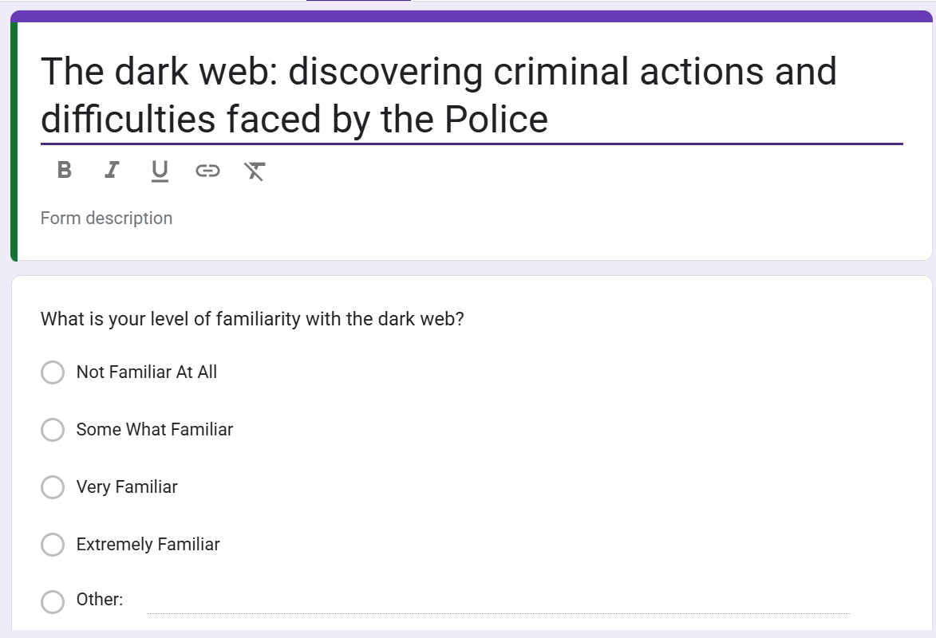
Copy of questionnaire

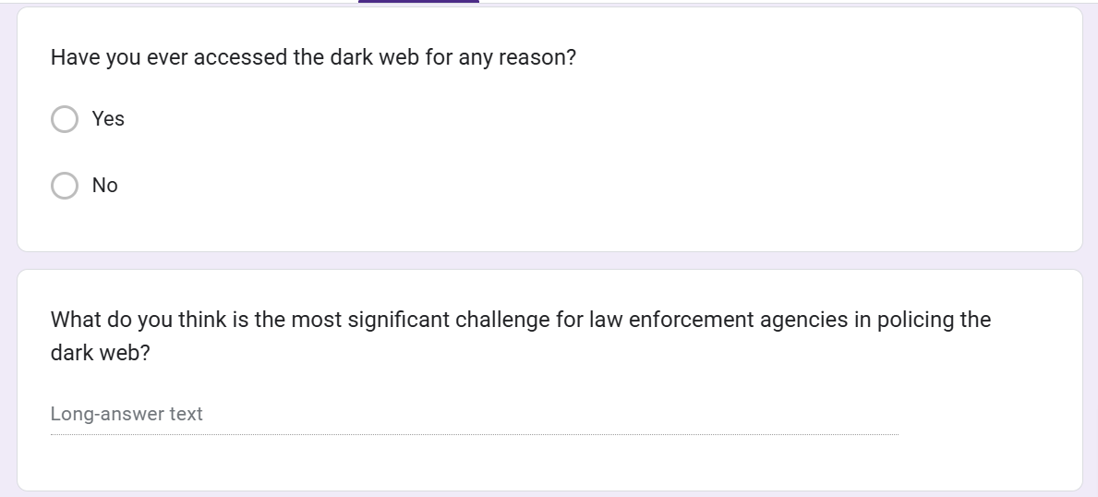

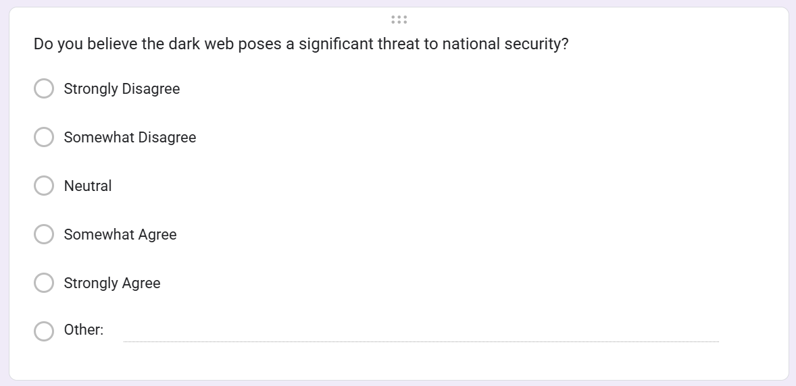

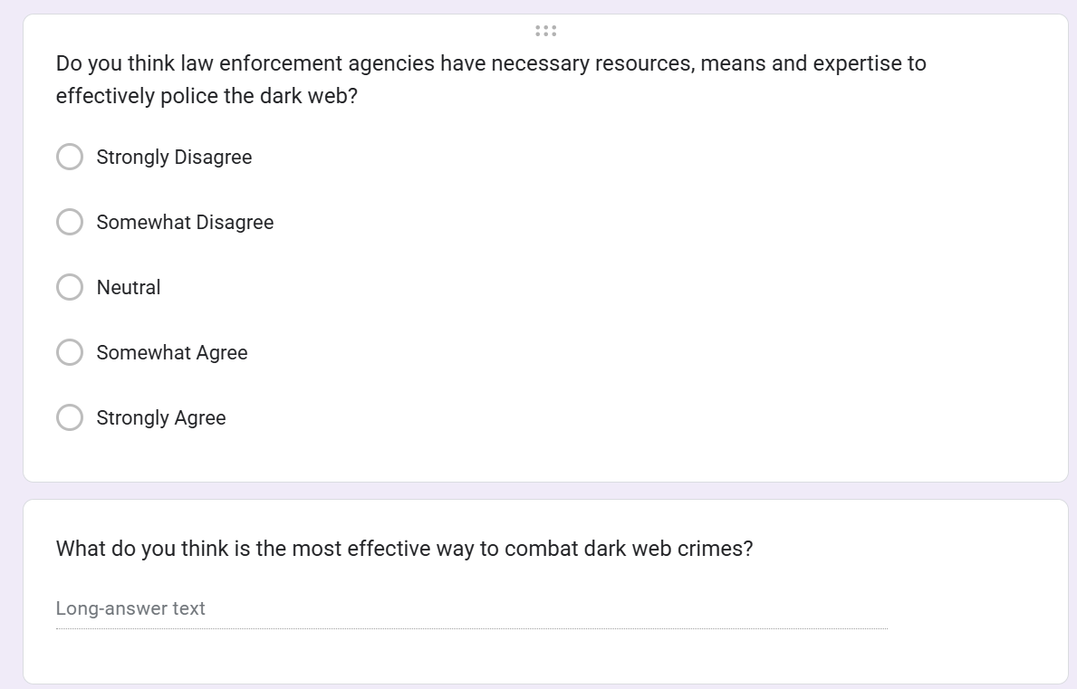
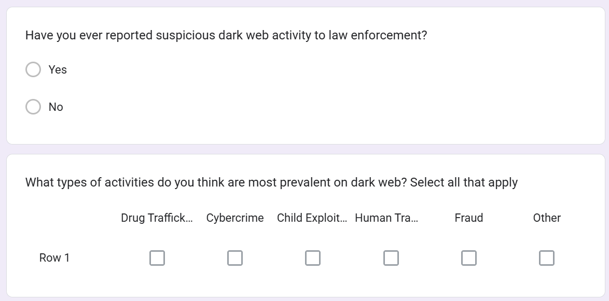

Appendix B
Copy of the results

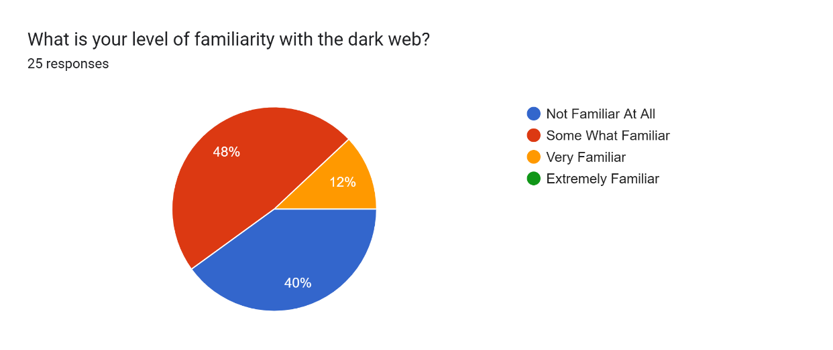

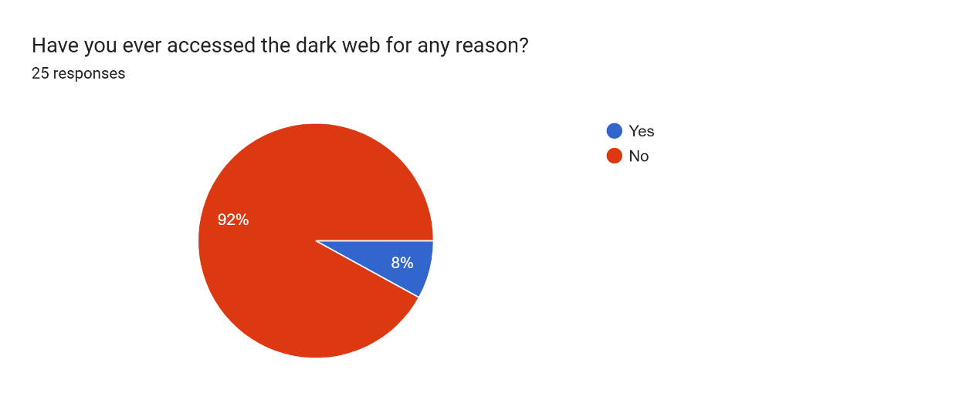

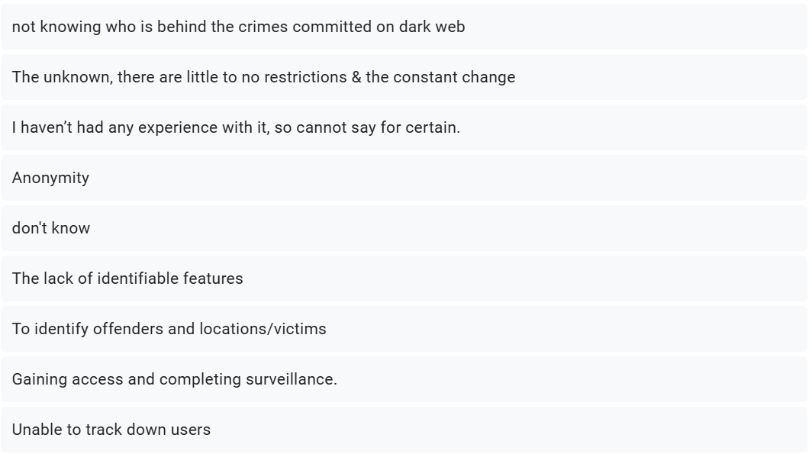
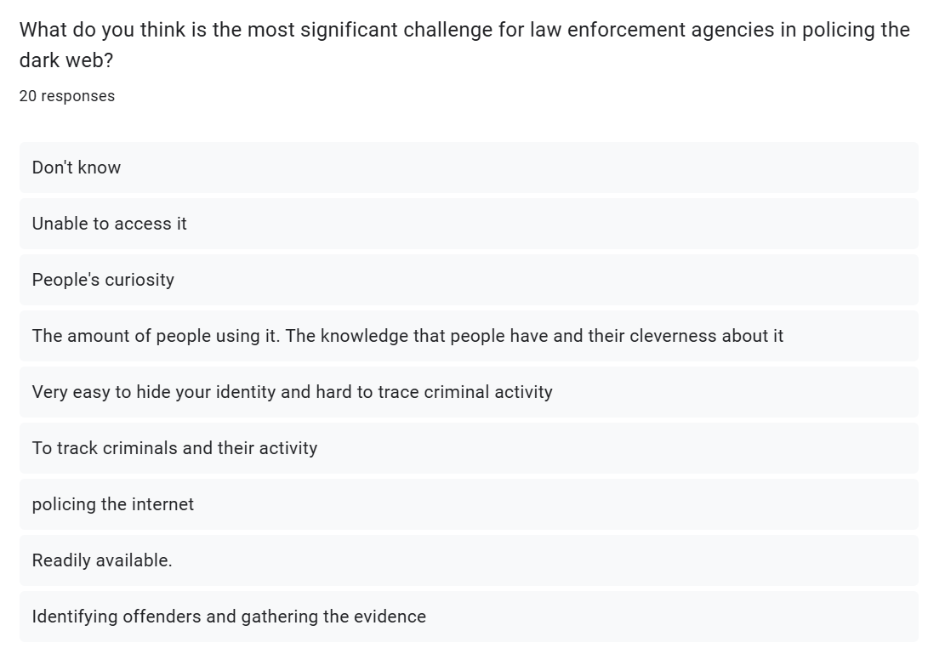

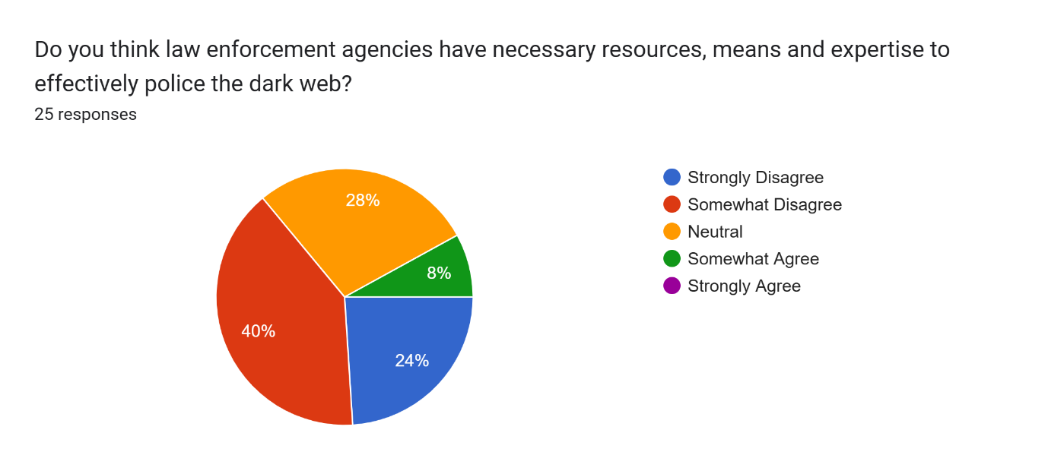
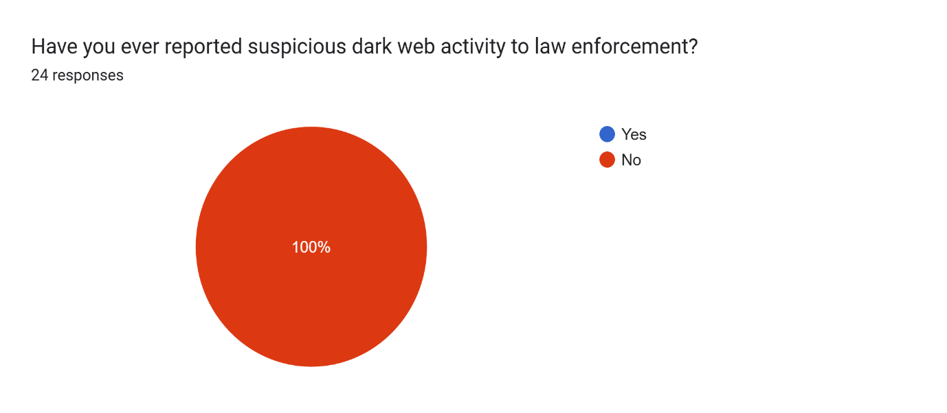
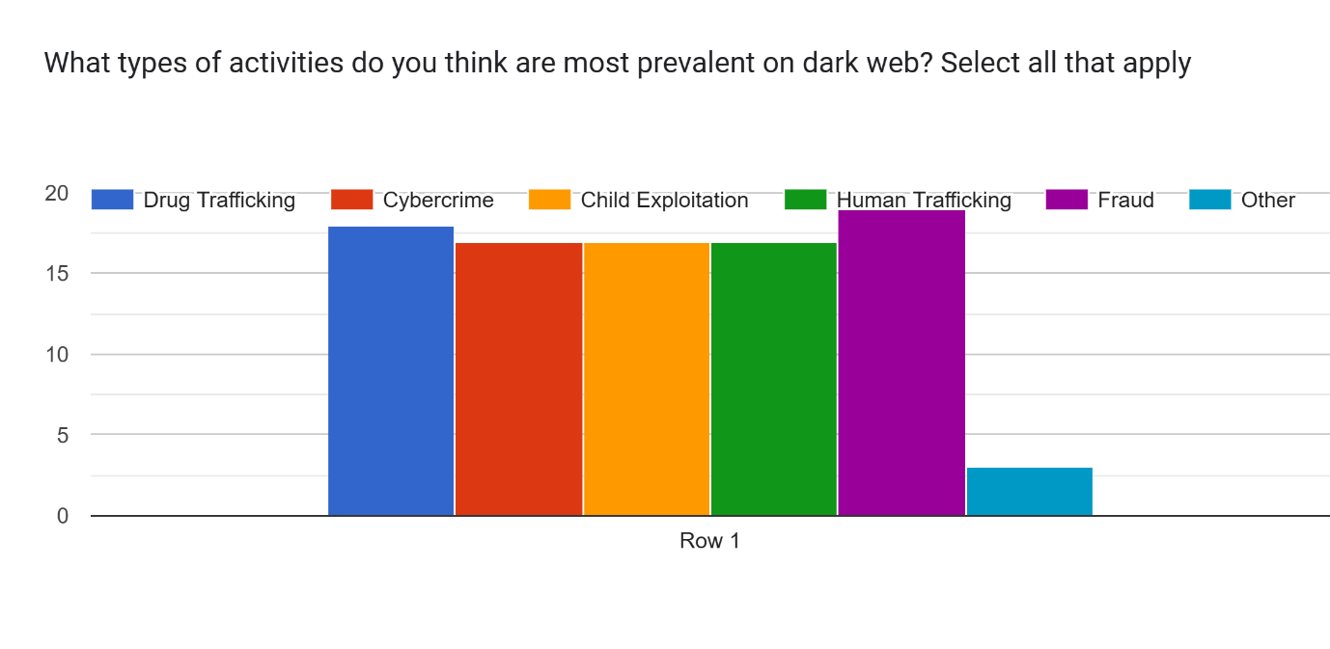

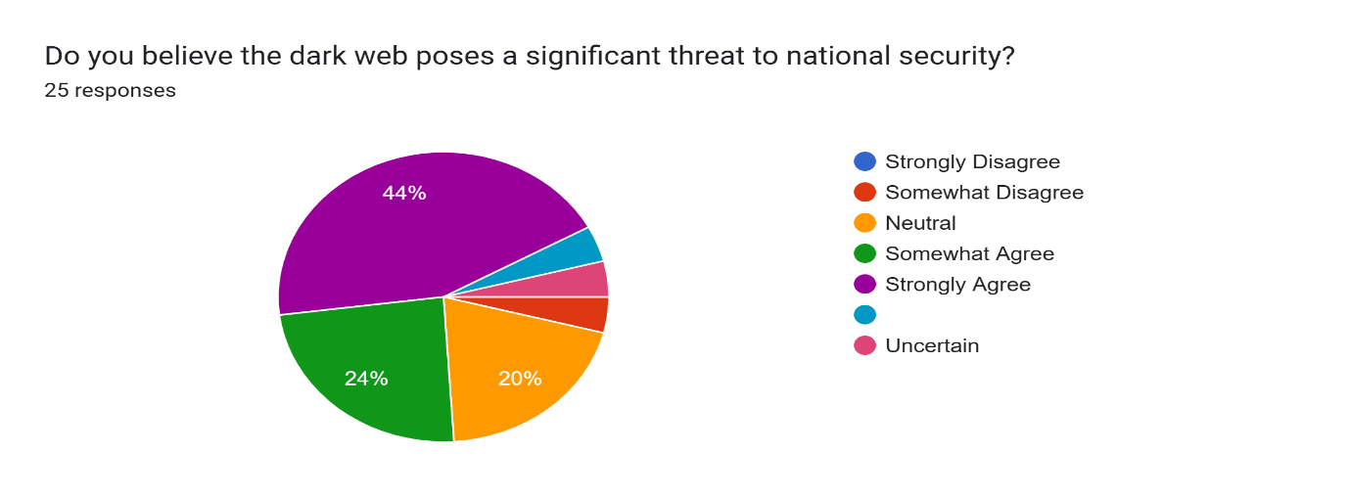
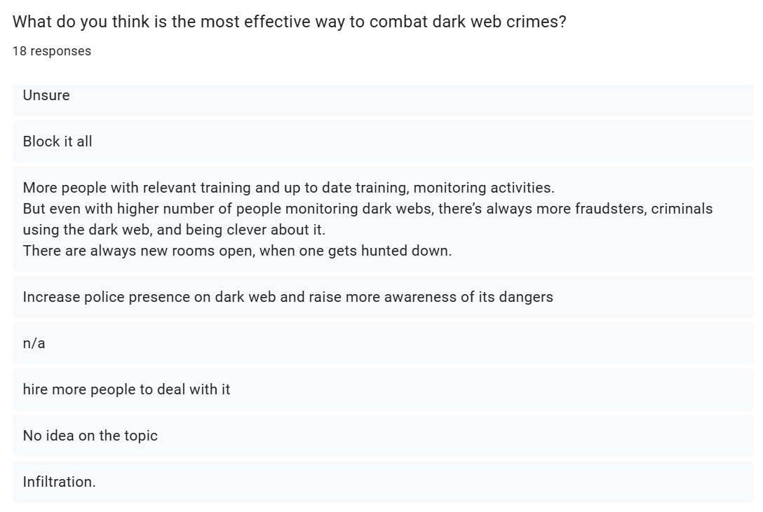

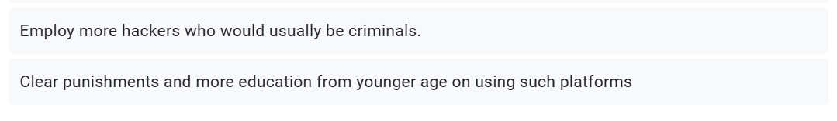
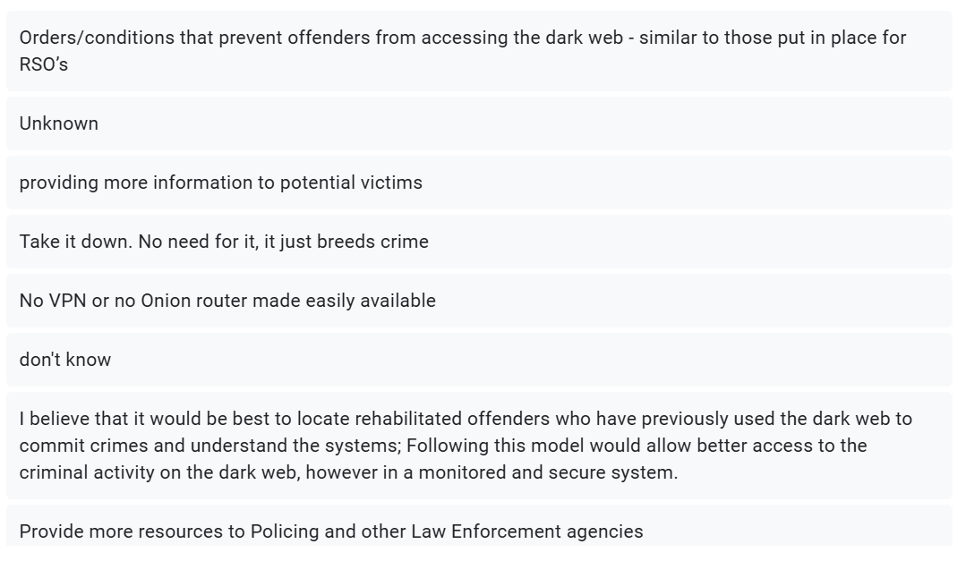

Appendix C
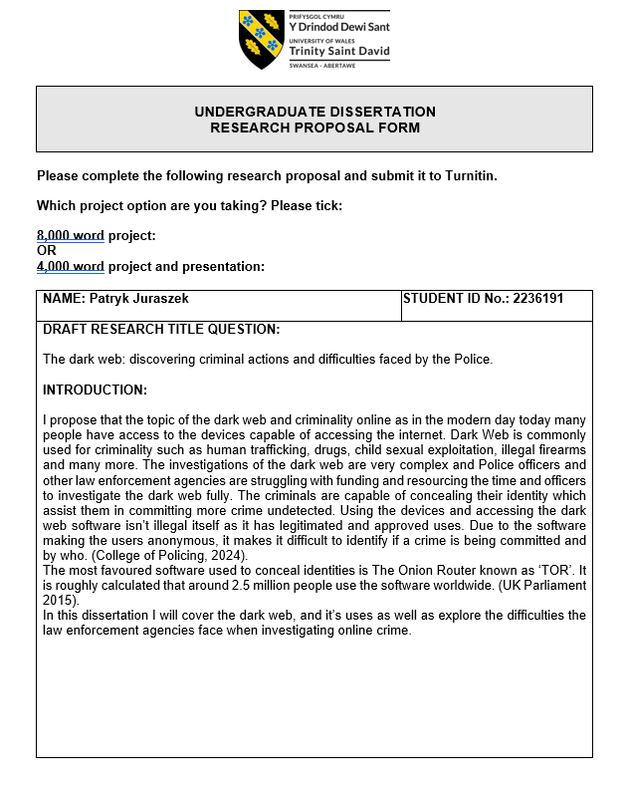
Research Proposal



