Network Programmability
Assessment – 1 : Report

Introduction
Cloud computing's impact on the industry
Increased competition
New business models
More choice for customers
Greater focus on security
Increased collaboration
Adapting to the technical challenges of the cloud has changed the role of network professionals
Virtualization
Software-Defined Networking
Network Function Virtualization
Changes made possible by RESTful Web Services
Despite software defined networking being adapted to network engineers' job responsibilities, industry has embraced it heavily
What led to the selection and implementation of standards in computer networks like JSON and REST
Conclusion
References

Introduction
In recent years, computer networking has undergone a dramatic transformation. In the past, the primary focus of networking was hardware: the physical devices and cables that made up the network. But today, the emphasis is increasingly on software. This shift is being driven by the rise of cloud computing, which is changing the way we use and think about networks [1], [2].
In the early days of computing, networks were primarily used to connect computers together, so they could share data and resources. But as the internet began to take off in the 1990s, networks became increasingly important for connecting people and devices. This led to the development of new technologies, such as the World Wide Web, that made it possible to access information and resources from anywhere in the world [1], [2].
Today, the internet is used for much more than just information sharing. It’s become the backbone of our economy, enabling businesses to reach new markets and customers. And as more and more devices are connected to the internet—from smartphones to wearables to connected cars—the opportunities for businesses and individuals are growing exponentially. But the Internet is also a complex network of interconnected systems, and managing this complexity is a challenge. This is where cloud computing comes in [1], [3].

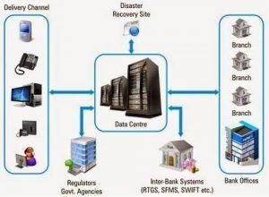
Figure 1. A core banking system
Cloud computing is a way of using the Internet to access and share resources, such as data storage and computing power, without having to physically own or operate the infrastructure. This model is becoming increasingly popular as it offers a number of advantages over traditional methods of computing. For businesses, cloud computing can provide a more flexible and cost-effective way to scale their operations. And for individuals, it can offer access to powerful resources and applications that were once out of reach [1], [5].
The shift to a focus on software is also being driven by the growing popularity of mobile devices. More and more people are using smartphones and tablets to access the internet, and this trend is only going to continue. As a result, businesses, and developers are increasingly looking for ways to optimise their websites and apps for these smaller screens [2], [1].
The move to a software-centric approach to networking is also being driven by the rise of the Internet of Things (IoT). This is the term used to describe the growing number of devices that are connected to the internet, such as thermostats, security cameras, and even cars [1], [2], [7].
The IoT is opening up a whole new world of possibilities for businesses and developers. For example, imagine being able to remotely control the temperature of your office from your smartphone. Or being able to monitor the performance of your car in real-time. The potential of the IoT is only just beginning to be realised, but it’s clear that it’s going to have a big impact on the way we use and think about networks [1], [2], [3].
As the field of computer networking evolves, it’s important to stay up-to-date with the latest developments. This means keeping up with the latest trends and technologies, and understanding how they’re going to impact the way we use and think about networks [2], [3].

Cloud computing's impact on the industry
Cloud computing has been one of the most disruptive forces in the tech industry in recent years. The shift to cloud-based services has been rapid and widespread, with businesses of all sizes adopting cloud technologies to improve their operations [1], [3].
The impact of cloud computing on the tech industry has been profound. The most obvious effect has been the growth of cloud computing providers such as Amazon Web Services (AWS) and Microsoft Azure. These companies have seen explosive growth as businesses flock to the cloud. But the impact of cloud computing goes far beyond the growth of cloud providers. The entire tech industry has been transformed by the shift to cloud computing. As a result of the cloud, the industry has been changed in the following ways [2], [3], [4]:

Increased competition
The rise of cloud computing has led to increased competition in the tech industry. Traditional tech giants such as IBM and Oracle have been forced to adapt to the new world of cloud computing or risk being left behind. The increased competition has also been good for customers, as it has driven down prices and led to the development of new and innovative services [5], [4].

New business models
The shift to cloud computing has created new opportunities for businesses to develop innovative new business models. For example, companies such as Netflix and Spotify have been able to succeed by offering their services ”as a service” (SaaS) instead of selling traditional software licences [6], [4].

More choice for customers
The move to the cloud has also given customers more choice when it comes to the products and services they use. There are now a wide range of cloud-based services to choose from, and businesses can mix and match different services to meet their specific needs [1], [2].

Greater focus on security
As more businesses move to the cloud, there is an increased focus on security. Cloud providers have to meet high standards of security to ensure that their customers' data is safe [2], [3].

Increased collaboration
The cloud has also made it easier for businesses to collaborate with each other. Cloud-based services such as Google Docs and Office 365 allow businesses to work together on documents and projects in real-time. The impact of cloud computing on the tech industry has been far-reaching and profound. The shift to the cloud has transformed the way businesses operate and has created new opportunities for growth [2], [3], [4].

Adapting to the technical challenges of the cloud has changed the role of network professionals
The term cloud computing has been in use for over a decade, but the technology only recently gained widespread adoption. The cloud is a way to deliver computing services—including servers, storage, databases, networking, software, analytics, and intelligence—over the Internet (“the cloud”) to offer faster innovation, flexible resources, and economies of scale. The cloud is a major shift in how IT is delivered, and it’s also changing the role of network professionals. In the past, network professionals were focused on designing, building, and managing on-premises networks. Today, they’re increasingly responsible for connecting users to cloud-based resources and services [1], [2], [6].
The cloud has created new challenges for network professionals, who must now design and manage highly distributed networks that span multiple data centres and connect to a variety of cloud-based resources. They must also ensure that these networks are secure and performant [1], [2], [6].
Fortunately, there are a number of new tools and technologies that network professionals can use to meet these challenges.

Virtualization
One of the most important technologies for network professionals is virtualization. Virtualization allows us to create multiple virtual machines (VMs) on a single physical server. This can be very helpful in a cloud environment, where we might need to create multiple VMs to support different workloads [8], [9].
Virtualization can also help us reduce the cost of our infrastructure. By consolidating multiple physical servers into a smaller number of virtual servers, we can save on hardware, energy, and space costs. Virtualization is also a key technology for security. By isolating different workloads on separate VMs, we can help to prevent one workload from affecting another [8], [9].

Software-Defined Networking
Another significant technology for cloud networking is software-defined networking (SDN). SDN is a way to manage and configure networks using software, rather than hardware. This can be very helpful in a cloud environment, where networks are often highly dynamic and need to be able to scale quickly [10], [11].
SDN can also help us improve the performance of our network. By abstracting the network control plane from the data plane, SDN can help to improve network flexibility and make it easier to add new features and services [10], [11].
In this way, SDN can help to improve security. By decoupling the control plane from the data plane, SDN can help to isolate different parts of the network and make it more difficult for attackers to gain access to sensitive data [10], [11].

Network Function Virtualization
Another important technology for cloud networking is network function virtualization (NFV). NFV is a way to virtualize network functions—such as routers, switches, and firewalls—so that they can be run on commodity hardware. This can be very helpful in a cloud environment, where we might need to deploy numerous network functions. NFV can also help us improve the performance of the network. By virtualizing network functions, we can improve resource utilisation and make it easier to add new features and services [12], [13].
In the end, NFV can help to improve security. By virtualizing network functions, we can help to isolate different parts of the network and make it more difficult for attackers to gain access to sensitive data. Cloud computing is a major shift in how IT is delivered, and it’s also changing the role of network professionals. In the past, network professionals were focused on designing, building, and managing on-premises networks. Today, they’re increasingly responsible for connecting users to cloud-based resources and services [12], [13].
The cloud has created new challenges for network professionals, who must now design and manage highly distributed networks that span multiple data centres and connect to a variety of cloud-based resources. They must also ensure that these networks are secure and performant [12], [13].

Changes made possible by RESTful Web Services
The recent changes in the field of computer networks have necessitated a move towards RESTful web services. This is because traditional web services are not well suited to handle the increased complexity and heterogeneity of modern networks. RESTful web services are more scalable and have better performance compared to traditional web services. In addition, they are more flexible and can be easily adapted to new requirements [14], [15].
The main reason for the shift towards RESTful web services is the need for more flexibility in how computer networks are managed. In the past, networks were managed through hardware-based solutions. However, this is no longer feasible as networks have become more complex. As a result, there is a need for more software-based solutions that can be easily adapted to changing requirements [14], [15].
The use of RESTful web services has already led to a number of benefits for computer networks. For example, they have made it possible to manage networks more effectively. In addition, they have made it possible to improve the efficiency of network operations [14], [15].
The benefits of RESTful web services will continue to grow in the future as more and more organisations move towards using them. This is because they offer a number of advantages over traditional web services. In particular, they are more scalable, more flexible, and more able to meet the changing needs of computer networks [14], [15].

Despite software defined networking being adapted to network engineers' job responsibilities, industry has embraced it heavily
As previously discussed, software defined networking provides many benefits that traditional networking does not. For example, software defined networking is much more flexible and can be easily customised to fit the specific needs of a company. In addition, software defined networking is much easier to manage and scale, making it ideal for use in large enterprise networks [10], [11].
Despite these benefits, there are still some challenges that need to be addressed before software defined networking can be fully embraced by the industry. One of the biggest challenges is the lack of standardisation. Because software defined networking is still a relatively new technology, there are no universally accepted standards for how it should be implemented. This lack of standardisation makes it difficult for companies to interoperate with each other and makes it difficult to compare different solutions [10], [11], [16].
Another challenge that needs to be addressed is the lack of skilled personnel. Because software defined networking is a new technology, there is a lack of people with the necessary skills to properly implement and manage it. This lack of skilled personnel is one of the biggest obstacles to the widespread adoption of software defined networking [11], [16].
Despite these challenges, software defined networking is still a promising technology with a lot of potential. With the right investment in training and education, the industry will be able to overcome these challenges and fully embrace the benefits of software defined networking [11], [16].

What led to the selection and implementation of standards in computer networks like JSON and REST
It is no secret that the world of computing is constantly evolving. What was once a niche market is now a mainstream industry, with new technologies and standards emerging on a regular basis. This can make it difficult for businesses to keep up with the latest trends, particularly when it comes to choosing the right standards for their computer networks. One of the most important decisions that businesses have to make is which standards to use for their computer networks. There are a number of factors to consider, such as compatibility, cost, and performance. However, one of the most significant factors is interoperability [1], [2], [4].
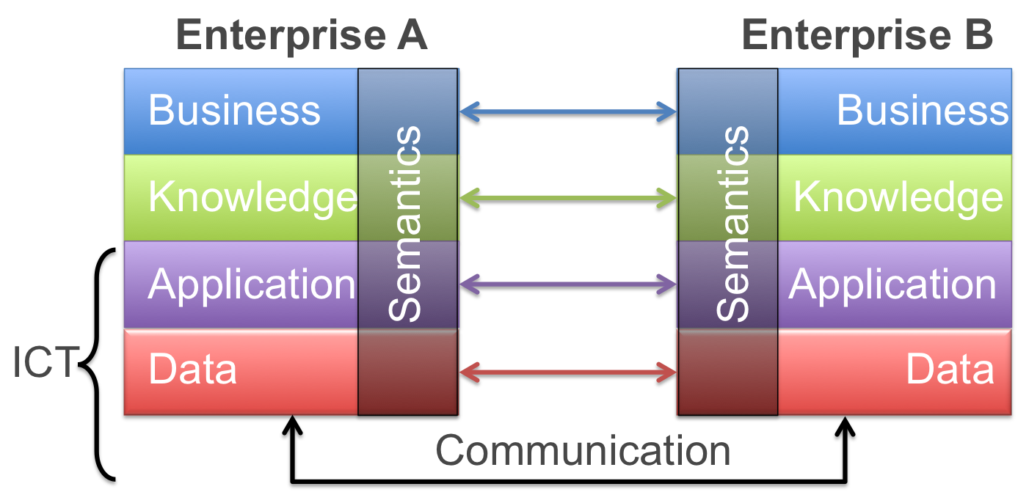
Figure 2: Model Driven Interoperability Levels
Interoperability is the ability of computer systems to work together. It is essential for businesses that rely on computer networks to exchange data and applications. Standards such as JSON and REST have been selected and utilised in the field of computer networks because they offer excellent interoperability [4], [17].
JSON is a language-independent data format. It is easy to read and write, and it can be used with any programming language. REST is an architectural style for building web services. It is based on the principle of statelessness, which means that each request is independent of the others [18].
Both JSON and REST are designed to be simple and easy to use. They are also designed to be scalable and efficient. These characteristics make them well suited for use in cloud computing. Cloud computing is a model for delivering IT services over the Internet. It enables businesses to outsource their IT infrastructure and applications. This can provide a number of benefits, such as reduced costs, increased flexibility, and improved scalability [2], [18], [19].
However, one of the challenges of cloud computing is ensuring that data and applications are interoperable. This is where standards such as JSON and REST come in. By using these standards, businesses can ensure that their data and applications can be accessed and used by any cloud-based system [18], [19].
There are a number of other standards that are also used in the field of computer networks. However, JSON and REST are two of the most popular and widely used. This is because they offer excellent interoperability and are well suited for use in cloud computing [18], [19].

Conclusion
In recent years, computer networking has undergone a dramatic transformation. In the past, the primary focus of networking was hardware: the physical devices and cables that made up the network. But today, the emphasis is increasingly on software. This shift is being driven by the rise of cloud computing, which is changing the way we use and think about networks [1], [2].
In the early days of computing, networks were primarily used to connect computers together, so they could share data and resources. But as the internet began to take off in the 1990s, networks became increasingly important for connecting people and devices. This led to the development of new technologies, such as the World Wide Web, that made it possible to access information and resources from anywhere in the world [1], [3].
Today, the internet is used for much more than just information sharing. It’s become the backbone of our economy, enabling businesses to reach new markets and customers. And as more and more devices are connected to the internet, it’s becoming clear that the future of networking is in software [1], [2], [5].

References
[1] | K. Jamsa, Cloud Computing, 2nd ed. Sudbury, MA: Jones and Bartlett, 2022.
[2] | D. C. Marinescu, Cloud computing: Theory and Practice. London, England: Elsevier Science, 2022.
[3] | F. Montesi, G. A. Papadopoulos, and W. Zimmermann, Eds., Service-oriented and cloud computing: 9Th IFIP WG 6.12 European conference, ESOCC 2022, Wittenberg, Germany, march 22-24, 2022, proceedings. Cham: Springer International Publishing, 2022.
[4] | M. Saratchandra and A. Shrestha, “The role of cloud computing in knowledge management for small and medium enterprises: a systematic literature review,” J. Knowl. Manag., 2022.
[5] | M. N. O. Sadiku, S. M. Musa, and O. D. Momoh, “Cloud computing: Opportunities and challenges,” IEEE Potentials, vol. 33, no. 1, pp. 34–36, 2014.
[6] | B. Grobauer, T. Walloschek, and E. Stocker, “Understanding cloud computing vulnerabilities,” IEEE Secur. Priv., vol. 9, no. 2, pp. 50–57, 2011.
[7] | Neha, P. Gupta, and M. A. Alam, “Challenges in the adaptation of IoT technology,” in A Fusion of Artificial Intelligence and Internet of Things for Emerging Cyber Systems, Cham: Springer International Publishing, 2022, pp. 347–369.
[8] | M. Portnoy, Virtualization Essentials. Indianapolis, IN: Sybex, 2012.
[9] | B. Golden, Virtualization For Dummies. For Dummies, 2011.
[10] | K. Kirkpatrick, “Software-defined networking,” Commun. ACM, vol. 56, no. 9, pp. 16–19, 2013.
[11] | Leading Digital Business Transformation: Cisco CIO. 2018.
[12] | K. Joshi and T. Benson, “Network Function Virtualization,” IEEE Internet Comput., vol. 20, no. 6, pp. 7–9, 2016.
[13] | K. Gray and T. D. Nadeau, Network Function Virtualization. London, England: Elsevier Science, 2016.
[14] | H.-Y. Paik, A. Lagares Lemos, M. C. Barukh, B. Benatallah, and A. Natarajan, Web Service Implementation and Composition Techniques, 1st ed. Cham, Switzerland: Springer International Publishing, 2017.
[15] | S. Wang, I. Keivanloo, and Y. Zou, “How do developers react to RESTful API evolution?,” in Service-Oriented Computing, Berlin, Heidelberg: Springer Berlin Heidelberg, 2014, pp. 245–259.
[16] | D. Kreutz, F. M. V. Ramos, P. Esteves Verissimo, C. Esteve Rothenberg, S. Azodolmolky, and S. Uhlig, “Software-defined networking: A comprehensive survey,” Proc. IEEE Inst. Electr. Electron. Eng., vol. 103, no. 1, pp. 14–76, 2015.
[17] | P. Wegner, “Interoperability,” ACM Comput. Surv., vol. 28, no. 1, pp. 285–287, 1996.
[18] | B. Smith, A. Elk Grove, CA: Apress, 2015.
[19] | E. Wilde and C. Pautasso, REST: From research to practice, 2011th ed. New York, NY: Springer, 2011.

