Nikolay Kanchev Kostov
2530998@student.uwtsd.ac.uk
EXPLORING THE EXTENT OF ARTIFICIAL INTELLIGENce IN ORGANISATIONAL DECISION-MAKING WITHIN CONTEmPORARY HIGHER EDUCATION: A CASE STUDY OF LEEDS TRINITY UNIVERSITY
[Document subtitle]
UNIVERSITY OF WALES TRINITY SAINT DAVID
Prof Amare Desta
CONVERTING RESEARCH INTO PRACTICE
LCDB7010_LON

Abstract
This study examines the extent to which AI influences organisational decision-making within HE. It uses Leeds Trinity University (LTU) as a case study. AI is widely discussed and investigated in the context of pedagogy and learning analytics. However, its characteristics in decision-making and organisational governance remain underexplored within UK HEIs. This research focuses on this gap through a quantitative pilot survey united with a critical secondary literature review.
This academic work analyses staff perceptions of AI implementation, trust, effectiveness, and ethical implications. Furthermore, it focuses on measurable indicators of AI use in decision-making processes. Findings suggest that AI is moderately embedded within LTU’s organisational processes. However, its application is more evident in operational efficiency and data analysis. Furthermore, it's less developed in strategic decision-making. The respondents have delivered a general AI awareness. Furthermore, they recognise its potential to improve efficiency and capability. However, they have concerns about ethical governance, transparency, and trust.
This research contributes theoretically to the Technology Acceptance Model (TAM) and the Decision-Making Theory (DMT) in the HEIs context. Moreover, it delivers insights into AI integration within complex institutional structures. These findings highlight a critical tension between technological capability and human oversight. They suggest that, within HEI’s functions, AI serves as a decision-support tool rather than a decision-making authority.
Keywords: AI, HEIs, Leeds Trinity University, organisational governance, human-AI collaboration, AI implementation, organisational decision-making process.

Table of Contents
Abstract 2
List of Figures 7
List of Abbreviations 8
1. Introduction 9
2. Rationale 10
Problem Statement 11
2.1 The Big Picture Problem 12
2.2 Core Problem and Research Area 12
Lack of Clarity on Impact 13
Human – AI Interaction Gap 13
Sector Imbalance in Search 13
Limited Empirical Data 13
2.3 Explaining the Novelty of the Research 13
What Has Already Been Done to Address the Big Picture Problem 13
2.3.1 Educational Technology Research 13
2.3.2 Conceptual Discussions 13
2.3.3 Technology Adoption Models 13
2.3.4 Corporate-Focused Studies 14
2.3.5 Limitations of the Existing Studies 14
2.4 How This Research Improves on Existing Work 14
2.4.1 Empirical Contribution 14
2.4.2 Practical Applicability 14
2.4.3 Contextual Novelty / HE Focus 14
2.4.4 Focus on Organisational Decision-Making 14
2.4.5 Integration of Practice and Perception 15
2.5 Summary of Novel Contribution 15
2.6 Main Research Question 15
2.7 Research Questions 15
2.8 Research Aim and Objectives 15
2.8.1 Aim 15
2.8.2 Objectives 15
3.1 Reframing AI in HE Context 15
3.2 Contemporary Literature on AI in Organisations 17
3.2.1 AI in Organisations 17
3.2.2 AI in Organisational Management 17
3.2.3 AI in Organisational Management 18
3.2.4 Algorithmic Decision-making Systems 18
3.2.5 AI Governance and Organisational Accountability 18
3.2.6 Human-AI Collaboration 18
3.2.7 Digital Transformation in HEIs 18
3.2.8 AI implementation in the HEIs environment 19
3.2.9 Ethical and Governance Issues 19
3.3 Key Theoretical Perspectives 19
3.3.1 Technology Acceptance Model (TAM) 19
3.3.2 Resource-Based View (RBV) 20
3.3.3 Decision-Making Theory (DMT) 21
3.4 Current knowledge 23
AI, Governance, and Organisational Complexity 23
3.5 Critical Evaluation of Current Knowledge 23
3.6 Research Gap 24
3.7 Justification 24
3.8 Conceptual Framework 24
4.1 Research Design 24
4.1.1 Approach 24
4.1.2 Strategy 25
4.1.3 Sample size 25
4.1.4 Research Paradigm 25
Ontology 25
Epistemology 25
Axiology 25
Methodological Implications 25
4.1.5 Scope of the Pilot Study 25
4.1.6 Sampling Strategy 26
4.2 Data Collection 26
4.2.1 Structured questionnaire 26
4.2.2 Distribution 26
4.2.3 Ethical Consent Obtained Prior to Participation 26
4.2.4 Measurement of Variables 26
4.3 Data Analysis 27
4.3.1 Descriptive statistics 27
4.3.2 Correlation analysis 27
4.3.3 Use of Statistical Software 27
4.3.4 Validity and Reliability 27
4.4 Justification of Methodology 27
4.5 Epistemology and Theoretical Perspective 27
4.6. Ethical and Logistical Considerations 27
4.6.1 Ethical Issues 27
4.6.2 Logistical Challenges 28
4.6.3 Mitigation Strategies 28
4.7 Estimated budget for this Research Project 28
4.8 Thematic Coding 28
5. Findings and Analysis 28
A. Demographic Profile of Respondents 29
B. Awareness of AI 29
C. AI in Organisational Decision-Making 29
D. Satisfaction and Trust in AI Systems 29
E. Open-Ended Responses 29
Summary of Key Findings 29
6. Discussions 30
6.1 Introduction 30
6.2 Discussions of RQ1: AI Usage 30
6.3 Discussions of RQ2: Staff Perceptions 31
6.4 Discussion of QR3: AI and Decision Outcomes 31
6.5 Discussion of RQ 4: Ethics and Governance 32
6.6 Implications for HEIs 33
6.7 Highlights 33
6.7.1 Greater Transparency in AI Systems 33
6.7.2 Clear Positioning of AI as a decision-support tool 33
6.7.3 Strong ethical and governance frameworks 33
6.7.4 Staff Training and AI Literacy 33
6.8 Summary of discussions 33
7. Limitations 34
8. Contribution to Knowledge 34
9. Implications for Practice: 34
10. Conclusion 35
PART 2 36
REFLECTIVE ACCOUNT 36
1. Reporting (What happened) 36
2. Responding (How I felt and thought) 37
3. Relating (Connection to my experience and skills) 38
4. Reasoning (What I learned and why it happened) 38
5. Reconstructing (What I will do next time) 39
6. Conclusion 40
References and Bibliography 41
Appendix A 45
Survey 45
Section A: Demographics 45
Section B: Awareness of AI 46
Section C: AI use in decision making 46
Section D: Satisfaction and Trust 47
Section E: Open-ended questions 48
Appendix B 49
Survey Results 49
Appendix C 58
Project Timetable (Gantt Chart) 58
Appendix D 59
Budget 59

List of Figures

1.1 | Ecological Education Policy Framework | p.16
1.2 | TAM 2 | p.20
1.3 | AI Adoption as a Strategic | p.21
1.4 | AI Governance Model | p.22
B1 | Gender | p.49
B2 | Age | p.49
B3 | Role within LTU | p.50
B4 | Years of Experience | p.50
B5 | Familiarity with AI Technology | p.51
B6 | AI Tool Usage | p.51
B7 | AI Tools Improve the Quality of Organisational Decisions | p.52
B8 | AI Tools Improve Efficiency in Analysing Data | p. 52
B9 | AI Tools Support Strategic Planning | p.53
B10 | Satisfaction with the Usage of AI Tools in the Organisation | p.53
B11 | Trust in AI-generated Insights | p.54
B12 | AI systems should always be supervised by human decisions | p.54
B13 | Ethical Concerns Related to Data Use about AI Implementation | p. 55

List of Tables

B1 | Benefits for AI Usage in Organisational Decision-Making | p. 56
B2 | Concerns about AI Adoption | p. 57
C1 | Project Timetable | p.58
D1 | Budget of the Project | p.59

List of Abbreviations

AI | Artificial Intelligence
DMT | Decision-Making Theory
HE | Higher Education
HEI | Higher Education Institution
LTU | Leeds Trinity University
RBV | Resource-Based View
RQ | Research Question
TAM | Technology Acceptance Model
UK | United Kingdom
UWTSD | University of Wales Trinity Saint David

1. Introduction
The role of AI for organisations is fundamental to their strategic decision-making, resource allocation, and information processing (Daniel & Philip, 2025). Across all industries, AI serves as a transformative force, reshaping governance, organisational logic, and control mechanisms (Alshahrani, 2024; Panizzon, 2025). However, within HEIs, the AI implementation into organisational decision-making remains fragmented, critically underexamined, and uneven (McConvey, Guha, & Kuzminykh, 2023; Oncioui et al, 2025).

The UK’s HEI sector is navigating a complex landscape marked by evolving educational demands, policy challenges, and financial constraints (Watermeyer et al., 2022; Bobola, 2024). This situation has led to the increasing integration of AI into organisational processes, especially in decision-making (Crompton, Burke, & Gregory, 2023; Holmes & Tuoni, 2022). In HEIs such as Leeds Trinity University, these modern technologies significantly influence management, administration, and academic functions (Selwyn, 2022; Zawacki-Richter et al., 2023).
The literature converges to challenge the assumption that AI implementation in HEIs is inherently beneficial. Makhlouf et al. (2026) argue that AI integration reproduces institutional inequalities rather than resolving them. Furthermore, Sen (2026) argues that HEIs' governance frameworks are underdeveloped and have limited response to the deployment of AI in decision-making. This suggests that AI is not purely conceptualised as a technical enhancement but as a socio-political intervention. Furthermore, it shapes institutional power structures (Keding, 2021).
However, this significant transformation has many challenges. HEIs are characterised by strong professional autonomy among the academic staff and very complex governance structures (Enders, Schmank, & Boer, 2021; OECD, 2022). Decision-making is often negotiated rather than strictly hierarchical (Kezar & Sam, 2023). This highlights a fundamental issue regarding the meaningful integration of AI in such a decentralised and pluralistic decision-making environment (Selwyn, 2022).
There is an optimistic view of AI regarding predictive accuracy and efficiency. However, AI systems are not neutral tools (Barnes, 2024; Zhu, Luo, & Chen, 2025). Moreover, they embed biases, limitations and assumptions. This may conflict with the academic values such as transparency, intellectual independence and collegiality (Chiu, 2024). However, the reliance on algorithmic outputs brings new forms of epistemic authority. This shifts decision-making power away from humans (Buston, 2024; Alfiras, Alharbi, & Alshammari, 2025).

2. Rationale
AI becomes a transformative mechanism within the organisational environment. Moreover, there is a growing institutional reliance on data-driven processes (Dwivedi, Hughes, & Ismagilova, 2021). However, in the HEI context, AI extends beyond the technological implementation (Davenport, Guha, & Grewal, 2023). In addition, it is important to understand how complexities interact with institutional decision logics and professional autonomy (Pesek, 2026).
HEI operates within a hybrid structure that unifies public accountability, academic values, and management efficiency requirements (Jarrani et al., 2023). Additionally, this creates a distinct environment in which the decision-making process cannot serve as the unique basis for optimisation. However, it is shaped by normative considerations such as academic freedom, transparency, and fairness (Dotan, Parker, & Radzilowich, 2024). Furthermore, AI is a structural intervention into how decisions are legitimised and enacted (Dung, Toan, & Minh, 2025).
The literature converges on the view that AI implementation is not neutral. Furthermore, it is embedded within institutional priorities and organisational politics. Favero et al. (2026) argue that AI affects not only efficiency but also decision autonomy and human agency. This raises concerns about AI-enhanced professional judgement within HEIs (Raisch & Krakowski, 2021).
A key rationale for this academic study is the growing disconnection between AI capability and its appropriateness within HEIs. Furthermore, these complex AI systems can process large datasets and generate predictive insights (Azevedo, 2025). However, their alignment within institutions remains uncertain. Staff members involved in organisation decision-making have a limited understanding of whether AI-driven outputs are trusted, interpreted or meaningfully utilised (McConvey, Guha, & Kuzminykh, 2023).
Furthermore, there are assumptions that AI implementation is inherently beneficial and technologically sophisticated (Almasi, Bleher, & Weuts, 2025). However, this study challenges the idea that effectiveness in decision-making is shaped not by analytical precision but by the integration of AI within existing decision frameworks and by the credibility of systems among staff members (Favero et al., 2026; Oncioiu et al., 2025).
Furthermore, the rationale is strengthened by the need to produce empirical evidence in a domain dominated by conceptual analysis (Bobula, 2024). There is a lack of quantitative data capturing on how staff are perceived through conceptual analysis. However, without this evidence, all discussions about AI risk will remain disconnected from practice (Crompton, Burke, & Gregory, 2023).

Problem Statement
This topic has been chosen due to the growing relevance of AI implementation in the HEI organisational context (Butson, 2024). Another reason is the visible gap within HE. It’s vital to understand how AI influences LTU decision-making (McConvey, Guha, & Kuzminykh, 2023). Furthermore, the researcher’s professional role as an academic administrator provides direct access to the university’s practices. This enables contextual-informed investigation (Porayska-Pomsta, Holmes, & Nemorin, 2024).
This research focuses on the lack of empirical data on AI integration within LTU’s decision-making processes. The major expectations are academic and practical (Zawacki-Richter et al., 2023; Oncioiu et al., 2025). Academically, it contributes to management and organisational theory by extending the framework for implementing AI in HEIs. In practice, it highlights the support for strategic digital initiatives (Raisch & Krakowski, 2021). Moreover, it improves decision-making efficiency and informs institutional policy (Katsamakas, Pavlov, & Saklad, 2024).
The study immediately contributes to practical value by identifying the current level of AI use (Ruano-Borbalan, 2025). Furthermore, it has a strong focus on AI implementation, where improvements are required. The findings can be directly used to support AI tools in administrative processes, enhance staff training programmes, and inform policy decisions (Mosha, 2026).
This problematic issue is addressed because HEIs are under growing pressure to improve efficiency, transparency, and data-driven decisions (OECD, 2022; Watermeyer et al., 2022). However, without a proper understanding of how AI is used, the HEIs risk implementing it inefficiently (Keding, 2021). Focusing on that problem is vital for LTU to remain competitive in a digitally evolving environment.
The novelty of this research lies in:
- The integration of staff perceptions with measurable AI use. This provides operational and behavioural insights (Cicchetti, 2024).
- Institutional-specific and empirical approach within the UK HEIs context.
- It highlights the importance of the organisational decision process. (Dotan, Parker, & Radzilowich, 2024)
This combination helps close the gap between theory and practice.

2.1 The Big Picture Problem
AI is the core transformation of organisational transformation in these modern times. AI technologies significantly improve decision-making processes through automation and data analytics (Dwivedi, Hughes, & Ismagilova, 2021). Furthermore, it can reduce human bias and enhance efficiency (Raisch & Krakowski, 2021).
However, within HEIs such as LTU, this integration remains underexplored. Universities’ complex organisation is characterised by academic autonomy, administrative control, and layered governance structures (Kezar & Sam, 2023). In the end, the decision-making process is multi-dimensional and fully adjusted by technological tools. The digital transformation initiatives are ongoing, and much more attention to this big problem is required (Crompton, Burke, & Gregory, 2023).

2.2 Core Problem and Research Area
The central problematic issue which is investigated by this research is the lack of empirical evidence on how AI is currently used. Furthermore, whether it is effective in the organisational decision-making process within HEIs (Pesek, 2026). There are four main challenges that form a research area, such as:

Lack of Clarity on Impact
It is not clear whether AI is meaningfully transparent, efficient, and improves decision quality in HEIs (Zhu, Luo, & Chen, 2025).

Human – AI Interaction Gap
AI tools remain insufficiently understood in terms of acceptance, trust and academic staff members' perceptions (Favero et al, 2026).

Sector Imbalance in Search
Most researchers focus on private-sector organisations. This leads HEIs to be under research (Dwivedi, Hughes, & Ismagilova, 2021).

Limited Empirical Data
There is insufficient quantitative evidence on the use of AI among academic staff (Oncioiu et al., 2025).

2.3 Explaining the Novelty of the Research

What Has Already Been Done to Address the Big Picture Problem
There are several approaches in which existing research has attempted to focus on the big problem:

2.3.1 Educational Technology Research
Within the HEIs, AI has a strong focus on:
- Automated assessment tools (Brusilovsky, 2024).
- Adaptive learning systems (Blakemore, 2020).
- Student learning analytics (Butson, 2024)

2.3.2 Conceptual Discussions
Some students provide theoretical insights into AI potential. However, this lacks empirical validation (Alshahrani, 2024).

2.3.3 Technology Adoption Models
TAM is one framework for explaining users’ acceptance of AI systems. Furthermore, it has a strong focus on perceived usefulness (Bobula, 2024).

2.3.4 Corporate-Focused Studies
AI topics are mainly in business environments, where they highlight the improvement of operational efficiency and strategic decision-making processes (Dotan, Parker, & Radzilowich, 2024).

2.3.5 Limitations of the Existing Studies
- Lack of small-scale, HEI-specific empirical studies (Pesek, 2026).
- Minimal focus on organisational decision-making processes (Schiff, 2022).
- Limited integration of staff perceptions with measurable AI use (McConvey, Guha, & Kuzminykh, 2023).
- Over-reliance on non-educational contexts (Bhat, Nirmal, & Misra, 2026).

2.4 How This Research Improves on Existing Work

2.4.1 Empirical Contribution
The research generates primary quantitative data from 25 participants from LTU. They address the lack of empirical evidence (Davenport, Guha, & Grewal, 2023).

2.4.2 Practical Applicability
The findings are designed to be immediately applicable, with recommendations for:

Policy development

AI adoption strategies

Policy development
This aligns with growing emphasis on translating AI research into practical institutional strategies within HEIs (Azevedo, 2025). See Appendix C -Project Timetable. The project timeline spans six weeks to ensure all stages are completed.

2.4.3 Contextual Novelty / HE Focus
This research investigates AI in the UK HEI context and provides insights relevant to universities. It addresses the limited empirical studies in this area (Pesek, 2026).

2.4.4 Focus on Organisational Decision-Making
This study examines the internal decision-making processes which remain underexplored in current literature (McConvey, Guha, & Kuzminykh, 2023)

2.4.5 Integration of Practice and Perception
This study links measurable AI use to staff perceptions, such as trust, usability, and effectiveness.

2.5 Summary of Novel Contribution
- Bridge the gap between organisational practice and AI theory
- Shift the focus from educational technology to organisational decision-making
- Provide context-specific empirical evidence

2.6 Main Research Question
To what extent does AI influence organisational decision-making processes at LTU?

2.7 Research Questions

RQ1: To what extent is AI currently used in organisational decisions at LTU?

RQ2: How do staff perceive the effectiveness and reliability of AI?

RQ3: What is the relationship between AI usage and outcomes of decision-making?

RQ4: What ethical and governance concerns influence AI adoption?

2.8 Research Aim and Objectives

2.8.1 Aim
To evaluate the role and extent of AI in organisational decision-making at LTU

2.8.2 Objectives
- To identify the current AI usage in academic and administrative decision-making
- To assess staff perceptions of AI reliability and effectiveness
- To analyse the relationship between AI use and decision-making outcomes
- To contribute to theory on AI implementation in HEIs

3. Background and Literature Review

3.1 Reframing AI in HE Context
AI has become a growing force for innovation within the organisational environment (Bal & Hashmi, 2025). Moreover, this is relevant to operational efficiency and data-driven decision-making. However, within the HE environment, AI applications cannot be understood through an efficiency-based or technological lens. Furthermore, it must be examined in relation to governance structures and professional norms (Begum & Zhang, 2021).
The literature converges on the view that AI implementation is addressing pedagogical applications, such as learning systems and automated assessment tools (Zawacki-Richter et al., 2023). These developments are very important and reflect a narrow conceptualisation of AI. Moreover, it highlights the potential impact on internal organisational processes, particularly decision-making. This creates a critical imbalance in the literature, as educational innovation is prioritised over organisational transformation. This limitation is illustrated in the diagram below. This is a policy framework in which AI policy is structured across three interrelated dimensions (Chan, 2023, p. 6). See Figure 1.1.
Figure 1.1: AI Ecological Education Policy Framework
Source: (Chan, 2023)
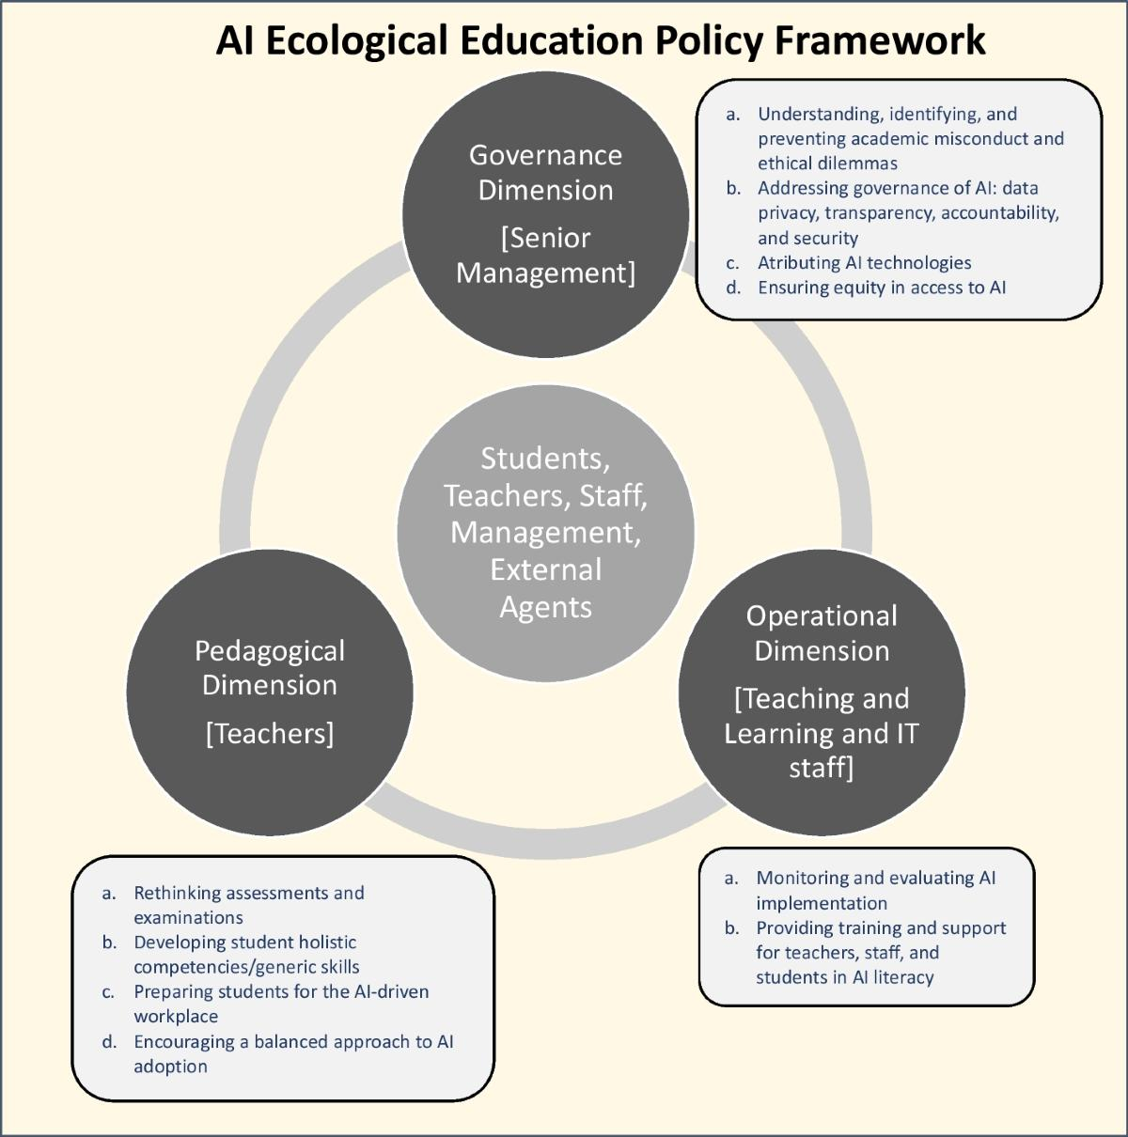

Moreover, the HEI environment is fundamentally different from the corporate environment. They operate within very complex hybrid structures that include managerial governance, public accountability, and academic autonomy (Kezar & Sam, 2023). However, the decision-making process is not efficient and rational. Furthermore, it is shaped by negotiation, consensus, and institutional norms. That raises the vital issues regarding AI, which is designed for optimisation (Madanchian & Taherdoost, 2025).
The recent literature converges on the imbalances. Pesek (2026) argues that AI is highlighted as a pedagogical innovation while organisational governance is neglected. Furthermore, the internal HEIs’ decision-making processes remain theoretically underdeveloped and empirically underexplored (Schmidt, 2025).

3.2 Contemporary Literature on AI in Organisations

3.2.1 AI in Organisations
The literature converges on the view that AI is transforming organisational processes, structures, and strategic capabilities. Dwivedi et al. (2021) argue that AI acts as a general-purpose technology. This reshapes the organisational decision environment by enhancing predictive capabilities and data processing. Davenport, Guha, and Grewal (2023) highlight that AI enables organisations to move from reactive to proactive decision-making through advanced analytics. Furthermore, Alshahrani (2024) argues that AI integration improves efficiency but introduces governance complexity in algorithmic systems.

3.2.2 AI in Organisational Management
AI is increasingly embedded in decision-making processes. McConvey, Guha, and Kuzminykh argue that AI supports decision-making by providing insights from large datasets. However, its effectiveness depends on human interpretation. Buston (2024) suggests that AI-driven decision-making enhances speed and consistency. However, this raises concerns about reduced human agency. Zhu, Luo and Chen (2025) emphasise that algorithmic systems can reproduce bias. This affects fairness and decision quality.
However, this perspective assumes that AI-enhanced decision is inherently more objective. Jarrahi et al., (2023) argue that algorithmic decision-making redistributes human bias, not to eliminate it. This challenges the assumption of neutrality of AI-supported decision-making. Furthermore, it highlights the need for human oversight.

3.2.3 AI in Organisational Management
AI reshapes managerial practices through automatic routines. Davenport et al. (2023) argue that AI enables managers to focus on high-level decisions. Furthermore, it delegates analytical tasks to intelligent systems. Favero et al. (2026) highlight that AI influences managerial roles by shifting authority from human judgment to data-driven systems. However, this raises concerns about autonomy and control (Amarteito & Asamoah, 2025).

3.2.4 Algorithmic Decision-making Systems
They are central for AI integration for HEIs. McConvey et al. (2023) argue that such systems operate through complex models. Barnes (2024) highlights that algorithmic opacity creates challenges in accountability and transparency. However, Zhu et al., (2025) emphasise that algorithmic bias can reinforce existing inequalities.

3.2.5 AI Governance and Organisational Accountability
Alfiras, Alharbi, and Alshammary (2025) argue that a governance framework is necessary to ensure the ethical use of AI. Oncioiu et al. (2025) suggest that organisations must establish accountability mechanisms. Furthermore, they manage risks associated with AI deployment. Maklouf et al. (2026) emphasise that AI governance in institutions remains underdeveloped, especially for ensuring ethical compliance and transparency.

3.2.6 Human-AI Collaboration
This is highly recognised as essential for effective AI integration. McConvey et al. (2023) argue that AI should be viewed as a decision-support tool rather than a replacement for human decision-making processes. Favero et al. (2026) highlight that successful collaboration depends on trust, interpretability, and user integration. However, limited AI literacy among staff members can reduce effectiveness.

3.2.7 Digital Transformation in HEIs
This is accelerating with the HEI's environment due to technological advancement and external pressure. Watermeyer et al. (2022) argue that digital transformation reshapes institutional operations and governance structures. Crompton, Burke and Gregory (2023) highlight that AI has a significant role in this transformation. Furthermore, this is highlighted in data-driven decision-making processes.

3.2.8 AI implementation in the HEIs environment
The recent literature converges on the idea that AI adoption within the HE environment remains uneven. Pesek (2026) suggests that the institutional barriers, such as staff resistance and governance complexity, limit wider AI adoption. Furthermore, Sen (2026) highlights that regulatory frameworks are not developed enough to support AI adoption. Dotan, Parker, and Radzilowich (2024) emphasise the significance of responsible AI adoption from the academic perspective. However, Moukhlouf et al. (2026) highlight that AI may reinforce institutional inequalities if it's not properly governed.

3.2.9 Ethical and Governance Issues
They have a core role for the AI implementation within the HEI environment. Barnes (2024) argues that AI raises relative issues of bias, transparency and fairness.

3.3 Key Theoretical Perspectives

3.3.1 Technology Acceptance Model (TAM)
This theory explains user adoption of AI systems in terms of perceived usefulness. In an AI context, TAM suggests that staff are more likely to adopt AI tools if they are perceived as user-friendly and beneficial. TAM is widely used in AI adoption. It suggests that staff can easily engage with AI tools if they believe that it can improve performance (Dwivedi, Hughes, & Ismagilova, 2021).
However, in the context of HEI, TAM has several limitations. It neglects the collective and institutional nature of the university’s decision-making processes (Raisch & Krakowski, 2021). Furthermore, it is not linked to organisational culture, professional identity and power relations. However, all of them have a significant influence on the implementation of technology in the academic industry (Barnes, 2024).
Literature converges on highlighting that TAM is a useful baseline framework. That requires extension to ethical, institutional and social dimensions. Figure 1.2 illustrates the key structure of TAM and highlights the limitations by omitting broader ethical, social, and institutional influences (Venkatesh & Davis, 2000).
Figure 1.2: TAM2
Source: (Adapted from Venkatesh & Davis (2000), p. 197)
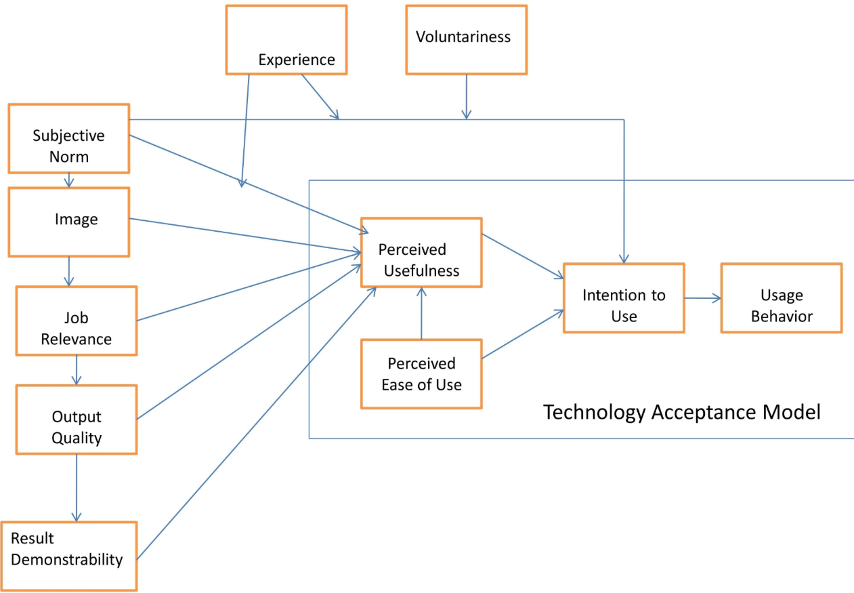
3.3.2 Resource-Based View (RBV)
AI, as a strategic organisational capability, the RBV posits, can deliver a competitive advantage. Within the HEI context, AI may enhance operational efficiency and strategic decision-making (Davenport, Guha, & Grewal, 2023). AI is seen as a valuable organisational resource within this framework. It can support strategic planning and optimise processes.
However, this perspective is more applicable is corporation settings. Furthermore, its relevance to the HEI environment is complex. The main reason is that universities do not operate solely on a competitive logic. Furthermore, the strategic deployment of AI is limited by institutional priorities that extend beyond performance optimisation (Katsamakas, Pavlov, & Saklad, 2024).
RBV assumes that organisations can effectively exploit and integrate technological resources. However, HEIs face challenges from staff competencies, organisational resistance, and digital infrastructure (Zawacki-Richter et al., 2023). The RBV perspective frames AI as a strategic resource that can generate competitive advantage. See Figure 1.3 below, which illustrates how AI is adopted in practice
Figure 1.3: AI adoption as a staged process
Source: (Davenport, Guha, & Grewal, 2023, pp. 538)
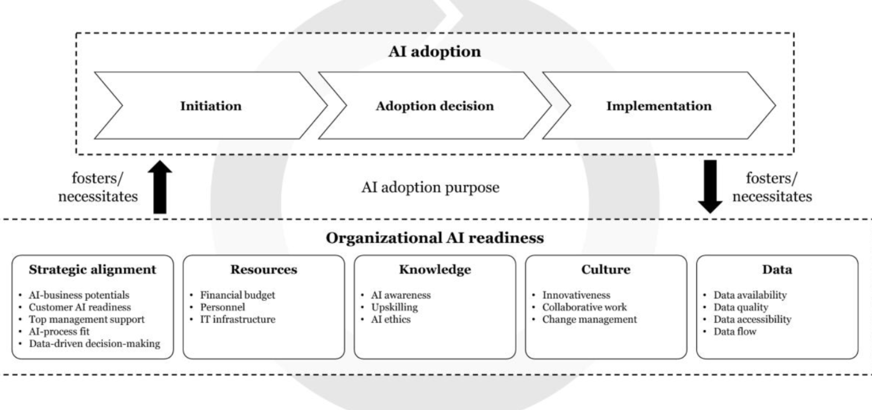

3.3.3 Decision-Making Theory (DMT)
Traditional DMT theory distinguishes between bounded and rational approaches. AI introduces:

Reducing Human Bias

Enhancing Rational Decision-Making

Data-Driven Dimension

AI is positioned as a solution to the limitations that human decision-makers face under conditions of limited information. Moreover, AI offers data-driven insights that enhance decision quality and reduce bias (Dwivedi, Hughes, & Ismagilova, 2021).
However, AI can improve the analytical capacity, but it introduces new forms of algorithmic bias and opacity (Zhu, Luo, & Chen, 2025). Furthermore, AI systems may reproduce existing inequalities embedded in datasets.
There are significant concerns in the HEI context. DMT is about legitimacy, transparency and accountability. If AI-generated decisions cannot be justified, their acceptance is limited (Selwyn, 2022). As illustrated by Neil Selwyn (2022, p.153), AI-driven decision-making operates through a loop in which biased data, opaque algorithms, and institutional outcomes reinforce one another. However, this raises critical concerns about transparency, accountability, and legitimacy in the HEI industry.
Figure 1.4: AI Governance Model
Source: (Selwyn, 2022, p. 153)
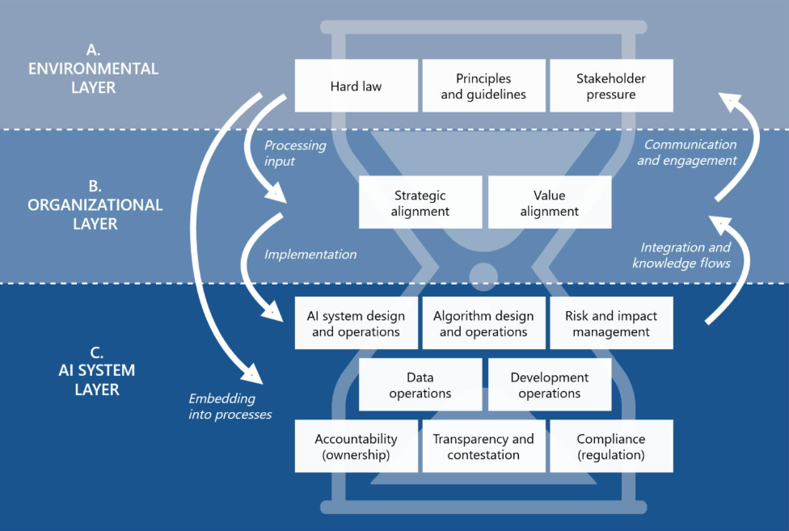
Tam focuses on individual acceptance, RBV emphasises organisational capability, and DMT highlights rational decision-making processes. However, none of these frameworks can capture the complexity of these processes within the HEI industry (Sen, 2026). At that point, social, ethical and institutional factors have significant roles.

3.4 Current knowledge

AI, Governance, and Organisational Complexity
The literature converges on the view that AI systems require accountability mechanisms, institutional oversight, and ethical frameworks to ensure responsible use (Alfiras, Alharbi, & Alshammari, 2025). In the HEI environment, governance is extremely complex due to a decentralised decision-making structure and strong professional autonomy. Together with multiple stakeholder groups, create obstacles to the standardisation and integration of AI systems (Abdulrahman, 2024).
However, AI implementation is inconsistent and fragmented across various institutions (Abdullah & Berhe, 2025). This limits its impact. Furthermore, the introduction of AI into decision-making processes raises vital issues about control and authority. However, there are significant implications for accountability and institutional governance, as decision-making power may shift from human decisions to technology systems (Jarrahi et al., 2023).

3.5 Critical Evaluation of Current Knowledge
The literature converges on the view that AI has significant potential to enhance organisational decision-making. However, its implementation within HEIs has several limitations, including limited understanding of staff perceptions, over-reliance on corporate models, insufficient integration of organisational theory, and a lack of empirical evidence (Pesek, 2026).
Moreover, many researchers have focused on conceptual rather than empirical evidence. This limits its applicability to a real institutional context (Dwivedi, Hughes, & Ismagilova, 2021). This gap is a reality in the UK HE industry, where institution-specific and small-scale studies are limited.
Furthermore, Makhlouf et al. (2026) argue that current models fail to capture the normative dimensions of AI decision-making, especially in the HEI industry. This reinforces the argument that AI adoption must be analysed beyond efficiency metrics.
Pesek (2026) highlights that the key limitation in the literature is the reliance of corporate-based models for AI adoption. However, these models do not align with complex and decentralised structure of the HEI industry (Abu, Beirat, & Gasaumeh, 2024). This leads to the need of context-specific empirical research. It needs to integrate the institutional practice with theory.

3.6 Research Gap
Several gaps are identified from the critical literature review:
- There is a lack of small-scale pilot research
- Limited empirical data from UK HEIs
- insufficient understanding of academic staff perceptions and practical use
- Limited quantitative studies that examine AI in HE decision-making
- Insufficient focus on organisational applications (not pedagogical)
- Lack of integration between theory and empirical data
- Minimum exploration of staff and engagement

3.7 Justification
This study contributes by bridging practice and theory, supports the development of institutional policies, and provides empirical evidence (Oncioiu et al., 2025).

3.8 Conceptual Framework
This academic work adopts an integrated conceptual framework that unites TAM, RBV and DMT. It analyses AI in the HEI environment. TAM explains staff acceptance. RBV conceptualised AI as a strategic resource. DMT evaluates decision quality and rationality. However, this study extends these frameworks by incorporating ethical considerations and governance. Furthermore, it recognises AI as a socio-technical system rather than a technological tool.
4. Methodology

4.1 Research Design

4.1.1 Approach
This study adopts a quantitative research design, consistent with a positivist epistemological stance. Furthermore, this approach allows measurements and analysis of variables for decision-making and AI use (Slater et al., 2024).

4.1.2 Strategy
Survey-based pilot study

4.1.3 Sample size
Small sample size from 25 participants from LTU, such as academic staff, senior university managers, and academic administrators. This sample is purposive, targeting academic staff members directly involved in organisational decision-making processes.

4.1.4 Research Paradigm
This refers to a set of philosophical assumptions. Those guides on conducting research. This includes belief about reality (ontology), knowledge (epistemology), and value (axiology). It provides the foundation for methodological choices. Moreover, it determines how data is collected, analysed, and interpreted. In this study, the research paradigm aligns with a positive perspective. It enables objective measurement of AI use and its impact on organisational decision-making within the HEI industry (Slater et al, 2024).

Ontology
This research adopts an objectivist ontology. It assumes that university decision-making processes exist independently of individual perceptions. Furthermore, it can be measured objectively.

Epistemology
This study is grounded in positivism. It focuses on observable and quantifiable data to investigate AI use and its impact.

Axiology
This research maintains value neutrally. It recognises ethical concerns about AI, including transparency, accountability, and bias.

Methodological Implications
This paradigm justifies the use of a quantitative survey approach. It enables statistical analysis and generalised findings.

4.1.5 Scope of the Pilot Study
This pilot study is limited to Leeds Trinity University. It includes 25 respondents. This research focuses on administrative and academic staff involved in decision-making. The scope is exploratory. It aims to identify the patterns rather than produce conclusions. The findings are indicative rather than definitive.

4.1.6 Sampling Strategy
A purpose sampling strategy was adopted to select participants directly involved in the university’s decision-making process. This ensures relevance. However, it introduces limitations in generalisability and representativeness (Campbell et al., 2020).

4.2 Data Collection

4.2.1 Structured questionnaire
It consists of:
- Likert-scale questions measuring perceptions of AI
- Closed-ended questions assessing AI usage (Slater et al., 2024).

4.2.2 Distribution
Distributed with LTU’s email to guarantee a high response rate.

4.2.3 Ethical Consent Obtained Prior to Participation
This refers to the process of ensuring that all respondents are fully informed about the research before participating. A clear understanding of the research is provided, including its purpose, the nature of the questions, and how the data will be used. It follows the ethical research guidelines of Leeds Trinity University. The respondents take part only after understanding the conditions, such as the aim of the research, what participation involves, the voluntary nature of participation, and their right to withdraw at any time without penalty.
Moreover, their responses would remain anonymous and confidential. Furthermore, data would be used solely for academic purposes. There are no risks for participants as no sensitive data is collected.

4.2.4 Measurement of Variables
AI use was measured through frequency-based questions. Perceived effectiveness and trust were measured using Likert-scale responses. Ethical concerns were operationalised through agreement level on data governance and bias-related questions.

4.3 Data Analysis

4.3.1 Descriptive statistics
- Mean
- Frequency
- Distribution

4.3.2 Correlation analysis
Relationship between AI usage and decision-making effectiveness

4.3.3 Use of Statistical Software
This was conducted by using Excel/SPSS

4.3.4 Validity and Reliability
The survey was pilot tested to ensure consistency and clarity. Reliability is supported through a standardised Likert-scale measurement. However, internal reliability was not assessed, which is a limitation (Slater et al., 2024).

4.4 Justification of Methodology
A quantitative approach is appropriate because:
- It enables measurable evaluation of AI usage
- Supports hypothesis testing and probability-based conclusions
- Provides replicable results aligned with scientific research principles

4.5 Epistemology and Theoretical Perspective
- Epistemology is Positivism
- Theoretical stance is Objectivist, focusing on measurable organisational phenomena

4.6. Ethical and Logistical Considerations
These considerations are vital and are addressed in this research due to their academic importance.

4.6.1 Ethical Issues
- Informed consent
- Confidentiality and anonymity
- Voluntary participation

4.6.2 Logistical Challenges
- Access to participants
- Time constraints
- Response bias

4.6.3 Mitigation Strategies
- Clear communication with academic staff members
- Efficient scheduling
- Pilot testing questionnaire

4.7 Estimated budget for this Research Project
It is presented in Appendix D. It includes travel and material costs.

4.8 Thematic Coding
This study is primarily quantitative. However, qualitative responses from open-ended questions were analysed using thematic coding. Responses were grouped into recurring themes such as efficiency, trust, ethical concerns, and human oversight. This enables a deeper interpretation of academic staff perceptions (Naeem et al., 2023).

5. Findings and Analysis
These findings are structured around key variables. They include AI use, perceived effectiveness, trust, and ethical concerns. Furthermore, they correspond directly to research questions and hypotheses. This enables a structured analytical approach.
This section provides a summary of findings from a questionnaire survey of academic staff at LTU. The analysis is based on descriptive statistics, including frequency and percentage distribution. See Appendix A (Survey) for the survey structure. For detailed results, including figures and tables (Google Form output), see Appendix B (Survey Results).
The findings are organised in questionnaire sections. This allows a systematic evaluation of staff awareness and AI usage in organisational decision-making and staff perception.

Demographic Profile of Respondents
This suggests that participants are experienced professionals from diverse backgrounds within LTU. This strengthens the reliability of the findings for university decision-making.

Awareness of AI
This demonstrates a moderate level of AI implementation and awareness within LTU. However, academic staff have concerns and uncertainty about the presence of these technologies in their university departments. This suggests that AI is not fully understood by all groups at LTU.

AI in Organisational Decision-Making
The data summary suggests that AI is perceived as highly effective in enhancing data analysis and operational efficiency. However, there are concerns about its strategic role in the university’s decision-making processes.

Satisfaction and Trust in AI Systems
The findings indicate high satisfaction with AI tools. However, trust remains moderate. Furthermore, there is a strong emphasis on the necessity of human oversight. The most problematic questions concern ethical concerns, as these are vital issues influencing AI implementation and adoption.

Open-Ended Responses
The LTU participants highlight several core advantages of AI in organisational decision-making. This includes improved efficiency, enhanced data-analysis capabilities, and faster decision-making processes.
The qualitative responses reinforce the quantitative findings. This highlights a balance between perceived benefits and significant concerns regarding governance and trust.

Summary of Key Findings
The findings demonstrate that AI is moderately embedded within the university’s organisational processes. The strongest impact is on data analysis and operational efficiency. In these two areas, the LTU staff report a high level of satisfaction with AI effectiveness.
However, AI has a more limited role in strategic and final decision-making processes. There is high satisfaction with AI tools. However, there are concerns about transparency, ethical implications, and trust.
A key finding is strong consensus on the necessity of human supervision. This indicates that AI is primarily perceived as a decision-making tool rather than an autonomous decision-maker.
Overall, the results highlight a critical balance between technological capability and the need for human oversight. This reflects the complex nature of AI implementation within the HEI sector.
The findings suggest a relationship between AI usage and perceived effectiveness. This results from higher usage, which correlates with positive perceptions of efficiency. However, trust does not increase proportionally. This indicates a gap between implementation and confidence.

6. Discussions

6.1 Introduction
This chapter highlights findings related to the research aim. It critically engages with theoretical frameworks from the literature review, such as TAM, RBV, and DMT. Moreover, this chapter focuses on the wider HEI environment.

6.2 Discussions of RQ1: AI Usage
Findings indicate that moderate AI usage supports RQ1. However, this aligns with Pesek (2026), who argues that AI adoption in HEIs remains fragmented (Oncioiu et al., 2025; Zawacki-Richter et al., 2023).
The findings indicate that most LTU participants are familiar with AI technologies. This aligns with TAM, which suggests that perceived usefulness and perceived use are core drivers of technology adoption. AI is widely perceived as beneficial, especially in improving data analysis efficiency and supporting operational processes.
However, the results reveal that AI is accepted at a functional level, and its deeper integration into decision-making processes remains limited. There is partial support from TAM, but it highlights limitations. TAM focuses on individual perceptions. This does not account for professional autonomy, organisational culture, or institutional complexity. However, they are highly relevant in the HE environment.
Therefore, TAM is not enough for meaningful integration. In HEIs context, institutional norms, collective decision-making and trust are vital.
This finding partly support TAM. However, it does not account for limited strategic integration. Jarrahi et al. (2023) argue that AI adoption is superficial. However, AI use at LUT reflects functional adoption rather than transformation integration.

6.3 Discussions of RQ2: Staff Perceptions
According to Favero et al. (2026), staff perceptions reflect both concern and optimism, especially for trust and autonomy.
From the RBV view, AI can be understood as a strategic organisational resource. This enhances efficiency and provides a competitive advantage. The findings support this in relation to data analysis and operational efficiency.
However, the limited role of AI in strategic decision-making processes challenges the full application in the RBV context. HEIs operate within hybrid structures, with a strong focus on governance, academic values, accountability, and efficiency (Lelescu et al., 2025).
The findings suggest that AI has the potential to be a strategic asset. However, its effectiveness is influenced by factors such as trust, institutional priorities, and staff competencies (Dotan, Parker, & Radzilowich, 2024).

6.4 Discussion of QR3: AI and Decision Outcomes
AI improves efficiency. However, its limited strategic impact suggests partial support for RBV assumptions.
DMT provides a useful framework for understanding AI's role in enhancing data-driven decision-making. The findings demonstrate that AI significantly improves efficiency and analytical capacity. This supports the view that AI reduces human limitations related to information overload (Raisch & Krakowski, 2021).
However, the findings reveal important limitations. Participants report moderate trust in AI-generated insights, so human oversight is required. This indicates that AI is not perceived as autonomous decision-making but as a supportive tool (Li, 2026).
Furthermore, ethical concerns such as accountability, bias, and transparency are linked to algorithmic decision-making. This aligns with DMT critics who argue that the decision-making process in HEIs is not pure but is influenced by ethical, institutional, and social factors. On one side, AI enhances the technical aspects of decision-making. From the other side, decision-making is not purely ethical but is influenced by ethical, institutional, and social factors.
Therefore, AI enhances technical aspects; however, its integration requires transparency, human oversight, and legitimacy.
These findings demonstrate a clear gap between trust and efficiency gains. Moreover, AI enhances analytical capacity. However, AI introduces a paradox, but this increased confidence does not mean increased performance. This gap highlights the significance of governance and transparency of AI adoption.

6.5 Discussion of RQ 4: Ethics and Governance
Ethical concerns strongly support RQ4. This aligns with Makhlouf et al. (2026), who emphasise the governance gap in AI deployment.

The core topic that emerges from the findings is the tension between human control and technological capability. Despite high satisfaction with AI tools, trust remains limited. This suggests that service users want to engage with AI but are cautious about making critical decisions (Stracke et al., 2023).
There is a strong focus on human supervision. This reflects on maintaining accountability and professional judgement within HEIs environment. These lead to the core issues identified by participants, including bias, transparency, and data use.
These findings reinforce the argument that AI is not a purely technical process but a socio-organisational transformation. Effective integration requires ethical oversight, a governance framework, and technological capability.
These findings highlight that AI adoption is a socio-technical transformation, not a pure technical process. Stracke (2026) emphasises that effective AI integration requires alignment between technical capability, governance framework and institutional values. However, without this alignment, AI adoption risks creating ethical challenges and inefficiencies.

6.6 Implications for HEIs
The findings have wider implications for HEIs. They reveal that AI implementation in HE is a partial integration. However, technological tools are used to support specific functions rather than to transform decision-making processes. These findings suggest that HEIs should implement structured AI governance. Furthermore, they need to improve the understanding and trust in AI systems with investments in staff training.

6.7 Highlights

6.7.1 Greater Transparency in AI Systems

6.7.2 Clear Positioning of AI as a decision-support tool

6.7.3 Strong ethical and governance frameworks

6.7.4 Staff Training and AI Literacy

6.8 Summary of discussions
The findings demonstrate that AI has a significant but limited role in LTU’s decision-making processes. It enhances efficiency, but its influence on strategic decision-making remains constrained.
The study confirms that AI implementations are shaped by perceived usefulness (TAM), strategic value (RBV), institutional complexity, trust, and ethics (DMT).
Overall, it is a supportive technology rather than a replacement for human decisions within HEIs.
AI demonstrates measurable advantages. However, its limited impact challenges the assumption that technological capability directly translates into organisational transformation. This supports the argument that institutional culture and governance structures are more influential than technological sophistication.

7. Limitations
- Small sample size (n=25) limits generalisability
- Single case study (LTU)
- Self-reported data may introduce bias
These limitations restrict the generalisability of the findings. Furthermore, they highlight the need for future research with more diverse and larger samples.
Future research should include larger, multi-institutional samples and mixed methods approaches. This ensures that quantitative and qualitative insights are available for decision-making processes.

8. Contribution to Knowledge
This research helps bridge the gap between theoretical models and the practical implementation of AI in the HEI industry.
This study will:
- provide empirical insights into AI implementation in HEIs
- Identify patterns of AI usage in decision-making
- Support development of AI-related organisational strategies

9. Implications for Practice:
These implications are important for universities. They aim to improve digital transformation and to maintain governance and ethical standards.
- Inform the university policy on AI integration
- Improve decision-making processes
- Enhance staff training and digital transformation strategies
HEIs should implement a structured AI adoption model. This includes operational integration, governance alignment, and strategic decision support (Dotan, Parker, & Radzilowich, 2024). Furthermore, this approach ensures alignment between technological capability and institutional priorities.

10. Conclusion
This study highlights that AI implementation within the HEI context is operating with limited knowledge. The main areas of AI uncertainty are ethical concerns and organisational complexity. The findings reveal that AI is accepted as supporting the existing policies. Outside of that area, it challenges established decision-making norms. It emerges that AI adoption in the HEI context is a socio-organisational transformation problem.
This study reveals a picture of AI impact that is mediated by governance structures, institutional culture and trust. Without focusing on these dimensions, AI adoption will remain superficial. AI has multiple applications beyond purely technical innovation.
This research highlights the limitations of existing models, such as TAM and RBV, in their application to the HEI context. Furthermore, these frameworks need to be expanded to account for professional autonomy and institutional complexity. AI is not going to replace human decision-making but rather augment it with responsibility and uphold the core academic values of academic institutions.
This study provides valuable insights for institutional strategy and policy. It emphasises the importance of developing governance frameworks, which enhance staff training and ensure transparency in AI systems. AI needs to address these factors to not remain superficial. This research bridges a gap between theoretical discussions of AI and practical applications within the AI sector. It highlights the importance of balancing technological innovation with human-centred values. AI must support the core principles of academic institutions rather than undermine them. Ultimately, the successful AI integration in HEIs depends on balancing technological innovation with human-centred values and institutional accountability.

PART 2

REFLECTIVE ACCOUNT

Reporting (What happened)

This reflective account followed the steps I finished to complete my research project “Exploring the extent of AI within organisational decision-making with contemporary higher education. A case study of Leeds Trinity University”. The study focused on my workplace, where I am an academic administrator at the Nottingham campus. The aim of the project is to understand how AI is used in organisational decision-making and to assess academic staff members' attitudes towards AI.
The project followed several stages. Some days I’ve worked so hard that I've gone to bed at 1 am. I used all my time to prepare that project, even though I wrote sections of my report while travelling daily from Derby to Nottingham. First, I completed my literature review. I used online libraries of LTU and UWTSD. My completed literature review had too many repetitive parts and it wasn’t easy to read it. Then I put graphs in the main theories, but for the first time, I put the page number from where the figures were taken.
Although I have experience from Buckinghamshire New University for my bachelor's degree and from the University of Sunderland for my master’s degree, this research project was new to me compared to doctoral research.
It is very important that the academic sources are relevant to the research topic – the first important criterion for me. The second criterion is that the sources are academic articles published in the last 5 years. It is very important that all parts of the study be cited from relevant sources.
The questionnaire survey was a great challenge for me because my colleagues were unwilling to participate in the project. I wanted to have a big number but because of this unwillingness the final number is only 25. The respondents were from LTU and are working as academic staff managers, student services, and administrators. The final version was sent by email to participants, and all results from Google Forms are described in my study.
Initially, I included a section in my research thanking the LTU staff for their support, which encouraged me to complete my doctoral studies at UWTSD and granted me Wednesday and Thursday as my days off. Thanks to this, I was able to arrive at Canary Campus by train and bus every Wednesday and Thursday during term 1. However, it was interpreted that these people had contributed to my work, and that section was deleted. I love writing poems, texts, and articles for various social media platforms.
To be honest, finishing that project on time and submitting the work cost me 6 weeks. Moreover, I took several days as annual leave to complete both doctoral works on time. The most valuable part for me was following the points from classes and the questions the professors gave us, and I was ready with data collection, analysis, discussions, and the whole work.

Responding (How I felt and thought)
During this project, I had very different feelings. At the beginning, I was excited that I had experience and I needed only to upgrade. However, at one point I was racing again the time that I don’t have to finish my projects. When the project was ready, it was too descriptive, too many parts were repetitive, and it was difficult to read because different paragraphs came from different academic sources, and I was worried. After several reductions to reduce repetition and to shift the study from descriptive to critical, it took me many days to make that change.
I was very stressed, especially from the time pressure, and some nights I didn’t sleep. But six weeks were enough to complete both projects. I relaxed a little when my first piece of work was ready. So, I have all my attention on this study to be a good reality.
I was very confused throughout the literature review, and especially with theories such as TAM, RBV, and DMT. It was vital for me to be confident. For this reason, I found valuable online academic articles and included figures of these models, which made it easier to explain them. To be honest, the main gap in my research is a lack of knowledge about AI. For example, in my practice at LTU, I have several AI-based programmes; however, more training is required to use them properly and build trust in them.
At the end of week 6, I am happy that my research is useful and meaningful.

Relating (Connection to my experience and skills)
This experience has strong connections with my previous learning and skills. As I already mentioned in Reporting, I have a distinction from Buckinghamshire New University and additional high-level experience from the University of Sunderland. Also, I have experience with surveys.
However, this project was more complex than previous experiences. I have made several reductions of the work to change it from descriptive to critical. Moreover, I needed to link them with theories. All this is new for me.
This project aligns with my experience. I can understand better now how decisions are made in these organisations. Based on my own experience, sometimes decisions are made by trust.
Furthermore, I have had similar time-management problems in the past. However, in this project, I saw good planning. This is important not only to complete the project but also for his success.
Compared to my previous work experience, this project required more independent decisions, such as what to include in the methods, analysis, and writing. It was difficult not only to make decisions but to trust them. All of this helps me to develop confidence.

Reasoning (What I learned and why it happened)
This experience helped me understand many important aspects of research. One key learning is the importance of conducting a literature review. Furthermore, I learned that I need to be critical in these projects. The knowledge I have received is more than to fill the gaps identified in the work.
In my project, I found and learned very important things about AI in decision-making in HEIs. I collected my own data to better understand the reality of the problem. Then, there were connections between theories and practice.
I used three main theories in my research: TAM, RBV, and DMT. TAM explains how people accept technology. RBV explains how organisations use resources. DMT explains how decisions are made.
I also learned that there is pressure on academics to publish. Researchers need to produce work that is useful and interesting. There is also an impact on that. The research not only needs to be correct but also relevant.
There are so many academic articles today. To be honest, all my ideas already exist. This makes it hard to find the original topic. I learned that originality comes from applying ideas to something new. I did it for LTU.
Another vital issue is academic integrity. It is vital to use sources correctly and avoid copying. I have properly referenced all my ideas.
Finally, I learned that research in business administration and management is challenging. The main reason is to find completely new ideas. For this reason, many researchers improve existing ideas or test them in new situations.

Reconstructing (What I will do next time)
This experience helped me become more confident and understand how to improve my work in the future.
First, I need to improve my time management. I didn’t have enough time to finish my projects, and I took extra annual leave days; some of the texts were written on the train on my way from Derby to Nottingham; I went to bed at 1 am several nights. A clear schedule is required at the beginning of my new project so I will have extra time for unexpected problematic issues.
Second, I need to start with the literature review earlier. So, I will have more time to understand the theories and to find the research gaps. I need to focus on analysing sources, not just to describe them.
Third, data collection needs improvement. I had only 25 participants, which is below my expectations. This left me very disappointed. Also, the current research includes no interviews. I want to include it in future projects.
Fourth, in my current project, there were no new ideas. This is something I need to work on in the future. I need to focus on my research contribution.
Fifth, I need to improve my academic writing. I need to express myself better. Also, I need to organise my ideas clearly. I am thinking about the audience and what they expect.
Finally, I will continue to follow ethical rules and maintain academic integrity. This is very important for all future research.
As a next step, I will use these lessons in future assignments. I believe that I will become more confident and produce better work.

Conclusion
In conclusion, this project was a valuable learning experience. I developed important skills, including research design, data analysis, and academic writing. I also learned about the challenges of research, including time pressure, finding original ideas, and understanding theory.
The most important lesson for me is not data gathering. Furthermore, it is critical thinking, using theories, and connecting ideas to real situations. I also learned that good planning and organisation are very important.
The experience will help me in my future studies and professional career development. I will use what I learned to improve my work and become a better researcher.

References and Bibliography
Abdullah, N. & Berhe, S. (2025). "Impact of Artificial Intelligence (AI) Tool on University Students' Cognitive-Metacognitive Capabilities: A Pilot Study". Momona, Ethiopian Journal of Science, p. 324–351.
Abdulrahman, M. (2024). "Unveiling the shadow: Beyond the hype of AI in education". Heliyon, p. 30696.
Abu, Q., Beirat, M., & Gasaumeh, S. (2024). "University Students' Insights into Generative Artificial Intelligence (AI) Writing". Education Services, 14(10), p. 1062.
Alfiras, M., Alharbi, A., & Alshsmmari, S. (2025). ‘Ethics and governance of generative AI in education: A systematic review’. AI and Ethics, advance online publication, pp. 1–18.
Almasi, Z., Bleher, H., & Weuts, R. (2025). ‘AI governance in higher education: Ethical and regulatory considerations’. AI and Ethics, advance online publication, pp. 1–18.
Alshahrani, A. (2024). ‘Artificial intelligence and decision-making in government functions: Opportunities, challenges and future research’. Government Information Quarterly, pp. 101–115.
Amarteito, J., & Asamoah, M. (2025). "Exploring the role and ethical concerns of generative AI in doctoral education at the University of Ghana". Social Sciences, 5(9), p. 149.
Azevedo, L. (2025). ‘Institutional policies on artificial intelligence in higher education’. New Directions for Higher Education, pp. 45–60.
Bal, A. & Hashmi, N. (2025). "Generative AI in Higher Education interaction and output quality on university students' learning outcomes: a technology-mediated and motivation-driven approach". Scientific reports, p. 24054–16.
Barnes, E. (2024). ‘Navigating the ethical terrain of artificial intelligence in higher education’. Journal of Educational Technology Systems, pp. 45–62.
Bhat, M., Nirmal, P., & Misra, D. (2026). "Self-Regulated Learning and Governance of AI in Higher Education". Higher Education Quarterly, 80(1).
Begum, A., & Zhang, K. (2021). "AI technologies for education: Recent & Future directions". Artificial Intelligence, p.11.
Blakemore, M. (2020). "AI in education: learner choice and fundamental rights". Learning Media and technology, 45(3), p. 312–324.
Bobula, M. (2024). ‘Generative artificial intelligence in higher education: Opportunities, challenges and implications’. Journal of Learning Development in Higher Education, 28, pp. 1–17.
Brusilovsky, P. (2024). "AI in education, learner control and Human-AI Collaboration". Artificial Intelligence in Education, p. 122–135.
Butson, R. (2024). ‘AI and its implications for research in higher education: A critical dialogue’. Higher Education Research & Development, pp. 210–225.
Campbell, S., Greenwood, D., Prior, S., Shearer, T., Walkem, M., Young, S., Walker, S. (2020). "Purposive sampling: complex or simple? Research case examples". Journal of Research in Nursing, 25(8), pp. 652–661.
Cao, G., Duan, Y., Edwards, J., & Dwivedi, Y. (2021). "Understanding managers’ attitudes and behavioural intentions towards using artificial intelligence for organisational decision-making". Technovation, p. 102312.
Chan, C. (2023). ‘A comprehensive AI policy education framework for university teaching and learning’. International Journal of Educational Technology in Higher Education, 20(1), pp. 1–22.
Chiu, T. (2024). "Future research recommendation for transforming higher education with generative AI". Artificial Intelligence, p. 100239.
Cicchetti, C. (2024). "AI in higher education: Does not help, might hurt". Journal of Education for Business, 99(7), p. 438–443.
Crompton, H., Burke, D., & Gregory, H. (2023). ‘Artificial intelligence in higher education: The state of the field’. Computers and Education: Artificial Intelligence, 4, pp. 100–125.
Daniel, B., & Philip, T. (2025). "AI for social good". Royal Society Open Science, 12(6).
Davenport, T., Guha, A., & Grewal, D. (2023). ‘How artificial intelligence will change the future of marketing’. Journal of the Academy of Marketing Science, 51(1), pp. 24–42.
Dotan, R., Parker, L., & Radzilowich, J. (2024). ‘Responsible adoption of generative AI in higher education: A faculty perspective’. Computers and Education: Artificial Intelligence, pp. 100–120.
Dung, D., Toan, N., & Minh, N. (2025). ‘Artificial intelligence, governance and the politics of data in higher education’. Higher Education for the Future, pp. 50–73.
Dwivedi, Y., Hughes, L. & Ismagilova, E. (2021). ‘Artificial Intelligence (AI): Multidisciplinary perspectives on emerging challenges, opportunities, and agenda for research’. International Journal of Information Management, pp. 101–120.
Ender, J., Schimank, U., & Boer, H. (2021). ‘On the way towards new public management? The governance of higher education systems. Higher Education, pp. 1–17.
Favero, L., Perez-Ortiz, J., Kaser, T., & Oliver, N. (2026). ‘AI in education beyond learning outcomes: Cognition, agency, emotion, and ethics’. Computers and Education: Artificial Intelligence, pp. 1–20.
Francis, N. (2025). "Generative AI in higher education: Balancing innovation and integrity". British Journal of Biomedical Science, 82(1), pp. 1–10.
Holmes, W., & Tuomi, I. (2022). ‘State of the art and practice in AI in education’. European Journal of Education, pp. 542–570.
Jarrani, M., Newlands, G., Lee, M., Wolf, C., Kinder, E., & Sutherland, W. (2023). "Algorithmic management in a work context". Big Data & Society, pp. 1-14.
Katsamakas, E., Pavlov, O., & Saklad, R. (2024). "Artificial intelligence and the transformation of higher education institutions". Technological Forecasting and Social Change, p. 122866.

Keding, C. (2021). "Understanding the interplay of artificial intelligence and strategic management". Long Range Planning, 54(5), p. 102031.
Kezar, A., & Sam, C. (2023). ‘Understanding the role of shared governance in higher education decision-making’. The Journal of Higher Education, 94(2), pp. 185 - 210.
Lelescu, A, Vartiainen, H., Tedre, M., & Kahila, J. (2025). "Exploring trust in generative AI for higher education: A systematic review." Humanities and Social Sciences Communications, p. 2160.
Li, H. (2026). "Advancing decision-making through AI–human collaboration". Group Decision and Negotiation, pp. 1-20.
Madanchian, H., & Taherdoost, H. (2025). "Decision-making criteria for AI tools in digital education". Digital Transformation and Education, p. 100069.
Makhlouf, A., Dali, S., & Makhlouf, A. (2026). ‘Rethinking university governance in the age of artificial intelligence: Ethics, accountability and human-centred decision-making’. European Journal of Philosophical Research, 13(1), pp. 82–95.
Marin, S., Bond, V., Stracke, C., & Gouverneur, S. (2023). "Artificial intelligence policies for higher education". MAP Education and Humanities, 20(1), p.39.
McConvey, K, Guha, S., & Kuzminykh, A. (2023). ‘A human-centred review of algorithms in decision-making in higher education’. Computers and Education: Artificial Intelligence, pp. 100–118.
Mosha, D. (2026). "A systematic review of artificial intelligence in higher education: Functions and challenges". Education Sciences, pp. 185–205.
Naeem, M., Ozuem, W., Howell, K., & Ranfangi, S. (2023). "‘A step-by-step process of thematic analysis to develop a conceptual model in qualitative research’". International Journal of Qualitative Methods, 22, pp. 1–18.
OECD. (2022). Education at a Glance 2022: OECD Indicators. Paris.
Oncioiu, I., Capusneanu, S., Topor, D., Tanase, I. (2025). ‘Artificial intelligence governance in higher education: Ethical, organisational and strategic implications’. Societies, 15(6), pp. 144–160.
Panizzon, M. (2025). ‘The role of universities in AI-augmented anticipatory governance’. Information Processing & Management, 62(4), pp. 103–120.
Pesek, I. (2026). ‘Rethinking education governance in the age of AI’. Frontiers of Digital Education, pp. 11–25.
Raisch, S., & Krakowski, S. (2021). "Artificial intelligence and management: The automation–augmentation paradox". Academy of Management Review, 46(1), pp. 192–210.
Porayska-Pomsta, K., Holmes, W., & Nemorin, W. (2024). "The ethics of AI in education". AI and Society, 39(2), pp. 1–15.
Ruano-Borbalan, J. (2025). "The transformative impact of artificial intelligence on higher education". European Journal of Futures Research, 13(1), pp. 1–15.
Schiff, D. (2022). "AI in Education, Learner Control, and Human-AI Collaboration". Artificial Intelligence in Education, p. 527–563.

Schmidt, D. (2025). "Integrating artificial intelligence in higher education: Perceptions, applications and challenges". Computers and Education: Artificial Intelligence, p. 100233.
Selwyn, N. (2022). ‘Artificial intelligence and the future of higher education: A critical perspective’. Teaching in Higher Education, pp. 1161–1175.
Sen, E. (2026). ‘Balancing regulation and innovation: Artificial intelligence governance in higher education’. Studies in Higher Education, pp. 1–15.
Slater, P., Hasson, F., Gillen, P, Gallen, R., & Parlour, V. (2024). "Quantitative research designs, hierarchy of evidence and validity". Evidence-Based Nursing, pp.74–76.
Strack, C. (2026). "Artificial intelligence policies for higher education". MAP Education and Humanities, 6(1), pp. 1–12.
Venkatesh, V., & Davis, F. (2000). "A theoretical extension of the technology acceptance model: Four longitudinal field studies." Management Science, 46(2), pp. 186–204.
Watermeyer, R., Crick, T., Knight, C., & Goodall, J. (2022). ‘COVID-19 and digital disruption in UK universities: Afflictions and affordances of emergency online migration’. Studies in Higher Education, 47(7), pp. 1439–1453.
Younas, M., Rahul, T., Aithal, P., & Aithal, S. (2025). "The impact of AI-based learning tools in higher education". Frontiers in Education, pp. 1–12.
Zawacki-Richter, O., Marin, V., Bond, M., & Gouverneur, F. (2023). ‘Systematic review of research on artificial intelligence applications in higher education’. International Journal of Educational Technology in Higher Education, pp. 1–27.
Zhu, H., Luo, M., & Chen, Y. (2025). ‘A systematic review on identifying and mitigating ethical risks of artificial intelligence in education’. Humanities and Social Sciences Communications, 12(1), pp. 1–15.

Appendix A

Survey

Section A: Demographics
1. What is your gender?
⃝ Male
⃝ Female
⃝ Prefer not to say
⃝ Other

2. What is your age group?
⃝ Under 25
⃝ 25-34
⃝ 35-44
⃝ 45-54
⃝ 55+

3. What is your role within the university?
⃝ Academic staff
⃝ Administrative staff
⃝ Senior management
⃝ Technical / Data Analytics
⃝ Other

4. Years of experience
⃝ Less than 5 years
⃝ 5-10 years
⃝ 10-20 years
⃝ Over 20 years

Section B: Awareness of AI
5. How familiar are you with AI technologies used in organisational decision-making?
⃝ Very unfamiliar
⃝ Unfamiliar
⃝ Neutral
⃝ Familiar
⃝ Very familiar

6. Does your department use data analytics or AI tools?
⃝ Yes
⃝ No
⃝ Unsure

Section C: AI use in decision making
7. AI tools improve the quality of organisational decisions
⃝ Strongly disagree
⃝ Disagree
⃝ Neutral
⃝ Agree
⃝ Strongly agree

8. AI tools improve efficiency in analysing data
⃝ Strongly disagree
⃝ Disagree
⃝ Neutral
⃝ Agree
⃝ Strongly agree

9. AI tools support strategic planning within the university
⃝ Strongly agree
⃝ Disagree
⃝ Neutral
⃝ Agree
⃝ Strongly Agree

Section D: Satisfaction and Trust
10. How satisfied are you with the use of AI tools in your organisation?
⃝ Very dissatisfied
⃝ Dissatisfied
⃝ Neutral
⃝ Satisfied
⃝ Very satisfied

11. I trust AI-generated insights when making organisational decisions.
⃝ Strongly disagree
⃝ Disagree
⃝ Neutral
⃝ Agree
⃝ Strongly agree

12. AI systems should always be supervised by human decision-makers
⃝ Strongly disagree
⃝ Disagree
⃝ Neutral
⃝ Agree
⃝ Strongly agree

13. AI adoption raises ethical concerns related to data use
⃝ Strongly disagree
⃝ Disagree
⃝ Neutral
⃝ Agree
⃝ Strongly agree

Section E: Open-ended questions
14. What benefits do you see in using AI for organisational decision-making?
Your answer……………………………………………………………………………………………..

15. What concerns do you have about AI adoption in the university?
Your answer……………………………………………………………………………………………

Appendix B

Survey Results
Detailed Survey Results – Author’s own work / Google output
Figure B1: Gender
Source: (Author’s Survey Data / Google Forms Output)
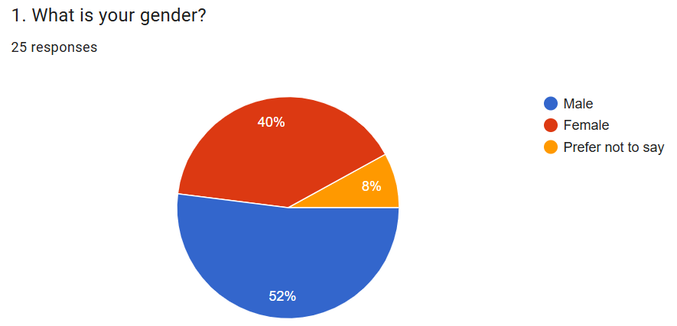
According to the results from Figure B1, 52% of respondents are male, and 40% are female. 8% prefer the option not to say.
Figure B2: Age
Source: (Author’s Survey Data / Google Forms Output)

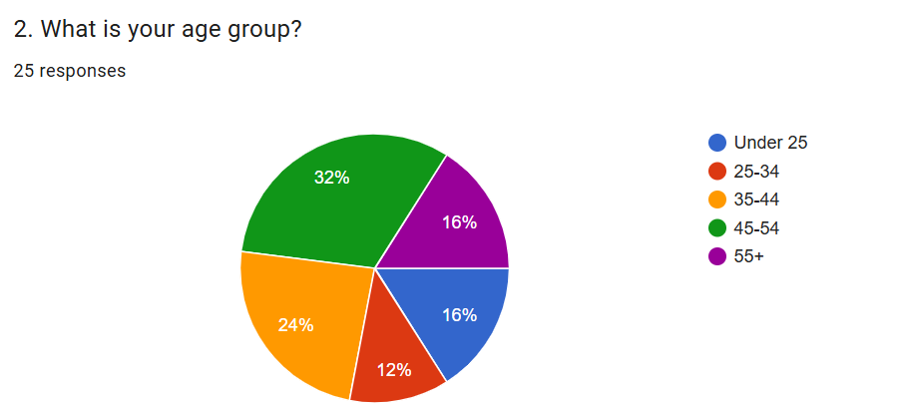
According to the results in Figure B2, 32% of participants from LTU are in the 45-54 age group. 24% of respondents are between 35 and 44 years old. 16 % each is for the group 55 and over and the age group under 25. The last age group is 25-34, at 12%.
Figure B3: Role within LTU
Source: (Author’s Survey Data / Google Forms Output)

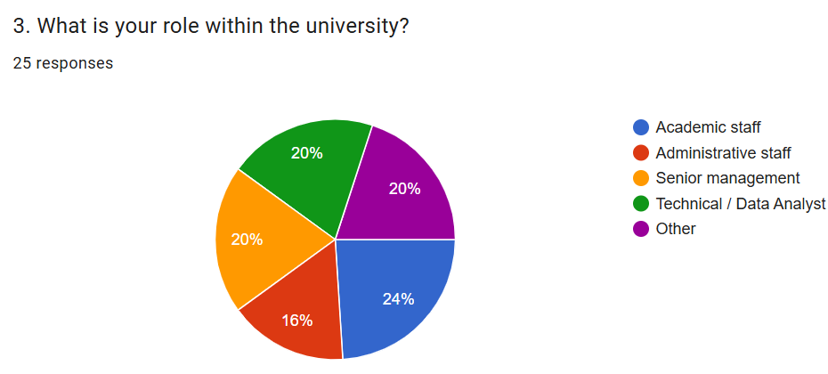
24% of the respondents are academic staff. Senior managers, technical staff, and others are 20% each. The last group is administrative staff, accounting for 16% of respondents.
Figure B4: Years of Experience
Source: (Author’s Survey Data / Google Forms Output)

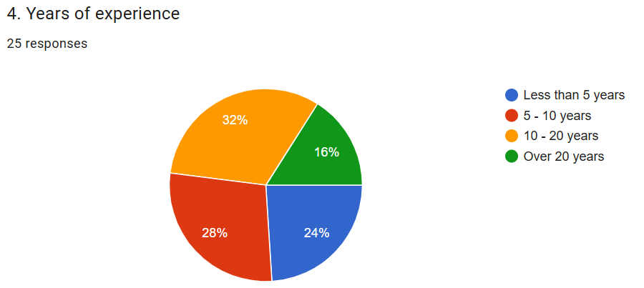

According to the results in Figure B4, 32% of respondents have worked for LTU for 10-20 years. 28% of participants are university staff with 5 to 10 years of experience. However, 24% of the academic staff participants have been working for less than 5 years. The last group is for people who have worked more than 20 years, with a 16% rate.

Figure B5: Familiarity with AI technologies used in organisational decision-making
Source: (Author’s Survey Data / Google Forms Output)

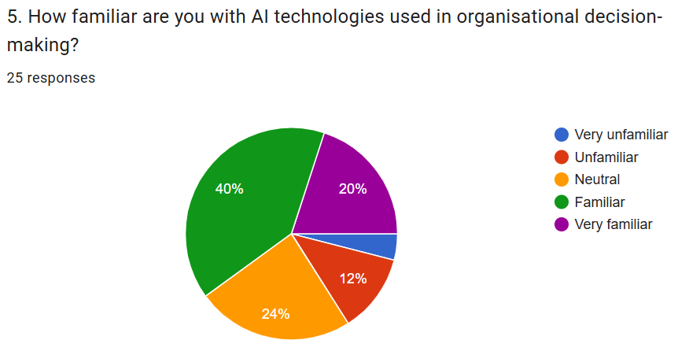
According to the results from Fig. B5, 40% of respondents are familiar with AI technologies in organisational decision-making. Another positive group, with a 20% positive rate, is very familiar. However, 24% of respondents are neutral, 12% are unfamiliar, and 4% very unfamiliar.
Figure B6: AI tool usage
Source: (Author’s Survey Data / Google Forms Output)

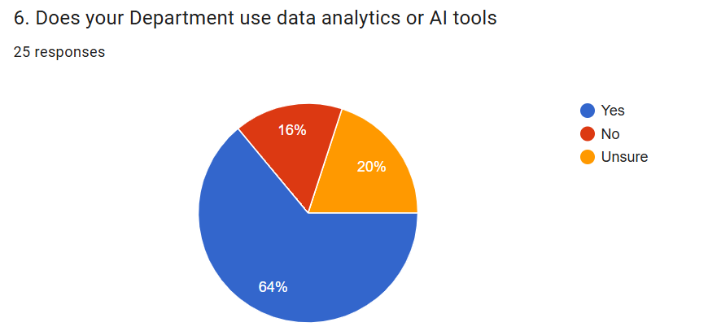
According to the results from Fig. B6, 64% of LTU participants reported using AI tools. However, 16 % do not confirm, and 20% are neutral.

Figure B7: AI tools improve the quality of organisational decisions
Source: (Author’s Survey Data / Google Forms Output)

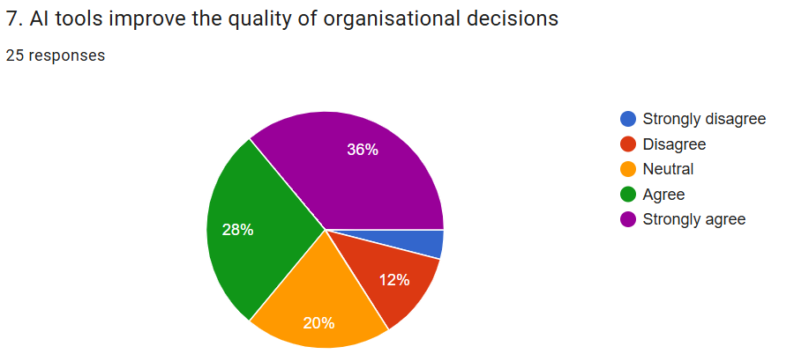

According to the results from Figure B7, 36% of respondents strongly agree that AI tools improve the quality of organisational decisions. 28 % of respondents agree that. However, 20% of respondents are neutral. 16% of respondents provide a negative answer – 12% disagree, and 4% strongly disagree.
Figure B8: AI tools improve efficiency in analysing data
Source: (Author’s Survey Data / Google Forms Output)

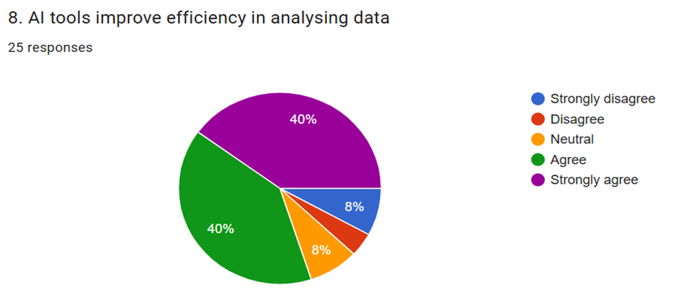
According to results from Fig. B8, 40% of respondents agree, and another 40% strongly agree. 8% is for strongly disagree and neutral. The last group is 2% for Disagree.

Figure B9: AI tools support strategic planning
Source: (Author’s Survey Data / Google Forms Output)

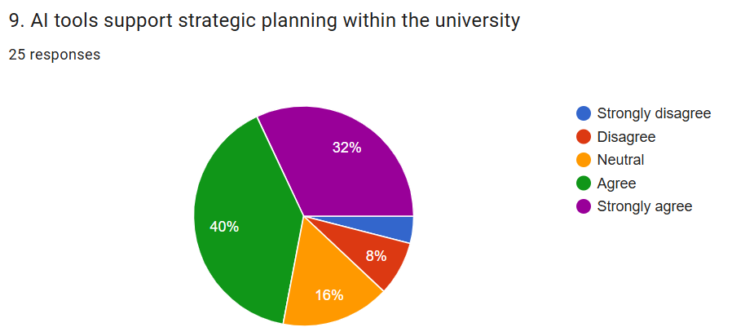
According to Fig. B9, 40% of respondents agree, 32% agree, 16% are neutral. Negative answers account for 12% of participants, with 8% disagreeing and 4% strongly disagreeing.
Figure B10: Satisfaction with the usage of AI tools in the organisation
Source: (Author’s Survey Data / Google Forms Output)

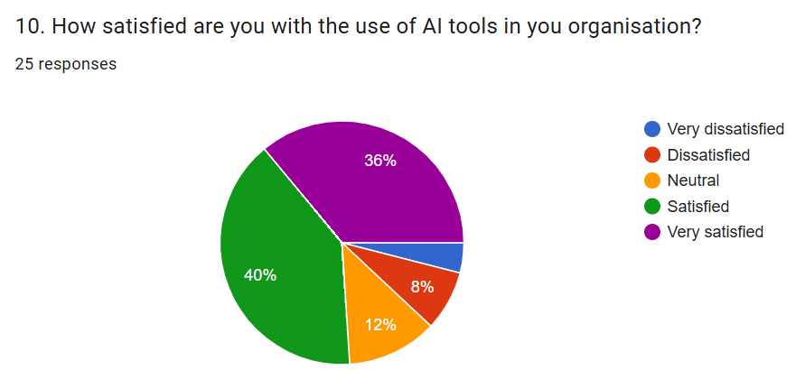
According to the results from Fig. B10, 76% of LTU respondents reported satisfaction with AI tools in organisations – 40% satisfied and 36% very satisfied. However, 12% are neutral, 8% are dissatisfied, and 4% are very dissatisfied.

Figure B11: Trust in AI-generated insights
Source: (Author’s Survey Data / Google Forms Output)
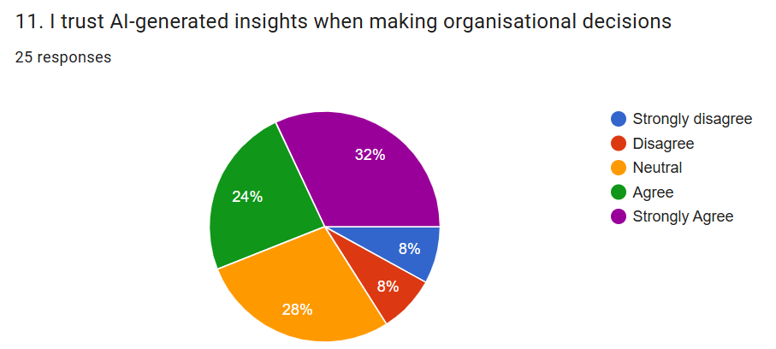
According to the results from Fig. B11, 32% strongly agree that they trust AI-generated insights when making organisational decisions. 24% agree that. However, 28% are neutral, and the last two negative groups each have 8%.
Figure B12: Supervision of AI systems by human decision-makers
Source: (Author’s Survey Data / Google Forms Output)

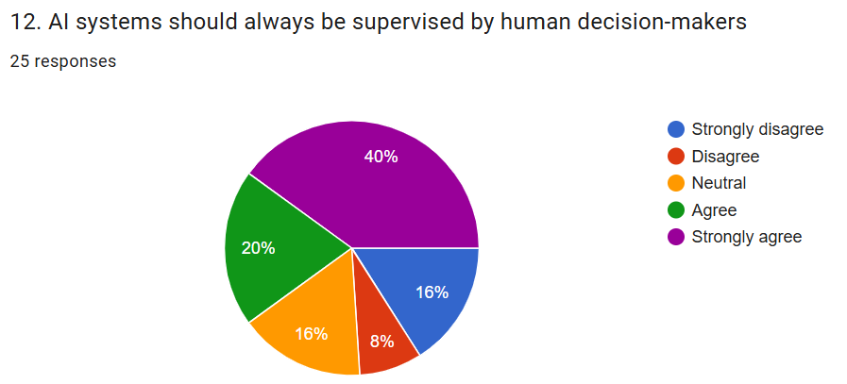
According to the results from Fig. B12, 40% are strongly agree that AI systems should always be supervised by human decision-makers. 20% of participants agree with that. However, 16% of participants were neutral, and 16% strongly disagreed, and 8% disagreed.
Figure B13: Ethical concerns related to data use about AI implementation
Source: (Author’s Survey Data / Google Forms Output)

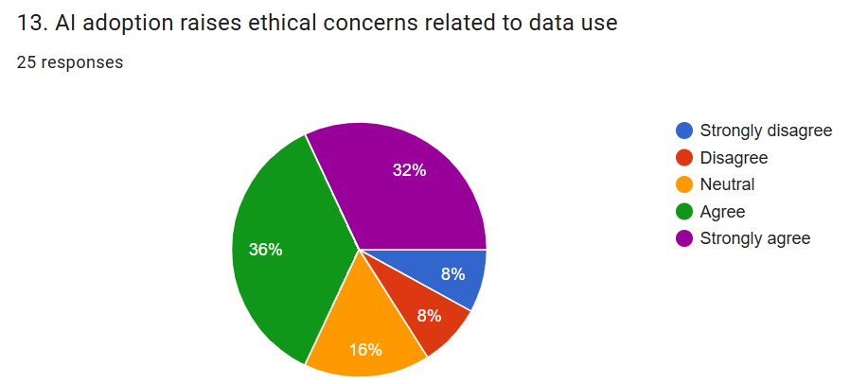
According to the results in Fig. B13, 36% agree that there are ethical concerns about AI adoption and data usage. However, 16% are neutral. Groups for "disagree" and "strongly disagree" are at 8% each.

Table 1: Benefits for AI usage in organisational decision-making
Source: (Author’s Survey Data / Google Forms Output)

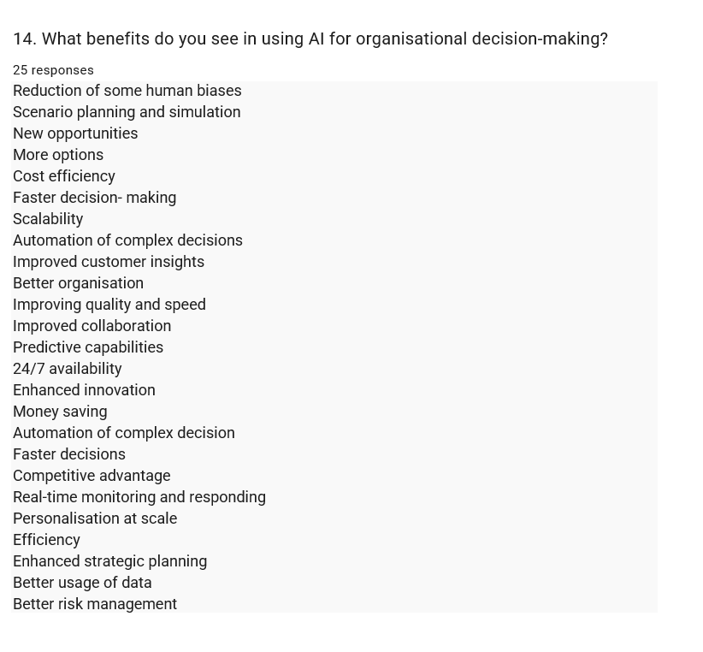
25 participants reported different benefits related to AI use in organisational decision-making.

Table B2: Concerns about AI adoption
Source: (Author’s Survey Data / Google Forms Output)
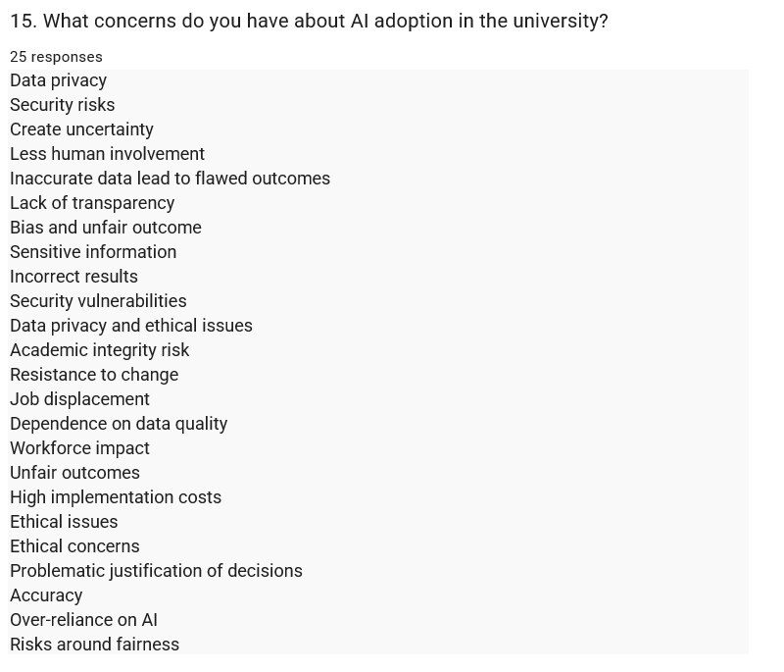
According to responses from 25 participants at LTU, there are different concerns regarding AI adoption.

Appendix C

Project Timetable (Gantt Chart)

Table C1: Gantt Overview
Source: (Author's own work)
Week | Activity
Week 1 | Literature review completion
Week 2 | Survey design and ethics approval
Week 3 | Data collection at LTU
Week 4 | Data analysis
Week 5 | Writing findings
Week 6 | Final report

Appendix D

Budget

Table D1: Budget of the Project
Source:(Author’s own work)
Item | Estimated Costs
Travel from Derby to Leeds | £58 return ticket
Printing questionnaires | £10
Miscellaneous | £12
Total: | £80

