Advanced Character Animation - ACCA5038

Ava Daniels
2218486
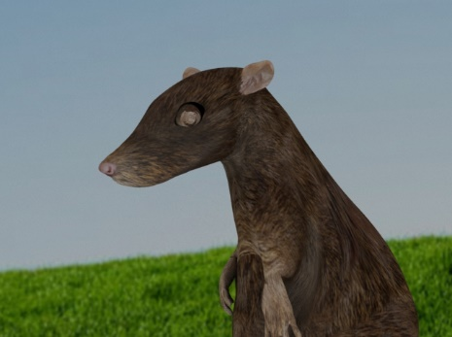

Contents of pages:
- Title page
- Research on Anthropomorphism and the film Ratatouille
- Learning about Animal action and animal walk cycles
- Workflow
- 2nd Animations – Anthropomorphism
- Bibliography

YouTube link to 30 Sec Progression Video: (Minimum length was accidently taken as maximum...)
https://youtu.be/XRa8JnSBFqo

2. Research on Anthropomorphism and the film Ratatouille
I chose to research into Anthropomorphism.
Anthropomorphism is the attribution of human characteristics to animals. It is similar but different to personification, that is when “figurative language is used to give inanimate objects or natural phenomena (such as saying a hurricane is angry) humanlike characteristics in a metaphorical and representative way.” – [7]

Anthropomorphism, on the other hand is more, “nonhuman entities like animals or inanimate objects displaying literal human traits and being capable of human behaviour.”
- “People generally anthropomorphize to make sense of events and behaviours they experience. Further, attributing emotions, attitudes, mental states, faces, and values to non-human things can help you feel connected to something.” – [6]

I also delved into reading about the film ratatouille and the anthropomorphic subjectivity of the specific rat character.

Some interesting thoughts:
The film doesn’t completely anthropomorphise Remy, he switches between human characteristics and natural movements and other behaviours. The film also touches on the concept that rats are disgusting to human’s, “a marker of unsanitary conditions, alleged spreader of the plague, symbol of disloyalty” [3] and especially not belonging in a restaurant.
Unlike other media, Remy accepts that he is a rat, and so then the viewer has their own opinion to create about ‘rats’.
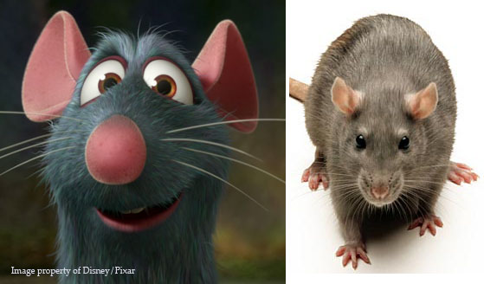
Remy is exaggerated for film purpose seen on the left, with a normal rat on the right. [5]
Remy is given human eyes with eyelids and chooses himself to act ‘human’ by standing on his hind legs.
But he switches between, also acting like a natural rat and having the same characteristics such as heightened sense of smell. Which obviously plays well into the story of him being a chef!

The film ratatouille does a great job of “allowing us, as human beings, to identify with the rats.” “This rodent has been quickly and efficiently transformed into a sympathetic, or at least believable, character”. - [2]
“Therefore, encourages the audience to rethink the potential (im)balance of human representation and animality across animated anthropomorphism, offering a glimpse into how computer-animated films might begin to restructure its human/beast binary” - [1]

- Learning about Animal action and animal walk cycles
Next: the idea and plan for my animation!
I carried on the idea of a rat as an anthropomorphised character. My plan is to create separate animations of a natural walk cycle of a rat, and then an anthropomorphism animation. Clips of the same rat with human behaviour and ‘characteristics’.
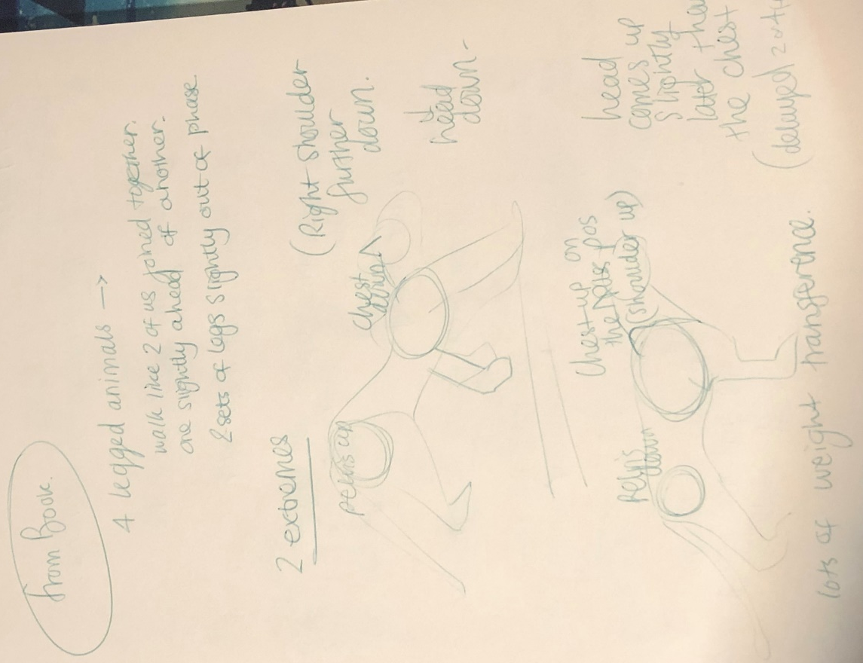
For the Walk cycle I want it to look as realistic as possible. With limited animation knowledge on animal animation, I did some learning on this.
- Animation Learning –
Animal Action + ‘basic animal walk pattern’ Section
From the book “The Animators Survival Kit” By Richard Williams [9]
I have learnt that as a novice animator animating a real animal was quite optimistic to produce a realistic looking outcome.
But it was good knowledge learning still which I can improve on.
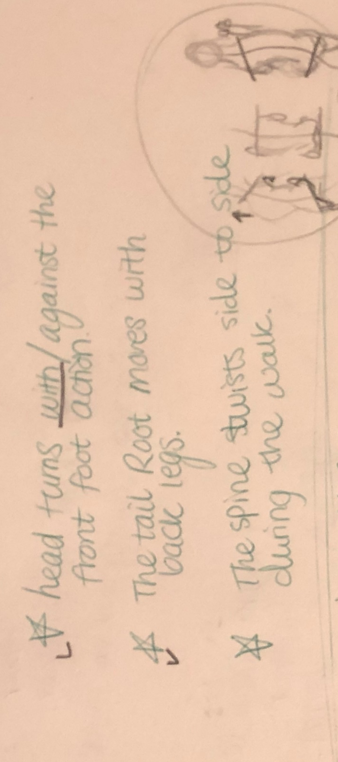
For the walk cycle I also referenced a live reference video. [10] https://www.youtube.com/watch?v=qsJ3Zlae5Cg
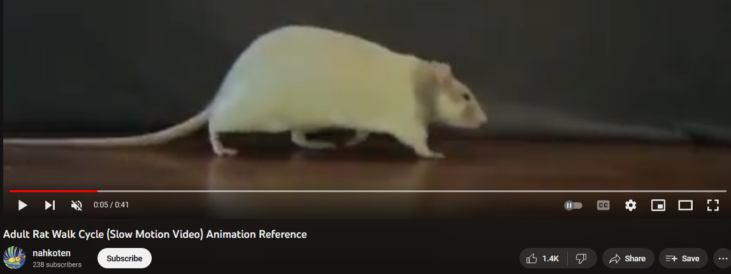
4. Workflow
I also decided to add some of my own movements to add to the animation, tail movement and the rat reacting to a noise ‘off-screen’.
A big challenge was timing the legs with the correct body movements.
Movements add to the rat:
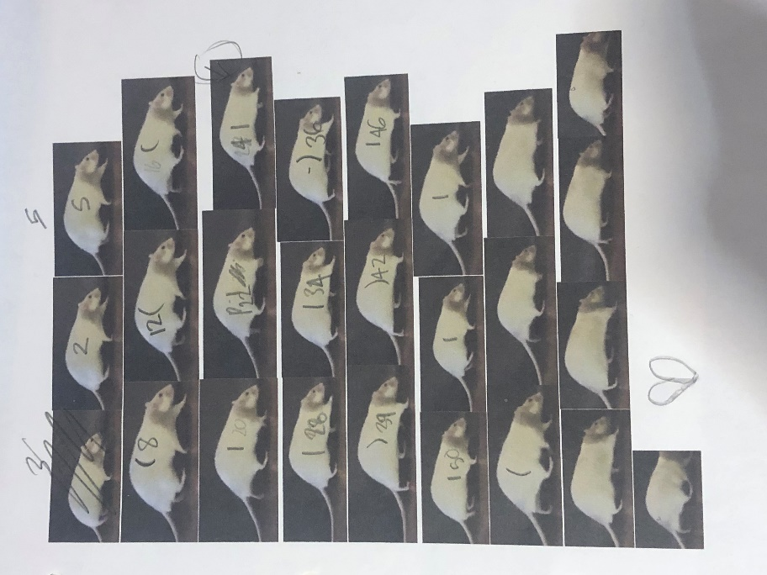
- Spine curves
- Head bobs with steps
- Ears reacting to sound before head
- Tail root moving with hind legs steps
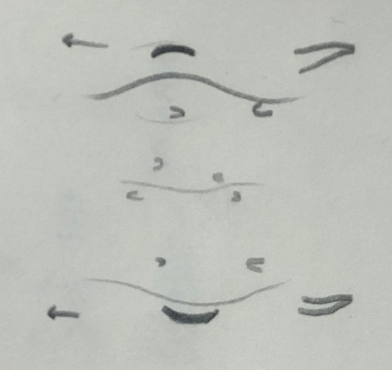

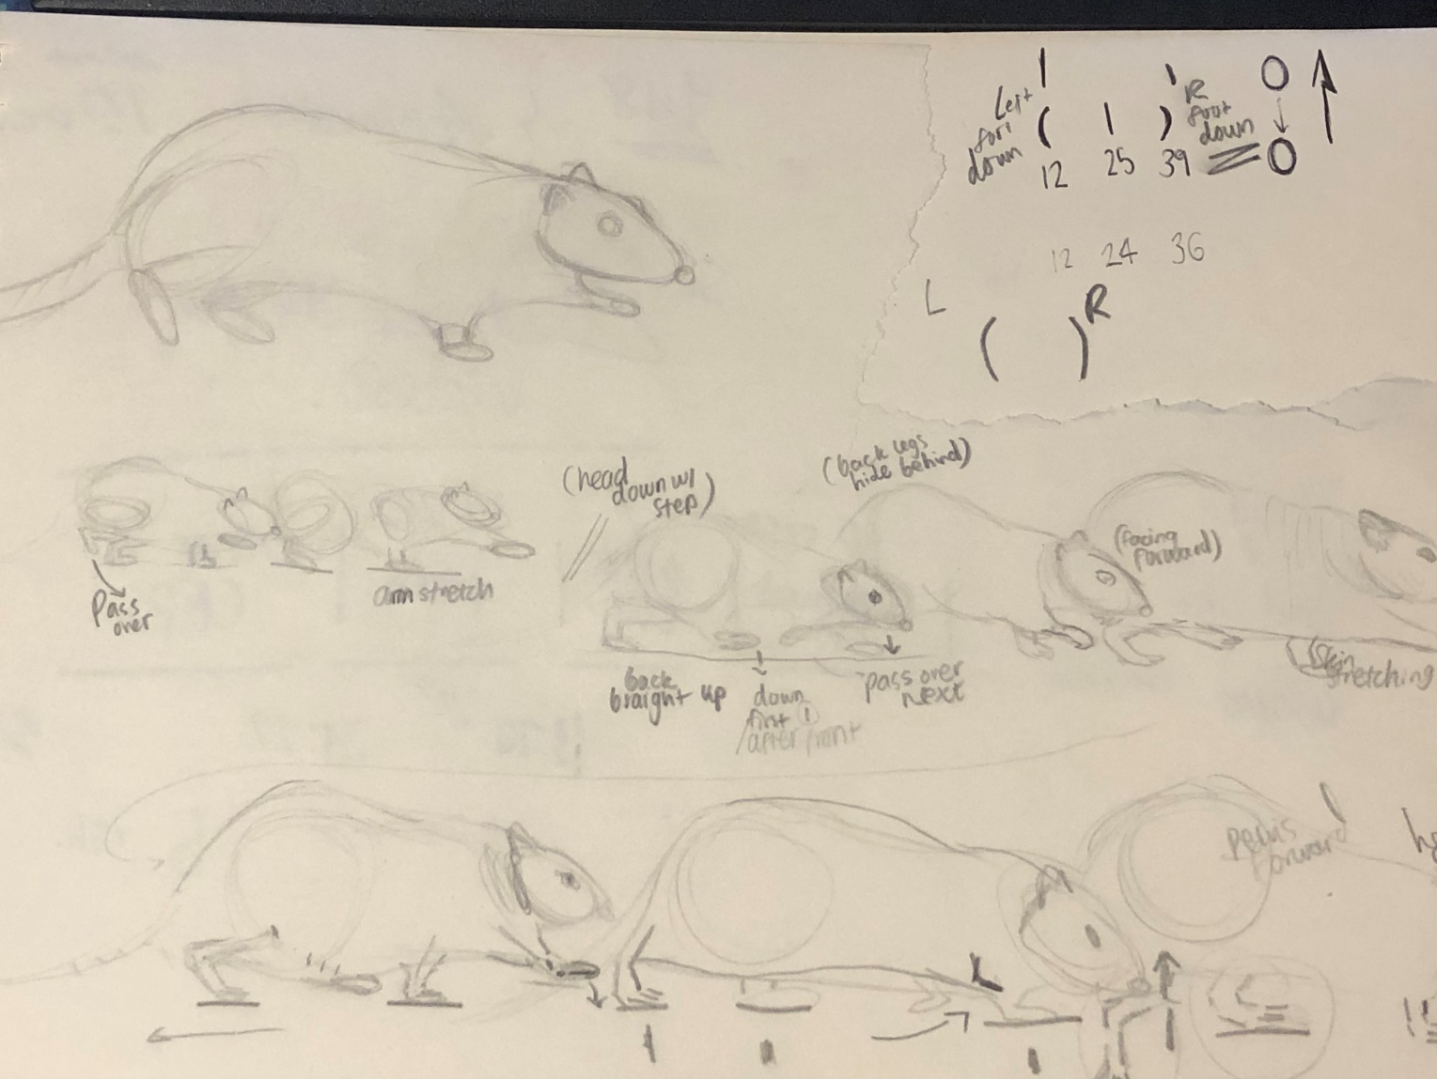
Here are reference plans and sketches I made to aid my main walk cycle animation.
- 2nd Animations – Anthropomorphism
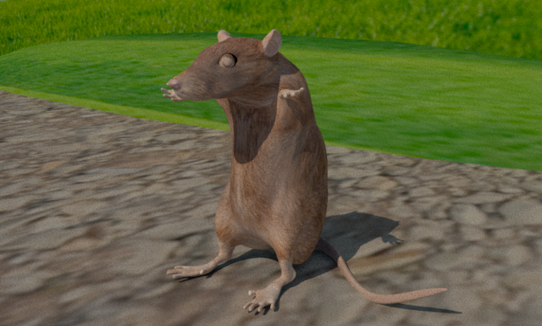
The Second half of my progressive video is my take on anthropomorphism and giving character to an animal.
Both clips were made because of the boundaries of the rig on the rat. The rig was very natural like, so it was hard to manipulate into ‘human’ poses, bring hands up to the head for example. Both animations referenced videos I took of myself doing the desired movements.
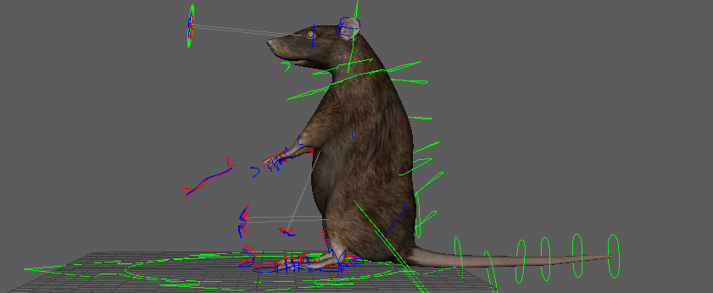
Improvements I could do to my animations and other attributes of the submission:
- Correct and improve texture of Rat for correct eyes and more realistic ‘fur’.
- Learn how to lock limbs in place for no ‘sliding effect’ and movement through floor.
- More knowledge and application on weight and shifting of it when walking.
- Better backdrops/floors and renders of such.

- Bibliography
Research:
[1] C. Holliday, “‘I’m not a real boy, I’m a puppet’: Computer ... - sage journals,” Sage Journals, https://journals.sagepub.com/doi/10.1177/1746847716661456?icid=int.sj-abstract.citing-articles.7 (accessed Dec. 8, 2023).
[2] S. Brandes and T. Anderson, (PDF) ratatouille: An animated account of cooking, taste ... - researchgate, https://www.researchgate.net/publication/233076455_Ratatouille_An_Animated_Account_of_Cooking_Taste_and_Human_Evolution (accessed Dec. 8, 2023).
[3] A. Siegel, “Culinary tail,” The Ringer, https://www.theringer.com/2017/6/29/16042036/movies-of-2007-ratatouille-pixar-brad-bird-jan-pinkava-768f60f4313d (accessed Dec. 8, 2023).
[4] Y. K. Y. M. Grazia, “Anthropomorphic Animal Characters in Disney Animated Films: The Representations and Impositions of Human Nature,” The Education University of Hong Kong Handbook for ... - eduhk library, https://www.lib.eduhk.hk/pure-data/pub/202001537/202001537_2.pdf (accessed Dec. 8, 2023).
[5] J. Gurney, “Animal characters 2: Humanization,” Gurney Journey, http://gurneyjourney.blogspot.com/2008/02/animal-characters-2-humanization.html (accessed Dec. 8, 2023).
[6] S. Barkley, “What is anthropomorphizing? psychology, benefits, and downsides,” Psych Central, https://psychcentral.com/health/why-do-we-anthropomorphize (accessed Dec. 8, 2023).
[7] “How to write anthropomorphism: Examples and definition - 2023,” MasterClass, https://www.masterclass.com/articles/how-to-write-anthropomorphism (accessed Dec. 8, 2023).
[8] Bird, B., & Pinkava, J. (2007). Ratatouille. Buena Vista Pictures.

Book:
[9] R. Williams, The Animator’s Survival Kit: A Manual of Methods, Principles and Formulas for Classical, Computer, Games, Stop Motion and Internet Animators. Farrar Straus & Giroux, 2012.

Reference video:
[10] “Adult rat walk cycle (slow motion video) animation reference,” YouTube, https://www.youtube.com/watch?v=qsJ3Zlae5Cg (accessed Dec. 8, 2023).

Music/sounds used in progression Reel:
[11] “Free music for YouTube videos & creators • uppbeat,” Free Music For YouTube Videos & Creators • Uppbeat, https://uppbeat.io/ (accessed Dec. 8, 2023).

