In the UK, crime committed by adolescent people has often been linked to a wide range of social economic areas of concerns. This essay will examine race and class with its correlation with youth offending, exploring difficulties such as deprivation, discrimination and education in the aim of understanding and engaging in issues within the youth justice system.
Firstly, racism historically has been deep rooted in society, with the same opportunities often being less attainable for black youth and other ethnic minorities than it is for many white people in the UK. The criminal justice system in particular to this day has seen controversy with institutional racism, reports such as the mcpherson report have contributed to highlighting the lack of care and the incompetence of the police which have led to miscarriages of justice for black people in the UK such as stephan lawrence (Gloucestershire County Council, 2023). These failures drew national attention to the ways in which racial bias can become embedded in institutional practices, from policing to court procedures.
Key findings according to HM Inspectorate of Probation concluded that within the youth justice system there is a vast amount of ethnic disproportionality within areas such as social deprivation, education, family and labelling all contributing to crime patterns (HM Inspectorate Of Probation, 2017).
It is proven that black people have a higher probability to be arrested, charged, convicted and given a custodial sentence over white people (Stockdale and Casale, 1992, pp.249–250). Due to this system black children are raised with unequal justice and opportunities. stop and searches In 2023-4 reported 103,135 stop and searches were carried out against children (Youth Justice Board, 2025). While stop and searches are under the police and criminal evidence act 1984 (PACE) they are widely controversial due to its misuse, especially with youth and ethnic minorities. Black people have been disproportionately targeted and over-represented in stop and searches. Experiences of racial profiling, harassment, and exposure to police-involved violence can create feelings of mistrust and insecurity towards law enforcement. Research shows that stop and search practices disproportionately affect minority groups; for example, in the year ending March 2023 there were 24.5 stop and searches per 1,000 Black people compared to 5.9 per 1,000 White people in England and Wales (Home Office, 2024). These experiences are damaging to trust with the police, particularly among young people who may feel targeted. As a result, negative interactions with law enforcement in such circumstances may increase tensions between young people and the police.

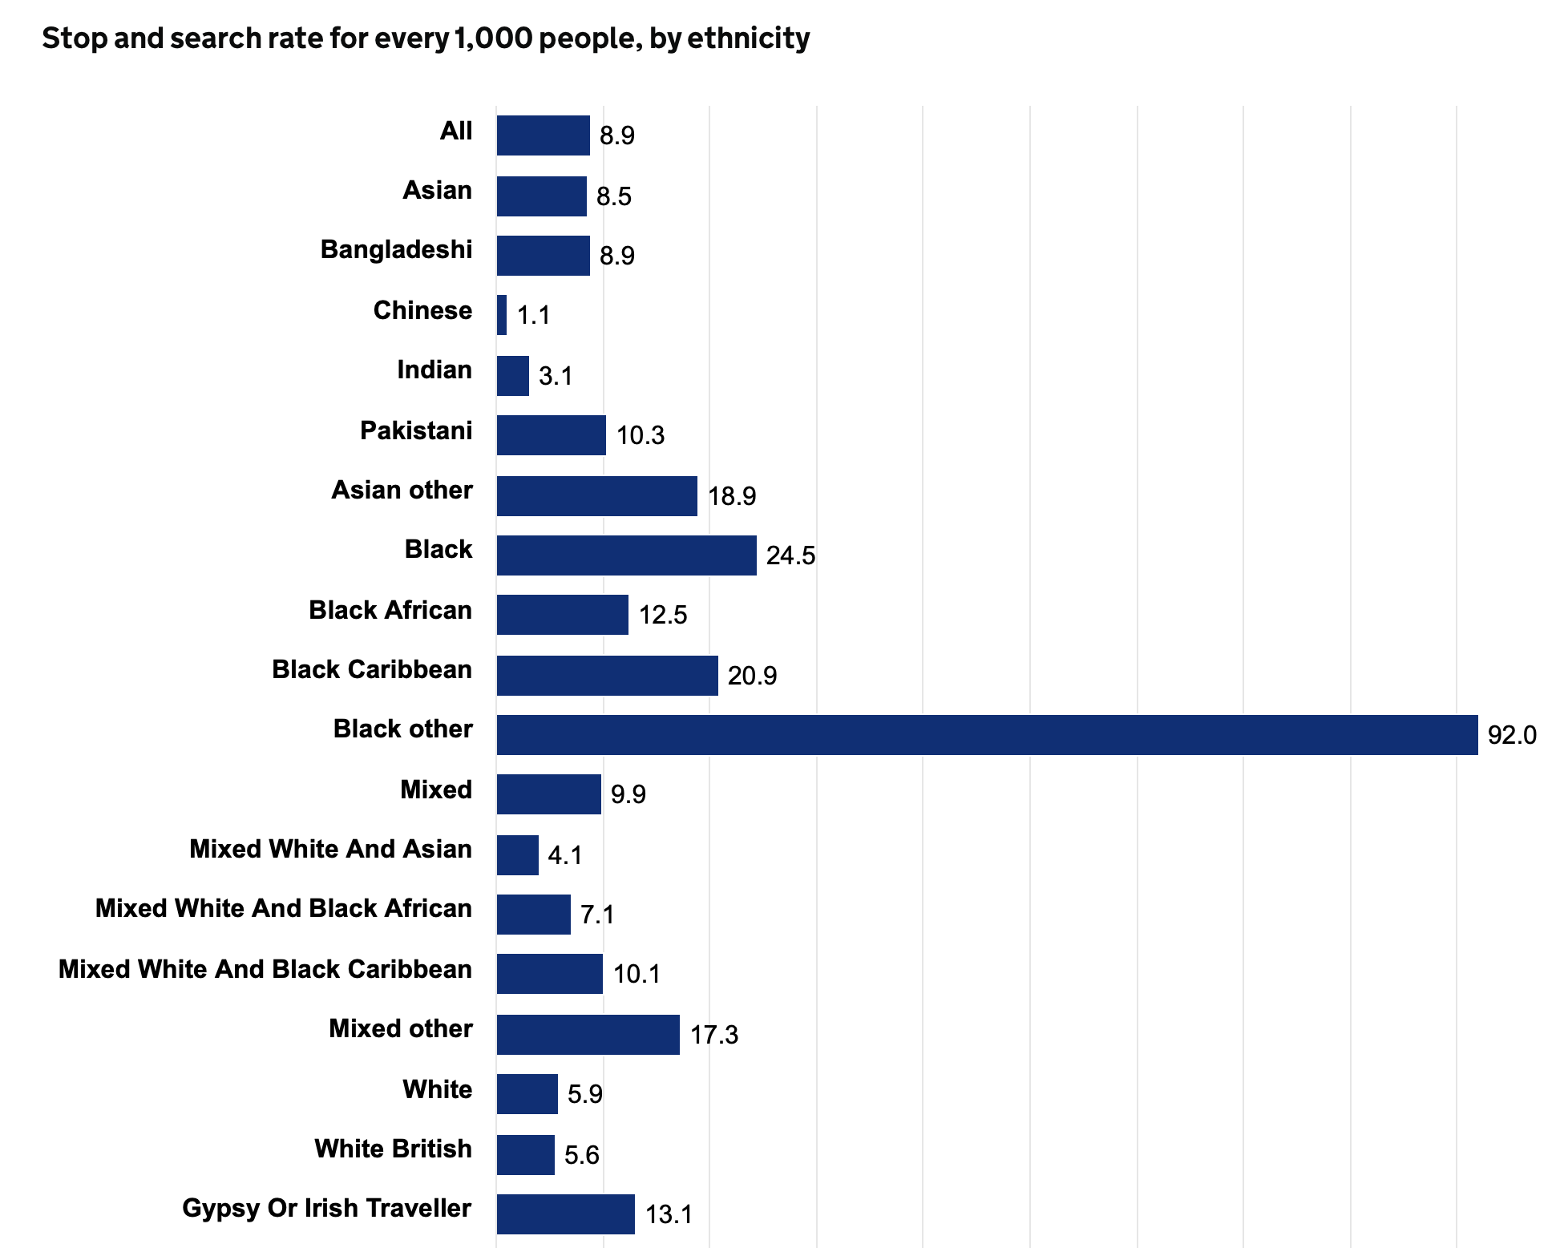

(Home Office, 2024).
Moreover, Percentages show that 45.3% of black youth feel targeted by police and 35.8% believe that officers deny mistreatment and wrong doings. (Wendel et al., 2022). Without trust comes many other issues such as dark figures of crime, directly affecting crime trends and patterns, and lack of justice (Biscontini, 2024).
In terms of police violence against black youth, many brutal methods of restraints such as pepper spray and tasers were more likely to be used against black people. One third of 114 restrained youth offenders/suspects were black or in a ethnic minority. And police were 5.7% times more likely to use force on a black young individual than someone who is white. (Institute of Race Relations, 2024).
Secondly, is the discussion of class. Deprivation is known to have a negative impact on the outcome of a child's life, with factors such as being raised in a low income area and/or household having an effect on the probability of a crime being committed. Children raised in persistent poverty are five times more likely to have been arrested and/or taken into police custody, Moreover they are twice as likely to have carried a weapon (Dickinson, 2025). Gang culture and county lines have often been at the hand of youth offending. Financial deprivation may make an adolescent more vulnerable to gang grooming, enticing them with material goods and opportunities they may not otherwise have access to thus glorifying gang culture to youth offenders (Clemmow et al., 2025). The exploitation of these children and teens may lead into county lines organisations where violence and coercion may be used against them (National Crime Agency, 2018). Merton's strain theory has often been used to correlate poverty and youth offending, arguing that the limitations and inequalities in achieving success in life may make a child more susceptible to crime and to attain their goals in any means necessary (Kurpiel and McVie, 2025), this can be used within understanding the initial desire for a child to initiate gang culture. The county lines strategic assessment dated from april 2024 to march 2025 gathered that there are over 6,500 county lines in the UK with 2,659 children officially recorded in the system, the official figures are unknown as many operations remain discreet and underground to this day (National Police Chiefs’ Council, 2025). While county lines tend to be more unknown and so the figure tends to be smaller, the figures for gang involvement in general are much larger combining both street gang and organised crime involvement. Children in Need deemed that in 2023 11,110 children were at risk due to gang involvement. Moreover gang involvement consistently endangers the lives of thousands of children around the UK with involvement in drug trades, violence, knife crimes, sexual abuse and more. (Children in need, 2025). While these children are in fact youth offenders committing crimes and causing harm, they are still victimising themselves. While it is still relevant that some youth offenders join gangs due to the desire for better life, another reason they may join is peer pressure and familiarity (Tonks and Stephenson, 2019) having group protection and almost a ‘family’ may be comforting for a teen especially one that grew up in an unsafe/distant environment at home, or not a family at all such as children within the care system.
Intergenerational deprivation is also seen to affect youth offending as children from welfare families are more likely to partake in risk-taking and delinquent behaviour (Bubonya and Cobb-Clark, 2021), . Substance abuse is an example of criminal behavior that is addressed by this study. In addition, young people from welfare backgrounds are more likely to partake in unprotected sex, with a higher chance of teenage pregnancy, with this comes educational barriers and continuing generational difficulties. This might affect young people’s ability to continue their education and pursue further education, which might affect their employment prospects in the future. This might therefore create a vicious circle where people living in deprived circumstances, which lack opportunities, resources, and support systems, might be more prone to criminal behavior, which might create a repeat circle of deprivation and disadvantage among families and societies, reinforcing the barriers between the social classes in society. While this is not always the case it is still important to note examples and trends within children from lower class and ‘poorer backgrounds’.

To continue with educational inequalities, Lack of education and schooling is also proven to increase the likelihood of a young person to offend. 52.5% of young adults that were convicted with a custodial sentence had struggled with attendance throughout their education, additionally 35.9% of young adults with a non custodial sentence and or cautions were persistently absent (Office for National Statistics, 2022). Both race and class have been closely linked with educational inequality. Schools with low funding, fewer resources, larger class sizes, and higher rates of exclusion tend to have higher proportions of students from disadvantaged homes. Black and mixed-race boys have higher rates of exclusion from schools in England and Wales, which is a risk factor for criminal activity with permanent records and other difficulties. With this is the social barriers within education, in this case Young people are disengaged from structured settings through exclusions and low educational engagement. This accounts for increased vulnerabilities for delinquent connections such as gangs and more. After exclusion, young people are faced with difficulties such as less employment opportunities and permanent records of their wrongdoings in education, due to this many young people may essentially ‘give up’ and begin risk taking behaviours, as they have less too lose than a person who has not been excluded or comes from a better background. (Parr-Morley, 2024).
To summarise, the numerous structural elements that influence juvenile criminality are highlighted by the junction of race, class, and education. Black and minority children from low-income families are more likely to encounter social and economic disadvantages that may impact their criminal behavior, encounter the criminal justice system disproportionately, and encounter obstacles in obtaining a high-quality education. While policies that prioritize fairness and support for at-risk adolescents may help reduce offending in the long run, interventions that do not address these structural inequities run the danger of perpetuating current cycles of disadvantage and criminalization. And in a final conclusion, by understanding the context of youth offending, policymakers and practitioners will be able to come up with effective strategies to prevent crime and ensure equality for all young people.

Reference list - alphabetical order

- Biscontini, T. (2024). Dark figure of crime | EBSCO. [online] EBSCO Information Services, Inc. | www.ebsco.com. Available at: https://www.ebsco.com/research-starters/law/dark-figure-crime.

- Bubonya, M. and Cobb-Clark, D.A. (2021). Pathways of Disadvantage: Unpacking the Intergenerational Correlation in Welfare. Economics of Education Review, 80. doi:https://doi.org/10.1016/j.econedurev.2020.102066.
- Children in need (2025). Children in need, Reporting Year 2025. [online] Service.gov.uk. Available at: https://explore-education-statistics.service.gov.uk/find-statistics/children-in-need/2025.

- Clemmow, C., Rottweiler, B., Unal, C., Doherty, P., Seaward, A., Marchment, Z. and Gill, P. (2025). EVIDENCE REVIEW Evidence Review on Poverty and Youth Crime and Violence Prepared by. [online] Available at: https://youthendowmentfund.org.uk/wp-content/uploads/2025/08/YEF-Poverty-Evidence-Review-Technical-Report-August-2025.pdf.

- Dickinson, E. (2025). Childhood Poverty and/or Parental Mental Illness May Double Teens’ Risk of Violence and Police Contact - BMJ Group. [online] BMJ Group - Helping Doctors Make Better Decisions. Available at: https://bmjgroup.com/childhood-poverty-and-or-parental-mental-illness-may-double-teens-risk-of-violence-and-police-contact/.

- Gloucestershire County Council (2023). The Murder of Stephen Lawrence and the Macpherson Report - Gloucestershire County Council. [online] www.gloucestershire.gov.uk. Available at: https://www.gloucestershire.gov.uk/your-community/black-history-month/black-history-month-2020/race-relations-acts-1965-2000/the-murder-of-stephen-lawrence-and-the-macpherson-report/.

- Higginson, A., Benier, K., Shenderovich, Y., Bedford, L., Mazerolle, L. and Murray, J. (2018). Factors Associated with Youth Gang Membership in Low‐ and Middle‐income countries: a Systematic Review. Campbell Systematic Reviews, [online] 14(1), pp.1–128. doi:https://doi.org/10.4073/csr.2018.11.

- HM Inspectorate Of Probation (2017). Ethnic Minorities – HM Inspectorate of Probation. [online] Justiceinspectorates.gov.uk. Available at: https://hmiprobation.justiceinspectorates.gov.uk/our-research/evidence-base-youth-justice/specific-sub-groups/ethnic-minorities/?utm_source=chatgpt.com.

- Home Office (2024). Stop and Search. [online] www.ethnicity-facts-figures.service.gov.uk. Available at: https://www.ethnicity-facts-figures.service.gov.uk/crime-justice-and-the-law/policing/stop-and-search/latest/.
- Institute of Race Relations (2024). Criminal Justice System Statistics. [online] Institute of Race Relations. Available at: https://irr.org.uk/research/statistics/criminal-justice/.

- Kurpiel, A. and McVie, S. (2025). The Relationship between Dimensionality and Duration of Household Poverty during Childhood and Onset of Youth Offending. The British Journal of Criminology. doi:https://doi.org/10.1093/bjc/azaf075.

- National Crime Agency (2018). County Lines. [online] National Crime Agency. Available at: https://www.nationalcrimeagency.gov.uk/what-we-do/crime-threats/drug-trafficking/county-lines.

- National Police Chiefs’ Council (NPCC). (2025). Annual County Lines report: Threat Remains Stable but Business Model Used by Perpetrators Continues to Evolve. [online] Available at: https://news.npcc.police.uk/releases/annual-county-lines-report-threat-remains-stable-but-business-model-used-by-perpetrators-continues-to-evolve.

- Office for National Statistics (2022). The Education and Social Care Background of Young People Who Interact with the Criminal Justice System - Office for National Statistics. [online] www.ons.gov.uk. Available at: https://www.ons.gov.uk/peoplepopulationandcommunity/educationandchildcare/articles/theeducationandsocialcarebackgroundofyoungpeoplewhointeractwiththecriminaljusticesystem/may2022.

- Parr-Morley, B. (2024). The Prevalence of School Exclusions in the UK, Their Root causes, and the Importance of Preventative Offerings over Reactive Interventions. [online] Catch22. Available at: https://www.catch-22.org.uk/resources/the-prevalence-of-school-exclusions-in-the-uk/.

- Stockdale, E. and Casale, S. (1992). Criminal Justice Under Stress. Blackstone Press Limited, pp.249–250.

- Tonks, S. and Stephenson, Z. (2019). Disengagement from Street gangs: a Systematic Review of the Literature. Psychiatry, Psychology and Law, 26(1), pp.21–49. doi:https://doi.org/10.1080/13218719.2018.1482574.

- Wendel, M.L., Jones, G., Nation, M., Howard, T., Jackson, T., Brown, A.A., Kerr, J., Williams, M., Ford, N. and Combs, R. (2022). ‘Their help is not helping’: Policing as a tool of structural violence against Black communities.. Psychology of Violence, 12(4), pp.231–240. doi:https://doi.org/10.1037/vio0000411.

- Youth Justice Board (2025). Youth Justice Statistics: 2023 to 2024. [online] Gov.UK. Available at: https://www.gov.uk/government/statistics/youth-justice-statistics-2023-to-2024/youth-justice-statistics-2023-to-2024.

