Student Name: Bilal Mohammed
Student Id: 2022701
Module name: BMGM4001
Module tutor: Jayne Griffith Parry
Module name: Introduction to Gastronomy

The Restaurant - operation, and function

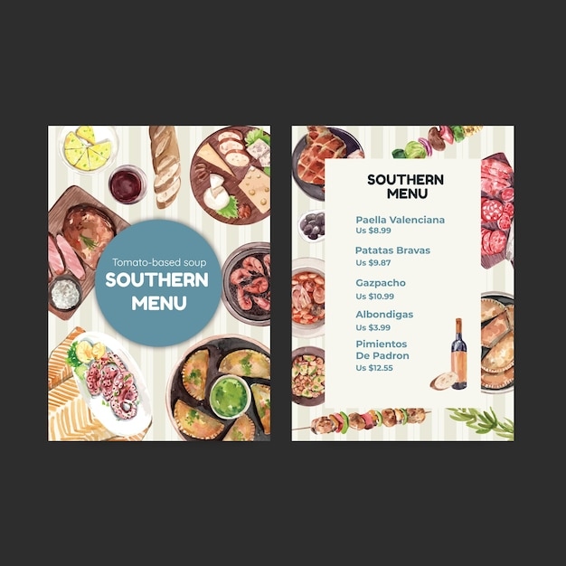
A restaurant is a place where anyone can satisfy their hunger for a specific amount of money. It is a part of every country and cannot be avoided by the general public. In West Bengal, "The Southern Restaurant" is a well-known hotel. Based on their orders, it serves all customers at the appropriate time. Customers began arriving at their restaurants early in the morning. They set aside some seats for customers so that they can rest if they are unable to serve on time (Nicholas,2006). It has some functions that include a food menu, customer satisfaction, behaving with customers, and food serving systems. As a result, a restaurant can indeed be defined as a place where customers want to eat and where the restaurant assists them in fulfilling their desires.
Figure No:1.1

The customer, as well as the food manager or chef, must be presented in a restaurant. A restaurant gives the food manager orders based on various perceptions (Oyster, The Southern Steak &, n.d.). Consumer behavior has a significant influence on orders. Customers place orders based on their personal preferences or motivations. Customers order the same food in the morning and then order different foods at the launch time (Sachin Gupta, 2007). These are the shifts in consumer preferences and orders. Satisfaction, repeat purchases, and restaurant performance all have a strong correlation. They have lot of food items such as potatoes, crispy chicken, and fried chicken that are familiar to their restaurant.

“The southern restaurant” first opens on the country’s national al. It’s a franchise operation run by four owners. They justified each other at the end of the month and observe the total profit, sell, and cost. Information technology keeps track of profits and total sales. Technology aids in the creation of a strong account that can be used to bring all of the accounts from a specific period together (Daryl Ansel 1999). After a long period, over two decades, information technology has advanced to the point of being sufficiently sophisticated.

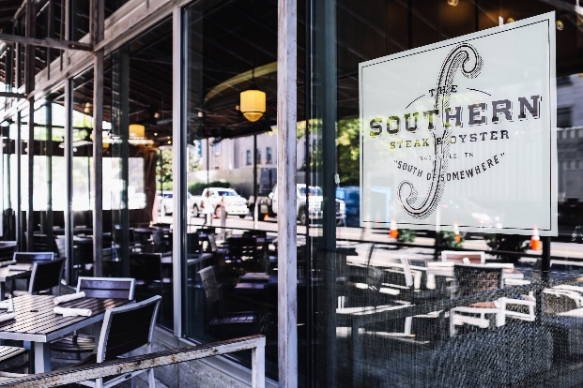
Figure No:1.2
During the customer order process at "The Southern Restaurant," they were told to "Please take a seat!". The customer asked the waiter when the seat would be available (The Southern, n.d.). When the waiter approached them, he or she inquired as to what type of food they preferred. He or she also hands out a menu card with the names of all the food items on it. Customer dissatisfaction, loss of probability, and restaurant losses result from improper, unstructured menus. (Julien E. 2008). Despite the fact that some restaurant owners disagree with the menus, they all agree to support them, and the delicious food helps them make money.
This hotel has a lovely interior design. It's completely decked out with lighting and other electronic gadgets. The hotel's decor, according to the owners, aids in attracting more customers to the business. As a result, a large number of people visit their hotels and make purchases ( (Jeou-Shyan Horng, 2013). The Southern Hotel is entirely made of glass, and there are numerous water tanks throughout. They also paint some artwork on the wall so that customers can take pictures of it. As a result, hotel decoration is required and aids in attracting customers.
Five days ago a photography event was launched in “The Southern Hotel”. The waiter approached all the customers and handed them a lovely tissue box, telling everyone to take a seat. Then people went to the rooftop and took some photos; it was an incredible location. So that everyone can see each other and every customer can take in the beauty of the place. The heart of a restaurant is the arrangement and decoration. As a result, it is a basic requirement to make it beautiful. A restaurant, once again, adds some amenities. Such as sporting events, indoor games, children's games, and so on (Oswald Mhlanga, 2018). In addition, they turned their restaurant into a large play area for couples and their children to enjoy.
Some of the requirements that help to make a restaurant effective must be met by a restaurant. A restaurant owner must establish a standard procedure that all employees must follow. Everyone will adhere to a standard law that is sometimes imposed by the owner or the metropolitan. The amount of salary or increment that the worker will end up receiving is included in the laws. The most important thing is that the laws should be followed by everyone. (Bharath M, 2004). As a result, everyone in the corporation must be aware of the duty time, extra time, and behavioral approach. These are the basic guidelines that hotels must follow.

A restaurant has some processes that help to achieve better results and outcomes. Employees at a hotel must be paid a competitive wage. In addition, the wages and overtime pay must be perfect. At different times of the year, such as during the 'Eid festival and other festivals, a restaurant may offer bonuses (THOMAS AHRENS, 2010). It makes it easier to hire hotel staff who are more motivated. If a hotel is unavailable, the employee may be able to stay with family or friends. Laborers must also consider issues such as maternity leave.
Training the workers and chefs is badly needed for the workers. The hotel restaurant program is becoming a professional degree in every world. It gives the proper training and other facilities that help to get things done. The degree is divided by four characteristics. These are purpose, curriculum, faculty, and industry communication ( (Solozhentsev, 2012). Financial, feedback from employees, and contemplated new programs bring a great revolution to the restaurants’ management and training systems. Training makes the employer educated and experienced which helps to obtain the goals.
In a hotel, human resource management is inevitable and incredibly integral to success. Nowadays human resources become part of every sphere of the restaurants. The owner must have to manage and keep the HR updated so that they can make every decision as they want. Proper human resource management helps to gain the motto of the hotels timely and accurately. Also, the owner or the restaurant’s manager must keep good planning, organizing, motivating, and leading them properly (J. BRUCE TRACEY, 2004). HR professionals establish a business knowledge with workers and make administrative choices properly. HR is also performed in the finance, sales, marketing, and individual operations.
A restaurant can indeed examine how culinary skills, creativity, and innovation affect workers and the hotel industry. Every business has a distinguishing feature that helps to set it apart from other hotels or restaurants (Napitupulu Joshua H, 2016). As a result, a business owner must identify the products or foods that work together to help it increase revenue and achieve its goals and objectives. If a worker develops good competencies among his or her coworkers, the worker can assist in the production of a profit.
Choosing a location is also crucial for a hotel, so a business owner must pay close attention to the business location. Another important factor in maintaining the product value standard. A customer will only eat food that is both standard and food-valued (Tsung-Han Chang, 2010). As a result, every restaurant must maintain a high level of food quality. Also, a restaurant's beverage stays frozen and good, so the customer doesn’t have to worry about detracting from its food value. The owner also keeps track of marketing expenses, advertising, and customer expectations, among other things.

References

BATMALE, L. M. G. G., (2010). CAREER TRAINING IN HOTEL AND RESTAURANT OPERATION...AT CITY COLLEGE OF SAN FRANCISCO.. 29 January.
Bharath M Josiam, M. M. a. P. S., (2004). The Historaunt: heritage tourism at Mickey's Dining Car. 4 August, pp. 453-461.
Chang, T.-H., (2010). Restaurant location selection by utilizing the fuzzy preference relations. 23 December, pp. 30-42.
CHAPMAN, T. A. a. C. S., (2010). Accounting for Flexibility and Efficiency: A Field Study of Management Control Systems in a Restaurant Chain*. 15 January, pp. 271-301.
Christian, N. a., (2006). The restaruent operation and its process. 2 June.
Dyer, D. A. a. C., (1999). A Framework for Restaurant Information Technology. 1 June, p. 4.
J. BRUCE TRACEY, A. C., (2004). Professionalizing the Human Resources Function: The Case of ARAMARK. 1 November, pp. 2-3.
Jeou-Shyan Horng, S.-F. C.-H. L.-Y. T., (2013). Tousrim Managent. Creativity, aesthetics and eco-friendliness: A physical dining environment design synthetic assessment model of innovative restaurants, Volume 36, pp. 15-25.
Juline E. Mills, L. T., (2008). Assessing Customer Expectations of Information Provided On Restaurant Menus: A Confirmatory Factor Analysis Approach. 1 February.
Mhlanga, O., (2018). Drivers of restaurant efficiency in South Africa: a stochastic frontier approach. 5 October.
Napitupulu Joshua H, A. E. S. H. D. R. K., (2016). Knowledge Based Model Of Competition In Restaruant Industry. 10 October.
Oyster, The Southern Steak &, n.d. The Southern Steak & Oyster. [Online]
Available at: https://www.thesouthernnashville.com/menu
[Accessed 17 6 2022].
Sachin Gupta, E. a. M. G., (2007). Guest Satisfaction and Restaurant Performance. 1 August, pp. 1-3.
Solozhentsev, E. D., (2012). Risk Management Technologies. Risks Management Technologies of Restaurant, Volume 20, pp. 231-239.
The Southern, n.d. The Southern Steak & Oyster. [Online]
Available at: https://www.thesouthernnashville.com/
[Accessed 17 6 2022].

