Component 2 - Research Report
Student Name:
Student Number:
Lecturer Name:
LCHS4002_BIRM
Digital Skills and Research Methods.

Contents

1. Introduction 3
2. Research design 4
2.1. Research Question 5
2.2. Method 5
2.3. Ethical Considerations 6
3. Results 7
4. Discussion 7
5. Conclusion 8
6. Reference List 9
7. Appendix A – A blank copy questionnaire 10

Introduction

In this report I will start by discussing how recreated a questionnaire and how we collected the data from the results of the questionnaire I will also be talking about what tool is used to collaborate with students at UWTSD and I will finish off by talking about how I created a graph with the results of the questionnaire.
Students at UWTSD use different technology to collaborate, here are some of the tools students used to collaborate. Firstly students can use Microsoft Word, Microsoft PowerPoint and Microsoft teams to collaborate these are the easiest tool used by a lot of students. Students at UWTSD can collaborate with each other by using Microsoft teams this may be the most easiest way to collaborate because Microsoft teams has different benefits such as sharing files with your peers you can also do one-to-one calls and live video calls with your colleagues. Microsoft teams also benefit you because you can have live meetings wherever you are weather you are at home or away. Microsoft Teams automatically record meeting so if you have missed anything you can go back to it and catch up on whatever you have missed with Microsoft Teams you can stay connected any where and any time just by having the Microsoft teams app. Microsoft teams has improved their collaboration and communication by having a app where you can access it whenever you like just by logging into your account with averse to the internet.
Melissa Hubbard and Matthew J Bailey have stated in 2018 Microsoft teams is the heart of collaboration Microsoft Teams provides efficiency and time saving features which benefits students and its benefits anyone within the workplace so they can communicate with each other.

Research design

Research Question

These are some of the questions we used in our questionnaires
- I use Microsoft PowerPoint more than Microsoft Teams to collaborate with others
- I consent to participate in this research and take part voluntarily
- Do you use Microsoft office to collaborate with peers.
- I use Microsoft Teams and OneDrive to collaborate with others
The reason why I used some of these questions was because I wanted accurate results from my peers so I know which tool was used the most to collaborate with students at UWTSD.

Method

We created a questionnaire as a team by asking students at UWTSD What tools they uses most to collaborate with peers.
In the questionnaire we used different methods to collect information and data the methods we used were the quantitative research method we done this by sending out questionnaires and collecting data from other students, We used the quantitive research method because we wanted to measure the results by creating charts and graphs. We didn’t use qualitative research method because we didn’t want to collect our results by interviews or groups Because I collecting data using the qualitative research method you will not get accurate results. The other research method we used was primary research method because we created charts to collect the information With the results from the questionnaire the charts and graphs will show which tool was used more and rich to always use the least. We didn’t use secondary research because we wanted to get results from our students and by doing it ourselves.
The best way to collect data is by using the quantitative research method and by using the primary research method this allows you to get accurate results
We collected this data by sending out the questionnaire to students at UWTSD by email. We created the questionnaire by using Microsoft forms. Microsoft forms it’s a great tool to create a questionnaire because it allows you to add how many ever answer you like to each question. We chose up to 10 questions to ask the students so we can get more results we ask different questions and this questionnaire we also ranked some of the question from strongest to least strongest and we also wanted students at UWTSD to let us know if they Agree or Disagree with what we were asking them once we collected all the results we created tables and charts for the final results.

Ethical Considerations

Ethical considerations are a must remind it comes to creating questionnaires all if you have to collect any type of data. Before making this questionnaire we had to choose different ethical considerations such as.
- I will not force people to give answers
- I will keep information secure
- I will ask for consent before collecting information

Before collecting any data is it is important to ask for consent and permission and it is important to keep all personal data secure you can do this by keeping them safe in a file with protection or you can have a password where only you can access the information. Collecting information and data without consent is against the data rules and regulations.

- Results
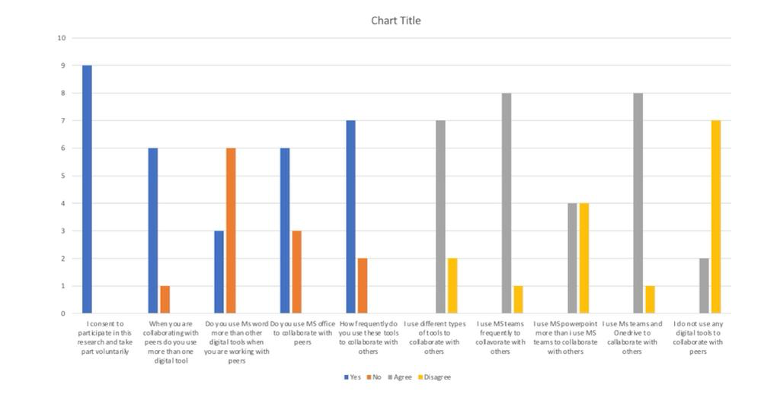

Discussion

My results from my questionnaire showed that students have answered all the questions with consent and have given clear results. We sent out the questionnaire via email to 11 students we had 9 responses back, with this information we created a chart with the results to show which was the most used tool to collaborate and which was the least tool used to collaborate with Student at UWTSD. I was surprised with one of the results from my questionnaire which was I use Microsoft teams and OneDrive to collaborate with others because I expected students to use Microsoft 365 more than other tools and I was surprised that students use.
Microsoft Teams and OneDrive to collaborate with peers more. I personally think Microsoft teams is a good way to collaborate with peers as you can share information with each other you can have live chats with each other and you can discuss meetings, Microsoft teams is beneficial to students because they can share documents by email or they could send it through the Microsoft Teams app. The results showed that students at UWTSD use different tools to collaborate and they use whatever tools they find easier to collaborate with.

- Conclusion

Which digital app are you most confident in using?
I am confident in using Microsoft Teams because all conversations, meetings and files are found and shared on the Microsoft teams app you can access it whenever you like Microsoft teams allows you to set up meetings straight away one of the most productive benefits of Microsoft teams is that you can edit documents seamlessly documents are automatically saved and the information will never be lost.
In future I would like to improve my research skills this will help me with collecting information better and it will help my grades. Also in future I can improve myself by feeling more confident in using different tools to collaborate with my peers researching on different tools to collaborate with peers has made me more confident in using these tools in future. The good thing about creating this questionnaire was that it improved my skills And it also made me better at using different tools to create graphs and charts and using Microsoft forms

- Reference List

By Anon Container: dispatch.m.io URL: https://dispatch.m.io/microsoft-teams-tools/

By Anon Container: www.microsoft.com URL: https://www.microsoft.com/en-gb/microsoft-365/online-surveys-polls-quizzes

By Nikoletta Bika Year: 2017 Container: Recruiting Resources: How to Recruit and Hire Better URL: https://resources.workable.com/tutorial/collaboration-

- Appendix A – A blank copy questionnaire



