Component 1 - Report

Effective Teamworking for team success.

Student Name: | Samir Mhanna
Student Number: | 2119514
Lecturer Name: | Muhammad Islam
Module: | Effective Team Working and Communication
Module code: | BMSW4002

2022

Abstract
Working out in groups and encouraging effective employee teamwork could give organisations a lot of advantages and the capacity to succeed. The objective of this report finds out the difference between team and group. Highlight some of the theoretical models that can be used to develop an effective team. Discuss the advantages and disadvantages of teamwork. The study outcome with developing to a successful team must first identify and understand the basic characteristics of effective teamwork. There are different stages that teams pass through to become effective t. Team members' abilities and behaviours are important to their performing. Communication, trust, poor leadership, and conflicts are all challenges that can adversely impact team performance and success.

Contents
Abstract 2
Introduction 3
1. Develop an effective team 3
1.1 Team Development in Five Stages: Tuckman’s Theory 4
1.2 Tuckman’s five stages 5
1.2.1 Stage Forming 5
1.2.2 Stage Storming 5
1.2.3 Stage Norming 5
1.2.4 Stage Performing 6
1.2.5 Stage Adjourning 6
2. Team roles 6
2.1 Belbin’s Team Roles 6
3. The Advantages of Effective Teamwork 8
3.1 Increased motivation and productivity 8
3.2 Better communication 8
3.4 Flexibility 9
4. The Barriers to effective teamworking at Next Plc. 9
4.1 Communication challenges 9
4.2 Ineffective resolving conflict skills 9
4.3 Lack of trust 10
4.4 Ineffective leadership 10
5. Conclusion and recommendations 10
6. references 11

Introduction
Work teams are groups of personnel integrated in companies that do activities that assist the organisation in achieving its objectives. They maintain ultimate power and resources to achieve these objectives (West, 2012). “Businesses and corporations are well aware of the potential of teams and frequently use them to carry out the missions of their organizations” (Griffith, p3. 2015). The goal of this report is to find out how can develop effective teamwork that will lead to the organization's success. The report is structured based on a case study as follows. First, how can develop an effective team? Second, discuss the different types of roles that you need to create an effective team. Tuckman and Bilen's models will be used in these two sections as theoretical formworks. Third, what influence does successful collaboration have on team success? Finally, and what were the case study's identified challenges to teamwork? Some many studies and theories have been published to find out how can create an effective team for team success.

Develop an effective team
Although the term "team" is commonly used to refer to any group, groups and teams are not similar. Morgan (2017) defined “A group is usually defined as the number of people sharing something in common and meeting together about their shared characteristics”, while the author went on describing “A team is a number of individuals working as one to achieve a particular goal to which they are mutually committed” (Morgan, 2017, P. 204). A team is defined as "a relatively small group of people working on a clearly defined, challenging task that is most efficiently completed by a group working together, rather than individuals working alone or in parallel; who have clear, shared, challenging, team-level objectives derived directly from the task; who must work closely and interdependently to achieve those objectives; whose members work in distinct roles within the team (Woods and West, 2014). So, to develop a successful team must first identify and understand the basic characteristics of effective teamwork. Campion and colleagues have shown that the features of a work team can be linked to its effectiveness. McGregor and Likert outlined some of the components of effective teams that collaborate well. those were one of the first authors to emphasize the necessity of effective teamwork (Likert, 1989). McGregor and Parker almost developed a similar list of the characteristics of effective teams and there are others covered from different views, in table-1 provides an outline of the qualities of effective collaboration (Mickan and Rodger, 2000, p. 202).

Table 1: Effective teamwork characteristics
Source: design by Mickan and Rodger, 2000
Teams formation is critical for any successful business; nevertheless, it requires a while for individuals to develop the essential teamwork skills; this typically entails passing through several phases.
1.1 Team Development in Five Stages: Tuckman’s Theory
Internal procedures in a team frequently grow over time. Teams, like individuals, improve their abilities as they utilise them more. After a period of time together, team functioning usually improves (Priestley, 2015). This means that teams often follow a predictable path in their growth. Bruce Tuckerman proposed his theory for the first time in 1965, based on research he performed on team dynamics. It discussed the four growth stages which every team pass through. forming, storming, norming, and performing. The fifth stage, Tuckman and Jensen developed it in 1977: "Adjourning." When the team adjourns, the current project is completed (Tuckman and Jensen, 1977).
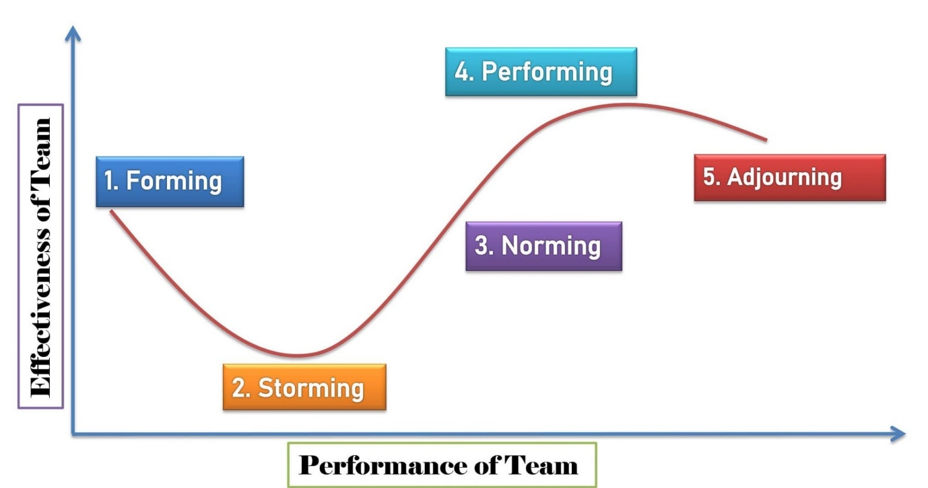
Diagram1: Tuckman’s model

Source: Kobiruzzaman, 2019

1.2 Tuckman’s five stages
According to Tuckman and Jensen (1977), each stage is as follows:

1.2.1 Stage Forming
The team will meet for the first time. They introduce themselves to each other, share their background interests and experience, and discuss the project's goals and team responsibilities/roles. The team's leader should offer clear guidance and direction for the project at this point to ensure that all members are involved and working collaboratively.

1.2.2 Stage Storming
Storming frequently begins when there is a conflict between teamwork natural habits and behaviours or when there is a disagreement of viewpoint, ideals, and values. The team leader lets this stage to turn off of control, it may be incredibly destructive and demotivating. The storming phase is crucial for the team's growth.

1.2.3 Stage Norming
Teams have recognised that they can accomplish work together. Members of the team come to realise the value in their diversity and begin to trust one another. Working as a team is more natural at this point. Members are becoming more flexible and dependent on one another, and communication improves.

1.2.4 Stage Performing
In this stage, relationships have established, and a clear and solid framework has emerged. The teamwork is competent and organised, with a strong sense of agreement and cooperation. Of course, problems and disagreements still exist, but they are handled successfully. The team's primary focus is on solving problems and fulfilling objectives; productivity is at its greatest.

1.2.5 Stage Adjourning
The project is winding down this time, and team members are dispersing to various locations. Instead of pushing a team past the first four phases of development. Throughout this phase, the group praises their achievements. Participants focus to reflect on their work in order to adjust what they have learnt to upcoming work. A team can also be formed based on the respective role, which means that each team member is supposed to carry out a certain role that lines up with their skills.

2. Team roles
Team members' skills and behaviours are important to their performance. This is relevant to the roles that team members play. As a result, authors such as Belbin (1981, 1993), Margerison & McCann (1990), Parker (1990), Spencer and Pruss (1992), and Woodcock (1989) developed the concept of team roles, or, in Parker's case, team-player styles. A variety of team roles may be recognised, and these differ depending on the writer. The most team roles are fifteen (Davis et al., 1992) and the fewest are four (Davis et al., 1992). (Parker, 1990). Belbin's (1981,1993) work is particularly significant as an early proponent of the team role concept and, perhaps, the foundation upon which other team role frameworks have been constructed. Belbin's formulation of the team role idea resulted from nine years of observation (Senior, 1997).

2.1 Belbin’s Team Roles
Belbin (2010) noted that people engage in an infinite number of different behaviours. However, there are just a few pertinent behaviours that have a major impact on team effectiveness. These behaviours are grouped into a number of interconnected groups known as "Team Roles." which means every offer should make valuable contributions to teamwork. Belbin created the team role model related to behavioural characteristics. Among Belbin's nine team roles are innovator, implementer, completer, evaluator, investigator, shaper, team maintainer, co-ordinator, and expert. Belbin classifies these roles into three main roles: action-oriented, thought-oriented, and people-oriented. Team members that are action-oriented are motivated to get stuff accomplished and perform well under strain. Team members that are thought-oriented are able to think critically and can provide innovative thoughts. Team members that are people-oriented have outstanding communication skills, that could positively affect the team.
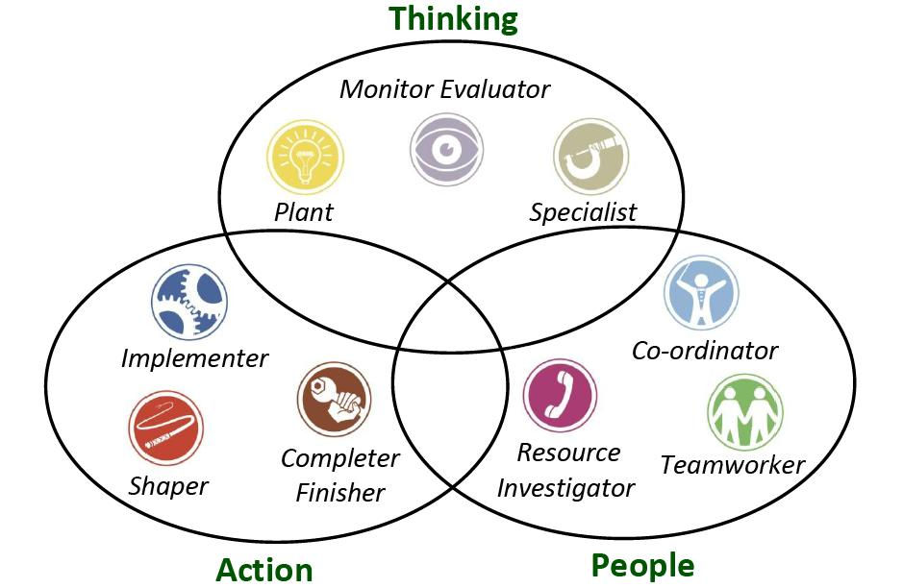
Diagram2:Belbin’s 9 team roles
Source design by Thoncianus, 2022

No team can be effective unless there is some form of balance, and it is vital to ensure that while establishing roles, your team members' needs are observed and addressed. Everyone has different skills and limitations, so discover the ideal fit for everyone to ensure your act collectively. “Belbin and others argued that the combination of personalities in a team or the combination of individual team member roles could significantly improve or diminish the ability of a team to complete a particular task.” (Morgan, 2017, p. 207)

3. The Advantages of Effective Teamwork
According to McGregor, the sheer existence of teams or work groups inside an organisation does not guarantee success; instead, a group must be effective in order to be successful (Heil et al, 2000). Working out in teams and promoting strong collaboration between employees could provide businesses with a number of advantages and the ability to succeed. There are many benefits of teamwork, including;

3.1 Increased motivation and productivity
People that contribute to a team's ability to achieve outcomes will feel appreciated, encouraged, and dedicated to one another. it also could make employees more satisfied, effective, and motivated. teamwork enables the task to be distributed evenly among members and in accordance with their individual abilities and skills. According to Stanford research (2014), people become more motivated when they are seen as team members working together with others, even though they are not there physically. teamwork enables the task to be spread evenly among members and in accordance with their individual abilities and skills.

3.2 Better communication
To ensure the success of any team project, each team leader must communicate and discuss with the rest of the group the decisions that are taken so that every team member is in line. If this occurs on a regular basis, overall decisions and communications inside an organisation will be made more concisely. Pentland (2012) recognized five crucial factors that affect team performance. These factors, such as talking and listening in equal measure, eye contact, direct communication between members, and back-channel communication, are associated with establishing better communication.

3.3 New ideas, various opinions, share knowledge
Hodson (2001) states that group thinking can impact the quality of decision-making. Teamworking Delivers together people from a variety of backgrounds and experiences, which offers an ideal environment for discussing and creative problem-solving. Developing a team with different extent of skills and background is being considered as a benefit since it allows others to further develop their talents while also making members feel respected and appreciated. Once members are skilled to work as a team will achieve more than individuals.

3.4 Flexibility
Teamwork provides for flexibility between members of the team since they may help and assist one another in meeting their needs. Flexibility is a crucial consideration since team member will need to collaborate. It is a critical challenge that has emerged as a most important issue in a variety of organisational design and management theories/models, including socio-technical system theory, self-organization, lean manufacturing, and Just-In-Time management (Fraser, 2010). with flexibility, performing individually is improved compared with personal working habits. It promotes higher accountability and responsibility.

4. The Barriers to effective teamworking at Next Plc.
there might be many barriers to effective teamworking. However, working as a team might present certain challenges. This consumes more time, work, and support from the organization's leaders. In this section, will be discussing the 5 main barriers to effective teamworking identified in the case study.

4.1 Communication challenges
Ineffective communication occurs for a variety of causes in a variety of ways. Effective communication does not need us to become specialists in communication issues, however, it does necessitate having a fundamental awareness of the topics at hand so that we all can engage in critical reflection engagement and enhance our understanding, abilities, and trust during the time (Thompson, 2018). Poor communication could lead to unnecessary effort and time, incorrect supply, and missed deadlines., and much more significant concerns such as HR difficulties and social media catastrophes. Remote working, misunderstandings, rapid replies, and knowledge transfer are all common issues. Lines of communication must be available for any team to perform efficiently.

4.2 Ineffective resolving conflict skills

Conflicts can emerge for a variety of reasons, and when they do, they hamper efficient cooperation. What matters is that you seek to resolve the issue rather than focus on the conflict. When a conflict doesn’t get fixed, it intensifies and people start taking positions, creating effective interaction even more complicated. Personality conflicts were frequently mentioned as a barrier to collaboration by Etherington(2021), and respondents recognised the difficulty of working with people they would not socialise with outside of the OR (Etherington et al, 2021).

4.3 Lake of trust
Working together as a team and collaborating requires trust. Without trust, the team members won't be able to rely on one another for support or resource sharing. Given the hurdles that may inhibit the establishment of trust in these teams, Zaccaro and Bader (2003) believe that the building and maintenance of trust may be one of the most essential variables contributing to virtual team success. Moreover, a loss of trust could principal to misinterpretation and disagreement, stifling teamwork. Professionals could be more successfully nurture trustworthy relations beyond team up-building events and normal chances for cooperation.

4.4 Ineffective leadership
Every business wants leaders who can consistently steer them, provide insight, and inspire cooperation. Leadership has long been acknowledged as a fundamental tool of coordinating the efforts others. As a natural consequence, ineffective leadership could render teams alienated and distant, affecting their capacity to work. Leaders may take charge of such circumstances by expanding chances for teamwork, aiding members of the team in improving their skills, and designing tactics to foster successful collaboration.

5. Conclusion and recommendations
In many businesses, teams seem to be a way of life, and researchers have kept up. Team development is vital for every successful organisation; nevertheless, it takes time for individuals to develop the necessary teamwork abilities; generally, this means passing through many stages. Storming is the most sensitive stage of team formation, and it is also the stage that the team goes through in the scenario. The Belbin model ‘team role’s’ is one of the model's formations of teams ensuring successful team members' involvement based on the skills that individuals have. However, working as a team presents certain challenges such as communications challenges, personal conflicts, poor leadership and trust. Effective leadership necessitates a thorough awareness from each stage in facilitating a seamless transition from one to another, resulting in effective teamwork led to the achievment team goals.

6. references

Belbin, R. M. (2010) Management teams. 3rd edn. Oxford: Elsevier Limited.
Etherington, C., Burns, J.K., Kitto, S., Brehaut, J.C., Britton, M., Singh, S. and Boet, S. (2021) Barriers and enablers to effective interprofessional teamwork in the operating room: A qualitative study using the Theoretical Domains Framework. PloS one, 16(4), p.e0249576.
Fraser, K. (2010) "Effective teamworking: can functional flexibility act as an enhancing factor?: An Australian case study", Team Performance Management, vol. 16, no. 1, pp. 74-94.
Griffith, B.A. (2015) Working in teams : moving from high potential to high performance . SAGE, Los Angeles, [California] :
Heil, G. et al. (2000) Douglas McGregor, revisited : managing the human side of the enterprise. New York: Wiley.
Hodson, C. (2001) Psychology and work, Hove, England: Routledge.
Katzenbach, J. R. and Smith, D.K. (1993) The Wisdom of Teams: Creating the High-performance Organisation, Harvard Business School, Boston.
Kobiruzzaman, M. (2022) Tuckman Theory- Tuckman’s Stages of Group Development. Available at Tuckman Theory- Tuckman's Stages of Group Development - Newsmoor. (Accessed: 17 June 2022).
Likert, J.G. (1989) Rensis Likert and Douglas McGregor. Writers on Organizations, p.177.
Morgan, P. (2017) The Business Student’s guide to study and employability, London,: SAGE.
Pasleau, P. (2017) Tuckman Model: Understanding the stages of team formation, [video], Available at: https://www.youtube.com/watch?v=2QbXc6E08H4 (Accessed: 14 June 2022).
Pentland, A.S. (2012) The new science of building great teams. Harvard business review, 90(4), pp.60-69.
Senior, B. (1997) Team roles and team performance: is there ‘really’a link?. Journal of occupational and organizational psychology, 70(3), pp.241-258.
Stanford News. (2014) Stanford research shows that working together boosts motivation. Available at Research at Stanford shows that working together boosts motivation. (Accessed: 26 June 2022).
Thompson, N. (2018) Effective communication: A guide for the people professions. Bloomsbury Publishing.
Thoncianus, Andi. (2022) Belbin Theory. Available at Belbin Theory (andythoncianus.wixsite.com). (Accessed: 23 June 2022).
Tuckman, B. W. and Jensen, M. A. C. (1977) Stages of Small-Group Development Revisited’, Group & Organization Studies, 2(4), pp. 419–427. doi: 10.1177/105960117700200404.
Tuckman, B.W. (1965) Developmental sequence in small groups. Psychological bulletin.
West, M.A. (2012) Effective teamwork: Practical lessons from organizational research. John Wiley & Sons.

