INTERNATIONAL BUSINESS COMMUNICATIONS
Module code: LCBB6001
ID number: 2118130
Name: Stela Zacon

Slide 1: Title slide
Cross-Cultural Negotiations: Tesco's Strategic Expansion in China
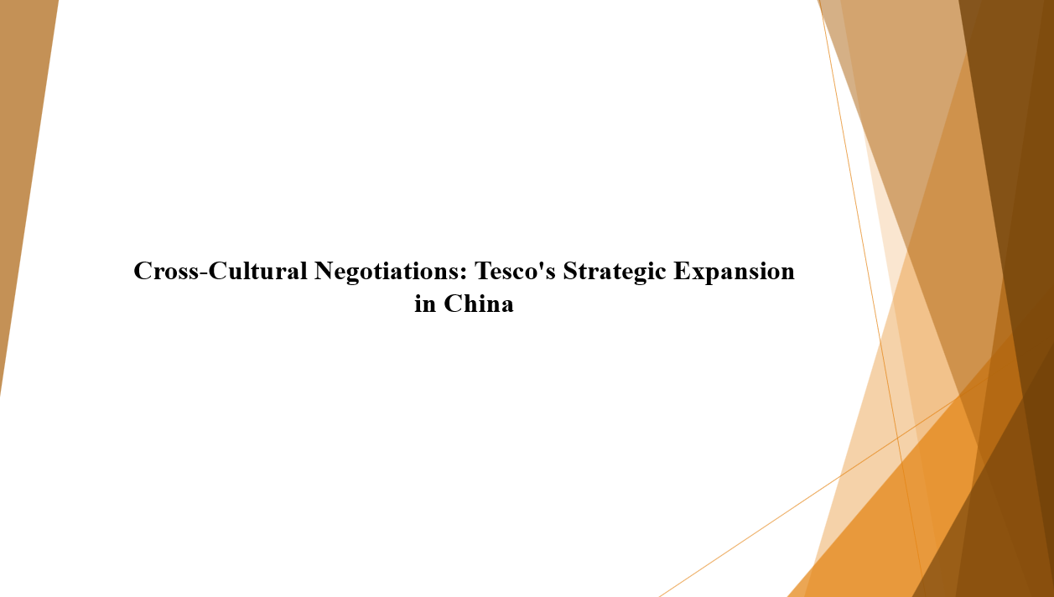
Slide 2: Presentation Outline
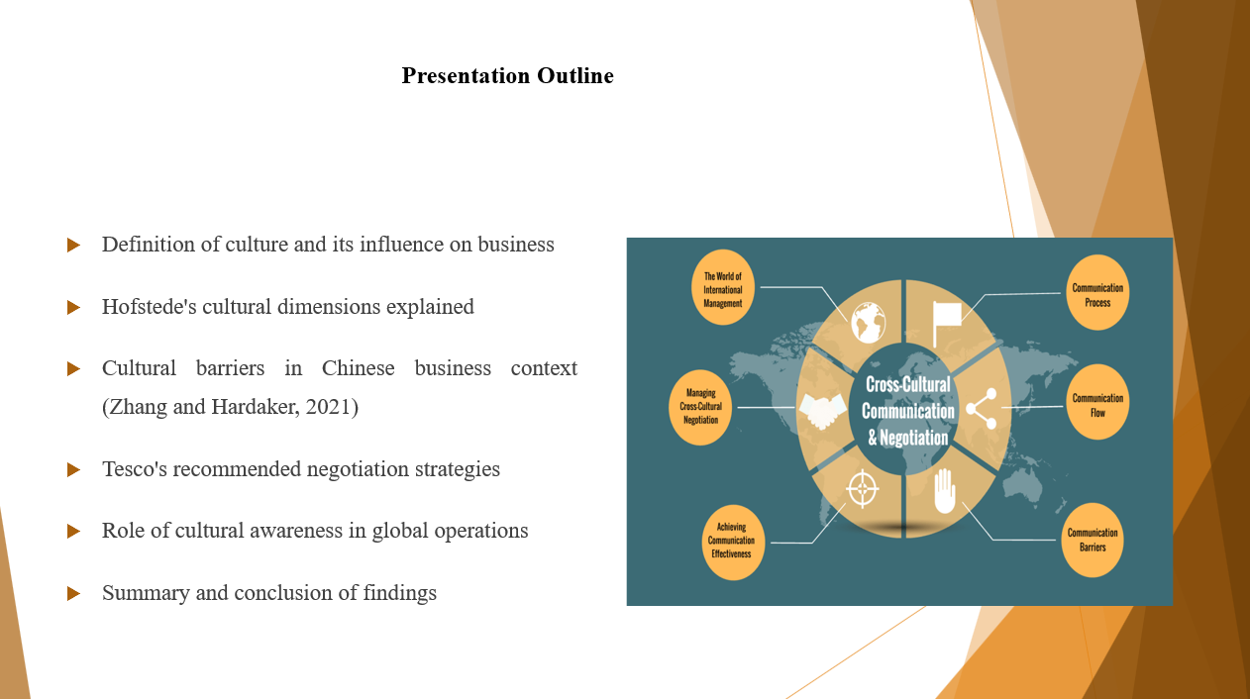
Speaker Notes:
This presentation begins with a definition of culture and its subsequent impacts to international business operations. Then refer to Hofstede's cultural dimensions-theoretical framework-for the comparative study of different national cultures. The lens then changes to cultural challenges that are specific to Chinese business practices. From this, the proposals for negotiation strategies that Tesco should employ are made (Zhang and Hardaker, 2021). Cultural awareness is emphasised as critical for global success and concluded with a summary of the key findings and practical recommendations. The importance of cultural dimensions then becomes apparent in avoiding misunderstandings as well as damage to relationships. Finally, a summary of the core findings and practical recommendations based on cultural principles composes the conclusion of the paper.
Slide 3: What is Culture?
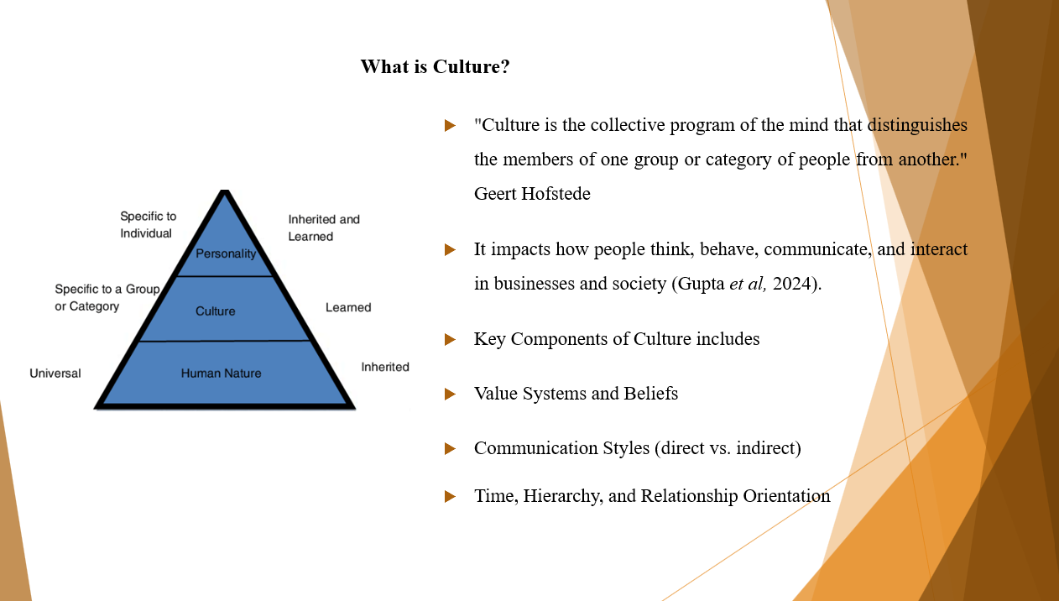Speaker Notes:
Culture means shared values, beliefs, and behaviours that influence how a group of people perceive and react to the world around them. Culture is like a mental program that is different among societies, so says Geert Hofstede. In business, these important cultural dimensions include values and beliefs, preferred communication styles either direct or indirect and attitudes toward time, authority, and human relationships. All of these factors have significant implications for business and cross-cultural interactions (Gupta et al, 2024).). In the business context, cultural parameters can be from values, attitudes toward hierarchies, time, communication, and relationships, for example, western cultures favour much direct communication as opposed to indirect cues used by others. Understanding cross-cultural differences is critical to cross-cultural management as these affect negotiations, leadership styles, team dynamics, and, in total, business success in markets like China.
Slide 4: Cultural Influence on Business
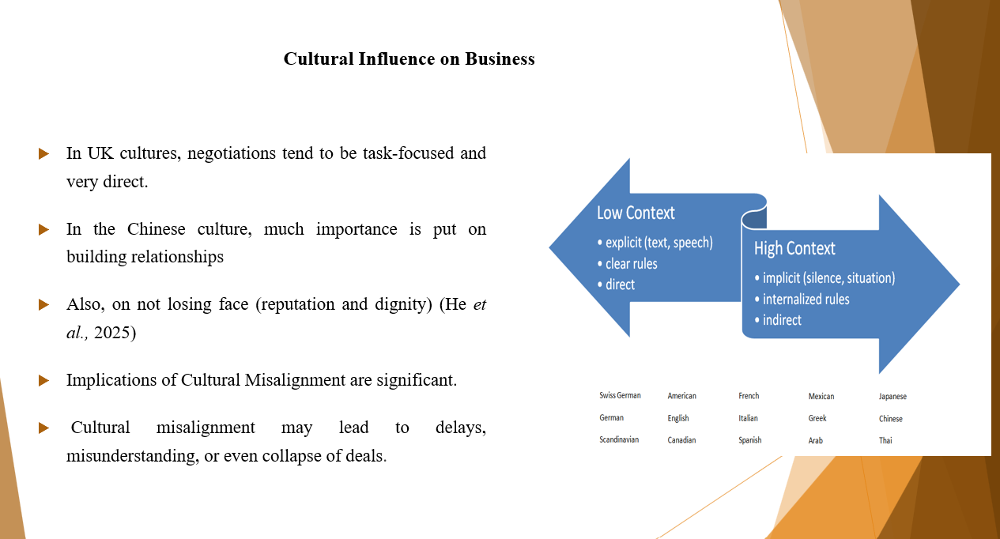Speaker Notes:
Cultural expectations can greatly intervene in the way business is conducted. For instance, the professionals in the UK place an importance on direct, task-oriented negotiation. Cultural expectations can significantly influence how business dealings are conducted. In the UK, negotiations are usually direct and task-oriented with a focus on reaching the desired outcome. In this culture, efficiency and clarity are topmost priorities. By contrast, the Chinese way of doing business stresses relationship building (guanxi) and saving face, which means to dignity and to avoid the risk of causing public embarrassment. These values impact communication style, decision-making, and trust. When entering the Chinese market, any neglect on the part of Tesco toward these cultural differences could lead to misunderstandings, broken relationships, or even a failed negotiation (He et al., 2025).
Slide 5: Theoretical Framework – Hofstede’s Cultural Dimensions
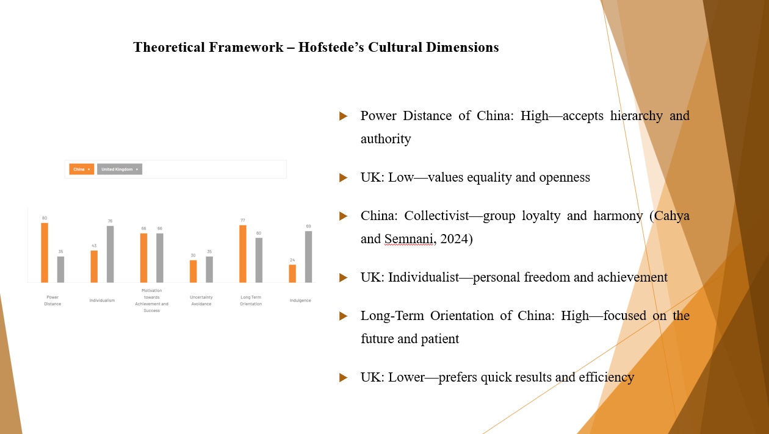Speaker Notes:
This slide compares the UK and China with key Hofstede's cultural dimensions. Power distance has high numbers in China, which reflects the idea of acceptance of authority, while low values in the UK assert rejection of such authority. Accordingly, in China, group relationships are very important; in contrast, individual goals form the basis for successful interaction in the UK (Cahya and Semnani, 2024). Lastly, the Chinese way of thinking is more long-term action; whereas, British culture tends to short- and medium-term outcome-oriented. This shows how these cultural paradigms have implications for communications, leadership styles, and business strategies in each of these countries. Insofar as effective communication, trust-building, and long-term success in international business pursuits are concerned, recognising and understanding these expectations becomes important.
Slide 6: Cultural Elements to Overcome (Specific to China)
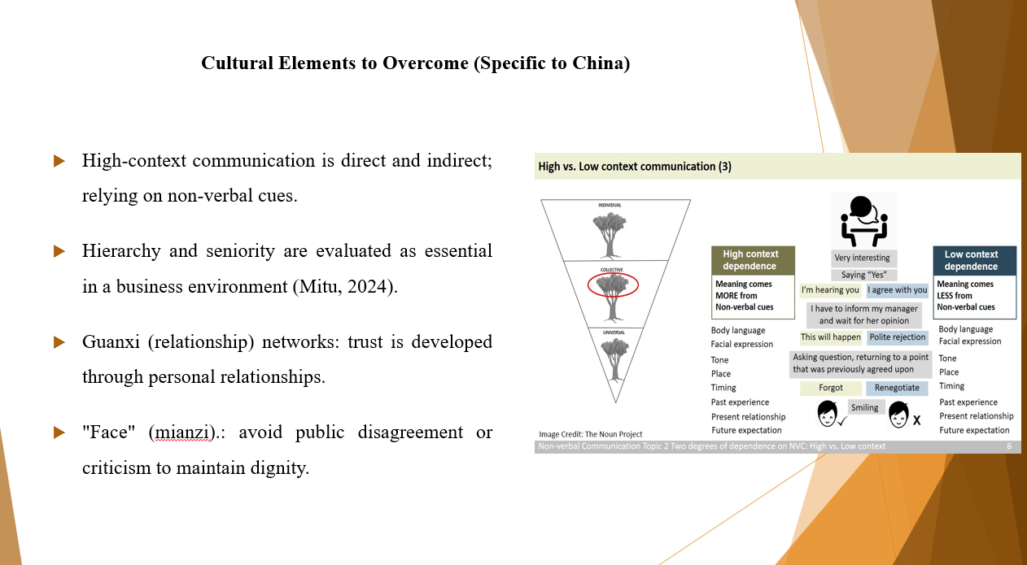.
Speaker Notes:
One such culture is high-context communication that Tesco can have to adopt. This means that messages from very subtle channels, including tone, body language, and mutual understanding, not from explicit words employed, are usually conveyed real-time (Salam, 2024). Hierarchy is something rooted in the culture of the Chinese; this also involves respect for seniority, especially during meetings and negotiations. In order to build personal relationships over guanxi, trust and cooperation are encouraged. Finally, but by no means least, the public disagreement or criticism could lead to embarrassment and damage to business, thus mianzi or "face" is kept.
Slide 7: How These Impact Tesco's Operations
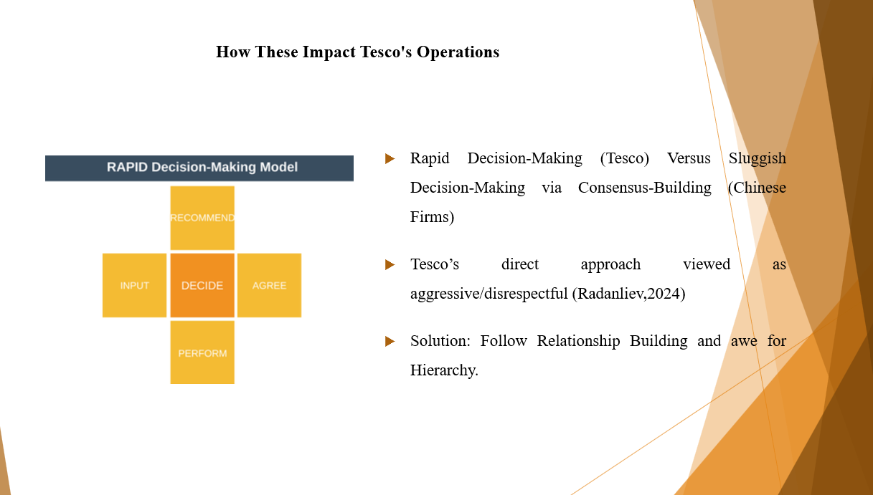Speaker Notes: With the usual, Tesco fast approach in conducting business - fast decisions, speaking clearly in direct communication style - it is highly likely that culture would not hold well with such conditions in China (Radanliev,2024). In fact, consensus-building prior to making decisions consumes a lot of time from Chinese firms. It is quite common for Tesco to think it is slow. Further, the perceived directness of Tesco is too aggressive or even could be tagged disrespectful. Thus, acquiring the necessary relationship-investment and hierarchical respect during negotiation or partnership with Tesco means winning the operation way in China.
Slides 8: Negotiation Strategies for Tesco
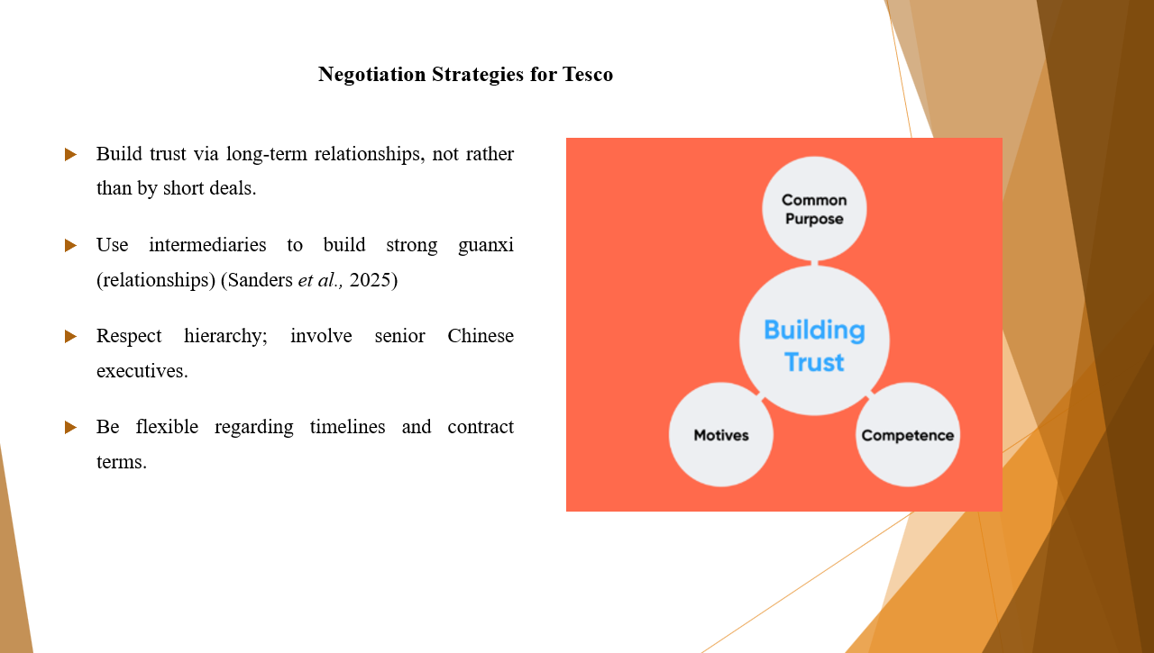Speaker Notes:
Tesco has to adapt its negotiation strategies to fit with Chinese cultural expectations. In China, trust cannot be built overnight; rather, it is established out of consistent engagement and long-term commitment to sustenance. Therefore, instead of putting emphasis on quick wins, it should demonstrate reliability and patience. Respectable intermediaries should be engaged to assist in developing guanxi, which are relationship networks of doing business in China (Sanders et al., 2025). Also, it is imperative to give respect involved with hierarchy by including senior executives in discussions. Finally, flexibility on timelines and negotiations regarding contracts would give Tesco deeper insight into their way of doing business. It is with this understanding that acceptance for any decisions may take longer, as mutual respect and understanding can be built gradually along the way.
Slide 9: Importance of Cultural Awareness
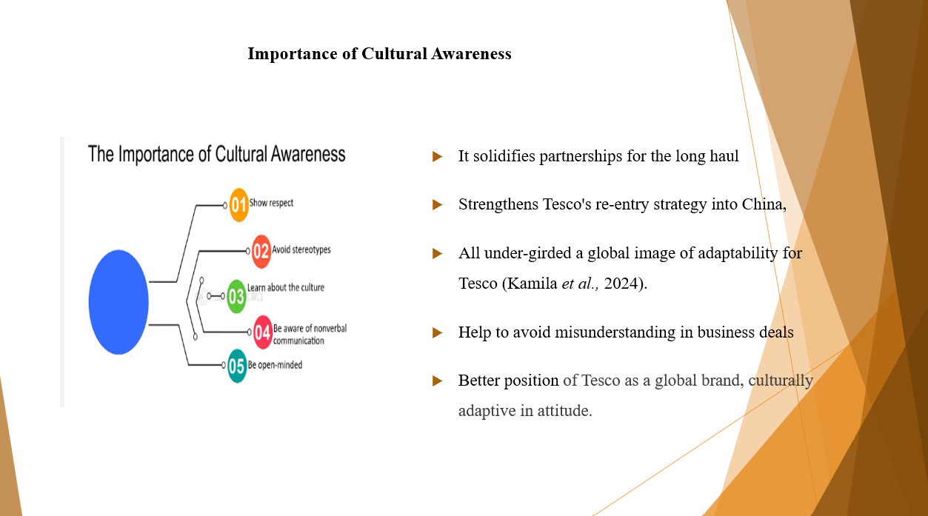Speaker Notes:
For international growth, Tesco requires cultural awareness, particularly as it reasons re-entry into the Chinese market. Cultural norms drawn from misunderstandings draw poor communications, oftentimes offense, and finally end in poor negotiations. Cultural sensitivity is what can allow Tesco to build a long-term, sound relationship with Chinese partners; relationships that are most important in a trust-based business environment. Awareness of culture also adds to Tesco’s image as a respectful, globally-minded company (Kamila et al., 2024). This dynamic obviously improves its reputation as a dynamic, culturally adapt brand and gives it a cutting-edge advantage at entry into diverse international markets where cultural adoption is key to operational and strategic success.
Slide 10: Conclusion
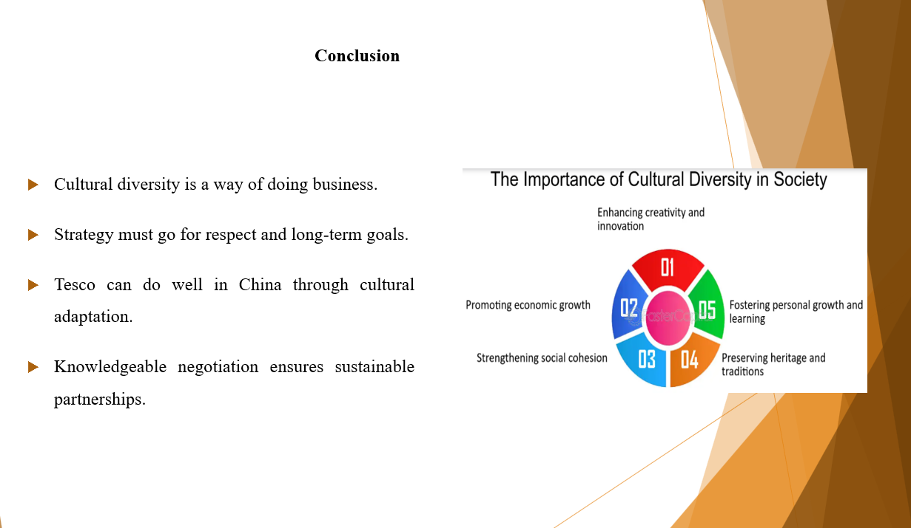Speaker Notes:
Cultural differences should be redefined: they cannot be barriers but promises for the generations of meaningful growth, good money-making, and real innovations in partnerships. For Tesco, sustainability in China depends on understanding cultural expectations, particularly around communication, hierarchy, and the formation of relationships. Respectful and well-informed strategy in that regard would enable Tesco to foster long-term, sustainable business relationships aligned with Chinese values. Such a strategy can support entry re-establishment in that market while also serving to bolster the global reputation of Tesco. Simple last word to the Board: with cultural awareness and strategic negotiation, Tesco can realise the market and thus become a respectable player in the Chinese market.

References
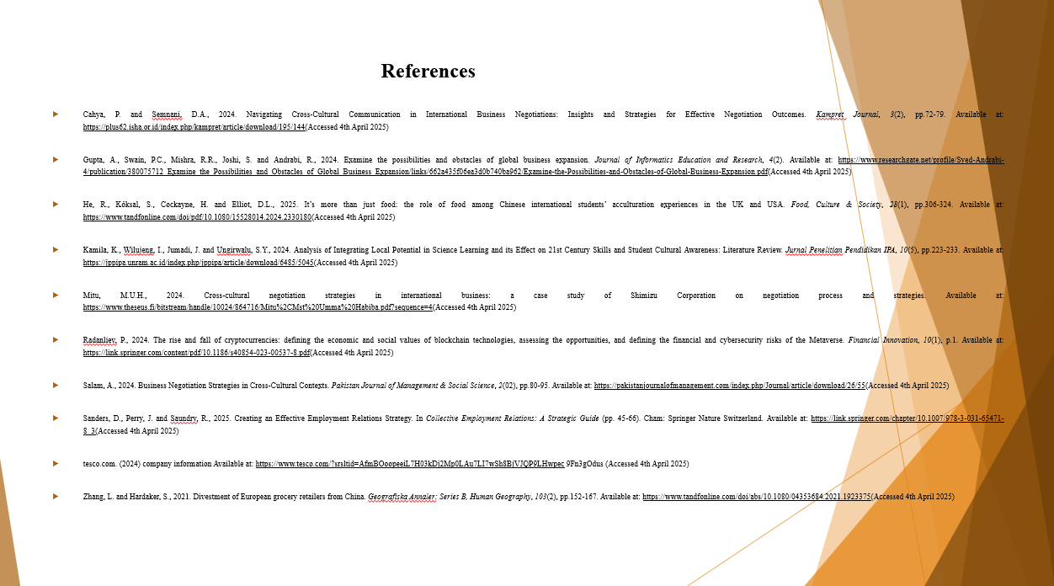
Cahya, P. and Semnani, D.A., 2024. Navigating Cross-Cultural Communication in International Business Negotiations: Insights and Strategies for Effective Negotiation Outcomes. Kampret Journal, 3(2), pp.72-79. Available at: https://plus62.isha.or.id/index.php/kampret/article/download/195/144(Accessed 4th April 2025)
Gupta, A., Swain, P.C., Mishra, R.R., Joshi, S. and Andrabi, R., 2024. Examine the possibilities and obstacles of global business expansion. Journal of Informatics Education and Research, 4(2). Available at: https://www.researchgate.net/profile/Syed-Andrabi-4/publication/380075712_Examine_the_Possibilities_and_Obstacles_of_Global_Business_Expansion/links/662a435f06ea3d0b740ba962/Examine-the-Possibilities-and-Obstacles-of-Global-Business-Expansion.pdf(Accessed 4th April 2025)
He, R., Köksal, S., Cockayne, H. and Elliot, D.L., 2025. It’s more than just food: the role of food among Chinese international students’ acculturation experiences in the UK and USA. Food, Culture & Society, 28(1), pp.306-324. Available at: https://www.tandfonline.com/doi/pdf/10.1080/15528014.2024.2330180(Accessed 4th April 2025)
Kamila, K., Wilujeng, I., Jumadi, J. and Ungirwalu, S.Y., 2024. Analysis of Integrating Local Potential in Science Learning and its Effect on 21st Century Skills and Student Cultural Awareness: Literature Review. Jurnal Penelitian Pendidikan IPA, 10(5), pp.223-233. Available at: https://jppipa.unram.ac.id/index.php/jppipa/article/download/6485/5045(Accessed 4th April 2025)
Mitu, M.U.H., 2024. Cross-cultural negotiation strategies in international business: a case study of Shimizu Corporation on negotiation process and strategies. Available at: https://www.theseus.fi/bitstream/handle/10024/864716/Mitu%2CMst%20Umma%20Habiba.pdf?sequence=4(Accessed 4th April 2025)
Radanliev, P., 2024. The rise and fall of cryptocurrencies: defining the economic and social values of blockchain technologies, assessing the opportunities, and defining the financial and cybersecurity risks of the Metaverse. Financial Innovation, 10(1), p.1. Available at: https://link.springer.com/content/pdf/10.1186/s40854-023-00537-8.pdf(Accessed 4th April 2025)
Salam, A., 2024. Business Negotiation Strategies in Cross-Cultural Contexts. Pakistan Journal of Management & Social Science, 2(02), pp.80-95. Available at: https://pakistanjournalofmanagement.com/index.php/Journal/article/download/26/55(Accessed 4th April 2025)
Sanders, D., Perry, J. and Saundry, R., 2025. Creating an Effective Employment Relations Strategy. In Collective Employment Relations: A Strategic Guide (pp. 45-66). Cham: Springer Nature Switzerland. Available at: https://link.springer.com/chapter/10.1007/978-3-031-65471-8_3(Accessed 4th April 2025)
tesco.com. (2024) company information Available at: https://www.tesco.com/?srsltid=AfmBOoopeeiL7H03kDj2Mp0LAu7LI7wSh8BjVJQP9LHwpec 9Fn3gOdus (Accessed 4th April 2025)
Zhang, L. and Hardaker, S., 2021. Divestment of European grocery retailers from China. Geografiska Annaler: Series B, Human Geography, 103(2), pp.152-167. Available at: https://www.tandfonline.com/doi/abs/10.1080/04353684.2021.1923375(Accessed 4th April 2025)


