Alba Del Rocio Torres Cordero (1904926)

Strategic hr in hospitality: a comparative case study between traditional and hybrid work environments
Assignment 1

EXECUTIVE SUMMARY
This report focuses on the comparison between traditional and hybrid work environments, exploring the role of people management in organizations. Two specific organizations are analysed: Amazon, representing the traditional approach, and Swansea City and County Council, which has adopted a hybrid approach. Through this analysis, it is highlighted how HR strategies adapt and progress in response to changing market demands and emerging trends. The structure of the report addresses the traditional structure of the work environment, which is characterized by organized processes directed towards specific activities within the organization, allowing control and leadership by superiors to ensure the execution. Hybrid work environment is identified as a remote work modality that uses information and communication technologies to achieve its objectives, with a focus on the individual. How these selected organizations are influenced by internal and external environmental changes in forming their human resource strategies are examined, using tools such as SWOT analysis and PESTLE analysis. Amazon and Swansea City Council are affected by a variety of factors, from political and economic regulations to technological and social aspects, influencing their human resources policies. The report evaluates how these organizations approach human resource management differently depending on their size, scope, and sector within the industry. Amazon, as a international company in the private sector, focuses on market competitiveness and technological innovation, while Swansea City Council, as a government entity in the public sector, focuses on the efficient delivery of public services at a local level. Key HR concerns such as employee engagement, performance management and diversity within these organizations are discussed, as well as the advantages and disadvantages of hybrid working from the company's perspective. Role and impact of technological advances, especially artificial intelligence, on the human resources strategies of these organizations is examined.

Contents
INTRODUCTION 3
BODY OF REPORT 3
Investigate how these selected organisations are influenced by internal and external environmental changes when forming their HR strategies. 5
Evaluate how these specific organisations approach HR differently depending on their size, reach, and sector within the chosen industry. 6
Analyse key HR concerns like employee engagement, performance management and diversity within these organisations. 7
Examine the role and impact of technological advancements, particularly AI, on the HR strategies of these organisations. 9
RECOMMENDATIONS 9
REFERENCE LIST 10

INTRODUCTION
This report will explain the difference between traditional and hybrid work environments focuses on the role of people management in organizations. Two specific organizations are analysed: one of a traditional type and another adopting a hybrid environment. Exploring HR strategies used by these organisations, emphasizing how different work environments shape their approach to people managing.
Managing people in organizations plays a fundamental role in influencing culture, performance, and sustainability in an increasingly dynamic business environment. In this perspective, this report focuses on a comparison between traditional and hybrid work environments, exploring how HR strategies adapting and progress in response to changing market demands and rising trends. Two organizations have been chosen for this report that represent two different models of work environment: Amazon, a recognized company for its traditional approach to people management, and Swansea City & County Council, which has adopted a hybrid approach, combining in-person and remote elements in its workforce. These organizations not only are representing different people management models, but also are operating in diverse sectors and contexts, providing a solid framework to evaluate the differences and similarities in the HR strategies.

BODY OF REPORT
Structure of traditional work environment, which consists of a series of processes organized and directed towards specific activities within the organization, which allows for control and leadership on the part of the superiors to ensure its execution. The strategies of organizations involve aspects that have to do with the accompaniment and permanent monitoring of workers by the direct manager, to develop monitoring skills and results. These aspects are directly influenced by the environment in which workers, infrastructure, environmental conditions, and the roles, all of this is part of traditional processes where the worker's performance is measured by compliance with specific tasks and not for achievements.
With the above said, a fundamental competence comes to light that human beings develop leadership. Thanks to it, areas are led in traditional work, work teams are delivered to develop specific activities that sometimes become operational (reports deadlines, productivity, results). This allows the goals to be achieved from the efforts of each one of the members of an equipment (as in this report Amazon is the example of traditional work environment).
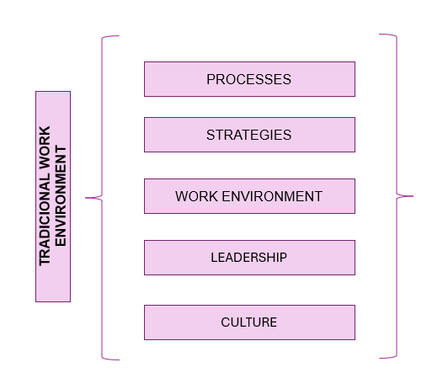

Hybrid work environment is identified as a remote work modality that uses information and communications technologies (ICT) to achieve their goals. Elements of hybrid work environment in a different way because it has an approach aimed at the person, since the individual management is now the letter of introduction. The remote office comes to break the paradigm of organizations since walls are torn down and borders are opened to workers by working from home.
Administrative sciences cover different fields of action and resources (human, financial, technological, infrastructure, etc.) which they fulfil a specific role in each of the organizations. Within these human resources are fundamental in administrative sciences and therefore this is the importance of the emergence of new trends for the generation of jobs and forms of work such as working from home.

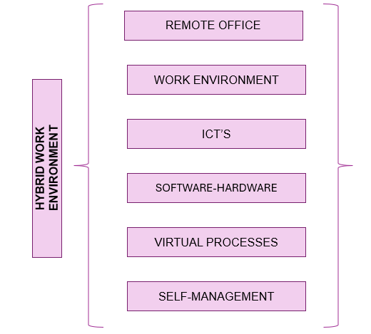

Investigate how these selected organisations are influenced by internal and external environmental changes when forming their HR strategies.
How can these organisations, Amazon and Swansea City Council have influenced by internal and external environmental changes when implementing their HR strategies?
It is crucial to conduct a thorough analysis of both the internal and external environment.
To be able to analyse how these internal factors can impact in the organisations, SWOT could be used (Strengths, Weaknesses, Opportunities and Threats).
Amazon, as a traditional company, has specified strengths, such as its massive infrastructure and market experience. But it also faces weaknesses, such as criticism for working conditions in its warehouses. On the other hand, Swansea City Council, with its hybrid approach, may have strengths in working flexibility and adaptability, but may face weaknesses in coordination and communication between remote and in-person teams.
Opportunities and threats, Amazon could find opportunities in global expansion and e-commerce growth, while facing threats such as aggressive competition and government regulation. On the other hand, Swansea City Council may find opportunities improving operational efficiency through remote working, but also faces threats such as the digital divide and separation between teams.
PESTLE analysis to investigate the external factors that can be count influencing these organisations (Political, Economic, Social, Technological, Legal and Environmental).
Amazon, political factors such as antimonopoly regulation and economic factors as changes in interest rates can have a significant impact on its operations. In public perception of Amazon's labour practices can influence its reputation and customer relationships. Technologically continued innovation in logistics and automation is crucial to maintaining Amazon's competitive advantage. Legally, changes in labour and environmental laws may require adjustments to a company's human resources policies. On the other hand, Swansea City Council may be politically influenced by government decisions and local regulations. Economically the availability of public funds and resources may establish the Council's ability to implement effective human resources policies. Socially, workforce diversity and changing employee expectations can influence human resources strategies. Technologically the implementation of digital tools and collaboration platforms is essential to facilitate hybrid work. Legally labour and data protection laws must be considered when designing human resources policies.
Amazon and Swansea City Council are persuaded by a variety of internal and external factors when planning their HR strategies. Interpretation of these factors and their impact on organizations is critical to designing effective human resources policies that drive success and sustainability in a constantly altering business environment. Comparing both organizations challenge exceptional challenges and opportunities expected to their different business models and work environments. As Amazon faces pressure to maintain its dominant position in the global market and address concerns over working conditions, Swansea City Council must adapt to changing employee demands and ensure effective collaboration between remote and in-person teams.

Evaluate how these specific organisations approach HR differently depending on their size, reach, and sector within the chosen industry.
The chosen organizations, Amazon and Swansea Council approach human resource management differently due to their differences in size, scope and sector within the industry. Amazon, as a large multinational company in the private sector, focuses on technological innovation and global market competitiveness, while Swansea Council, as a local government entity in the public sector, focuses on the delivery of efficient public services within of its local community.
According to the size
Amazon is a massive multinational company with a globally distributed workforce. Due to its massive size, Amazon has highly specialized and distributed human resources departments to address the needs of its vast workforce. Using advanced human resource management systems, such as applicant tracking software, data analytics for decision making, and large-scale training programs.
According to the scope
Amazon has a global reach, which means its human resource management must adapt to diverse labour regulations and work cultures in different countries. This requires a flexible and adaptable HR strategy that can meet different legal and cultural requirements.
Depending on the sector
Amazon operates in the private sector as an e-commerce and technology company. Its HR approach may be more geared toward market competitiveness, technological innovation, and talent retention in a highly competitive labour market.
……………………………………………………………………………………………………………
According to the size
Swansea Council is a more modestly sized local government entity compared to Amazon. Likely to have a smaller, centralized human resources department that addresses the needs of a workforce located in a single geographic area. Due to their smaller size, it may rely more on manual processes and traditional human resource management practices.
According to the scope
Swansea Council, has a more localized reach, focusing on addressing the needs of the community and local government. Its human resources approach may be more geared toward local public service delivery and community interaction, rather than worrying about the complexities of global operations.
Depending on the sector
- Swansea Council, as a government entity, operates in the public sector. Its human resources management may be more influenced by government policies, specific public sector labour regulations, and a focus on delivering high-quality, efficient public services.

Analyse key HR concerns like employee engagement, performance management and diversity within these organisations.
Advantages and disadvantages of hybrid work from the company's perspective.
For the organization it brings a series of important advantages that the company must consider, to improve the performance of the workers and therefore higher productivity. In first instance, the recognizable advantages of the application of working from home for organizations, resulting mainly from the use of ICT’s to remotely access information and be able to process it, then it is generated a culture of corporate responsibility with the environment.
Advantages that the company obtains with homeworking.
- Reduction of variable operating costs, since production costs are reduced maintenance of equipment and furniture, costs of basic services such as electricity and telephone among others.
- Increase in business productivity, determined by immediate access of information by employees working from home, reducing response times.
- Improvement in process control, with a correct system of information can be monitored in real time on the development and execution of tasks associated with activity working from home.
- Devolving of processes, tasks can be divided among several employees, and at the same time the process can be integrated as a whole, to obtain results more quickly than if a single worker executed the task.
- Given the flexibility in terms of the geographical dispersion of workers, can hire staff with higher qualifications and training, regardless location.
- The employee's ability to balance their professional spaces with families, allows their quality of life to improve and this in turn generates greater productivity the company.
- Regarding the technological systems, given that the working TVs invest in the necessary equipment to be able to carry out their tasks from their place of residence, reduces the cost of acquisitions for the company in terms of hardware and software.
- With an adequate control system, control over virtual desktops and the flow of information.
- The greater the growth in the market, the company can hire more staff than perform tasks remotely, without investing in furniture, software...
- In the area of group image, from the perspective of responsibility social, the company is friendly to the environment by reducing its footprint of carbon, since it reduces the trips of its employees.

- Also, working from home allows the company to join the initiatives of socio-labour inclusion of the vulnerable population, understood as people with some degree of disability that limits their mobility options to work centres.
Disadvantages for the organization the following are considered:
- Loss of control of the worker, to improve this, a new work scheme must be developed focused on results, so that what the home-worker contributes to the organization can be significant.
- Loss of control of events, for example, a failure of remote equipment of homeworking or a power outage, would not have the support that they have at least generally medium and large companies.
- Possible leaks of key information for the maintenance of the business, this is an always present risk, but in this scheme, it is maximized if the company is not in ability to implement appropriate security controls.
- Lack of a consistent element such as friendship at work, which could deteriorate personal and work relationships between collaborators and with other levels classified structures of the organization, resulting in a risk of loss of the human capital of the organization.
- When working from home, being independent in terms of schedule and location of work do not develop the same bonds of work relationship as working traditional, facilitating decisions to separate from a company for other opportunities labour.

Examine the role and impact of technological advancements, particularly AI, on the HR strategies of these organisations.
In today's digital world a series of disruptive technologies are changing the way businesses operate. Especially Artificial Intelligence (AI), has caused an unprecedented technological boom. AI, being the protagonist of this revolution, is reshaping sectors, from healthcare to finance, becoming a fundamental element for any organization that wants to remain competitive. To survive and thrive in this era of constant change, companies must adapt to AI, a process that brings challenges, limitations and challenges, but also enormous opportunities.
Companies that are adopting AI are developing a comprehensive approach that involves working on three areas or aspects at the same time: business transformation, improved decision making, and modernization of systems and processes. This approach involves leaders from different areas of the organization and allows for greater scalability and more efficient data sharing.
On the other hand, large companies in the market such as Amazon are focusing on increasing the number of customers and that is why are taking strategic initiatives, such as mergers, acquisitions or associations with other companies.
Strategic alliances are essential to adopt and advance AI, thanks to international and regional cooperation. These alliances allow benefits mutual, such as knowledge transfer and problem solving regional and global in fields such as employment, mobility and health through the joint use of AI, among many others.

RECOMMENDATIONS
For Amazon:
Continue investing in advanced human resources technologies, such as artificial intelligence and data analytics, to improve efficiency in recruiting, retaining, and developing talent.
Improve transparency and internal communication to address concerns about working conditions in your warehouses and build a culture of trust and commitment.
Implement customized training and professional development programs to empower employees and adopt an environment of continuous learning.
Diversify recruiting strategies to attract and retain diverse talent, promoting inclusion and equity throughout the organization.
Establish wellness and work-life balance measures to improve employee health and well-being and increase job satisfaction.

To Swansea City and County Council:
Optimize collaboration and communication technologies to facilitate interaction between remote and in-person teams, promoting a culture of collaboration and teamwork.
Develop flexible remote work policies that adapt to the individual needs of employees, encouraging flexibility and autonomy at work.
Implement training programs in digital skills and remote work competencies to ensure all employees are equipped to succeed in a hybrid environment.
Strengthen cybersecurity and data protection measures to ensure the confidentiality and security of sensitive information, especially in a remote work environment.
Promote cohesion and a sense of belonging among employees, through team building activities and social events both online and offline.

REFERENCE LIST

