
APPORACHES to innovation and organisational changes
Management, Innovation and Sustainability

April 1, 2025
University of Wales Trinity Saint David

Gethin Dyer Davies
2307576
Executive Summary

The purpose of this report is to analyse a significant organisational change undertaken by General Dynamics Land Systems UK (GDLS-UK), focusing on the consolidation of two production lines into one, in order to optimise the production of the AJAX armoured vehicle variant. This change was strategically implemented to improve manufacturing output to meet delivery expectations under a major defence contract with the British Army.
The report critically evaluates the change using Lewin’s Force-Field Analysis and Kotter’s 8-Step Change Model. Lewin’s model identified that the driving forces, such as production shortfalls, the contractual volume of the AJAX variant, and opportunities for workforce upskilling. Outweighing the restraining forces, such as employee resistance, the short notice of change, and logistical challenges. Kotter’s framework revealed strong urgency and clear vision for the change but highlighted weaknesses in communication, employee empowerment.
Further analysis using Adair’s Action-Centred Leadership Model and Herzberg’s Two-Factor Theory revealed that leadership at GDLS-UK focused heavily on task completion with less emphasis on team and individual support. Although financial incentives and promotion opportunities partially mitigated dissatisfaction, the short notice and shift changes negatively impacted morale and trust.
Despite these limitations, early outcomes show improved production performance and enhanced employee capability. However, the long-term success of the transformation remains dependent on securing material availability, reintroducing paused production lines, and embedding cultural change.
This report concludes that while the change initiative has delivered short-term wins and shows promise, sustained leadership focus, improved communication, and greater employee engagement will be essential to anchor the change and ensure long-term strategic success.

Table of Contents
Introduction 3
Main Findings 4
Defining Change 4
Overview of the Change 4
Lewin’s Force-field Analysis 6
Application of Lewin’s Force-Field Analysis 6
Evaluation of the Model 7
Kotter’s 8 Step Model 9
Step 1 – Create Urgency 9
Step 2 – Build Coalition 9
Step 3 – Develop Vision 10
Step 4 – Communicate Vision 10
Step 5 – Empower Others to Act 10
Step 6 – Short-Term Wins 10
Step 7 – Consolidate 10
Step 8 – Anchor Change 11
Leadership and Motivation 12
Leadership Styles and Practice 12
Motivational Factor 12
Conclusion 14
Bibliography 15

Introduction

General Dynamics land System UK (GDLS-UK) is a defence contractor specialising in the design, development and manufacture of armoured fighting vehicles. (n.d, General Dyanmics UK.) The assembly plant in south Wales is currently contracted to delivering 589 armoured vehicles across six difference variants. The AJAX programme represents a significant investment in modernising the United Kingdoms armoured vehicle capabilities, providing greater protection, mobility and situational awareness. (2025, EDR Magazine)

To increase productivity and efficiency to achieve contracted agreed targets, GDLS-UK implemented a strategic organisational change by consolidating two existing production lines into one, to optimise the assembly of the AJAX variant. This variant was selected due to its simpler assembly and lower parts count compared to other variants. (Add Figures). Also, the AJAX platform is 41% of the units ordered by the customer making them the majority out of the variants. This offers the potential to maximise the number of completed units per month by enabling a continuous 24 hour production cycle, supported by the reallocation of manpower. However, the implementation of this change present several challenges. (2016, Mullins) Some key barriers include insufficient staffing levels to support the round the clock operation, the change in contracts to all staff involved, parts procurement planning and material. These concerns underscored the need for an effective management, leadership strategy and planning for the transition, to maintain workforce motivation and mitigation resistance while ensuring success in the change. This report will critically evaluate how the change was managed applying Lewin’s Force-Field Analysis and Kotter’s 8-step Change Model to assess effectiveness and identify areas for improvement.

Main Findings

Defining Change

Organisational change refers to any transformation within an organisation that affects its structure, operations, processes or culture. (2019, Cameron). In context of manufacturing and engineering, such change is often driven by external factors such as market demand. For GDLS-UK, war or risk of war, politics, policies, technology advancements or internal efficiency goals. It’s a critical process that enables businesses to adapt and remain competitive in the dynamic environment. (2005, Cadwell)

Change can be categorised as proactive or reactive/emergent. Proactive is structured tendency to be smoother with slight changes to improve current systems to ensure least disruption while ensuring the company success, also known as continuous change or incremental changes. While emergent arises spontaneously in response to unpredicted factors creating the change effect to be more extreme and noticeable to the workforce, relating to discontinuous or bumpy incremental changes. (2005, By) In the case of GDLS-UK the transition from two to one line as a bumpy incremental change due to projected production output at 16 a month, with the output in reality only at 4 a month. Strategically implemented to improve operational output on a single variant while allowing other production lines least disruption.

While the concept of change is straightforward, its implementation is often complex. Resistance from employees, lack of resources or ineffective leadership can hinder the success of change. (2014, Harvey) So, reviewing and applying models such as Lewin’s Forcefield and Kotter’s 8-step change model helps organisations better navigate the psychological and logistical aspects of transformation.

Overview of the Change

The organisational change implemented at GDLS-UK involved a major restructuring of its production processes. The company decided to close the “Uplift Line”, which was responsible for the labour intensive task of stripping and rebuilding older armoured vehicles to meet the latest build standards. This line dealt with a small volume of 59 vehicles spanning multiple variants making the line a very complex, labour intensive and unpredictable for material procurement. In contrast, resource were redirected to double the workforce and shift coverage from 12hrs to a 24hrs on the “AJAX production line”, which constitutes the primary variant purchased by the British Army with the quantity of 243 units contracted. By consolidating manpower and extending the operational hours, GDLS-UK aimed to significantly increase the monthly output of the AJAX vehicles to meet the customer delivery expectations.(2025, EDR Magazine)

This change was first prompted by the company’s consistent failure to meet production targets, with many uplift vehicles being used for training purposes. The change recognised the strategic needs to prioritise new production, over refurbishment, while still preserving the option to upgrade units in the future, once manufacturing output had improved. In essence for the customer, the company is producing vehicles for active deployment while allowing the customer to retain vehicles for training purposes. The long-term goal of this change is to get ahead of the delivery schedule, allowing for uplift activities to resume later, with the operatives then have gained more experience and skills for the extra complexity of refurbishment with the potential of the variants to run through their respective production lines. Moreover, improving delivery performance is expected to restore and strengthen customer trust which is critical for securing future defence contracts.

This transition officially began on 01 January 2025 after two month planning with GD CANADA and all departments senior management and Vice Present. The staff receiving just two weeks’ notice prior to the operational change, while this timeline reduced disruption to the assembly lines prior to the change , it also posed challenges in term of communication, planning and employee readiness placing them in a unsure environment due to their needs for example childcare and other factors.

Lewin’s Force-field Analysis

Kurt Lewin’s Force-Field Analysis (1951) is a foundational model used to understand the dynamics of organisational change. Identifying and evaluating the driving forces that push change forward and the restraining forces that hinder it. According to Lewin, for successful change to occur the driving force must outweigh the resisting forces. (n.d, The Open University) Implementing successful change involves three key stages. First, the organisation must “unfreeze” its current state by loosening the driving and restraining forces that maintain the existing equilibrium. Next, change is facilitated by deliberately shifting the balance either by strengthening the driving force, weakening the resisting ones, or both. Finally, once the desired change is achieved, a new state is established and “re-frozen” to stabilise the organisation. (n.d, Institute for Manufacturing, University of Cambridge)

In the context of GDLS-UK, this model can be used to assess the effectiveness and preparedness surrounding the consolidation of the production from two lines into one, specifically focusing on increasing the overall product output per month.

Application of Lewin’s Force-Field Analysis

By applying this method, listing the driving forces and the resisting forces we can also score them by the weight of their importance, achieving a clearer and more accurate picture of the current state. Bellow the scoring is from 1 to 5, with 1 being the weakest and 5 being the strongest. (2019, Sheffield Hallam University)

Driving Forces
- Failure to meet customer contract – Repeated shortfalls in number of delivered vehicles = (Score) 5
- AJAX variants accrue 41% of the total contract – Securing, delivery of the main variant purchase of the customer order = 2
- Ease in planning and procurement – focusing on delivering materials for only one variant and no variation in assembly time = 3
- Training value of uplift vehicle – Uplift vehicle are used for training purposes by the customer, lessening the impact of the pause = 3
- Opportunity for future uplift resumption – Delaying uplift builds allows operators to build and improve their skills and knowledge = 3
- Opportunity for other variant lines include AJAX to uplift their own variants in the future – Allows for continuous flow with same materials and tooling required at each station = 3
- Improved customer confidence – Meeting targets builds trust and supports future contracts = 5
- Promotion Opportunities – Opportunities for job roles created by the 24hr support demand = 3
Total = 27
Restraining
- Additional Labour Cost – Shift pattern bonuses = 3
- Workforce resistance – Concern over redeployment and working hours = 4
- Skills Mismatch – Uplift line may require training to adapt to AJAX assembly line = 2
- Loss of focus on uplift capability – suspending the uplift line may cause long-term scheduling issues = 3
- Short notice to employees – causes uncertainty and limited preparation = 3
- Logistical challenges – Moving labour and resources disrupts established routines = 3
Total = 18

Figure 1 shows this in a visual form.

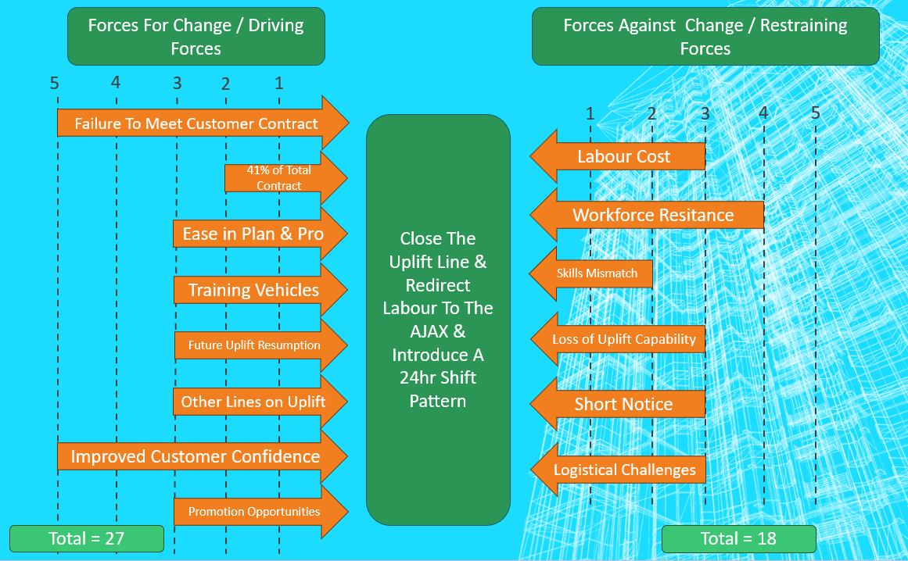
Figure 1- Force-Field Analysis Chart (n.d, Whatfix)

Evaluation of the Model

Lewin’s model is particularly valuable in its simplicity and clarity, making. It supports a proactive approach to identifying what are the driving forces and the resisting forces, while allowing to identify what needs to be strengthened or reduced to support the effective change. (2019, Change Management Insite) Critics argue that it lack details, while scoring can be done on personal preference that may oversimplify complex changes. (n.d, SixSigma.us)
In this case, as shown in Figure 1 GDLS-UK driving forces score is clearly stronger suggesting that the change is required but it does hide the cultural impact of the employee’s moral, with introducing shift changes and a redundancy of one production line.

Kotter’s 8 Step Model

Kotter’s 8 step model for change is widely adopted framework that helps organisations manage transitions by focusing on both rational and emotional components of change. Each step builds momentum and embeds the transformation into the culture of the organisation (2019, Van Assen, Van den Berg and Pietersma). Below we analyse GDLS-UK approach to their change against this model.

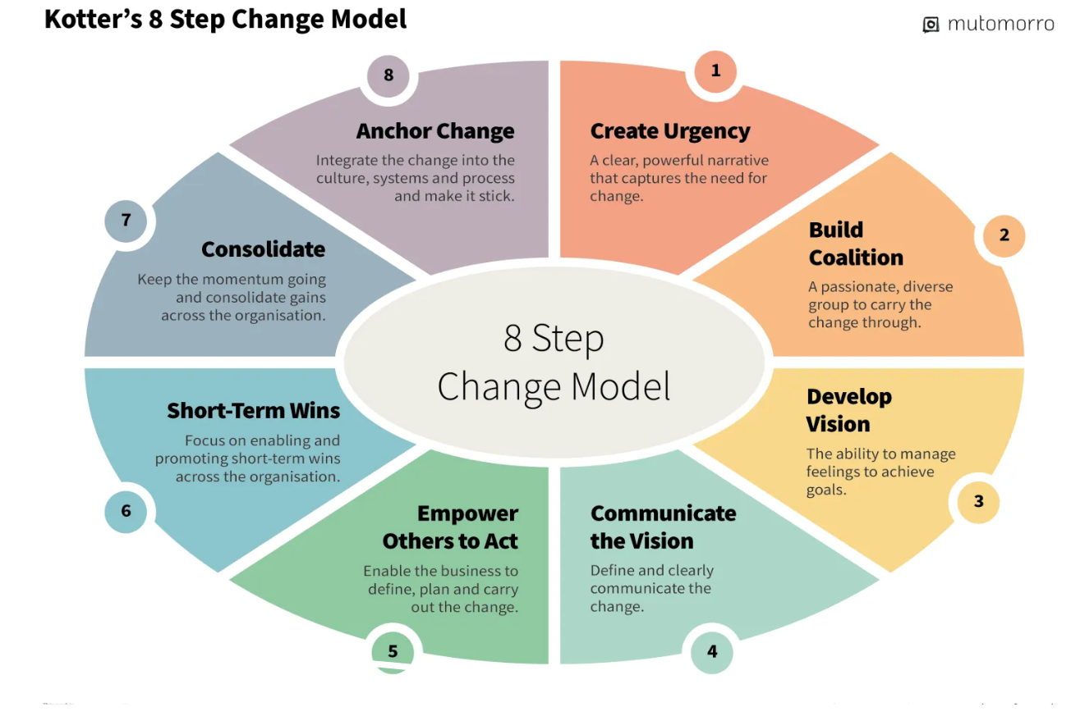
Figure 2 - Kotter's 8 Step Chart (n.d, mutomorro)

Step 1 – Create Urgency

The decision to consolidate the production lines was primarily driven by missed production targets, this created a business critical situation where a change was essential to restore contract agreement targets and client confidence. The urgency was largely operational, focused on productivity and customer satisfaction.

Step 2 – Build Coalition

Building a coalition is important to drive through the change and having people from all expertise of the organisation ensures a thorough and collective movement (2006, Kotter & Rathgeber). In this case the coalition team was he senior leadership team with the support of GD Canda unfortunately employees weren’t aware of these proposal and couldn’t voice their opinion.

Step 3 – Develop Vision

The development of change is to create the vision of tomorrow, first getting the final goal agreed, look for solutions to achieve this vision (2005, Cadwell). The core vision was to increase the production numbers by concentrating on the variant that required the least assembly time. Allowing production to get ahead of delivery schedule releasing additional time for more complex assemblies, “Uplift”.

Step 4 – Communicate Vision

Communication is powerful for a successful change, inspiring and showing the future of the company to its employees, allowing all to pull in the same direction to achieve the goal. Nothing undermines change more than the managers that are inconsistent with verbal and other forms of communication to their employees (2012, Kotter). GDLS-UK arguably have failed to communicate their vision to its employees by only issuing letter to whom the working hours change physically effect and all others below the managerial level hear about the changes by word of mouth.

Step 5 – Empower Others to Act

Have the organisation allowed the employees the tools and the flexibility to make this vision a reality (2012, Kotter). GDUK-LS have allowed the employees from other production lines and supporting department to transfer over to the shift patter allowing additional and willing labour. Other employees have had promotions due to the restructure. There is no evidence of training or consultation on shopfloor level regarding methods to ensure success.

Step 6 – Short-Term Wins

Short-term wins are important ensuring that the moral and momentum is positive allowing the long-term plan the time to succeed. (2015, Cagley) The short terms win are shown in the positive rise of the production monthly output from 4 to 13, with the company also celebrating its 100th vehicle delivered to the customer.

Step 7 – Consolidate

Maintaining the change but using the momentum from the early wins and allowing additional problem to be looked at. It’s been a challenge with a forecast of parts shortages as production run ahead of material procurement forecasted from previous projected plans and performances. However, with GDLS-UK planned to resume uplift in the future with strong indication of operative’s improved skillset and efficiency.

Step 8 – Anchor Change

With the importance of securing the change to ensure the culture, structure and process stay true to the new success and not return to the old way. It’s hard to judge the GDLS-UK in these early day but also with other production lines operating different hours and the module with it’s future to reinclude the uplifts doesn’t present itself with a stable fixed plan. However, its clear that the skillset has been built for the future. (2024, Jakobsen)

Leadership and Motivation

The success of organisational change is closely tie to the effectiveness of leadership and their impact on employee motivation. The change has presented an opportunity for management, team leaders and senior operatives to demonstrate responsive and adaptive leadership. (2020, International Conference on Human Factors).

Leadership Styles and Practice

GDLS-UK general strategy is cascaded top down to the local managers to deliver the goal, with this we can analysis the change and the leadership roles against Adair’s Action-Centred leadership model. This model identifies three key responsibilities, achieving the task, building and maintaining the team, and developing the individual. In theory, successful leadership balances all three elements to sustain productivity and people. (1979, Adair)

At GDLS-UK, the leadership focus during the change was primarily task-oriented to achieve the goal of increasing production output, this was urgent and was carried out by moving operatives from their original production line and introducing a day, night shift working pattern. The two-week notice suggests limited attention was initially paid to the team and individual sections. However, are positives actions aligned to the teams’ needs with a focus on the AJAX line a group feeling has developed with both shift motivated and pulling the project along to reach their targets. More employees have been given the greater responsibilities in team leadership roles and senior operatives to guide others creating a greater team bond. Looking at the individual needs they have benefited financially with the shift bonus and other individuals have managed to progress their career with promotions. A greater emphasis on a two-way communication would have aligned more closely with Adair’s model.

Motivational Factor

Ensuring the employees are motived increases the change to be successful and are fully bought into by the staff, using Herzberg’s Two-Factor theory we can evaluate and class the motivation to judge its strength. Herzberg’s Two-Factor theory proposes that workplace motivation is influenced by two groups of factors called Hygiene factors, which are factors related to the work environment for example salary and their absence can lead to dissatisfaction. (Alshmermri, Shahwan-Akl & Maude, 2017). The other factor grouping is called motivation factors which relate to the work itself and its content, this relates more to the opportunities of recognition, more responsibility and the challenge of the work. These directly contribute to the employee motivation. (Bevins, 2018)

Below the factors of the change have been grouped
Poor Hygiene Factors
- Shift Pattern – working unsociable hours, this would increase this dissatisfaction
- Shift Pattern Bonus – Extra financial award for the shift pattern, this would reduce the negative effect
- Two weeks’ notice – short notice would leave a feel of distrust between staff and management

Motivating Factors
- Promotion Opportunities
- More of a realistic method of achieving the delivery goals
- Develop new skills on a different variant

This shows that there are factors in both group with the shift pattern dissatisfaction factor being reduced by the pay increase there are then motivational factors of working towards a goal that’s more realistic with opportunity for individual growth and skill development this may create a more positive environment for the employees even though the relationship with the management isn’t strong.

Conclusion

The consolidation of two production lines into one represents a strategic response to the need for productivity improvements to revert the current failures and to succeed in at achieving the contract agreement with the customer. By analysing the organisational change through Lewin’s Force-Field Analysis and Kotter’s 8-Step Model that the change was required with the driving force and the created urgency of the change clearly highlighted, there are weaknesses shown in the lack of communication and opportunity of voice on the behalf of the operatives, which was highlighted in the restrictive force, communicate the vision and empower others to act. This restrictive is also shown as a weakness in the leadership method which also has a negative on the motivation of the employee. However, the early outcomes indicates that the change is a success with production increase and employees gaining valuable skills, knowledge and promotions.
Securing and anchoring this change is yet still to be determined with plans to reintroduce the closed production line and indications of part shortages making it hard to judge the success of the change on an everchanging and complex production plant.

Bibliography

Adair, J.E. (1979) Action-centred leadership. Farnborough, Hants: Gower
Alshmemri, M., Shahwan-Akl, L., & Maude, P. (2017). Herzberg’s Two-Factor Theory. Life Science Journal, 14(5), 12–16. Retrieved from http://www.lifesciencesite.com
Bevins, D. T. (2018). Herzberg’s Two Factor Theory of Motivation: A Generational Study (Honors thesis, Eastern Kentucky University). Encompass. Retrieved from https://encompass.eku.edu/honors_theses/530
By, R.T. (2005) ‘Organisational Change Management: A Critical Review’, Journal of Change Management, 5(4), pp. 369–380. Available at: https://doi.org/10.1080/14697010500359250 [Accessed 05 April 2025]
Cagley, T. (2015) Re-Read Saturday: Generating Short-Term Wins – Leading Change, John P. Kotter (Chapter 8). [blog] Tom Cagley’s Blog, 3 January. Available at: https://tcagley.wordpress.com/2015/01/03/re-read-saturday-generating-short-term-wins-leading-change-john-p-kotter-chapter-8/ [Accessed 16 April 2025]
Caldwell, C.M. (2005) Planning and Managing Change: EBook Edition. New York: AMACOM. Available at: https://ebookcentral.proquest.com/lib/imechetest-ebooks/detail.action?docID=1043661 [Accessed 05 April 2025]
Cameron, E. (2019) Making Sense of Change Management: A Complete Guide to the Models, Tools and Techniques of Organizational Change. London: Kogan Page.
Change Management Insight (2019) Lewin’s Force Field Analysis (Change Management). Available at: https://changemanagementinsight.com/lewins-force-field-analysis-change-management/ [Accessed 16 April 2025]
EDR Magazine. (2025) IAV 2025 – GDLS gives latest updates on Ajax. [online] Available at: https://www.edrmagazine.eu/iav-2025-gdls-gives-latest-updates-on-ajax [Accessed 16 April 2025]
General Dynamics UK. (n.d.) AJAX: The future of Armoured Fighting Vehicles. [online] Available at: https://generaldynamics.uk.com/systems/land-systems/ajax/ [Accessed 02 April 2025]
Harvey, J.M. (2014) Leaders’ Experience of Employee Resistance to Organizational Change: A Qualitative Exploratory Inquiry. PhD thesis. ProQuest Dissertations & Theses Global.
Institute for Manufacturing, University of Cambridge (n.d.) Force Field Analysis. [online] Available at: https://www.ifm.eng.cam.ac.uk/research/dstools/force-field-analysis/ [Accessed 12 Apr. 2025]
International Conference on Human Factors, Business Management and Society Online) (2020 : et al. (2020) Advances in human factors, business management and leadership : proceedings of the AHFE 2020 Virtual Conferences on Human Factors, Business Management and Society, and Human Factors in Management and Leadership, July 16-20, 2020, USA. Cham: Springer
Jakobsen, G. (2024) Leading Transformations : Using the LEGO® Way of Change to Drive Transformations Effectively and Successfully. New York, NY: Routledge
Kotter, JP 2012, Leading Change, with a New Preface by the Author, Harvard Business Review Press, La Vergne.
Kotter, J.P. and Rathgeber, H. (2006) Our Iceberg is Melting: Changing and Succeeding Under Any Conditions. New York: St. Martin’s Press
Mullins, L.J. (2016) Management and Organisational Behaviour, 11th ed. Harlow: Pearson Education
Mutomorro. (n.d.). Kotter’s 8-Step Change Model. Retrieved April 17, 2025, from https://mutomorro.com/kotters-8-step-change-model/
Sheffield Hallam University (2019) Force Field Analysis: Analysing the Pressures For and Against Change. [online] Available at: https://blogs.shu.ac.uk/shupdreviewtoolkit/files/2019/01/Force-field-analysis.pdf [Accessed 16 April 2025]
SixSigma.us (n.d.) Lewin Force Field Analysis in Change Management. [online] Available at: https://www.6sigma.us/six-sigma-in-focus/lewin-force-field-analysis-in-change-management/ [Accessed 16 April 2025]
The Open University (n.d.) Succeed with learning: Week 8 – 1.1 Force-field analysis. [online] Available at: https://www.open.edu/openlearn/mod/oucontent/view.php?id=19244&section=1.1 [Accessed 12 April 2025]
Van Assen, M., Van den Berg, G. and Pietersma, P. (2009) Key Management Models: The 60+ Models Every Manager Needs to Know. 2nd ed. Harlow: Financial Times/Prentice Hall
Whatfix (n.d.) Force Field Analysis: Definition, Examples & Template. [online] Available at: https://whatfix.com/blog/force-field-analysis/ [Accessed 16 April 2025]

