ECAD 4014: Developing Professional Literacy, Numeracy & Digital Competence
Target 1- To ensure the reference list is in alphabetical order. - I have taken care to ensure the reference list is alphabetised.
Target 2- To follow the Harvard Referencing Guidance (e.g. when to use page numbers). – I have referred to referencing guidance to ensure I refer to evidence accordingly.
Target 3- Consider the impact of research on your own professional learning and how this may transform your future professional practice. – I have used the opportunity to reflect upon my own learning and how, or what I shall be taking forward into my own practices.
Education in Wales has undergone a significant transformation, propelled by the implementation of the Curriculum for Wales Framework in September 2022, influenced by Donaldson’s seminal report ‘Successful Futures’ (2015). This framework marks a break from traditional subject-centric instruction, emphasising a holistic approach from Foundation Learning to Key Stage 4. At its core, the framework aims to standardise educational practices, guide curriculum development and set assessment standards to facilitate learner progression. Departing from traditional subjects, the curriculum organises learning into Areas of Learning and Experience (AoLEs) such as Expressive Arts, Health & Wellbeing, Humanities, Languages, Literacy & Communication, Mathematics & Numeracy and Science & Technology. Each of these is underpinned by the ‘What Matters Statements’ prioritising conceptual understanding alongside subject-specific knowledge.
Central to this reform is the promotion of cross-curricular capability within the framework. While AoLEs are recognised as interlinking and supporting one another, the framework places emphasis on three mandatory cross-curricular skills: Literacy, Numeracy and Digital Competence. Supported by their own frameworks, these skills are integrated throughout the curriculum to foster transferrable problem-solving skills and a meaningful learning experience for learners (Wales, 2019). This approach aligns with theories advocating for active learning such as those proposed by Maria Montessori, Rachel Macmillan, Susan Isaacs and Jean Piaget. By transcending traditional subject boundaries, experiences and opportunities, enhancing their engagement and understanding.
However, the implementation of this approach is not without challenges. While the integration of subjects offers numerous benefits, it requires careful planning, alignment and teacher training to be effective (Earp, 2016). Additionally, tensions may arise between cross-curricular teaching and individual subject assessments, necessitating a balance between depth and breadth of learning (University of Cambridge, 2024). Teachers must ensure that links between subjects are meaningful, learning objectives remain clear and focused (Kydd, 2015). Moreso, the effectiveness of cross-curricular teaching hinges on high quality instruction, underscoring the need for ongoing professional development for educators (Blair & Francis, 2011), as well as the financial and physical capability of the primary setting to employ Teaching Assistants to assist and acquire resources.
In order to comprehensively evaluate the efficacy of implementing a cross-curricular approach, a meticulously designed lesson plan has been formulated (refer to Appendix B). This plan will undergo scrutiny to assess its adherence to the Curriculum for Wales Framework, its efficacy in nurturing cross-curricular skills, as well as its influence on learner engagement and learning outcomes. Through dual examination encompassing both theoretical principle and practical implementation, this analysis seeks to furnish valuable insights into the inherent strengths, limitations and prospective areas for refinement within this pedagogical methodology.
In Appendix B I have completed a lesson plan which I aim to carry out during my Professional Teaching Experience 1 (PTE1) through discussion with my mentor I have linked the lesson to the new terms topic ‘Our Wonderful World,’ even though I have planned a four group rotational lesson plan, for the purpose of this assignment I shall focus on critically analysing the Group 1 activity of sorting recyclable materials. I have created laminated images of bins and labelled them with the English material name and the Welsh, employing the use of incidental Welsh, which reflects the Welsh Governments (2017) aim to promote Welsh within the community and future generations.
Additionally I have curated an assortment of authentic recyclable materials to facilitate hands-on exploration and discussion among learners, culminating in the categorisation of these items into predetermined groupings. Doull (2022) advocates for both indoor and outdoor exploration as pivotal for fostering the development of identity and opinions in learners. Educators are encouraged to establish conducive environments that afford children the opportunity to navigate and appreciate disparities in opinions and physical attributes, thereby facilitating their growth within their surroundings. While the confines of the classroom may limit outdoor engagement, the integration of tangible representations pertinent to the subject matter endeavours to spark dialogue conducive to exploring divergent viewpoints and practicing conflict resolution strategies amongst learners. This supports some of the various ‘What Matters’ Statements that are included within the lesson plan from the Humanities Framework (Welsh Government, 2020) and Languages, Literacy & Communication (LLC) Framework (Welsh Government, 2021).
Employing authentic materials serves as a pivotal strategy in addressing the diverse linguistic needs of learners, particularly those with English as a second language or those encountering difficulties in verbal expression. Through direct interaction with tangible resources, learners are afforded opportunities to engage meaningfully with the materials, thereby enriching their cognitive schema and enhancing language acquisition. This experiential learning process is further augmented by peer interactions, as learners engage in discussions and receive descriptive input from their classmates, aligning with Vygotsky’s (Bates, 2023) theory of the More Knowledgeable other (MKO), Moreover, the deliberate integration of the MKO within the lesson plan, delineated in the ‘Role of the teacher’ section (refer to Appendix B), is poised to infuse the activity with dynamic facilitation, fostering a rich and immersive learning environment conducive to linguistic and cognitive growth.
The overarching objective of the lesson is for the class teacher to orchestrate a structured learning experience wherein learners are empowered to autonomously engage in exploration and classification activities with authentic materials. The teacher's role encompasses initial guidance, fostering independent inquiry and collaborative discourse during the sorting process and culminates in a reflective phase where learners are prompted to articulate their rationale behind categorisation decisions. This reflective dialogue not only encourages critical thinking but also facilitates metacognitive awareness of the cognitive processes involved. Anticipating potential misconceptions, the lesson design accommodates varying levels of familiarity with the materials, fostering an inclusive learning environment where all learners are encouraged to participate actively and embrace errors as integral to the learning process. Drawing inspiration from the ethos observed at School X, which prioritises a growth mindset and celebrates effort over mere achievement. The lesson endeavours to instil a culture of constructive learning where mistakes are viewed as opportunities for growth and refinement. This approach mirrors the principles outlined in Dweck’s (2017) research of fostering a growth mindset in education. By mitigating the fear of failure and emphasising continuous learning and perseverance, it cultivates an environment conducive to enhanced learner engagement, improved learning outcomes and bolsters mental well-being. Encouraging a growth mindset not only promotes resilience and perseverance, but also paves the way for higher levels of achievement.
The process of categorising materials holds considerable cross-curricular significance, as it underscores the recognition and utilisation of how a single activity or lesson can intersect with various Areas of Learning and Experience (AoLEs), facilitating the establishment of meaningful connections for learners. By aligning the activity with two of the mandatory cross-curricular skills, it became apparent that the scope of the activity did not fully encompass Digital Competence. This highlights the need to acknowledge that not all activities can encompass all three mandatory cross-curricular skills and adjustments may be necessary to address specific progression steps within these skills frameworks. Bernstein’s examination of cross-curricular teaching warns of the potential risk of diluting disciplinary knowledge (BERA, 2020), underscoring the importance of careful planning and alignment with curriculum objectives.
Reflectively looking back there is potential to include Digital Competence by adding an extension task, such as having the learners document their findings by using photography on an iPad and then using this to create a digital visual of their work at the end.
In the Foundation Learning classroom, planning is facilitated through the implementation of three key approaches: Focus Task, Enhanced Provision and Continuous Provision. Focus Task serves as a method for guiding, modelling and encouraging learners to develop their skills, knowledge and concepts necessary for lifelong learning. Enhanced Provision involves the incorporation of additional materials and resources by teachers, aimed at enriching continuous provision and offering learners opportunities for more challenging experiences. This approach is instrumental in tailoring independent learning techniques and broadening learner's horizons. Continuous Provision entails the provision of resources and activities that are consistently available to learners, allowing them to engage in learning autonomously even in the absence of adult guidance. Starting with a basic setup of materials such as sand, water and paint, teachers then expand provision based on learner’s interests and the topics being covered (Welsh Government, 2023).The sorting activity is the Focus Task, learners knowledge has the potential to be expanded upon to include enhanced and continuous provision, it is vital with the Focus Task to include misconceptions in order to plan to address these, as well as to include inclusivity in order to meet the variety of learner capabilities, as seen in Appendix B.
Within Appendix B I have set the assessment for learning (AfL) to be achieved by summative assessment, by discussing the groupings of materials the learner has placed materials and the reason behind this. This method allows for the learner to practice progression steps which link to the Literacy and Numeracy Framework, gauging the learning they have achieved as well as providing a means to address and correct misconceptions to the learning (Welsh Government, 2024). It has been observed during placement that by allowing learner to express verbally their learning, reasoning and understanding not only empowers them, but also allows for learners to feel valued and as part of their individual learning journeys. This is supported in the Foundation learning classroom by educators, including teachers and teaching assistants engaging with learners by empathising with their emotions, demonstrating genuine interest in their curiosity about the world and acknowledging their competence as learners to foster self-esteem. This approach recognises that listening is equally essential as speaking in interactions with learners (Aldrup, Carstensen & Klusmann, 2022).
The foundation of curriculum design for all learners' rest upon twelve pedagogical principles, emphasising the importance of effective learning and teaching (Welsh Government, 2023). These principles advocate to maintain a steadfast focus on the overarching goals of the curriculum, challenging every learner to acknowledge the significance of persistent effort in attaining expectations set high yet within their reach. They advocate for a diversified approach, combining direct teaching methods with those fostering problem-solving, creativity and critical thinking skills. This holistic approach ensures that learners are engaged and empowered to excel across various learning domains.
Barnes (2015) states that the world beyond the classroom is cross-curricular, this implies that to prepare learners for the world they are entering, embodying the Four Purposes, that cross-curricular teaching and learning may be the most optimum method.
Darling-Hammond (2016) outline the extensive skills and knowledge teachers need: This includes:
- Understanding learners and learning: recognising social contexts, developmental stages and catering to diverse learners.
- Mastery of subject matter and curriculum objectives: possessing deep subject knowledge, making curriculum decisions and selecting appropriate materials.
- Proficiency in teaching techniques: employing strategies to engage and organise learners, maintaining effective classroom management and using formative assessment methods to gauge understanding levels.
Kennedy, Hay and McGovern (2020 offer valuable insights into the complexities of classroom dynamics, identifying six significant concerns including content delivery, student learning, engagement, lesson continuity, classroom culture and educator well-being. These concerns intersect with the professional standards in Wales, which aim to elevate teaching quality and learner outcomes by delineating the competencies expected of educators, administrators and Higher-Level Teaching Assistants (HLTA) (Welsh Government, 2011). Embedded within the broader standards signify a pivotal aspect in ensuring a comprehensive and effective approach to professional development (Welsh Government, 2021). Recognising the importance of these skills, I prioritise their utilising and development in my teaching endeavours, aiming to enhance my personal teaching practices to meet desired standards.

Appendix A
Note: Images are of the completion of the resource in use. It was noted at this time that there was an error where there was a duplicate of words on the bins (there were two glass bins instead of a glass and plastic) this shall be rectified for implementation in the classroom setting.
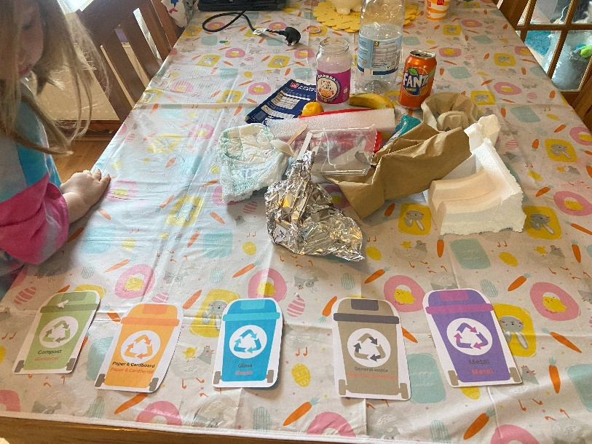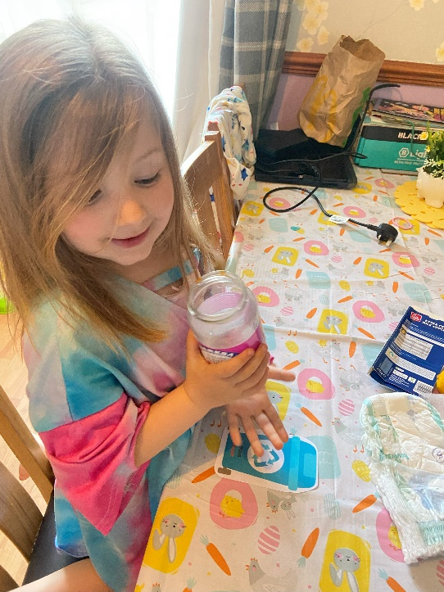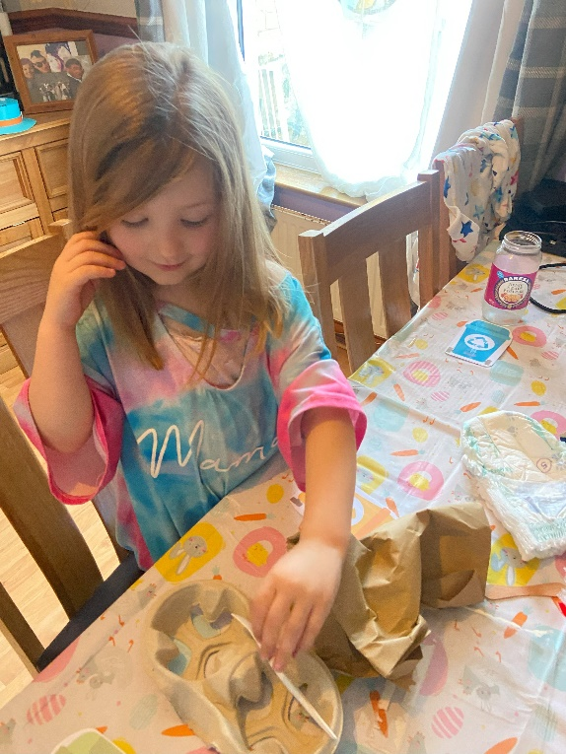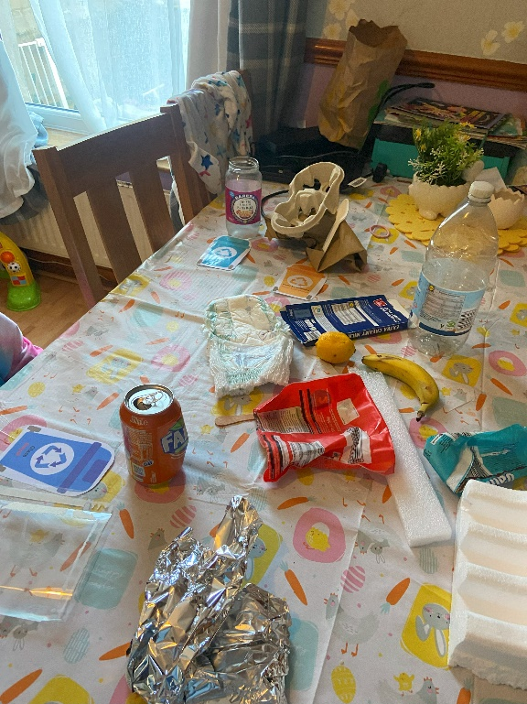

Appendix B
Lesson Plan:
Student-teacher: | Miss Hughes | Class / Group: | Dosbarth Newgale  Year 2/3
AoLE or Subject: | Humanities  Theme- Our wonderful world.  Topic- Identify and sort different recyclable materials. | Date (please note that this may be a continuous session): | TBC
Meaningful links to Curriculum (What Matters Statements, Descriptions of learning, ‘previous’ curriculum...) | WMS- Enquiry, exploration and investigation inspire curiosity about the world, its past, present and future.  Principles of progression- Increasing breadth and depth of knowledge  Progression step 1- I am beginning to communicate my observations in simple ways
Meaningful links across the curriculum  Links to other AoLEs or the Cross-curricular skills frameworks) | Science and Technology  WMS- Being curious and searching for answers is essential to understanding and predicting phenomena.  Progression Step 3- I can understand how my actions and the actions of others can impact on the environment and living things.  Health & Wellbeing  WMS- Our decision-making impacts on the quality of our lives and the lives of others.  Progression Step 2- I can recognise that my decisions can impact on me and others, both now and in the future.  Mathematics & Numeracy  WMS- The number system is used to represent and compare relationships between numbers and quantities.  Progression Step 1- I can use my experience of the counting sequence of numbers and of one-to-one correspondence to count sets reliably. I can count objects that I can touch and ones that I cannot.  Languages, Literacy & Communication  WMS- Expressing ourselves through languages is key to communication.  Progression Step 2- I can explain where and why I have made any changes or corrections.
Personal Targets (targets and consequent impact on learning - refer to any targets that have been identified in learning journal or weekly reflection meeting and describe the desired impact on learning)
By having a rotation of groups, I want to work on my ability manage the learning environment in order to facilitate fluid and effective learning.

Learning Intention
‘This should focus on the pupils’ learning during the lesson, rather than what they will be doing, and should be short, achievable and measurable.’ (Crichton, H., and Mcdaid, A. 2016 p. 196)
Identify what materials can be recycled?

Success Criteria
What the pupils need to demonstrate to successfully meet the Learning Intention.
Learners to understand what materials can be recycled at home.
Learners to recognise what materials can be recycled at school.
I can explore and identify different materials for recycling.
I can separate materials into appropriate groupings based on prior knowledge, peer discussion and exploration.
Planning for misconceptions:
Use this section to anticipate pupil errors and misunderstandings and your planned responses to them.
Learners may confuse foil as paper possibly, or certain plastics as glass. Discussion prior to activity in order to draw upon previous knowledge and experiences of recycling in the home or school. Wooden utensils, flowers, teabags, children may be confused if these can go into compost. Glass bottles or jars with lids on may not be separated to go into individual piles.

SEQUENCE OF TEACHING & LEARNING
(Add or remove rows below as appropriate)

Timing:  Break down timings into groups if appropriate. ensure pupils are ‘doing’ quickly and that transitions are taken into account | Role of the teacher & support staff:  e.g., key questions, retrieval of prior learning, modelling and explanations, checking understanding, planned use of additional adults.  Choice of pedagogical model or of the 12 pedagogical principles | Pupils’ learning and activities:  What will the pupils be learning to do and what activities / resources will facilitate this?  Please refer to Foundation Learning planning document for details of continuous provision. | Inclusive Strategies (including differentiation):  Reasons for and details of scaffolding.  Types of representation in tasks. | Check what pupils know, understand, and can do:  Key questions, types of retrieval practices, self and peer assessment opportunities, purposeful AfL strategies, live marking opportunities, planned feedback.
10 minutes | Class teacher to read poem to class, explain the 4 group activities and what each group will be doing and that they will rotate after a certain amount of time.  Attempt to group learners into an even number of groups, ensuring to mix low and high ability learners within a single group. | - Poem printed and available in case of IT issues. Display on main whiteboard for class to follow along and view.  - A table of pupil names allocated to groups. Class teacher to display this during activities.  - 4 group rotation. | Use visual template and display in class for learners to see which group they are in and what activity they are doing. | Ask learners to share amongst themselves what they feel the poem is trying to tell us. Select a few to share their opinions.
Each rotation 20 minutes each. | Class teacher to introduce this task and then allow learners to engage independently. Check in at the end of the activity time. Review learners’ knowledge of materials for recycling. Link into the school's term topic of ‘Our Wonderful World’.  Whole class introduction to activity sat at assigned tables.  Group learners into four rotational groups for activities and introduce these.  Introduce the key vocabulary compost, glass, cardboard, plastic, metal, general waste, paper, reduce, reuse, recycle.  As well as Welsh vocabulary: metel, gwastraff cyffredinol, plastig, cartonau, papur, cardfwrdd, gompost. | - Group 1- sorting materials into recyclable groups (either worksheet/3D authentic objects/mixture) include incidental Welsh.  Using the laminated recycle bins, use loose materials of rubbish examples for students to sort out into recycling categories. Allow learners to explore and discuss the items amongst themselves.  At the end of the group activity, ask the group if anyone disagrees with a decision to place an item in a certain pile, enquire why they think it belongs to another.  Class teacher then to go through the piles with learners and address any misconceptions through discussion. | Group learners with at least one high ability and one low ability learner in order to provide MKO.  There is a learner identified in class who requires consideration when information processing, experience has shown best to avoid using ‘why’ questions. | Link Voice 21 into discussion at the end, enquire why some learners chose one material to be grouped over another. Do they have any suggestions or examples of recycling that links to their activities.  Questions to use: ‘What does the material feel like?’  ‘What made you decide to put it in ‘X’ group?’  ‘Have you seen ‘material X’ before? Where?’
Each rotation 20 minutes each. | Class teacher to facilitate activity, encourage discussion while looking at the poem line by line.  Key questions: “what message is this line trying to get across?”  “What do you think the author was trying to mean by this?”  “Can you think of any other materials that can be recycled?”  “Can you identify any lines that rhyme?” | Group 2- Discuss poem and as a group use sentence strips to explore their meanings on white board, add important words, or drawings (e.g. the world). Allow learners to share their own knowledge and experiences of recycling. Use worksheet to cut and stick poem into book, learners to decorate. | Teacher-led group prompts to be given for those who may require more guidance. | “What groups of materials are there?”  “Can you name any other examples of items that can be recycled?”
Each rotation 20 minutes each. | Class teacher to introduce the task, facilitate, then allow to be learner-led.  Explore the learner's knowledge of our duty to the planet. Can link to school's religious values. | Group 3- for the continuous provision of ‘What we have learned’ area to be introduced, pupils to use a ‘why do we care for our planet’ template writing down why we need to protect our world, why should we recycle. Discuss possible ideas before writing.  Dictionaries to be available for spelling. | Can provide prompt cards for sentence starters. | ‘What does recycle mean?’  ‘What does reuse mean?’  ‘What does reduce mean?’
Each rotation 20 minutes each. | TA to support pupils in following instructions and guiding pupils in correct application, to ensure safety and use blender. | Group 4- Using the provided instructions sheet, learners will follow the instructions in how to make recycled paper. Pulp that can be used will have been made prior to session (as it needs to be soaked for hours), pupils can still make a new batch and use the prepared pulp to shape and strain their own pieces of paper. Class teacher to support pupils with this activity, guide them to read and explain their understanding of what the instruction is telling them. Use correct terminology, the mixture is called ‘pulp’.  Use class iPad to take photos for display. | If any learners have allergies, sensitive skin or sensory issues in regard to manipulating the pulp gloves can be provided. | Have learners been able to recall the steps to make the paper. Was there any problem solving required?

Lesson Plan Resources:
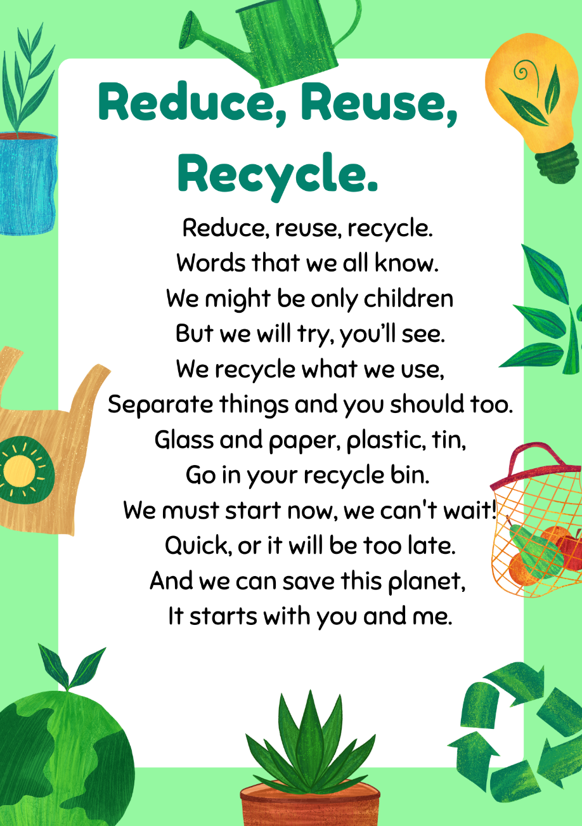
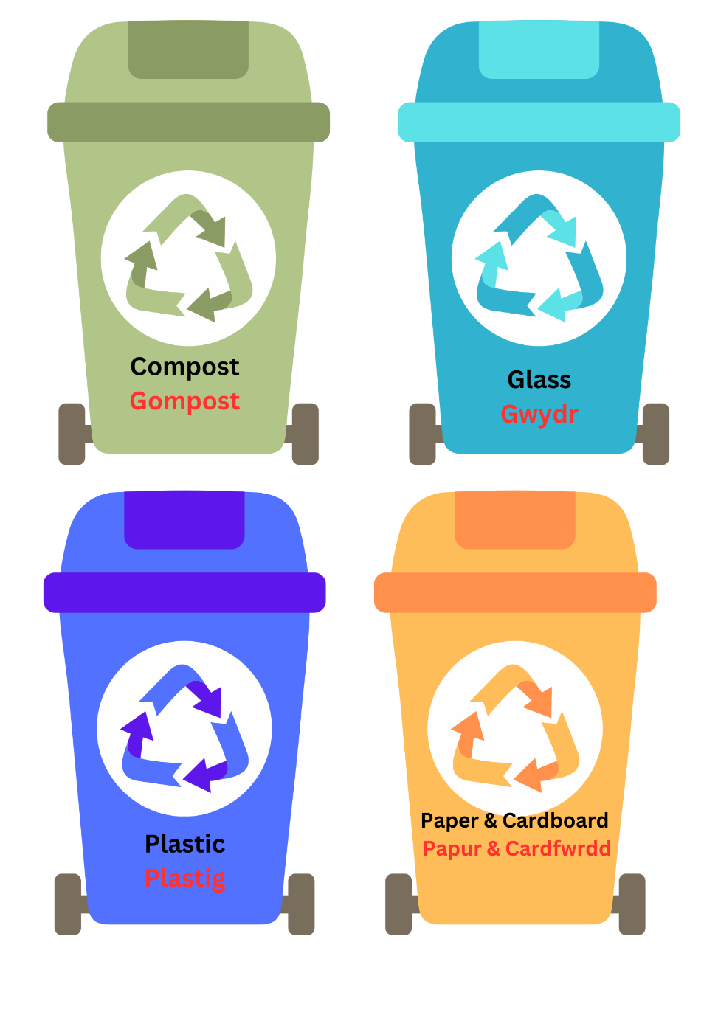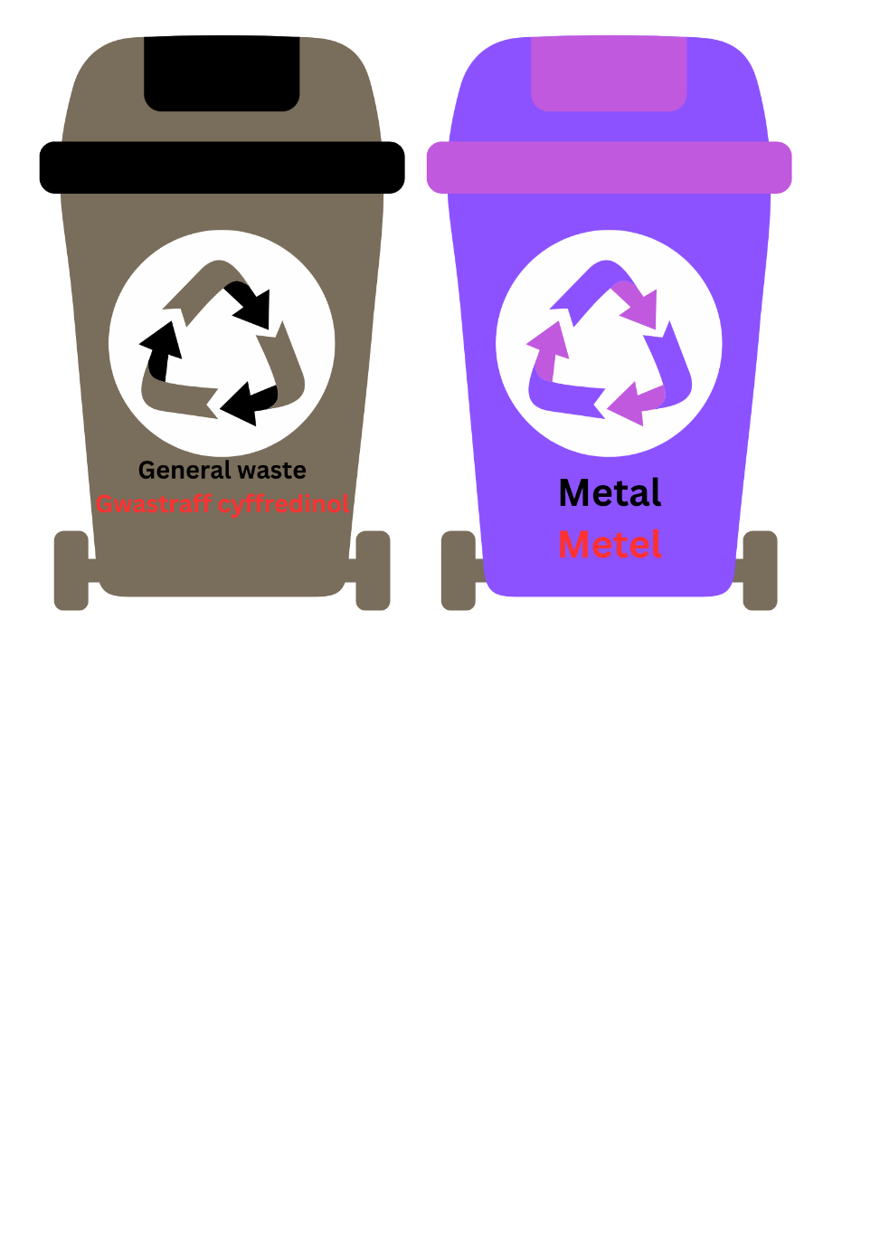

Reference List
- Aldrup, K. Carstensen, B. & U, Klusmann. (2022) ‘Is Empathy the Key to Effective Teaching? A Systematic Review of Its Association with Teacher-Student Interactions and Student Outcome.’ Educ Psychol Rev. 34. Pp. 1177-1216. Available at: https://link.springer.com/article/10.1007/s10648-021-09649-y#citeas (Accessed: 14th April 2024) DOI: 10.1007/s10648-021-09649-y
- Barnes, J. (2011) Cross-Curricular Learning 3-14. 3nd Edition. London: Sage
- Bates, B. (2023) Learning Theories Simplified… and how to apply them to teaching. 3rd Edition. London: Sage
- BERA (2020) The Curriculum Journal- Curriculum integration: the challenges for primary and secondary schools in developing new curriculum in the expressive arts. Available at: https://bera-journals.onlinelibrary.wiley.com/doi/10.1002/curj.34 (Accessed: 12th April 2024)
- BERA. (2024) Differential Effects of Subject-based and Integrated Curriculum Approaches on Students Learning Outcomes: A Review of Reviews. Available at: https://bera-journals.onlinelibrary.wiley.com/doi/full/10.1002/rev3.3465 (Accessed: 10th April 2024)
- Blair, E. and Francis, L. (2011) Was it right to abandon the creative curriculum? NFER Practical Research for Education. 44: 26-32
- Darling-Hammond, L. (2016). ‘Research on Teaching and Teacher Education and Its Influences on Policy and Practice’. Educational Researcher, 45(2), pp.83-91. DOI: 10.3102/0013189X16639597
- Doull, K. (2022) Teaching a Divers Primary Curriculum. London: Learning Matters A Sage Publishing Company
- Dweck, C. (2017) Decades of Scientific Research that Started a Growth Mindset Revolution. Available at: https://www.mindsetworks.com/science/ (Accessed: 12th April 2024)
- Earp, J. (2016) Navigating the Challenges of Cross-Curricular. Available at: https://www.teachermagazine.com/au_en/articles/navigating-the-challenges-of-cross-curricular (Accessed: 10th March 2024)
- Kennedy, A. Hay, L. & McGovern, B. (2020) A Story of Transforming Teacher Education. Available at: https://strathprints.strath.ac.uk/75746/1/Kennedy_etal_SER_A_story_of_transforming_teacher_education.pdf (Accessed: 14th April 2024)
- Kydd, B. (2015) The Advantages and Disadvantages of Cross Curricular Approaches to Teaching. Available at: https://prezi.com/pwolphrenqos/the-advantages-and-disadvantages-of-cross-curricular-approac/ (Accessed: 10th April 2024)
- University of Cambridge. (2024) Key Obstacles Hindering Cross-curricular Teaching. Available at: https://nrich.maths.org/8453 (Accessed 10th March 2024)
- Welsh Government. (2011) Revised Professional Standards for Education Practitioners in Wales. Available at: https://hwb.gov.wales/api/storage/1e4ebd38-122d-41c8-9730-97adc9d054d9/professional-standards-for-education-practitioners-in-wales.pdf (Accessed: 14th April 2024)
- Welsh Government. (2017) Cymraeg 2050 A million Welsh speakers. Available at: https://www.gov.wales/sites/default/files/publications/2018-12/cymraeg-2050-welsh-language-strategy.pdf (Accessed: 12th April 2024)
- Welsh Government (2019) Cross-curricular Skills Framework. Available at: https://hwb.gov.wales/curriculum-for-wales/cross-curricular-skills-frameworks/ (Accessed: 14TH April 2024)
- Welsh Government. (2020) Curriculum for Wales- Humanities. Available at: https://hwb.gov.wales/curriculum-for-wales/humanities/ (Accessed: 12th April 2024)
- Welsh Government. (2021) Curriculum for Wales- Languages, Literacy and Communication. Available at: https://hwb.gov.wales/curriculum-for-wales/languages-literacy-and-communication/ (Accessed: 12th April 2024)
- Welsh Government. (2021) Evaluation of the Professional Standards for Teaching, Leadership and Assisting Teaching: Year 1 (Summary). Available at: https://www.gov.wales/sites/default/files/pdf-versions/2021/11/4/1637223388/evaluation-professional-standards-teaching-leadership-and-assisting-teaching-year-1-summary.pdf (Accessed: 14th April 2024)

- Welsh Government. (2023) A Quality Framework for Early Childhood Play, Learning and Care in Wales. Available at: https://hwb.gov.wales/api/storage/031bbc2d-d2f8-429d-a944-5fc33484827d/a-quality-framework-for-early-childhood-play-learning-and-care-v1.pdf (Accessed: 14th April 2024)
- Welsh Government. (2023) Curriculum for Wales- Designing your Curriculum- Pedagogy. Available at: https://hwb.gov.wales/curriculum-for-wales/designing-your-curriculum/pedagogy/#:~:text=Curriculum%20design%20for%20all%20learners%20is%20underpinned%20by,promote%20problem-solving%2C%20creative%20and%20critical%20thinking%20More%20items (Accessed: 14th April 2024)
- Welsh Government. (2024) Literacy and Numeracy Framework. Available at: https://hwb.gov.wales/curriculum-for-wales/cross-curricular-skills-frameworks/literacy-and-numeracy-framework/ (Accessed: 14th April 2024)

