
Student name : Stefanie Fregonezi
Student ID : 2415546
Module code : LCLM5003
Module name : Organization Culture
Lecture name : Christopher Osborne

Organisational Culture at Severn Trent Water

2026
Contents
1. Introduction 2
2. Organisational Culture, Structure and Decision Making 3
3. Identifying Organisational Culture Through Theoretical Models 4
3.1 Schein's Model of Organisational Culture 4
3.2 Hofstede's Cultural Dimensions 5
3.3 Handy's Cultural Types 5
4. Organizational culture and adaptation to the external environment 7
5. Evaluate the impact of organisational culture on organisational performance 8
6. Impact on Performance and Recommendations for Improvement 10
7. Conclusion 11
8. REFERENCE LIST 12

Introduction
Organisational culture refers to the shared beliefs, values, behaviours and norms that influence how employees interact, make decisions and carry out their work. It reflects the everyday working environment, including leadership approaches, communication and teamwork. A strong organisational culture helps employees feel connected to the organisation's purpose, encourages engagement and collaboration, and contributes to improved organisational performance(Achievers, 2026). Mullins and Christy (2016) argue that culture represents the shared assumptions, beliefs, values and behaviours that guide how employees think and act within organisations. Culture influences not only internal relationships but also how organisations respond to external environmental pressures and strategic challenges.
Critically evaluates the organisational culture of Severn Trent Water (STW), one of the largest water utility companies in the United Kingdom, supplying water and wastewater services to millions of customers across the Midlands and Wales. Severn Trent operates in a highly regulated and environmentally sensitive industry where customer trust, sustainability and operational reliability are essential for success(Severn Trent Water, 2026).
This report explores how organisational culture influences Severn Trent Water's organisational structure and decision-making processes. It applies recognised theories and frameworks, including Schein's Model of Organisational Culture, Handy's Cultural Types and Hofstede's Cultural Dimensions, to identify and evaluate the organisation's prevailing culture. The report also examines how Severn Trent uses its organisational culture to adapt to external environmental challenges and critically assesses whether its culture acts as an enabler or a barrier to organisational effectiveness. In addition, it evaluates the impact of organisational culture on organisational performance and concludes by providing theory-informed, evidence-based recommendations to support continuous improvement and long-term success.

2. Organisational Culture, Structure and Decision Making
Mullins and Christy (2016) describe organisational culture as the personality of an organisation because it influences employees' behaviours, attitudes and methods of working. They argue that organisational culture and structure are closely connected, as shared values shape reporting relationships, communication patterns and decision-making processes throughout the organisation.
As a regulated water utility, Severn Trent Water operates within a formal organisational structure designed to ensure accountability, compliance and effective service delivery. The company is regulated by Ofwat and other environmental regulators, requiring clear governance arrangements and defined responsibilities to protect public health, the environment and customer interests (Severn Trent Water, 2026). Consequently, strategic decisions are made within a structured governance framework that supports legal compliance while maintaining operational efficiency.
Although Severn Trent has a hierarchical structure, its organisational culture promotes collaboration, ethical behaviour and continuous improvement. The company's Doing the Right Thing: The Severn Trent Way outlines core values that encourage employees to act with integrity, take responsibility for their actions and make decisions that benefit customers, communities and the environment (Severn Trent Water, 2022). These shared values influence both leadership behaviour and everyday decision making across different organisational levels.
The company's Strategic Direction Statement further demonstrates that decision making is guided by long-term objectives rather than short-term financial performance. Severn Trent prioritises sustainability, innovation and resilience by investing in infrastructure, environmental protection and customer service improvements, reflecting a culture that supports responsible and forward-looking decision making (Severn Trent Water, 2025). This approach encourages managers to balance commercial objectives with environmental and social responsibilities when making strategic decisions.
Furthermore, Severn Trent's organisational structure combines formal governance with collaborative working practices. While major strategic decisions remain centralised within the Board of Directors and senior management, operational teams are encouraged to contribute ideas and identify opportunities for continuous improvement. This combination reflects what Mullins and Christy (2016) describe as a balance between mechanistic and organic organisational characteristics, where formal procedures ensure regulatory compliance while collaboration and employee involvement support innovation and organisational learning.
Overall, Severn Trent's organisational culture strongly influences its structure and decision-making processes by promoting accountability, stakeholder engagement and sustainable business practices. The alignment between the company's strategic objectives, governance framework and organisational values enables it to operate effectively within a highly regulated industry while responding to changing customer and environmental expectations.

3. Identifying Organisational Culture Through Theoretical Models

3.1 Schein's Model of Organisational Culture
According to Schein (2010), organisational culture can be understood through three interconnected levels: artefacts, espoused values and basic underlying assumptions. At the artefact level, Severn Trent's culture is reflected in its visible practices and organisational symbols, including its corporate branding, the Doing the Right Thing: The Severn Trent Way code of conduct, health and safety procedures, operational standards, and community and environmental initiatives. These visible elements demonstrate the organisation's commitment to responsible business practices, employee safety and environmental sustainability, including its pledge to support England's nature recovery network (Severn Trent Water, 2022; Severn Trent Water, 2025).
The second level, espoused values, refers to the principles and beliefs that the organisation publicly promotes. Severn Trent emphasises providing reliable water and wastewater services while creating long-term value for customers, communities and the environment. Its strategic ambition to become the most trusted water company reflects core values centred on sustainability, innovation, customer focus and responsible leadership (Severn Trent Water, 2025; Severn Trent Water, 2026).
At the deepest level, Schein describes basic assumptions as hidden beliefs that guide behaviour. At Severn Trent, this means keeping water services safe and reliable at all times. Because it is a regulated company, it focuses on meeting rules and keeping public trust rather than competing in a market. As a result, decisions often focus on safety, reliability and following regulations instead of taking risks. Although the company supports innovation, it tends to be careful because mistakes could harm the environment, public health and its reputation.

3.2 Hofstede's Cultural Dimensions
Hofstede's (1980) Cultural Dimensions Theory, though designed for national cultures, can also explain organisational behaviour (Mullins and Christy, 2016). As a UK-based company, Severn Trent reflects traits such as low power distance, individualism and a long-term outlook, though these are shaped by its regulated environment.
In terms of power distance, Severn Trent promotes collaboration, but key decisions remain centralised with senior management to meet regulatory responsibilities (Severn Trent Water, 2026).
Regarding uncertainty avoidance, the company shows a stronger preference for formal procedures and risk management than typical UK norms, due to its need to ensure safety and compliance (Severn Trent Water, 2022).
Severn Trent also demonstrates strong long-term orientation, focusing on sustainability, infrastructure and future customer needs (Severn Trent Water, 2025).
Overall, while reflecting UK cultural traits, Severn Trent’s culture is shaped by regulation, emphasising governance, risk management and long-term planning.

3.3 Handy's Cultural Types
Handy’s (1993) model, based on Harrison’s work, identifies four types of organisational culture: power, role, task and person. This model helps explain how organisations are structured and how decisions are made. When applied to Severn Trent, the company mainly shows a role culture, with some elements of a task culture.

Culture Type | Key Characteristics (Handy, 1993) | Application to Severn Trent Water
Power Culture (Zeus) | Decisions are made by one person or a small group, with few rules. | This is not common at Severn Trent. As a large, regulated company, decisions are made by a board and leaders, not one person.
Role Culture (Apollo) | Clear roles, rules and procedures, with a structured hierarchy. | This is the main culture at Severn Trent. The company has clear departments, rules and policies, such as Doing the Right Thing: The Severn Trent Way, which supports ethical behaviour.
Task Culture (Athena) | Focus on teamwork and solving problems through projects. | Severn Trent shows this through teamwork, innovation projects, digital changes and environmental work.
Person Culture (Dionysus) | Individuals have more control and focus on their own goals. | This is not common at Severn Trent, as the company focuses on rules, safety and meeting organisational goals.

Overall, Severn Trent mainly has a role culture, with clear structures and rules to ensure safe and reliable services. However, it is also developing task culture through teamwork and innovation, helping the company adapt to change and improve performance.
Based on these frameworks, the dominant culture at Severn Trent can be described as:
A stakeholder-oriented role culture with strong sustainability and task culture characteristics.
The organisation combines:
- Formal control systems.
- Regulatory compliance.
- Collaborative working practices.
- Environmental stewardship.
- Long-term strategic thinking.
This combination is appropriate for a utility organisation operating within a complex external environment.

4. Organizational culture and adaptation to the external environment
According to Mullins and Christy (2016), organisations operate as open systems, meaning that organisational culture influences how they respond to changes and challenges in their external environment. For Severn Trent Water, the external environment is shaped by several significant factors, including stricter environmental regulation, climate change, increasing public concern about sewage pollution, technological developments and rising infrastructure costs. These external pressures require the organisation to remain adaptable while maintaining high standards of operational performance.
PESTLE analysis is a strategic tool used to examine the external factors that may influence an organisation's decisions and operations. It helps organisations identify potential opportunities and threats by evaluating six key external influences: Political, Economic, Social, Technological, Legal and Environmental factors (CIPD, 2025).
PESTEL Factor | External Influence | Cultural Response
Political | Ofwat regulation and government water policies | A culture of accountability, compliance and ethical governance supports regulatory requirements.
Economic | Rising operating costs and infrastructure investment | A culture focused on efficiency and long-term value encourages responsible financial decision-making.
Social | Increasing customer expectations for reliable and affordable water services | A customer-focused culture promotes service quality and stakeholder engagement.
Technological | Digital water management, AI and smart meters | A culture of innovation encourages investment in new technologies and continuous improvement.
Environmental | Climate change, droughts, flooding and pollution | A sustainability-oriented culture supports environmental protection and resilience strategies.
Legal | Environmental legislation and water quality standards | Strong governance and ethical values ensure compliance and reduce legal risks.
(Severn Trent Water, 2025).
A PESTEL analysis demonstrates that Severn Trent operates in a complex external environment characterised by political regulation, technological advancements and increasing environmental pressures. The company's organisational culture plays a significant role in responding to these challenges. For example, its commitment to sustainability and responsible business practices encourages investment in resilient infrastructure and environmental protection, enabling the organisation to adapt to climate change and stricter environmental regulations (Severn Trent Water, 2025). Similarly, a culture based on accountability and integrity supports compliance with legal and regulatory requirements established by Ofwat and other regulatory bodies (Severn Trent Water, 2026).
Overall, Severn Trent demonstrates how organisational culture can support adaptation to a complex external environment. By combining strong governance with innovation and sustainability, the organisation is able to respond effectively to regulatory, environmental and technological challenges while continuing to improve operational performance and maintain stakeholder trust.

5. Evaluate the impact of organisational culture on organisational performance
Whether organisational culture helps or hinders depends on how well it fits an organisation’s goals and environment. Mullins and Christy (2016) explain that culture is not always positive or negative; it depends on whether shared values support the organisation’s aims. In Severn Trent Water’s case, its culture mainly helps the organisation, but there are also some weaknesses that have caused challenges.
On the positive side, Severn Trent’s culture focuses on responsibility, following regulations and long-term planning. This has helped the company run effectively and maintain good relationships with regulators. It has also allowed the company to keep drinking water quality high and invest in improving infrastructure and the environment. Ofwat also recognised that Severn Trent invested in wastewater improvements before being forced to do so, showing that the company often takes action early rather than waiting for penalties (Ofwat, 2026). This shows that a responsible and improvement-focused culture can support long-term success.
As shown in the table below, Ofwat (2026) found that Severn Trent Water consistently recorded fewer average spills per storm overflow than the industry average from 2021 to 2025.
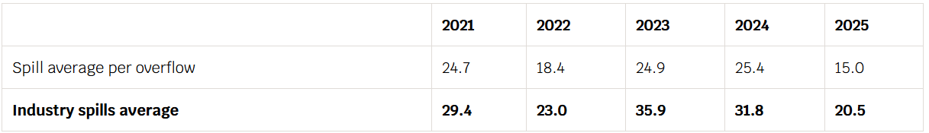

However, the culture has also acted as a barrier in some cases. The company received criticism after an increase in sewage spills in 2022, especially as executive pay remained high during this period (BBC News, 2022). These examples suggest that there have been times when financial and operational priorities did not fully align with environmental goals.
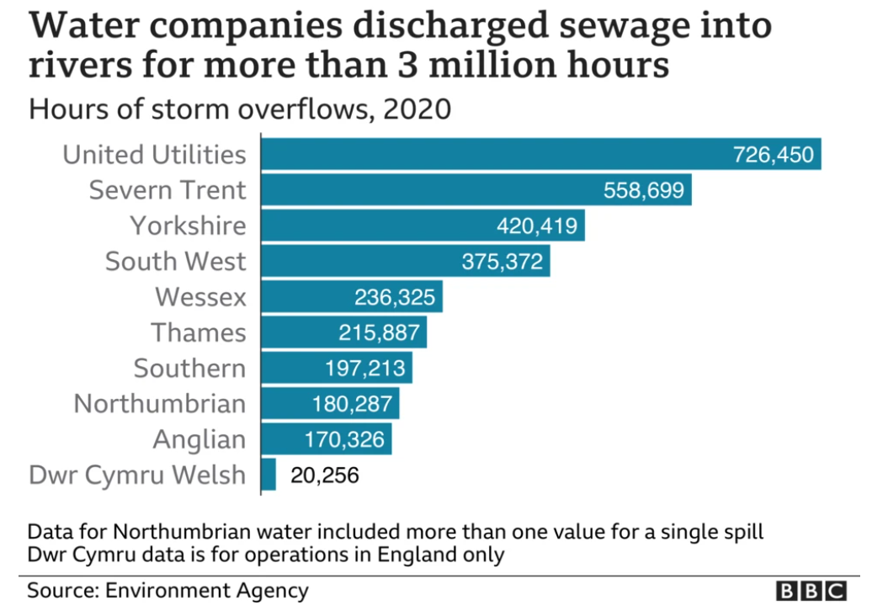

This supports Mullins and Christy’s (2016) idea that culture only works well when it matches the organisation’s strategy. While Severn Trent’s structured and rule-based culture helps with stability and compliance, it has not always ensured strong environmental performance.
Overall, Severn Trent’s culture is mainly an enabler because it supports stability, compliance and long-term planning. However, the company still needs to make sure its actions always match its environmental values in order to maintain trust and improve sustainability outcomes.
Freeman’s (1984) Stakeholder Theory helps explain Severn Trent’s organisational culture. It suggests that a company is most successful when it considers the needs of all stakeholders, not just financial goals. These include customers, employees, regulators and local communities. Although Severn Trent has invested in improving the environment and customer service, issues such as sewage pollution show that failing to meet stakeholder expectations can harm trust and reputation. This shows that organisational culture works best when the company’s actions match its values and meet stakeholder needs.

6. Impact on Performance and Recommendations for Improvement
The relationship between organisational culture and performance can be seen in Severn Trent’s work. Mullins and Christy (2016) explain that culture improves performance when it supports company goals and responds to external changes. At Severn Trent, a structured and safety-focused culture has helped the company achieve good results, such as a four-star Environmental Performance rating, lower customer bills than many other water companies, and increases in revenue and profit. However, the company has also had problems, including pollution incidents and criticism of executive pay, which have damaged its reputation. This shows that while the culture supports financial and operational success, it has not always delivered strong environmental and reputational results.
Based on this, the following recommendations are made:
- Link values to leadership actions (Schein, 2010): Make sure bonuses for senior leaders depend on environmental results, such as reducing pollution and storm overflows. This would encourage better environmental responsibility.
- Improve teamwork (Handy, 1993): Use more cross-department teams like the Zero Spills Hub and give them more control over local decisions. This would improve flexibility and cooperation.
- Strengthen leadership culture (Schein, 2010): Leaders should show company values in their actions, improve staff training, and share success stories like the £98 million wastewater investment to build trust and responsibility.
- Encourage open communication (Hofstede, 1980): Create a workplace where employees can report problems without fear. This would help fix issues earlier and reduce pollution risks.
- Measure more than financial results (Mullins and Christy, 2016): Include environmental performance, customer trust, and reputation in reports alongside financial data. This ensures these areas are given proper attention in decision-making.

7. Conclusion
This report has evaluated the organisational culture of Severn Trent Water and demonstrated how culture influences organisational structure, decision-making, adaptation to the external environment and overall organisational performance. Using Schein's Model of Organisational Culture, Hofstede's Cultural Dimensions and Handy's Cultural Types, the analysis identified that Severn Trent mainly operates with a role culture supported by elements of task culture, promoting accountability, collaboration and long-term planning. The report also found that the company's organisational culture has generally acted as an enabler by supporting regulatory compliance, sustainability, innovation and operational effectiveness. However, environmental incidents and public criticism have shown that there are occasions when organisational practices have not fully reflected the company's stated environmental values, affecting stakeholder trust and corporate reputation. Overall, Severn Trent's culture provides a strong foundation for long-term success, but continued improvement is needed to strengthen the alignment between organisational values, leadership behaviour and environmental performance. Implementing the proposed recommendations would help improve organisational effectiveness, stakeholder confidence and sustainable performance in the future.

8. REFERENCE LIST
Achievers (2026) What is organisational culture and how do you build it? Available at: https://www.achievers.com/gb/blog/organisational-culture/ (Accessed: 24 July 2026).
BBC News (2022) Sewage: Ban water firm bonuses until discharges end. Available at: https://www.bbc.co.uk/news/uk-politics-61065588 (Accessed: 30 July 2026).
CIPD (2025) PESTLE analysis. Factsheet. Chartered Institute of Personnel and Development. Available at: https://www.cipd.org/uk/knowledge/factsheets/pestle-analysis-factsheet/ (Accessed: 24 July 2026).
Freeman, R.E. (1984) Strategic Management: A Stakeholder Approach. Boston: Pitman.
Handy, C. (1993) Understanding Organizations. 4th edn. London: Penguin Books.
Hofstede, G. (1980) Culture's Consequences: International Differences in Work-Related Values. Beverly Hills: Sage Publications.
Hofstede, G., Hofstede, G.J. and Minkov, M. (2010) Cultures and Organizations: Software of the Mind. 3rd edn. New York: McGraw-Hill.
Mullins, L.J. and Christy, G. (2016) Management and Organisational Behaviour. Harlow: Pearson.
Ofwat (2026) Ofwat finds Severn Trent Water in breach of wastewater obligations. Available at: https://www.ofwat.gov.uk/ofwat-finds-severn-trent-water-in-breach-of-wastewater-obligations/ (Accessed: 30 July 2026).
Schein, E.H. (2010) Organizational Culture and Leadership. 4th edn. San Francisco: Jossey-Bass.
Severn Trent Water (2025) Strategic Direction Statement 2050. Available at: https://www.stwater.co.uk/content/dam/stw/about_us/documents/strategic-direction-statement.pdf (Accessed: 24 July 2026).
Severn Trent Water (2026) How we are regulated. Available at: https://www.stwater.co.uk/about-us/responsibility/our-responsibilities-to-you/how-we-are-regulated/ (Accessed: 24 July 2026).
Severn Trent Water (2022) Doing the Right Thing: The Severn Trent Way. Available at: https://www.stwater.co.uk/content/dam/stw/ST_Corporate/About_us/Docs/Doing%20the%20right%20thing%202022%20V2.pdf (Accessed: 24 July 2026).
Severn Trent Plc (2025) Corporate Governance Report 2025. Available at: https://www.severntrent.com/content/dam/stw-plc/Severn_Trent_AR25_Governance_Report.pdf (Accessed: 24 July 2026)

