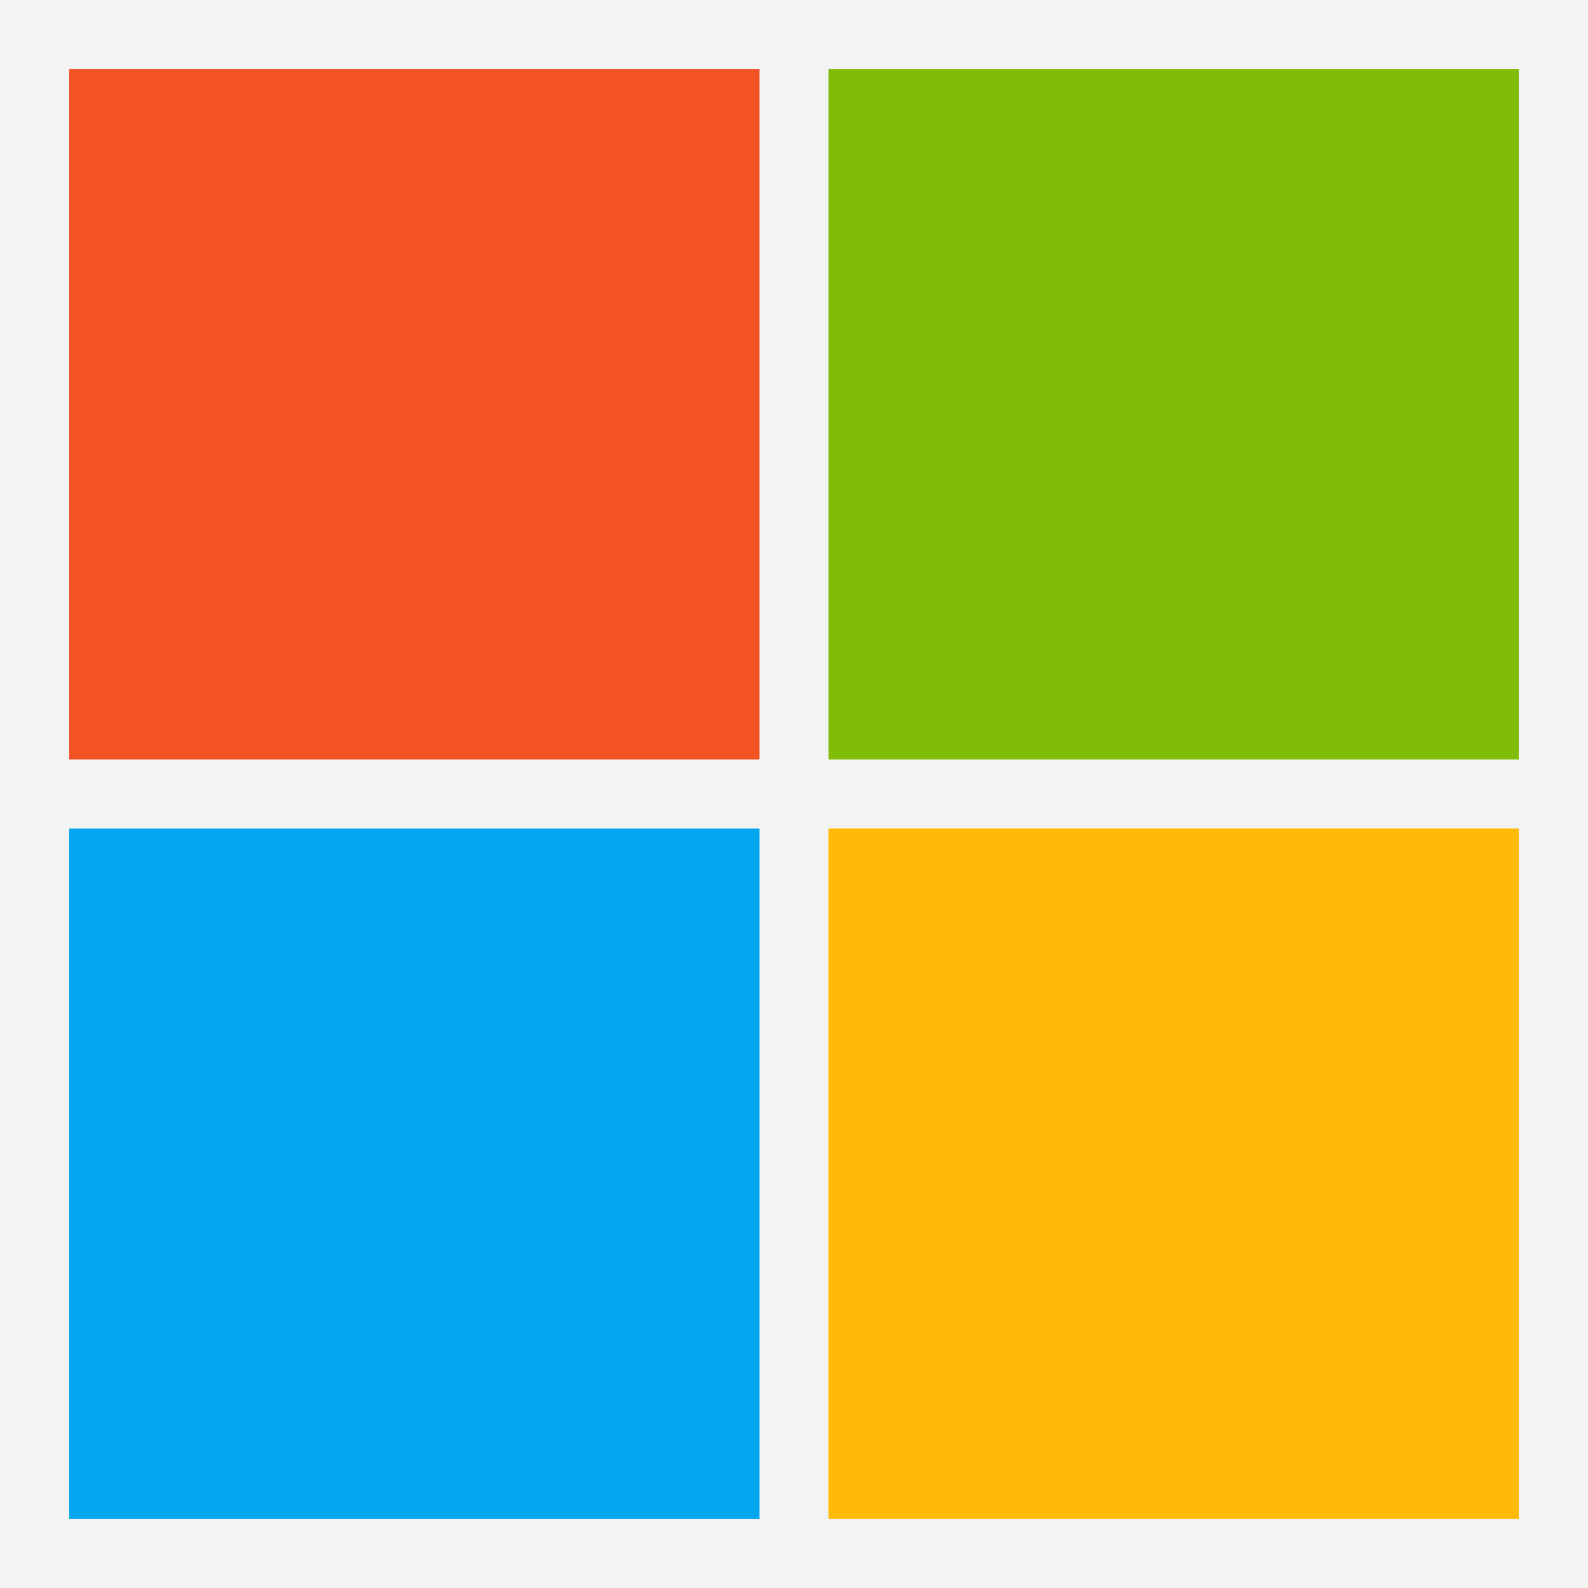
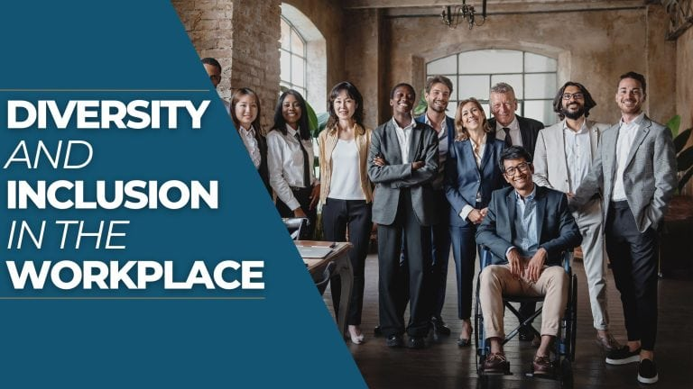
Figure 2: (“Diversity and Inclusion in the Workplace”, n.d.)
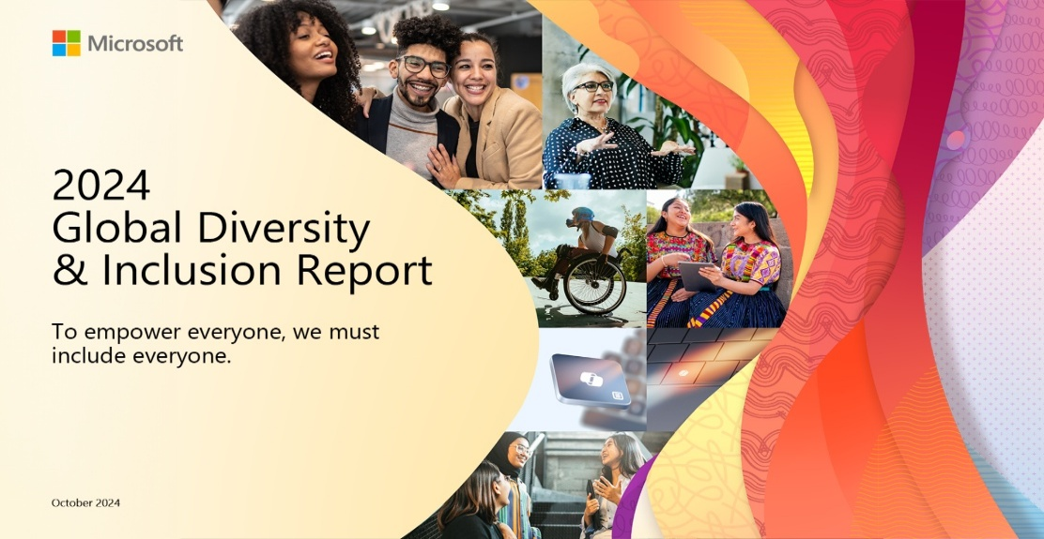
Title: A Case Study Analysis of Microsoft’s Diversity and Inclusivity Practices in The Workplace
Name: Iestyn Thomas
Student ID: 2404285
Lecturer: Laura James
Module: Working in an Inclusive World (BMSP5020)
3,000 Word Report

Figure 3: (McIntyre, 2024)
Figure 1: (Stone, 2026)
Introduction
In today’s world, diversity and inclusivity in the workplace are essential to ensure a thriving and successful organisation (“Embracing Diversity”, n.d.). Diversity in the workplace refers to having a representation of individuals from a wide range of backgrounds, experiences and identities within an organisation. For example, this includes people with different personal characteristics such as age, ethnicity, gender, physical ability and education level, to name a few (Gray, 2025; “Diversity and Inclusion”, n.d.). Inclusivity in the workplace refers to a culture and environment developed in which all employees feel comfortable and confident to be themselves at work, and feel valued, respected, and able to contribute fully regardless of their individual differences (“What Is Inclusion in the Workplace?”, 2025; “What is inclusion?”, n.d.).
Both diversity and inclusivity are essential in modern workplaces for a variety of reasons, including to fulfil legal and ethical responsibilities. In the UK, the Equality Act 2010 requires organisations to prevent discrimination and ensure fair treatment of people in the workplace regardless of personal characteristics such as age and gender. Companies that fail to follow these requirements could face legal action as well as significant reputational damage (Butler-Sims, 2024; “Discrimination at work”, 2021).
Another reasons why diversity and inclusion in the workplace are important for businesses is because they can enhance an organisation’s performance by improving decision‑making, problem‑solving, creativity and innovation. Inclusive environments can help encourage employees to speak up, contribute and share their ideas, which fuels innovation, creativity, decision‑making and problem‑solving. Furthermore, research shows that groups with diverse members from varied backgrounds are more effective at these 4 features because they challenge assumptions, avoid groupthink and consider a wider range of options and ideas, due to the variety of experiences and perspectives that each individual brings (Butler-Sims, 2024; “Embracing Diversity”, n.d.; “Why Is Diversity Important”, 2026). This is demonstrated by a Cloverpop study, which found that diverse teams are 87% better at decision making (Brown, 2025).
Diversity and inclusivity in the workplace can also improve talent attraction and retention, as people increasingly want to work for organisations that value inclusivity, embrace diversity, and provide equal access to opportunities (Butler-Sims, 2024). Acting in a diverse and inclusive manner can significantly improve an organisation’s reputation and broaden its talent pool which can help to attract talented individuals from diverse backgrounds, bringing a range of different perspectives, knowledge and skills to the workplace (Needham, 2023). Furthermore, inclusive workplaces tend to retain staff more effectively, as employees are generally happier and more likely to stay in environments where they feel supported and respected (Butler-Sims, 2024).
In recent years, there has been a significant rise in public awareness and a shift in societal expectations towards diversity and inclusivity in the workplace. This is reflected by the increase in job seekers who consider an organisation’s DEI reputation when choosing where to work, rising from 67% in 2014 to 76% in 2021 (“67% of job seekers”, 2014; “What job seekers really think”, 2021). A factor that has contributed to the increased relevance of diversity and inclusion is major social movements. Recent movements such as Black Lives Matter, #MeToo, and LGBTQ+ rights activism have highlighted discrimination and inequality across many areas of life but particularly within workplaces (von Burkersroda, 2025; Winfield, 2020). The rise of globalisation has also contributed to the increased relevancy of diversity and inclusivity in workplaces in recent years by enabling organisations to access a broader talent pool and normalising multicultural and diverse workforces (“The Impact of Globalization”, n.d.). These factors demonstrate why diversity and inclusivity have become central considerations for modern organisations and are now a necessity to be successful.
The purpose of this report is to analyse the diversity and inclusivity practices of Microsoft and evaluate their impact on the organisation’s performance and overall success. Following the introduction, this report provides background information on Microsoft. After this it then presents a detailed analysis of Microsoft’s diversity and inclusivity practices, along with an evaluation on the impact of these practices on organisational performance. Following this, the report provides a conclusion summarising the key findings from the analysis and outlines a set of recommendations.
Case Study Selection
Microsoft is a global technology company founded in 1975 by Bill Gates and Paul Allen. Originally formed as a computer software developer, it has since evolved into one of the largest and most influential technology companies in the world, shaping how billions of people use computers and digital services (“The History of Microsoft”, 2025). Today, Microsoft operates across multiple technology sectors, offering a wide range of products and services. These include software and operating systems such as Windows and Microsoft Edge, productivity tools like Microsoft 365 which consists of widely used platforms such as Word, Excel, and PowerPoint, cloud computing and AI services including Microsoft Azure and Copilot, as well as hardware and gaming products like Microsoft Surface devices and Xbox, among many other services (“Microsoft”, n.d.). Microsoft is recognised globally as one of the world’s largest companies, which was reflected in 2025 when the organisation ranked second in terms of global brand value at $461.1 billion, behind only Apple (Neufeld, 2025). Additionally in 2025, became just the second public corporation in history to reach a market capitalisation of $4 trillion, further demonstrating its worldwide success (Folk, 2025). Microsoft operates in more than 190 countries with a workforce of approximately 228,000 employees, making its approach to diversity and inclusion particularly significant (Parker, 2025; Mortensen, 2024). Major competitors for Microsoft include tech giants like Amazon, Google, Apple and Salesforce. Today Microsoft is headquartered in Redmond, Washington, USA, and are led by Satya Nadella (“Microsoft”, 2025; Parker, 2025).
Microsoft has been selected as the organisation for analysis due to the extensive range of public data available. From 2019 to 2024 the company published detailed annual diversity and inclusion reports, offering a transparent and comprehensive insight into its D&I performance and progress (“2024 Global Diversity & Inclusion Report”, 2024; Moon, 2025).
An Analysis of Microsoft is Diversity and Inclusivity Practices
Diversity and inclusivity have become a central component of Microsoft’s strategy and organisational culture under the leadership of Satya Nadella. Since his appointment as CEO in 2014, Nadella has reshaped the mindset, culture, approach, and strategic priorities of Microsoft, placing a significant emphasis on creating a diverse and inclusive workplace where every employee can thrive. This shift was demonstrated in 2015 when Nadella’s Microsoft updated its mission to “empower every person and every organization on the planet to achieve more,” signalling a commitment to diversity and inclusivity both internally and externally. Further evidence of this culture shift and increasing priority towards diversity and inclusion came when Nadella sent a letter to all employees highlighting three main areas that he wanted Microsoft to focus on, one of which was diversity and inclusivity (McIntyre, 2024; Frank, 2015; “Diversity and Inclusion Strategies”, n.d.).
To achieve its mission and strengthen its diversity and inclusivity in the workplace, Microsoft use a wide range of initiatives, including a Neurodiversity Hiring Program. In 2015, Microsoft launched the Autism Hiring Program, which was designed to recruit and support individuals with autism. This program later evolved into the Neurodiversity Hiring Program, which supports not only autistic individuals but also people with ADHD, dyslexia, and other cognitive differences (“Microsoft Neurodiversity Program”, n.d.; “Why Every Neurodivergent”, 2024).
Microsoft's Neurodiversity Hiring Program focuses on attracting and supporting neurodivergent candidates through an extended multi-day assessment event rather than just an interview process. The program includes activities like mock interviews, open discussions and even groups tasks on Minecraft, which allows individuals to demonstrate teamwork, creative problem-solving, leadership, and communication skills in real time in a more relaxed and comfortable environment (MSFTEnable, 2021; “How Microsoft is making Hiring more Inclusive”, 2021).
The program also addresses challenges neurodiverse individuals often face in traditional hiring process by offering accommodations such as extended interview and task time, longer breaks, structured feedback, and a less stressful interviewing environment. Additionally, all interviewers are trained to work effectively with neurodiverse candidates, ensuring a supportive experience (“Why Every Neurodivergent”, 2024; MSFTEnable, 2021).
A potential disadvantage of this initiative is that critics might see it as a tick the box exercise to improve the organisations reputation rather than to create real change (Global, n.d.). However, the program has proven to be successful as within just three years of it being founded, over 50 full-time neurodivergent employees joined Microsoft through the program, taking on various roles across software engineering, data analysis, content creation and more (“Why Every Neurodivergent”, 2024). Furthermore, Microsoft also provide support for neurodiverse employees beyond the hiring phase, including through the Disability at Microsoft ERG, demonstrating that this is an effort to make real change from Microsoft (“Inside Microsoft”, n.d.).
Employee Resource Groups (ERGs) are another initiative Microsoft has implemented to foster diversity and inclusivity in the workplace (“Microsoft Careers and Diversity”, n.d.). ERGs are voluntary, employee‑led groups that bring together people who share common identities, experiences, or interests to foster a sense of belonging, support underrepresented employees, nurture professional development, and help organisations build a more inclusive workplace culture (“What is an Employee Resource Group”, 2026; Rumage, 2025).
Microsoft currently has a total of 9 ERGs representing major communities within the organisation, including women, people with disabilities, LGBTQ+ individuals, ethnic minorities, military personnel, and employees with families. Examples of the ERGs include HOLA, Asians at Microsoft and Women at Microsoft (“Inside Microsoft”, n.d.).
ERGs are beneficial to organisations such as Microsoft as they can help to foster a sense of belonging among employees which can improve employee happiness, retention rates and talent attraction (“What is an Employee Resource Group “, 2026). This has been illustrated through the growth of communities represnted by ERGs such as Asian employees. For example, Asian employees exit rates decreased from 38.3% in 2022 to 27.7% in 2024, while representation increased from 34.2% to 35.9% over the same period. This suggests improved employee happiness, higher retention rates, and increased talent attraction, indicating that ERGs have played a vital role in improving Microsoft’s diversity and inclusion (“2024 Global Diversity & Inclusion Report”, 2024; “Global Diversity & Inclusion Report”, 2022).
In recent years, there has been a significant shift in societal expectations towards diversity and inclusivity in the workplace, A factor that has contributed towards this is major social movement, Black Lives Matter (von Burkersroda, 2025; Winfield, 2020). In response to the 2020 Black Lives Matter protests, Microsoft launched the Racial Equity Initiative, a five-year programme launched to address racial inequality and increase racial diversity within the organisation. For this initiative Microsoft set a goal of doubling the number of Black and African American managers and senior employees in the United States by 2025. To help achieve this, the company invested $150 million into both existing and new programmes at the company, such as the Blacks at Microsoft (BAM) ERG. The initiative also focused on investing in Black communities by supporting their education and digital skills through non-profit organisations such as Black Girls Code, helping to create long‑term opportunities and pathways for them to the company (McIntyre, 2021).
This initiative proved to be successful for the organisation as the number of Microsoft employees in the United States who were Black and African American increased from 4.4% in 2019 to 6.9% in 2022. Furthermore, over the same period, representation increased in technical roles from 3.3% to 5.7%, and in executive roles from 3.7% to 5.7% (“Global Diversity & Inclusion Report”, 2022). As well as this Microsoft also managed to achieve its target of doubling the number of Black and African American managers and senior leaders by 2025, two years ahead of schedule in 2023 (Keenan, 2023).
However, although this initiative contributed to D&I improvements and increased the proportion of Black and African American employees at Microsoft, progress stagnated and, in some areas, declined following the achievement of its initial targets. For example, the proportion of Black and African American individuals in executive roles decreased from 5.7% in 2022 to 4.9% in 2024, while the overall amount of Microsoft employees who are Black and African American fell slightly from 6.9% to 6.6% over the same period (“2024 Global Diversity & Inclusion Report”, 2024). This suggests that efforts potentially dipped in Microsoft following the achievement on their goal, highlighting how important goal setting can be as a motivation for organisations and that Microsoft need to look at introducing continued goal setting to sustain focus and improvement.
While Microsoft has made significant progress in many areas of its diversity and inclusivity since Satya Nadella became CEO, large representation gaps remain at leadership and senior roles, which continue to be dominated by white men. As of 2024, men account for 75.4% of director positions, while white employees represent 53.7% of them. Similarly, executive roles are comprised of 71% male and 62.2% white employees. These figures demonstrate that, Microsoft still has considerable work to do to diversify its higher‑level positions and that further initiatives are needed to address these disparities (“2024 Global Diversity & Inclusion Report”, 2024).
Impact on Microsoft’s Organisational Performance
The diversity and inclusivity initiatives implemented by Microsoft have not only positively influenced the organisation’s diversity figures and inclusive workplace culture but have also consequently had an impact on the organisation’s performance across multiple key areas including employee happiness and satisfaction, innovation, and financial performance.
Diversity and inclusivity initiatives in the workplace such as ERGs can have a significant impact on employee happiness and job satisfaction. An inclusive environment where employees feel that they are valued, heard and treated fairly, regardless of their unique differences, helps build a strong sense of belonging which in turn enhances job satisfaction and employee happiness (Butler-Sims, 2024; Needham, 2023).
A 2015 survey indicated that Microsoft employees were happier under CEO Satya Nadella, whose employee approval rating reached 88% than under former CEO Steve Ballmer who had an approval rating of just 51%. This suggests that employee satisfaction and happiness had increased following the organisational changes under Nadella and the shift towards a stronger focus on diversity and inclusion (Vijayasarathy, 2016).
Another key area of Microsoft that has been positively impacted by its diversity and inclusivity initiatives is innovation. A diverse workforce can improve innovation as it brings together a wide range of unique perspectives, experiences, and ideas, which can help with thinking outside the box, creativity and problem-solving which are essential drivers of innovation. However, this is only possible in an inclusive workplace environment which gives individuals the confidence and encouragement to share their unique ideas in discussions, which Microsoft has successfully managed to foster (Butler-Sims, 2024; “Embracing Diversity”, n.d.; “Why Is Diversity Important”, 2026). This is suggested through an internal survey where 83.5% of employees report to having observed employees demonstrating allyship behaviours, which indicates that Microsoft’s workplace is highly inclusive (“2024 Global Diversity & Inclusion Report”, n.d.).
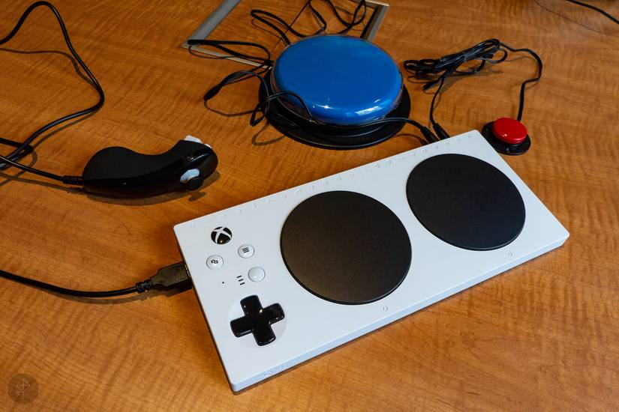

Figure 4: (Sakar & Stark, 2018)
An example of how innovation has been positively impacted by Microsoft is diversity and inclusion practices is the development of the Xbox Adaptive Controller by its accessibility team. Microsoft’s accessibility team is made up of employees with various disabilities, who work on designing products that are more inclusive, such as the Xbox Adaptive Controller. This is an alternative to traditional controllers designed for players with limited mobility, allowing users to customise their controllers and setup with external devices to meet their individual needs and make gaming more accessible and enjoyable (“Diversity and Inclusion”, n.d.; “What Is The Xbox Adaptive Controller”, 2023).
Some members of the accessibility team were recruited through Microsoft’s neurodiversity hiring programme. This demonstrates how diverse and inclusive recruitment initiatives can enhance an organisation’s innovation by bringing in underrepresented talent with valuable and unique skills and perspectives, which can help lead to innovative solutions that better cater to the needs of diverse user groups and strengthen Microsoft is ability to innovate for its global audience (“Diversity and Inclusion”, n.d.).
Financial performance is another organisational area that has been impacted by Microsoft’s diversity and inclusivity initiatives. In 2014, the year prior to Microsoft’s organisational shift towards diversity and inclusion, the company generated approximately $86 billion in revenue. Whereas in 2024 nearly a decade into the organisational shift under Satya Nadella, Microsoft’s revenue had increased significantly to around $245 billion (“2014 Annual Report”, 2014; “Annual Report”, 2024).
While undoubtedly this growth cannot be attributed solely to the diversity and inclusion initiatives, as several other key factors such as the rapid expansion of its cloud computing services have contributed to the company’s increase in revenue, there is evidence to suggest that these practices contributed in some way to the business is overall financial success (Neufeld, 2025).
The potential link stems from Microsoft’s organisational shift towards diversity and inclusivity in 2015, which overtime had led to a more inclusive environment and an increasingly more diverse workforce (Frank, 2015; “2024 Global Diversity & Inclusion Report”, n.d.). This has then contributed to increased employee satisfaction, enhanced problem-solving, improved decision-making, and better innovation, all of which can support an organisation’s revenue growth (Needham, 2023; “Why Is Diversity Important”, 2026). Therefore, these organisational improvements caused by Microsoft’s change in mindset and approach towards diversity and inclusivity have played a role in Microsoft’s significant revenue growth over the past decade, highlighting a link between improved D&I initiatives and revenue growth for Microsoft. Further evidence of this connection can be seen by the clear increase in diverse employees at Microsoft from 2016 to 2024 (as shown in appendix 1 and 2), and the increasing in revenue Microsoft received from 2014 and 2024, further indicating at a link between the two (“2014 Annual Report”, 2014; “Annual Report”, 2024).
Conclusion
In conclusion, this report demonstrates that diversity and inclusivity in the workplace has become a core part of Microsoft’s organisational strategy and has played an important role in the company’s success. The company’s organisational shift under Satya Nadella and initiatives, including the Neurodiversity Hiring Program, and Employee Resource Groups, have contributed to significant improvements in the organisations workforce diversity and in fostering an inclusive culture. Additionally, these efforts have also had a positive impact on the organisation’s performance across multiple key areas including employee happiness, innovation, and financial revenue.
However, the analysis does also highlight D&I related challenges for Microsoft. For example, despite progress being made there is still a large representation gap in senior leadership roles. Furthermore, Microsoft has found difficulty in sustaining D&I progress over time without continuous targets, for example, regarding the Black Equity Initiative, demonstrating potential areas for improvement
Overall, the analysis shows that making diversity and inclusivity an organisational priority can deliver significant benefits for organisations across a variety of areas.
Recommendations
A recommendation for Microsoft to improve their diversity and inclusivity efforts in the workplace is to increase diverse representation at senior leadership levels. Microsoft could do this by introducing targeted leadership development and mentorship programmes for underrepresented groups.
An example that Microsoft could follow is the company mentorship program that Avison Young launched to improve diversity and inclusivity in leadership roles. Their specific focus was on advancing women into senior leadership positions, however, Microsoft could expand this to include other diverse groups also. The program connected organisational leaders with members of various employee resource groups, which supported women, providing them with the skills and guidance needed for leadership roles.
The mentorship proved to be successful, as a year after it began there was an increase in women in leadership roles, a decrease in turnover and an increase in retention rates. Furthermore, the program had 98% of participants rating it satisfactory or very satisfactory, indicating at it being popular amongst employees (Reeves, 2022).
A diversity and inclusivity effort that other organisations should adopt from Microsoft is its neurodiversity hiring program, which has proven to be highly successful in creating a more diverse talent workforce and in driving innovation, such as the Xbox Adaptive Controller (“Why Every Neurodivergent”, 2024; “Diversity and Inclusion”, n.d.).

Reference List
2014 Annual Report. (2014). Microsoft. Available at: https://www.microsoft.com/investor/reports/ar14/index.html?msockid=38838867965e632638b59b9597be6262
2024 Global Diversity & Inclusion Report. (2024) Microsoft. Available at: https://cdn-dynmedia-1.microsoft.com/is/content/microsoftcorp/microsoft/dni/documents/presentations/microsoftcorp_gdi_report_2024_final.pdf
2024 Global Diversity & Inclusion Report. (2024). Microsoft. Available at: https://cdn-dynmedia-1.microsoft.com/is/content/microsoftcorp/microsoft/dni/documents/presentations/microsoftcorp_gdi_report_2024_final.pdf
2024 Global Diversity & Inclusion Report. (n.d.). Microsoft. Available at: https://www.microsoft.com/en-us/diversity/inside-microsoft/annual-report?msockid=38838867965e632638b59b9597be6262
67% of job seekers care about your diversity statistics. (2014). Human Resources Online Available at: https://www.humanresourcesonline.net/67-job-seekers-care-diversity-statistics
Annual Report 2024. (2024). Microsoft. Available at: https://www.microsoft.com/investor/reports/ar24/?msockid=38838867965e632638b59b9597be6262
Brown, G. (2025). Diversity and Innovation Statistics: How Diverse Teams Drive Workplace Innovation. Niagara Institute and Humance Company Available at: https://www.niagarainstitute.com/blog/how-diverse-teams-drive-innovation-in-the-workplace-statistics
Butler-Sims, T. (2024). Inclusion In The Workplace And 6 Reasons Why It Matters. Forbes. Available at: https://www.forbes.com/councils/forbeshumanresourcescouncil/2024/02/13/inclusion-in-the-workplace-and-6-reasons-why-it-matters/
Discrimination at work Discrimination and the Equality Act 2010. (2021). acas. Available at: https://www.acas.org.uk/discrimination-and-the-law
Diversity and Inclusion (D&I) – Definition and Explanation. (n.d.). The Oxford Review. Available at: https://oxford-review.com/the-oxford-review-dei-diversity-equity-and-inclusion-dictionary/diversity-and-inclusion-di-definition-and-explanation/
Diversity and Inclusion in the Workplace. (n.d.). HR Service. Available at: https://www.hrserviceinc.com/diversity-and-inclusion-in-the-workplace/
Diversity and Inclusion Strategies How Satya Nadella Champions D I. (n.d.). Faster Capital. Available at: https://fastercapital.com/articles/Diversity-and-Inclusion-Strategies--How-Satya-Nadella-Champions-D-I.html
Embracing Diversity: Why Inclusion Is Key to UK Business Success. (n.d.). Britwealth. Available at: https://britwealth.com/uk/business/business-insights-uk/embracing-diversity-why-inclusion-is-key-to-uk-business-success/
Folk, Z. (2025). Microsoft Becomes Second Company Valued Over $4 Trillion After Strong Second Quarter Earnings. Forbes. Available at: https://www.forbes.com/sites/zacharyfolk/2025/07/31/microsoft-becomes-second-company-valued-over-4-trillion-after-strong-second-quarter-earnings/
Frank, B. (2015). Satya Nadella’s new mission for Microsoft: help people ‘achieve more’. Computer World. Available at: https://www.computerworld.com/article/1636101/satya-nadellas-new-mission-for-microsoft-help-people-achieve-more-2.html
Global Diversity & Inclusion Report 2020. (2020). Microsoft. Available at: https://d110erj175o600.cloudfront.net/wp-content/uploads/2020/10/GDI-2020-Report-FINAL-2020-10-19-webz.pdf
Global Diversity & Inclusion Report 2022. (2022). Microsoft. Available at: file:///C:/Users/jitho/Downloads/2022_DI_Report_Final_print%20(1).pdf
Global, E. (n.d.). Wokeism vs Equal Opportunity: The Truth About Neurodiversity Hiring in the UK (Enna Global’s Stand). Enna Global. Available at: https://enna.org/wokeism-vs-equal-opportunity-neurodiversity-hiring-uk/
Gray, C. (2025). The Importance of Diversity. Bain and Gray. Available at: https://www.bainandgray.com/blog/the-importance-of-diversity-in-the-workplace
How Microsoft is making Hiring more Inclusive with Minecraft. (2021). Minecraft Education. Available at: https://education.minecraft.net/en-us/blog/inclusive-hiring-programs-minecraft
Inside Microsoft. (n.d.). Microsoft. Available at: https://www.microsoft.com/en-us/diversity/inside-microsoft/default?msockid=38838867965e632638b59b9597be6262
Keenan, S. (2023). Microsoft’s Latest DEI Data Shows Positive Change Over The Past Five Years. POCIT. Available at: https://peopleofcolorintech.com/articles/microsofts-latest-dei-data-shows-positive-change-over-the-past-five-years/
Mcintyre, L-R. (2021). Racial Equity Initiative: A year of progress on our commitments. Microsoft. Available at: https://blogs.microsoft.com/blog/2021/06/21/racial-equity-initiative-a-year-of-progress-on-our-commitments/
McIntyre, L-R. (2024). Microsoft’s 2024 Global Diversity & Inclusion Report: Our most global, transparent report yet. Microsoft. Available at: https://blogs.microsoft.com/blog/2024/10/23/microsofts-2024-global-diversity-inclusion-report-our-most-global-transparent-report-yet/
Microsoft Careers and Diversity: Building an Inclusive Workforce. (n.d.). Microsoft Careers and Diversity: Building an Inclusive Workforce. Jennie Johnson. Available at: https://jenniejohnson.com/bestjobs/microsoft-careers-and-diversity-building-an
Microsoft Neurodiversity Program. (n.d.). Microsoft. Available at: https://www.microsoft.com/en-us/diversity/inside-microsoft/cross-disability/neurodiversityhiring?msockid=38838867965e632638b59b9597be6262
Microsoft. (n.d.). Companies Explained. Available at: https://companies-explained.com/companies/microsoft.html
Moon, M. (2025). Microsoft isn't releasing a diversity report for 2025. Available at: https://www.engadget.com/big-tech/microsoft-isnt-releasing-a-diversity-report-for-2025-180000401.html
Mortensen, O. (2024). How Many People Work at Microsoft? Statistics & Facts (2025). Seo.ai. Available at: https://seo.ai/blog/how-many-people-work-at-microsoft
MSFTEnable. (2021). Microsoft Neurodiversity Hiring Program Overview. Available at: https://www.bing.com/videos/riverview/relatedvideo?q=does+microsoft+neurodiverse+hiring+practice+Microsoft+replaces+standard+interviews+with+Multi-day+assessment+workshops&mid=A7E20B3F21DADC983C92A7E20B3F21DADC983C92&FORM=VIRE
Needham, A. (2023). Why Equality, Diversity and Inclusion Matters in the Workplace. University of Salford Manchester. Available at: https://www.salford.ac.uk/spd/why-equality-diversity-and-inclusion-matters-in-workplace
Neufeld, D. (2025). Charted: How Microsoft Makes Its Billions. Visual Capitalist. Available at: https://www.visualcapitalist.com/how-microsoft-makes-its-billions/
Neufeld, D. (2025). The World’s 50 Most Valuable Brands in 2025. Visual Capitalist. Available at: https://www.visualcapitalist.com/the-worlds-50-most-valuable-brands-in-2025/
Parker, B. (2025). Microsoft SWOT 2025 | SWOT Analysis of Microsoft. Business Strategy Hub. Available at: https://bstrategyhub.com/swot-analysis-of-microsoft/
Reeves, M. (2022). 8 Successful Mentoring Programs: Real Examples & Strategies. Together From Asorb. Available at: https://www.togetherplatform.com/blog/examples-of-successful-mentoring-programs
Rumage, J. (2025). What Are Employee Resource Groups (ERGs)?. Built in. Available at: https://builtin.com/diversity-inclusion/employee-resource-groups-erg
Sakar, S & Stark, C. (2018). Microsoft’s new Xbox controller is designed entirely for players with disabilities. Polygon. Available at: https://www.polygon.com/2018/5/17/17363528/xbox-adaptive-controller-disability-accessible/
Stone, K. (2026). 5 Companies Embracing Diversity and Inclusion Through Initiatives. Engagedly. Available at: https://engagedly.com/blog/5-companies-embracing-diversity-and-inclusion-through-initiatives/
The History of Microsoft: Key Milestones and Innovations. (2025). World History. Available at: https://worldhistoryjournal.com/2025/02/24/the-history-of-microsoft-key-milestones-and-innovations/#google_vignette
The Impact of Globalization on Workforce Diversity and Inclusion. (n.d.). Jobya. Available at: https://jobya.com/learn/workplace/trends_in_the_workplace/the_impact_of_globalization_on_workforce_diversity_and_inclusion
Vijayasarathy, S. (2016). Microsoft Employees Happier Under Satya Nadella as Compared to Steve Ballmer. Gadgets 360. Available at: https://www.gadgets360.com/laptops/news/microsoft-employees-happier-under-satya-nadella-as-compared-to-steve-ballmer-1476384
von Burkersroda, F. (2025). The Most Influential Social Movements of the 21st Century. Festivaltopia. Available at: https://festivaltopia.com/the-most-influential-social-movements-of-the-21st-century/
What is an Employee Resource Group (ERG) and why is it important?. (2026). IMD. Available at: https://www.imd.org/blog/management/employee-resource-group/
What Is Inclusion in the Workplace? A Guide for Leaders. (2025). Center For Creative Leadership. Available at: https://www.ccl.org/articles/leading-effectively-articles/what-is-inclusion-in-the-workplace-a-guide-for-leaders/
What is inclusion?. (n.d.). Inclusive Employers. Available at: https://www.inclusiveemployers.co.uk/about/what-is-workplace-inclusion/
What Is The Xbox Adaptive Controller And How Does It Work?. (2023). Citizenside.com. Available at: https://citizenside.com/technology/what-is-the-xbox-adaptive-controller-and-how-does-it-work/
What Job Seekers Really Think About Your Diversity and Inclusion Stats. (2021). Glassdoor. Available at: https://www.glassdoor.com/blog/diversity/
Why Every Neurodivergent Should Want to Work at Microsoft: A Leader in Inclusive Hiring. (2024). Mentra. Available at: https://www.mentra.com/post/why-every-neurodivergent-should-want-to-work-at-microsoft-a-leader-in-inclusive-hiring
Why Is Diversity Important in the Workplace?. (2026). Coursera. Available at: https://www.coursera.org/enterprise/articles/why-is-diversity-important?msockid=38838867965e632638b59b9597be6262
Winfield, A. (2020). How #BLM has redefined D&I in the workplace. HR Executive. Available at: https://hrexecutive.com/how-blm-has-redefined-di-in-the-workplace/

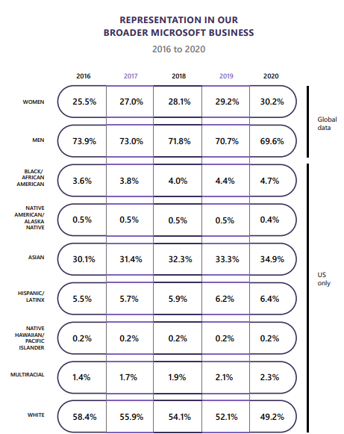
Appendix 1

Figure 5: (“Global Diversity & Inclusion Report 2020”, 2020)

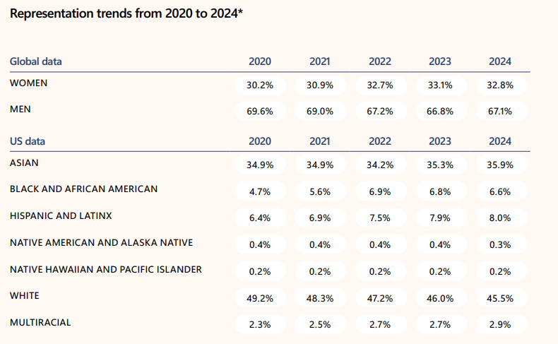
Appendix 2
Figure 6: (“2024 Global Diversity & Inclusion Report”, 2024).

