Global Business Management - LCBB4005_BIRM

Table of Contents
Introduction 2
Overview of Higher Education Sector 2
Main Discussion 4
University of Wales Trinity Saint David 4
Global Business Environment Factor’s Impact on Higher Education Sector 4
Impact on UWTSD 5
PESTEL Framework 6
Porter’s Five Forces 7
Conclusion 8
References 10

Introduction
This report will cover the business environment factors and how they effect on higher education sector. For the higher education sector, the report will discuss on University of Wales Trinity Saint David (UWTSD). The report will provide the PESTEL and Porter’s Five Forces analysis of the higher education sector. Also, it will show how UWTSD is affected by global business environment factors.

Overview of Higher Education Sector
The higher education sector is a big business, and it's growing rapidly. In the UK, as per figure 01, the revenue of higher education has been estimated to be worth over $34 billion by the year 2025.
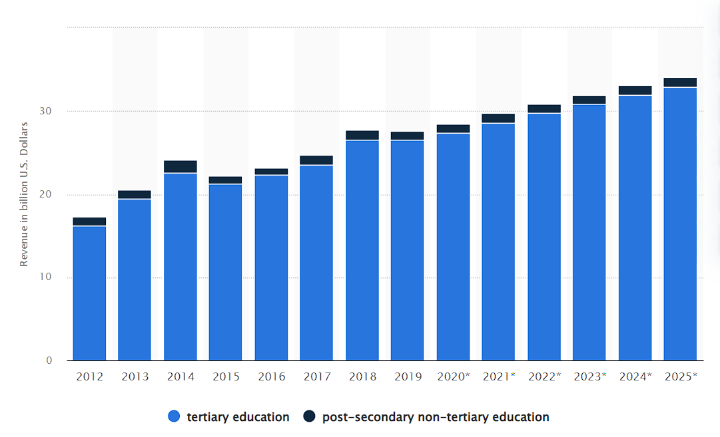
Figure 01: Higher Education Industry Revenue of UK. Source: Statista, 2022
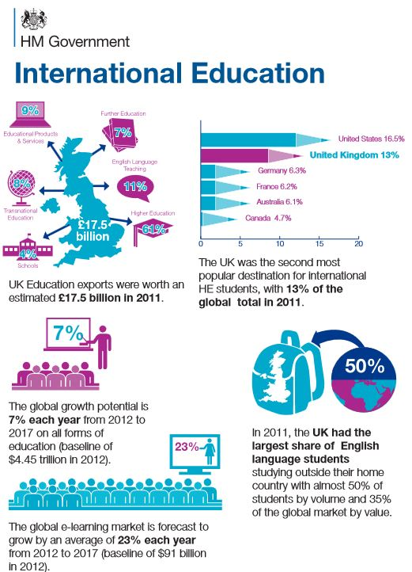
Higher education is an important part of society because it helps people learn and develop their skills in order to pursue careers that will enable them to improve their lives. It also helps to fill gaps in the workforce and provide a better quality of life for everyone (Antony et al., 2019). There are several types of higher education institutions, including traditional universities, colleges, vocational colleges, and learning centres. They all offer different programs and degrees that can help students achieve their goals. Most people who go to college eventually end up getting a degree in some kind of traditional university.

Figure 02: International Student Market. Source: ICEF Monitor, 2022
UK and US have become world’s most top destination for higher education students as per figure 02. This is due to the popular schools of the countries. These schools typically have large campuses with many facilities and services available on-site. They also have strong academic programs that prepare students for future careers. Colleges are usually smaller than traditional universities, with fewer resources but equally strong academic programs. Many students choose colleges as their first choice when looking into higher education options because they offer more flexibility and easier access to career opportunities (Ntim, Soobaroyen and Broad, 2017). Vocational colleges focus on training students in specific fields so that they can gain entry level jobs after graduation. They're popular for people who want flexible schedules or who want to study a specific subject matter in depth without having to worry.

Main Discussion

University of Wales Trinity Saint David
The University of Wales Trinity Saint David (UWTSD) is a university in United Kingdom that offers undergraduate and postgraduate courses in a variety of disciplines. UWTSD was established in 2010 as part of the college merger, and it has since expanded its campus to include buildings on two other campuses (Hayles, 2017). The University of Wales Trinity Saint David (UWTSD) is a world-leading university with a strong reputation for teaching and research. It offers an excellent range of courses in both undergraduate and postgraduate levels, and its students are highly sought after by employers. The university has a very diverse mix of students, from all over the UK and around the world (Castle, 2017). It also has a strong commitment to social justice, which is reflected in its teaching and research. UWTSD is renowned for its innovative approaches to teaching, which combine traditional methods with new technologies.

Global Business Environment Factor’s Impact on Higher Education Sector
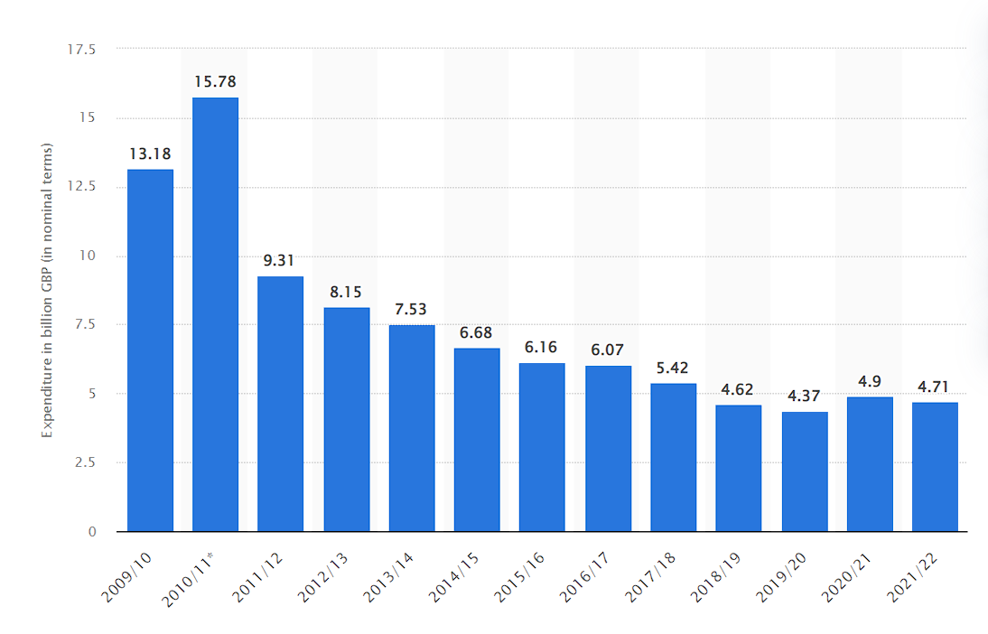
The global business environment is a critical factor that affects the higher education sector. It has a significant impact on how universities are funded, how they operate, and what their priorities are. One of the main ways in which the global business environment affects higher education is by impacting university funding.
Figure 03: UK Higher Education Expending. Source: Statista, 2022
The above figure shows the public sector expenditure on tertiary education in the United Kingdom. It is seen that UK used to expend more in previous years than current. This can be due to many reasons. Countries that are experiencing growth or are developing economically tend to invest more money in higher education, while those that are struggling financially will tend to slash funding for institutions of learning (Heinicke and Guenther, 2020). This has a direct impact on the quality of education that students receive and whether they can afford to continue their studies. The global business environment also impacts how universities operate. For example, if there is increased competition for talent, then universities will have to innovate and find new ways to attract and keep talented staff. This may lead them to change their curriculum or increase tuition fees in order to stay afloat. Higher education institutions also have to weigh up their priorities when it comes to the global business environment (Gralka, 2018). In some cases, they may decide that it's more important for them to focus on exporting their knowledge rather than domesticating it in order to better compete with rivals.

Impact on UWTSD
The University of Wales Trinity Saint David (UWTSD) is an internationally renowned university with a strong focus on business and management. The global business environment factors can affect the university in a number of ways, some of which are outlined below.
One way in which the global business environment factors can affect UWTSD is by influencing the location of the university. With increasing competition from other universities around the world, it is crucial for UWTSD to find a location that offers excellent facilities and accessibility to businesses and clients (Elrehail, 2018). Additionally, it's also important that the location has enough job opportunities so that graduates can find good employment right after they finish their studies. The global business environment factors can also affect UWTSD through its admissions policies. Due to the competitive nature of the market, admission requirements must be high enough to ensure that only quality students are accepted into the university. Furthermore, as tuition fees continue to increase across the world, UWTSD must make sure that its fees are fair and reasonable for all students (Hayles, 2017). Finally, global economic conditions can also have a significant impact on UWTSD. If there are times when businesses are struggling due to poor economic conditions, this will have a negative impact on recruitment at UWTSD as well as tuition fee revenue.

PESTEL Framework
PESTEL has been used by organizations in various industries to assess their vulnerabilities and determine where resources should be directed in order to protect themselves from impending threats (Hassanien, 2017). Its usefulness does not end there; PESTEL also provides insight into how best to manage existing risks within an organization. By understanding which challenges are most pressing right now and which ones have the potential for becoming more serious down the road, individuals can make informed decisions that will safeguard his business interests. With the use of PESTEL framework analysis, the report can easily identify how the University is being affected by the most significant factors. The PESTEL analysis framework for UWTSD is given below:
Political: The University of Wales Trinity Saint David is currently facing some political effect due to the global business environment factors. Some of these factors include: Brexit, the US-China trade war and other geopolitical events. All of these have had a negative impact on the value of the UK pound, which has made it difficult for businesses to generate profits in the country (Versloot, 2016). As a result, many universities around the UK have been forced to make tough decisions about which courses to cut or cancel. The University of Wales Trinity Saint David has also been affected by this trend, and has decided to close its business school.
Economic: Since the UK voted to leave the European Union in 2016, the university has experienced a number of economic challenges. These challenges have had a negative impact on UWTSD's ability to recruit new students and staff, as well as its ability to generate revenue from tuition and other fees. In addition, there have been financial penalties imposed by the government on universities that do not meet certain targets for student enrolment and staff recruitment.
Social: The University of Wales Trinity Saint David is currently experiencing a number of social effects as a result of the global business environment factors. These factors include: changing demographics, Brexit, political instability, and increasing competition from foreign universities. All of these factors are causing significant challenges for the university, which is trying to keep up with the changing demands of the market (Cox, 2021). For example, Brexit has led to a decline in UK student enrolment, which has had a negative impact on the university's income. Meanwhile, political instability in various parts of the world is preventing many international students from enrolling in courses at the university.
Technological: One of the most important aspects of the business environment is technological infrastructure. Because Trinity Saint David is recognised as a world-class university, it needs to keep up with the latest trends in technology in order to remain competitive. This often requires investing in new technologies and equipment, which can be costly. However, this investment pays off because it helps the university to keep pace with rapidly evolving trends and offers its students an edge when competing for jobs.
Environmental: The water crisis at the University of Wales Trinity Saint David is caused by the low amount of rainfall that's been occurring recently. The rainwater that does reach the campus mostly flows into River Usk, which is then contaminated with sewage and industrial waste. This has led to an increase in cases of typhoid, hepatitis A and other diseases.
Legal: The University of Wales Trinity Saint David (UWTSD) is currently facing a number of legal challenges. These challenges include allegations of financial mismanagement, breaches of contract, and unfair dismissal. In light of these allegations, the university has been forced to take various steps to address the situation (Pan, Chen and Zhan, 2019). For example, it has appointed an external review panel to look into the allegations, established a compensation scheme for employees who have suffered loss as a result of the misconduct, and set up a fund to help students affected by the crisis.

Porter’s Five Forces
The Porter's five forces model is a business strategy tool that helps to analyse the competitive environment and determine company’s position (Bruijl and Gerard, 2018). It consists of five factors—threat of new entrants, bargaining power of suppliers, threat of substitution, rivalry among rivals and bargaining power of buyers. When applied to businesses, these forces can help anyone to assess how strong each competitor is relative to his business and what strategies may be most effective in reducing or preventing competition from entering the market. Porter’s five forces theory on UWTSD has been applied below:
Threat of New Entrants: The rise of new entrants is a major threat to the University's business because it means that there are now more options for students and staff alike. This has caused prices to drop and made it easier for people to find quality education elsewhere. Additionally, this competition has forced the University to make radical changes to its courses and facilities in order to stay afloat.
Bargaining Power of Suppliers: The main factors that affect a company's bargaining power are its financial strength, size, and ability to threat competitors. The University of Wales Trinity Saint David falls into the small-to-medium business category, which makes it less able to threaten its competitors or raise prices significantly (Mathooko and Ogutu, 2015). It also has low levels of financial strength and modest investment in equipment and technology. As a result, the university is not in a position to demand better terms from its suppliers or increase production rates significantly.
Rivalry Among Existing Competitors: The university is a direct competitor to several other institutions, such as Cardiff University, Aberystwyth University, and Bangor University. Over the past few years, there has been a marked increase in tuition fees and grants for UK universities. This has made it harder for UWTSD to compete with its rivals, who are able to charge much higher prices for their services. In addition, there has been a decrease in government funding for universities across the UK, which makes it difficult for UWTSD to keep up with the demands of its students.
Threat of Substitutes: Alternative universities are schools that offer similar courses to those at traditional universities, but they typically charge lower fees. This has made it more difficult for University of Wales Trinity Saint David to compete with alternative universities, as they don't have the same level of funding or prestige. The vote to leave the European Union has also caused a drop in student enrolment because many students are worried about the future economy (De Haan, 2015). Many people who were originally planning on studying at University of Wales Trinity Saint David have instead decided to go elsewhere because they don't know what will happen next.
Bargaining Power of Buyers: The University of Wales Trinity Saint David (UWTSD) is experiencing significant business environment factors that are affecting its ability to generate revenues and grow. These factors include a weak pound, Brexit, and the high cost of living in Wales. The weak pound is making it difficult for UWTSD to compete with universities in England that are not affected by Brexit. This has led to a decline in enrolment and an increase in tuition fees. In addition, the high cost of living in Wales has made it difficult for UWTSD to recruit talented staff who can afford to live there.

Conclusion
Higher education has always been a critical part of any country’s development, and in today's globalized world, it is becoming even more important. A sound higher education system not only contributes to the economic growth of a country but also provides skilled workers who can compete in the global workforce. As businesses continue to face increasing competition from foreign countries, they are looking for employees with specialized knowledge and skills. This is where our high-quality academic institutions come into play. They provide graduates with the necessary training that will enable them to start their own business or work in an existing company as a consultant or specialist. In addition to providing jobs directly, universities have played an important role by creating sophisticated job market systems that connect academia and industry together. This ensures that students get real-world experience while they're studying so that when they graduate, they are well prepared for employment opportunities both inside and outside of academia.

References
Antony, J., Karamperidis, S., Antony, F. and Cudney, E.A., 2019. Understanding and evaluating teaching effectiveness in the UK higher education sector using experimental design: A case study. International Journal of Quality & Reliability Management.
Bruijl, D. and Gerard, H.T., 2018. The relevance of Porter's five forces in today's innovative and changing business environment. Available at SSRN 3192207.
Castle, C., 2017. Make a Meal of It: Lessons from a household food waste project in West Wales. Submitted to the University of Wales in partial fulfilment of the requirements for the Degree of Master of Education University of Wales Trinity Saint David.
Cox, J., 2021. The higher education environment driving academic library strategy: A political, economic, social and technological (PEST) analysis. The Journal of Academic Librarianship, 47(1), p.102219.
De Haan, H.H., 2015. Competitive advantage, what does it really mean in the context of public higher education institutions?. International Journal of Educational Management.
Elrehail, H., Emeagwali, O.L., Alsaad, A. and Alzghoul, A., 2018. The impact of transformational and authentic leadership on innovation in higher education: The contingent role of knowledge sharing. Telematics and Informatics, 35(1), pp.55-67.
Gralka, S., 2018. Persistent inefficiency in the higher education sector: evidence from Germany. Education Economics, 26(4), pp.373-392.
Hassanien, M.A., 2017. Strategic planning in higher education, a need for innovative model. Journal of Education, Society and Behavioural Science, 23(2), pp.1-11.
Hayles, C.S., 2017. An INSPIREd Education, The University of Wales Trinity Saint David. In Sustainable development research at universities in the United Kingdom (pp. 1-12). Springer, Cham.
Heinicke, X. and Guenther, T.W., 2020. The role of management controls in the higher education sector: an investigation of different perceptions. European Accounting Review, 29(3), pp.581-630.

