

Integration of Marketing Communication, Digital Marketing, and Consumer Behaviour in the Fashion Industry in the UK

STUDENT NAME: Eugenia Adriana Manda DISSERTATION PROJECT:
STUDENT ID: 2113738 MODULE CODE:LCBB6000
SUBMISION DATE: 02.09.2024
SUPERVISOR NAME: Tushara Balendran

Integration of Marketing Communication, Digital Marketing, and Consumer Behaviour in the Fashion Industry in the UK

Student: Eugenia Adriana Manda
Supervisor: Tushara Balderan
Words:26,100

Abstract

In the present economic climate, fashion industry marked by intense competition aimed at capturing or retaining different consumer segments, as well as an unparalleled technological advancement, marketers must focus on adopting innovative methods of communication and bidding to achieve fashion business success. Integrated marketing communication and Digital Marketing are the most prominent aspects of marketing that attracts the attention of both sellers and customers. It is particularly important for purchasers, as they rely on information from several sources to make informed purchasing decisions. This paper aims to emphasise the primary tools utilised integrated marketing communication and digital marketing to establish a consistent and effective connection with potential and existing behaviour consumers.
Results suggest various recommendations for fashion brands, such as customising content and engagement, and expanding their social media presence. The research findings suggest that fashion brands are actively utilising social media channels to interact with their customers, and these platforms have a substantial impact on shaping client behaviour choices.
The efficacy of social media marketing differs among various age demographics, with younger consumers being more susceptible to the influence of platforms like Facebook, Instagram, and TikTok. Additionally, the report emphasises the significance of customisation programs in improving customer behaviour experience and maintaining customer trust.

Acknowledgements
I am filled with deep appreciation and an overwhelming sense of pride when I finally finish my work. The last few years have left a significant mark on me, which has turned me into a responsible person with discernment and great attention to detail. It has been a difficult and demanding road, but as is often said, the most beautiful experiences are learning and happen outside of the comfort zone. I put in maximum effort in the previous months and successfully completed my work, overcoming the fear and worry of not having enough time to complete it.
This memorable experience is one that I will cherish.
I wish to express my deep gratitude to my supervisor, Professor Tushara Balderan, who served as an outstanding source of motivation and inspiration. My words fail to fully capture the extent of my sincere appreciation for you. Your knowledge, skills, commitment, and valuable assistance contributed to the timely and successful completion of the dissertation. Your contributions, recommendations, support, and academic advice have been extremely helpful for this dissertation. I appreciate the trust you have placed in me and the assistance you have given me during the completion of my dissertation. Your support and mentorship contributed significantly to the completion of this dissertation.
I wish to convey my appreciation to my family, whose unwavering support and devotion have played a crucial role in the successful completion of my academic pursuits.
I would like to express my appreciation and thanks to Mr.Dr. Anupam Mazumdar for the assistance he provided us for three years.
I would like to express my gratitude to the survey participants, whose valuable contributions have significantly helped in completing my work.
In addition, I would like to convey my appreciation for the library's steadfast support and the educational initiatives it provides to students.

Contents
1. Introduction………………...……………………..……………………..……………….. 8
  - Background……………………………………………………………………………………………….…………….10
1.2 Signification of the research …………………………………………………………………………………………....11
1.3 Rationale of study.............................................................................................................................................................12

  - Research Objectives.......................................................................................................................................................12

  - Research questions………………………………………………………………………………………..12

  - Dissertation online…………………………………………………………………………………………13
2. Literature Review…………………………………………………………………………14
2.1 Research gap...................................................................................................................................................14

2.1.1 Digital marketing – Definition…………………………………………………………….….16
2.1.2 Integrated Marketing Communication – Definition………………………………………………………16
2.1.3 Consumer Behavior- Definition...................................................................................................................17

2.1.4 Acritical review of Digital marketing and Integrated Marketing Communication in fashion industry in the UK....................................................................................................................................................................17

2.1.5 Advantages and Disadvantages of Digital marketing …………………………….……………………..20
2.1.6 Advantages and Disadvantages of Integration Marketing Communication in the UK fashion Industry.22
2.1.7 The Integrated Marketing Communication strategies implemented in the UK fashion Industry……...25
2.1.8 The current Digital Marketing strategies implemented in the UK fashion industry……….…………..28
2.1.9 The impact of Integrated Marketing Communication and Digital Marketing strategies on consumer behaviour in the UK fashion industry………………………………………………………………………….30

2.1.10 The impact of Consumer Behaviour in the UK Fashion Industry…………………………………….33

3.Literature gap…………………………………………………………………………..…….………..….34

3.1 Shannon and Weaves Models……………………………………………………..…36
3.2 Advantage and Disadvantages of Shannon and Wever Models………………………………………….40
3.3 Conclusion…………………………………………………………………………………………………..42
4.Frameworks Models………………………………………………………………………………………….43

4.1 The RACE Model.………………………………………………………………………………………..43

4.2 The HONEYCOB Model……………………………………………………………………………....…46
4.3 Advantages and disadvantages of the Honeycomb Model......................................................................49

4.4 RACE Model versus Honeycomb Model. Similarities and Differences.................................................50

5 Research Methodology…………………………………………………………………………………….51
5.1 Introduction………………………………………………………………………………………………51
5.2 Research Philosophy……………………………………………………………………………………..52
5.3 Research Approaches…………………………………………………………………………………….53
5.4 Research Choices………………………………………………………………………………………….53
5.5 Advantage and Disadvantage of Quantitative Research……………………………………………….54
5.6 Types of investigation..................................................................................................................................55

5.7 Advantage and Disadvantage of Primary Research.................................................................................56
5.8 Advantages and disadvantages of secondary research………………………………………………….57
5.9 Time Horizon………………………………………………………………………………………………58
5.10 Data collection and analysis……………………………………………………………………………..58
5.10.1 Sampling……………………………………………………………………………………………….59
5.10.2 Sampling size..........................................................................................................................................59

5.10.3 Sampling type.........................................................................................................................................59

5.10.4 Sampling method....................................................................................................................................59

5.11 Advantages and disadvantages of convenience sampling......................................................................60
6. Data Collection method…………………………………………………………………………………….60
6.1 Analysis of data …………………………………………………………………………………………..61
6.2 Research ethics……………………………………………………………………………………………61
7. Analysis of data…………………………………………………………………………………………….62
7.1 Introduction………………………………………………………………………………………………62
7.2 Questionnaires Analysis………………………………………………………………………………….62
8.Conclusion and recommendations………………………………………………………………………..76
8.1 Conclusion………………………………………………………………………………………………..76
8.2 Recommendation.......................................................................................................................................78

8.3 Limitation and furthermore Research....................................................................................................80

9 References.....................................................................................................................................................83

10 Appendix.....................................................................................................................................................95

Table of figures
Table 2: Main advantages/ disadvantages of media channels. Source: Kotler and Keller, Marketing Management .....................25
Figure 1 The establishment of IMC, (Source: Fill 2002:469). Integrate marketing Communication………………....…….…….26
Figure 2. Shannon-Weaver – model (Mishra.2017) Model Shannon -Weaver communication…………………………………..37
Figure 3. Shannon- Weaver – Model (Mishra.2017) ……………………………………………………………………………...38
Figure 4 The marketing plan framework (Chaffey and Ellis-Chadwick, 2019) ………….......................………………………...43
Figure 5. Honeycomb model (Kietzmann et al.2011)………………………………………………………………………….….47
Figure 6: Onion Research (Saunders, 2019) ..............................................................................................................51
Figure 7. Question 1 Table (Create by researcher)………………………………………………………………….62
Figure 8. Question 1. Age group representation (Chart created by the researcher)………………………………………………..63
Figure 9 Question 2. Gender representation (Chart created by the researcher)……………………………………………………64
Figure 10.Question 3 Table (Chart created by the researcher)………………………………………………………………….65
Figure 11.Question 3 Table (Chart created by the researcher)…………………………………………………………………65
Figure 12.Question 3 Table (Chart created by the researcher)………………………………………………………………65
Figure 13.Question 4 Table (Chart created by the researcher)………………………………………………………………..67
Figure 14.Question 4 Table (Chart created by the researcher)………………………………………………………………..68
Figure 15.Question 4 Table (Chart created by the researcher)………………………………………………………………..68
Figure 16.Question 5 Table (Chart created by the researcher)……………………………………………………………….69
Figure 17.Question 5 Table (Chart created by the researcher)……………………………………………………………….70
Figure 18.Question 5 Table (Chart created by the researcher)……………………………………………………………….70
Figure 19.Question 5 Table (Chart created by the researcher)……………………………………………………………….71
Figure 20.Question 6 Table (Chart created by the researcher)………………………………………………………….72
Figure 21.Question 6 Table (Chart created by the researcher)………………………………………………………………73
Figure 22.Question 7 Table (Chart created by the researcher)………………………………………………………………74
Figure 23.Question 7 Table (Chart created by the researcher)………………………………………………………………75

Topic: Integration of Marketing Communication, Digital Marketing, and Consumer Behaviour in the Fashion Industry in the UK

Introduction
In recent years, there have been many changes in the fashion industry including a recent report saying how the British fashion industry is worth £21 billion to the UK economy and growing (Albesa, 2007). With the increasingly changing dynamics and consumer wishes and desires, today's fashion industry is a quite different place to what it was some 50 years ago. Marketing communication has had a significant impact on the recent changes, as companies are aiming to build relationships with their consumers, and with the use of integrated marketing communication strategies through public relations, advertising, direct marketing, and interactive marketing (Baker, S., & Mitchell, H. 2000). There are many forms of digital marketing, from a company creating a website to paid search advertising that shows marketing messages to searchers based on keywords searched. One of the many benefits that digital marketing has is it allows companies to adapt creatively at once and at a lower cost than traditional marketing. The author explores the impact of digital marketing on consumer purchasing decisions in UK fashion industry, a country where online fashion is gaining popularity as a new trend, highlighting the importance of showcasing products and services effectively on digital platforms. Importance of Marketing Communication within the fashion industry Marketing communication is the delivery of a message to a recipient via a medium. It is an important part of the fashion business since it provides a more direct and personal kind of marketing. There are two forms of marketing communications: Above the queue. Marketing is the process by which a company connects with a larger, more general audience, typically through paid-for advertising, such as television advertisements. Below the line marketing occurs when a company utilises more specialised methods of contact with customers and groups. This can be accomplished using strategies such as direct mail or sales promotions.
A Review of the Fashion Industry in the UK Fashion is a significant and vital sector in the United Kingdom. It is a fast-paced industry that is continually evolving and progressing. The fashion industry has several segments, including design, manufacture, marketing, and retailing. This essay will concentrate on the marketing side of the fashion industry. The fashion marketing industry in the United Kingdom is constantly expanding, with new fashion brands emerging year after year. The UK is well-known for fostering new and emerging designers, and the fashion marketing industry guarantees that these designers could be recognised and build their brands. This is accomplished through several annual fashion events. Worldwide, the fashion industry is worth £800 billion. The UK fashion sector is worth £26 billion, ranking 14th globally. The UK fashion sector is noted for its inventiveness and cutting-edge trends. It is also known for being fashion-forward when compared to other countries. The sector is fiercely competitive, and the United Kingdom is regarded as a fashion trendsetter. The fashion sector in the United Kingdom is also well-known for its considerable economic impact.
Consumer behaviour, as described by Hawkins et al., is the study of how people, groups, or organisations apply strategies to select, acquire, use, and dispose of items, services, experiences, or ideas to meet their requirements. Additionally, it investigates the effects of these strategies on both the consumer and society (Hawkins et al., 1998). This field is highly intricate, and a significant amount of literature exists, often originating from different sources and offering fragmented viewpoints. This study does not attempt to cover all aspects of consumer behaviour in the field of fashion. However, it is crucial to initiate an investigation into the conduct of fashion consumers by comprehending diverse viewpoints and degrees of analysis.
Many literature sources prefer to see consumer behaviour as a problem-solving or decision-making process that follows a linear development to find the optimal answer for a need or problem (Hawkins et al., 1998).The 'rational' approach, as it is known, originates from economic theory. Holt (1995) provides a thorough critique of this concept, while Hodgkinson (2002) presents a significant and compelling alternate perspective. According to him, conduct should be viewed as an adaptive process in which the consumer looks for and finds solutions to issues in areas of his life that he believes are affecting his wellbeing (Hodgkinson et al., 2002). He distinguishes three categories of problems: the presence of an undesirable state, the absence of a desirable state, and a mixed state containing both positive and negative features. It would be difficult to demonstrate that previous conceptions of consumer behaviour were fully relevant to general consumer decision-making, but it is possible that the adaptive perspective is more relevant to more involved and committed consumer decisions, which are especially common in fashion. This could be a very valuable setting to consider when identifying learning problems connected to consumer behaviour in fashion.

1.1 Background
Examining the historical context of the subject, the shift from analogue marketing media to digital marketing media is an area of great importance to consider. In the current age of digitization, a significant portion of society has embraced digital marketing as a crucial component of brand marketing. The brands are employing technology in a wide range of innovative and imaginative ways, and the customer response is equally inspirational.
Social networking sites have significantly accelerated the development of digital marketing. The emergence of Facebook and Gmail in 2004, followed by Twitter in 2006, brought about a new era in digital marketing. In 2010, the growth of digital marketing was expected to be over 48%(Appel, G.,2020) because of the widespread adoption of social media and other marketing platforms. Recently, it has become crucial for both the customer and the supplier. The study conducted by Tiago and Veríssimo (Tiago, M.,2014) reveals that most of the investment in digital marketing is allocated to social media platforms, accounting for almost 80% of the total expenditure. This strategic allocation aims to establish a stronger connection with customers. The interaction of individuals with social media greatly enhances understanding.
Within the multibillion-dollar global fashion sector, digital marketing plays a significant role, employing many sorts of marketing strategies. It is extensively utilised in the fashion sector. Regarding social media, visual communication plays a significant role in conveying a brand's credibility and offerings to its customers and community. In addition, fashion businesses frequently utilise digital media as a prevalent instrument to exhibit various actions, such as promoting sustainability and ensuring market integrity. The fundamental issue in the fashion industry is effectively and rapidly reaching customers amidst the always changing trends, particularly in quick fashion. Utilising digital marketing, namely social media digital marketing, is an effective strategy to address this difficulty. By utilising various digital platforms, information can be efficiently disseminated to a large portion of the community with minimal delay. Furthermore, digital marketing allows for the seamless transition from one-way communication to interactive selling, a feat that is challenging to accomplish through traditional analogue marketing methods.
Linking the context of customer buying choices with digital marketing will enhance the understanding and significance of the situation. "Consumer purchasing behaviour, also known as decision-making, is an internal cognitive process that takes place within the consumer's mind (referred to as the black box). The ultimate decision to make a purchase is made by the customer independently, influenced by both internal and external stimuli." (Rathnayaka, U.,2018). From a logical standpoint, the more time people spend on social media sites and the more attached they are to them, the stronger the stimulation in their minds when marketing is conducted through these digital channels.
Essentially, digital marketing has expanded its scope through the utilisation of social media platforms. It is more accessible, impactful, and streamlined for clients, making it an essential component of the business. In the highly competitive fashion sector, it is essential for fashion brands to maintain competitiveness in the market.
While the marketing strategies and platforms may be similar across all brands, the communication strategy to customers is crucial and can potentially decide the success of the brands. The effectiveness of firms utilising social media's digital marketing to achieve significant success prospects is clearly apparent (Di Pietro, L., and E. Pantano 2018).
This effective marketing strategy has numerous benefits, including regular updates, increased interaction between the company and customers, full and transparent information, effortless sharing of content, and a constant presence of marketing material on the platform.
1.2 Signification of the research
Marketing communication is consumer-oriented, and the activity of the fashion industry is built around the consumers desires. It is often used to persuade and lead customer behaviours, but for the UK fashion industry, it is used more to build and enhance the brand image. Brand image in the fashion industry is crucial; it has a high influence on the consumer decision-making process since there are so many competing brands with related products (Duncan, T., & Moriarty, S. E. 1998). The stronger brand image will make the consumer feel more certain in their purchase, often a person's identity can be linked to the brand of clothes they wear. This has huge implications on brand loyalty; if a good brand image is effectively communicated, it will keep the customer satisfied and will create a repeated purchase or brand loyalty. Brand images are built through advertising, celebrity endorsements, and public relations, all of which are marketing communication tools. Advertising is the main tool for building brand image; fashion companies will use emotional and self-expressive adverts to connect with the target market, any good advert will filter through to the subconscious of a person and will affect their attitude and behaviour. Celebrity endorsement can be very costly, but if successful, it can do wonders for a brand image. People tend to idolize celebrities, so if a celebrity is associated with a particular brand, their fans will often buy the brand to feel closer to their idol.
1.3 Rationale of study
Digital marketing is a crucial strategy for customer behaviour and retention in the fashion retail industry. It involves promoting products and services through digital technologies and platforms. This study aims to explore the impact of Integrated Market Communication (IMC) and digital marketing on consumer behaviour in the UK fashion industry. It provides insights into the influence of digital marketing and IMC on consumer behaviour, finding key industry informants and case examples. The study is explorative, focusing on the UK fashion sector and not a comprehensive assessment of the role of fashion in national and international economies and cultures.
The aim of this research is to analyse the impact of Integrated Market Communication and Digital Marketing on Consumer Behaviour in the UK fashion industry.
  - Research Objectives.

- To determine the Integrated Marketing Communication strategies implemented in the UK fashion Industry.
- To investigate the current Digital Marketing strategies implemented in the UK fashion industry.
- Analize the impact of Integrated Marketing Communication and Digital Marketing –strategies on consumer behaviour in the UK fashion industry
1.5 Research Questions.

- What Integrated Marketing Communication strategies are implemented in the UK fashion Industry?
- What Digital Marketing Communication strategies are implemented in the UK fashion industry?
- What is the impact of Integrated Marketing Communication and Digital Marketing strategies on consumer behaviour in the UK fashion industry?
1.6 Dissertation outline
Chapter 1- Introduction
This part provides background information about the research issue, the rationale for doing this study, and the unique aspects of the research. In addition, this chapter includes the research objectives and questions, which serve as a guide for the researcher during the study and help address the research goal.
Chapter 2- Literature review
This section provides a review of the relevant literature to place the upcoming research within the existing frameworks and highlight the areas that require additional inquiry in the subject. The study will employ many well-established Integrated Marketing Communication (IMC) and Digital Marketing (DM) models to construct a conceptual framework that showcases the importance of the research topic and establishes links between the research outcomes. The available secondary data will be thoroughly examined to gain a deep understanding of the important issues, advantages, and disadvantages of different models. Additionally, the perspectives of many authors in the field will be studied to provide clarity on the most relevant argument.
Chapter 3 – Research methodology
This chapter, which delineates the methodologies and procedures employed for data collection and interpretation, is a crucial component of the study. Furthermore, it will present a comprehensive explanation of the study design, data collection methods, and data analysis strategies utilised in this research paper. It will also demonstrate the meticulousness and credibility of the procedures employed to ensure the precision and reliability of the results.
Chapter 4- Analysis of Data
This chapter employs a qualitative descriptive research design, which involves conducting interviews and administering survey questions. The qualitative descriptive design is a carefully crafted combination of demographic, sampling, and data collection methods that are rooted in representation and analysis .

Chapter 5- Conclusion and recommendation
This section will present a concise overview of the research, focusing on the research objectives. It will be based on the primary data collected and the literature review, specifically examining the influence of social media platforms on Integrated Marketing Communication, Digital Marketing, and Consumer behaviour in the fashion industry in the UK. In addition, this report will include recommendations for the fashion sector in the UK, discuss the limitations of the study, and offer proposals for future research.
2. Literature Review.
The purpose of this literature review is to provide a thorough summary of the current research on the influence of Integrated Marketing Communication and Digital Marketing on Customer Behaviour in the fashion business in the United Kingdom. The review will analyse various theoretical viewpoints and conceptual frameworks employed in literature, identify research deficiencies, and propose recommendations for future study. The review will analyse the concrete implications of the research findings for the Fashion industry in the UK. It will also propose ways for enhancing customer behaviour through digital marketing and integrated marketing communication.
Organisations have widely embraced integrated marketing communications (IMC) and digital marketing (DM) in fashion industry in UK as a significant trend for their marketing efforts related to products, services, and customer behaviour . Presently, the fashion industry environment is undergoing swift and significant transformations. For example, the sharing of knowledge, technology, and communication is crucial for fashion industry businesses to expand into the global market. In today's business landscape, enterprises are driven by intense rivalry, social issues, and environmental uncertainties (Knox & Maklan, 2004). It is imperative for firms to meet the expectations and needs of significant stakeholders to ensure their existence (Logsdon & Wood, 2002).

2.1 Research gap.

This study seeks to examine the influence of Integrating Marketing Communications and Digital Marketing on customers' behaviour in fashion industry in UK. Additionally, it identifies the crucial correlation among elements such as advertising, technology, sales promotions, direct marketing, public relations, and customers' behaviour. This research aims to enhance organisations' comprehension of consumers' behaviour regarding their implementation and practices of IMC, DM activities. It would empower them to efficiently utilise the tools of marketing by incorporating IMC, DM activities and effectively reaching their target audience.

The process of globalisation and the ongoing transformation of economies and societies have had an impact on the academic field and various sectors and disciplines. This has led to a discussion on how digital technologies are influencing our environment. Fashion, like other industries, has also been affected by the digital transformation, resulting in changes in both the market and consumer behaviour (Ando et al., 2019).The RACE marketing model has demonstrated its efficacy in assisting marketers in strategizing and implementing their campaigns. Nevertheless, the current literature fails to provide sufficient information regarding the potential drawbacks or restrictions of this strategy.

This study is unique since it focuses on the fashion sector in the UK and takes a customer behavior-centered approach. It also has implications for industry practitioners as it integrates digital marketing, integrated marketing communication, and consumer behaviour. This study fills a gap in the existing literature and offers practical insights that can help the fashion sector in the UK use social media to enhance customer behaviour and succeed in an ever-growing digital environment.
However, comprehending client wants poses a difficult undertaking for any enterprise, as numerous researchers have employed diverse classifications to elucidate consumer behavior. According to Belch (2004), consumer behavior refers to the process and activities individuals undertake to seek for, select, purchase, use, evaluate, and dispose of items and services to fulfil their needs and aspirations. The consumer buying process encompasses the series of steps that a buyer undergoes prior to making a purchase. These stages include recognition, information search, evaluation of alternatives, purchase decision, and post-purchase behavior (Bick, R., Halsey, E., & Ekenga, C. C. 2018).

2.1.1 Digital marketing – Definition.
Digital marketing, also known as online marketing, is a strategic strategy used by brands to connect with potential customers through various digital communication channels, including email, social media, web-based advertising, and text messages. It has evolved from promoting products and services through digital channels to utilizing digital technologies for customer acquisition, retention, and sales growth ( Belch, G. E., & Belch, M. A., 2004).
As definite by Kotler (2020), widely recognised as the pioneer and leading authority in the field of contemporary marketing. Before the advent of digital marketing, traditional marketing was the predominant means of reaching a partially targeted audience through offline advertising and promotional techniques that have undergone changes over the previous few decades.
Furthermore, Kingsnorth (2019), considered digital marketing is highly effective in both acquiring and retaining customers, while also fostering a deeper and more enhanced engagement with them. When considering the fashion retail business, it is important to understand that customer behaviour decisions are influenced by various aspects. One crucial component is how brands engage with customers through social media platforms.
2.1.2 Integrated Marketing Communication – Definition.
Integrated Marketing Communication is a comprehensive approach to marketing communication that ensures consistency and complementary use of media across both online and offline channels. It involves systematic standardization of a brand's messaging across various media platforms to effectively reach the intended audience, providing guidance for communication and techniques across multiple marketing platforms ( Belch, G. E., & Belch, M. A., 2004).
In vision of Kamal (2016). Integrated marketing communication increases brand recognition and trust by exposing audiences to multiple platforms. Consistency in communication is crucial to avoid fragmented encounters and ensure the intended message is effectively conveyed.
However, Kotler (2020), considered Integrated marketing communications (IMC) is the strategic coordination of all communication channels and messaging to ensure a cohesive marketing message is communicated across different channels, resulting in a unified brand identity. Integrated Marketing Communication (IMC) is the deliberate strategy management of brand communication initiatives that specifically target the audience, centred around several channels, and aimed at achieving specific results over a period (Klitschko, 2005: 21).

2.1.3 Consumer Behavior- Definition.
Consumer Behaviour, is defined by Hawkins et al.as studies individuals, groups, or organizations' processes for selecting, securing, using, and disposing of products, services, experiences, or ideas, and their impacts on consumers and society (Hawkins et al., 1998). Although this study does not pretend to cover all possible aspect of consumer behaviour, it is necessary to start investigating how people shop for clothing by learning about different points of view and degrees of analysis.
According to Hawkins et al. (1998), a lot of research tends to see consumer behaviour as a decision-making or problem-solving process that moves in a linear fashion in pursuit of the optimal solution.
Philip Kotler, (2020) considered Consumer Behaviour, the purchasing patterns exhibited by ultimate consumers, namely individuals and households, who acquire goods and services for personal use.
Peter D. Bennett, (1995) considered Consumer behaviour refers to the decision-making process by individuals regarding the purchase of goods and services, including their selection, timing, location, and source.

2.1.4 Acritical review of Digital marketing and Integrated Marketing Communication in fashion industry in the UK

Significant changes occurred in the consumer fashion industry in UK. As a result of the heightened economic and geopolitical uncertainties, there was a decrease in consumer and fashion expenditure across all sectors. Consumers are not just seeking more tailored and individualised fashion, but they are also increasingly anticipating it to be available at reduced prices. In 2016, most clothes purchases, namely 75 %, were made by off-price buyers across all sales channels. Additionally, several conventional merchants now have a greater number of outlet stores and discount stores compared to full-price shops. The emphasis on promotions and discounts is also becoming more widespread in other markets, where the number of outlet malls is expected to doubleted. Similarly, in Europe, there are now six scheduled markdown periods throughout the year in the United Kingdom. Although these strategies may be effective in attracting customers in the short-term, they are often detrimental to fashion companies. This is because offering discounts and promotions ultimately results in a competitive scramble to lower prices, which reduces profit margins and diminishes the value of the brand.

Many researchers have observed that reaching a consensus on a universal definition of IMC may be unattainable due to the diverse interpretations of IMC and its varying significance in academic and commercial contexts (Klitschko, 2005; Phelps and Johnson, 1996; Stewart, 1996). An analysis of past definitions of IMC and an evaluation of current IMC literature demonstrates that researchers have identified five essential characteristics that can be used to define IMC (Kitchen et al., 2004a; Low, 2000):
- The communication endeavor should be focused on consumers in order to influence or modify their behaviors.
- It is advisable to adopt an outside-in approach, initially focusing on the customer while formulating a communication plan.
- An extensive and firmly formed relationship between the organization and the customer is essential.
- To ensure accurate message delivery, all communication efforts must be incorporated with contact points integrated into the strategy.
- Effective coordination among the communication disciplines is essential for establishing a competitive brand.

Continuing previous research on IMC, researchers successfully identified the obstacles that are thought to hinder the implementation and deployment of IMC. The subsequent paragraphs outline a concise review of the primary obstacles to integration. The barriers mentioned in the following paragraphs (emphasised in italics) are discussed by Ranatunga and Ewing (2005), Kitchen et al. (2004a), Swain (2004), Eagle and Kitchen (2000), Hartley and Pickton (1999), Pickton and Hartley (1998), Bruhn (1997/1998), Gonring (1994), Duncan and Everett (1993), and Schultz, Tannenbaum, and Lauterborn (1993):
- power, coordination, and control issues.
- Client competencies, centralisation, and cultural challenges.
- Assessing agency competencies and addressing general time and resource concerns.
- Limitations in adaptability and customisation.
- Challenges in measuring IMC difficulties.
- Insufficient existence of a strategic vision and corporate culture.
- Ambiguous organisational positioning at the corporate level.
- Distinct subcultures exist throughout various communication departments.
- Requirement for multidisciplinary managing abilities.
- fear of change.
- Organisational structure characterised by hierarchy.
- Conflicts over territory and functional divisions.
  - need to protect status.
  - need for single budgeting process and shared performance.
  - need for equal consideration across all functional areas.
  - cross-functional training.
  - inside-out communication planning.
  - short-term planning.
  - lack of database development.
- media fragmentation.
  - IMC must continually demonstrate how their mix on nontraditional media creates more impact at less cost.
- mind-set – specialization, history, tradition, experience.
Integrated Marketing Communication (IMC) originated in the latter part of the 20th century, with a primary emphasis on safeguarding long-term brand value and effectively managing client relationships. It is traditionally regarded as a strategy exclusive to marketing professionals, however public relations professionals may consider it a restrictive method. Although most advertising and marketing professionals endorse Integrated Marketing Communications (IMC), public relations professionals generally resist it. The working relationship between marketing and PR is typically interdependent, and the challenges encountered by practitioners may be perceived as an obstacle or defect. Despite the considerable theoretical analysis, there is a scarcity of comprehensive empirical research to substantiate the conceptual viewpoints that have already been proposed. Given the absence of comprehensive empirical research, it is not advisable for marketing and PR professionals to draw definitive judgements
.2.1.5 Advantages and Disadvantages of Digital marketing.
Advantages

The fashion sector has experienced a significant overhaul due to the emergence of digital marketing. In response to the increasing popularity of social media and online purchasing, fashion firms have had to modify their marketing tactics to cater to the demands of their clients in the digital era. The influence of digital marketing on the fashion industry the advent of digital marketing has significantly facilitated the ability of fashion firms to effectively target a worldwide audience. Brands may utilise social media platforms like Instagram and Facebook to display their most recent collections and interact with their customers in real-time. As a result, there has been a rise in brand recognition and a broader audience, resulting in more sales and profits. A significant advantage of internet marketing for fashion firms is the capacity to customise their marketing messaging. By utilising data, firms can customise their marketing messages to target specific customers, resulting in heightened customer loyalty and higher repeat business. Benefits of utilising digital marketing in the fashion industry Digital marketing offers a multitude of benefits for fashion firms. One major benefit is the capacity to access a worldwide audience. Due to the emergence of e-commerce, fashion firms now could market and distribute their items to a global customer base. Digital marketing enables fashion firms to precisely target certain customer segments, resulting in heightened sales and profitability. One additional benefit of digital marketing is the capacity to monitor and evaluate the efficiency of marketing activities. By utilising analytics solutions, fashion firms may monitor the effectiveness of their marketing efforts and employ data-driven insights to enhance their marketing strategy. The prospective outlook for digital marketing in the fashion industry. The prospects for digital marketing in the fashion business are promising. With the ongoing advancement of technology, fashion firms will be presented with an array of additional prospects to connect with their clients through novel and inventive means. Hyper-personalization is a highly important trend in digital marketing for the fashion sector. The practice of modifying promotional photographs and material in response to an individual's behaviour is gaining popularity. This can result in heightened consumer loyalty and a higher rate of repeat business. Short-form and shoppable films are becoming increasingly popular in internet marketing for the fashion industry. Social media platforms have provided a more efficient and convenient means for fashion firms to engage with their customers and exhibit their items. Some of the digital marketing trends for fashion industry include Invest more in Social Commerce, Promote ethics and sustainability, Influencer marketing.
Disadvantages

An inherent drawback of social networking is its propensity to consume a significant amount of time. (Nadaraja and Yazdanifard, 2013). Indicating that it requires a significant amount of time. The emphasis is placed on cultivating enduring relationships that have the potential to result in increased revenue. (Nadaraja and Yazdanifard, 2013). According to Barefoot and Szabo (2010), it is necessary for fashion business to have an employee assigned to each component of social media, such as authoring posts and responding to comments and requests. Without a specialized social media specialist, a company's social media efforts will not effectively attract new customers. Hence, before opting to utilize social media, organizations must initially assess if they can meet the demands of this critical time investment. (Barefoot and Zsabo, 2010). It is recommended for fashion companies to embrace social media, as it is widely utilized by their competitors. Marketers consistently overestimate the budget they will allocate to social media sites, resulting in social media failing to meet projections." (Vizard, 2017). Proposing that social media may be less effective than often perceived.
However, the cause of this could be attributed to the fact that marketers are experiencing "limited advancement" in the integration of their social media platforms with their broader marketing plan. To achieve success in social media, it is imperative to utilize all channels simultaneously. Using social media in the fashion sector might pose a risk due to the multitude of products that need to be marketed. It is possible for the various platforms to become less integrated. However, dedicating an appropriate amount of time to social media each day will prevent this from occurring.

2.1.6 Advantages and Disadvantages of Integration Marketing Communication in the UK fashion Industry.
Every element of the marketing communication process is defined by specific principles that must be adhered to maximise communication and the impact it has on the target demographic. The following can be delineated as per Popescu (2002):
The message sender must establish themselves as a "powerful, appealing, and trustworthy" authority for the recipient to recognise and emulate their purchasing behaviour for the products or services being promoted in the campaign. Effective communication occurs when the sender possesses a thorough understanding of the recipients' identities, needs, and expectations. The sender must employ optimal methods to convey the intended idea in the message, ensuring that the recipient can accurately decode and comprehend the information being transmitted. When it comes to transmitting a message to receivers, the success of the campaign depends on important decisions regarding the content, structure, and form of the message. For the message to reach its intended audience and have an impact on the receiver, it must be transmitted through an appropriate communication channel. There are various options for this. The journal "Studies in Business and Economics" (volume 13, issue 2, 2018) focusses on both personal and non-personal communication channels. The response refers to the receiver's reaction to the message, and the relationship between feedback and response is an integral part of the communication process. Feedback is specifically defined as the portion of the response that is directed back to the original source of communication. The messages can be transmitted to the intended audience by many communication routes, each of which has its own advantages and disadvantages (Table 2).
Another barrier arises from the current inclination towards specialisation in the twenty-first century. For instance, a client-organization in fashion industry may choose to engage the services of a direct marketing agency, an advertising agency, and a packaging agency simultaneously. It is evident that numerous specialised agencies, such as advertising, PR, and promotion firms, have been established. However, what clients truly require is integration. This necessitates a more expansive perspective in which objectives and intentions are redirected. Additionally, it is possible for specialisation to also occur within the client organisation, where the various marketing communication functions are distinct and separate from one another. In addition, the responsibilities performed within each department are further subdivided into smaller fragments, which could potentially hinder the effectiveness of an Integrated Marketing Communications (IMC) program (Hartley and Pickton, 1999).
Hence, the segregation of departments can create both a physical obstacle and a disruption in staff tasks, thereby hindering the implementation of an Integrated Marketing Communication (IMC) approach. The challenge is in effectively establishing connections across various activities and departments to initiate communication and achieve integration.
Most organisations' structures are unlikely to be suitable for IMC programs. Integration requires both vertical and horizontal communication, which often leads to conflicts among personnel and their functions and tasks.
In addition, Cornelissen, and Harris (2004) found that most firms have not merged the functions of marketing and PR, and that they seldom collaborate. Ideally, it is preferable to merge these two communication tasks. Therefore, the challenges that professionals encounter in integrating these two functions can be viewed as an obstacle and a deficiency, as public relations practitioners may resist integrated marketing communications (IMC) to avoid being overshadowed by the broader "marketing" umbrella. This resistance denies them the opportunity to benefit from IMC's strategic value. Nevertheless, it is crucial to acknowledge that both marketing and PR experts should avoid making definitive judgements. The reason for this is that, despite thorough theoretical debates, there is a dearth of precise empirical testing on Integrated Marketing Communications (IMC) in organisations to support the current conceptual perspectives. 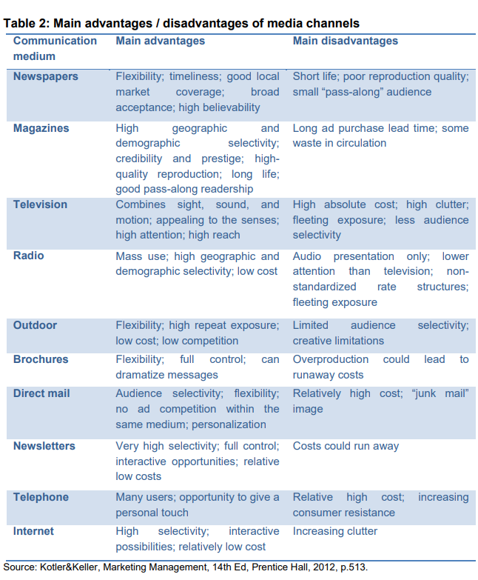

2.1.7 The Integrated Marketing Communication strategies implemented in the UK fashion Industry.

**** Integrated Marketing Communication
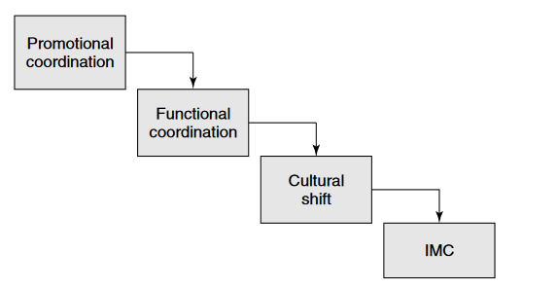
Figure 1 The establishment of IMC,( Source: Fill 2002:469).

The initial step in an IMC approach is to ensure consistency and thematic harmonization among the promotional tools used by the company (see the first box in Figure 1).Next, it is necessary to attend to the functional coordination. The many departments within the organisation, including human resources, finance, and corporate communications, need to be familiarised with the concept of "internal marketing relationships" to effectively execute an integrated marketing communications (IMC) approach across the entire firm (refer to the second box in Figure 1). Therefore, implementing an Integrated Marketing Communications (IMC) approach necessitates a fundamental change in the organization's values and beliefs. This transformation must originate internally for all workers to consistently prioritise and focus on the needs and desires of consumers (as seen in the third box in Figure 1). An IMC approach may only be completely embraced by referring to the fourth box in Figure 1.
Kietzmann et al. (2011) argue that social media has significantly transformed the traditional communication landscape by introducing new technology and interactive platforms. Social media platforms not only facilitate message dissemination but also foster dynamic engagement between an organization and its stakeholders. Mangold and Faulds (2009) argue that social media can be integrated with traditional IMC tools, enhancing communication between companies and their stakeholders. Moreover, social media allows users to distribute content across other platforms, thereby expanding the reach of the original message and fostering opportunities for collaborative creation and user-generated content (e.g. Nieman-Struweg 2014). The advent of social media has significantly enhanced the ability of consumers to express their thoughts, emotions, and concepts, hence emphasising the heightened significance of the outside-in approach in integrated marketing communication (IMC) (Christensen et al., 2008; Lussier & Sonfield, 2015). Given the growing phenomenon of media fragmentation and the emergence of numerous social media platforms, it is imperative for companies to not just ascertain the channels that possess the highest degree of significance. Integrated marketing communications (IMC) can be defined as a customer-centric, data-driven approach to integrating an organization's advertising, promotion, and PR. The intent is to convey a unified and consistent image of the brand to the consumer. This is done through the exceptional of creative and thoroughly thought-out promotional strategies. The primary focus of IMC is to influence the needs and wants of the consumer to better the organization's long-term profitability. The importance of IMC is based around the need for stable communications of value proposition to the many segments of the market. This is especially important in times of economic sustainability where consumer spending may be lower than its usual amount. A tiered method of communication is more effective than one that is information to all consumers at the same level (Clow, K. Baack 2002).A more in-depth view, however, will show a trend of larger organizations making use of cheaper labour to produce clothing abroad. Though often not the case, one can easily think of UK fashion as being controlled by a few major players and a tide of imported items. Although the industry is a northern hemisphere reflection of the globe and ethnocentric, it is useful to view UK fashion as its own entity.
It may be useful to define what is meant by 'UK fashion industry' before attempting to paint a picture of its current climate. An industry is a group of productive organizations that produce a good or service with the intent of making a profit. The UK fashion industry is an industry in which various businesses compete to satisfy the need for fashion-related goods and services. This concept is reflected by statistics showing that the UK fashion industry currently has a worth of £21 billion. This value consists of many organizations varying in size and production. Fashion is the word for a currently popular trend towards items or ways of doing things. It encompasses everything from language to several types of activities. When referring to the word industry, one usually imagines a place of work and a site of production, a term commonly associated with something in contrast to the leisurely acts of 'fashion'. The fashion industry, however, is complex and versatile enough to have a market that caters to an entire spectrum of lifestyle choices.
Fashion provides a way to express one's identity without a need for verbal language. It holds lifestyle and personal values, which can be represented through the type of clothes we choose. Fashion can only exist within a society that allows for constant change of social structure. To understand the current climate of the UK fashion industry, it is important to define what is meant by 'fashion' and 'industry’. The UK is known for the brash and bold fashion industry, for the eccentrics and the fashion designers that like to push the boundaries of fashion, and for what is acceptable. This may not be the accepted opinion of the fashion industry within the UK, but it is the opinion that many outsiders have, this however is changing. Consumers and the industry want to see an industry that is innovative, an industry that is dynamic and an industry that is Britain which is sophisticated, cool and an industry that is renowned for setting global trends. The UK fashion industry is vast and is more than just high street fashion. It is important to understand that it is not just the middle classes that take an interest in what they wear and the latest trends. The UK has a vast range of social and ethnic groups, each with their own subcultures and ways of defining street fashion whether it be punk, ska, reggae, rock, or urban fashion, all of which is not restricted to any age group and is commonly expressed through independent UK fashion labels. The growth in UK online fashion sales across all genres is an apparent sign of growth within the UK fashion industry, although it is still dwarfed by the sales of mainstream fashion that is targeted to the vast majority. In the UK fashion industry, most of the leading companies believe in brand communication. Brand communications require a solitary marketing message that is conveyed over a variety of marketing communications tools. It is an enduring message that is perceived by the consumer and potential consumer about a firm and its product. There are various media methods used by marketers to get the brand messages across to consumers to create a brand image. These days, the promotional mix has been dominated by advertising, direct marketing, and sales promotions. Therefore, there is tight competition between two sets of companies: fashion retailers and clothing manufacturers in the above-mentioned promotional mix field to communicate the brand image to potential consumers (Roderick White, 2004).Market communication helps organizations to develop a brand image in the mind of the customers. It involves all the messages and media used by organizations to communicate with the market. Brand communication is an art to develop a brand image in the customers' mind. In the following research work, we will see the importance of integrated market communication in the UK fashion industry (Wells et al, 2000).

2.1.8 The current Digital Marketing strategies implemented in the UK fashion industry.
Digital marketing has enabled fashion firms to reach a global audience through social media platforms like Instagram and Facebook, leading to increased brand recognition and market penetration. By leveraging data analytics and artificial intelligence, brands can customize marketing messages to specific customers based on their preferences, purchasing patterns, and demographic characteristics. This not only enhances the end-user experience but also fosters brand loyalty. Influencer marketing has become a crucial component of digital marketing strategies, partnering with influential individuals to promote products and expand their consumer base. E-commerce has transformed the fashion shopping experience, requiring firms to adapt their strategies to meet customer demands. Data analytics allows brands to gather valuable information about their customers' preferences and preferences, enabling informed marketing decisions. Digital marketing refers to the strategic use of the internet, mobile devices, social media, search engines, and other communication platforms to effectively target and engage with consumers. Certain marketing professionals perceive digital marketing as a completely novel undertaking that necessitates a fresh approach to audience engagement and a fresh comprehension of client behaviour in comparison to conventional marketing. Ever since the early 2000s, the fashion industry has been so-called "online" with marketing campaigns using website advertisements and pop-ups. However, the internet is a vast space and there is so much more to what the internet offers in terms of the technology that was available 10-15 years ago. Today's era and future era is the utilization of social media with reports in 2011 showing that social media only cost £3 million for fashion brands while returning revenues over £50 million in sales. So, in terms of today's market compared to the early 2000s and print media, the fashion industry has already doubled success in capital using digital marketing and strategies on increasing sales.
One of the most ever-growing industries in the world, the fashion industry is a global phenomenon that transforms the way people dress and carry themselves. Back in the days when televisions and billboards had been invented, the fashion industry used to publish and promote their designers or products through catalogues and traditional advertisements. This was the common way of promoting the products to the targeted audience as people would follow celebrities or popular public figures. However, in the year 2017, the mode of transforming a marketing campaign into a sale has changed drastically. The digital marketing sector has grown rapidly and has become the new way of doing and promoting business. Increased industries are getting into the trends of using the internet and promoting their campaigns through digital marketing. This includes SEO, social media marketing, email marketing, and the websites through PPC and marketing adverts. As discussed above, the UK fashion industry is populated by individuals with a great deal of creative talent who are seeking to translate that talent into profits. It is also an industry that is continually evolving in terms of style and technology. These factors make digital marketing a particularly important topic for UK fashion industry professionals. The Digital Marketing Institute indirectly backs this up, stating "digital marketing is arguably more important than it has ever been before. It is imperative for brands to remember whatever mode of marketing is employed, it must build and cultivate a customer relationship." According to Mintel, the internet has now become the UK's leading channel for buying fashion accessories.
As fashion is typically an impulse purchase, the industry needs to ensure it can create the right impulses. The report suggests this can be achieved by giving consumers a reason to spend, by promoting key events and higher-priced items. Lastly, and most importantly, we must consider the recent effects of the global recession on the UK fashion industry. Current indications suggest that it will be some time before fashion consumption returns to its pre-recession state. The implication is that companies will have to work much harder to gain their share of a smaller market. This makes it essential to identify the most cost-effective methods of marketing. Three key points may be identified with the UK fashion industry. Firstly, the UK fashion industry is different from many other creative industries, in that there is a long-established reputation for creating high-quality, innovative designs that are sold all over the world. This is compared to other creative industries, such as music or television, where the UK is seen to produce much more of the final product than create the original ideas. Another characteristic is the presence of many small companies. This is particularly true with designer fashion, where the industry is still largely made up of independent, often family-run businesses. Thirdly, the UK is known for its fashion education. Offering a high number of degree courses specializing in fashion design, as well as vocational courses in pattern cutting, sewing, and textiles. The result is an industry populated by highly skilled individuals seeking to turn their talents into profits. Step two will involve more desk research from academic sources, fashion business books, and any relevant information provided by the client. This seeks to understand the unique consumer behaviours of those who involve themselves in UK fashion. Step three aims to provide a comprehensive industry analysis based upon findings in steps one and two. An effective digital marketing strategy will result in successful marketing of a brand or product.
Being able to connect traditional marketing tactics such as print ads with interactive strategies is what makes digital marketing so effective in the fashion industry. With the fashion industry's target market being younger women between the ages of 16-35, it is easy to see why it has become such a big player in the digital marketing game. According to Mintel, 98% of young women aged 16-24 are online and using social networking sites regularly. This generation is very internet savvy and knows what they want; therefore, it is essential that fashion companies keep up to date with trends and modern technology to connect with and understand their consumers. The purchasing pattern of fashion consumers has also evolved significantly in recent years. People are more inclined to shop online around the clock due to the convenience, and it is much easier to compare prices between distinct brands. Many consumers also feel that they can find a better range of items online rather than shopping in-store. Therefore, companies need to ensure that their online brand image is strong and the consumer's ecommerce experience is a positive one. This is achievable through strong digital marketing and web practices.
2.1.9 The impact of Integrated Marketing Communication and Digital Marketing strategies on consumer behaviour in the UK fashion industry.
Brands can effectively engage with their desired target audiences through various digital media marketing techniques. These techniques include search engine optimisation (SEO) strategies, which enhance the visibility of websites in organic search results. Additionally, pay-per-click (PPC) advertising enables brands to reach target audiences quickly and effortlessly, regardless of their geographical location. Brands can also employ email campaigns tailored to specific customer segments, use video content to effectively convey engaging stories about products, and leverage influencer marketing programmes that leverage influential personalities from diverse communities. Digital marketing technologies like social media and email can effectively engage customers and disseminate information about new products, offers, price reductions, or promotional activities. Digital marketing boosts consumer trust and engagement by offering unique products and tailored content, enabling businesses to develop targeted marketing initiatives, leading to higher conversion rates, compared to traditional methods.
Consumer purchasing behaviour is an erratic occurrence. The duration of a consumer's decision-making process is inherently unpredictable. The duration can vary, ranging from a few days to several months. Marketers face a challenge when consumers wait longer to decide, since it increases the uncertainty around whether they will select our product or go for a competitor's. The resolution to this issue entails exerting influence on consumers' purchasing decisions in a consistent manner, thereby establishing a robust brand image in their thoughts. IMC has a crucial role in influencing consumers' purchasing decisions. By effectively integrating and aligning all selected marketing channels, IMC can ensure the delivery of coherent, accurate, and compelling messages to consumers. This strategy will establish a durable brand identity, as opposed to haphazardly delivering messages through various advertisements across numerous marketing media. A brand's message that is consistently conveyed will lead to heightened customer awareness and have a direct impact on the robustness of brand equity. The significance lies in the fact that a robust brand equity has a direct correlation with consumer persuasion to purchase a product. This is because a strong brand equity creates the perception among customers that there is no superior alternative to the brand or product they intend to purchase. Gradually, the messages will stimulate consumers by initiating a cognitive transformation process, ultimately resulting in a shift in customers' attitude and belief.
This is the ideal situation for marketers, where consumers are highly convinced to buy a product and believe that the product is the best choice in its category. Finally, IMC is proven to be a cost-efficient marketing strategy. This is because IMC avoids ad-hoc communication strategies where it is chosen based on the trend, but it is not effective to the target market. By well coordination and message delivery, a campaign success rate can be easily measured, and it can be improved in the next campaign by adjusting the message and the strategy itself. This will eventually minimize the waste of cost for a marketing strategy. Implementing Integrated Marketing Communications (IMC) is widely recognised as a crucial strategy for attaining the goals of a marketing campaign by effectively coordinating various promotional approaches that are designed to strengthen one other. Over the years, there has been a gradual shift towards the IMC approach in companies due to the corporate activities of different companies and a changing media environment, which is being given different explanatory factors. According to Schultz (1993), there are five key reasons why companies are adopting the IMC approach in their promotional activities. These factors could be seen as one of the explanations towards the importance of IMC. Integration occurring in the corporate structure of businesses has been well documented in the marketing and advertising literature. The rise of marketing communication effort has been a technical and structural part of marketing and advertising, frequently led by advertising and promotional sales. This has led to several organizations and brand groups incorporating the advertising function and promotional sales into a single position or department. The growing realization that marketing communication is a function apart has frequently been admitted as a separating finance and operational decisions from marketing communication decisions.
Fremantle and McGraw (1990) revealed that in changing from an executional advertising focus to a strategic integrated marketing communications focus, the multifaceted statement of advertising has frequently been replaced by a problem-solving approach. It was the feeling of advertising being an overt communicator of a strategy and the tactical implementation detailed in consumers' need for this strategy, which is currently seeing much development. The change in advertising styling initially suggests the creative styling at a tactical level. It is the desire for more creativity in the areas of planning and positioning that is seeing the development from strategy to higher-level strategies, which have led to increased use of promotion and other forms of marketing communication. Advertising and promotion decision-making has been repeatedly highlighted as a key area where integration is a vital function. This was demonstrated in a survey of high and promotion executives where it was revealed that the most desirable improvement in ad manning promotions was the improvement coordination and decision-making between the two marketing communication mix elements. The final decision-making model on the promotional tool of mix compatibility is a clear explanatory factor on the advertising and selling industries' current attempt to integrate promotion and other sales activities. This recent integration attempt is attempting to alter the tactical often correlate of the promotional tool mix with tools consistent with advertising strategy. Fremantle and McGraw (1990) suggested that this may effectively see a recreation of breakaway advertising and promotional activity coming full circle back into sales. Digital marketing is a broad approach in generating awareness and positioning a product in the consumers' minds. The digital tools can vary from mobile phones, instant messaging, wireless messaging, podcast, and mobile ringtones. Any tool that is using digital technology and has the potential to be downloaded is part of the digital marketing process when it is used to pass on a message. The integration of these methods, combined with the result of digital data, adds effectiveness and relevance to the campaign. It also provides an opportunity for marketing issues that relate to the understanding of consumer perception, consumer decision-making process, and behaviour. Globalization and advanced technology have had a significant effect on progress in the marketing field. The expansion of information and communication technology (ICT) in the last decade has encouraged high optimism for changes for the better in the future and has had an impact on consumer behaviour. Digital marketing is so varied, such as websites, SEO (search engine optimization), SEM (search engine marketing), banner ads on specific websites, email marketing, and mobile advertising, including the use of social media. Each tool above is a form of digital marketing activity designed to attract new consumers and maintain a relationship with existing consumers. This theme gives overly broad chances in understanding consumer behaviour and the effectiveness of each marketing activity in the digital world. The reason is that everyone has their own consumer behaviour in processing and decision-making when purchasing a product, which is affected by marketing activities. Step by step or impulse decision, it all comes back to the perception of an individual towards a specific product and the level of relevance in the marketing activities discussed. However, the effectiveness of the consumer behaviour theme is still rare to be investigated by digital marketing experts. Research on digital marketing is still mostly done on the technical side, such as web design, advertising, and pricing simulations.

2.1.10 The impact of Consumer Behaviour in the UK Fashion Industry.
Consumer behaviour involves the mental, physical, and emotional processes that people go through when they select, purchase, use, and dispose of products that they hope will satisfy their needs and desires. What happens in the market is dependent on the behaviour of the person. Consumer purchases are influenced strongly by cultural, social, personal, and psychological characteristics, so it is vital to be aware of these factors when developing marketing strategies. The fashion industry in the UK is no exception to this theory. The UK is known for being at the forefront of global fashion and a multi-cultural society, hence, the consumer in the UK has diverse spending patterns about clothing and fashion accessories. A study which seeks to understand the consumer behaviour for denim jeans in the UK, confirms through the social influence model, that consumers' decisions to purchase denim jeans can be determined by four factors: the role expectations of others, the judgement of others, individual's self-perception and presentation of the self, and the self-esteem of the individual. Although these factors are stated to be important to most general purchase situations, it was found that denim jeans have symbolic meaning about identity for teenagers and young adults, therefore, social influence becomes more pertinent as one aligns themselves with a specific identity and social group. The findings from this study reveal that social influence is an important factor for purchases within the fashion industry in the UK.
When analysing consumer behaviour, it is crucial to not only examine historical patterns and factors that have influenced people in the past, but also to consider future trends and prospective purchasing behaviour. Consumer behaviour, being an intricate domain, continues to be a topic of interest for marketers to investigate. Comprising perspectives such as social, technological, political, economic, and personal considerations, it can be challenging to determine the relative importance of these factors. The Australasian Marketing Journal conducted a study in 2001 that investigated the correlations among gender, age, self-monitoring, materialism, fashion clothing consumption reasons, and fashion clothing engagement (O'Cass, p.47, 2001). Certain subjects can be succinctly elucidated.
Self-monitoring is believed to indicate the extent to which a person observes and regulates their own behaviour and appearance based on social signals. Variations in orientation and considerations for status and aesthetics might influence the extent to which individuals possess self-monitoring traits, and consequently, the brands and products they select.
Materialism refers to the extent to which individuals consider possessions to be important and prioritise them in their lives. In addition to self-monitoring, materialism influences the use of things to project a specific image. Materialists have a strong dependence on external factors, particularly valuing the items that are visible or consumed in public settings. In summary, the importance of being trendy cannot be underestimated.
Fashion apparel participation refers to the level of personal investment that one makes in fashion. The degree of investment in fashion can vary depending on individuals. Some may just consider suggestions from magazine influencers, while others may closely monitor trends, the fashion cycle, and pay significant emphasis on materials and cuts.

3.Literature gap.

Consumer behaviour has shifted, with current consumers showing aversion to being compelled to view advertisements and demonstrating little engagement with traditional advertising channels. Therefore, it is imperative to develop a novel approach that captures customers' interest and enhances their engagement with our promotional efforts. Companies are required to effectively convey and promote their product or service in a consistent manner, ensuring that customers become acquainted with the offerings without the need for repetitive enquiries.

Integrated Marketing Communication, also known as IMC, is a continuous communication process aimed at potential consumers. It involves the planning, creation, integration, and implementation of various marketing communication disciplines, such as personal selling, advertising, sales promotion, and others .

Public relations are crucial for a company's viability as it helps to mitigate the spread of negative concerns among the public and establish a positive rapport with them, thereby enhancing the company's reputation. Belch & Belch (2009) define public relations as the process of assessing and analysing the policies and procedures developed by individuals or organisations to determine their alignment with the public's interests, with the goal of fostering community understanding and acceptance.

According to Kotler, advertising is a form of marketing where a specific sponsor presents nonpersonal information about ideas, commodities, or services in exchange for payment. Marketing management conducts advertising campaigns by analysing the objectives and motivations of the consumer. This objective is crucial in classifying consumers, namely whether they belong to the medium to upper-middle class or fall below that category. Both new and existing outstanding items employ distinct advertising strategies.

Marketing technique aimed at increasing the sales of a product or service through various promotional activities. Instances of sales promotion are frequently observed during visits to shopping malls or exhibits. There is a plethora of companies that provide discounts to entice buyers. While sales promotion is typically intended for short-term effects, it is possible for it to also have a long-term impact by enhancing the product's position. Examples of sales promotion include discounts and gift certificates.

Direct marketing, often known as direct response marketing, refers to marketing strategies that utilise various media channels to directly measure and track customer responses. Direct marketing, as defined by Hudson (2008), is a marketing strategy that involves employing media to directly promote and distribute products to consumers, with control held by the marketer. As stated by Robert (2008), Direct marketing refers to marketing efforts that aim to elicit reactions from potential consumers using various contact channels such as telephone, mail, and email. Meanwhile, Bob and Ron (2009) state that direct marketing media advertising is being utilised to directly induce behaviour modification. This allows for the tracking, recording, analysis, and storage of such behaviour in a database for future study purposes.

Direct sales Personal selling is a form of two-way communication that utilises professionals to effectively create relationships with customers. If the customer has certain requirements, they can request customised orders, which will be reserved by the seller to meet the buyer's needs. Personal selling enables the seller to immediately obtain feedback from potential purchasers regarding a sales presentation that has been delivered. (Morrisan,2010).

As stated by Kotler & Armstrong (2014), personal selling refers to the direct engagement between salespeople and consumers or potential customers to enhance the sales process and foster stronger customer relationships.

3.1 Shannon and Weaves Models.

Definition An alternate term for the Shannon-Weaver Model of Communication is the Shannon-Weaver Information Theory model. Claude Shannon and Warren Weaver introduced the theoretical foundation in 1949. It provides a methodical representation of the communication process, particularly in relation to the transmission of information via telecommunication networks (Mishra, 2017).

The Shannon Weaver Model of Communication is a groundbreaking framework that simplifies the intricate communication process into manageable components.

The Shannon Weaver Model is a comprehensive communication model utilised to identify and resolve possible issues in diverse circumstances. While it possesses advantages, such as the ability to analyse communication by breaking it down into its constituent parts, it also has drawbacks, such as oversimplifying the process and neglecting to account for power dynamics.

The model is evident in the realms of business, social connections, and technical breakthroughs. It assists in minimising sources of noise to ensure successful transmission and reception of messages through improved feedback mechanisms (Flensburg, P., 2009).


Figure 2. Shannon- Weaver – Model (Mishra.2017)

Shannon-Weaver data transmission models are widely used in technical communication, with behavioural sciences adapting them to various interpersonal situations. Originally proposed as an account of verbal communication, they have been distorted or exaggerated in recent years.
Identify the Shannon Weaver Model is a prevalent communication model that breaks down the process into its individual components, facilitating comprehension and the detection of communication errors. The model is derived from the mathematical theory of communication and comprises seven essential components: Sender, Encoder, Chanel, Noise, Decoder, Receiver, Feedback.
The interplay of these elements enables efficient communication between the transmitter and the recipient. Within the Shannon Weaver Model, noise is a physical interruption that might possibly hinder the successful reception of a message, emphasising the importance of addressing anticipated communication hurdles (Mishra,2017). The interplay of these elements enables efficient communication between the transmitter and the recipient. Within the Shannon Weaver Model, noise is a physical interruption that might possibly hinder the successful reception of a message, emphasising the importance of addressing anticipated communication hurdles.
According to the concept proposed by Shannon Weaver, an individual has a notion or idea in their mind and intends to transmit it to another person. Every component of the model holds significance, and the accurate or inaccurate utilisation of each component can lead to either successful or unsuccessful communication (Griffin, E. M. 2006).

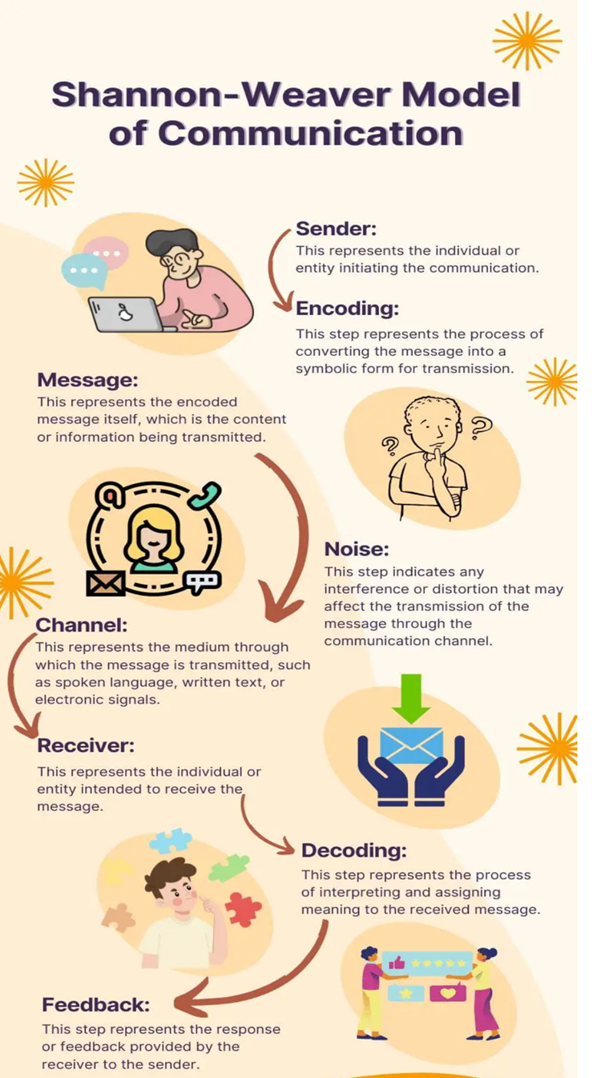
Figure 3 Shannon- Weaver – Model (Mishra.2017)
Sender is the originator of the message.).Accordingly with Verdú, S. (2000 ) the sender wishes to convey some information or substance to another individual. It is well recognised that the person who sends the message bears the main responsibility for the outcome of the communication. However, Griffin, E. M. (2006) considered , the sender has greater control on the variables of the communicative act compared to the message receiver.
Encoding is the cognitive process in which an individual selects verbal and nonverbal symbols from their surroundings to accurately reflect their ideas or thoughts (Griffin, E. M. ,2006) .
The encoding process is influenced by various aspects such as the social system, culture, past experiences, gender effects, formal and informal education, expectancies, and language.
Message refers according with Griffin,E.M.,2006 to the substance or information sent in a communication. The sender intends to convey certain information to their audience. A message can consist of various elements, such as composition, phrase structure, spelling, syntax, gestures, and even objects like fashion.
Channel is how a message must be transmitted. The means of communication are our sensory modalities: vision, audition, tactile perception, gustation, and olfaction. In his book "Understanding Media," Marshal McLuhan,( 2023) asserts that in our culture, which is accustomed to dividing and categorising everything for the sake of control, it can be surprising to realise that the medium itself holds significant influence and meaning, separate from the content it conveys.
Receiver refers to the intended audience of the message. The message may have a designated or main target audience, as well as a secondary audience consisting of all other individuals who have access to the communication. Although receivers are not initiators of the communication process, they are responsible for their communication behaviours, including active listening and delivering precise feedback( Griffin, E. M., 2006).
Decoding refers to the capacity to convert the code used in a message into symbols that can be comprehended by the recipient. The objective is for the recipient to decipher the message in the same way the sender encoded it. Exact replication of this task is unattainable due to the absence of shared backgrounds between the sender and receiver, resulting in the selection of different symbols. The optimal outcome we might aspire to is to achieve a near approximation. What is the reason? The factors that impact encoding, such as the social system, culture, past experiences, gender effects, formal and informal schooling, expectations, language, etc., also influence decoding(Griffin,E.M.,2006).
Noise refers to any factor that causes interference or distortion in the communication process. Noise can encompass both environmental irritations, such as someone coughing nearby, as well as psychological factors, such a gloomy mindset, that can distort any conveyed message. Noise can manifest as either external or internal disturbances that can occur at any stage of the communication process.
Feedback is the transmission of information from the recipient back to the sender. It can manifest in several ways, ranging from the recipient dozing off to a spoken communication. Feedback provides the sender with information on how accurately you have interpreted the message and how you have chosen to react to it. Communication is a dynamic process that involves the transmission of information from a sender to a receiver and vice versa. Communication is continuous and does not have fixed starting and ending points, nor does it strictly follow a linear path. It is a continuous process.
3.2 Advantage and Disadvantages of Shannon and Weaver Models.
An established framework in communication studies, the Shannon-Weaver Model of Communication is renowned for its systematic methodology, quantitative viewpoint, lucidity, focus on feedback, extensive applicability, impact on communication theory, and pertinence to modern communication technology. The model deconstructs communication into constituent elements such as sender, message, channel, noise, receiver, and feedback, thereby offering a lucid and structured depiction of the process. Furthermore, it integrates principles derived from information theory, including entropy and channel capacity, therefore enabling a quantitative examination of communication processes. The simplicity of the model renders it easily understandable for both scholarly researchers and practitioners, therefore emphasising the interdependence of communication components and the significance of feedback. Furthermore, its impact on communication theory and applicability to digital communication technologies enhance its extensive acceptance.
Although the Shannon-Weaver Model of Communication has had a significant impact and is considered a fundamental paradigm in the field of communication studies, it is not exempt from critiques and limitations(Griffin,E.M.,2006).
Critics argue that the model simplifies human communication, reducing it to a linear, mechanistic process, neglecting the dynamic nature of interpersonal interactions, feedback loops, and nonverbal cues. The model overlooks cultural and contextual factors, assuming uniform encoding-decoding processes across communicators, thereby ignoring the diversity of languages, social norms, and cultural perspectives.
Narrowed attention on emotional and psychological factors, the paradigm prioritises the conveyance of information while disregarding the emotional and psychological aspects of communication. It neglects to consider the significance of empathy, rapport, and interpersonal relationships in successful communication, which are crucial for establishing trust and shared comprehension.
Griffin, E.M., 2006, considers signification of Feedback, although the model recognises the significance of feedback in the communication process, it oversimplifies the feedback mechanism by considering it as a unidirectional reaction from the receiver to the sender. However, Al-Fedaghi, S. (2012) considered Feedback in communication engagements is typically multidirectional and intricate, encompassing continuous exchanges of information, clarification, and adjustment between communicators.
Disregard for Power Dynamics the approach fails to sufficiently account for the power dynamics inherent in communication relationships. It fails to consider the presence of power imbalances, disparities in wealth and resources, and social structures that can impact the way messages are sent, received, and understood. This constraint can result in an inadequate comprehension of how power dynamics influence communication interactions and results.
Insufficient regard for nonverbal communication, the Shannon-Weaver Model predominantly emphasises verbal and written communication, disregarding the significance of nonverbal clues such as body language, facial emotions, and gestures in transmitting meaning. Nonverbal communication is a crucial factor in interpersonal interactions and has a substantial influence on how messages are understood. However, the model does not specifically address this aspect (Al-Fedaghi, S. 2012).Lack of sufficient depiction of noise, although the model recognises noise as a factor that can disrupt message transmission, it lacks a thorough comprehension of the different types of noise and their individual impacts on communication.
The model provides a general classification of noise without exploring the unique difficulties and consequences associated with various types of noise, such as semantic noise, environmental noise, or psychological noise.
Inability to adjust to emerging communication technologies, the Shannon-Weaver Model was formulated within the framework of telecommunication systems that were predominant throughout the mid-20th century (Al-Fedaghi, S. 2012). Although the ideas of the model can be applied to other types of communication, including digital communication technologies, it may not be adaptable to new communication technologies and platforms that have emerged since its creation.
In brief, while the Shannon-Weaver Model of Communication offers a structured theoretical framework for understanding communication processes, it is not without its constraints. The approach is limited by oversimplification, cultural and contextual factors being disregarded, emotional and psychological aspects being limited, feedback mechanism being oversimplified, power dynamics being neglected, nonverbal communication being inadequately considered, noise being inadequately represented, and potential lack of adaptability to new communication technologies. It is imperative for researchers and practitioners to recognise these constraints in order to evaluate and improve the model with additional concepts and perspectives, therefore attaining a more thorough understanding of communication dynamics.
3.3 Conclusion
To summarise, the Shannon-Weaver Model provides a thorough structure for comprehending and enhancing communication in many situations (Al-Fedaghi, S. 2012). The model facilitates efficient communication by dissecting the intricate communication process into smaller elements, recognising possible challenges, and formulating remedies. Although the model has its limits, it nonetheless serves as a significant tool for analysing communication processes and finding areas that need improvement. With the ongoing advancement of technology and its impact on communication, the Shannon Weaver Model will become increasingly relevant and applicable(Griffin, E.M.,2006) . It will serve as an essential tool for anyone looking to improve their communication abilities.

4.Frameworks Models

4.1 The RACE Model.
The RACE model is a digital marketing framework that simplifies planning, execution, and evaluation of online strategies by breaking down customer journeys into manageable segments, ensuring a seamless digital presence, increased conversions, and customer loyalty.
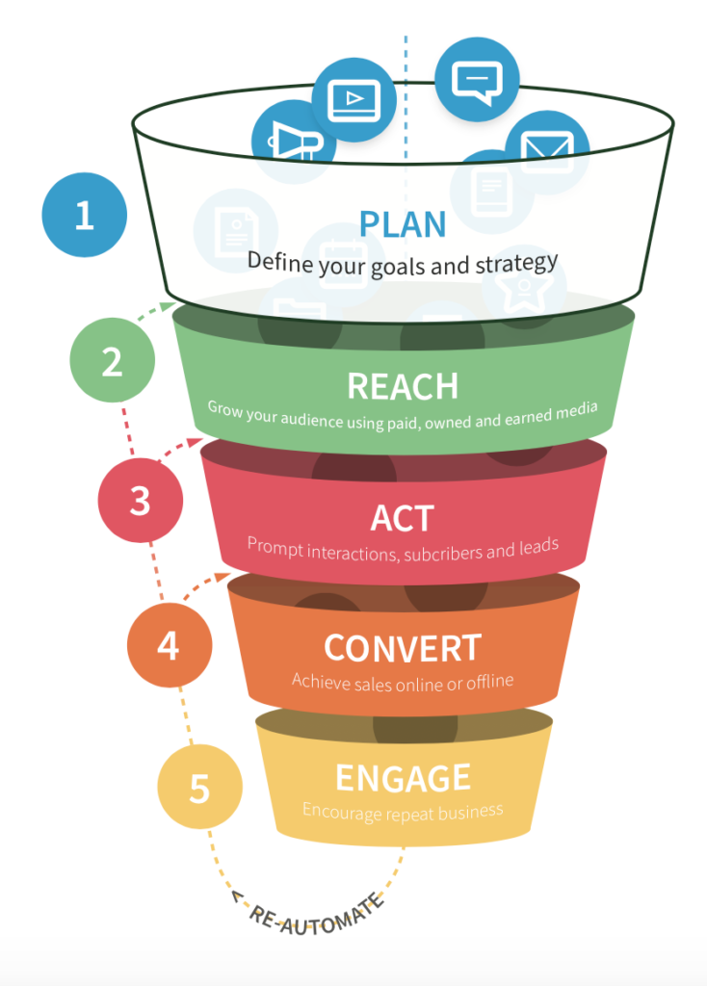
Figure 4:The marketing plan framework(Chaffey and Ellis-Chadwick, 2019).
The RACE framework is a commercial method that emphasises performance improvement. It promotes a data-driven marketing strategy by setting up key performance indicators (KPIs) that digital marketers should incorporate at every stage. These KPIs are used to set targets, evaluate outcomes through analytics and summary dashboards, and continuously optimise performance.
Plan that entails developing a comprehensive integrated digital strategy, setting up aims, and implementing governance measures, which includes distributing resources for the purpose of 'digital transformation'.
Reach refers to the strategic aim of enhancing brand recognition, product visibility, and service exposure across various online platforms and offline media channels. The main aim is to drive traffic to various web presences, perfecting exposure through sponsored, owned, and earned media channels, and using inbound marketing strategies like search, social media, content, and email marketing.
This stage includes creating brand recognition and enticing prospective clients to the firm. The strategy involves employing different channels, such as search engine optimization (SEO), social media marketing, email marketing, and online advertising, to ensure that the business's target audience is exposed to its brand offerings (Chaffey and Ellis-Chadwick, 2019).
Fashion brands can employ several strategies and techniques to generate awareness and entice prospective clients. These include utilizing search engine optimization (SEO) for both branded and non-branded keywords, implementing content marketing initiatives, engaging in influencer collaborations, and leveraging digital advertising methods (Dwivedi et al., 2021).
Act is an abbreviation for the term "Interact." The Act is a strategy used by businesses to generate internet leads, which can be nurtured along the 'path-to-purchase'. It encourages visitors to move to the next stage of their journey, such as researching products or reading blog posts. The Act also promotes active engagement, such as sharing content on social media or customer reviews.
This act is centered around engaging prospective buyers with the brand. The objective is to promote active participation, such as accessing the brand's website, perusing its material, or subscribing to the newsletter (Chaffey, 2022). Strategies for enhancing engagement can involve enhancing the user experience of the brand's website, delivering valuable and pertinent material, and providing incentives such as discounts or free trials (Chaffey & Ellis-Chadwick, 2012).
To achieve these goals, the content must be of superior quality, engaging, and intellectually stimulating, with a clear focus on creating value for the customer. The importance of electronic word-of-mouth, specifically in the fashion industry, cannot be exaggerated. Posted reviews play a critical role as an external measure of quality and brand legitimacy for fashion brands (Nam and Kannan, 2020).
Convert: The RACE marketing framework aims to convert content into sales through online or offline channels, persuading the target audience to convert them into buying clients, regardless of payment method.
Conversion refers to the transformation of individuals who visit a website or show interest in a product or service into customers who make a purchase. In this stage, persuasive approaches are employed to motivate users to make a purchase or fulfil a desired activity. These techniques include appealing copywriting, unambiguous calls-to-action (CTAs), and streamlined checkout processes that minimize obstacles. Conversion rate optimization (CRO) is crucial at this stage since it involves the testing and enhancement of various components of the brand's website or landing pages to boost conversion rates (Chaffey and Smith, 2017). The Convert phase is vital in the fashion sector as it directly influences consumer satisfaction, brand loyalty, and customer retention. During this phase, companies must demonstrate the value of their brand and offerings to the extent that customers choose to establish a financial relationship with them (Rosenbaum et al., 2022). Beauloy Epee (2023a) suggests that using methods such as personalization and leveraging technology in the fashion business can effectively enhance client loyalty and drive higher conversion rates for brands.
Engage: The strategy focuses on fostering customer loyalty through enduring engagement and communication through various channels like website, social media, email, and direct encounters, assessing recurring behaviors like repeat sales, email subscribers, and customer satisfaction and recommendation rates.
The final stage involves establishing a durable and enduring relationship with the clients. This phase entails cultivating customer loyalty and promoting repeat business by implementing customer retention techniques, such as executing personalized email marketing campaigns, delivering exceptional customer care, and establishing loyalty programs. Interacting with customers also offers a chance to collect feedback, enabling the company to enhance its products or services and customize its marketing strategies to better fit their requirements (Chaffey and Ellis-Chadwick, 2019). Many fashion firms utilize loyalty programs and exclusive events to incentivize clients to interact with the company and cultivate a sense of community among their clientele.
In addition, in the present era, numerous fashion brands have developed applications to offer exclusive benefits to their devoted clients (Rosenbaum et al., 2022). Members of the program get exclusive rewards and advantages, including prompt access to promotions, new collections, and live events, as well as member-only promotional events, private virtual consultations, and more.
The RACE model provides fashion businesses with a strategic framework for developing and implementing successful digital marketing campaigns. The fashion sector may enhance their digital marketing strategies and bolster their position in the highly competitive market by prioritizing the targeting of the appropriate audience, promoting engagement, converting leads into customers, and sustaining long-term relationships.

4.2 The HONEYCOB Model.

The honeycomb model of social media offers marketers a beneficial framework. Social media marketing (SMM) is a crucial component of contemporary digital marketing. The recent surge in the utilisation of social media platforms has made a substantial impact on the return on investment that fashion industry may attain by advertising their offerings on these platforms. Nevertheless, it is crucial to bear in mind that the process of overseeing a brand's image on social media platforms differs significantly from utilising a personal presence. You are not permitted to indiscriminately publish any content at any time. To achieve your business's objectives, it is imperative to have a well-defined plan, a structured schedule, and a comprehensive marketing strategy.

Furthermore, it is necessary to utilise data analytics to ensure the effectiveness of those strategies and adjust the plan to identify methods for ongoing enhancement. There exist multiple models and frameworks that can serve as the foundation for constructing your social media strategy.

The Honeycomb Model, developed by Jan Kietzmann, Kristopher Harkens, and Ian McCarthy, Canadian professors, elucidates the efficacy of social media in promoting brands and driving sales. The honeycomb model is based on the concept that organisations can choose the most relevant building pieces from the seven major components mentioned in the model(Kietzmann et all.,2011). The honeycomb model, initially proposed by Smith (2007) and then expanded upon by Kietzmann et al. (2011), posits that Identity, Presence, Conversation, Sharing, Reputation, Relationship, and Groups are the fundamental factors in social media marketing that significantly influence customer engagement.

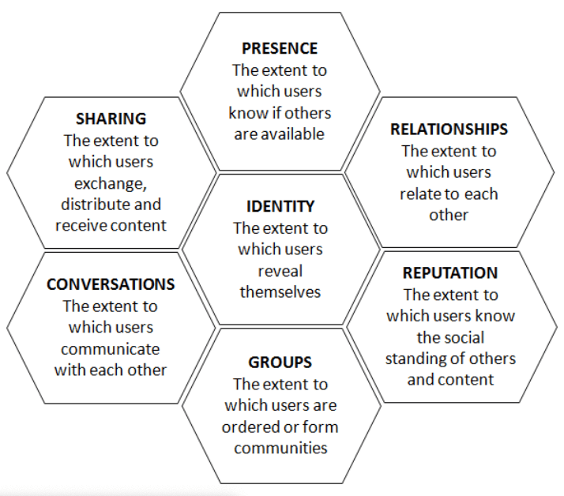

Figure 5. Honeycomb model (Kietzmann et al.2011)

Identity blocks represent a user’s profile on a social media platform, including personal information , such as name , age, and interest (Kietzmann et all.,2011). Fashion industry can utilise this block to target specific demographics and create tailored content that resonate with their audience, by expressing their preferences, aversions, opinions, and emotions, individuals disclose personal information and often project a certain perception of the brand (Kietzmann et al., 2011). The brand identity of companies on social media plays a crucial role in attracting and retaining a dedicated customer base, ultimately leading to increased purchase intent.

Conversation blocks the main purpose of social media is to facilitate engagement and discourse among individuals and collectives on the internet (Kietzmann et al., 2011). It serves as a platform for a wide range of discussions, including individuals or organisations seeking information, establishing a public image, or disseminating a message (Smith, 2007). The crucial component of the conversation dimension in social media marketing is the possibility to engage in brand-related discussions. By conveying a message that demonstrates concern for their audience, companies can establish a profound relationship with their customers (Babac, 2011). Furthermore, the organisation implemented client services to modernise the conventional store assistant for the smartphones age (Sanderson, 2019). By actively communicating with customers, fashion firms demonstrate their dedication to delivering outstanding service and support, which is a vital component of the fashion sector.

Sharing blocks the act of disseminating content on social media platforms, such as photographs, videos, and articles. The content that is shared elicits responses, which in turn results in a rapid and significant increase in the amount of content available on the internet. The significance of sharing resides in the inherent excellence of the content. The content that is shared might elicit positive or negative reactions, which can result in positive or negative electronic word-of-mouth (e-Wom). Therefore, it is important for brands to recognise that when they provide material, they are shaping the perception of their ideology and vision about their brand image and customer care. This has a lasting impact on their relationship with the consumer (Kietzmann et al., 2011).

The presence blocks the presence section provides information regarding the online existence of an individual's peer group such as the number of the followers, likes and comments. The presence dimension facilitates the integration of an individual with their peer group by finding the shared element that connects the actual world and the virtual world. Organisations derive benefits from having a significant presence on social media platforms, as it fosters a better connection with their target audience. This connection, in turn, leads to meaningful and long-lasting interactions that have a lasting impact on the audience (Kietzmann et al., 2011).

Relationship blocks studies indicate that the strength of a relationship has an impact on the level of influence it has inside a person's network of relationships. The implication for organisations involved in social engagement is significant. The effect of social media marketing on consumer-oriented media is to comprehend the amplified influence resulting from the establishment and cultivation of relationships between the brand and its consumers. Studies indicate that the strength of a relationship has an impact on the level of influence it has inside a person's network of relationships ( Kietzmann et al., 2011). According to a survey conducted by Sideqik (Loeb, 2022), most of the activity on the Facebook network is centred around personal and social connections. The presence of relationship building in the fashion sector is crucial for cultivating emotional bonds, improving customer loyalty, and encouraging brand support by means of tailored interactions and active participation on social media platforms( Kim and Ko in 2012).

Reputations blocks the reputation in social media marketing revolves around establishing a perception in the consumer's mind in comparison to other businesses (Babac, 2011). The reputation of a fashion industry brand on social media is established by the material that is posted, the ideas that are expressed, and the number of likes and shares it receives. This reputation can significantly impact how consumers perceive the fashion brand and influence their purchasing decisions (Kietzmann et al., 2011). To effectively manage their online reputation, fashion brands firms should employ measures such as monitoring social media sites, promptly addressing unfavourable comments or reviews, and employing methods for managing crises (Dwivedi et al., 2021).

Groups the group dimension in social media marketing refers to the brand's capacity to establish communities and attract followers who have a strong identification with the brand. The greater the number of followers and groups a company can establish, the more extensive its fan base will become. Therefore, this phenomenon enhances the probability of exerting influence on purchasing choices and establishing brand value (Kietzmann et al., 2011). This study does not encompass an investigation of group functionality within its analytical scope.

The Honeycomb model of social media facilitates businesses in comprehending the distinct functional components of social media and how they might exploit them to establish their online presence, interact with clients, and augment their reputation. Businesses can achieve their marketing goals by strategically improving each component of social media.
4.3 Advantages and disadvantages of the Honeycomb Model

The Honeycomb Model offers a complete framework for comprehending social media platforms by analyzing the seven fundamental components. This approach enables a holistic perspective on social media, which is essential for both professionals and researchers (Kietzmann et al., 2011). Based on Effing and Spil (2016), a framework serves as a solid basis for analyzing the many functions of social media. However, its limitation lies in its narrow focus on the operational level alone.
As stated by Senedheera, Warren, and Leitch (2017), a positive aspect of the model is its ability to be used on different social media platforms. This allows businesses and researchers to effectively assess these platforms and identify opportunities for growth, marketing, and communication. Additionally, the model facilitates the ability to clearly articulate the advantages and disadvantages of each platform and provides strategies for monitoring, implementing, and responding to various social media activities. However, Helms, Booij, and Spruit (2012) contended that a drawback of the Honeycomb model is its failure to consider significant content-related and time-related attributes of social media. The Honeycomb Model offers a complete framework for comprehending social media platforms by analyzing the seven fundamental components. This approach enables a holistic perspective on social media, which is essential for both professionals and scholars (Kietzmann et al., 2011).
Effing and Spil (2016) state that a framework provides a solid foundation for examining the many uses of social media. However, its drawback is that it focusses solely on the operational level. Gaganjot and Singh (2019) assert that the model offers firms a more efficient approach to monitor and react to their competitors in a dynamic market. In addition, Hanlon (2022) concurs that the model is a commendable framework for assessing social media networks. However, it lacks the functionality of a decision tree, which is a disadvantage. Consequently, the organization must still decide regarding which social media network to select.
The resources offer diverse viewpoints on the Honeycomb model, with some authors highlighting its use and flexibility, while others criticize its restricted emphasis and narrow concentration on specific functional features.

4.4 RACE Model versus Honeycomb Model. Similarities and Differences.

- Similarities

Both models highlight the significance of communication and involvement with the intended audience (Kietzmann et al., 2011). Additionally, both models’ priorities the creation and maintenance of customer relationships, which eventually results in an enhanced reputation for businesses (Chaffey and Ellis-Chadwick, 2019). Furthermore, both the RACE and Honeycomb models’ priorities utilizing digital channels to achieve marketing goals (Kietzmann et al., 2011).

- Differences

The RACE model defines the several phases of the customer's evolution in digital marketing, accentuating the significance of accurately identifying the appropriate audience and effectively conveying tailored messages at each stage of the customer journey (Chaffey & Ellis-Chadwick, 2019). Conversely, the Honeycomb model is founded on the concept that social media can be comprehended by seven fundamental components that symbolize various aspects of social media (Kietzmann et al., 2011).
The RACE model encompasses a broader variety of digital marketing operations, whereas The Honeycomb model exclusively focusses on social media marketing. According to Kietzmann et al. (2011), the Honeycomb model is designed to help organizations understand the social media landscape and optimize the effectiveness of their social media strategy.
The RACE model, in contrast, has a more all-encompassing approach and provides a strategic framework that can be used to many digital marketing platforms (Chaffey, 2022).
Although both models provide useful insights into the realm of digital marketing, they tackle the subject from distinct perspectives. The Honeycomb model primarily emphasizes the various dimensions of social media and their interrelationships, whereas the RACE model primarily emphasizes the customer journey and effective customer engagement at each stage.
5 Research Methodology
5.1 Introduction
Research method defines the processes and tools used to gather and evaluate data for a study subject. It includes study design, data collection techniques, and the research framework. Selecting the correct approach is crucial for achieving research aims and ensuring well-designed studies (Saunders,2019).Accordingly with Saunders (2019), research onion is a useful tool for holistic method thinking, aiding in decision-making about research design and method. The ‘onion’ research structure forms six layers, starting with the research philosophy, which must be developed individually as part of the research method.
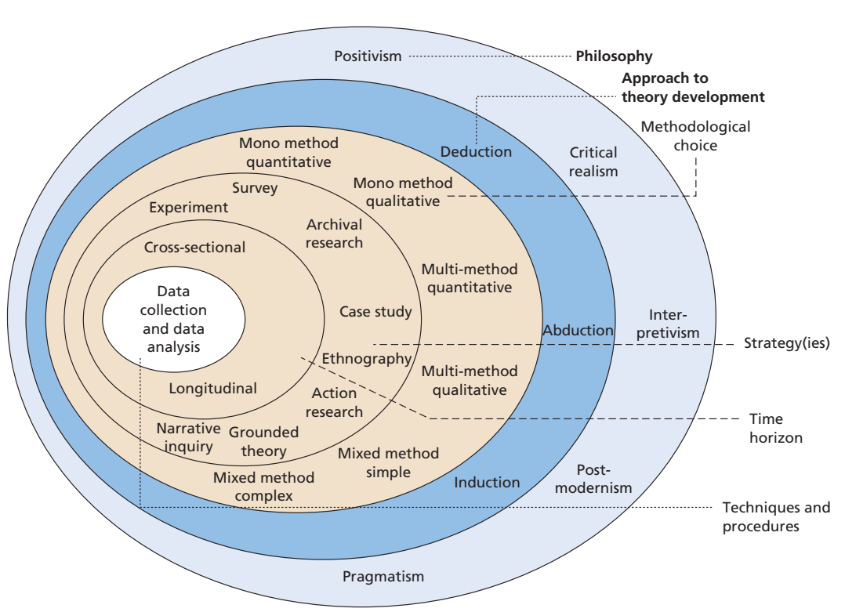
Figure 6: Onion Research ( Saunders, 2019)
The research "onion" is a conceptual framework used to illustrate the various stages and levels of complexity in the research process. Research technique is widely used in academic and professional environments to provide a structured approach for researchers to design and carry out their studies. The research onion model consists of a series of layers that are constructed in a sequential manner, starting from the outermost layer, and moving towards the interior ones. According to Saunder, Thomhill, and Lewis (2015), each layer of the model represents a certain aspect of the research process.
5.2 Research Philosophy.
Positivist research asserts that knowledge exists independently of the subject being studied, seeing objectively without private opinions or viewpoints, and that all meaning is consistent across subjects(Saunders,2019). This research employs positivism as the guiding philosophy to address the research questions developed in the introduction. The positivist approach, in this research, rooted in scientific methods, is ideal for quantitative studies, using techniques such as surveys, experiments and simulations to collect and analyse data, to accept or reject the research hypothesis.
Positivism supports the use of quantitative research methods such as experiments, surveys, and statistical analysis to measure events (Saunders, Lewis, and Thomhill, 2015). Positivists argue that knowledge can and should be generated in an objective manner, free from the impact of personal ideas held by both the participants and the researcher (Park, Konge, & Artino, 2020). Positivism research is characterised using a deductive methodology, whereby a hypothesis and research goals are formulated on the basis of established ideas and subsequently validated by empirical experimentation. Accordingly, the process of obtaining and expanding scientific knowledge is improved (Saunders, Lewis, and Thornhill, 2019).
To address the research issues stated at the beginning of this paper, this study will choose positivism as its guiding philosophy. The application of positivism in this study will assist the researcher in developing explanations based on the widely accepted worldview through the collection of scientific facts, which will then be examined to either support or refute the research aims.

5.3 Research Approaches.
Deductive, research begins with a hypothesis or theory set up through earlier studies and then seeks evidence to support or reject it (Saudres,2019).The development of a theory can be helped using a predetermined research technique known as the deductive approach. To decide the impact of digital marketing, consumer behavior, and integral marketing communication on the UK fashion industry, this study will use a deductive method. That is why the researcher will be able to evaluate the hypothesis that: "the Integrate Marketing Communication, Digital Marketing and Consumer Behavior in the fashion industry in UK" using previously collected data by employing a deductive method.
5.4 Research Choices.
When considering the research philosophy, theory development technique, and type of research, the researcher must select one of three methodological choices: quantitative, qualitative, or mixed methodologies.
Collecting and analysing data, qualitative research is defined as an exploratory method that aims to understand complex phenomena, by examining subjective experiences, beliefs, attitudes, and behaviours (Merriam and Tisdell,2016).
Qualitative research method is an expansive term that includes different interpretive methodologies used to understand and interpret the meaning of naturally occurring phenomena in the social world, rather than just their frequency (Merriam and Tisdell, 2016).
Quantitative research method, research involves non-numerical data analysis, while quantitative research uses questionnaires, structured interviews, and structured observation for survey and experimental methods (Crewell,2013). In this study researcher will focus on the mono-method and only collecting quantitative data.
Mixed research is a research approach that combines quantitative and qualitative research methods to facilitate a more thorough understanding of the subject being investigated (Saunders, Lewis, and Thornhill, 2019).
In this study, the researcher assumes an epistemological position by using positivism as the guiding philosophy. They also use a deductive approach that focusses on empirical, quantitative research to collect primary data and create findings that may be used more broadly. Only quantitative data will be collected for this study, and the research strategy chosen is the mono-method quantitative research approach.
5.5 Advantage and Disadvantage of Quantitative Research.

- Advantage

Impartiality and precision: Quantitative research relies on numerical data, reducing researcher bias and promoting objectivity, ensuring results are more dependable and accurate (Creswell,2013).
Can undergo testing and verification. The precise methodology and reproducibility of both the experiment and its results are essential in quantitative research. The implementation of this strategy enhances the reliability and reduces the vulnerability of the collected data to disagreement (Karavas, 2013).
Concise examination. The nature of the results obtained from collecting quantitative data determines the proper statistical tests to be employed. Consequently, analyzing your data and conveying the results is direct and less prone to mistakes and subjectivity (Crano, Brewer, & Lac, 2015).
Respect. Research that incorporates intricate statistical methods and rigorous data analysis is highly regarded and commendable due to the limited comprehension of the mathematical intricacies by most individuals. Quantitative research is linked to technological breakthroughs such as computer modelling, stock picking, portfolio evaluation, and other data-driven business decisions (Crano, Brewer, & Lac, 2015). Quantitative research can enhance the reputation and worth of your small business.

- Disadvantage

Misplaced emphasis on numerical values. Quantitative research can be limited in its concentration on precise statistical connections, leading researchers to disregard broader themes and linkages. There is a risk of disregarding unforeseen or comprehensive information that could be beneficial to your organization if only focus just on numerical data (Rahman, 2017).
Challenges encountered in establishing a research framework. When conducting quantitative research, it is crucial to carefully develop a hypothesis and plan a structure for collecting and analyzing data. The presence of any imperfections in the experimental design, biassed researcher, or implementation flaws has the capacity to invalidate all subsequent conclusions. Devising a hypothesis can be subjective, especially when you have a pre-established question that you intend to either confirm or disprove (Crano, Brewer, & Lac, 2015).
May be deceptive. Quantitative research is often perceived as more trustworthy or scientific than qualitative research due to its reliance on statistical analysis. Nevertheless, both types of study can be prone to subjectivity and can lead to misleading results. The researcher's beliefs and biases can equally influence quantitative methods of acquiring information. Indeed, the influence of this prejudice manifests itself at an earlier stage in the quantitative research process compared to qualitative research.
To summaries, quantitative research has numerous benefits such as impartiality, the ability to apply sophisticated statistical methods, the potential for generalization, and the ability to replicate findings. Nevertheless, there are drawbacks associated with it, including a deficiency in comprehending context, limitations in designing questions, worries about the quality of data, and a restricted capacity to investigate certain phenomena (Rahman, 2017). By comprehending these benefits and drawbacks, researchers can make well-informed choices, appropriately interpret findings, and contribute to the advancement of rigorous research in their specific domains.

5.6 Types of investigation.

The current study has employed primary and secondary research methods to gather and analyses data to substantiate research aims. These methodologies enabled the researcher to acquire a thorough comprehension of the research subject from several sources, providing a more dependable analysis.

Primary research

Saunders, Lewis, and Thornhill (2019) define primary research as the systematic collection of fresh and unique data or information that is customized to suit a particular research endeavor. Primary research, often known as field research, allows researchers to investigate research topics or objectives using methods such as interviews, surveys, observations, or experiments (Saunders, Thornhill, Lewis, 2015). Primary research involves the collection of original data specifically related to a specific study (Brace,2018). In this study the primary research will be conducted through a survey questionnaire.
The research "onion" offers a systematic framework for conducting primary research, assisting the researcher in choosing the suitable procedures that are in line with their study aims and questions. This systematic approach guarantees a consistent research methodology, improving the quality, validity, and reliability of the study by considering research philosophy, approach, strategy, choice, time horizon, and techniques. The main research for this study has been conducted through a survey questionnaire. The survey questionnaire is a widely used and effective approach for gathering data from many participants (Bryman, 2016). Survey research involves gathering, agreeing, and analyzing responses from a group of people through a series of questions, with the data then being analyzed. (Brace,2018).
In this study researcher will focus on data collection method as survey, distributing questionnaires with close -ended questions.
5.7 Advantage and Disadvantage of Primary Research

- Advantages
Customised for research goals: primary research can be strategically planned and customised to target certain research enquiries, aims, and hypotheses, guaranteeing that the gathered data is pertinent and concentrated (Saunders, Lewis, and Thornhill, 2019).
Up-to date information: primary research refers to the accumulation of novel data and the provision of up-to-date information that may not be readily available in current literature or secondary data sources (Saunders, Lewis, and Thornhill, 2019).
Enhanced control: Researchers possess a greater degree of authority over the research process, encompassing the selection of samples, techniques of data collecting, and utilisation of instruments. This heightened control contributes to the augmentation of the authenticity and validity of the research findings (Taherdoost, 2021).

- Disadvantages
Primary research can be a time-consuming process due to the need to design research instruments, choose a representative sample, collect data, and analyses the results (Bryman, 2016).
Expensive: performing primary research can incur significant costs, particularly when utilizing data gathering methods such as face-to-face interviews or observations (Punch, 2013).
Obtaining access to research subjects or participants can be difficult, particularly when the target demographic is hard to reach or has sensitivities related to the research topic (Saunders, Lewis, and Thornhill, 2019).

Secondary research

Secondary research refers to the systematic gathering, synthesis, and analysis of existing data and material that has been independently collected and published by other researchers (Mertens, 2020). Secondary literature pertains to the extant publications of original sources, including books and scholarly articles. The collection of secondary data was initially undertaken for a distinct objective. Yet, in order to get more accurate understandings, interpretations, or conclusions, it may need to undergo additional scrutiny (Saunders, Lewis, and Thornhill, 2019).
A literature evaluation was conducted to carry out secondary research for this study assignment. The literature analysis in this research paper demonstrates the author's understanding of the existing theoretical framework related to the subject matter (Punch, 2013). Information Technology (IT) constitutes the foundation for conducting original research, examining data, and drawing inferences from secondary data (Saunders, Lewis, and Thornhill, 2019).
5.8 Advantages and disadvantages of secondary research.
- Advantages
Secondary research is a more affordable option compared to primary research. It entails using existing data that has already been collected and is readily available (Saunders, Lewis, and Thornhill, 2019).
Secondary research is more time-efficient than primary research since it eliminates the need to conduct a study, collect fresh data, and analyse it. This is because secondary research utilises existing data that is readily accessible (Punch, 2013).
Conducting a comparative analysis by comparing the primary study data with the existing secondary data is beneficial for triangulating the results. Moreover, it facilitates the comparison of numerous studies, aiding in the identification of temporal or demographic trends or patterns (Saunders, Lewis, and Thornhill, 2019).
- Disadvantages
The researchers have insufficient knowledge of the methods used for data collecting and have no control over it, resulting in issues with data quality, accuracy, and lack of control. Consequently, they lack knowledge regarding both the correctness and the margin of error of the information (Sachdeva, 2009).
Insufficient or antiquated information: the data utilised in secondary research may lack completeness, currency, or fail to accurately represent the present research (Sachdeva, 2009).
The applicability of findings to a certain research topic may be limited due to the lack of accurate relationship between the secondary data and the research question or objectives (Saunders, Lewis, and Thornhill, 2019).
5.9 Time Horizon.
The research time horizon is cross-sectional, covering a short ten-week period at the certain point in time. A cross-sectional study seeks to gain insight into the phenomenon under investigation by collecting data at a specific moment in time. According to Saunders, Lewis, and Thornhill (2019), cross-sectional research often employs survey methods.
5.10 Data collection and analysis
5.10.1 Sampling
Bryman (2012) emphasizes the importance of considering sample size and selection process in quantitative research to ensure the credibility of findings, even when using smaller samples. Selecting a sample that accurately reflects the population it is taken from and possesses features that the researcher can justify in connection to answering the study question and achieving their aims is crucial (Saunders, Lewis, and Thornhill, 2019).

5.10.2 Sampling size

This study aims to examine the influence of digital marketing and integrated marketing communication on customer behavior in the fashion industry. The target demographic for this study comprises social media users who are followers or consumers of fashion businesses. Initially, a sample size of 50 respondents was deemed enough for this study to address the research issue, considering the limited time span of the project. Throughout the process of collecting data, a total of 50 individuals provided responses to this survey.

5.10.3 Sampling type
The online questionnaire specifically focused on persons of all genders who are users of social media sites that are impacted by fashion labels. The participants will consist of individuals aged 18 and above, from different social statuses, residing in the United Kingdom and Romania. They will represent a wide range of cultural backgrounds and have varied experiences with fashion brands on various social media platforms.

5.10.4 Sampling method
Convenience sampling is a type of sampling that does not include probability and is used to identify potential study participants based on their unique characteristics (Byriman, 2012). This study utilizes non-probability sampling. Cooper and Schindler (2014) define convenience sampling as a data collecting approach that prioritizes time and cost efficiency by selecting respondents who are easily accessible and willing to participate in the study.
The decision to employ convenience sampling in this study was driven by the convenient availability of respondents through popular social media sites like Facebook, Instagram, and TikTok. The researcher effectively contacted a varied collection of fashion brand-influenced consumers by disseminating this survey, so achieving the target sample size for the study in less time than anticipated. Despite its limits, the researcher has deemed the convenience sampling approach adequate for attaining the aim and objectives of this study, due to its advantages.

5.11 Advantages and disadvantages of convenience sampling.

- Advantages

Cost- effective: Convenience sampling is the most economical choice for researchers when compared to other sampling strategies (Cooper and Schindler, 2014).

Ease of access: Conducting this study is simple due to the convenient access to respondents who are readily available and eager to participate (Sunders, Lewis, and Thornhill, 2019).
Time -effective: Convenience sampling is a time-saving method that enables researchers to easily locate individuals who are readily accessible (Saunders, Lewis, and Thornhill, 2019).

- Disadvantages

Limited generalizability: The convenience sampling results may lack representativeness of the total population due to the absence of a random selection of participants, hence impeding the generalizability of the findings (Bryman, 2016).

Bias: The convenience sample results may lack representativeness of the overall population because participants were not randomly selected, which hinders the capacity to generalize the findings (Bryman, 2016).

Lack of credibility: Due to the very low likelihood of the sample being representative, convenience sampling may compromise the ratability of the research findings (Saunders, Lewis, and Thornhill, 2019).

6. Data Collection method
Microsoft Forms will create a multilingual online survey, with English as the default language and Romanian as an added language, consisting of eight to ten closed-ended questions, taking only ten minutes. ( the English-language version of the questionnaires is enclosed in the Appendix). The questionnaire consisted of seven questions, comprising two demographic choice questions, three Multiple-choice questions, one Rating scale question, and one 5-point Likert scale question. Participants were given a 5-minute time frame to anonymously complete the questionnaire, and 50 users provided responses. To ensure that all respondents answered every question, the researcher made the questions mandatory by include the compulsory choice (*). The average duration for individuals to complete the questionnaire was 1 minute and 10 seconds.
6.1 Analysis of data
The quantitative data collected in the study will be evaluated using Microsoft Excel. This software will be utilised to generate tables, graphs, and charts. The data analysis process was easy and without any challenges, thanks to the capability of Microsoft Forms to allow the download of all responses as a Microsoft Excel file. This feature streamlined the procedure for the researcher in producing tables, graphs, and charts.
6.2 Research ethics
The data collection for this study adhered to the regulations outlined in the Data Protection Act of 2018 (GOV.UK, n.d.), which governs the processing of personal data in the UK. To ensure adherence to the legislation, participants were provided with information regarding the goal and methods of the study, and their agreement was sought at the outset of the questionnaire. The data collected was solely utilised for the precise research objective delineated in the study and was not divulged. The anonymity of the participants' identities was preserved by abstaining from gathering any personally identifiable information. Ultimately, the gathered data will be safely held for a finite duration, following which it will be irreversibly erased. The researcher will conform to ethical norms by maintaining strict confidentiality of all original data and refraining from disclosing any information to third parties.
The ethical guidelines for research are based on prescriptive moral principles, guiding researchers on how to conduct their work effectively( Punch,1994).

7. Analysis of data
7.1 Introduction
This part provides a comprehensive examination of the data gathered to address the research objectives and derive significant conclusions. The researcher employed a methodical strategy to arrange, analyse, and interpret the quantitative data. The data analysis results are presented in a clear and straightforward manner, with the use of tables and graphs to aid in understanding and discussion. The inclusion of the literature review and introduction chapters provided substantial assistance to substantiate the debate and validate the conclusions.
7.2 Questionnaire Analysis
Question 1
Question 1 .What is your age?*
Age Group |  | Participants:50
under 25 |  | 9
25-34 |  | 10
35-44 |  | 19
45-54 |  | 8
55-64 |  | 3
65 or older |  | 1
Figure 7. Question 1 Table (Create by researcher)

Figure 8. Question 1. Age group representation (Chart created by the researcher)

Results: According to the graph, it is evident that there was a total of 50 participants that answered to the survey. The 35-44 age group had the most representation, accounting for 38% of the total. The 25-34 age group followed with a contribution of 20%, while those under 25 made up 18%. The age category of 45-54 had a percentage of 16%. These four interest groups encompass 92% of all participants in this study. Out of the entire group of representatives, only 8% remained. This small fraction was split between two age categories: 55–64-year-olds accounted for 6%, while those aged 65 or above made up 2%.
Discussion: Upon conducting a thorough analysis of the data, it is evident that the younger age group, particularly Millennials, constitutes most respondents. According to Frank (2023), Generation Z and Millennials were the driving force behind the expansion of the fashion market. However, the 65 or older demographic segment, which accounts for only 2% of the total population, shows less involvement with social media platforms or is not adequately represented in the sample due to the use of convenience sampling approach.

Question 2

Figure 9 Question 2. Gender representation (Chart created by the researcher).
Results: As illustrated in Figure 9, the survey participants included of 38 (68%) females and 16 (32%) males. No responses were documented for the non-binary gender category.
Discussion: The survey analysis reveals a higher proportion of female participants (68%) compared to male participants (32%) in terms of gender distribution. This finding indicates that female respondents may have a greater preference for fashion brands or show higher levels of involvement on the social media platforms used to distribute the survey. The study found that female customers exhibited higher levels of engagement with fashion businesses on social media platforms (Sabanoglu, 2022).

Question 3

Question 3. Which of those promotional strategies influences you to purchase fashion brands?*
 |  | Options | Participants: 50
 |  | Advertising | 16
 |  | Sales Promotions | 20
 |  | Public Relations | 3
 |  | Direct marketing | 3
 |  | Sponsorship | 2
 |  | Personal Saling | 6
Figure 10.Question 3 Table (Chart created by the researcher)

Figure 11.Question 3 Table (Chart created by the researcher)

Figure 12.Question 3 Table (Chart created by the researcher)
Results: The questionnaire prompted participants to select one promotional strategy from a provided list that influenced their purchase of fashion brands. A total of 64 replies were recorded from a group of 50 individuals. According to the data presented in Figure 11, the most influential promotional method for purchasing fashion brands is sales promotion, accounting for 44% of the total participants, followed by advertising at 34%. However, other promotional tactics have a relatively little impact on purchasing decisions, with personal selling accounting for 9%, direct marketing for 5%, public relations for 5%, and sponsorship for 3%.
Discussion: The visual representation unequivocally illustrates that sales marketing ranked highest among the promotional strategies that were consider (Rigby, D. 2011). This suggests that brand products elicit greater interest when they are being advertised. Similarly, advertising secured the second position, further suggesting a degree of interest in buying branded products (Rocamora, A. 2011). Figure 12 illustrates that none of the strategies, namely sponsorship, direct marketing, public relations, and personal selling, influenced the purchasing decisions of the respondents. The study indicates that women displayed a higher level of interest in fashion companies, specifically regarding promotions (22) and advertising (15), whereas males were more inclined towards advertising during the purchasing process.

Question 4
Question 4. Which of Digital Marketing strategies influence you to buy fashion brands?*

Options | Participants:50
Influencer | 8
Story telling | 18
Facebook | 11
Instagram | 16
TikTok | 7

Figure 13.Question 4 Table (Chart created by the researcher)

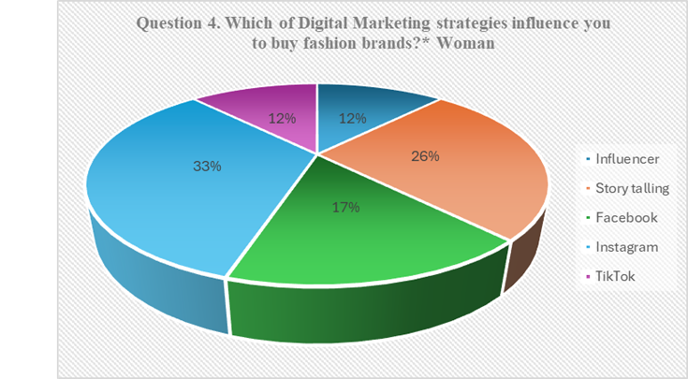
Figure 14.Question 4 Table (Chart created by the researcher)

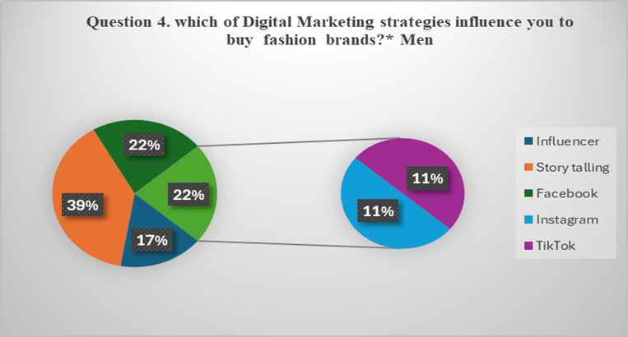
Figure 15.Question 4 Table (Chart created by the researcher)

Results: According to the data presented in Figure 14, the survey participants showed a preference for Storytelling, which was favoured by 30% of respondents. Instagram followed closely with 27%, while Facebook had 18%. In contrast, Influencer received 13% and Tic Tok received 12%, indicating lower interest among respondents. Among all the participants in this study, 18 explicitly stated that buying the fashion brand Storytelling has a beneficial influence.
Discussion: The findings indicate that storytelling is the most favoured medium among respondents for keeping up with fashion brands, constituting over half of the responses. This preference might be attributed to the platform's emphasis on visual storytelling, which enables fashion firms to effectively present their products and aesthetics. It is particularly popular among the younger generation, including Millennials and Generation Z(Dixon,2023).Based on the demographic question gender, both females and males, as shown in Figure 15 and Figure 14, have a higher percentage of followers who are influenced by storytelling when purchasing fashion brands. Specifically, more than 26% of women and 36% of men are impacted positively. Conversely, Tick Tock and Instagram garnered a somewhat smaller number of replies, suggesting that these platforms may not be as popular among the respondents for following fashion businesses. This could be attributed to the content formats or follower demographics on those platforms.
Question 5
How often do you buy fashion brands?*
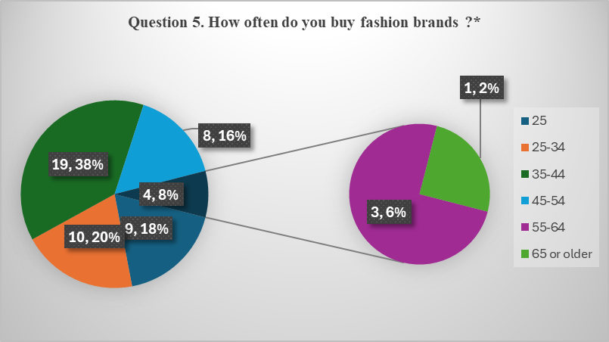
Figure 16.Question 5 Table (Chart created by the researcher)
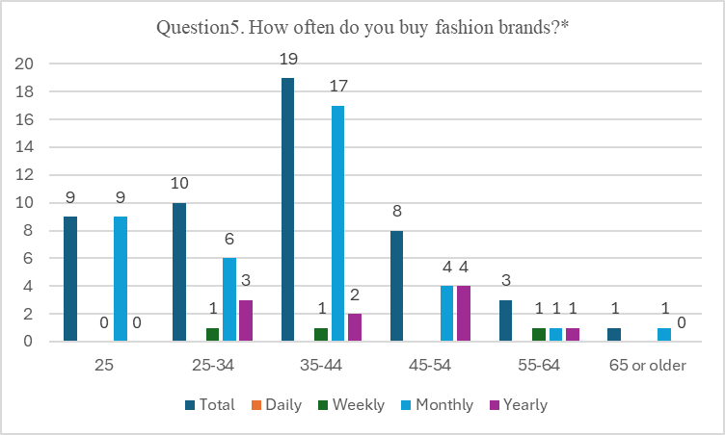
Figure 17.Question 5 Table (Chart created by the researcher)
Question 5. How often do you buy fashion brands?*
Age group | Woman’s | Men | Daily | Weekly | Monthly | Yearly
25 | 7 | 2 |  |  | 9
25-34 | 6 | 4 |  | 1 | 6 | 3
35-44 | 12 | 7 |  | 1 | 17 | 2
45-54 | 7 | 1 |  |  | 4 | 4
55-64 | 2 | 1 |  | 1 | 1 | 1
65 or older | 1 |  |  |  | 1
Total | 35 | 15 |  | 3 | 38 | 10
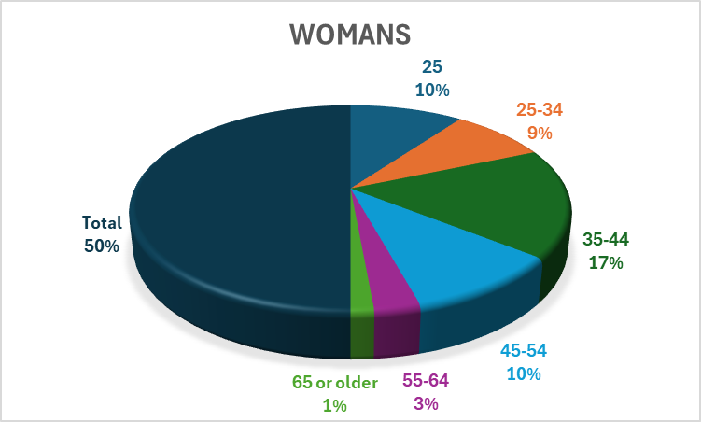
Figure 18.Question 5 Table (Chart created by the researcher)
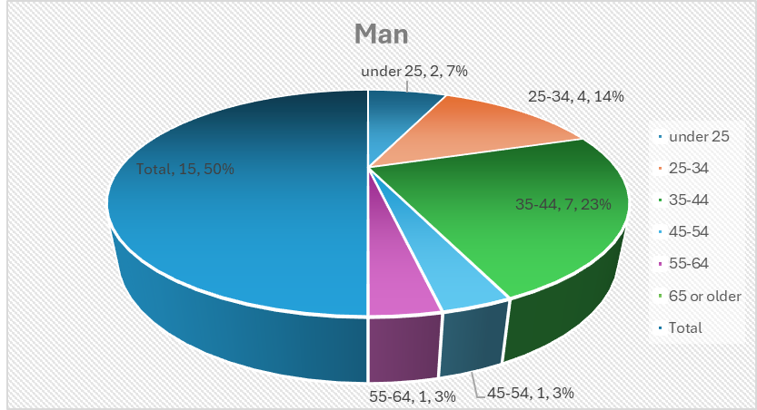
Figure 19.Question 5 Table (Chart created by the researcher)
Results: Among the 50 respondents in the survey, as shown in Figure 16 18% expressed interest in fashion brands under the age of 25, 20% in the age range of 25-34, 38% in the age range of 35-44, and 16% in the age range of 45-54 years old. At the other end of the spectrum, respondents in this survey who were between the ages of 55 and 64 (6%), and those under 65 years old, expressed interest in the percentage of (2%).
According to the data shown in Figure 18, the majority of respondents, regardless of gender (as shown in Figure 18), expressed interest in buying fashion brands in the following manner: among those under the age of 25, 9 respondents (both men and women) purchased fashion brands on a monthly basis, among those aged 25-34, 1 respondent demonstrated interest in purchasing fashion brands weekly, 6 responded monthly, and 3 respondents indicated yearly purchases. Survey participants in the 35-44 age group consisted of 19 respondents (both men and women). Among them, 1 respondent expressed interest in purchasing fashion brands on a weekly basis, 17 responded monthly, and 2 responded annually. Out of the total of 8 individuals, representing both men and women, in the age category of 45-54, 4 expressed a monthly interest in buying fashion brands, while the remaining 4 expressed a yearly interest in purchasing fashion brands. Contrasting with that, the 55-64 age group, consisting of 3 respondents (both men and women), expressed their interest in fashion brands on a weekly, monthly, and yearly basis. Lastly, individuals above 65 years old, represented by 1 respondent, indicated their interest in purchasing a fashion brand once a month.
Without exception, none of the 50 participants, including both women and men, expressed interest in purchasing fashion brands daily.
Discussion: Through a thorough analysis of the data, it is evident that most participants are from the younger demographic, specifically Millennials, who have a greater inclination towards increasingly frequent purchases of fashion brands. Frank (2023) asserts that Generation Z and Millennials have been the primary catalysts for the expansion of the fashion business. Nevertheless, the 65 and above age group, accounting for a mere 2% of the overall population, has no significant involvement with social media platforms or is not well represented in the sample because of the use of convenience sampling strategies.
Figures 18 and 19 demonstrate that among the entire participants in this survey, both women and men have a genuine interest in buying brand products. The proportions of interest in purchasing brands are adequate.

Question 6
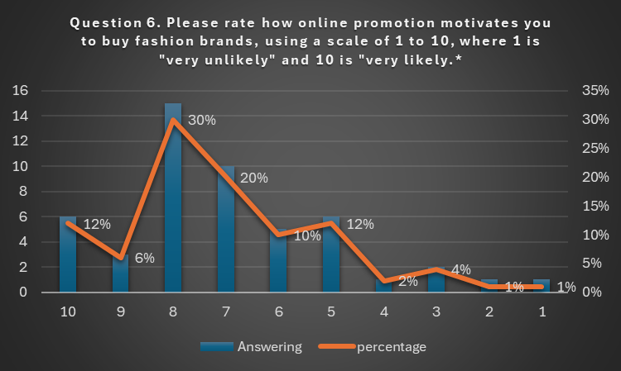
 | 10 | 9 | 8 | 7 | 6 | 5 | 4 | 3 | 2 | 1
Answering | 6 | 3 | 15 | 10 | 5 | 6 | 1 | 2 | 1 | 1
percentage % | 12% | 6% | 30% | 20% | 10% | 12% | 2% | 4% | 1% | 1%
Figure 20.Question 6 Table (Chart created by the researcher).

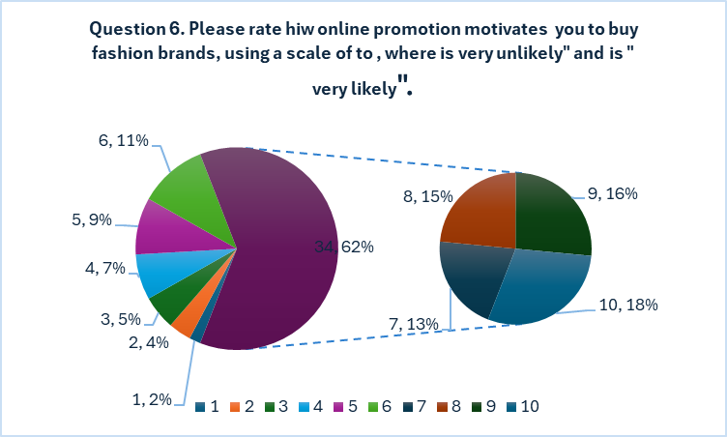
Figure 21.Question 6 Table (Chart created by the researcher).

Question 6. Please rate how online promotion motivates you to buy fashion brands, using a scale of to , where is " very unlikely " and is " very likely".
Rating | Answers
1 | 1
2 | 1
3 | 2
4 | 1
5 | 6
6 | 5
7 | 10
8 | 15
9 | 3
10 | 6
Average rate | 5

Results: Figure 21 demonstrates that 6 respondents expressed their satisfaction with after-sales services provided by fashion brands a 10, 3 rated it a 9, 15 rated it an 8, 10 rated it a 7, 5 rated it a 6, 6 rated it a 5, 1 rated it a 4, 2 rated it a 3, 1 rated it a 2 and 1 rated it a 1. This result in an overall average satisfaction of 5,indicate a positive perception among respondents.
Discussion: Analysis indicates that most respondents had a favourable experience with the post-purchase support offered by fashion companies. With 62% of participants indicating their happiness at 7, it implies that brands are either reaching or surpassing client expectations in this aspect. Conversely, a smaller group of participants indicated lower levels of happiness (14%). Among these, 6% expressed content with 3, 2% expressed satisfaction with 4, 4% expressed satisfaction with 3, 1% expressed satisfaction with 2, and 1% expressed satisfaction with 1. These findings indicate that there is limited scope for enhancing after-sales services in certain instances within the fashion sector.
Question 7
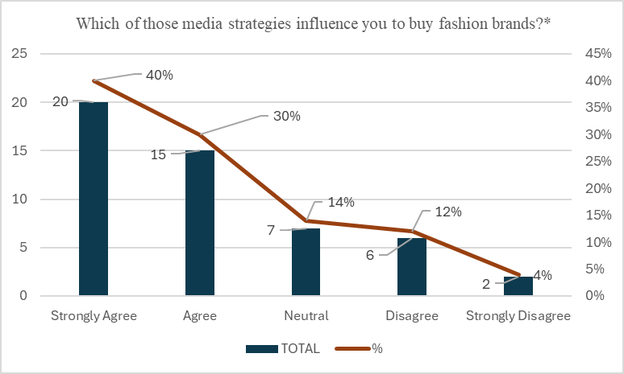
Figure 22.Question 7 Table (Chart created by the researcher).
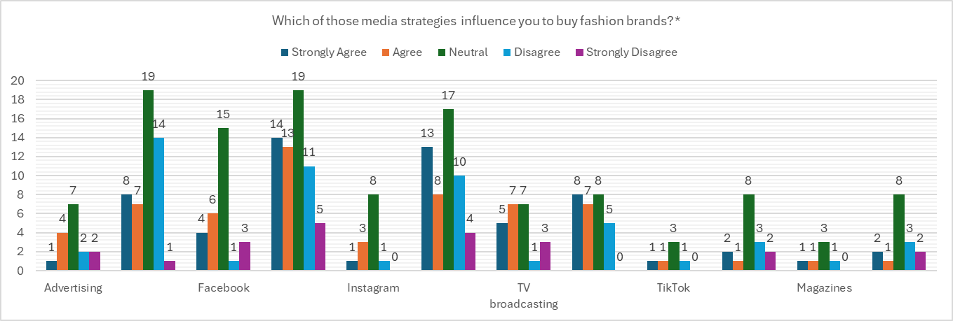
Figure 23.Question 7 Table (Chart created by the researcher).

Results: Based on a sample of 50 participants, Figure 22 indicates that 20 respondents (40%) highly agreed, 15 respondents (30%) agreed, 7 respondents (14%) remained neutral, 6 respondents (12%) disagreed, and 2 respondents (4%) strongly disagreed on the media strategies that affect their purchasing decisions for fashion brands.
According to Figure 23, out of the Advertising user segment, 9 respondents (1 male and 8 female) expressed a strong agreement, while 11 respondents (4 male and 7 female) indicated agreement with the statement. Among Facebook users, 18 respondents (4 male and 14 female) expressed a strong agreement, while 19 respondents (6 male and 13 female) indicated agreement. Among Instagram users, 14 respondents (1 male and 13 female) expressed strong agreement, while 11 respondents (3 male and 8 female) indicated agreement with the statement. Television broadcast viewers, who responded less often, reveal a comparable pattern, with 13 respondents (5 male and 8 female) strongly agreeing and 14 respondents (7 male and 7 female) agreeing with the statements. Although TikTok and Magazines had fewer replies, the majority still expressed agreement with the statement.
Discussion: The findings indicate that the majority of participants, irrespective of their gender, hold the belief that fashion companies effectively manage social media platforms to build brand recognition and cultivate a sense of exclusivity. These findings align with prior studies that suggest fashion companies are broadening their social media channels in order to engage with their target audience (Bozarth and Handfield, 2016). Social media tactics' capacity to captivate consumers and enhance brand recognition has rendered it an indispensable element of every company's marketing plan (Kim and Ko, 2012).
8.Conclusion and recommendations
8.1 Conclusion
The research addressed the objectives specified at the beginning of the investigation. Through the exploration of primary and secondary data sources, the researcher has acquired significant knowledge regarding the present condition of integrated marketing communication and digital marketing, as well as consumer behaviour, within the fashion business in the UK.
To determine the Integrated Marketing Communication strategies implemented in the UK fashion Industry, firstly, the researcher has analyzed the dominant marketing approaches used in the UK fashion industry to establish the Integrated Marketing Communication strategies applied in the UK fashion industry. The analysis of both primary and secondary sources indicated that the fashion companies successfully employed social media platforms for marketing purposes. After conducting an extensive analysis of scientific literature, it was concluded that fashion industry firms primarily use social media platforms like Instagram, TikTok, and Facebook to actively engage with customers and promote their products. To enhance customers' understanding of the impact of Integrated Marketing Communication on their decision-making behaviors, the study examined the significant strategies that influence consumer behavior, including advertising, sales promotion, public relations, direct marketing, sponsorship, and personal sailing. The findings of this study validate the significance of Integrated Marketing Communications processes and show their superiority as the most effective approach to engage customers. This is because consumers are significantly influenced by the implementation of integrated marketing communication and digital marketing strategies. Furthermore, the study validates the reliability and precision of previous research material by a methodical analysis of customer behavior data. This phenomenon can be attributed to the fact that consumers have a wealth of information and the capacity to make purchases from a wide range of fashion brands. Consequently, the brand that can effectively interact with consumers will have a greater impact on them. This study investigates the application of Integrated media communication and digital marketing in the fashion industry within the United Kingdom. An analysis of the literature highlighted the importance of Integrated marketing communications and digital marketing in shaping consumer behaviors.

The survey findings revealed that consumers considered advertising and sales promotions to be the main tools of Integrated Marketing Communications and Digital marketing strategies. This suggests that social media platforms greatly improve the customer experience at various stages of the customer life, including after-sales satisfaction. Participants showed a higher level of familiarity with these methods compared to other methods. With the growing levels of client involvement in social media, internet, and online activities, technology emerges as an additional pivotal determinant for them. Their need for recognition and thus their inclination towards direct marketing is contingent upon the brand they are purchasing. Incorporating consumer input and preferences helps optimise the effectiveness of design and implementation of Integrated Marketing Communications and Digital marketing activities.

To investigate the current Digital marketing strategies implemented in the UK fashion industry, secondary, the researcher examines the DM efforts employed in the UK fashion sector. Social media can function as a primary tool for marketing experts to directly engage with their intended audience and collect their feedback. This literature analysis demonstrates the significance of digital marketing (DM) in establishing and sustaining client relationships, customizing marketing initiatives, and developing fashion brands. The questionary results additionally demonstrated that social media platforms augment the consumer experience throughout various phases of the customer life cycle.
Moreover, secondary sources indicate that not all fashion brands, which provides diverse offers and incentives, may have a substantial impact on customer decision-making. However, all the techniques employed by fashion businesses can establish a lasting relationship.
Analize the impact of Integrate Marketing Communication and Digital Marketing strategies on consumer behavior in the UK fashion industry, lately, the researcher analyzed the impact of IMC and DM on customer behavior in the UK fashion industry, The present study investigates the impact of IMC and DM activity, advertising, and social media engagement by fashion brands on the decision-making process of consumers while purchasing fashion brands. Research indicates that interacting with a fashion brand has a beneficial impact on consumers' recognition of the brand, level of engagement, and intention to acquire.
The results of this study indicate that the consumer behavior decision-making process is indeed influenced by the level of social media involvement of a fashion brand. Therefore, the collected statistics suggest that IMC and DM are a viable and pertinent marketing communication tool for fashion brands.
However, this study indicate that various advertising materials have a significant impact on the consumer behavior. Furthermore, social media platforms are considered integral forms of marketing. The present study aims to enhance the existing knowledge on the impact of IMC and DM activities on the entire purchase decision process for fashion brands, by adopting a historical approach. Annoyance has emerged as a challenge for fashion brands in their marketing communication endeavors. Customers may experience annoyance due to the marketing activities of a fashion brand. Consumers can swiftly shift their loyalty away from the brand, for instance, by disregarding the fashion brand while making a purchasing choice or by disseminating negative comments. Digital marketing tools is typically seen as a more effective marketing communication platform since consumers can easily choose marketing material.
The survey conducted revealed that the participants expressed consensus on the enhancement of their overall customer experience with fashion businesses through media platforms. It is noteworthy that all customers have observed an improvement in their engagement with fashion brands on social media platforms.

8.2 Recommendation

Their significance within the broader digital marketing landscape should not be overlooked, as social media platforms play a crucial role in boosting brand awareness and sales for fashion firms. The literature review is imperative for brands to remain up to date with the latest trends and advancements as technology continues to progress and these platforms continue to shape customer behavior. A comprehensive understanding of user performances and expectations is essential for developing successful marketing strategies for social media sites. Considering this, the subsequent suggestions are intended to help fashion brands improve their social media visibility and further formulate tools to effectively interact with this target demographic.

Understanding Your Target Audience: Comprehensive understanding of the target demographic is crucial for developing effective digital marketing strategies for the fashion business. When formulating messages that effectively engage with your business, it is important to consider age, gender, geography, interests, and preferences of the target audience. This may encompass focused marketing campaigns, customized online promotions, or streamlined digital purchasing experiences that attract customers from different age groups and cultivate more robust customer relationships.

Consistent Branding: Maintaining brand consistency is crucial across all digital platforms, including your website, social media channels, email marketing, and any other digital interactions with your audience. Maintaining a consistent branding strategy fosters brand recognition and confidence among consumers. The survey results unveiled the popularity of platforms such as Instagram, Facebook, and TikTok, which effectively resonated with various customers categories, particularly the younger generations. To successfully connect with their target audience and align with their specific interests and expectations, brands need provide customised content for each platform.

High-Quality Visuals: Given that fashion is a visually oriented sector, optimal images are crucial for achieving success in digital marketing. This encompasses product photography, lifestyle photographs, and video material. Employing professional imagery enhances the presentation of your products and promotes active involvement with your target audience The study findings demonstrate the influence of utilising social media platforms like Instagram, Facebook, and TikTok on consumer buying behaviour towards fashion brands.

Influencer Marketing: Employing influencer marketing can be a very efficient strategy to expand your reach to untapped demographics and establish trustworthiness among your intended consumer bases. When choosing influencers, it is crucial to evaluate their pertinence to your business, audience characteristics, and levels of interaction rate. Collaboration with influencers who have congruent principles with yours and have an authentic audience will enhance interaction and boost sales for your products or services.

Data-Driven Decision-Making: Digital marketing provides an abundance of data about customer behaviour that can be utilised to enhance campaigns and increase return on investment (ROI). Through consistent analysis of website traffic, social media interaction, email open rates, and other relevant metrics pertaining to your marketing plan, you will be able to make decisions based on data that improve your efforts and achieve superior outcomes. Data-driven marketing is the use of scientific data to make well-informed judgements regarding marketing strategy. Fashion brands are employing this strategy to acquire profound understanding of their client behaviour, tastes, and purchasing patterns. This understanding may be utilised to create customised marketing strategies and improve the overall satisfaction of customers.

Mobile Optimisation: With the increasing number of consumers using their smartphones for online browsing and purchasing, it is crucial to ensure that your digital marketing initiatives are appropriately tailored for mobile devices. The encompasses responsive site design, emails optimised for mobile devices, and customised advertising campaigns designed exclusively for smartphones. Maximising the mobile usability of your campaigns enables you to expand your reach to a larger pool of potential clients and enhance the overall user experience.

Shoppable Content: Shoppable content allows consumers to make direct purchases of products right from the material they are currently reading. By selecting a product in an Instagram post, users are immediately redirected to its corresponding product page for the purpose of making a purchase. This phenomenon is gaining higher popularity in the fashion industry as companies may transform their material into a source of income.

Sustainability: has emerged as a progressively significant determinant for customers in their decisions to make purchases. Fashion firms are employing digital marketing strategies to advertise their sustainability efforts and showcase environmentally friendly products, including the use of recycled materials, waste reduction, and the minimisation of their operational carbon footprints.

Fashion brands need to proactively adapt to the digital marketing landscape to maintain competitiveness in a swiftly evolving sector and enhance their ability to engage with their intended consumer base. Digital marketing trends are essential for the fashion industry since they provide a cost-efficient means to expand the reach of the brand and curate customised experiences for consumers.
8.3 Limitation and furthermore Research

While this study does make a valuable contribution to customers’ behavior decisions when purchasing fashion brands, it is important to recognize the associated limitations of the study. Although the database has the largest collection of peer-reviewed literature, it is possible that another platform may have been utilized to offer more pertinent academic papers that pertain to the subject of this research. However, this study presents a wide range of potential areas for future research. Further sample and comprehensive interviews are necessary to establish the generalizability of the findings. Furthermore, the investigation did not consider the different types of social media advertising; hence, it is recommended that further study be undertaken to ascertain if there was a disparity in digital marketing between Facebook and other social media platforms such as Instagram, Twitter, YouTube, Google, LinkedIn, and others. This study employed quantitative data, whereas quantitative research would provide more comprehensive findings regarding consumer behavior influences and attitudes.
However, this study drew from a variety of experiences, the researchers recognize that the findings are derived from a small number of interviews and concentrate on the superficial aspects of noticeable impact, source identification, and positive experience.
Potential future study could include thorough examinations of how one consumer group, such the rationalizers, can be converted into another customer group through discussions or experiences that influence their fashion brand attitude. Moreover, this study specifically examines fashion industry in the UK.
Additionally, it is recommended to identify other social influence groups and analyses the influence of their interactions on fashion brand or consumer behavior decisions and responses. This investigation should ultimately determine the impact on loyalty towards brands. The present investigation specifically targets the millennial generation, so the results may vary for other demographic cohorts. Future research investigating these matters may be drawn from various groups, employing diverse methodological orientations. Implementing a longitudinal survey approach can provide a wider range of perspectives and deeper understanding by combining both quantitative and qualitative data to analyze the consumer categories established in the present study.

References
Albesa, J. G. (2007). Interaction channel choice in a multichannel environment, an empirical study. International Journal of Bank Marketing, 25 (7), 490-506.
Appel, G., et al., The future of social media in marketing. Journal of the Academy of Marketing Science, 2020. 48(1): p. 79-95.
Ando, R., Corsini, F., Terracciano, B., & Rossi, G. (2019). Understanding fashion consumption in the networked society: A multidisciplinary approach. In N. Kalbaska, T. Sádaba, F. Cominelli, &L. Cantoni. (Eds.), Fashion communication in the digital age. FACTUM 2019 (pp. 3–8). Springer.https://link.springer.com/chapter/10.1007/978-3-030-15436-3_1
Ambler, T, Bhattacharya, C. B, Julie E., Kevin L. K., Katherine N. L., & Mittal., V. (2002). Relating Brand and Customer Perspectives on Marketing Management, Journal of Service Research, 5, 13-25
Alvesson, M., & Kleberg, K. (2009). Reflective Methodology: New Vistas for Qualitative integrated marketing communication 17 better utilization of media and promotional mix elements (Pickton and Broderick, 2005).
Aaker, D.A. (2004) Leveraging the corporate brand. California Management Review, 46 (3), 6–18.
Alan, M. (1994) In good company. Marketing, March 3rd,22–24.
Alessandri, S.W. and Alessandri, T. (2004) Promoting and protecting corporate identity: the importance of organizational and industry context. Corporate Repu-tation Review, 7 (3), 252–268.
Alvarez, J.G., Raeside, R., and Jones, W.B. (2006) The importance of analysis and planning in customer relationship marketing: verification of the need for customer intelligence and modelling. Database Marketing and Customer Strategy Management, 13 (3), 222–230.
American Marketing Association (2007) Integrating the Brand Communications Process, American Marketing Association, http: //www. marketing power. com/ search. php? Search For = integrated + marketing + communication+definition&Session_ID=4b4335471 c719e98d9dbe84cd0711897&Type=0 (accessed 03 March 2007).
APQC (2007) Official Homepage, American Productivity Quality Centre (accessed 10 May 2007).
Baker, M.J. and Balmer, J.M.T. (1997) Visual identity: trappings or substance? European Journal of Marketing, 31 (5/6), 366–382.
Balmer, J. (2001a) The three virtues and seven deadly sins of corporate branch management. Journal of General Management, 27 (1), 1–17.
Balmer, J.M.T. (2001b) Corporate identity, corporate branding, and corporate marketing-seeing through the fog. European Journal of Marketing, 35 (3/4), 248.
Balmer, J.M.T. and Gray, E.R. (2003) Corporate brands: what are they? What of them? European Journal of Marketing, 37 (7/8), 972–997.
Beard, F. (1996) Integrated marketing communications: new role expectations and performance issues in the client-ad relationship. Journal of Business Research, 37 (3), 207–21Research. 2nd ed. Thousand Oaks: Sage Publications, Inc.
Baines, P., Fill, C., & Page, K. (2008). Marketing: Case insight. Oxford: Oxford University Press.
Baker, S., & Mitchell, H. (2000). Integrated marketing communication: Implications for managers. European Society for Opinion and Marketing Research, 239-241.
Belch, G. E., & Belch, M. A., (2004). Advertising and promotion: an Integrated Marketing Communications perspective. 6th edition. New York: Tata McGraw-Hill.
Berthon, P.R., Pitt, L. F., & Campbell, C. (2008). Ad lib: When customers create the ad. California Management Review, 50(4), 6-30.
Bezjian, A. A., Calder, B., & Iacobacci, D. (1998). New media interactive advertising vs. traditional advertising. Journal of Advertising Research, 38(4), 23-32.
Blood, R. (2002). The web log handbook: Practical advice on creating and keeping your blog. Cambridge.
Black S, Williams D, Burcikova M, Vecchi A, Norton Z, et al. (2019) Studyon Mapping Sustainable Fashion Opportunities for SMES. pp. 1-21.
Bryman, A., & Bell, E. (2007). Business research methods (2nd ed.). New York: Oxford University Press.
Bryman, A. (2012). Social research methods (5th ed.). Oxford: Oxford University Press.
Bryman, A., & Allen, T. (2011). Education Research Methods. Oxford: Oxford University Press.
Bryman, A., & Bell, E. (2011). Business Research Methods (3rd ed.) Oxford: Oxford University Press.
Brace, I.(2018). Questionnaire Design: How to Plan, Structure and Write Survey Material for Effective Market Research. Kogan Page Publisher,2018.
Bick, R., Halsey, E., & Ekenga, C. C. (2018). The global environmental injustice of fast fashion.
Environmental Health, 17(1). doi:10.1186/s12940-018-0433
Carlson, L., Stephen J. G., & Michael J. D. (2003). Services Advertising and Integrated Marketing Communications: An Empirical Examination, Journal of Current Issues and Research in Advertising, 25, 68-82.
Chaffey, D. and F. Ellis-Chadwick, Digital marketing. 2019: Pearson UK
Creswell, J. W. (2003) Qualitative Inquiry & Research Design: Choosing Among Five Approaches, London, Sage Publications

Cohen A. R. (2019). Am I speaking prose? Rejoinder to “critical language and discourse awareness in management education.” Journal of Management Education, 43(6), 680–685. https://doi.org/10.1177/1052562919871986

Colquitt J., Lepine J., Wesson M. (2021). Organizational communication: Improving performance and commitment in the workplace (7th ed.). McGraw-Hill.

Di Pietro, L., and E. Pantano, an empirical investigation of social network influence on consumer purchasing decision: The case of Facebook. Journal of Direct, Data and Digital Marketing Practice, 2018. 14(1): p. 18-29
Duncan, T., & Caywood, C., (Eds.) (1996). The Concept, Process, And Evolution of Integrated Marketing Communication. Mahwah, N. J., Lawrence Erlbaum Associates.
Duncan, T., & Moriarty, S. E. (1998). A Communication-based marketing model for managing customer relationships, Journal of Marketing, 62, 1-14.

Dave Chaffey, PR Smith Digital Marketing Excellence Planning, Optimizing and Integrating Online Marketing, 6th Edition,2022.
E.-J. Lee, H. Choi, J. Han, D. H. Kim, E. Ko, K. H. Kim. How to “Nudge” your consumers toward sustainable fashion consumption. Journal of Business Research.117,642-651(2021).
Hawkins et al., (1998), “Consumer Behaviour (Chapter 1) Flashcards | Quizlet”.
Kimmel, A. J. (1996). Ethical Issues in Behavioral Research: A survey. Oxford: Blackwell.

Philip Kotler,2020 “Marketing and Value Creation” volume 6, Issue 1 May 2020 SAGE Publications, Article Reuse Guidelines https://doi.org/10.1177/2394964320903559.

Griffin R., Phillips J., Gully (2020). Organizational behaviour: Managing people and organizations (13th ed.). Cengage.
Holm, O. (2006), "Integrated marketing communication: from tactics to strategy", Corporate Communications: An International Journal, Vol. 11 No. 1, pp. 23-33.
I. Hameed, Z. Hyder, M. Imran. Greenwash and green purchase behaviour: an environmentally sustainable perspective. Environment, Development and Sustainability. 23, 13113-13134 (2021)
Kawa, F., and D. Istanbulluoglu, Online fashion shopping paradox: The role of customer reviews and Facebook marketing. Journal of Retailing and Consumer Services, 2019. 48: p. 144-153. 92.
Klein, J.F., et al., Customer journey analyses in digital media: exploring the impact of cross-media exposure on customers' purchase decisions. Journal of Service Management, 2020.

Kingsnorth, S., Digital marketing strategy: an integrated approach to online marketing. 2019: Kogan Page Publishers

Philip J. Kitchen, Inga Burgmann ,Journal of Business Strategy ISSN:0275-6668, Article publication date 20 July 2015

Philip Kotler, Kevin Lane Keller, Marketing Management,2012-Consumer Behaviour
Peter D. Bennett, ed. Dictionary of Marketing Terms, 2nd ed. 1995
Punch, M. (1994). Politics and ethics in qualitative research. In N. K. Denzin, & Y. S. Lincoln
(Eds.), Handbook of qualitative research (pp. 83-97). Thousand Oaks, CA: Sage.

Rathnayaka, U., Role of digital marketing in retail fashion industry: A synthesis of the theory
and the practice. Journal of Accounting & Marketing, 2018. 7(02).

Y. K. van Dam, P. A. X. Apeldoorn. Sustainable Marketing. Journal of Micromarketing. 16, 56-56 (1996) .
Kamal, Y., Study of trend in digital marketing and evolution of digital marketing strategies. International Journal of Engineering Science, 2016. 6(5): p. 5300-5302.

King, N. and Brooks, J. (2016), Template Analysis for Business and Management Students, London: Sage

O’Gorman, K. (2015) Research methods for business & management: a guide to authoring your dissertation. 2nd ed. Oxford, England: Goodfellow Publishers Ltd.

Saunders, M.N.K. (2019) Research methods for business students. 8th ed. Harlow: Pearson.

Tiago, M.T.P.M.B. and J.M.C. Verissimo, Digital marketing and social media: Why bother? Business horizons, 2014. 57(6): p. 703-708.

Zikmund, W. G. (2010) Business research methods. 8Th ed. Mason, OH: South-Western Cengage Learning.

Kawa, F., and D. Istanbulluoglu, Online fashion shopping paradox: The role of customer reviews and Facebook marketing. Journal of Retailing and Consumer Services, 2019. 48: p. 144-153. 92.

Klein, J.F., et al., Customer journey analyses in digital media: exploring the impact of cross-media exposure on customers' purchase decisions. Journal of Service Management, 2020.
Ellen MacArthur Foundation (2013). Towards the Circular Economy Vol. 2: Opportunities for the consumer goods sector, UK, pp. 1-112.
Della Piana B, Vecchi A (2017) The Internationalization of a Family Business Group: The ownership, the leadership, and the importance of the socio-emotional wealth dimensions. Italian Fashion Industry 15(4): 380-404.
Kontu H, Vecchi A (2013) From Laggards to Leaders? The Strategic Use of Social Media in the Fashion Industry. In: Christiansen B, Williams N, Turkina E (Eds.), Published in Transcultural Marketing for Incremental and Radical Innovation, IGI Global, USA, pp. 1-46.
Kontu H, Vecchi A (2014) Why all that noise? Assessing the strategic value of social media for fashion brands. Journal of Global Fashion Marketing 5(3): 236-251.
Kontu H, Vecchi A (2016) Fashion and Social Media: Some Illustrative Evidence from Italian Luxury Brands. Handbook of Research on Global Fashion Management and Merchandising. In: Vecchi A, Buckley C (Eds.), IGI Global, USA, pp. 1-32.
Peng F, Vecchi A, Al-Sayegh M, Hamilton S (2016) How to Use Sizing Technology and Fashion Metadata to Improve the User Experience for Online Fashion Retail. Handbook of Research on Global Fashion Management and Merchandising. In: Vecchi A, Buckley C (Eds.), IGI Global, USA, pp. 261-279.
Vallisi V, Vecchi A (2016) Benetton’s response to the Increasing global competition. Handbook of Research on Global Fashion Management and Merchandising. In: Vecchi A, Buckley C (Eds.), IGI Global, USA, pp. 1-20.
Vecchi A, Buckley C (2016) Handbook of Research on Global Fashion Management and Merchandising. In: IGI Global, USA, pp. 1-862.
Vecchi A (2008) Globalisation and the Viability of Industrial Districts in :Germany, pp1-376.
Flensburg, P., 2009. An enhanced communication model’, International Journal of Digital Accounting Research, Vol. 9, pp. 31-43, ISSN: 1577-8517. hhttp://www.uhu.es/ijdar/10.4192/1577-8517-v9_2.pdf

Foulger, D., 2004. Models of the Communication Process, February 25http://davis.foulger.info/research/unifiedModelOfCommunication.htm .

Fill, C. (2001) Essentially a matter of consistency: intel-grated marketing communications. The Marketing Review, 1 (4), 409–425.

Fill, C. (2002) Marketing Communications - Contexts, Strategies and Applications, Financial Times Prentice Hall, Harlow

Schroeder, M. J., 2011. From philosophy to theory of information, International Journal of Information Theories and Applications, Vol. 18, No. 1. http://www.foibg.com/vol18/ijita18-1-p05.pdf;

Shannon, C. E. and Weaver, W., 1949. The Mathematical Theory of Communication, Urbana: University of Illinois Press.

Mishra, Sneha. "Shannon and Weaver Model of Communication." 2017, https://www.businesstopia.net/commun...-weaver-model- communication (Accessed June 15, 2017).
McLuhan, Marshall. Understanding Media. Boston: MIT Press 1994.

Berlo, David K. The Process of Communication: An Introduction to Theory and Practice. New York: Holt, Rinehart, and Winston, 1974
Mers, J. (2014). Forbes Welcome. [online] Forbes.com. Available at: https://www.forbes.com/sites/jaysondemers/2014/08/11/the-top-10-benefits-of-social-media-marketing/#12be7951f80d [Accessed 4 Jan. 2018].
Marshal McLuhan ( 2023). "Understanding Media,: the extension of a man (1964) Marshal McLuhan, November 1,2023.
Helmsley, S. (2000). “Keeping Custom,” Marketing Week (UK), 23 (7): 39-42.
Hill, S., Provost, F. & Volinsky, C. (2006). “Network-Based Marketing: Identify likely adopters via consumer networks”, Journal of Statistical Science, vol. 21, no.2, pp .256-276 DOI: 10.1214/088342306000000222
Long, J. (2017). 6 Must-Do’s for Effective Social Media Marketing. [online] Entrepreneur. Available at: https://www.entrepreneur.com/article/292169 [Accessed 5 Jan. 2018].
Macmillan, G. (2013). Eight creative ways fashion brands can use Twitter. [Blog] Available at: https://blog.twitter.com/marketing/en_gb/a/en-gb/2014/eight-creative-ways-fashion-brands-can-use-twitter.html [Accessed 5 Jan. 2018].
Nadaraja, Rubathee & Yazdanifard, Dr. Rashad. (2013). Social Media Marketing SOCIAL MEDIA MARKETING: ADVANTAGES AND DISADVANTAGES.
Vizard, S. (2017). Social media spend failing to live up to expectations – Marketing Week. [online] Marketing Week. Available at: https://www.marketingweek.com/2017/03/16/social-media-spend-failing-live-expectations/ [Accessed 4 Jan. 2018].
Weinberg, T. (2009). “The new community rules: Marketing on the social Web”. Sebastopol, CA: O’Reilly Media Inc.
Varey, R.J. (1998) Locating marketing within the corpo-rate communication managing system. Journal of Marketing Communications, 4 (3), 177–190.
Walsham, G. (1995) Interpretive case studies in IS research: nature and method. European Journal of Information Systems, 1995 (2), 7481.
Webb, R., Hassanal, F., Lemons, D. et al. (2000) Best Practice Reports, APQC, .http://www.apqc.org/portal/apqc/ksn?paf. (accessed 03 Nov. 2004).
Webster, F.E., Malter, A.J., and Ganesan, S. (2005) The decline and dispersion of marketing competence. MIT Sloan Management Review, 46 (4), 35–43.
Wells, W., Burnett, J., and Moriarty, S. (2003) Advertising Principles and Practice, Financial Times Prentice Hall, New Jersey,
Wightman, B. (1999) Integrated communications: organization and education. Public Relations Quarterly, 44 (2), 18–22.
Wilson, D.R. (2006) Developing new business strategies in B2B markets by combining CRM concepts and online databases. Competitiveness Review, 16 (1),38–43.
Wolter, L. (1993) Superficiality, ambiguity threaten IMC’s implementation and future. Marketing News,27 (19), 12–21.
Yarbrough, J.F. (1996) Putting the pieces together. Sales and Marketing Management, 148 (9), 68–74.
Ace, C. (2001) Successful Marketing Communications. A practical guide to planning and implementation, Published in association with The Chartered Institute of Marketing,
Butterworth-Heinemann. Balaure,V., Popescu,I.C., Şerbănică,D. (1994) Tehnici promotional, Metropol Publishing House, Bucharest.
Brannan. (1998) A Practical Guide to Integrated Marketing Communications, Kogan Page Limited.
Cătoiu, I. & Teodorescu, N. (2004) Compartmental consummator, Uranus Publishing House, Bucharest
Davidson, H., Even More Offensive Marketing (1997) in Yeshin,T. (1998) Integrated Marketing Communications. The holistic approach, Butterworth-Heinemann.
Duncan, T.R. & Everett, S.E. (1993) Client perceptions of integrated marketing communications. Journal on Advertising Research, 33, May/June, p.30 – 39.
Kotler, Ph. , Armstrong , G., Saunders , J., and Wong , V. (1999) Principles of Marketing, 2nd European edition, Europe: Prentice-Hall.
Kotler, Ph. (2003) Marketing Management: Analysis, Planning, Implementation and Control, 11th edition, New York : Prentice-Hall.
Kotler, Ph. & Keller, K.L. (2012) Marketing Management, 14th edition, Prentice Hall.
Percy, L. (2008) Strategic Integrated Marketing Communication- Theory and practice, Butterworth-Heinemann.
Popescu, I.C. (2002) Communicatee in marketing: concept, technical, strategi, Ed. a 2-a rev. is adding., Uranus Publishing House, Bucharest.
Schultz , D.E. , Tanenbaum , S.I. , and Lauterbuin , R.F. (1993) Integrated Marketing Communications, Lincolnwood, IL : NTC Business Books.
Yeshin, T. (1998) Integrated Marketing Communications. The holistic approach, Butterworth Heinemann.
www.ec.europa.eu, European commission, Flash Eurobarometer no. 464, Fake news, and disinformation online, retrieved on July 9, 2018.
Kotler, Philip. & Gary Armstrong. 2014. Principle of Marketing, 15th edition. New Jersey:
Pearson Prentice Hall.
Belch, George E., Belch, Michel A. (2009). Advertising And Promotion : An Integrated Marketing Communication Perspective. 8th Edition. New York : McGraw – Hill.
Aaker, D., (1996), “Measuring Brand Equity Across Products and Markets”, California Management Review, Vol.38 No.3, pp.102-120.
Abu-Rumman, A. H., & Alhadid, A., (2014), “The Impact of Social Media Marketing on Brand Equity: An Empirical Study on Mobile Service Providers in Jordan”, Review of Integrative Business & Economics Research.
Babac, R., (2011), “Impact of Social Media Use on Brand Equity of Magazine”, MSc International Marketing.
Bennett, R. and Rundle-Thiele, S., (2002), “A comparison of attitudinal loyalty measurement
approaches”, Journal of Brand Management, Vol.9 No.3, pp.193-209.
Constantinides, E., (2014), “Foundations of Social Media Marketing”, Procedia - Social and
Behavioural Sciences, Vol.148, pp.40-57.
De Vries, L., Gensler, S. and Leeflang, P., (2012), “Popularity of Brand Posts on Brand Fan Pages: An Investigation of the Effects of Social Media Marketing”, Journal of Interactive Marketing,Vol.26 No.2, pp.83-91.
Erdomu, and Cicek, M., (2012), “The Impact of Social Media Marketing on Brand Loyalty”,
Procedia - Social and Behavioral Sciences, Vol.58, pp.1353-1360.
Godey, B., Manthiou, A., Pederzoli, D., Rokka, J., Aiello, G., Donvito, R. and Singh, R., (2016),“Social media marketing efforts of luxury brands: Influence on brand equity and consumer behaviour”, Journal of Business Research, Vol.69 No.12, pp.5833-5841.
Hoeffler, S. and Keller, K., (2002), “Building Brand Equity through Corporate Societal Marketing”, Journal of Public Policy & Marketing, Vol.21 No.1, pp.78-89.
Kaplan, A. and Haenlein, M., (2012), “Social media: back to the roots and back to the future”, Journal of Systems and Information Technology, Vol.14 No.2, pp.101-104.
Keller, K., (2003), “Understanding brands, branding and brand equity”, Interactive Marketing, Vol.5 No.1, pp.7-20.
Kietzmann, J., Hermkens, K., McCarthy, I. and Silvestre, B., (2011), “Social media? Get serious! Understanding the functional building blocks of social media”, Business Horizons, Vol.54 No.3, pp.241-251.
Kim, A. and Ko, E., (2010), “Impacts of Luxury Fashion Brand's Social Media Marketing on
Customer Relationship and Purchase Intention,” Journal of Global Fashion Marketing, Vol.1
No.3, pp.164-171.
Kim, A. and Ko, E., (2012), “Do social media marketing activities enhance customer equity? An empirical study of luxury fashion brand”, Journal of Business Research, Vol.65 No.10, pp.1480-1486.
Majid, M., Alias, M., Samsudin, A. and Chik, C., (2016), “Assessing Customer-based Brand Equity Ratings in Family Restaurant”, Procedia Economics and Finance, Vol.37, pp.183-189.
Mangold, W. and Faulds, D., (2009), “Social media: The new hybrid element of the promotion mix”, Business Horizons, Vol.52 No.4, pp.357-365.
Netemeyer, R., Krishnan, B., Pullig, C., Wang, G., Yagci, M., Dean, D., Ricks, J. and Wirth, F., (2004), “Developing and validating measures of facets of customer-based brand equity”,
Journal of Business Research, Vol.57 No.2, pp.209-224.

Jayasuriya, N., Ferdous Azam, S., Khatibi, A., Atan, H. and Dharmaratne, I., (2018), “The Role of Social Media Marketing on Brand Equity - A Literature Review”, Global Journal of
Management and Business Research: E Marketing, Vol.18 No.5.

Perera, G. and Perera, I., (2016), “Influence of Social Media Marketing on the Brand Image of Organizations in the Hospitality Industry of Sri Lanka”, International Journal of Asian
Business and Information Management, Vol.7 No.1, pp.30-41.
Smith, G., (2007), “We help our clients create great websites, apps, and intranets for their customers”,
Retrieved October 25, 2017, from http://nform.com/ideas/social-software-building-blocks/.
Tresna, L., & Wijaya, J. C., (2015), “The Impact of Social Media Towards Brand Equity: An
empirical study of Mall X, Buss Management”
Yoo, B., Donthu, N. and Lee, S., (2000), “An Examination of Selected Marketing Mix Elements and Brand Equity”, Journal of the Academy of Marketing Science, Vol.28 No.2, pp.195-211
Statista. 2020 a. Fashion Brand Social Media Metrics 2019 | Statista. [online] Available at: [Accessed 20 September 2020].
Statista. 2020 b. Global Social Networks Ranked by Number of Users 2020 | Statista. [online] Available at: [Accessed 15 September 2020].
Statista. 2020 c. Instagram: Age and Gender Demographics | Statista. [online] Available at: [Accessed 15 September 2020].
Statista. 2020 d. Number of Social Network Users Worldwide From 2017-2025 | Statista. [online] Available at: [Accessed 15 September 2020].
Statista. 2020 e. social media metrics for global fashion brands in 2019. [online] Available at: [Accessed 8 February 2021].
Statista. 2021a. Leading social media platforms used by marketers worldwide as of January 2020. [online] Available at: [Accessed 8 February 2021].
Statista. 2021b. Social media penetration rate worldwide 2019 | Statista. [online] Available at: [Accessed 8 February 2021].
Sweeney, E., 2018. Business Insider: H&M Taps Instagram Influencers, User Polling to Inform Clothing Designs. [online] Marketing Dive. Available at: [Accessed 20 September 2020].
Tabaka, M., 2018. Forget Millennial Purchasing Power. Gen Z Is Where It's At. [online] Inc.com. Available at: [Accessed 8 February 2021].
Tajfel, H. and Turner, J., 1985. The Social Identity Theory of Intergroup Behaviour. 2nd ed. Chicago, IL: Nelson- Hall: In S. Worchel & W. G. Austin (Eds.),Psychology of inter group relations, pp.7-24.
Teona, G., Ko, E. and Kim, S., 2019. Environmental claims in online video advertising: effects for fast-fashion and luxury brands. International Journal of Advertising, pp.1-30*.
Al-Fedaghi, S. (2012). A conceptual foundation for the Shannon-Weaver model of communication. International Journal of Soft Computing, 7(1): 12 – 19.
Al-Fedaghi, S. (2012). Codeless Communication and the Shannon-Weaver Model of communication. International Conference on Software and Computer Applications.
Griffin, E. M. (2006). A first look at communication theory. London: McGraw-Hill.
Littlejohn, S. W., & Foss, K. A. (2009). Encyclopaedia of communication theory (Vol. 1). London: Sage.
Shannon, C. (1948). A Mathematical Theory of Communication. The Bell System Technical Journal, 27(1): 379-423. (you can access this article for free here)
Shannon, C. E. & Warren Weaver. (1963). The Mathematical Theory of Communication. Illinois: University of Illinois Press.
Verdú, S. (2000). Fifty Years of Shannon Theory. In: Verdü, S & McLaughlin, S. W. (Eds.). Information Theory: 50 Years of Discovery. (pp. 13-34). New York: IEEE Press.
Karavas, K. (2013). Fairness and Ethical Language Testing: The Case of the KPG. Directions in Language Teaching and Testing, 1
Crano, W. D., Brewer, M. B., & Lac, A. (2015). Principles and methods of social research (3rd ed.). London and New York, NY: Routledge
Rigby, D. (2011). The future of shopping. Harvard Business Review, 89(12), 65-76.
Rocamora, A. (2012). Hyper textuality and remediation in the fashion media: the case of fashion blogs. Journalism Practice, 6(1), 92-106.
Rickman, T. A., & Cosenza, R. M. (2007). The changing digital dynamics of multichannel marketing: The feasibility of the weblog: text mining approach for fast fashion trending. Journal of Fashion Marketing and Management, 11(4), 604-621.
Sheridan, Sheridan, M., Moore, C., Nobbs, C. (2006), "Fast fashion requires fast marketing: the role of category management in fast fashion positioning", Journal of Fashion Marketing and Management, Vol. 10 No.3, pp.301-15.
Mintel (2012) Fashion Online - UK- March 2011.
Rocamora, A. (2011). Personal fashion blogs: Screens and mirrors in digital self-portraits. Fashion Theory: The Journal of Dress, Body & Culture, 15(4), 407-424.

Appendix 1

Integration of Marketing Communication, Digital Marketing, and Consumer Behaviour in the Fashion Industry in the UK

Purpose: To explore the impact of IMC, DC, and Consumer Behaviour in Fashion Industry in the UK.
1.Your participation in this survey and your responses will be kept confidential. Your personal information will not be disclosed or shared with any third party, the data collected will be used for purposes only and will be reported in aggregate form. By participating in this survey, you agree to the terms of this privacy statement.*
- I agree
2. What is your age?*
- Under 25
- 25-34
- 35-44
- 45-54
- 55-64
- 65 or older
3. What is your gender?*
- Woman
- Man
- Non – binary
4.Which of those potential strategies influences you to purchase fashion brands?*
- Advertising
- Sales promotion
- Public relations
- Direct marketing
- Sponsorship
- Personal sailing
5.Which of Digital Marketing strategies influence you to buy fashion brands?*
- Influencer
- Story telling
- Facebook
- Instagram
- Tik Tok.

6. How often do you buy fashion brands?*
Daily | Weekly | Monthly | Yearly

7. Please rate how online promotion motivates you to buy fashion brands, using a scale of 1 to 10, where 1 is “very unlikely” and 10 is “very likely”. *

1 |  | 2 |  | 3 |  | 4 |  | 5 |  | 6 |  | 7 |  | 8 |  | 9 |  | 10

8.Which of those media strategies influences you to buy fashion brands?*

 | Strongly Agree | Agree | Neutral | Disagree | Strongly Disagree
Advertising
Facebook
Instagram
Tv broadcasting
Tick Tock
Magazines

