LEARNING IN THE DIGITAL ERA
(BMSW4010_CARD)

E-PORTFOLIO

SUBMITTED ON 10.03.2023

MARIANA ALINA ORBECI

Table of contents

Introduction 1
Main findings 2
Task 2 2
Task 3 3
Task 4 4
Conclusion 4
Reference List 5

Introduction

The introduction is the main body of a report. Any objectives of the report should be explained in detail. As well the introduction should explain the methods used by the written, the purpose of the work and the final goal, outline the issues to be discussed and inform the reader of any limitation of the report or any assumptions made. The introduction should contain the definition of terms in the question, the position the report will adopt or what will be argued.(libguides, 2022)
It could include information about the background of the research and also the writer could refer to the literature in this section.(library Leeds,2021)

Main findings

The main findings is the body of the report where the writer expose the method he used in order to reach the conclusion. This is the section where all the relevant information are exposed to the reader in order to understand the purpose of the report. The writer can choose to divide the main findings in more sections for a better organisation. Each topic should have his own section. To sustain every section point it is very important to come with evidence from articles, books or online research.(Scribbr, oct 2016, oct 2022).
According to Roddy Roediger, chair of psychology at Washington University “No reader wants to wait through ten pages of suppositional reasoning”.(American Psychological Association, 2006)

Task 2
Academic Writing

Academic writing is used in universities for reports, essays or in educational works and it demonstrate the knowledge of a certain subject..(libguides,2023)
Academic writing is the most important method of academic communication and it can be an really difficult skill for students. It has been identified two types of writing: Student academic writing and expert academic writing.(EAP FOUNDATION, 24 July 2022)

It has been identified more types of academic writing such as: Essay, reports, Dissertations ,reflective writing ,examination writing or academic posters.(University of York, 22 feb 2023)
The characteristics of academic writing are: Focused and planned, Structured, evidenced, formal tone and style.(IsEssay,2018)
The purpose of academic writing is to communicate research findings theories and ideas in a clear and concise manner to a specific audience of professionals and to demonstrate the knowledge of a subject as well to contribute new ideas or perspectives to the larger academic community. The academic writing is the opposite of the others less formal types of writing. It requires to be formal, focuses on style and technique.(LinkedIn, nov 2021)

It is important for students because is the way to share their ideas or their thoughts or opinions. By creating academic writing, the students achieve skills as becoming direct in their communication and most importantly able to make readers understand their topic.

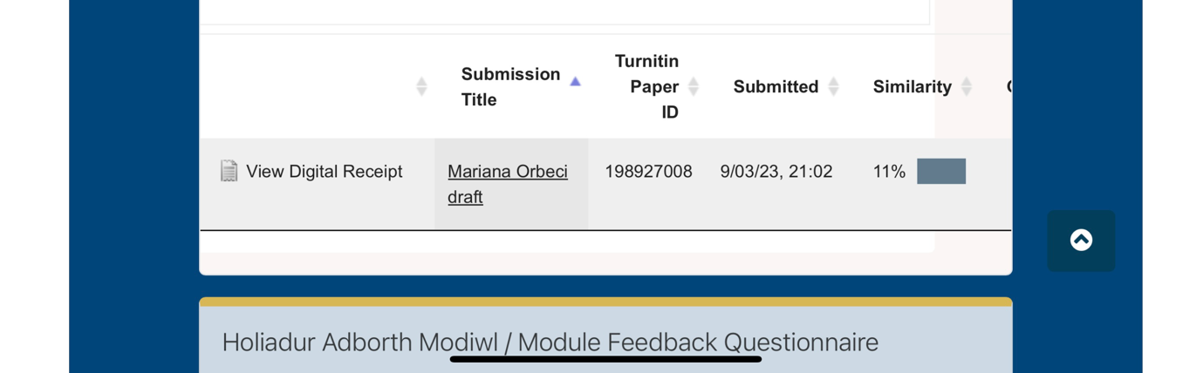

I am really happy with the similarity percentage. At the beginning I found it really difficult to paraphrase because I had never used this skill before. It took me a long time to complete tasks two and I had to make more attempts to have a final document with the score under 30%. I agree that it is a really useful skill to paraphrase and to demonstrate that you understood the text. I believe that it is important to develop your vocabulary in order to reach the final goal and have a good paraphrasing skill.

Task 3- Critical Analysis

Critical thinking is a process who allows the reader to question if the methods and the content used by the author of a report are useful and correct, if the sources are credible and if the topic is clear. As well has to be identified what is evidence and what is an argument. ( University of Wollongong, Australia, 2015)
According to Browne and Keeley analysing critically is a way to rationally and logically dismantle what is read, written or listened.(Browne, M& Keeley, S, 2012)
The critical thinking has to be rational and objective in order to make the right connections between the ideas.
Critical thinking helps the reader to have a better understanding over the information they process by questioning the author and his work. (Science and Education Publishing, 2015)
The term “critical analysis” in the context of academic writing means to demonstrate the understanding of evidence or showing reasoning and conclusion from your reading.(University College London,2023)
According to Stella Cottrell the critical thinking has applications in almost every aspects of the life. It is a key to career success and it should be an “ must have” for many professions.(Stella Cottrell,2005)
A few benefits of critical analysis are: helps developing problem-solving skills, improve decision making and stimulate the curiosity. One of the most important benefits of critical analysis is the independence gained by being able to learn something by pouting the right questions and find the answers without step by step guidance.
The critical thinking can be improved by opening discussions in the class room or at workplace and form personal opinions on a topic. It is really important to understand the mental process and become more self-aware about the values and ethics.

Task 4

Conclusion

The conclusion is the synthesis of the ideas that has been presented in the main body of the report. It is an important part of the report, not just “ the last paragraph” where the reader can notice the repercussions and the importance of the topic.(University of Maryland, 2022)
A successful conclusion has to demonstrate the importance of the ideas presented, to be clear and to restate the main topic.(Library of Sacred Heart University, dec 2022)
In this section the writer can not introduce new ideas but he should offer new intriguing insights which should come from the research already conducted.

Reference List

AMERICAN PSYCHOLOGICAL ASSOCIATION, Discussing your findings, 2006
Available at: https://www.apa.org/gradpsych/2006/01/findings
[Accessed on 06 March 2023]

BROWNE, M&KEELEY,S 2012 Asking the right question: a guide to critical thinking
Available at: http://www.sciepub.com/reference/361887

EapFoundation-Academic writing, 24 July 2022
Available at: https://www.eapfoundation.com/writing/what/

IsEssay-The Importance of Academic Writing, 29 dec 2018
Available at: https://isessay.com/blog/importance-of-academic-writing/

LIBRARY OF SACRED HEART UNIVERSITY- Organizing Academic Research Papers:9. The conclusion, 8 dec 2022
Available at: https://library.sacredheart.edu/c.php?g=29803&p=185935

LinkedIn-Importance of Academic Writing, 23 nov 2021
Available at: https://www.linkedin.com/pulse/importance-academic-writing-uvaldi-kleynhans?trk=public_profile_article_view

SCIENCE AND EDUCATION PUBLISHING-Categories of Questions and critical thinking, 2015
Available at: https://library.sacredheart.edu/c.php?g=29803&p=185935

SCRIBBR- How to write a results section, 27 October 2016 revised on 25th October 2022
Available at:
https://www.scribbr.co.uk/thesis-dissertation/results-section/

STELLA COTTRELL- Critical thinking skills developing effective analysis and argument,2005 First published 2005 by PALGRAVE MACMILLAN, New York, page 177
Available at: https://elearn.uni-sofia.bg/pluginfile.php/76858/mod_resource/content/1/%5BStella_Cottrell%5D_Critical_Thinking_Skills_Develo(BookFi.org).pdf

THE WRITING COOPERATIVE-Academic writing and it’s importance, 3 aug 2018
Available at: https://writingcooperative.com/academic-writing-and-its-importance-5-things-you-should-know-about-c95ad2e2d2b5

UNIVERSITY OF SUFFOLK-Types of academic writing, 22 Aug 2022
Available at: https://docs.google.com/document/u/0/d/1Fn64Wf8kIiIMPbglSIfu6JXe0rRSKQbCFMwsUMS2nKo/mobilebasic

UNIVERSITY OF LEEDS-Report writing, 2021
Available at: https://library.leeds.ac.uk/info/14011/writing/114/report_writing

UNIVERSITY OF YORK-Academic writing-a practical guide, 22 feb 2023
Available at: https://subjectguides.york.ac.uk/academic-writing/types-of-writing

UNIVERSITY OF MARYLAND-SCHOOL OF BUSINESS, Critical thinking
Available at: https://www.rhsmith.umd.edu/about/critical-thinking

UNIVERSITY COLLEGE LONDON-Critical analysis
Available at: https://www.ucl.ac.uk/ioe-writing-centre/develop-academic-voice/analysis

UNIVERSITY OF SACRED HEART- The discussion, 8 dec 2022
Available at: https://library.sacredheart.edu/c.php?g=29803&p=185920

UNIVERSITY OF WOLLONGONG, AUSTRALIA-Critical analysis, 2012
Available at: https://www.uow.edu.au/student/learning-co-op/assessments/critical-analysis/

