Claire Couch 1708237

What is pastoral care?
“Pastoral care is an ancient model of emotional and spiritual support that can be found in all cultures and traditions. It has been described in our modern context as individual and corporate patience in which trained pastoral careers support people in their pain, loss, anxiety and their triumphs, joys and victories. Pastoral care as a care model and profession is emerging in the public arena in our day, and its value and helpfulness is now recognised as applicable to people generally in their everyday life” (university of Canberra)
The term pastoral care derives from the word “pastor” meaning “shepherd” a biblical quote Jeremiah 3:15 “And I will give you shepherds after my own heart, who will feed you with knowledge and understanding” This is essentially the role of a pastoral carer, which I believe is separate to the academic side of the teaching assistant role.
The core purpose of delivering pastoral care is to support the pupils to succeed by raising their aspirations, self-esteem and motivation. Attempts to ensure the learning environment is based on a positive, healthy relationships, in which pupils feel safe, happy, supported and more importantly valued and respect. I believe a significant part of delivering high quality pastoral care is being aware of child protection issues, safety and welfare of the pupils and recognising changes in pupils general physical and emotional health and well-being.
How can teaching assistants provide pastoral care to their pupils? I believe this can be achieved in many ways, Firstly, we can look at the “10-point action plan”

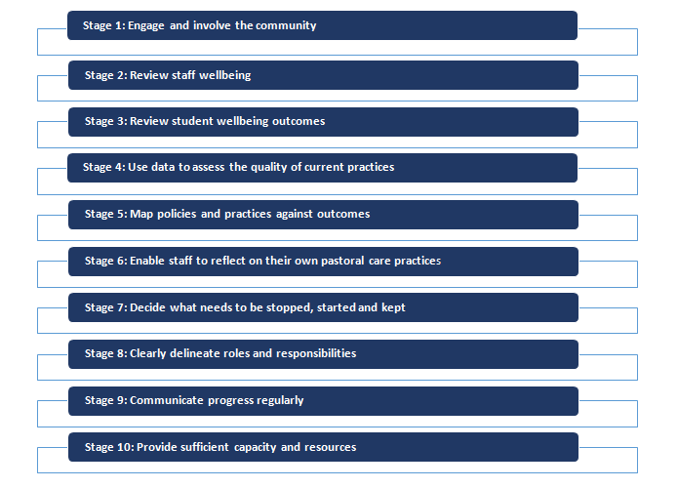
Image: Donna Cross and Leanne Lester accessed 2/1/2018
Stage 1: Engage and involve the community
Calmette and Pearcy (1989) believed that engaging the whole community (staff, students and parents) is a key strategy to promote pastoral care in schools. The school where I am employed at present fully embraces this ethos. We work closely with the community e.g. Swansea city football club who regular visit the school to develop our P.E programme. We hold regular opening days where parents/carers can come in and observe, ask questions, air views and opinions with regards to the school and more importantly the pupils can also take part in this. We also have suggestion boxes placed around the school where the pupils voice can be heard.
Stage 2: Review staff wellbeing
School A holds a staff meeting three times a week to discuss any issues or concern the staff might have. This is also an opportunity to praise staff for any accomplishments they might have achieved. If staff wellbeing is being care for, the staff are more likely to care about the students.
Stage 3: Review student’s wellbeing outcomes
“The review could assess the student’s wellbeing using the four critical components of pastoral care: promotion of health and wellbeing; resilience; academic care; and social capital within the school community (Nadge, 2005)
Stage 4: Use data to assess the quality of current practice
School A has access to different sources of data which they use to develop their pastoral care practices e.g. pupils, staff, parents/carers questionnaires and satisfaction survey.

Stage 5: Map polices and practice against outcomes
Each pupil who attends school A has an Individual Education Programme (IEP) The information contained within IEPS are deigned to inform the teacher, enabling them to develop a learning curriculum to target areas of needs and to deliver on individual outcomes. Also identified within IEP’s are pupil’s emotional wellbeing, possible challenging behaviours and possible triggers to these behaviours. The information collated within IEP’s is through a multi-agency approach, whereby all professionals involved decide the delivery of support to best meet the needs of the individual. This will always be done in a multi-disciplinary arena. Corresponding generic and individual risk assessments are present in respect of the needs of the pupil.

Stage 6: Enable staff to reflect on their own pastoral care practice
In our weekly meeting we reflect and share our ideas, discuss how we can develop skills to improve our service of being pastoral care providers. Staff are encouraged to attend courses to develop their skill and knowledge of pastoral care, in turn this will allow staff to reflect on their own practises.

Stage 7: Decide what needs to be stopped, started and kept
Working closely with the staff and more importantly the pupils, we can assess what Is working and what is not working. A sign that the pastoral care approach is working, would be evident in 1:1 sessions between the individual and myself. Whether the pupil feels at ease with me, feel they can discuss issues personal to them and generally feeling they can approach me at any time. This I feel summarises the true essence of pastoral care, whereby the impact of spending time getting to know the pupils, building trust and confidence has been proved to have a positive impact on young peoples lives and their learning experiences.

Stage 8; Clearly delineate roles and responsibilities
Our staff folders clearly define our roles and responsibilities within our school. This enables us to focus on our job role and develop strengths and work on our weakness.

Stage 9: Communicate progress regularly
Our weekly staff meetings and good working relationships with staff members and more importantly the pupils allow us to carry this out daily. All pupils have day books that go home with them to inform parents of daily progress and any issues throughout the day. Parents evening is a very helpful forum for teachers to discuss the term progress of the pupils and to identify goals for the coming term.

Stage 10: Provide sufficient capacity and resources
For pastoral care to have a positive impact on the classroom environment, the correct ratio of staff to pupils needs to be implemented, sufficient resources in terms of educational aids to offer pupils the best opportunities of fulfilling their potential academically.

As a teaching assistant I personally find these “Ten steps to delivering pastoral care” a foundation of how we can deliver high quality pastoral care to our pupils.
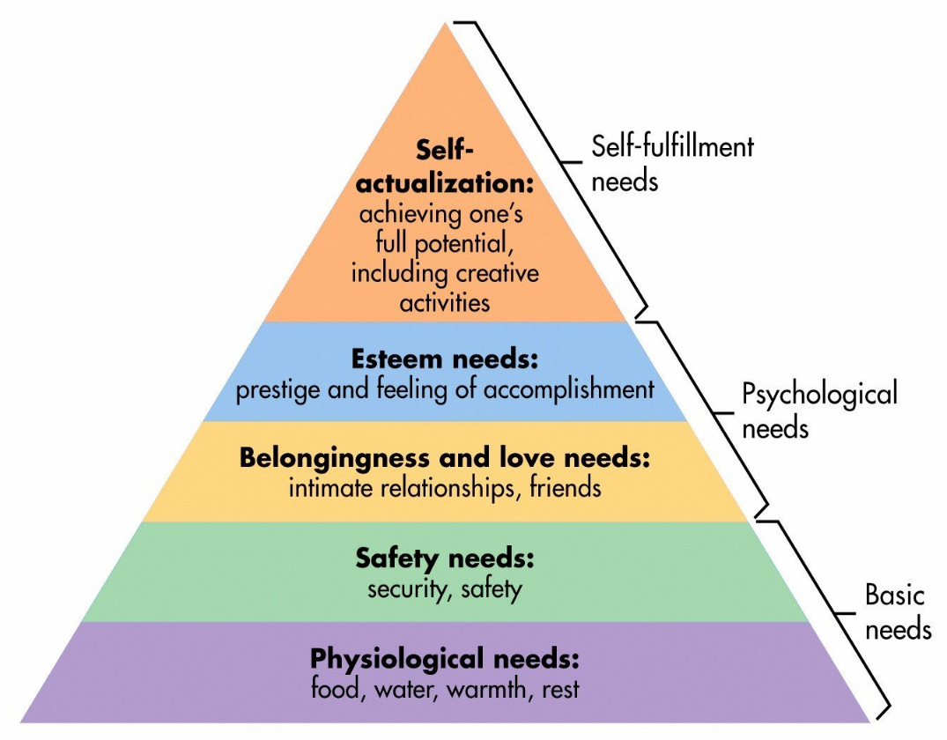
Maslow Hierarchy of Needs (1943) is a great foundation on how we can deliver pastoral care. It is basically what we need to survive and more importantly thrive and develop.

Image provide by google accessed 2/1/2018
*Physiological needs
School A provides breakfast clubs, water dispensers through out the school, and offer quiet rooms where pupils are encouraged to rest, sleep or just take time out. These are supervised by myself, I feel it is a great opportunity to talk to the pupil about any concerns they might have, the environment is safe and stable, therefore the pupil will hopefully feel safe and is more likely to open about his/her feelings.

*Safety needs
Pupils are aware they can discuss any concerns or worries they might have. We also offer a safe and stable environment where this can take place. As a school we have a duty of care to be vigilant and look for signs of abuse and distress and put measures in place to safeguard pupils within our care. This is achieved as delicate as possible following policies and procedures.

*Belongingness and love needs
Working closely with pupils we build up trust, acceptance and friendships, all of which is the foundation for them to learn. This is a key part of my role as a teaching assistant and a deliver of pastoral care.

*Esteem needs
Not only do I as a teaching assistant promote the pupil to build esteem for oneself, also for them to respect themselves, but also making the pupil aware they have the right to be treated with respect from others. It is important we praise pupils as much as possible, celebrating success and positive behaviour. Praise nurtures self-esteem, confidence and sense of self. By using praise, you are showing the pupil how you think positively about them.

*Self-actualization
Helping pupils to achieve their full potential, though work and personal development. This is key part of my role as a teaching assistant, working closely with the pupil, building trust and relationships so they can thrive and develop, not only personally but also academically. “To become everything, one is capable of becoming” (Maslow,1987, p.64)

Taking all this knowledge in to account, I truly believe following the ethos of the “Maslow hierarchy of Needs” (1943) and the “10- point action plan “myself and other teaching assistant can truly deliver a high quality, nurturing approach to delivering pastoral care to our pupils. Reading and understanding the information given in these two approaches to delivering pastoral care, we can learn so much and develop our skills, and more importantly the pupils within our entrusted care will benefit from our approach. Only when pupils feel calm, relaxed, safe and respected can learning truly take place. This will not only enhance their academic skills, but also their personal skills e.g. social, emotional, trust, independence, and self-fulfillment can be developed to, something I believe that pastoral care is all about.

*References
*Bernard. (1996)
*Jeremiah 3:15 New Testament
*www.universtyof Canberra.co.uk accessed 2/1/2018
*“10-point action plan” Donna Cross and Leanne Lester accessed 2/1/2018
*Pen-Y-Bryn School Policy and Procedures
*(Nadge, 2005)
*Maslow Hierarchy of Needs (1943) Access on 2/1/2018
*Images provide by “Goggle”
* Maslow,1987, p.64 Motivation and Personality

