Introduction to Leadership and Management

STUDEN NAME: Tanya Eftimova
STUDENT ID: 2317898

Table of Contents
Introduction 2
Main body 2
Amazon: Transformational Leadership 2
Primark: Servant Leadership 4
Describing Personal Experiences: 5
Conclusion 6
References 8

Introduction
Leadership, a core element of organizational success, is all the features to guide and deal with individuals in directing them to the attaining of common goals. Sustained by some basic theories and perspectives, leadership is a flexible entity that drives organizational culture, strategy, and ethical environment (Al Amiri et al., 2020). This report will be building on the many leadership styles that are prevailing in public organization like Amazon and Primark. More precisely, this article will be unleashing the intricacies of their approaches and how suitable they are in different environments. By applying information from scholarly articles, the critique evaluates transformational leadership and leadership via service, its strengths and weaknesses. Combining of theoretical conceptions with practical experiences results in a sophisticated comprehension of leadership capability to impact the organization's vision, mission, and operational effectiveness. When it comes to deciphering the intricate nature of modern business terrain, this exploration forms the foundation, from which the leadership role in attaining success in the organizations serves as the main component.

Main body

Amazon: Transformational Leadership
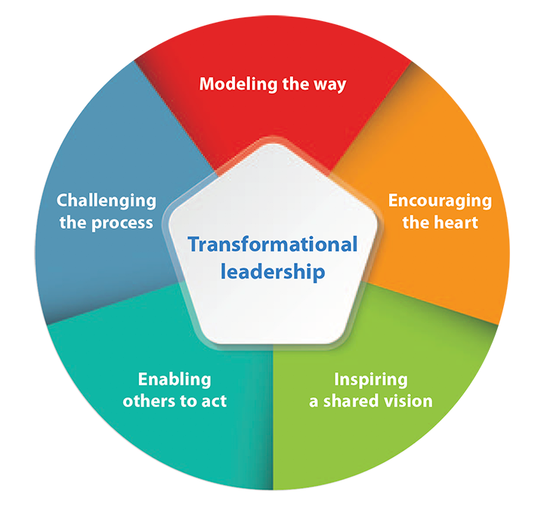
Figure 1: Transformational Leadership
Amazon, power hit by Jeff Bezos its founder and former CEO, is a case of transformational leadership. The main features of this approach include clear vision, endless inspiration and motivation from the side of the leader, and leaving aside the employees' conventional expectations as a mean to get their best performance (Hagemann, 2022). The founder, Bezos, with a record in innovation and queries for progress, has a culture that tolerates the working staff to imagine something new and take risks that are calculated.
Advantages:
- Innovation and Creativity: This transformational kind of leadership facilitates an atmosphere of mind that gives birth to new concepts and revolutionary ways of thinking. The fact that Amazon consistently puts a high level of importance on technology upgrades and as a result comes up with services like Amazon Prime clearly highlights this advantage (Onggowidjojo and Ellitan, 2023).
- Employee Engagement: This style connects employees with the mission of their organization and boosts their intrinsic, job emotions, which eventually turns into job satisfaction and loyalty. About Amazon's talents retaining and inspired staff maintenance Bezos leadership transformational answers.

Disadvantages:
- Potential for Burnout: Grounds of an always high demand and a perpetual push to innovation eventually threaten with the employee burnout. Amazon's work culture, which is very intense, has been criticized due to the fact that it puts the physical as well as mental condition of its employees in danger as well as work-life balance (Hagemann, 2022).
- Dependency on Leadership: Leaderships that are transformational may gradually decline, when transition happened with Bezos giving up the position of a CEO. The danger of being too dependent on the charismatic figure may happen and become the reason for the leadership succession process to be unstable.
Adaptation to Situational Contexts:
The staff run smoothly and perform great within these industries, transformational leadership is quite legitimate. This is actual boosting force that enables ongoing striving for increased innovation and response to shifting market patterns (Gradinaru et al., 2020). In addition to this, transformational style is needed particularly when organizations are going through a restructuring, or are facing a crisis. Such a situation calls for more of a transactional, or authority-style of leadership so that stability and swift decision-making can be ensured.

Primark: Servant Leadership
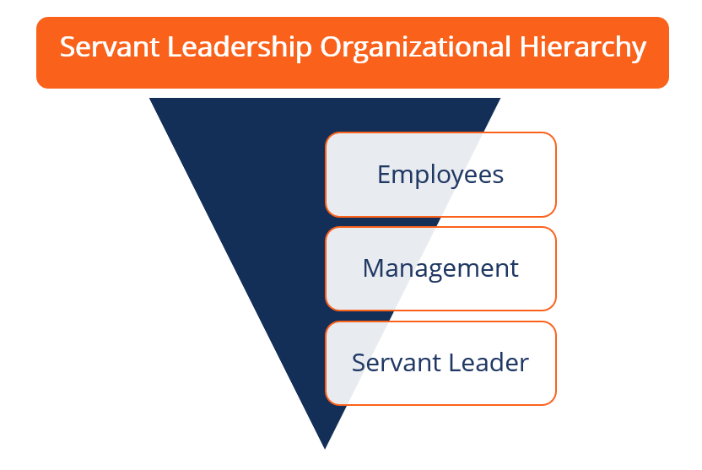
Figure 2: Servant leadership
Primark, considered the great player within the fashion retail sector, usually in a servo leadership style operates. Servant leadership is based on the principle that leaders come first in the team and exercise empathic care and support to create a truly collaborative and team-oriented culture.
Advantages:
- Employee Satisfaction: The first feature of a servant leader is that they pay attention to the welfare of their teams, which in turn increases job satisfaction and triggers loyalty to the leader. In retail business, within which frontline workers are absolutely critical, this aim creates a positive corporate atmosphere (Onggowidjojo and Ellitan, 2023).
- Team Cohesion: Servant leadership relies on working together and joint decision-making, which leads to a well-aligned team and cooperation. Primark's ability to help maintain a constantly loyal and working-together staff and the servant leadership principles go hand in hand.
Disadvantages:
- Decision-Making Speed: The involve style of servant leadership may see the slow nature of decision-making being a factor. The retailing environment, which is undergoing constant change, could negatively affect the organization if critical decisions are postponed.
- Potential for Exploitation: When with team members try to benefit of leader servant attitude problems occur as accountability and performance are downgraded (Pawar et al., 2020).
Adaptation to Situational Contexts:
Servant leadership may be very effective in industries like retail which have an abundance of workers and is seldom changing. Nevertheless, in the case of some prominent situations or strategic shifts transformation or authoritative style might be appropriate to solve the problems with speed and to facilitate resolving the opportuneness (Eva et al., 2019).
Finally, Amazon and Primark both represent distinct leadership styles that serve, as the organization well. Transcendent leadership at Amazon has caused innovation and dominance in the market, nonetheless it has generated some employment issues, including times of burnout. In contrast, servant leadership at Primark has increased both staff welfare and teamwork with a possibility of being under pressure during rapid changes, though. Aware of leadership as a changing phenomenon, organizations must do it the critical way to blend leadership styles as a situation requires to enhance effectiveness and promote sustainable success.

Describing Personal Experiences:
Previously I have grown through leadership roles in addition, I performed well in both academic and organizational sectors. These encounters have however enlightened me of the methods which are practical and effective in the world we live in today.
Academic Leadership:
In the course of my college studies, I held the position of the head of a set of students who were in charge of the organization and promotion of the academic events aimed at getting the initiative from the students. Hereby, I found myself utilizing a transformational leadership approach, which needed to focus on the common ground and inspire team players to join with their talents. Establishment of environment allowing stimulating ideas which were welcomed and supported would to successful holding events devoted to the enrichment of the student activity (Benmira and Agboola, 2021).
Professional Leadership:
I discovered what it was to be a leader during the period I was heading a multi-functional team that brought a new software system into our workplace. For me, being banking transaction officer required a leader who could combine transactional and transformative leadership skills. As a leader of the team, I have to be sharp and hold off the creativity from the staff, finish the tasks promptly during the task set's turbulence.
Both activities were eye-opening in their own way and stimulated a desire to redo the whole thing. From the list below, please find one that is interesting, creative, and expresses a clear sentence. In my college courses, personal views were valued as much as collaborations and group commitments. I found myself to be at the root of the solution, communicating correctly and resolving problems (Guzmán et al., 2020). I have learned the power of leading by example as I had to juggle the pressure of completion of tasks on time while at the same time keeping the team coordinated, a skill I have adopted as a manager by handling conflicting situation with maturity in tough as well as confusing time frames.
This articulated leadership position from various angles. True moral and motivational leadership in academics however tended to first raise and horn the talents, while on the other side pragmatic leadership was crucial for businesses. Flexibility of leadership and adjustment to possible team changes and environmental conditions were identified, as the key technical components.
Integration with Leadership Theory:
I witnessed leadership style in practice and how thoroughly it works in this service-based structure. Both the instances revealed me that a great leader uses a balanced technique and combines task-oriented and people-oriented methods, which is mentioned in leadership literature, also.
My core leadership experience was when I was elected to lead the college club that made me learn practical leadership beyond the book theories. The fact that I am exposed to scholastic and professional challenges for the first time has shocked me. It has taught me how vital adaptability and overall knowledge of how to do what is needed in different scenarios are (Benmira and Agboola, 2021). Thus, all of these experiences have not only grown my leadership abilities, but they also taught me that my leadership skills can always be improved; hence I must constantly evaluate my leadership traits and not to be obstinate.

Conclusion
The reading task led me to the following conclusion that theory and personal experience can bring changes to the way Amazon and Primark bosses approach their laborers. The leadership analysis presents us with the idea of it being dynamic. Amazon which is innovation-oriented leader and Primark, which value employees, on the other hand, make assumptions about different leadership styles. I believe leaders learn leadership work better when they teach and use specific leadership types. Implementing of academic theories on practice engages necessary ability in flexibility, work among colleagues, and situation awareness. The next leaders should do more than echoing the glory days strategies, but approach their leadership from a holistic view by combining synergy, inoculation and other leadership styles. Visionaries of tomorrow should possess different types of leadership styles, create new opportunities, fuel team engagement and joy, and handle a degree of vagueness to guarantee the survival of their businesses. The study specifically concentrates on leadership and why it is integral in the growth and progress of the organization, and how the theory and practice are related.

References
Al Amiri, N., Rahima, R.E.A. and Ahmed, G., 2020. Leadership styles and organizational knowledge management activities: A systematic review. Gadjah Mada International Journal of Business, 22(3), pp.250-275.
Benmira, S. and Agboola, M., 2021. Evolution of leadership theory. BMJ Leader, pp.leader-2020.
Eva, N., Robin, M., Sendjaya, S., Van Dierendonck, D. and Liden, R.C., 2019. Servant leadership: A systematic review and call for future research. The leadership quarterly, 30(1), pp.111-132.
Guzmán, V.E., Muschard, B., Gerolamo, M., Kohl, H. and Rozenfeld, H., 2020. Characteristics and Skills of Leadership in the Context of Industry 4.0. Procedia Manufacturing, 43, pp.543-550.
Gradinaru, C., Toma, S.G., Catana, S. and Andrisán, G., 2020. A view on transformational leadership: The case of Jeff Bezos. Manager, (31), pp.93-100.
Hagemann, M., 2022. Does Current Popular Leadership Literature Show a Preference for Transformational Leadership?. Managing Global Transitions, 20(4).
Onggowidjojo, V. and Ellitan, L., 2023. Strategies for Achieving Competitive Advantage: The Case of Amazon.
Pawar, A., Sudan, K., Satini, S. and Sunarsi, D., 2020. Organizational servant leadership. International Journal of Educational Administration, Management, and Leadership, pp.63-76.

